

School of Computing, Engineering and Mathematics (CEM)

Faculty of Engineering, Environment and Computing (EEC)

**5001CEM SOFTWARE ENGINEERING** | 2122

**PROJECT REPORT**

**NAME:** Rajdeep Mehra

**SID: 10803110**

1. **CODE PURPOSE**

The purpose of this code is to allow a user to be able to participate in an online auction. The auction has multiple function designed to meet the users need.

1. **CODE LOCATION**

<https://github.coventry.ac.uk/mehrar/5001NewExam/tree/main/auction>

1. **CODE INSTALLATION**

First download the code from <https://github.coventry.ac.uk/mehrar/5001NewExam/tree/main/auction> and then open Codio and create a new project with a python stack, enter any name you want for the project. Unzip the file you downloaded and paste it into the project.

Then do **sudo apt update**

Followed by **sudo apt-get install python3-venv**

And **python3 -m venv venv**

Which should add a new folder venv as shown above, because I have already added it.

Then activate the virtual environment by adding : **. venv/bin/activate**

Which prints out:

After this start installing all the files one at a time, the files are needed for the code to work for stuff like the database:

**pip install Flask**

**pip install Flask-SQLAlchemy**

**pip install cs50**

**pip install flask_session**

**pip install passlib**

**pip install flask_jsglue**

Finally, to run the program add:

export FLASK_APP=application

After that add flask run --host=0.0.0.0 which shows:

After that go to project on the top tab, and then click Box info.

This shows:

Copy the link from here and add 5000 to it to run the application. For me it’s <https://almanac-canada-5000.codio-box.uk/>

Which shows:

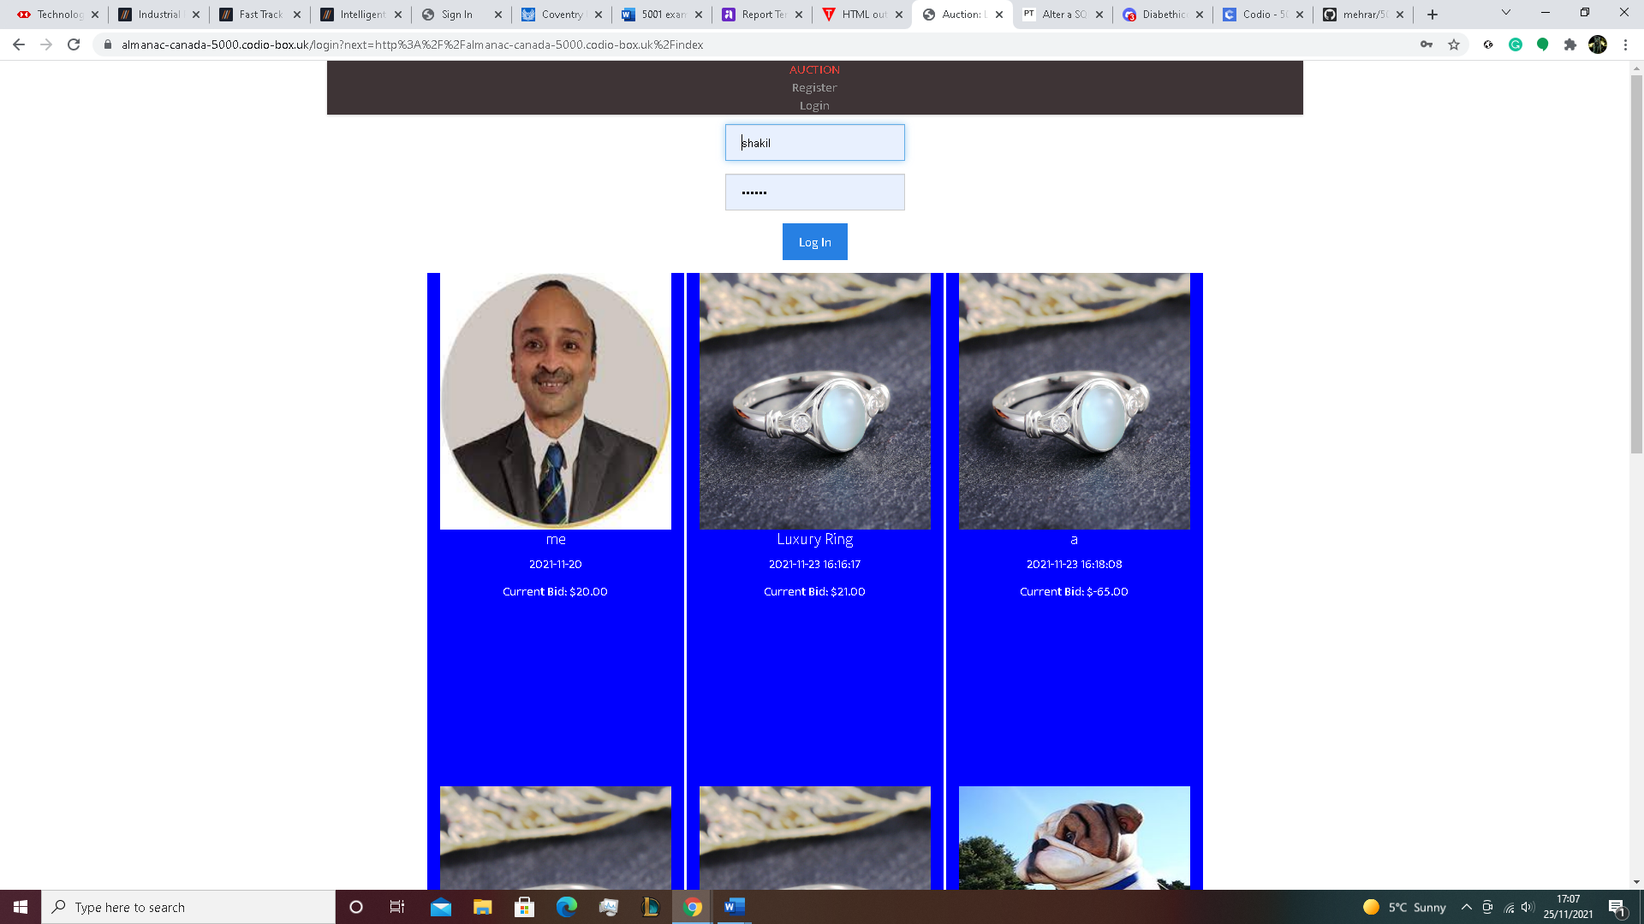

You can do what you want after, try to register and login first to try it out.

1. **CODE EXPLANATION**

First of all, the code structure is very simple with the main folder as bring ‘auction’ and the two sub folders templates and static, included with some other python files, the main application is application.py. which is used to run this code. The templates folder has many templates to show the data and other infiormation relevantly in the browser. The static folder has a css subfolder to handle styling as well as another images subfolder which has the product images.

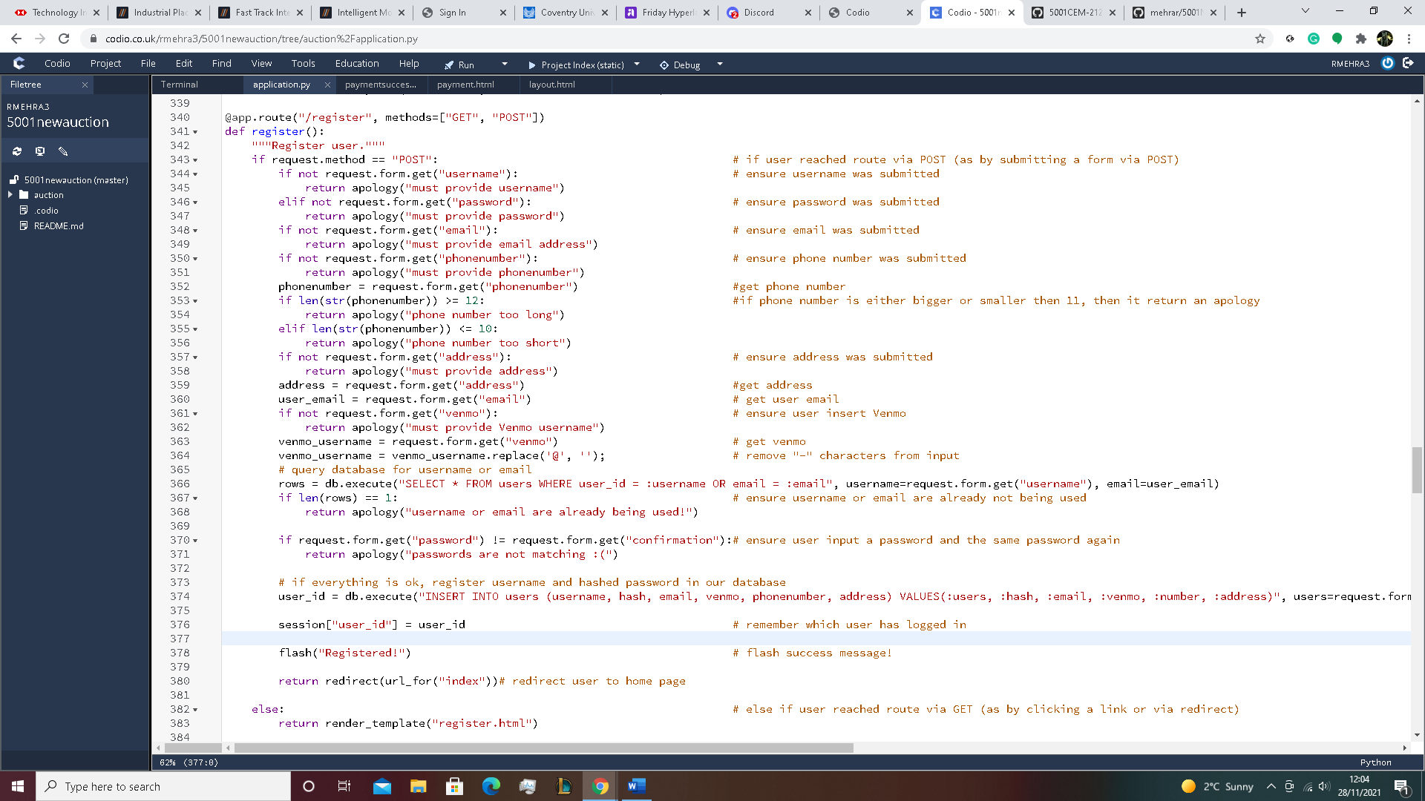

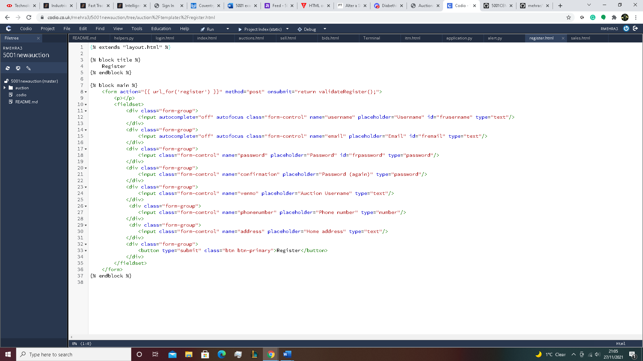

The first 2 picture show the code and html for my registeration which have been adapted from the 5001CEM 2122 GIVEN CODE, from the start the first thing that’s done in my registeration function is get a person to enter their details such as username, email, password, another password to match with the first one, an auction username, phone number and finally their address, and for each spaces that they have missed, it will keep showing a popup saying that you have not entered a specific value for that case. Also for every value that’s , entered is also checked, first the username and email can not be the same as another person that has already registerd with and this can be checked by looking through the user database which stores all of the users details so if the details you entered match with any that has been entered before, you will have to change them, next you also have to make sure your passwords match with each other so that you know what your password is and not just a jumble of letters and numbers, next is the phone number where it has to be exactly 11 number long otherwise it won’t be accepted as a real phone number. After every value has been entered and checked so that it meets the standard, it will then take them and store them into the user databse so that the user’s detail can be used for later such as login or buying ans selling in the auction. For the registratrion is html, it’s a very standard html where there is mostly just boxes that a user can write into, but each box has a specific data type you can enter so like in text you can enter anything, in number you can only enter number and so on, after the user has enter the specific detaials for each box, the user can then press the register button to check if all the values are proper and if they are, then is send into hmepage of the auction. For this code that I addapted, I had to add an extra 2 details, which are mainly phone number and home address and in html I added to more form groups for where the user can enter these details.

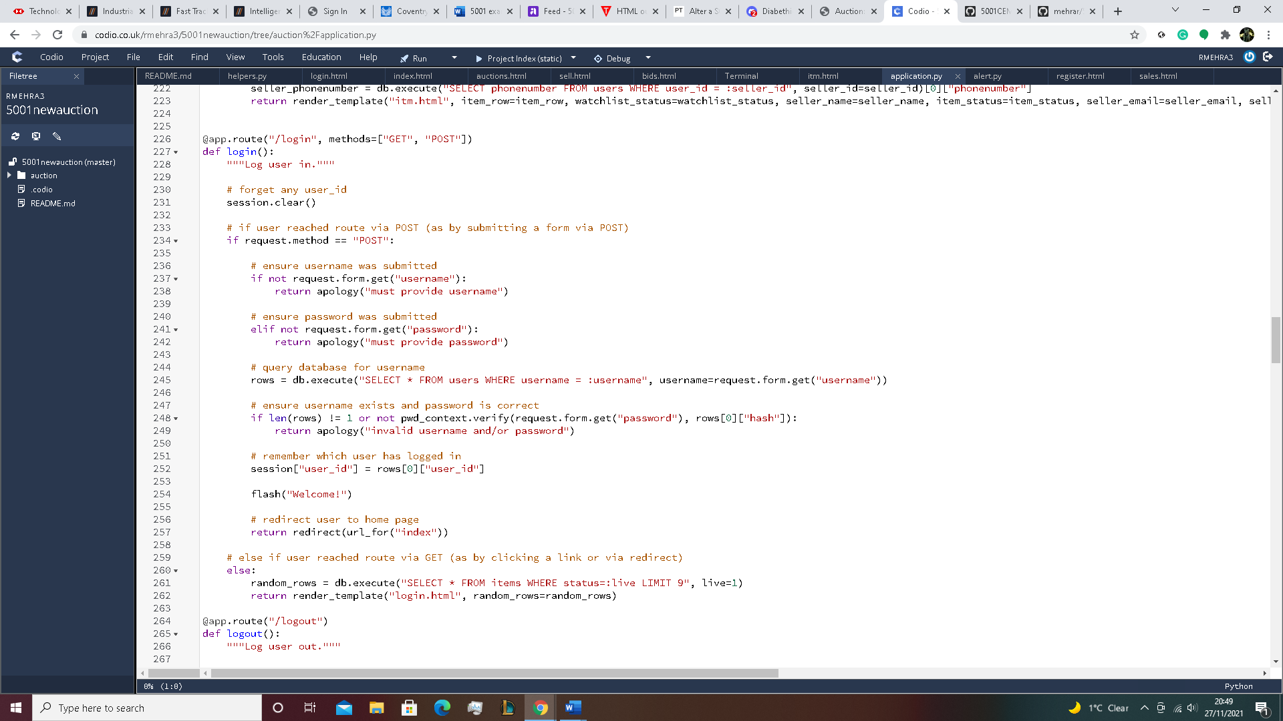

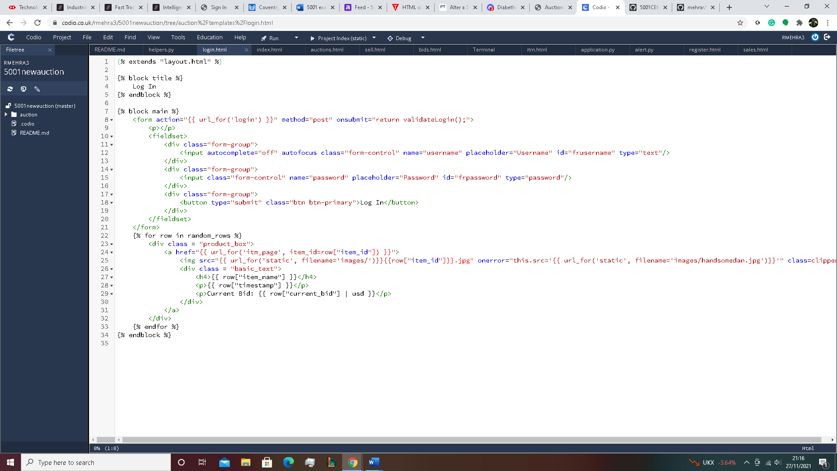

The 2 picture above show the code and html for my login which have been adapted from the 5001CEM 2122 GIVEN CODE, first of the code shows how the user has to enter a username and password, this is the first thing a user sees when they enter my website, for the username and password, the user has to have registered already, if user doesn’t add any details to login in, it will keep shwing a popup saying you haven’t entered this or that detail until they have, and after that the details that the user entered will be scrutanized by looking through the database, both the username and password has to have matched so it first gets username of the user and matches it in the database, if it matches it will then match the password for the same user and if the password does match it will have let the user login and go to the homepage, else if the password does not match it will show that in a popup saying invalid username/password and it will do the same for if the username didn’t match. Now when adapting it, I change the line for random_rows so that it selects everything about an item if it’s still not expirred and that only the top 9 items are shown. Now for the html it has 2 boxes where the user can enter their details and it has a text datatype for both of them so the user can enter anything and press the login button but if it doesn’t pass the check from the code, it will not be let through. Also I added items to login screen by adding everyting from {% for row in random_rows %} to {% endfor %} to the html which just shows that it goes through every item and each of their details, it then shows the top 9 live item from auction with their pictures, name, dateadded and their current bid inside each product box, this lets the user know what is up to bid on today without going through the hassel of loggin in. Also if the user try to click on them to go to bid, even though the code is correct it will not allow the user to do that because to go the items page, you need to have already logged in.

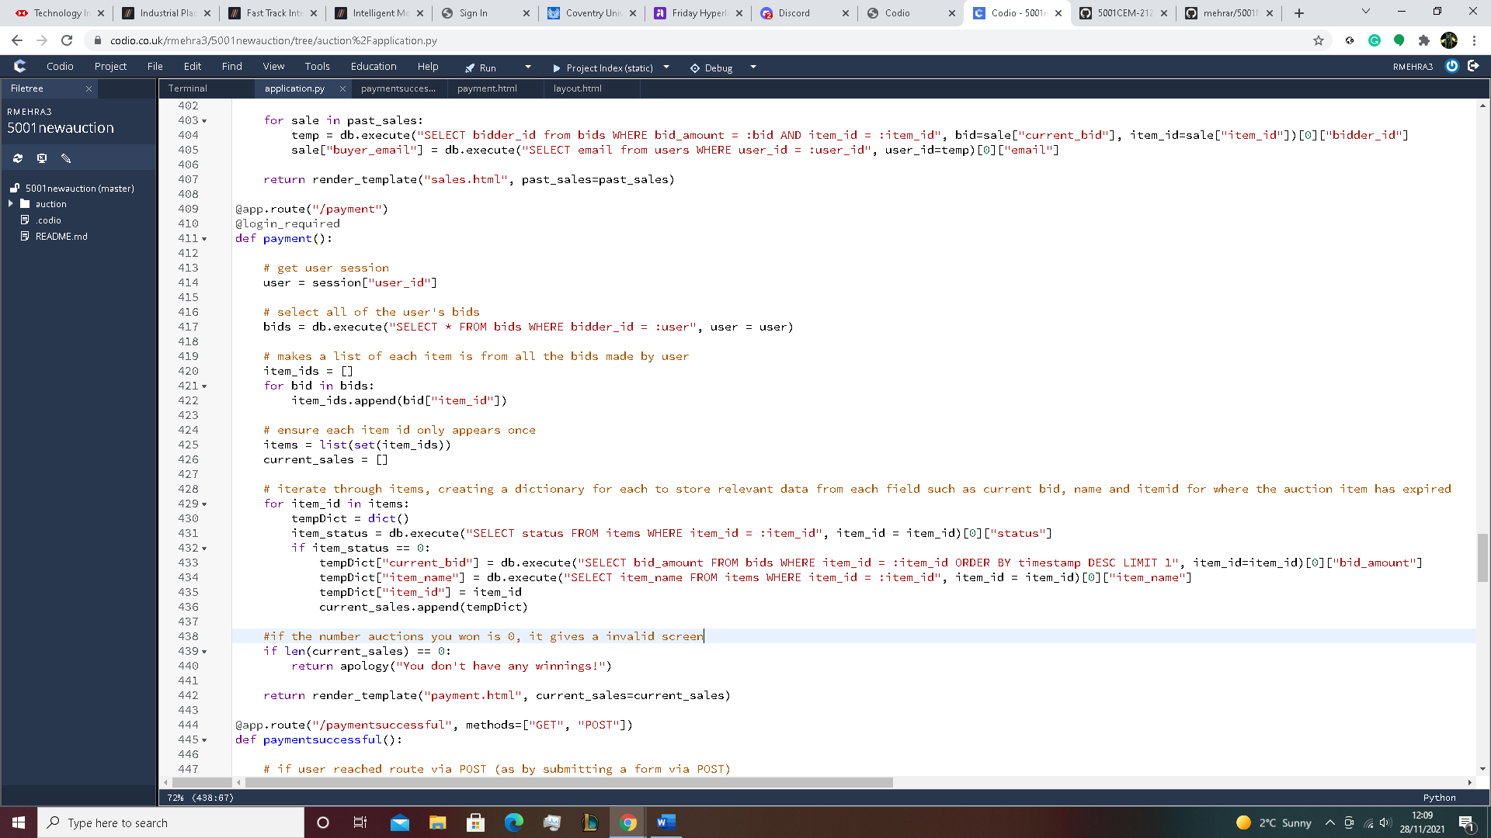

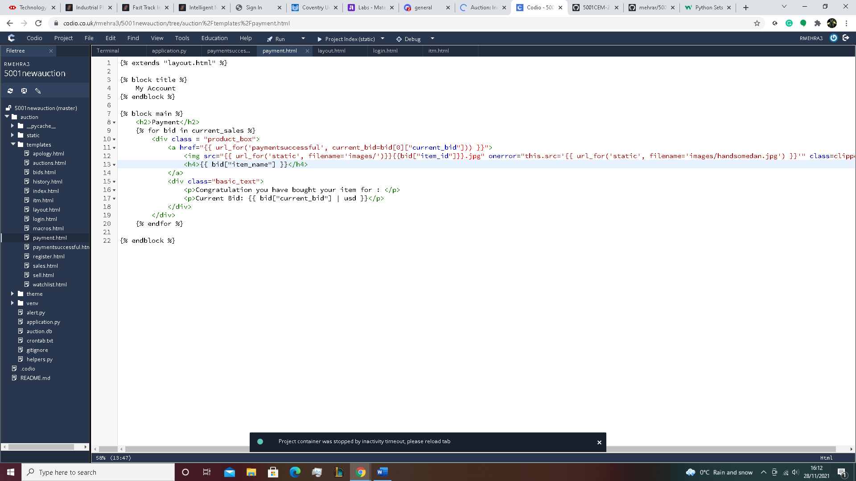

The 2 picture above show the code and html for my payment which have been adapted from the 5001CEM 2122 GIVEN CODE, however I created my own function and html for the payment system as the code doesn’t provide me with one, first it selects every bid that the user has made and from there work through every bid with a for loop and find the item id for each of the bids placed, item ids are then placed in a list of item_ids and this in turn is stored in another list for items but first it sets them to store multiple items in a single variable and them made into a list to be stored as. Another list is made but for the number of items that the user has won from bidding which is current_sales, for this list we first use a for loop to to iterate through item which has a status of 0, which means the item has expired and the auction for it has ended, so it takes the items that have been expired and iterates through each of their current bid, item name and item id and places them into current sales, it also check to see if there are any items in current sale otherwise it just returns a invalid screen saying you haven’t won anything yet. Then comes the html in which I just show all the items the user has won or just a invalid page if they haven’t won any. It shows all the images of the item, with their name and text saying you won the for the price that is the current bid inside the product box, also to make sure when the user clicks on the images it doesn’t take them to the item page but the payment successful page where the user can enter his bank details so for this I had to edit the url so that it directs it to payment successful with the current bid so that we can use the item amount. Also just so that the user can find they payment page I had to edit the layout html so that it would show up in the websit by adding “<li><a href="{{ url_for('payment') }}">Payment</a></li>” in the <ul class="sub-menu"> .

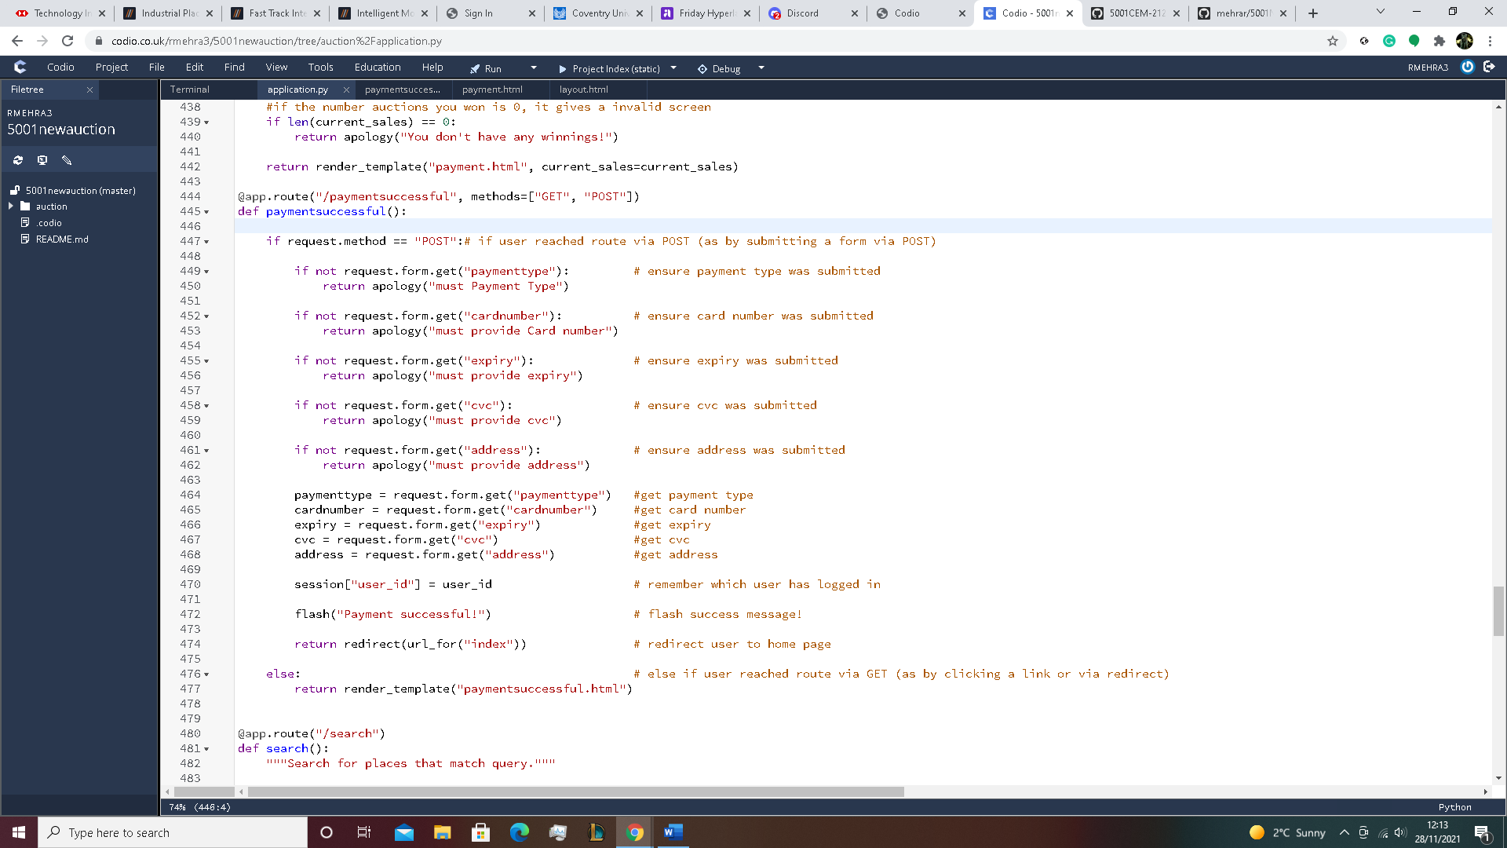

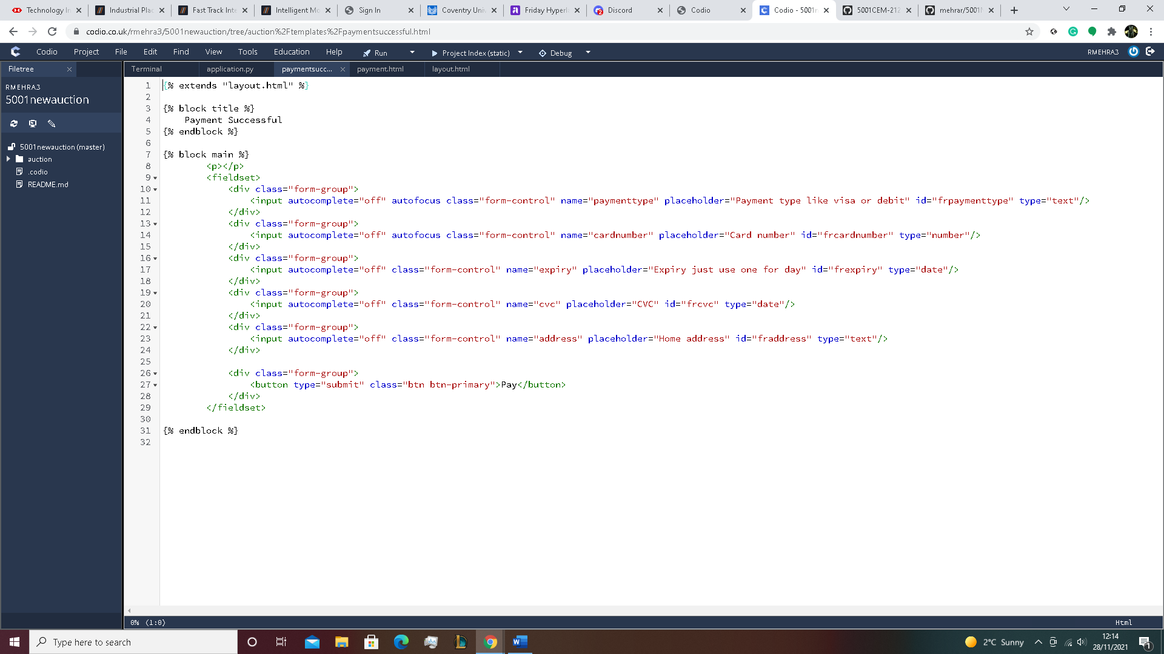

The 2 picture above show the code and html for my payment which have been adapted from the 5001CEM 2122 GIVEN CODE, however I created my own function and html for the payment successful system as the code doesn’t provide me with one. So first after getting the payment successful page, the first it tells the user to do is enter their, payment type, card number, expiry date, security number, and their address to where item will be delivered. Also for each spaces that they have missed, it will keep showing a popup saying that you have not entered a specific value for that case. Also I would have liked to add these to database but due to time difficulty wasn’t able to because this code never had place to edit the database, they just gave a datbase that was already made so I have to directly edit the table. Also due this being a dummy website, a fake website, it generally just accepts any details so the user can enter anything and they would have successfully paid. For the html, it shows boxes where the user can enter his details into, each box also a data type such as text, numberand date which only allow that can of data. There is also a button to click pay, which should let you pay and then send you to homepage and a payment success sign. Also the only way to get to this page is from payment and no way else so there was no need to change the layout.

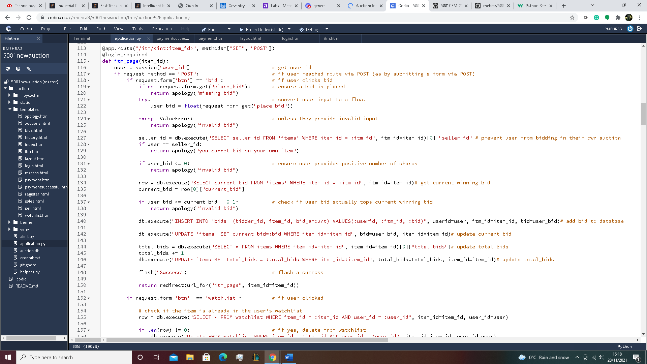

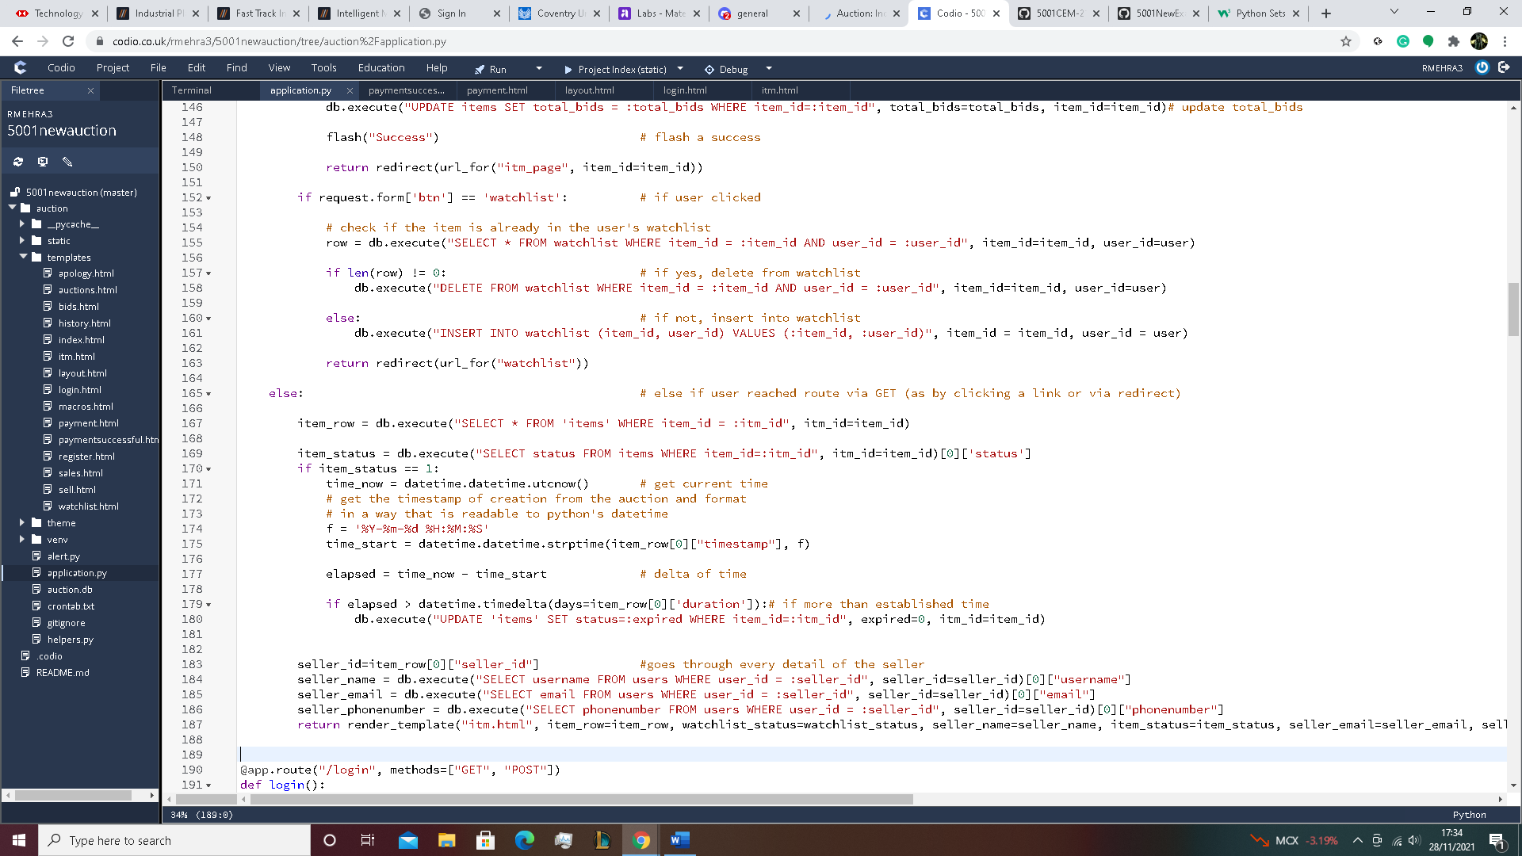

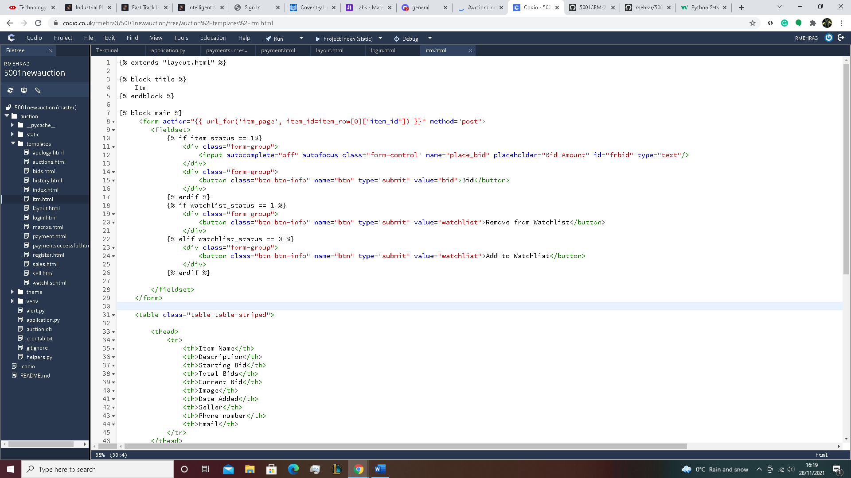

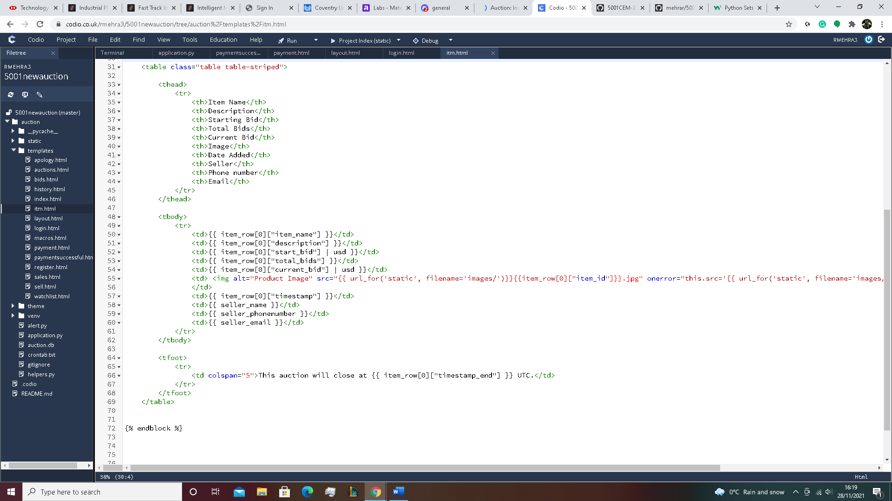

The 4 pictures above show the code and html for my item page which have been adapted from the 5001CEM 2122 GIVEN CODE. To beign with, there are a lot of this inside the item page, for example the bidding, the watchlist, the details of the item such as, item name, description of the item, the starting bid, the total number of bids, the current bid, the image of the item, date added, seller, phone number and email address, also at the bottom it also has a timeline for when the auction will end. So first of all the bids, if the user tries to bid without entering the number it will just show a popup saying, you have to enter a bid, if you then enter a word, it will show it as a invalid, a negative number will also show an invalid bid, so it will only accept integer and float number witch is 10 pence higher then the current bid. Also it make sure that you are not able to bid on your own item by looking through the database for a seller id with the item id and then use that seller id to match with the user and if it is a match then there is a popup saying you can’t bid on your own item, otherwise it will accept the bid and the bid would be into to bids for bid amount where item id matches, it will also update the current bid using the item id and after that it will return you to homapge with a success sign. Then for the watchlist, when you click on the watchlist it first selects everything from watchlist using item id and user id, it then checks if there is a item from what it selected, if there is, then it will be deleted from watchlist and if there isn’t then it will add it to the watchlist by using item id and user id so it knows it’s for the user. It will then redirect to watchlist where you can see this item. From there It will then check the status of the items from items using item id. It will then using the status to see if it’s expired or not, and if not it then note down the current time and use the time from when the item was added to the time now and see how much time has passed and if the number of days passed has exceed the number of days the auction can stay on then the status is update to expired using item id. That is when you click on a item and then go back to auction, the item would have dissapeared as it just changed the status of the item. After that, it will now move on to the details that will needs to appear in the item page so it will select everything in items with item id and then use that get the items seller id, name, email and phone number, which will be used in the template. The template is very basic it will just post a box for the user to bid in, which will only accept number data typle. There will be a bid button where the user can click to bid after entering a number. There is also a add to watchlist button which will allow the user to either add the item to his watchlist or remove it. Then finally it’s seller details, which will be printed out in a table, where the top header tells what kind of detail it is and the row bellow shows all the details. Finally at the bottom there is a date for when the auction ends and if the date is already passed then the you will not be allowed to bid and the item will be removed from the homepage and your watclist.

1. **TESTING**

TESTING REGIME

**Rajdep Mehra - 10803110**

**Project**

My project is a simple auction with a registration and login, there is also lots of function such as bidding and keeping a watchlist but with no advanced functionality, limited data, and no real payment facility to show a simple workflow in Flask / sql / html / css. Security and UX.

**Test scope**

* Registration
* Login
* Shopfront
* Adding to and removing from cart
* Checking out

**out of scope**

* security

**Test time**

1 hour and 8 mins

**Test regime**

5.1 Registration (13 mins)

.1 First try to register, when registering sometimes miss a block of detail to see if you still register. You can try this with all of them.

|  |  |  |  |  |
| --- | --- | --- | --- | --- |
| Pass for Yes | Fail for No | Yes / No | Comments |  |

should show a popup saying you need to fill the specific space you haven’t filled.

.2 Try to register with no details by leaving everything blank and just click the signup button.

|  |  |  |  |  |
| --- | --- | --- | --- | --- |
| Pass for Yes | Fail for No | Yes / No | Comments |  |

should show a popup saying you need to fill the specific space you haven’t filled.

.3 When registering try to register with 2 different passwords and fill the other block.

|  |  |  |  |  |
| --- | --- | --- | --- | --- |
| Pass for Yes | Fail for No | Yes / No | Comments |  |

should show a popup saying your passwords are not matching.

.4 After registering once, register again and the details should not match with another user so trying to register another account with same details

should show a popup saying the details are already being used.

|  |  |  |  |  |
| --- | --- | --- | --- | --- |
| Pass for Yes | Fail for No | Yes / No | Comments |  |

.5 When registering trying to enter a fake email to see if you can register.

|  |  |  |  |  |
| --- | --- | --- | --- | --- |
| Pass for Yes | Fail for No | Yes / No | Comments |  |

should show a popup saying your email doesn’t exist.

.6 Register with proper details for each of the blanks.

|  |  |  |  |  |
| --- | --- | --- | --- | --- |
| Pass for Yes | Fail for No | Yes / No | Comments |  |

Should send you direct you to the homepage of the auction with a welcom post.

.7 When registering trying to enter a fake phone number to see if you can register.

|  |  |  |  |  |
| --- | --- | --- | --- | --- |
| Pass for Yes | Fail for No | Yes / No | Comments |  |

should show a popup saying your number doesn’t exist.

.8 When registering try registering with a number bigger or smaller then 11.

|  |  |  |  |  |
| --- | --- | --- | --- | --- |
| Pass for Yes | Fail for No | Yes / No | Comments |  |

should show a popup saying your number is either too long or too small.

.9 When registering trying to enter a fake home address to see if you can register.

|  |  |  |  |  |
| --- | --- | --- | --- | --- |
| Pass for Yes | Fail for No | Yes / No | Comments |  |

should show a popup saying your adress doesn’t exist.

.10

|  |  |  |  |  |
| --- | --- | --- | --- | --- |
| Pass for Yes | Fail for No | Yes / No | Comments |  |

should show a popup saying your number doesn’t exist.

5.2 Login(5 mins)

.1 First try to login, to login you need to fill all the blanks so first leave some blanks and try to register.

|  |  |  |  |  |
| --- | --- | --- | --- | --- |
| Pass for Yes | Fail for No | Yes / No | Comments |  |

should show a popup saying you need to fill the specific space you haven’t filled.

.2 When logging in the details should match the one you registered with so try the wrong details to see if you login.

|  |  |  |  |  |
| --- | --- | --- | --- | --- |
| Pass for Yes | Fail for No | Yes / No | Comments |  |

should show a popup saying you need to fill the correct details.

.3 Log in with the correct credentials.

|  |  |  |  |  |
| --- | --- | --- | --- | --- |
| Pass for Yes | Fail for No | Yes / No | Comments |  |

should let you login, and go to the homepage with a welcom post at the top.

.4 In the login page, it lets you see what the items in auction but doesn’t let you do through to the item page to bid.

|  |  |  |  |  |
| --- | --- | --- | --- | --- |
| Pass for Yes | Fail for No | Yes / No | Comments |  |

5.3 Selling (10 mins)

.1 When selling an item, you must fill all the cases so try to leave one each time you sell.

|  |  |  |  |  |
| --- | --- | --- | --- | --- |
| Pass for Yes | Fail for No | Yes / No | Comments |  |

should show a popup saying you need to fill the specific space you haven’t filled.

.2 When selling an item, you must use a jpg file for photo so use one that’s not.

|  |  |  |  |  |
| --- | --- | --- | --- | --- |
| Pass for Yes | Fail for No | Yes / No | Comments |  |

should show a popup saying you need to use the correct file type.

.3 When selling an item, try putting words for money.

|  |  |  |  |  |
| --- | --- | --- | --- | --- |
| Pass for Yes | Fail for No | Yes / No | Comments |  |

should show a popup saying you need to fill the specific space with numbers.

.4 When selling an item, try putting negative number.

|  |  |  |  |  |
| --- | --- | --- | --- | --- |
| Pass for Yes | Fail for No | Yes / No | Comments |  |

should show a popup saying starting bid must be positive.

.5 When selling an item, try putting decimal number.

|  |  |  |  |  |
| --- | --- | --- | --- | --- |
| Pass for Yes | Fail for No | Yes / No | Comments |  |

Should succesfully allow you to sell.

.6 Try selling an item, it should show the item in my auction.

|  |  |  |  |  |
| --- | --- | --- | --- | --- |
| Pass for Yes | Fail for No | Yes / No | Comments |  |

.7 After selling an item, it should show the item in homepage.

|  |  |  |  |  |
| --- | --- | --- | --- | --- |
| Pass for Yes | Fail for No | Yes / No | Comments |  |

.8 After selling an item, the details should say the current bid, seller id and date added for both my auction and homepage.

|  |  |  |  |  |
| --- | --- | --- | --- | --- |
| Pass for Yes | Fail for No | Yes / No | Comments |  |

5.4 Bidding(15 mins)

.1 When bidding on an item, you need to insert something in so try leaving it blank.

|  |  |  |  |  |
| --- | --- | --- | --- | --- |
| Pass for Yes | Fail for No | Yes / No | Comments |  |

should show a popup saying it’s a invalid bid.

.2 When bidding on an item, try putting words for money.

|  |  |  |  |  |
| --- | --- | --- | --- | --- |
| Pass for Yes | Fail for No | Yes / No | Comments |  |

should show a popup saying it’s a invalid bid.

.3 When bidding on an item, try putting negative number for money.

|  |  |  |  |  |
| --- | --- | --- | --- | --- |
| Pass for Yes | Fail for No | Yes / No | Comments |  |

should show a popup saying it’s a invalid bid.

.4 When bidding on an item, try putting decimal number for money.

|  |  |  |  |  |
| --- | --- | --- | --- | --- |
| Pass for Yes | Fail for No | Yes / No | Comments |  |

should show a popup saying it’s a invalid bid.

.5 When bidding on an item, try putting 0.

|  |  |  |  |  |
| --- | --- | --- | --- | --- |
| Pass for Yes | Fail for No | Yes / No | Comments |  |

should show a popup saying it’s a invalid bid.

.6 When bidding on an item, enter the same bid as the current bid.

|  |  |  |  |  |
| --- | --- | --- | --- | --- |
| Pass for Yes | Fail for No | Yes / No | Comments |  |

should show a popup saying it’s a invalid bid.

.7 When bidding on an item, the bid must be 10 pence more than the current. Try a bid within that range.

|  |  |  |  |  |
| --- | --- | --- | --- | --- |
| Pass for Yes | Fail for No | Yes / No | Comments |  |

should show a popup saying it’s a invalid bid.

.8 Do a successful bid that’s 10 pence over the current bid.

|  |  |  |  |  |
| --- | --- | --- | --- | --- |
| Pass for Yes | Fail for No | Yes / No | Comments |  |

should show a popup saying success.

.9 After a successful bid check my bids.

|  |  |  |  |  |
| --- | --- | --- | --- | --- |
| Pass for Yes | Fail for No | Yes / No | Comments |  |

should show the item you bid on my bid.

.10 After a successful bid check homepage.

|  |  |  |  |  |
| --- | --- | --- | --- | --- |
| Pass for Yes | Fail for No | Yes / No | Comments |  |

should show the item you bid is not there.

.11 After a successful bid check the current bid.

|  |  |  |  |  |
| --- | --- | --- | --- | --- |
| Pass for Yes | Fail for No | Yes / No | Comments |  |

should show the current bid has changed in homepage.

5.5 Auction(25 mins)

.1 Click on the pictures in the homepage.

|  |  |  |  |  |
| --- | --- | --- | --- | --- |
| Pass for Yes | Fail for No | Yes / No | Comments |  |

should send you to the item description page of the item.

.2 The information should be correctly displayed

|  |  |  |  |  |
| --- | --- | --- | --- | --- |
| Pass for Yes | Fail for No | Yes / No | Comments |  |

Test 1: Each detail is in a correct coressponding row.

|  |  |  |  |  |
| --- | --- | --- | --- | --- |
| Pass for Yes | Fail for No | Yes / No | Comments |  |

Test 2: Each detail does not over into another coloumn and is correctly resized into their own column.

|  |  |  |  |  |
| --- | --- | --- | --- | --- |
| Pass for Yes | Fail for No | Yes / No | Comments |  |

Test 3: A time for the end of the auction should be displayed at bottom of the item page.

.3 Images are being displayed correctly

Test 1: The images are correctly resized and fit bounding box

|  |  |  |  |  |
| --- | --- | --- | --- | --- |
| Pass for Yes | Fail for No | Yes / No | Comments |  |

Test 2: The bounding boxes are not overlapping with eachother

|  |  |  |  |  |
| --- | --- | --- | --- | --- |
| Pass for Yes | Fail for No | Yes / No | Comments |  |

Test 3: The detaisl of the picture are correctly placed below the picture and are all inside the bounding boxes.

|  |  |  |  |  |
| --- | --- | --- | --- | --- |
| Pass for Yes | Fail for No | Yes / No | Comments |  |

.4 On the item description page, click the watchlist button, then go to watchlist in my auction

|  |  |  |  |  |
| --- | --- | --- | --- | --- |
| Pass for Yes | Fail for No | Yes / No | Comments |  |

should be able to see the item you clicked watchlist on.

.5 After bidding on an item, wait till the auction finishes.

|  |  |  |  |  |
| --- | --- | --- | --- | --- |
| Pass for Yes | Fail for No | Yes / No | Comments |  |

should be able to see the item you succesfully won on a auction in purshases history.

.6 Wait till someone bids on your item and wait till the auction finishes.

|  |  |  |  |  |
| --- | --- | --- | --- | --- |
| Pass for Yes | Fail for No | Yes / No | Comments |  |

should be able to see the item you sold in sales history.

.7 Using your separate account to bid on an item that you have already bided on

|  |  |  |  |  |
| --- | --- | --- | --- | --- |
| Pass for Yes | Fail for No | Yes / No | Comments |  |

should receive a email saying you were outbided.

.8 Complete a final bid and wait for the auction to end.

|  |  |  |  |  |
| --- | --- | --- | --- | --- |
| Pass for Yes | Fail for No | Yes / No | Comments |  |

should receive an email to payment page for the item.

.9 Complete a final bid and wait for the auction to end.

|  |  |  |  |  |
| --- | --- | --- | --- | --- |
| Pass for Yes | Fail for No | Yes / No | Comments |  |

You should see the item you won on payment page

.10 Click on the picture of the item you won in payment page.

|  |  |  |  |  |
| --- | --- | --- | --- | --- |
| Pass for Yes | Fail for No | Yes / No | Comments |  |

You should be sent to another page to enter your account details.

.11 First try to miss a block of detail to see if you still pay. You can try this with all of them.

|  |  |  |  |  |
| --- | --- | --- | --- | --- |
| Pass for Yes | Fail for No | Yes / No | Comments |  |

should show a popup saying you need to fill the specific space you haven’t filled.

.12 Try to pay with no details by leaving everything blank and just click the pay button.

|  |  |  |  |  |
| --- | --- | --- | --- | --- |
| Pass for Yes | Fail for No | Yes / No | Comments |  |

should show a popup saying you need to fill the specific space you haven’t filled.

.13 Try to pay with the wrong details and just click the pay button.

|  |  |  |  |  |
| --- | --- | --- | --- | --- |
| Pass for Yes | Fail for No | Yes / No | Comments |  |

should show a popup saying your account isnn’t real.

.14 Enter your real details.

|  |  |  |  |  |
| --- | --- | --- | --- | --- |
| Pass for Yes | Fail for No | Yes / No | Comments |  |

should show a popup payment successful and go to homepage.

.15 Click the log out button.

|  |  |  |  |  |
| --- | --- | --- | --- | --- |
| Pass for Yes | Fail for No | Yes / No | Comments |  |

should send you back to the login screen.

.2 TESTS RUN ON EXTERNAL CODE

1. **QUALITY ASSURANCE**
   * **Brief and requirements delivered on**

Most of the requirements from feature 1 - 4 have been met except for the final feature. For feature 2 it adds date to the item in the homepage and on your item page. For feature 3, the sellers ID was added to items on the home and your item page. For feature 4, When registering phone number and home address was added. Also on the item description page, date added, phone number and address was added. Final for the last feature, you have to bid 10 pence more then the current bid. It also allows users to see item without logining in by displaying the item currently in auction in the login page.

* + **Coding standards**

My code is modualar and up to par so it can be resuable and repeated, even though it was adapted from an opensource from aula, and comes with it’s own comments, I have fully commented things that they have missed and also commented to my own code. The code I have added or edditted is definetly effective as it does what it needs to very effectively.

* + **Documentation standards**

My documentation is deffienetly outstanding as every part of it’s done with detail and is carefully explained .The major ones such as code explaination is done with extreme care as it includes detailed explaination for each of the function and how it’s supposed to be implented and how it affects the rest of the code. The testing is also up to par witht the rest as it includes every parts that needs to be tested and is important to the cde.

* + **Team details and support**

Mostly for my team we accted independently and only worked together if we had common problems with any coding, using we would hold some meeting to then give any support if needed.

* + **Timely delivery**

The Code and report were both delivered on time before the soft deadline which is shown by the GitHub time elapsed messages.

.2 EXTERNAL QA EVALUATION

1. **DOCUMENTATION**

.1 DOCUMENTATION LIST

Documentation included with this project is:

* The statement of code purpose is at section 1 of this report explainig what this project is.
* The Statement of code location is at section 2 of this report showing where this commented code can be found and downloaded at <https://github.coventry.ac.uk/mehrar/5001NewExam>
* The Install instructions on how to get the code from github and what to do with it is found on section 3 of this report
* The code explanation which shows how exactly the code runs in detail is foun(Section 4 of this report.
* The Testing Regime which will test every aspect of the code is found on section 5 of this report.
* Finally the QA Statement which show how good the quality of my report and code is in section 6 of this report.

Bug report:

* Doesn’t show my items in my auction when I sell an item.
* Doesn’t show any of my bids in my bids when I bid on an item
* Sales history doesn’t work and shows an interval server error.
* When adding to the login page so users can see what the items in the auction before logging in are, doesn’t work and show an interval server error at login page.
* It doesn’t register when I added in phone and address and shows an invalid screen.
* Home page doesn’t work suddenly and has an interval server error.
* The username of the seller doesn’t show up on their items in the homepage
* Register won’t work even when edited the database and shows an internal server error.
* Sell item stopped working and shows an internal server error.
* Payment option doesn’t show up as option for my auction options.

.2 EXTERNAL DOCUMENTATION INSPECTION

// Does all documentation appear? Is it usable – can you install and run? Do the tests make sense, and can you run them?

// Do you understand the code explanation? Is there anything missing? Are there improvements you’d suggest?

**REFERENCES**

Alter A SQLite Table Using Python, Pythontic, viewed 28 November 2021, <https://pythontic.com/database/sqlite/alter%20table>

HTML <output> tag, javaTpoint, viewed 28 November 2021, <https://www.javatpoint.com/html-output-tag#:~:text=HTML%20tag%20is%20used,and%20was%20introduced%20in%20HTML5>

AUCTION PROJECT, Aula, viewed 28 November 2021, <https://coventry.aula.education/#/dashboard/d0f2228a-9eff-445e-953d-ebf4082fa218/journey/materials/b4440ae9-1918-44ac-8324-fe013aa6477b>