The Etiq graph as a shared state and memory layer for long-horizon agents — Version 2
Version 2, updated 30 July 2026 with a fresh GPT-5.5 four-arm comparison, source-verified issue-quality metrics, six scoped repair attempts, and updated dashboard results.

Intro
Long-horizon agents are limited not only by how well the underlying model can reason, but by how the system represents what has happened during a long piece of work. Without structured, execution-aware state, the agent has to reconstruct its position from conversation history, summaries, logs, and files. A deterministically derived graph of its code and execution activity can improve both what the agent can trust and how efficiently it selects context.
The literature increasingly points in this direction. Foundational agent papers show that explicit intermediate state can improve performance [1]–[3], but that state is still usually encoded as text, which is a weak representation for long-horizon tasks. SWE-bench showed that text alone is not enough for real software-engineering work [4][5], while SWE-Search demonstrated gains from more structured search [6]. PARC and newer graph-memory work support the graph framing [7][8]. Provenance systems capture execution lineage for audit and reproducibility, but do not generally use it as live agent control state [9]. MAGE frames memory as execution-state management [10], while LocAgent uses code graphs but relies on static analysis [11]. More recent systems work has begun to converge on a similar view: event-sourced execution graphs with deterministic replay [14], execution lineage as a basis for reproducible AI-native work [15], evidence tracing and execution provenance in LLM agents [16], and typed memory representations that keep provenance separate from judgment [17].
This project targets a different class of long-horizon task from code-localisation work. We focus on high-dimensional, discovery-heavy workflows with vague initial specifications, particularly data-science and analytics work in enterprise settings. In these workflows, agents must refine goals, explore uncertain solution spaces, and adapt as evidence accumulates. Current approaches for these settings still fall short of providing an overall graph view [12][13].
We propose a long-horizon agent architecture that begins with sequential, iterative work and moves towards graph-guided coordination as the context grows. The key distinction is that the graph is not a semantic memory, ontology, or reasoning trace. It is a deterministically derived graph of executed code and executable artifacts, used as the central state and control layer. It records what actually ran, what data was touched, what was produced, and what depends on what.
The core architecture has now been built and exercised through two review benchmarks. The latest run started from a clean job store, executed a Codex-authored demand pipeline through Etiq, applied three independently reviewed source-scoped repairs, and then failed closed when strict review requested a fourth repair. A controlled replay compared semantic-only, full-Etiq, and graph-selected Etiq context over the same immutable results.

Long-horizon agents need more than a longer conversation
A long-horizon agent works across an extended sequence of actions. It may plan, write and execute code, inspect intermediate results, delegate work, retry failures, wait for approval, and resume later. As this happens, the current state of the work becomes distributed across functions, artifacts, agents, retries, and points in time. It can no longer be reconstructed reliably from the latest message.
The challenge is therefore not memory capacity alone. It is selecting the right part of memory and presenting it at the right level of detail. Long contexts bury useful evidence among obsolete material. Different agents may hold different partial versions of the state. Retries make it unclear which outputs remain valid, while summaries often lose the relationships between actions and results.
A long-horizon architecture needs both shared task state and shared memory:
- Shared task state describes what is true and actionable now.
- Shared memory preserves what happened and what may need to be recovered later.
For code-driven agents, execution memory is the more reliable half: what actually ran, with which inputs and outputs, and with which dependencies. Semantic traces still matter because they explain the objective, plan, constraints, and rationale. The central claim is that an executed-code graph, combined with these semantic traces, can provide much of the shared state and memory layer.

Execution lineage as shared state and memory
Etiq records execution as a dependency graph containing executed functions, nested calls, observed input and output states, transformations, and downstream dependencies.
One implementation finding changed how we think about capture. Capture is anchor-based. The scanner reliably captures recognised lineage objects—such as DataFrames, models, and agents—and the activity that flows around them, without requiring a particular code style.
This includes LLM calls. An agent object, such as a pydantic-ai agent, a LangChain agent, or a registered OpenAI client, creates an anchor at each call site. The question sent to the model and the response returned are captured as first-class data states, including the observed values. The graph therefore records not only which code ran, but also each model interaction and its inputs and outputs. This provides the execution evidence needed to review an agent step.
The reverse is also important. Dataflow made only from primitive values, with no recognised anchor, produces no captured boundary evidence by design. A scan can therefore complete successfully while observing no meaningful stage boundary. This led to a practical rule: use recognised objects to anchor stage boundaries where that is natural, and verify after every run that the declared boundaries were actually observed.

The useful graph unit is function plus artifact
The useful operational unit combines an executed function with its observed input and output artifacts. The function tells us which transformation ran. The artifacts show what entered the function and what came out.
Reviewing only the function is not enough because its behaviour depends on the data it received. Reviewing only the artifact is also not enough because it does not identify the transformation responsible for producing it.
Implementation showed that this boundary must be declared and then verified, rather than inferred from code structure. A rule such as “the first function below the entry point is a stage” depends too heavily on authoring style. A wrapper function can hide every meaningful stage, a loop can merge several invocations, and values passed through side channels may not create a usable boundary at all.
We therefore use three controls:
- The generated pipeline specification declares its review boundaries, including stage names, roles, and expected inputs and outputs.
- A deterministic conformance check compares that declaration with what the scanner observed and fails when a declared stage produced no boundary evidence. In the first live run, the agent’s own pipeline failed this check and then corrected its specification, showing that the gate caught the mismatch as intended.
- Every review unit carries a boundary-health record, including its anchoring mode, any declared but missing artifacts, and invocation counts. This keeps “the artifact looks wrong” separate from “the boundary itself is not trustworthy.”

Nested functions provide variable resolution
The full execution graph contains far more detail than any one decision needs: loop variables, helper outputs, temporary dictionaries, wrapper states, and nested calls. These details can be useful during forensic inspection, but they should not be included in every review.
The nested-function hierarchy provides a natural way to control resolution. A review begins at the outer stage boundary: the highest-level function-and-artifact unit that represents a meaningful part of the workflow. Nested helpers are initially kept as collapsed references. If the stage inputs, outputs, intent, and current review state are enough to make a decision, the review stays at that level. If the output is unclear or suspect, the next context package expands only the relevant child function and its observed inputs and outputs.
The system does not use a fixed depth, such as always inspecting two or three levels of functions. The depth depends on the operation and on the evidence needed. A normal pipeline review usually remains at the stage level. If a stage cannot be judged, the graph is expanded one relevant branch at a time. Retrace may follow several nested functions in execution order until it finds the earliest meaningful point of divergence. Repair stops once it has identified the faulty boundary, the last trusted upstream boundary, and the affected downstream work.
Frame fingerprints - identifiers that differ for each invocation - also allow the graph to separate calls that a loop would otherwise merge. This means the inspection can reach a specific function call, rather than only the function definition, when a gate-critical decision requires it.
The rule is therefore minimum sufficient depth: start at the highest meaningful function-and-artifact boundary, go deeper only along the branch relevant to the current decision, and stop as soon as there is enough evidence to review, diagnose, or repair the result.

Execution evidence and trust are separate
The scanner can establish that code ran, that particular values were observed, and how those observations depend on one another. It cannot establish on its own that the result is correct, useful, complete, or safe to reuse.
Trust therefore comes from a separate review process. The implemented protocol adds three controls:
- Expectation-first review. The reviewer derives acceptance criteria from the intent and records them before inspecting the outputs. This reduces post-hoc rationalisation, and each criterion outcome cites the evidence inspected.
- Graded trust. Trust is not binary. A result may be trusted_for_reuse, meaning downstream work may build on it; trusted_for_reporting, meaning it may be cited but not used as a dependency; or provisionally_trusted, meaning trust decays if its evidence references stop resolving.
- Validated receipts. A validator checks integrity, including input hashes, an append-only hash-chained event log, and reviewer provenance. It also checks completeness and frontier discipline: the review stops at the first suspect node and invalidates the downstream nodes that depend on it. Only a validated receipt promotes trust into the graph. Worker judgments enter only as proposals.
The graph records execution facts. Review converts selected observations into a trusted frontier. That frontier tells the agent which work can be reused and where further action should begin.

How the long-horizon agent uses the graph
The agent uses the graph through six bounded operations. Each operation declares what it anchors on, which evidence it may retrieve, and what it must return.
Operation | Anchor | Returns
planning | an objective, plus an optional upstream job or state filter | trusted upstream stage outputs and known gaps
review | a target job or run | unreviewed stage boundaries and their input and output artifacts
retrace | a failed or suspect stage or artifact | the ordered upstream path and likely helper-level divergence points
repair | a failed or suspect stage or artifact | the trusted ancestor, invalidated descendants, and rerun boundary
resume | an interrupted job or run | the latest trusted stage and missing downstream stages
memory | a failure signature or objective | similar reviewed repairs and their evidence

Review
A review begins with a target job or run. The context builder divides the execution into meaningful review regions, using the declared stage boundaries and Etiq’s nested-function hierarchy.
For the current region, the agent receives:
- the objective, plan, constraints, and acceptance criteria;
- the functions that ran;
- the inputs they consumed and the outputs they produced;
- relevant captured values and hashes;
- the current review state; and
- references to nested functions that remain collapsed.
The agent decides whether the observed result meets the intended objective. If the evidence is sufficient, it records a review receipt. If the result is unclear or suspect, the next package expands only the relevant nested branch.

Retrace
Retrace begins from a failed or suspect function or artifact. The package includes the suspect result, its producer stage, the relevant nested helpers, their inputs and outputs in execution order, and the criterion that was not met.
The agent follows the dependency path backwards and asks at each boundary: was the input already wrong, or did this function turn a valid input into an invalid output? It stops at the earliest meaningful divergence and records that boundary as the leading diagnosis or suspect candidate.
This restores the relevant middle of the execution through dependency and observed values, rather than through the position of information in a long conversation.

Repair
Repair starts from the boundary identified during retrace. The current implementation exposes two experimental scopes: faulty_node permits only the identified statement to change, while boundary permits only the identified function to change. The agent receives the suspect evidence, the selected source span, the retraced upstream path, and the review findings that justify the patch.
Codex returns a complete replacement bundle because the structured response schema transports the pipeline as one object, but a mechanical validator rejects any change outside the selected statement or function. Every accepted repair persists its actual unified diff and then re-executes the pipeline as a new Etiq evidence branch. Source changes are therefore scoped and auditable; execution is not yet branch-local, because the current runner re-executes the complete pipeline after each patch.

Resume
Resume begins from the latest reviewed state, not from the latest conversation message. The agent receives the last trusted function-and-artifact boundary, the reviewed outputs that remain reusable, the first unresolved downstream region, and the constraints that still apply.
It then selects the next valid action from that frontier. Re-running a chain skips stages whose receipts have already passed their gates.

Planning and memory
Planning reads trusted upstream outputs and known gaps to decide what should happen next. Memory retrieves comparable failures and reviewed repairs, with their evidence, so the agent can reuse previous learning without treating an old result as automatically valid.
These operations are building blocks rather than separate features or one fixed sequence. The result of review determines how they are combined:
- If the result is untrusted, the system uses retrace where diagnosis is needed, applies repair, reruns only the affected work, and sends the new execution back through review.
- If the result is trusted and sufficient, resume continues from the trusted frontier to the next unresolved stage, or finishes the chain.
- If the result is trusted but insufficient, the system checks whether another iteration is likely to add useful evidence. It uses retrace to compare the current evidence with previous iterations, memory to recover what has already been tried, planning to target the remaining gaps, and resume to launch the next bounded run. The new result then returns to review.
The next section shows this combination in one concrete control loop.

How the operations combine in the control loop
The first experiment ran the chain once, straight through. The next question is what the system should do when a reviewed coverage result is not good enough. The main iteration is not simply execute and review. It is a loop between demand generation and coverage mapping, with a review gate after each stage.
In the marketing example, demand generation collects evidence about where agents are needed. Coverage then maps those needs to the areas where the product can help. If coverage is thin, the system may return to demand generation—but only after it has established that the demand evidence and the coverage result are trustworthy, and that another demand run is likely to add something new.
The naive version read a flat field from the coverage job's final_report.json: effectively, the job grading its own homework through a number with no independent review and no lineage. The graph version uses the operations as a control policy. Review gates each stage; retrace and repair recover untrusted work; memory and planning define a better next demand run; and resume moves the chain forward from the latest trusted frontier.
The control loop can be represented as follows:
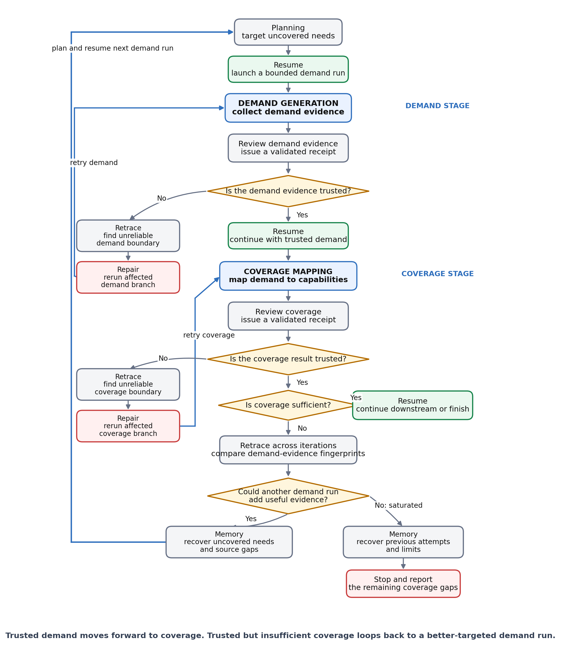
How demand generation, coverage, review, and recovery operations form one control loop.
The branches are summarised below.
Reviewed outcome | Operations combined | Next action
The demand evidence is untrusted | review → retrace → repair → review | Repair only the affected demand branch. Do not proceed to coverage until the demand evidence is trustworthy.
The demand evidence is trusted | review → resume | Pass the trusted demand outputs into coverage mapping.
The coverage result is untrusted | review → retrace → repair → review | Repair only the affected coverage branch. Do not widen demand until the coverage result itself is trustworthy.
The coverage result is trusted and sufficient | review → resume | Continue from the trusted frontier to the next downstream stage, or finish the chain.
The coverage result is trusted but insufficient | review → retrace across iterations → memory → planning → resume | Stop if the evidence has saturated. Otherwise, target the remaining gaps, launch a new demand run, and repeat demand review and coverage.
In practice, one pass through the loop works as follows:
- Planning and resume launch demand generation. Planning uses the remaining coverage gaps and relevant memory to define the next demand search. Resume starts that bounded run from the latest trusted frontier.
- Review gates the demand evidence. If the demand evidence is untrusted, retrace finds the unreliable boundary, repair reruns only that branch, and the new evidence returns to review. Coverage does not run yet.
- Trusted demand moves forward into coverage. Resume passes the reviewed demand outputs to coverage mapping.
- Review also gates the coverage result. If coverage is untrusted, retrace and repair operate only on the coverage branch and return the repaired result to coverage review. The system does not widen demand yet.
- Trusted coverage determines whether the chain finishes. If coverage is sufficient, resume continues downstream or completes the chain.
- Trusted but insufficient coverage returns the system to demand generation. Retrace compares demand-evidence fingerprints across iterations. If the evidence has saturated, memory supports a stop decision. If another run may add evidence, memory recovers prior attempts, planning targets the uncovered needs, and resume launches the next demand run.
The complete cycle is therefore:
planning → resume → demand generation → review → coverage mapping → review → either finish, repair the affected stage, or use retrace + memory + planning + resume to return to demand generation
The centre of the loop is now explicit: trusted demand moves forward into coverage; trusted but insufficient coverage moves back into a better-targeted demand run. All six operations control that movement, although not every operation runs on every pass.
The mechanism has now been exercised in a live demand-stage repair loop. The clean GPT-5.5 run produced an initial 102-node Etiq graph. Three source-scoped repairs produced graphs with 70, 42, and 102 nodes. Each version returned through strict review, and the workflow failed closed when the final review requested a fourth repair after the configured three-repair allowance was exhausted. Coverage correctly did not run because demand evidence never reached reusable trust.
This is live evidence for review → repair → rerun, but not yet for the complete demand → coverage → demand loop. The run also exposed a control limitation: all three repairs selected the first failed unit, discover_public_sources, while retrieve_source_documents remained unresolved. Repair target selection must advance among unresolved faulty units, and branch-local execution still needs to be measured separately.

Measuring the loop
The bounded-review benchmark compared two context regimes. The loop needs a separate measurement design. To keep the distinction between what is implemented and what is observed clear, we separate the checks already verified against the recorded graph from the measures a live run will produce.

Verified against recorded runs
Check | Result
Trusted-frontier read of the completed coverage job | trusted; 8 promoted nodes; 5 not-covered, 1 partial
Demand-evidence fingerprint, using per-node content hashes | deterministic across repeated reads
Anchored planning query (operation=planning) | selected; 18-node slice
Untrusted-verdict routing | routes to repair, not to a fresh demand run
Regression test suite and full-chain dry run | 23 tests pass; invalid generated bundles now receive a fresh authoring retry before execution
Fresh GPT-5.5 demand-stage loop | 4 Etiq executions: 102 → 70 → 42 → 102 nodes; failed closed before coverage after a fourth repair request
Scoped repair audit | 3 persisted repair diffs; every accepted source change stayed inside discover_public_sources
Controlled review-context replay | Graph-selected context matched full-Etiq issue coverage with 64% and 61% fewer input tokens on the initial and latest runs
These are implementation checks, not a comparative benchmark.

Remaining live-loop measures
- Iterations to sufficiency: how many demand-to-coverage passes clear the not-covered threshold, or where the result plateaus.
- Saturation stops taken: how many iterations the evidence fingerprint saves against the configured cap.
- Repair recovery rate: how often an untrusted verdict is restored without spending another demand cycle.
- Planning-seed efficacy: whether the sources added by the next demand run belong to the classes identified as failed or thin.
- Cost per iteration: tokens and wall-clock time.
The fresh run supplies one observation for repair and context selection, but it is not a statistically powered benchmark and it did not reach coverage. Iterations to coverage sufficiency, saturation stops, and planning-seed efficacy therefore remain open. Repair recovery was 0/3 in this run: every patch executed successfully, but none produced reusable trust before the repair allowance ended.

Capture, annotation, and trust
The graph supports two kinds of write.
Capture. Every scanned entry point adds its observed execution to the append-only ledgers.
Annotation. The agent or reviewer can attach annotations such as review, status, failure, repair, memory_link, or policy to a node or edge. A review annotation may promote trust, but only through a validated receipt.
The trusted frontier is derived rather than stored. A node counts as trusted when the latest authoritative review annotation says so. Downstream trust is recomputed from those decisions instead of being read from a mutable field.
Underneath this is the function-and-artifact graph described earlier: executed functions and their observed data states appear as alternating nodes, joined by consumes and produces edges. Each substantive node carries a content hash. This allows evidence from one iteration to be compared with evidence from another and allows planning queries to walk lineage from a selected node.

Orchestration and worker communication
The orchestration itself joins the graph. Chains of jobs—plan, run, and review—are driven by a declarative specification through a runner that is also scanned. Launches, gate decisions, and approval pauses therefore appear as execution evidence rather than remaining in opaque shell scripts.
Workers communicate through the graph. Delegated tasks carry graph references as inputs. The worker runtime resolves a bounded slice of the referenced evidence into the local model’s context. Results return as artifacts linked to the delegating stage, with those references preserved. Workers do not communicate directly with one another; a downstream worker consumes an upstream worker’s registered output nodes.
In our implementation tests, small local models needed grammar-constrained generation—enforcement of the output schema at the sampler—to behave reliably as schema-bound workers. They were useful for bounded extraction and drafting tasks, but final judgment remained with the stronger model.

What should be measured
The architecture should be judged on whether it improves context selection and agent decisions, not simply on whether it produces a graph.
The original context metrics remain useful:
- context-to-bounded-context ratio;
- relevant-context proportion;
- context-relevance density;
- middle-context recovery; and
- tokens to decision.
Implementation adds verifier metrics that validated receipts make computable:
- trusted-then-invalidated rate, as a proxy for receipt precision;
- suspect-confirmed rate;
- expansion efficiency—whether drilling into nested helpers changed a verdict;
- boundary-alignment rate; and
- rerun scope per repair.
The context builder also writes a standard accounting artifact for every decision: the full available context, the bounded context supplied, what was included, and what was excluded and why.

Experiment: bounded review

Setup
OpenClaw is the command and approval interface. Codex owns planning and final review. Bounded local workers, using pydantic-ai over a local Llama endpoint, prepare structured evidence.
A new three-stage chain ran end to end from scratch: demand-discovery planning, an approved fresh demand run against public sources, and a pipeline review. Every Python execution was captured through the scanner, and the review produced receipts over the observed boundaries.

Benchmark
Two review jobs judged the same completed demand run under two context regimes:
- Graph-bounded review: the reviewer received sectioned packets selected from the graph, with full accounting.
- Full-history baseline: the reviewer could read anything in the complete job folder and logged what it consumed.
We compared tokens delivered per decision, total available context, stage coverage, agreement between the two reviewers, and wall-clock time. This was one target with one run per arm, and consumption in the baseline arm was self-reported. The result is therefore directional evidence, not a controlled study.

Results
Metric | Graph-bounded | Full-history baseline
Tokens delivered per decision | 63,529 | 57,650 (self-reported estimate)
Full context available per decision | 96,219 | same corpus
Mean reduction relative to full available context | 1.54× | —
Stages decided | 7 / 7 | 7 / 7
Wall-clock minutes | 14.1 | 15.8
Exact decision agreement | 1 / 7
Agreement counting graded-trust adjacency | 7 / 7
At first glance, the reviewers appeared to disagree on six of the seven stages. The bounded reviewer marked them as trusted, while the baseline marked them as suspect. Their reasoning, however, showed that the difference was mainly one of vocabulary.
For every contested stage, the bounded verdict was specifically trusted_for_reporting: acceptable to cite in a summary, but not strong enough for downstream work to build on. The baseline’s “suspect” verdict meant almost the same thing. Both reviewers identified the same cause: the main collection run had exceeded its scan timeout, so the available execution evidence was thinner than the output files.
The reviewers therefore reached the same substantive position in different vocabularies. Exact label agreement was 1/7, but agreement rose to 7/7 when adjacent graded-trust states were treated as equivalent.
Three lessons follow.
First, the bounded reviewer reached substantively equivalent conclusions while receiving approximately one-third less context than was available in the full corpus. It did not, in this first run, receive fewer tokens than the baseline reviewer reported consuming.
Second, binary agreement is the wrong measure for graded trust. “Trusted for reporting only” and “suspect” are neighbouring positions, not opposites.
Third, the bounded design repeated the same orientation material—the job objective and plan—once for each of seven stage packets. Batching several stages into one packet should spread that cost. The per-decision accounting produced by the bounded system makes this possible to tune.
One further asymmetry should remain explicit: the bounded arm’s consumption is measured by construction, while the baseline’s consumption is whatever the reviewer reported reading.

Controlled graph-context comparison
A second experiment replayed the same immutable initial and latest repaired demand results through three fresh GPT-5.5 reviewers. The model, prompt contract, schema, source, runtime result, assigned units, and repetition count were held constant. Only review context changed: semantic_only omitted Etiq nodes and edges, etiq_full supplied the complete captured graph, and etiq_selected supplied the deterministic graph-selected subset.
Run | Context | Input tokens | Issue paths | Recall vs selected
Initial | semantic_only | 28,656 | 1 / 2 | 50%
Initial | etiq_full | 111,635 | 2 / 2 | 100%
Initial | etiq_selected | 40,180 | 2 / 2 | 100%
Latest repaired | semantic_only | 30,842 | 1 / 2 | 50%
Latest repaired | etiq_full | 118,476 | 2 / 2 | 100%
Latest repaired | etiq_selected | 46,479 | 2 / 2 | 100%
Graph-selected context found the same two issue paths as the full Etiq graph—discover_public_sources and retrieve_source_documents—while using 64% fewer input tokens on the initial run and 61% fewer on the latest repaired run. Semantic-only context was cheaper, but found only the discovery issue. The additional graph evidence exposed that retrieval usually copied a search snippet into document_text instead of fetching the underlying source, so downstream extraction operated on truncated, keyword-rich text and could preserve unrelated candidates as medium-confidence demand evidence.
The result supports context selection relative to the full graph, not an unqualified claim that graph context is always cheapest. Selected Etiq used more tokens than semantic-only context but recovered an issue that semantic-only review missed. The experiment used one repetition per arm, so the measured token counts and judgments are observations, not estimates of model variance. None of the two issue paths was resolved after the three repairs because target selection repeatedly chose the discovery boundary and never advanced to retrieval.

Follow-up experiment: issue quality, attribution, and context cost
A fresh comparison replayed the same initial and latest repaired execution through semantic-only, accumulated-history, full-Etiq, and graph-selected Etiq reviewers. The first comparison counted issue paths, but raw path counts hid the meaningful differences. We therefore inspected the pipeline source, runtime outputs, and each review rationale, then attached an explicit assessment rather than treating any one reviewer as ground truth.
The source-verified assessment identified three real defects in one causal chain:
discover_public_sources admitted broad keyword matches that did not demonstrate demand from the target segment.
extract_evidence_records promoted unrelated text into demand evidence through regex and keyword co-occurrence.
synthesize_market_demand converted weak evidence into confident demand claims and omitted important gaps.
All four context setups found all three core defects on both the initial and latest runs. The main difference was attribution. Some reviewers also marked retrieve_sources as suspect because it transported contaminated material. For this observed failure that is an attribution error: discovery admitted the material and extraction validated it incorrectly. Retrieval nevertheless has a separate, useful completeness risk because it can rely on API summaries instead of full pages. The metrics preserve both facts instead of forcing the finding into a single true-or-false label.

Measured results
Verified precision below is the share of raised issue paths that were correctly attributed to the three source-verified defects. Secondary detail gives credit for useful observations that do not constitute another root defect. Input tokens are the measured context cost.
Run | Context | Core recall | Attribution | Secondary detail | Input tokens
Initial | semantic_only | 3/3 | 75% (1 error) | — | 32,043
Initial | history_full | 3/3 | 100% (0) | — | 32,661
Initial | etiq_full | 3/3 | 100% (0) | — | 134,996
Initial | etiq_selected | 3/3 | 75% (1 error) | — | 65,491
Latest | semantic_only | 3/3 | 75% (1 error) | source failures, missing propagation, retrieval risk | 26,937
Latest | history_full | 3/3 | 100% (0) | — | 127,017
Latest | etiq_full | 3/3 | 75% (1 error) | source failures, retrieval risk | 103,657
Latest | etiq_selected | 3/3 | 100% (0) | — | 77,703
Source-verified issue quality and measured context cost for the four review setups.
Raw true-issue recall was identical: every setup found 3/3 core defects. Graph selection therefore did not improve core recall in this one-repetition experiment. It did reduce context relative to the full Etiq graph: selected context used 51% fewer input tokens on the initial run and 25% fewer on the latest run. It retained 36 of 136 nodes initially and 50 of 86 nodes in the latest graph. Semantic-only was cheapest, while accumulated history grew from one to 61 artifacts and from 32,661 to 127,017 input tokens.
The meaningful quality differences were attribution and secondary detail. History-full and selected-Etiq attributed all three latest defects correctly. Semantic-only and full-Etiq added the retrieval attribution, but they also surfaced useful secondary detail about source failures and retrieval completeness. No arm in the four-way replay produced a pure false-positive issue path. Because there was only one invocation per arm, these differences are observations, not stable model rankings.

Control-plane findings exposed by the same run
The workflow reviewer, which sits outside the four replay arms, produced one clear false positive by suspecting collect_runtime_context, a plumbing function that only copied the supplied request and segment. More importantly, all seven workflow review receipts were rejected by validation: sixteen evidence references pointed outside the allowed package, and three trusted decisions had unmet or uncited criteria. A rejected receipt should cause a fresh review attempt; it should not trigger pipeline repair.
This distinction changes how the repair result should be interpreted. The workflow accepted and evaluated six repairs across discovery, retrieval, extraction, and synthesis, but none removed its target from the following review, giving a measured repair effectiveness of 0/6. Because invalid review records were allowed to request repairs, that number reflects both pipeline quality and a control-plane validation bug. The next experiment should retry invalid reviewer output first and repair the pipeline only after a valid blocked-for-repair receipt.

From trusting the output to covering the input
A reviewer can only judge the evidence it was shown. It can identify that an output is thin, but it cannot easily establish that the pipeline searched widely enough in the first place.
Trust is therefore a depth signal: is the collected evidence sound? It leaves a second axis unmeasured: recall, or whether the system looked widely enough. The loop above is the first instance of a broader mechanism intended to address that gap across different kinds of jobs.
Every enumerating stage draws a consumed subset from a candidate frontier: sources for demand, capability pairings for coverage, or channels for distribution. The nouns change, but the recall problem is the same. We use three separate checks rather than collapsing them into one invented score:
- Collection completeness: the set difference between declared candidates and those successfully consumed.
- Stratum coverage: whether every declared class contributes at least one successful element. This catches a whole source class collapsing to zero, even when surviving classes still clear an overall floor.
- Saturation: output stability under input perturbation. This is tested through leave-one-out analysis over the collected evidence, using the downstream decision itself as the threshold, together with a simple support-multiplicity check. A ranked conclusion supported by only one source is not robust to that source being removed.
The boundary contract’s requirement for pure stages with declared inputs is what makes leave-one-out testing mechanisable.
These checks remain part of the graph rather than sitting beside it. The function-and-artifact view already records declared and observed artifacts at each boundary. The candidate frontier reuses the existing artifact-role field, and the resulting coverage judgment is attached as a node annotation like any other review judgment.
There is also an important limit. The candidate list is itself model-authored. A coverage ratio against that list is therefore a completion check, not proof of recall against an unknown universe. Claiming otherwise would create false precision. Saturation and stratum coverage are the more honest measures available.
The general mechanism has been designed, and its first instance is included in the demand-to-coverage loop. Applying it across all job types is an engineering change that has been scoped but not yet completed.

What kind of agentic system this is
The system pursues one objective across a long chain of dependent jobs. It decomposes the goal into workstreams, keeps its state in the graph rather than in one conversation, recovers from failure, and adapts as evidence accumulates. Under the working definition used here, it is a long-horizon agentic system. It is also a vertical system, specialised end to end for a particular business function rather than designed as a general assistant.
Where the reasoning physically lives—inside a rolling context window or in inspectable job-local code—is an implementation choice, not the defining distinction.
The system uses recognised long-horizon patterns as first-class design choices:
- plan-then-execute, with a strong model planning and smaller local models performing bounded tasks;
- context isolation, with each job using a fresh window over a bounded graph slice;
- structured hand-offs through graph references;
- checkpoint and resume; and
- an append-only event log whose current state is replayed rather than repeatedly re-summarised [14][15].
These are not workarounds. They are ways to reduce context degradation and the memory drift that can accumulate when an agent repeatedly summarises its own history.
What the system does not allow is self-authorising autonomy. Irreversible actions remain behind hard human gates, and prior work becomes reusable only after an independent review-and-receipt gate. It is therefore a long-horizon agentic system, but deliberately not a self-authorising one. It can plan, execute, recover, and continue across an extended workflow, while irreversible actions and the promotion of prior work remain subject to explicit human and review gates.

Seeing the graph: the visualizer
The same stored nodes, captured relationships, review units, context accounting, and trust annotations are rendered in a local dashboard. The lineage page is generated from the job artifacts and exposes links to the underlying JSON, so the visualization is an inspectable view of the recorded graph rather than a hand-drawn illustration.
Three current views are particularly useful. The figures below were captured directly from the latest live dashboard.
- Run overview shows the available immutable runs, captured node and relationship counts, derived review units, trusted-frontier state, context-selection ratio, and actual review input tokens.
- Review-unit drill-down filters the graph to one function boundary and its incident artifacts and relationships. The selected unit panel exposes its boundary health and exact captured evidence references.
- Review-context comparison presents semantic-only, full-Etiq, and graph-selected arms together, including package size, measured input tokens, issue paths, and recall relative to selected context.
The dashboard explicitly separates deterministic structure from model judgment. Captured nodes and edges are immutable observations for a stored run; review-unit selection, sectioning, filtering, and layout are deterministic functions of that snapshot; trust, suspect, and failure labels are persisted Codex judgments and are not assumed deterministic.
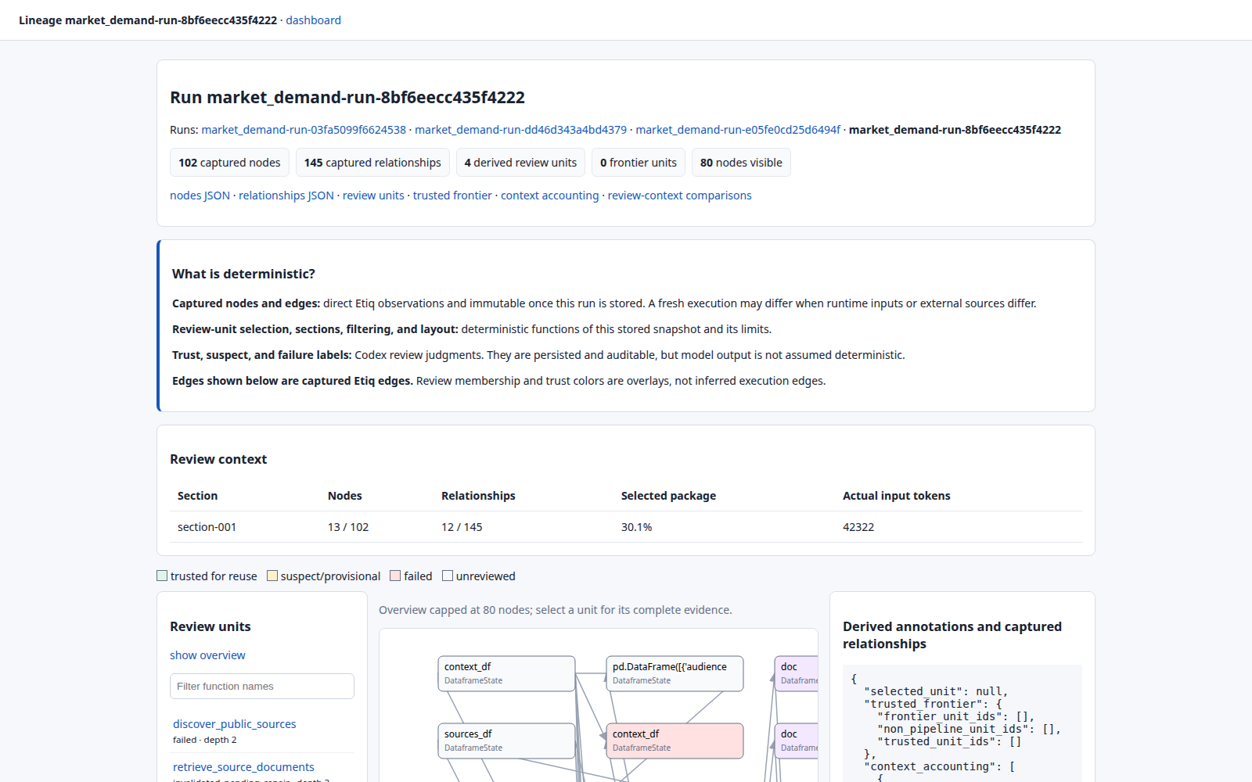
Latest repaired run overview. The dashboard reports 102 captured nodes, 145 captured relationships, four review units, no trusted frontier, and the graph-selected production review context.
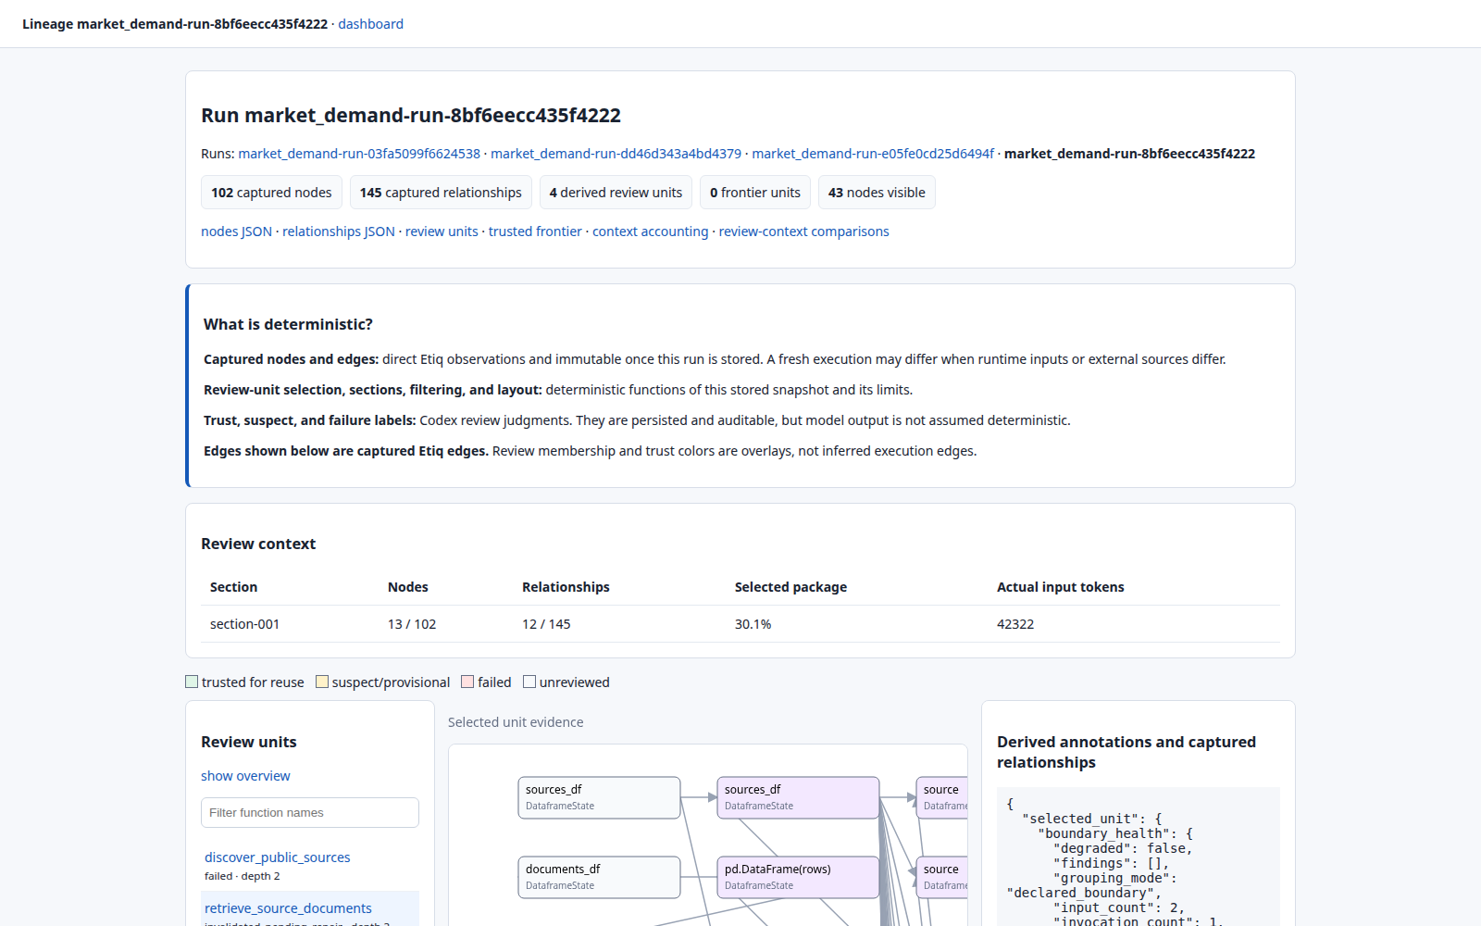
Unit-focused lineage for retrieve_source_documents. The centre graph is restricted to the selected function boundary and its captured evidence.
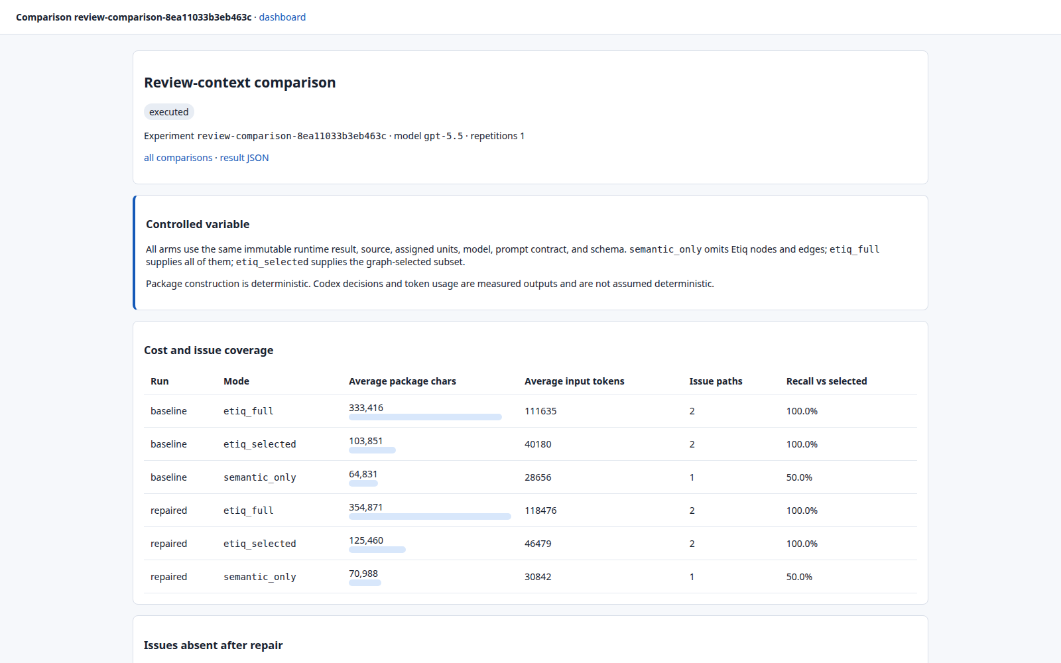
Executed review-context comparison. Graph-selected context retains both issue paths while reducing measured input tokens relative to full Etiq.

Conclusion
The implementation and latest controlled replay support the central architectural claim: execution lineage can be more than an audit record. Graph-selected context preserved the full graph's two issue paths while substantially reducing the context supplied to review, and it exposed a retrieval defect that semantic-only review missed.
The evidence remains deliberately bounded. This was one GPT-5.5 repetition per arm, selected graph context still cost more than semantic-only context, and the live workflow failed closed after three repairs because target selection kept returning to the first failed unit. The next engineering test is therefore concrete: rotate repair targets across unresolved units, repair the retrieval boundary, and then measure whether the complete demand-to-coverage loop reaches reusable trust with less total context and fewer wasted iterations.
That is the distinction this architecture is designed to make. The graph does not merely record what the agent did. It provides the execution-grounded state from which the system decides what it can trust and what it should do next.

References
[1] Wei et al. (2022). Chain-of-Thought Prompting. arXiv:2201.11903.
[2] Yao et al. (2023). ReAct. ICLR.
[3] Yao et al. (2023). Tree of Thoughts. NeurIPS.
[4] Jimenez et al. (2024). SWE-bench. ICLR.
[5] Wang et al. (2025). OpenHands. ICLR.
[6] Antoniades et al. (2025). SWE-Search. ICLR / arXiv:2410.20285.
[7] Orimo et al. (2025). PARC. arXiv:2512.03549.
[8] Wu et al. (2026). GAM. arXiv:2604.12285.
[9] McPhillips et al. (2015). YesWorkflow. arXiv:1502.02403.
[10] Chen et al. (2026). MAGE: Memory as Execution State Management for Long-Horizon Agents. arXiv:2606.06090.
[11] Chen et al. (2025). LocAgent. ACL.
[12] Hong et al. (2025). Data Interpreter. ACL Findings.
[13] Nam et al. (2025). DS-STAR. arXiv:2509.21825.
[14] (2026). The Log is the Agent: Event-Sourced Reactive Graphs for Agent Execution. arXiv:2605.21997.
[15] (2026). From Agent Loops to Deterministic Graphs: Execution Lineage for Reproducible AI-Native Work. arXiv:2605.06365.
[16] (2026). From Agent Traces to Trust: A Survey of Evidence Tracing and Execution Provenance in LLM Agents. arXiv:2606.04990.
[17] (2026). Mitigating Provenance-Role Collapse in Long-Term Agents via Typed Memory Representation. arXiv:2605.25869.

