The Etiq graph as a shared state and memory layer for long-horizon agents — Version 3
Version 3, updated 30 July 2026 with an isolated end-to-end GPT-5.5 review–repair–replay comparison, a frozen source corpus, blind graph-selected judging, repair-effectiveness metrics, and updated live-dashboard figures.

Intro
Long-horizon agents are limited not only by how well the underlying model can reason, but by how the system represents what has happened during a long piece of work. Without structured, execution-aware state, the agent has to reconstruct its position from conversation history, summaries, logs, and files. A deterministically derived graph of its code and execution activity can improve both what the agent can trust and how efficiently it selects context.
The literature increasingly points in this direction. Foundational agent papers show that explicit intermediate state can improve performance [1]–[3], but that state is still usually encoded as text, which is a weak representation for long-horizon tasks. SWE-bench showed that text alone is not enough for real software-engineering work [4][5], while SWE-Search demonstrated gains from more structured search [6]. PARC and newer graph-memory work support the graph framing [7][8]. Provenance systems capture execution lineage for audit and reproducibility, but do not generally use it as live agent control state [9]. MAGE frames memory as execution-state management [10], while LocAgent uses code graphs but relies on static analysis [11]. More recent systems work has begun to converge on a similar view: event-sourced execution graphs with deterministic replay [14], execution lineage as a basis for reproducible AI-native work [15], evidence tracing and execution provenance in LLM agents [16], and typed memory representations that keep provenance separate from judgment [17].
This project targets a different class of long-horizon task from code-localisation work. We focus on high-dimensional, discovery-heavy workflows with vague initial specifications, particularly data-science and analytics work in enterprise settings. In these workflows, agents must refine goals, explore uncertain solution spaces, and adapt as evidence accumulates. Current approaches for these settings still fall short of providing an overall graph view [12][13].
We propose a long-horizon agent architecture that begins with sequential, iterative work and moves towards graph-guided coordination as the context grows. The key distinction is that the graph is not a semantic memory, ontology, or reasoning trace. It is a deterministically derived graph of executed code and executable artifacts, used as the central state and control layer. It records what actually ran, what data was touched, what was produced, and what depends on what.
The core architecture has now been built and exercised through review benchmarks and an end-to-end controlled comparison. The latest experiment executed one frozen demand-pipeline baseline, then gave four isolated GPT-5.5 arms different context packages. Each arm independently reviewed, repaired, and replayed its own branch for three iterations. A fresh blind graph-selected judge assessed every final branch against the same contract.

Long-horizon agents need more than a longer conversation
A long-horizon agent works across an extended sequence of actions. It may plan, write and execute code, inspect intermediate results, delegate work, retry failures, wait for approval, and resume later. As this happens, the current state of the work becomes distributed across functions, artifacts, agents, retries, and points in time. It can no longer be reconstructed reliably from the latest message.
The challenge is therefore not memory capacity alone. It is selecting the right part of memory and presenting it at the right level of detail. Long contexts bury useful evidence among obsolete material. Different agents may hold different partial versions of the state. Retries make it unclear which outputs remain valid, while summaries often lose the relationships between actions and results.
A long-horizon architecture needs both shared task state and shared memory:
- Shared task state describes what is true and actionable now.
- Shared memory preserves what happened and what may need to be recovered later.
For code-driven agents, execution memory is the more reliable half: what actually ran, with which inputs and outputs, and with which dependencies. Semantic traces still matter because they explain the objective, plan, constraints, and rationale. The central claim is that an executed-code graph, combined with these semantic traces, can provide much of the shared state and memory layer.

Execution lineage as shared state and memory
Etiq records execution as a dependency graph containing executed functions, nested calls, observed input and output states, transformations, and downstream dependencies.
One implementation finding changed how we think about capture. Capture is anchor-based. The scanner reliably captures recognised lineage objects—such as DataFrames, models, and agents—and the activity that flows around them, without requiring a particular code style.
This includes LLM calls. An agent object, such as a pydantic-ai agent, a LangChain agent, or a registered OpenAI client, creates an anchor at each call site. The question sent to the model and the response returned are captured as first-class data states, including the observed values. The graph therefore records not only which code ran, but also each model interaction and its inputs and outputs. This provides the execution evidence needed to review an agent step.
The reverse is also important. Dataflow made only from primitive values, with no recognised anchor, produces no captured boundary evidence by design. A scan can therefore complete successfully while observing no meaningful stage boundary. This led to a practical rule: use recognised objects to anchor stage boundaries where that is natural, and verify after every run that the declared boundaries were actually observed.

The useful graph unit is function plus artifact
The useful operational unit combines an executed function with its observed input and output artifacts. The function tells us which transformation ran. The artifacts show what entered the function and what came out.
Reviewing only the function is not enough because its behaviour depends on the data it received. Reviewing only the artifact is also not enough because it does not identify the transformation responsible for producing it.
Implementation showed that this boundary must be declared and then verified, rather than inferred from code structure. A rule such as “the first function below the entry point is a stage” depends too heavily on authoring style. A wrapper function can hide every meaningful stage, a loop can merge several invocations, and values passed through side channels may not create a usable boundary at all.
We therefore use three controls:
- The generated pipeline specification declares its review boundaries, including stage names, roles, and expected inputs and outputs.
- A deterministic conformance check compares that declaration with what the scanner observed and fails when a declared stage produced no boundary evidence. In the first live run, the agent’s own pipeline failed this check and then corrected its specification, showing that the gate caught the mismatch as intended.
- Every review unit carries a boundary-health record, including its anchoring mode, any declared but missing artifacts, and invocation counts. This keeps “the artifact looks wrong” separate from “the boundary itself is not trustworthy.”

Nested functions provide variable resolution
The full execution graph contains far more detail than any one decision needs: loop variables, helper outputs, temporary dictionaries, wrapper states, and nested calls. These details can be useful during forensic inspection, but they should not be included in every review.
The nested-function hierarchy provides a natural way to control resolution. The current builder derives review units deterministically from captured function-stack boundaries and graph-crossing relationships, splitting structurally when a unit exceeds configured size limits. Within a selected unit, artifacts are initially represented with bounded values or representative slices, while nested helpers remain available for targeted expansion.
The system therefore does not use one fixed review depth. Automatic structural splitting establishes the initial units; a reviewer can then request a relevant helper prefix or a larger artifact slice when the supplied evidence is insufficient. Retrace can walk captured predecessors from a suspect node, but repair stops at the selected function boundary or faulty statement.
Frame fingerprints - identifiers that differ for each invocation - also allow the graph to separate calls that a loop would otherwise merge. This means the inspection can reach a specific function call, rather than only the function definition, when a gate-critical decision requires it.
The rule is therefore minimum sufficient depth: start at the highest meaningful function-and-artifact boundary, go deeper only along the branch relevant to the current decision, and stop as soon as there is enough evidence to review, diagnose, or repair the result.

Execution evidence and trust are separate
The scanner can establish that code ran, that particular values were observed, and how those observations depend on one another. It cannot establish on its own that the result is correct, useful, complete, or safe to reuse.
Trust therefore comes from a separate review process. The implemented protocol adds three controls:
- Criteria-based review. The reviewer records explicit acceptance criteria and cites the evidence used for every criterion outcome. This makes the judgment inspectable and reduces unsupported conclusions.
- Graded trust. A result may be trusted_for_reuse, meaning downstream work may build on it; trusted_for_reporting, meaning it may be cited but not used as a dependency; or provisionally_trusted. The current workflow advances only when every required review unit is trusted_for_reuse.
- Validated receipts. A deterministic validator checks unit assignment, completeness, decision consistency, boundary acknowledgement, and whether every cited node or relationship belongs to the supplied package. Failed or suspect units invalidate their captured downstream review units. Only a non-rejected receipt writes trust annotations; model judgments begin as proposals rather than execution facts.
The graph records execution facts. Review converts selected observations into a trusted frontier. That frontier tells the agent which work can be reused and where further action should begin.

How the long-horizon agent uses the graph
The architecture is described through six bounded operations. Review, retrace, and scoped repair are implemented in the current repository. Planning exists at the initial segment level, while memory-driven replanning and execution resume from the trusted frontier remain target operations.
Operation | Anchor | Returns
planning | current request and segment constraints | a bounded segment list; dynamic gap-directed replanning is planned
review | a stored Etiq execution and assigned review unit | validated decisions, evidence references, and trust annotations
retrace | a failed or suspect unit or node | captured predecessor references and an early causal repair candidate
repair | a selected function boundary or faulty statement | a mechanically scoped source change followed by complete-stage replay
resume | planned: a persisted trusted frontier | planned: skip trusted execution and continue only affected downstream work
memory | planned: prior attempts, gaps, and evidence | planned: comparable reviewed evidence for replanning and stopping

Review
A review begins with a target job or run. The context builder divides the execution into meaningful review regions, using the declared stage boundaries and Etiq’s nested-function hierarchy.
For the current region, the agent receives:
- the objective, plan, constraints, and acceptance criteria;
- the functions that ran;
- the inputs they consumed and the outputs they produced;
- relevant captured values and hashes;
- the current review state; and
- references to nested functions that remain collapsed.
The agent decides whether the observed result meets the intended objective. If the evidence is sufficient, it records a review receipt. If the result is unclear or suspect, the next package expands only the relevant nested branch.

Retrace
Retrace begins from a failed or suspect function or artifact. The package includes the suspect result, its producer stage, the relevant nested helpers, their inputs and outputs in execution order, and the criterion that was not met.
The agent follows the dependency path backwards and asks at each boundary: was the input already wrong, or did this function turn a valid input into an invalid output? It stops at the earliest meaningful divergence and records that boundary as the leading diagnosis or suspect candidate.
This restores the relevant middle of the execution through dependency and observed values, rather than through the position of information in a long conversation.

Repair
Repair starts from the boundary identified during retrace. The current implementation exposes two experimental scopes: faulty_node permits only the identified statement to change, while boundary permits only the identified function to change. The agent receives the suspect evidence, the selected source span, the retraced upstream path, and the review findings that justify the patch.
Codex returns a complete replacement bundle because the structured response schema transports the pipeline as one object, but a mechanical validator rejects any change outside the selected statement or function. Every accepted repair persists its actual unified diff and then re-executes the pipeline as a new Etiq evidence branch. Source changes are therefore scoped and auditable; execution is not yet branch-local, because the current runner re-executes the complete pipeline after each patch.

Resume
Resume from a trusted frontier is a target operation rather than current execution behaviour. The repository persists run ancestry, review receipts, trust annotations, and a derived trusted frontier, so the state needed for resume is inspectable.
Today, however, orchestration resumes only at stage or job level. After a repair, the selected source scope changes but the complete stage pipeline executes again. The runner does not yet skip trusted functions inside that pipeline.

Planning and memory
Current planning creates a bounded segment list before execution and passes retained coverage gaps to later preplanned segments. Job artifacts and repair ancestry preserve what has already happened. Retrieval of comparable historical failures, gap-directed replanning, and memory-guided selection of a new run are not yet implemented.
The current and planned combinations should therefore be kept separate:
- Current: if a result is untrusted, the system selects an early graph-causal boundary, applies a source-scoped repair, reruns the complete stage, and reviews the new execution.
- Current: if demand is trusted, coverage may run; if trusted coverage is sufficient, final synthesis completes the chain.
- Current partial hand-off: trusted but insufficient coverage passes retained gaps to the next preplanned segment. Planned: compare evidence across iterations, detect saturation, dynamically target uncovered needs, and resume only the affected execution branch.
The next section shows this combination in one concrete control loop.

How the operations combine in the control loop
The first experiment ran the chain once, straight through. The next question is what the system should do when a reviewed coverage result is not good enough. The main iteration is not simply execute and review. It is a loop between demand generation and coverage mapping, with a review gate after each stage.
In the marketing example, demand generation collects evidence about where agents are needed. Coverage then maps those needs to the areas where the product can help. If coverage is thin, the system may return to demand generation—but only after it has established that the demand evidence and the coverage result are trustworthy, and that another demand run is likely to add something new.
The naive version treated a flat sufficient field from the coverage output as enough to continue. The current graph-backed version independently reviews demand and coverage, blocks downstream execution until required units reach reusable trust, retains insufficient-coverage gaps, and scopes source repairs to a selected boundary. Evidence saturation, memory-guided replanning, and trusted-frontier execution resume are shown separately as planned extensions.
The implemented control loop and its planned extensions can be represented as follows:
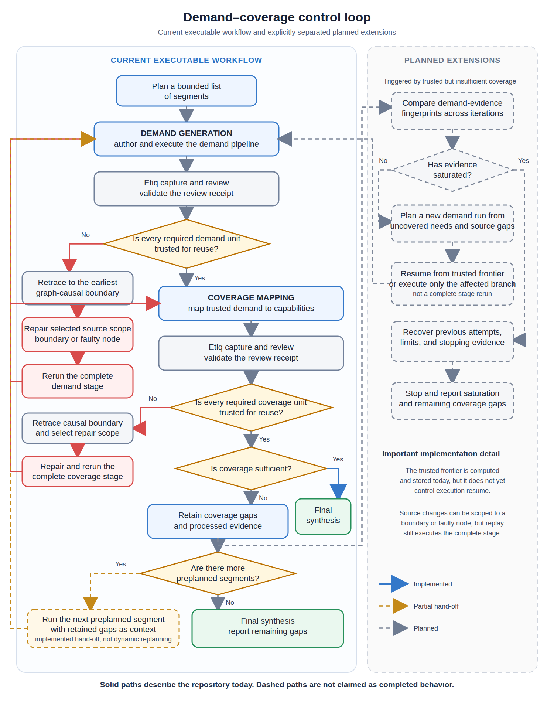
Current demand–coverage workflow and planned extensions. Solid paths are implemented, amber dashed paths are partial hand-offs, and grey dashed paths are planned.
The branches are summarised below.
Reviewed outcome | Operations combined | Next action
The demand evidence is untrusted | review → retrace → repair → full-stage replay → review | Repair only the selected demand source scope, then rerun the complete demand stage. Coverage remains blocked until demand reaches reusable trust.
The demand evidence is trusted | review → coverage mapping | Pass the trusted demand result and trust context into coverage mapping.
The coverage result is untrusted | review → retrace → repair → full-stage replay → review | Repair only the selected coverage source scope, then rerun the complete coverage stage.
The coverage result is trusted and sufficient | review → final synthesis | Run final synthesis and finish the chain.
The coverage result is trusted but insufficient | review → retain gaps → next preplanned segment | Pass retained gaps to the next preplanned segment. If no segment remains, report the gaps. Fingerprinting, saturation, dynamic replanning, and trusted-frontier resume are planned.
In practice, one pass through the loop works as follows:
- The current workflow plans a bounded list of segments up front, then authors and executes a demand pipeline for the active segment.
- Review gates the demand evidence. If a required demand unit is untrusted, retrace selects the earliest graph-causal boundary, repair changes only the selected source scope, and the complete demand stage is rerun before review.
- Trusted demand moves forward into coverage. The reviewed demand result and trust context are passed to the coverage pipeline.
- Review also gates the coverage result. If coverage is untrusted, retrace and repair select a coverage source scope, but the complete coverage stage is rerun before review.
- Trusted coverage determines whether the chain finishes. If coverage is sufficient, final synthesis completes the chain.
- If trusted coverage is insufficient, the current workflow retains its gaps and processed evidence and moves to the next preplanned segment. Demand-evidence fingerprints, saturation detection, dynamic gap-directed planning, and execution resume from the trusted frontier remain planned extensions.
The complete cycle is therefore:
current: plan segments → demand generation → review → repair and full-stage replay if needed → coverage mapping → review → either finish, continue with the next preplanned segment, or report remaining gaps
The distinction is explicit: the repository already uses Etiq capture, validated review receipts, causal repair targeting, and trust gates to control movement. It does not yet use evidence saturation or the trusted frontier to resume only an affected execution branch.
The implemented mechanism has been exercised through demand-stage review, graph-causal repair selection, source-scope validation, complete-stage replay, and repair-effectiveness accounting. Coverage remains blocked whenever demand does not reach reusable trust.
The latest controlled comparison did not reach reusable trust in any arm, so it provides no observation of the coverage half of the loop. It evaluates context selection and repair behaviour within the demand stage; the complete demand → coverage → further-demand cycle remains future experimental work.

Measuring the loop
The current benchmark measures demand-stage review and repair. The complete loop needs a separate measurement design. The checks below separate what has been verified in the repository from measures that remain open until coverage and multi-iteration demand runs execute.

Verified against recorded runs
Check | Result
Final selected lineage | 130 captured nodes, 267 captured relationships, and 4 derived review units
Arm isolation | 4 context arms; fresh ephemeral Codex sessions; no cross-arm history
Frozen replay | One recorded HTTP corpus replayed independently after every accepted repair
Repair accounting | 3 repairs per arm; effective: semantic 0, history 1, full Etiq 0, selected Etiq 1
Final reusable trust | No arm reached reusable trust after three repairs
Regression suite | 39 tests pass
Context result | Selected Etiq used 24.8% fewer input tokens than full Etiq and 45.1% fewer than accumulated history
Open loop measures | Coverage sufficiency, evidence fingerprints, saturation, and gap-directed replanning remain unmeasured
These are implementation checks, not a comparative benchmark.

Remaining live-loop measures
- Iterations to sufficiency: how many demand-to-coverage passes clear the not-covered threshold, or where the result plateaus.
- Saturation stops taken: how many iterations the evidence fingerprint saves against the configured cap.
- Repair recovery rate: how often an untrusted verdict is restored without spending another demand cycle.
- Planning-seed efficacy: whether the sources added by the next demand run belong to the classes identified as failed or thin.
- Cost per iteration: tokens and wall-clock time.
The controlled run supplies one observation for context selection and repair, not a statistically powered benchmark. No arm reached reusable trust. history_full and etiq_selected each produced one repair classified as effective; semantic_only and etiq_full produced none. Coverage sufficiency, saturation stops, and gap-directed planning therefore remain unmeasured.

Capture, annotation, and trust
The graph supports two kinds of write.
Capture. Every Etiq-executed pipeline writes a stored snapshot of its observed functions, artifacts, and captured relationships. Job events and trust annotations are appended to separate JSONL records.
Annotation. A validated review receipt can append trust, suspect, failure, non-pipeline, or downstream-invalidation annotations to review units. These judgments remain separate from captured Etiq nodes and relationships.
The trusted frontier is derived rather than stored as a mutable truth field. A unit counts as reusable only when its latest authoritative annotation says trusted_for_reuse and its required upstream units are also reusable. The resulting frontier projection is persisted for inspection.
Underneath this is the function-and-artifact graph described earlier. Captured records carry stable references, bounded value representations, and hashes. These support integrity checks and cross-run comparison, but the current workflow does not yet compute demand-evidence fingerprints or use hashes for saturation decisions.

Current orchestration
The repository runs one synchronous local workflow. It plans segments, asks fresh Codex sessions to author stage pipelines, executes those pipelines through Etiq, validates their semantic outputs, reviews captured evidence, and either repairs, advances, or fails closed.
Codex invocations communicate only through explicit persisted packages. Each invocation runs in an ephemeral session with a strict invocation-directory read boundary; it does not inherit another reviewer’s conversation or an experimental arm’s history unless that context mode explicitly supplies branch-local artifacts.
There is no separate local-model worker layer in the current implementation. The controlled experiment uses GPT-5.5 for all review and repair arms so context selection—not model identity—is the variable being compared.

What should be measured
The architecture should be judged on whether it improves context selection, review quality, and repair outcomes, not simply on whether it produces a graph.
The original context metrics remain useful:
- context-to-bounded-context ratio;
- relevant-context proportion;
- context-relevance density;
- middle-context recovery; and
- tokens to decision.
The current implementation also makes the following verifier and repair metrics computable:
- effective repairs: whether the targeted function is no longer flagged in a later review;
- unresolved function boundaries under a common blind judge;
- expansion and artifact-inspection requests;
- boundary versus faulty-node repair scope; and
- reported tokens, cached input, output tokens, and elapsed time per branch.
The context builder writes accounting with each review package: available and selected node and relationship counts, estimated package size, reported input tokens, and expansion state. Controlled results additionally aggregate actual Codex-reported usage across each branch.

Controlled end-to-end graph-context comparison
The latest experiment tests outcomes, not reviewer agreement alone. One successful pipeline execution and its network responses were frozen. Four branches then ran independently: every Codex invocation used a fresh ephemeral session; no arm could see another arm’s prompts, decisions, code changes, or results; and each branch replayed the same recorded source corpus after every accepted repair.
The four context packages were:
semantic_only: pipeline source, task input, runtime output, and logs, with no Etiq nodes or relationships.
history_full: the semantic package plus that branch’s accumulated non-Etiq ancestor artifacts.
etiq_full: pipeline source plus every captured Etiq node and relationship for the relevant execution.
etiq_selected: the graph-selected review unit, boundary hand-offs, and inspectable artifacts; full source was not sent during review, while repair received only the source scope needed for the selected target.
Each arm was allowed three scoped repair and replay cycles. “Effective” means that the targeted function was no longer failed or suspect in the next branch review. Final outcomes were rejudged by separate fresh graph-selected judges using the same contract. An initial attempt to use one full-graph judge exceeded the 1,048,576-character request limit; it was discarded and did not supply evidence to the replacement judges.
Context | Repairs | Effective | Input tokens | Final unresolved boundaries | Time
semantic_only | 3 | 0/3 | 568,715 | 4 | 568.1 s
history_full | 3 | 1/3 | 1,824,533 | 4 | Not recorded
etiq_full | 3 | 0/3 | 1,331,686 | 3 | 508.4 s
etiq_selected | 3 | 1/3 | 1,000,797 | 2 | 722.1 s
End-to-end controlled comparison. Token counts are the input tokens reported by Codex across each branch; they are not estimates. Repair count alone is not treated as success.
No arm reached reusable trust after three repairs, so this run is directional rather than a claim of solved long-horizon repair. etiq_selected used 24.8% fewer input tokens than etiq_full and its fresh blind judge reported two rather than three unresolved boundaries. Relative to history_full it used 45.1% fewer input tokens and its blind judge reported two rather than four. semantic_only was cheapest and its judge reported four unresolved boundaries; etiq_selected used 76.0% more input tokens and its judge reported two. These boundary counts are model judgments, not proof that two repairs succeeded: only define_research_plan was directly classified as resolved in the selected branch, while the retrieve_public_sources difference reflects disagreement between the branch review and the fresh judge.
The selected arm’s one directly effective repair and smaller blind-judge issue set justify further testing of graph selection, but its longer elapsed time and the absence of final trust show that selection alone is not enough. Root-cause targeting and repair quality remain the limiting parts of the controller. The next experiments should repeat the frozen-corpus design across more jobs and report final trust, effective repairs, reviewer disagreement, regressions, unresolved causal boundaries, tokens, and time together.
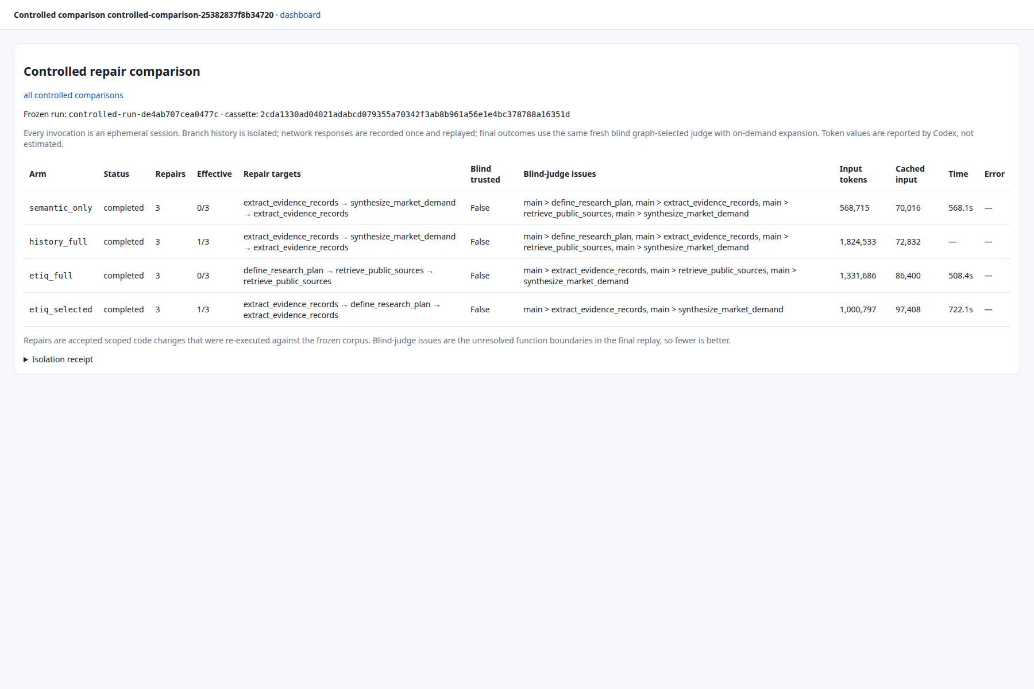
Live controlled-comparison dashboard. It exposes branch isolation, repair targets, measured repair effectiveness, fresh blind-judge outcomes, reported input tokens, cached input, time, and errors for all four arms.

From trusting the output to covering the input
A reviewer can only judge the evidence it was shown. It can identify that an output is thin, but it cannot easily establish that the pipeline searched widely enough in the first place.
Trust is therefore a depth signal: is the collected evidence sound? It leaves a second axis unmeasured: recall, or whether the system looked widely enough. A future demand–coverage loop needs an explicit mechanism for that second axis.
Every enumerating stage draws a consumed subset from a candidate frontier: sources for demand, capability pairings for coverage, or channels for distribution. The nouns change, but the recall problem is the same. A future implementation should keep three checks separate rather than collapse them into one invented score:
- Collection completeness: the set difference between declared candidates and those successfully consumed.
- Stratum coverage: whether every declared class contributes at least one successful element. This catches a whole source class collapsing to zero, even when surviving classes still clear an overall floor.
- Saturation: output stability under input perturbation. One possible test is leave-one-out analysis over collected evidence, using the downstream decision as the threshold, together with a support-multiplicity check. A ranked conclusion supported by only one source is not robust to that source being removed.
Pure stages with declared inputs would make leave-one-out testing mechanisable, but the current workflow does not run this test.
These future checks could remain graph-linked rather than sitting beside the execution record. Candidate and consumed artifacts could reuse artifact roles, while the resulting coverage judgment could be attached as a derived annotation.
There is also an important limit. A model-authored candidate list would make a coverage ratio a completion check, not proof of recall against an unknown universe. Claiming otherwise would create false precision. Saturation and stratum coverage would still be bounded indicators rather than ground truth.
This mechanism remains a design proposal. Demand-evidence fingerprints, saturation detection, and their use in gap-directed planning are not implemented in the current repository.

What kind of agentic system this is
The system pursues one objective across a long chain of dependent jobs. It decomposes the goal into workstreams, keeps its state in the graph rather than in one conversation, recovers from failure, and adapts as evidence accumulates. Under the working definition used here, it is a long-horizon agentic system. It is also a vertical system, specialised end to end for a particular business function rather than designed as a general assistant.
Where the reasoning physically lives—inside a rolling context window or in inspectable job-local code—is an implementation choice, not the defining distinction.
The system uses recognised long-horizon patterns as first-class design choices:
- plan-then-execute, with a bounded segment plan and fresh Codex invocations for authoring, review, and repair;
- context isolation, with each job using a fresh window over a bounded graph slice;
- structured hand-offs through graph references;
- persisted checkpoints and stage-level replay, with trusted-frontier execution resume still planned; and
- an append-only job event record plus immutable run branches for audit and ancestry [14][15].
These are not workarounds. They are ways to reduce context degradation and the memory drift that can accumulate when an agent repeatedly summarises its own history.
The current system is deliberately bounded rather than self-authorising. Codex invocations have no network access and can read only their explicit invocation package; pipeline execution is limited to the declared local workflow and its configured source policy. Irreversible external actions are outside the current system’s scope. A general human-approval mechanism would be required before adding such actions.

Seeing the graph: the visualizer
The live interface renders the same stored Etiq observations used by the controller. It now explains the connection between four layers: a derived review unit selects a captured function-stack boundary; lineage boxes show the function invocations and artifacts owned by that unit; captured relationships connect those boxes; and derived annotations attach validated review judgments to units and evidence references.
The interface distinguishes deterministic stored structure from model judgment. Nodes and relationships are direct Etiq observations and immutable once stored. Review-unit selection, filtering, and layout are deterministic functions of that snapshot and configured limits. Trust, suspect, and failure labels are Codex judgments: persisted and auditable, but not assumed deterministic. Selecting a unit filters the graph to its boundary hand-offs; selecting a box reveals only its incident captured relationships, unit membership, derived annotations, and value preview.
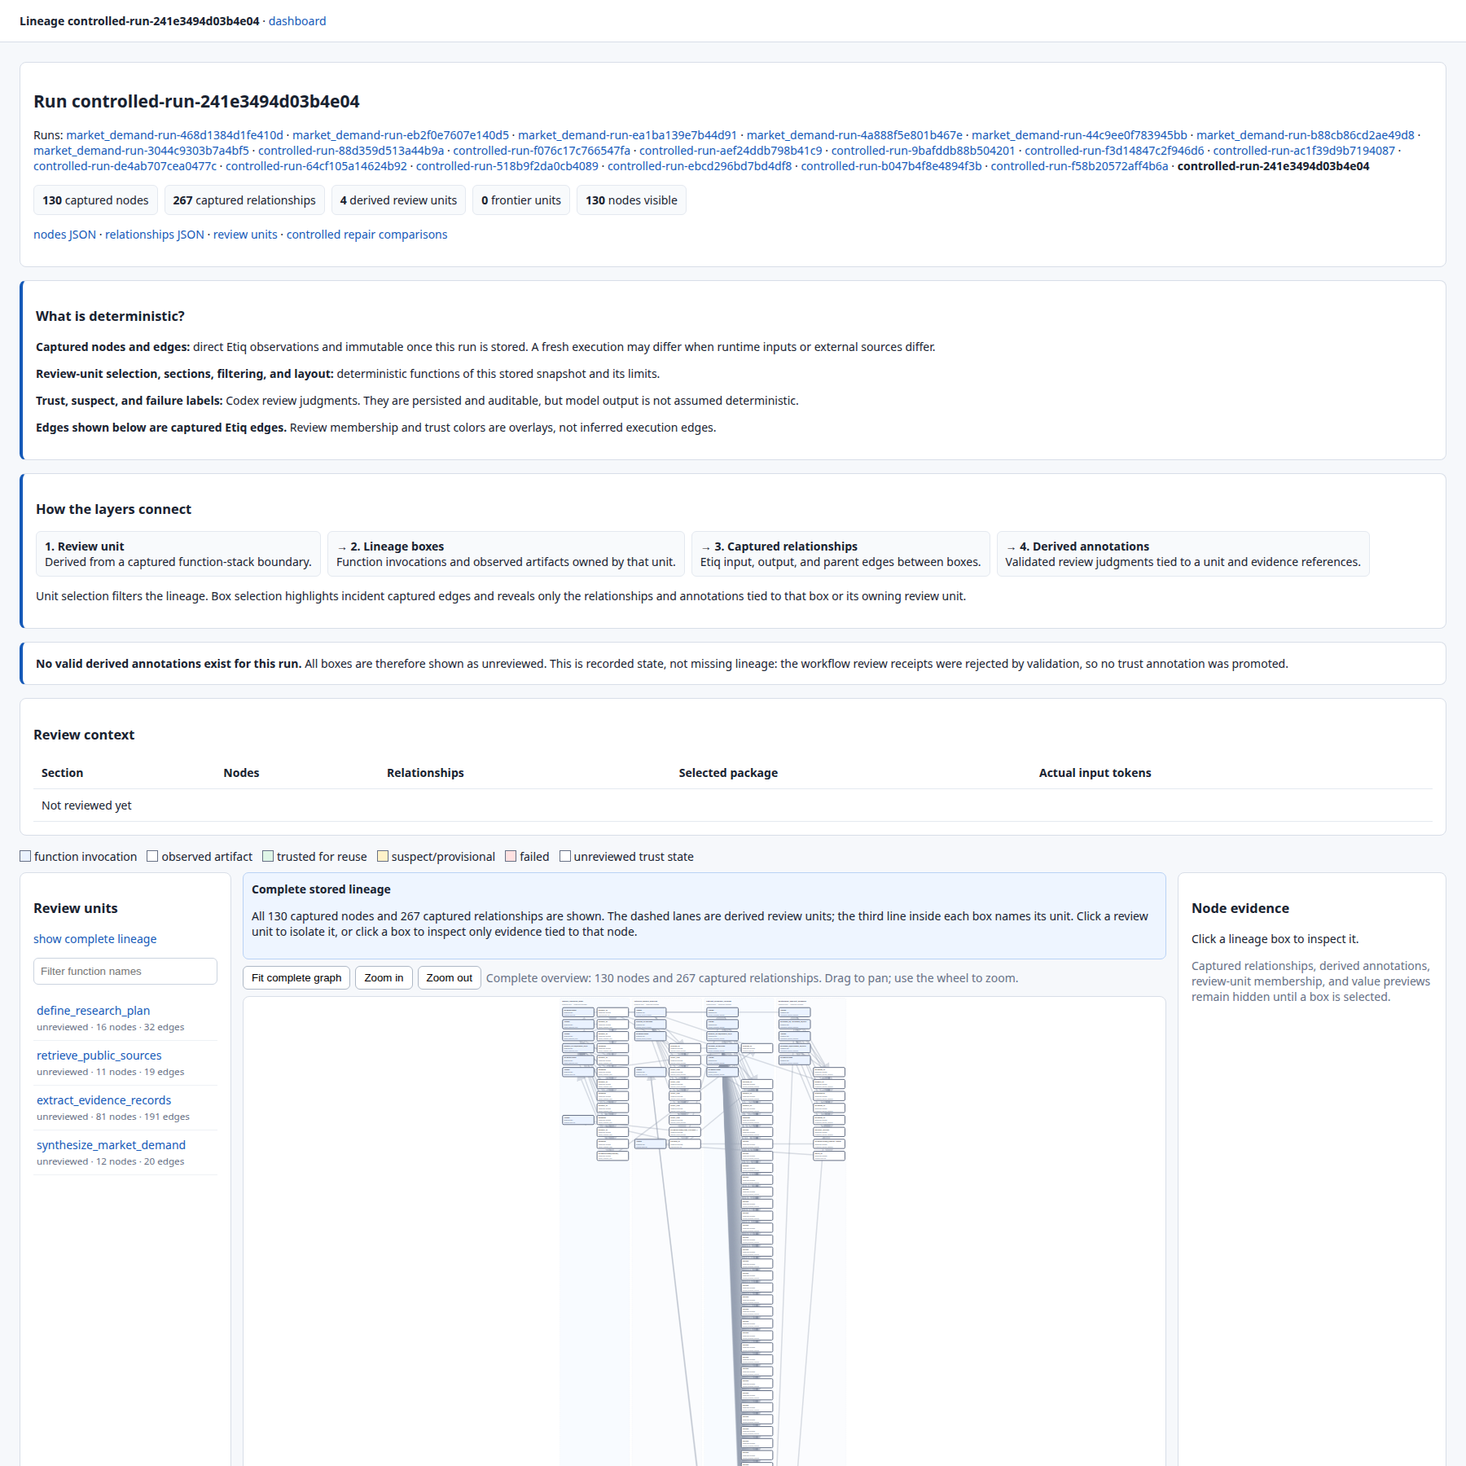
Complete stored lineage for the final etiq_selected replay: 130 captured nodes, 267 captured relationships, and four derived review units. The explicit empty-annotation notice is recorded state: invalid workflow receipts were rejected, so no trust label was promoted.
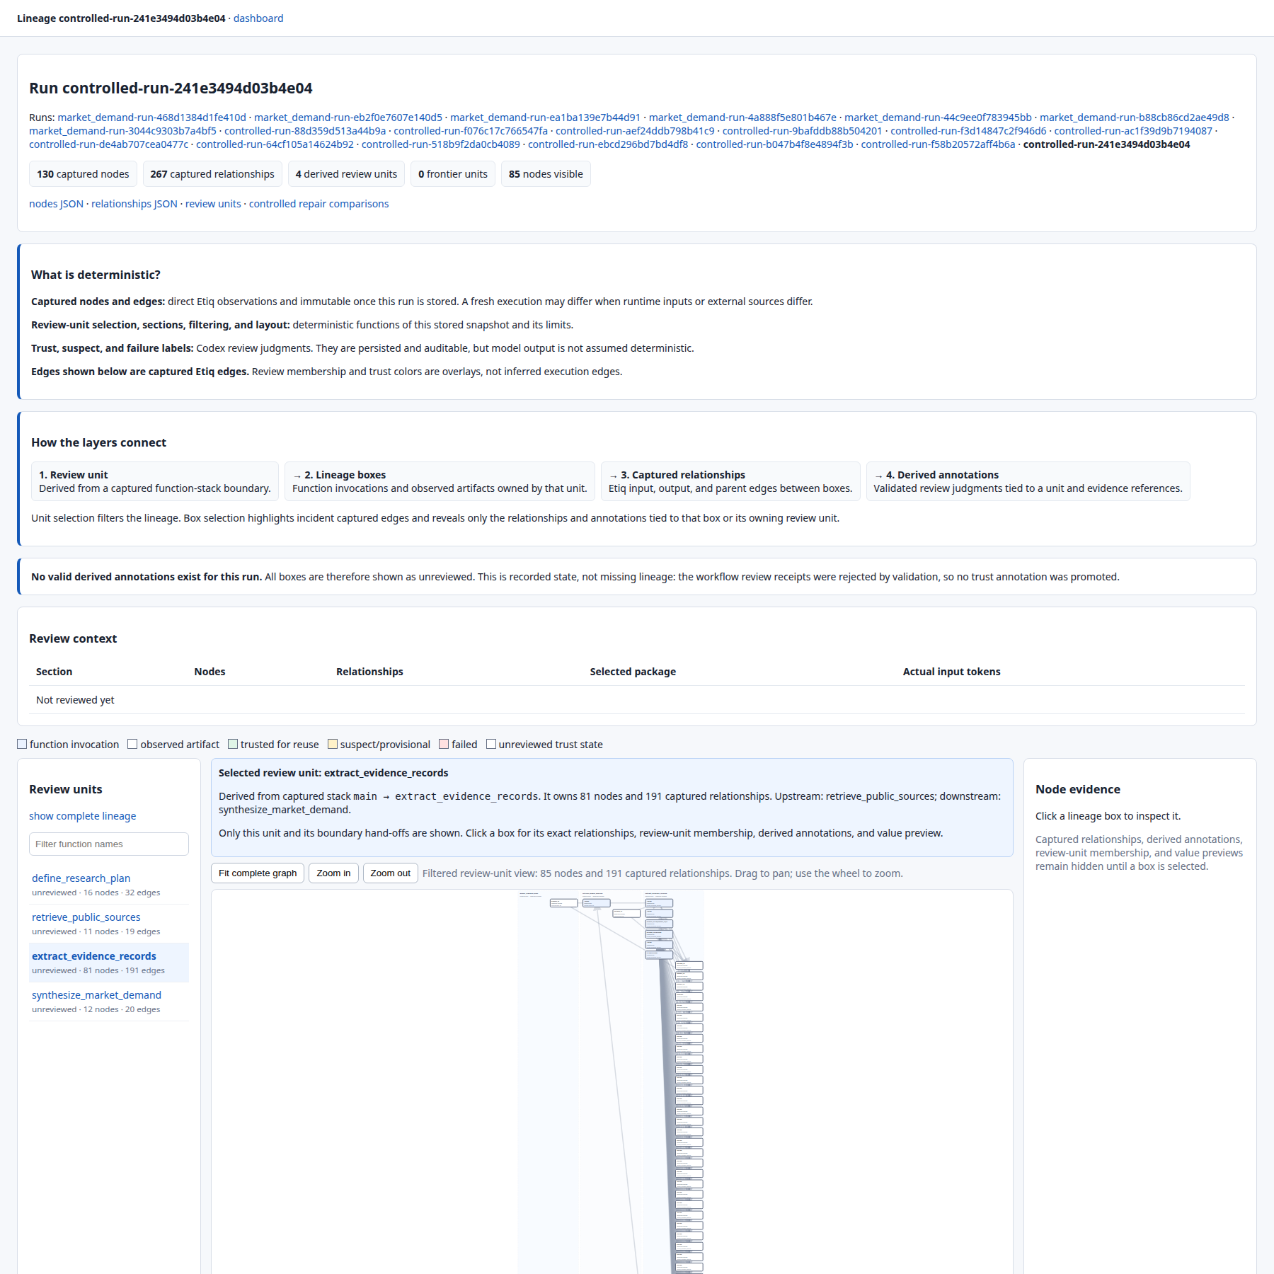
Review-unit drill-down for extract_evidence_records. The unit owns 81 nodes and 191 captured relationships and shows its upstream retrieve_public_sources and downstream synthesize_market_demand hand-offs. The lower graph can be panned and zoomed, and individual boxes expose their exact evidence on demand.

Conclusion
The implementation and latest controlled experiment support a narrower, more useful claim than “more graph is always better.” Execution lineage can act as control state: it can isolate a causal review boundary, expose the artifacts crossing that boundary, and limit what a reviewer or repair agent receives. In this run, the common blind judges reported a smaller unresolved-boundary set for graph-selected context than for full graph or non-graph history, while graph selection also reduced input tokens relative to those larger contexts. Because one boundary difference reflects reviewer disagreement, this is evidence for further testing rather than proof of two additional repairs.
The evidence also sets clear limits. One job and one three-repair branch per arm are not enough to establish a general performance advantage. semantic_only remained substantially cheaper; etiq_selected took longer; and no arm reached reusable trust. Repair targeting and code-change quality, rather than graph capture or display, are now the main constraint.
That is the distinction this architecture is designed to make. The graph does not merely record what the agent did. It provides execution-grounded state from which the system can decide what evidence to inspect, where a defect may begin, what source scope to repair, and what still prevents safe reuse. The next phase should test that mechanism over longer sequences of frozen, repeatable jobs and measure context cost against effective repair and final trust.

References
[1] Wei et al. (2022). Chain-of-Thought Prompting. arXiv:2201.11903.
[2] Yao et al. (2023). ReAct. ICLR.
[3] Yao et al. (2023). Tree of Thoughts. NeurIPS.
[4] Jimenez et al. (2024). SWE-bench. ICLR.
[5] Wang et al. (2025). OpenHands. ICLR.
[6] Antoniades et al. (2025). SWE-Search. ICLR / arXiv:2410.20285.
[7] Orimo et al. (2025). PARC. arXiv:2512.03549.
[8] Wu et al. (2026). GAM. arXiv:2604.12285.
[9] McPhillips et al. (2015). YesWorkflow. arXiv:1502.02403.
[10] Chen et al. (2026). MAGE: Memory as Execution State Management for Long-Horizon Agents. arXiv:2606.06090.
[11] Chen et al. (2025). LocAgent. ACL.
[12] Hong et al. (2025). Data Interpreter. ACL Findings.
[13] Nam et al. (2025). DS-STAR. arXiv:2509.21825.
[14] Nakajima (2026). The Log is the Agent: Event-Sourced Reactive Graphs for Auditable, Forkable Agentic Systems. arXiv:2605.21997.
[15] Rosen and Rosen (2026). From Agent Loops to Deterministic Graphs: Execution Lineage for Reproducible AI-Native Work. arXiv:2605.06365.
[16] Wang et al. (2026). From Agent Traces to Trust: A Survey of Evidence Tracing and Execution Provenance in LLM Agents. arXiv:2606.04990.
[17] Jin et al. (2026). Mitigating Provenance-Role Collapse in Long-Term Agents via Typed Memory Representation. arXiv:2605.25869.

