DOCUMENTATION

ASSIGNMENT 1

Andronescu Raluca-Antonia
Group: 30421

CONTENTS
1. Assignment Objective 3
2. Problem Analysis, Modeling, Scenarios, Use Cases 3
3. Design 3
4. Implementation 3
5. Results 3
6. Conclusions 3
7. Bibliography 3

Assignment Objective
Main objective : Design and implement a polynomial calculator with a dedicated graphical interface through which the user can insert polynomials, select the mathematical operation to be performed and view the result.
Sub-Objective | Description | Section Addressed
Analyze the problem and identify requirements. | Identify the functional and non-functional requirements of the polynomial calculator application. | Problem Analysis, Modeling, Scenarios, Use Cases
Design the polynomial calculator. | Develop the object-oriented design of the polynomial calculator application, including user interface components and backend logic. | Design
Implement the polynomial calculator. | Translate the design specifications into executable code, including classes, methods, and graphical user interface components. | Implementation
Test the polynomial calculator. | Execute various testing scenarios to ensure the functionality, correctness, and reliability of the polynomial calculator application. | Results

Problem Analysis, Modeling, Scenarios, Use Cases
- Functional Requirements:
- Perform basic arithmetic operations on polynomials : addition, subtraction, multiplication, division, derivation and integration.
- Display the results of polynomial operations in a user-friendly graphical interface.
- Non-Functional Requirements:
- Intuitive interface.
- Clear error handling.
- Fast computation.
- Modern design.
- Responsive layout.
- Accurate calculations.
- Use Cases:
- Addition:
Scenario: User wants to add two polynomials.
Input: Two polynomials provided by the user.
Action: System calculates the sum of the polynomials.
Output: The result of the addition operation is displayed to the user.
- Subtraction:
Scenario: User wants to subtract one polynomial from another.
Input: Two polynomials provided by the user.
Action: System calculates the difference between the polynomials.
Output: The result of the subtraction operation is displayed to the user.
- Multiplication:
Scenario: User wants to multiply two polynomials.
Input: Two polynomials provided by the user.
Action: System calculates the product of the polynomials.
Output: The result of the multiplication operation is displayed to the user.
- Division:
Scenario: User wants to divide one polynomial by another.
Input: Two polynomials provided by the user.
Action: System performs the division operation and calculates both the quotient and remainder.
Output: The quotient and remainder of the division operation are displayed to the user.
- Derivation:
Scenario: User wants to derivate a polynomial.
Input: A polynomial provided by the user in the first text field.
Action: System calculates the derivative of the polynomial.
Output: The result of the derivation operation is displayed to the user.
- Integration:
Scenario: User wants to integrate a polynomial.
Input: A polynomial provided by the user in the second text field.
Action: System calculates the integral of the polynomial.
Output: The result of the integration operation is displayed to the user.

Design

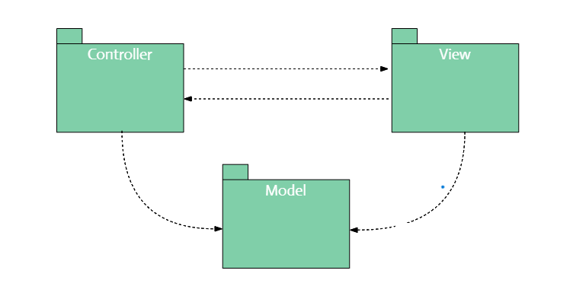
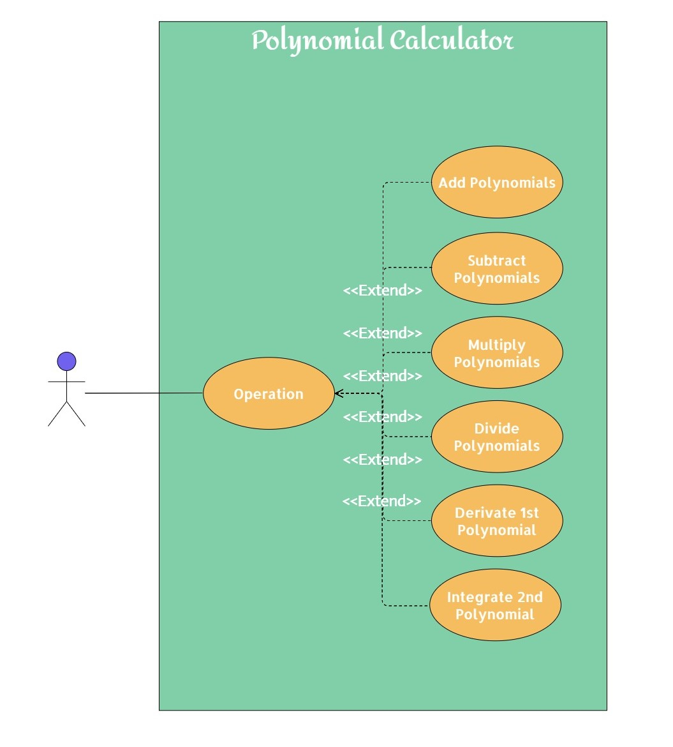
- Use case diagram
- Package diagram

- Class diagram
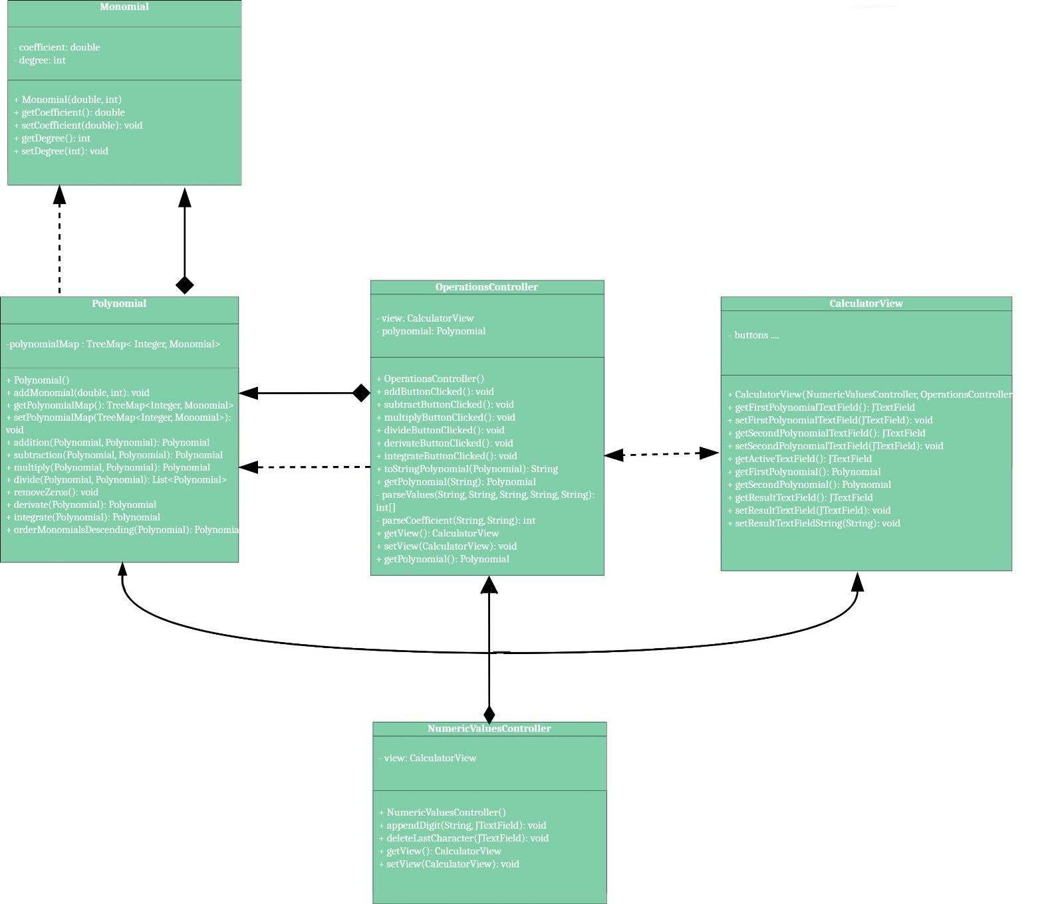

Implementation
- NumericValuesController:
- Fields: None.
- Important Methods: None.
- Description: This class likely handles the control logic related to numerical values in the polynomial calculator. It might provide functionality for parsing and validating numerical inputs.

- OperationsController:
- Fields:
- polynomial: Polynomial - Instance of the Polynomial class.
- view: CalculatorView - Instance of the CalculatorView class.
- Important Methods:
- addButtonClicked(): Handles addition operation.
- subtractButtonClicked(): Handles subtraction operation.
- multiplyButtonClicked(): Handles multiplication operation.
- divideButtonClicked(): Handles division operation.
- derivateButtonClicked(): Handles derivation operation.
- integrateButtonClicked(): Handles integration operation.
- Description: This class manages the operations performed on polynomials based on user input. It communicates with the Polynomial class to perform the mathematical operations.

- Monomial:
- Fields:
- coefficient: double - The coefficient of the monomial.
- degree: int - The degree of the monomial.
- Important Methods: None.
- Description: Represents a single term in a polynomial equation.

- Polynomial:
- Fields: polynomialMap: TreeMap<Integer, Monomial> - A map containing monomials as values, with their degrees as keys.
- Important Methods:
- addMonomial(double coefficient, int degree): Adds a monomial to the polynomial.
- addition(Polynomial first, Polynomial second): Performs polynomial addition.
- subtraction(Polynomial first, Polynomial second): Performs polynomial subtraction.
- multiply(Polynomial first, Polynomial second): Performs polynomial multiplication.
- divide(Polynomial first, Polynomial second): Performs polynomial division.
- derivate(Polynomial polynomial): Computes the derivative of the polynomial.
- integrate(Polynomial polynomial): Computes the integral of the polynomial.
- Description: Represents a polynomial equation and provides methods to perform arithmetic operations on polynomials.

- Graphical User Interface (GUI) Implementation
The graphical user interface (GUI) is implemented using the CalculatorView class. This class extends Component and provides a user-friendly interface for interacting with the polynomial calculator.
The GUI consists of various components organized within panels and frames to facilitate user input and display results. Here's an overview of the components and their functionalities:
- Main Frame: A JFrame serves as the main window for the application.
- Upper Panel: Contains a title label indicating the purpose of the polynomial calculator.
- Text Fields Panel: Displays text fields for entering the first polynomial, second polynomial, and result.
- Arithmetic Operation Buttons Panel: Contains buttons for performing arithmetic operations such as addition, subtraction, multiplication, division, derivation, and integration.
- Numeric Buttons Panel: Displays numeric buttons (0-9), as well as buttons for the variable 'x' and exponentiation (^).
- Action Listeners: Action listeners are attached to buttons to handle user interactions, such as appending digits, performing arithmetic operations, and navigating between text fields.
The GUI elements are styled using colors and fonts to enhance readability and visual appeal. User input is validated and processed to perform the desired mathematical operations on polynomials. Additionally, the GUI allows users to switch between text fields for entering multiple polynomials and obtain the corresponding results efficiently.
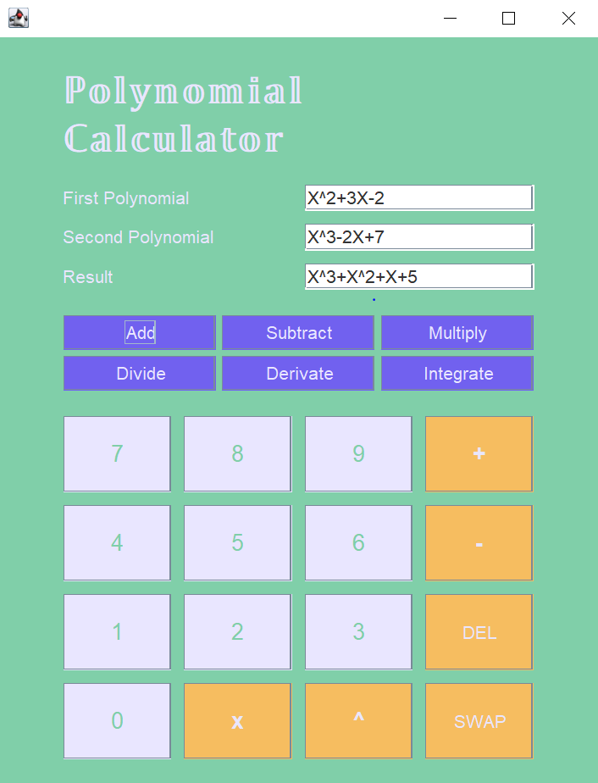

Results
The polynomial calculator project underwent rigorous testing to ensure its functionality and reliability. Testing scenarios were devised to cover various use cases, including addition, subtraction, multiplication, division, derivation, and integration of polynomials.
Additionally, JUnit tests were implemented to verify the correctness of each mathematical operation within the calculator. The integration of JUnit tests provided a systematic approach to validate the implemented functionalities and detect any discrepancies or errors. Through extensive testing, the polynomial calculator demonstrated its capability to accurately perform mathematical operations on polynomials, meeting the project requirements effectively..

Conclusions
The polynomial calculator project successfully enables users to perform diverse mathematical operations on polynomials through an intuitive graphical interface, ensuring efficient input and accurate result presentation.
Key takeaways from this assignment include mastering intricate mathematical algorithms, crafting Java Swing-based graphical user interfaces (GUIs), and implementing effective user input validation and error handling mechanisms.
Potential future enhancements for the polynomial calculator entail integrating additional mathematical functions like trigonometric operations, refining the GUI with enhanced features and customization options, and incorporating unit testing with JUnit for enhanced reliability and robustness.

Bibliography
- Creating a GUI With Swing - https://docs.oracle.com/javase/tutorial/uiswing/index.html
- A Guide to JUnit5 - https://www.baeldung.com/junit-5
- Polynomial Arithmetic - https://www.khanacademy.org/math/algebra2/x2ec2f6f830c9fb89:poly-arithmetic

