**Programming for Mobile Devices**

**BookLoop**

Final report

15 - 03 - 2021

Supervisor Student

**Liviu-Octavian Mafteiu-Scai**  **Raluca Chiș IE2**

# 

# 

# 

# 

# ABSTRACT

The aim of this report is to present details about the mobile application BookLoop. It contains information about the application’s target audience, features, goals and makes a comparison with other similar apps.

# GOAL and USERS

The goal of the report is to help people keep track of the books they own in an organized way. Reading is an interest shared by many people so the app targets users from all age groups.

# INTRODUCTION

In the last years e-books have become a mainstay of the publishing industry. However, the e-book sales decrease every year and readers prefer the printed books. Therefore in 2018 a total of about 675 billion printed books were sold only in the United States showing a growth of +19% in sales. BookLoop is made for book lovers, people who enjoy the smell of the freshly printed books and the physical feel of the progress through a book as the upcoming pages get fewer and fewer. At some point before buying a new book you question yourself if you will enjoy it or it will end up on the unfinished shelf.

**STATE OF ART**

Other similar apps are Google Play Books, Uread and My Library:Book Summaries available on Google Play.

Google Play Books is very popular for purchasing textbooks, ebooks, comics and audiobooks.

With a subscription you can have your favorite books in an electronic format.

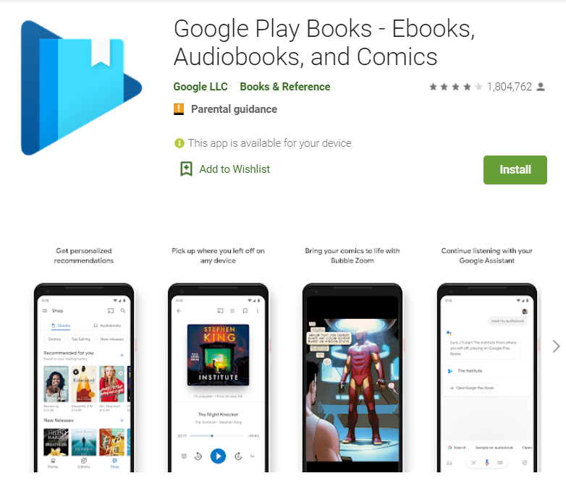

Uread is not such a popular app, having only 742 downloads. It provides a platform for readers to interact and discuss their favorite books.

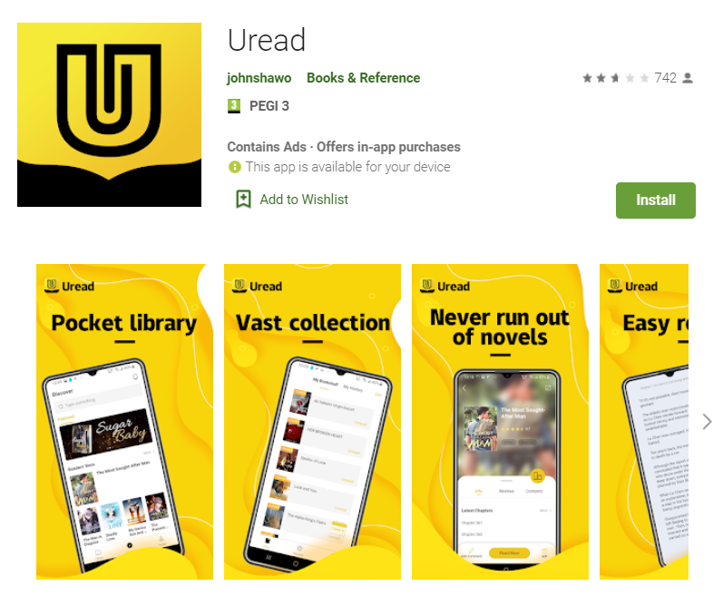

My Library provides summaries for books, written and audio.

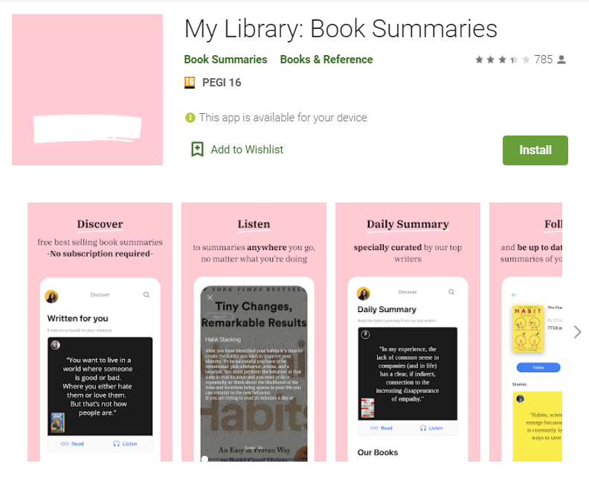

## ORIGINAL CONTRIBUTION

Inspired by Uread’s idea of writing a final thought on a book freshly finished, BookLoop will provide a way to keep an electronic database of the books that the user owns along with a rating of the novel and short review. When another reader asks you about your opinion on a book you can just open the app and search for your thoughts on the book.

## DEVELOPMENT PLAN

The application was firstly designed using Adobe XD.

Then I continued the project in Android Studio following an OOP approach. The main technology used is Java since IDE provides top notch functionality built in that helps the development process.

Saving data to a database is ideal for structuring the data, such as book information. SQLite is a structured query based database, that is open source, light weight, it requires no network access and is a standalone database. Android has built in SQL database implementation that is available locally over the device and contains data in text format.

I used a database to store the books along with their details (title, author, rating, review and the date of the day the user finished the book). The user can perform simple CRUD operations to create, read, update and delete a book.

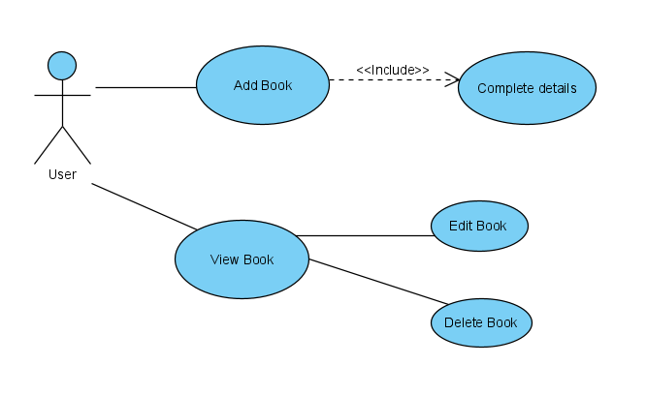

## USER INTERFACE

The user interface is simple to use, the main screen has the list of books added. In the top right corner is the add button for creating another entry. This leads to a new screen where the user can complete the information for another book. The title, author and review are text fields, and a rating bar consisting of 5 stars for giving a rating. After finishing to add the information, and clicking the save button, the user is taken back to the main screen, where is the list of books added. Every entry has a date of the day it was created.

## 

## 

## 

## 

## 

## 

## 

## 

## 

## REFERENCES

[1] https://developer.android.com/

[2] https://play.google.com/store/apps/details?id=com.google.android.apps.books

[3] https://play.google.com/store/apps/details?id=com.uread.novel.huawei

[4] https://play.google.com/store/apps/details?id=com.bookvitals

[4] <https://www.xdguru.com/xd-mobile-templates/>

[5] <https://github.com/>