**Setting up Database**:

1. Copy all text of dump file
2. Replace word “local” with your database name

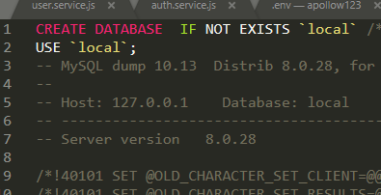

1. Run query, it will create all tables in database

**Setting up Server Side:**

1. Run command “npm install”
2. After that goto “.env” file and values of those variables according to your database settings
3. Run “nodemon” to run server

**Setting up Client side:**

1. Run command “npm install”
2. After installation of all dependencies run command “npm start”