1) Logon to the portal with an administrative user and navigate through:

Content Administration - Portal Content Management Portal Content - Content Provided by SAP

- End User Content - Standard Portal Users - iViews - com.sap.km.iviews - URL Access <-right mouse click :

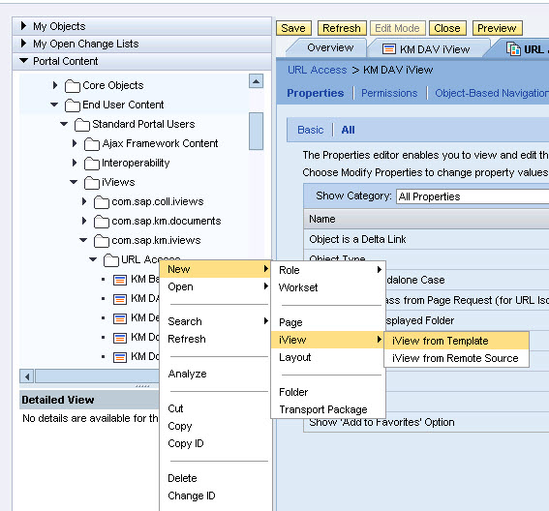

From ‘New’ button choose to create an “iview from Template” using the KM Document iView template:

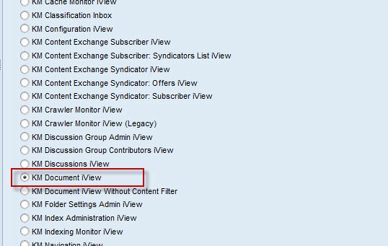

2) Name the iview as of the picture bellow and save it afterwards:

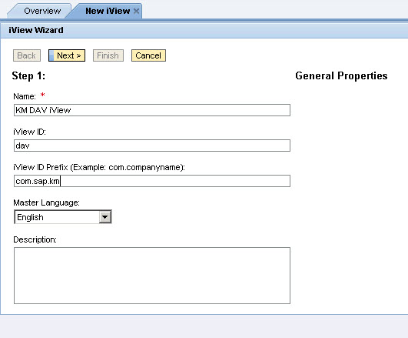

3) Navigate to URL Access workset ,i.e.

Content Administration - Portal Content Management Portal Content - Content Provided by SAP

- End User Content - Standard Portal Users - Worksets – com.sap.km.worksets – URL Access(workset)

and open it: 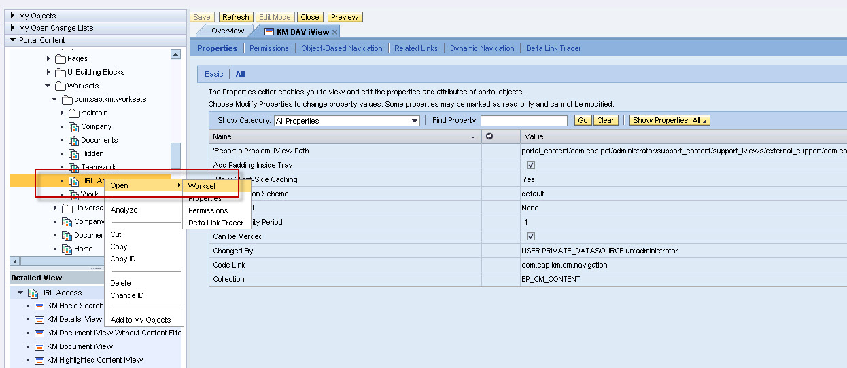

4) navigate back to the path where the newly ‘KM DAV iView ’ has been created and right click choose add as a “Delta link”

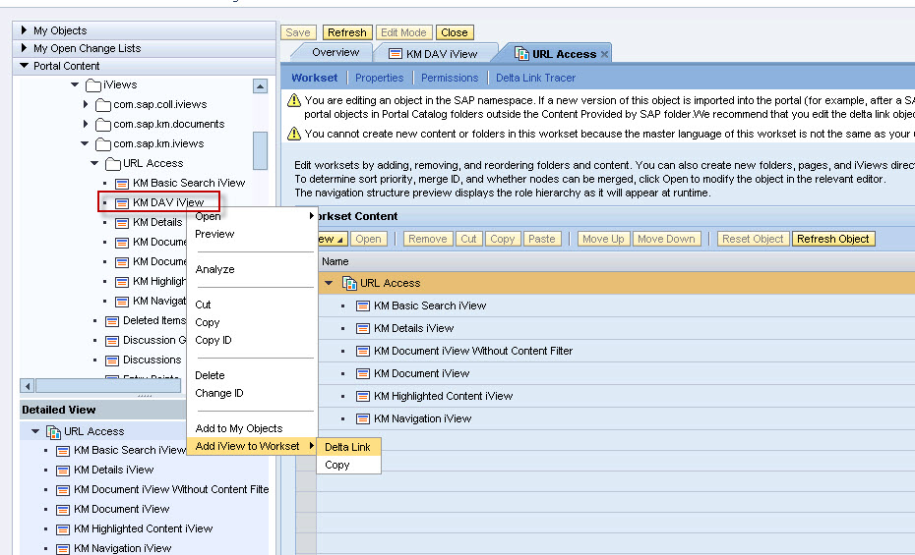

This would add the ivew in question to the URL Access workset as a delta link

5) Once after that “Open” the delta link configuration and edit it with the “Modify Properties” button:

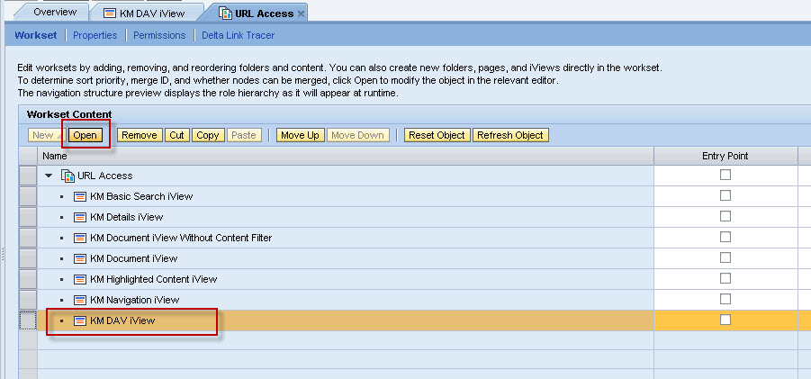

6) change the authschema to ‘basicauthentication’ and check out if the property “Path to Document” is empty – if not make it empty and save the changes using the “Save” button on top/left of the frame.

