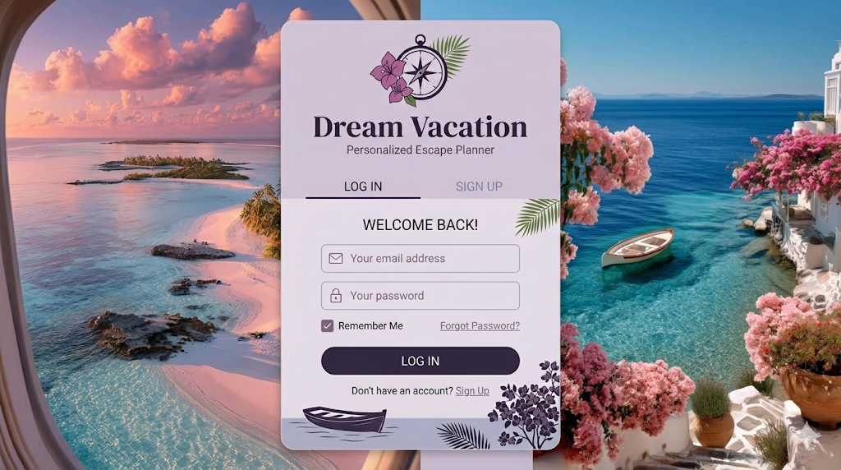
Graphical User Interface (GUI) prototype

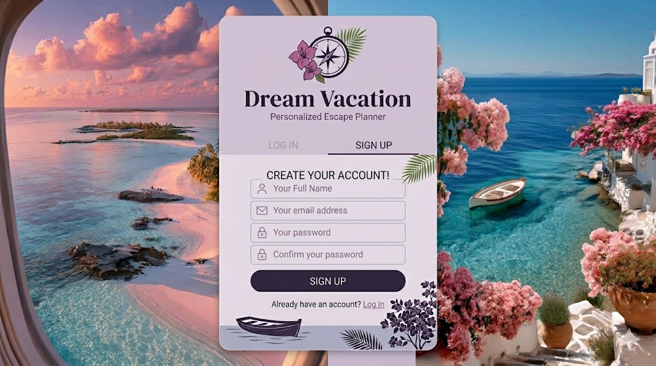

Screen 1: Authentication & User Onboarding (UC-1 & UC-2) This screen serves as the welcoming entry point to the "Dream Vacation" application, featuring a clean, split-panel interface set against an inspiring dual-destination background.
- Left Panel (UC-1: Register): Dedicated to new visitors, allowing them to create a personalized profile. It includes input fields for their Full Name, Email Address, and Password (with confirmation), alongside a primary "Sign Up" button.
- Right Panel (UC-2: Login): Designed for returning tourists to securely access their planning dashboard. It features inputs for Email and Password, a "Remember Me" checkbox for convenience, a password recovery link, and the main "Log In" button.

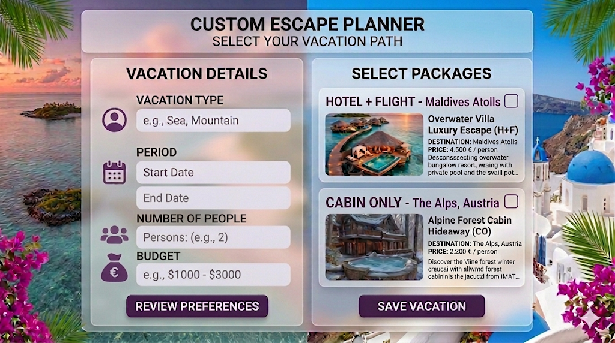
Screen 2: Vacation Preferences & Package Selection (UC-3 & UC-4) This interface is the core "Custom Escape Planner," where the user's dream trip starts taking shape based on the recommendation engine.
- Left Panel (UC-3: Create Vacation Preferences): Here, the tourist defines the parameters of their ideal getaway. The form captures the Vacation Type (e.g., Sea, Mountain), a specific Period (Start Date and End Date), the Number of People traveling, and an estimated Budget. A "Review Preferences" button processes this data.
- Right Panel (UC-4: Select Vacation Package): Based on the preferences set on the left, this section displays curated travel bundles. Users can view options like a "Hotel + Flight" package to the Maldives or a "Cabin Only" retreat in the Austrian Alps. Each card shows a preview image, destination, and calculated price per person, allowing the user to select their favorite option and click "Save Vacation."

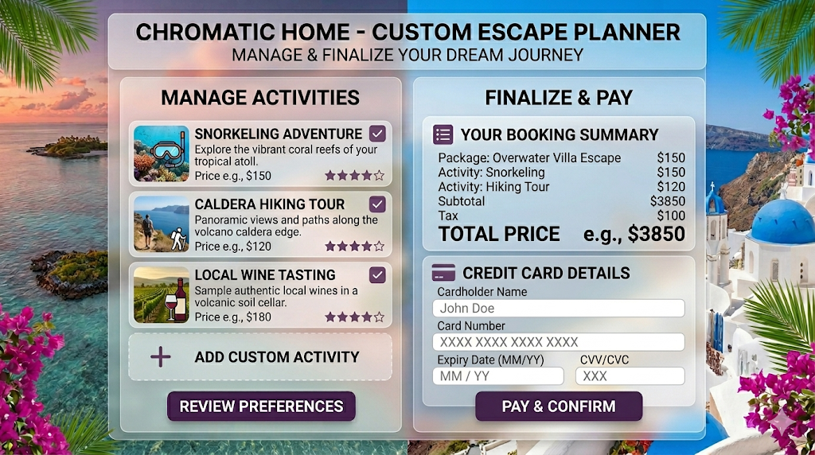
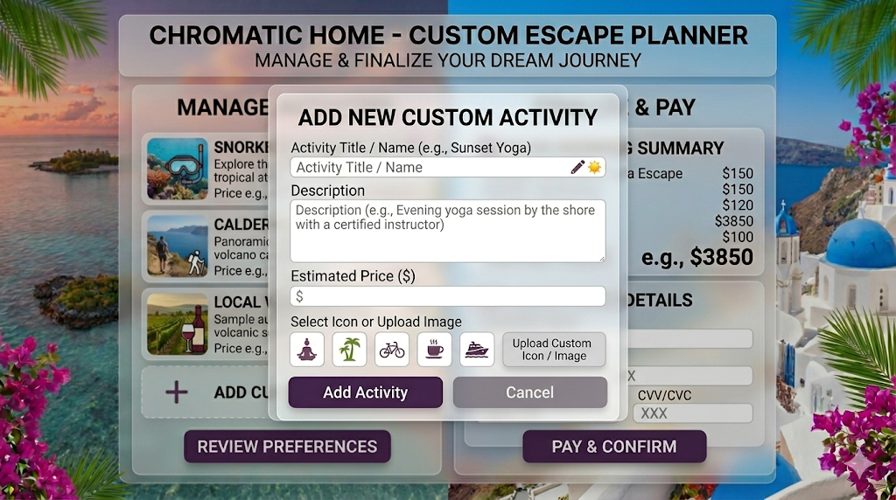

Screen 3: Itinerary Customization & Final Checkout (UC-5 & UC-6) The final screen is dedicated to managing the trip's schedule and completing the financial transaction in a secure and transparent way.
- Left Panel (UC-5: Manage Activities): This section allows tourists to enrich their itinerary. It displays a list of suggested activities tailored to their chosen destination (such as Snorkeling, Hiking, or Wine Tasting) with associated prices and ratings. Users can select multiple events via checkboxes or use the "Add Custom Activity" feature to include personal plans.
- Right Panel (UC-6: Pay Vacation): The checkout module provides a transparent "Booking Summary" that itemizes the costs for the selected package, chosen activities, subtotals, and taxes to display the final Total Price. Below the summary, a secure payment form collects Credit Card Details (Cardholder Name, Card Number, Expiry Date, CVV), finalized by a "Pay & Confirm" button to complete the reservation.

