GLUON PaaS - OHE
End to End API&Microservices

Version 0.1
20230915

Document information

Document source
This document is maintained as an online document. Contact the author for the latest version.

Revision history
Version number | Date | Summary of changes | Revision marks
0.1 | 2024/01/25 | Initial version

Author
This document has been created by the follow people.
Name | Function | Date of created | Signature
Global CTO | Global CTO

Approvals
This document has been approved by the following people. The signed approval forms are filed in the Project Control Book.
Name | Function | Date of approval | Signature
Global CTO | Global CTO
Global CIO | Global Supply
Entity Brazil
Entity SCIB

Attachments
Version number | Date | Title | Object

Distribution
This document has been distributed to:
Name | Function

Table of Contents

0 Objective & Scope 1
0.1 Context 1
0.2 Scope 1
0.3 Principles 1
1 Use Cases 2
1.1 Touchpoint applications in Internet 2
1.2 Touchpoint applications in Intranet 3
1.3 Inter-domain APIs 4
2 Capabilities, Building Blocks & Tech-Stack 4
2.1 MicroFrontEnds 4
Capabilities 5
Building Blocks 8
Tech-Stack 8
2.2 Global Load Balancing & Network 9
Capabilities 9
2.2.1.1 GTMs exposure APIs capabilities 9
2.2.1.2 Health-Check from GTM to API Gateways 9
2.2.1.3 Load Balancer capabilities 9
2.2.1.4 SLAs 11
Building Blocks 12
2.2.1.5 DNS 12
2.2.1.6 WAF 13
2.2.1.7 GTM 13
2.2.1.8 LOCAL LOAD BALANCER 14
Tech-Stack 14
2.3 APIs 14
Capabilities 14
Building Blocks 18
Tech-Stack 19
2.3.1.1 API Manager 19
2.3.1.2 API Catalog 19
2.3.1.3 API Gateway 19
2.3.1.4 API Lightweight Gateway 19
2.3.1.5 Standards & Patterns 19
2.3.1.6 Dictionary of Terms 19
2.3.1.7 API Definition & Design 19
2.3.1.8 API Sandbox virtualization tool 19
2.3.1.9 Monitoring 19
2.3.1.10 Authorization Server 19
2.3.1.11 Backup tool 19
2.3.1.12 Testing 19
2.4 Microservices 20
Capabilities 20
Building Blocks 20
2.4.1.1 Diataxis Documentation 20
2.4.1.2 Framework Library 20
2.4.1.3 Framework Archetype 20
2.4.1.4 Helm Chart 21
Tech-Stack 21
2.4.1.5 Java 21
2.4.1.6 Maven 21
2.4.1.7 Quarkus 21
2.4.1.8 Apache Camel 21
2.4.1.9 Spring Framework 21
2.4.1.10 Quarkus Panache 21
2.4.1.11 Spring Data 21
2.4.1.12 Resillience4j 21
2.4.1.13 Redis 22
2.4.1.14 CheckStyle for Java 22
2.4.1.15 Kafka (MSK / Confluent / EventHub) 22
2.5 Kubernetes 22
Capabilities 22
Building Blocks 23
Tech-Stack 24
2.5.1.1 On-Prem: OpenShift 24
2.6 Gluon Data Persistence 25
Capabilities 25
2.6.1.1 Relational Databases 25
2.6.1.2 Data Dictionary 26
2.6.1.3 Data Modeling Catalog 26
Building Blocks 27
2.6.2 Tech-Stack 27
2.7 Security 28
Capabilities 28
Building Blocks 28
Tech-Stack 30
2.8 Observability 30
Capabilities 30
Building Blocks 31
Tech-Stack 31
2.8.1.1 General Observability Stack 31
3 Challenges & Decisions taken in the E2E 32
3.1 MicroFrontEnds 32
Challenges 32
Decisions taken. 32
3.2 Global Load Balancing & Network 33
Challenges 33
DNS 33
WAF 33
GTM 34
LOCAL LOAD BALANCERS 34
Decisions taken 34
3.3 APIs 34
Challenges 34
3.3.1.1 Standardisation 34
3.3.1.2 Multi-Exposition Public & Private Cloud 35
Decisions taken 35
3.4 Microservices 36
Challenges 36
3.4.1.1 Auto-scaling 36
3.4.1.2 Orchestration 36
3.4.1.3 GRPC 36
3.4.1.4 Choreography 37
3.4.1.5 Multi-Environment Configuration 38
3.4.1.6 Rate Limiter 38
3.4.1.7 Circuit Breaker 38
3.4.1.8 Caching 38
Decisions taken 39
3.4.1.9 Versioning 39
3.4.1.10 DDD 39
3.4.1.11 gRPC 39
3.4.1.12 Choreography 39
3.4.1.13 Orchestration 40
3.4.1.14 Multi-Environment Config 40
3.4.1.15 REST 40
3.4.1.16 Caching 40
3.4.1.17 Application Structure 41
3.4.1.18 Persistence 41
3.4.1.19 Resilience Patterns 41
3.4.1.19.1 Rate Limit / Throttling 41
3.4.1.19.2 Retry 43
3.4.1.19.3 Circuit Breaker 44
3.4.1.19.4 Bulkhead 46
3.4.1.19.5 Compensated Transaction 47
3.4.1.19.6 Saga 48
3.4.1.19.7 Sharding 49
3.4.1.19.8 CQRS 51
3.4.1.19.9 Health Check 54
3.4.1.19.10 Read Replica 56
3.5 Kubernetes 57
Challenges 57
Decisions taken 57
3.6 Gluon Data Persistence 57
Challenges 57
Decisions taken 58
3.7 Security 58
Challenges 58
Decisions taken 58
3.8 Observability 58
Challenges 58
3.8.1.1 Quality / Standardization of logs 58
3.8.1.2 Amount of processed and stored information 58
3.8.1.3 End-to-End Traceability 59
3.8.1.4 Incompatibility with Tools 59
3.8.1.5 Coexistence with Legacy Systems 59
3.8.1.6 Outstanding Issues with ElasticSearch SaaS 59
Decisions taken 59
3.8.1.7 Tools/Environments 59
3.8.1.8 Out of Scope 60
4 Architecture 61
4.1 Macro-Architecture 61
4.2 Conceptual Architecture 62
MicroFrontEnds 62
4.2.1.1 Sequence Diagram 62
Global Load Balancing & Network 63
4.2.1.2 Sequence Diagram 63
APIs 64
4.2.1.3 Sequence Diagram 64
Microservices 66
4.2.1.4 Sequence Diagram 66
Kubernetes 66
4.2.1.5 Sequence Diagram 66
Gluon Data Persistence 66
4.2.1.6 Sequence Diagram 66
Security 67
4.2.1.7 Sequence Diagram 67
When the application calls the API 67
When a Domain A microservice calls Domain B API 67
Authorization 67
Diagram flow 68
Observability 70
4.2.1.8 Sequence Diagram 70
4.3 Technical Architecture 70
MicroFrontEnds 70
4.3.1.1 Technical Solution 70
Global Load Balancing & Network 70
4.3.1.2 Technical Solution 70
4.3.1.2.1 Observability 70
4.3.1.2.1.1 WAF Service 70
4.3.1.2.1.2 Local Load Balancing 70
4.3.1.2.1.2.1 HW Monitoring 70
4.3.1.2.1.3 Service Monitoring 71
APIs 71
4.3.1.3 Technical Solution 71
Microservices 73
4.3.1.4 Technical Solution 73
Kubernetes 73
4.3.1.5 Technical Solution 73
Gluon Data Persistence 74
4.3.1.6 Technical Architecture for Relational RDBS - Oracle 74
4.3.1.6.1 On Prem 74
4.3.1.6.1.1 Non-Production Environments 75
4.3.1.6.1.2 Production Environments 75
4.3.1.7 Technical Architecture for Documental Store – Mongodb 76
4.3.1.7.1 On Prem 76
4.3.1.7.1.1 Non-Production Environments 76
4.3.1.7.1.2 Production Environments 76
4.3.1.8 Technical Architecture for Key Value Store – Redis 77
4.3.1.9 On Prem 77
4.3.1.10 Non Production Environments 77
4.3.1.11 Production Environments 77
Security 77
4.3.1.12 Technical Solution 77
Observability 83
4.3.1.13 Technical Solution 83
4.4 Deployment Architecture 84
5 Glossary 88
6 Annexes 88

Objective & Scope

Context
This document is part of the Gluon PaaS initiative which defines a new global end2end technical architecture for APIs & Microservices. Outcomes of this initiative will lead the design of the implementation of API & Microservices maximizing the reusability across entities.

Scope
The scope of this document is to define the conceptual architecture, components and components configuration guidelines, and the technical architecture including the deployment model and the environment model for this End2End for touchpoints, API & Microservices.
To be more specific, this document covers the use cases when a touchpoint (mainly) in internet is the origin of the e2e so that it’s executed in a fully synchronous way. Other use cases such as batches or assisted channels (branches/contact center…) consuming APIs are out of the scope for the moment.
The e2e model proposed will reuse the OneWeb project approach mainly in micro-fronts, security, APIs y microservices, although any aspects considered necessary shall be adapted and/or extended.

Principles
- Channels are 100% stateless based on MicroFrontEnds (no BFF, session or data in the channel level)
- APIs are published in a GLB service (imperva, akamai, …) to enable dynamic load balancing between different CSP (private or cloud)
- 100% of the APIs exposed to the channels should be in a certified API Gateway (OHE: Apigee OPDK or IBM API Connect v10)
- All the APIs published in the gateways should come from Gluon and 100% aligned with the Gluon Global Catalog
- Technical services and middleware required to optimize the infrastructure (cache, databases, message queues, …) should have a standard consumption model (through Gluon) and a detailed technical standard.
- Business logic is organized in namespaces.
- Every access to the microservices from the API layer would be secured through a microapigw (https)
- Calls from microservices from one namespace to another one should go always through the microapigw (east-west connections are not allowed), through HTTPS/GRPC
- Only K8S standard methods would be allowed in the container management platform (no native calls)
- 100% of the infrastructure and security provisioning should be 100% automated both in private and public cloud through a single set of standard services globally owned.
- Microservices max size should align best practices.
- All the access to data from the microservices should go through standard architecture services, with different flavors depending on the persistence.
- 100% of the north-south calls (from the channel) should be traceable, including the device information through Alma (functional monitoring)

Use Cases

Touchpoint applications in Internet

The first use case to be considered is the Applications exposing APIs to a touchpoint in Internet.
NOTE: Only web and mobile applications consuming APIs are in the scope. Other use cases will have to be analyzed in detail to design their architecture appropriately (processes, batches, etc.), although part of what is defined in this document may apply.
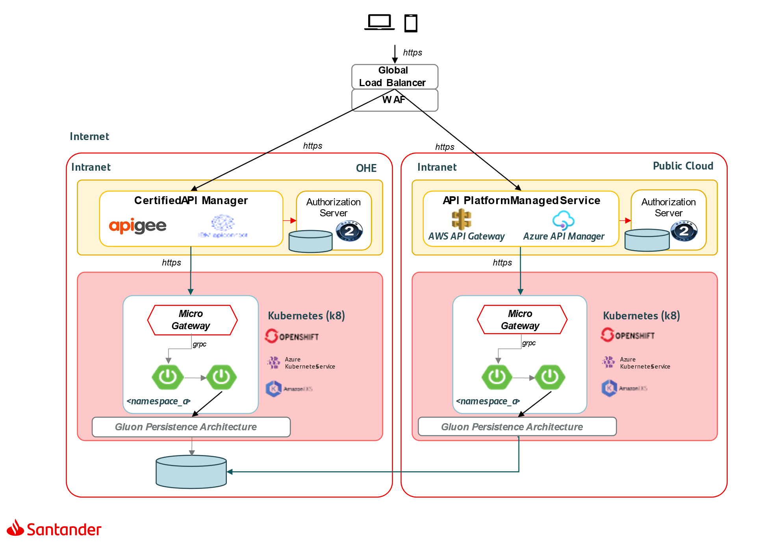

Touchpoint applications in Intranet
A similar case happens when an application exposes APIs to a touchpoint internally via Intranet.
NOTE: Only web and mobile applications consuming APIs are in the scope. Other use cases will have to be analyzed in detail to design their architecture appropriately (processes, batches, branches, contact center, etc.), although part of what is defined in this document may apply.

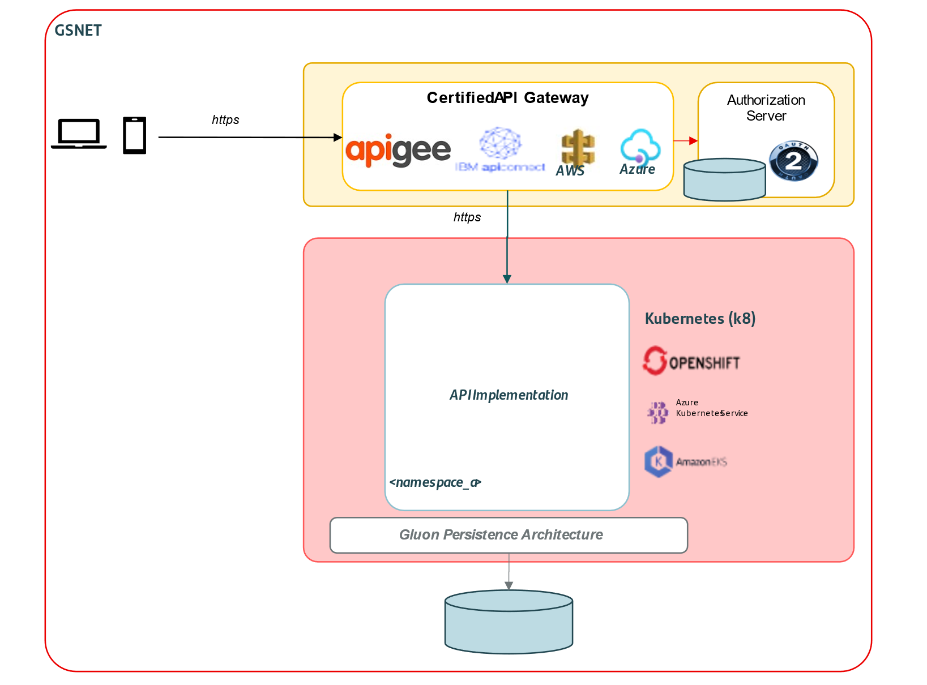

Inter-domain APIs
This use case covers the use case of an application that consumes APIs from other business domains (deployed in different namespaces or Kubernetes clusters)
NOTE: Only inter-domain API consumption originated by a mobile or a web application are in the scope. Other use cases will have to be analyzed in detail to design their architecture appropriately (processes, batches, branches, contact center, etc.), although part of what is defined in this document may apply.
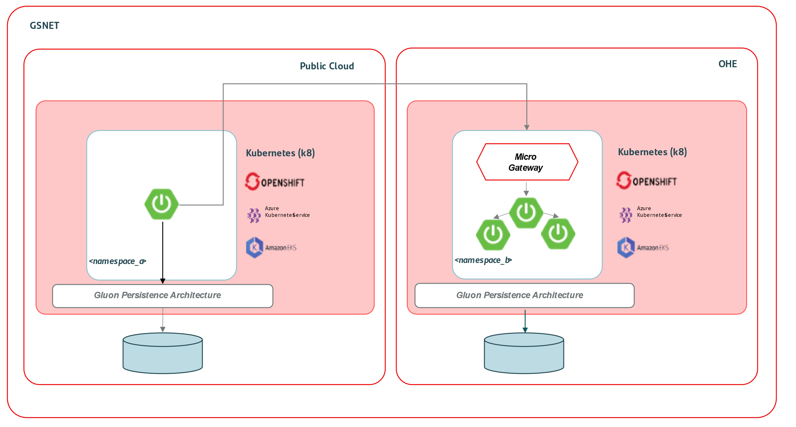

Capabilities, Building Blocks & Tech-Stack

MicroFrontEnds

Microfronts bring the same concepts to the frontend that microservices brought to the backend.
- The application could be divided vertically in independent features or products.
- They could be developed by different teams with different lifecycles.
- Improved agility and time-to-market.
They need an application (a.k.a. Shell) as an integration layer who will present all together at runtime.

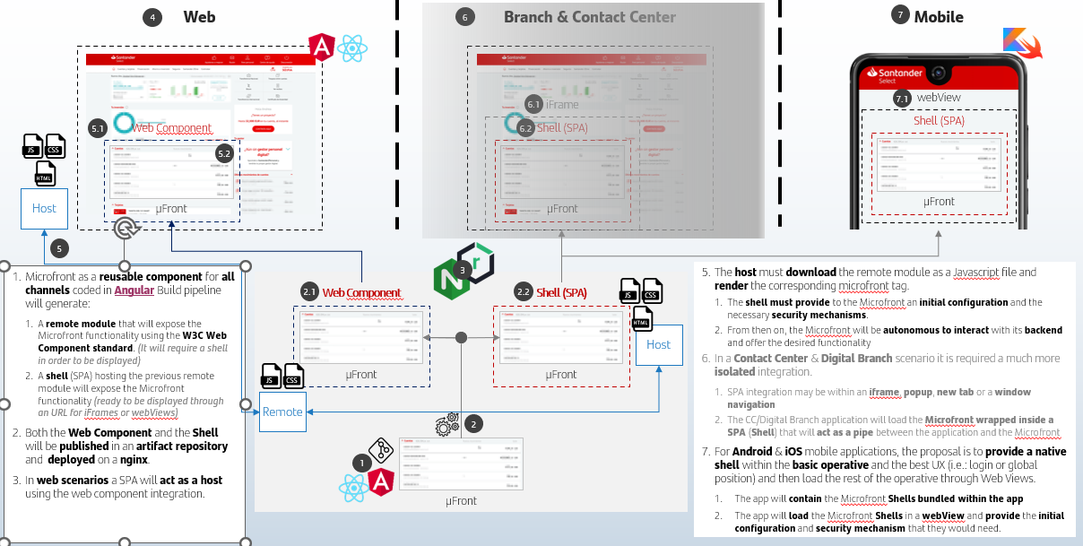

Additional resources:
- µFront TRA

Capabilities
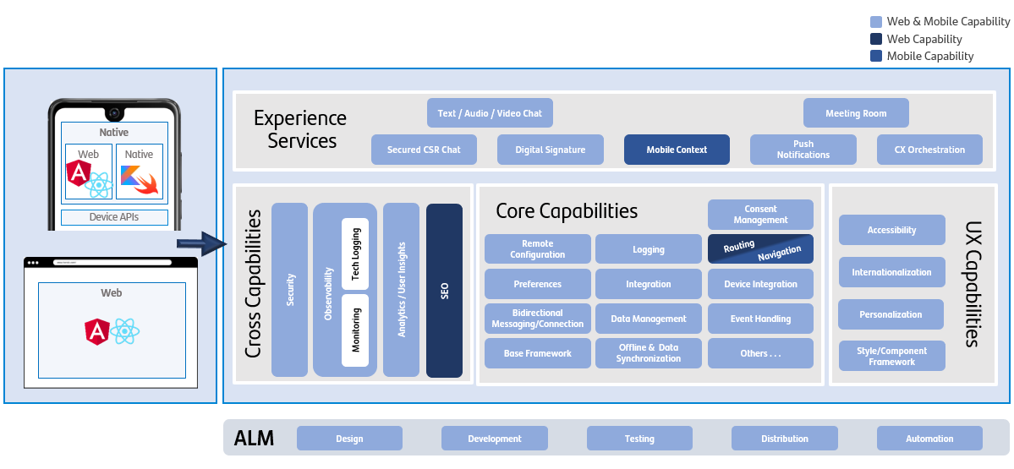

Type | Capability | Description | PoC
Touchpoints | Web | Private portal for bank customers and public web as Commercial portal where the products and services are exposed by the Banks in an open market environment, with no need to identify the user |  | Yes
Touchpoints | Native | Mobile Banking APPs including Wearables, devices that in combination with their mobile, provide access to services and content with a simpler or more innovative user experience |  | Yes
Experience Services | Text / Audio / Video Chat | Chat (with the possibility of audio and video) between the customer and the bank (manager, pool of managers, contact center, etc.). On the part of the bank, it can be a person, or a more evolved version integrated with a BOT |  | NA
Experience Services | Secured CSR Chat | Asynchronous chat between the customer and a bank employee (manager, pool of managers, contact center, etc.). It is possible to hold several conversations in parallel and to associate documents |  | NA
Experience Services | Digital Signature | Digital signature application integrated in digital channels that allows the customer to certify any operation without the need of going to a branch |  | NA
Experience Services | Mobile Context | Individual’s current environment captured by the device to help understand the circumstances under which the user is using the application: geo-location, motion, battery and memory usage, network access... |  | NA
Experience Services | Meeting Room | Meeting solutions blend communications, collaboration and content sharing to enable virtual meeting scenarios to satisfy a variety of use cases with the customer. |  | NA
Experience Services | Push  Notifications | Push notifications provide a customer communication interface and access to mobile applications |  | NA
Experience Services | CX Orchestration | Orchestration that includes TouchPoints navigation, Invocation of other Experience Services and Request of business Services and Customer Journeys |  | NA
Core Capabilities | Remote Configuration | Ability of a system to vary its operational parameters without re-compiling or re-installing. |  | NA
Core Capabilities | Preferences | Create applications with predetermined values and give the user the possibility of structuring them in the way that best suits their needs |  | NA
Core Capabilities | Integration | Process of enabling individual applications—each designed for its own specific purpose—to work with one another. |  | NA
Core Capabilities | Device Integration | Interaction between the running app and the different devices the mobile or computer has plugged in |  | NA
Core Capabilities | Bidirectional Messaging/Connection | Communication between a client and a server where both can initiate the data flow. |  | ????
Core Capabilities | Data Management | Involves the process of acquiring, validating, storing, protecting and processing required data. |  | NA
Core Capabilities | Event Handling | Mechanism that controls the event and decides what should happen if an event occurs. |  | Partially
Core Capabilities | Base Framework | Reusable software and tooling that provides core functionality to facilitate development of software applications, products and solutions |  | Partially
Core Capabilities | Offline & Data Synchronization | Offline indicates a disconnected state as online indicates a state of connectivity. In the offline state, users can perform offline browsing where pages can be browsed using local copies of pages or data and work as if they were connected. |  | NA
Cross Capabilities | Security | Ability to reduce the probability of malicious or accidental actions, as well as the possibility of theft or loss of information |  | Partially
Cross Capabilities | Observability | Measures how well you can understand a system’s internal states from its external outputs. |  | Yes
Cross Capabilities | Analytics/User Insights | Analytics: The process of discovering, interpreting and communicating significant patterns in data than helps us to see insights and meaningful data that we might not otherwise detect.  User Insights: Relates to all aspects of a user interaction with your product including behaviors, actions, perceptions and satisfaction. |  | NA
Cross Capabilities | SEO | Search Engine Optimization (SEO) is the process of affecting the online visibility of a website or a web page in a web search engine’s unpaid result — often referred to as "natural", "organic", or "earned" results. |  | NA
UX Capabilities | Accessibility | Practice of making applications sensible, meaningful and usable for as many people as possible including those with any type of disability. |  | NA
UX Capabilities | Internationalization | Process of enabling individual applications—each designed for its own specific purpose—to work with one another. |  | NA
UX Capabilities | Personalization | Given an application with predefined values, the personalization capability allows to structure and change those values in the way that best suits the user needs |  | NA
UX Capabilities | Style/Component Framework | Accessible, open-source library of production-ready, customizable, and reusable code components—like buttons and accordions—component libraries let UI and UX designers leverage faster development and growth |  | Partially
ALM | Design | Process dedicated to helping a user make their way through a digital process with minimal effort and maximum value. |  | Yes
ALM | Development | Processes involved in coding an application |  | Yes
ALM | Testing | Methods to check whether the actual software product matches expected requirements and to ensure that software product is Defect free |  | Yes
ALM | Distribution | Actions related to publishing or deploying software |  | Yes
ALM | Automation | Process of automating the creation of a software build and the associated processes such as compiling computer source code into binary code, packaging binary code or running automated tests |  | Yes
Core Capabilities | Consent Management | System, process or set of policies for allowing customers to determine what information they are willing to permit their providers to access |  | NA
Core Capabilities | Routing/Navigation | Routing: Be able to go from a SPA state to another one  Navigation: Be able to go from a page or state to another one |  | Yes
Core Capabilities | Logging | Act of keeping a log of events that occur in a computer system, such as problems, errors or just information on current operations |  | Yes

Building Blocks
Type | Building Block | Description
Web | Shell | Native shell artifact that will act as application, orchestrating the different µFronts and including main dependencies.
Web | µFront | Artifact with every isolated functionality served as µFront that communicates with the shell following the rules the shell establishes
Web | Flame UI Library | Reusable UI Library based on Flame that offers the visual components required to implement the user interface
Web | SecurityContextManager Library | Security library defined with Security Architecture Team to implement the authentication and authorization workflows.
Web | Core Libraries | Core libraries required to provide the application with the required capabilities
Mobile | Shell | Native shell artifact that will act as application, orchestrating the different native modules, µFronts and including main dependencies
Mobile | WebView Library | Boosted WebView to be used as main artifact in the mobile application to load the µFront that communicates with the shell following the rules the shell establishes
Mobile | Flame UI Library | Reusable UI Library based on Flame that offers the visual components required to implement the user interface
Mobile | SecurityContextManager Library | Security library defined with Security Architecture Team to implement the authentication and authorization workflows from native side.
Mobile | Core Libraries | Core libraries required to provide the application with the required capabilities

Tech-Stack
- Web: Angular (priority) & React (second priority). Coexistence of both technologies is possible.
Web development framework in most entities is Angular, but Microfront architecture guarantees it is not tied to a specific framework and, therefore, allows further evolutions. As a best practice:
  - Architectural components should be developed in two layers:
    - Core Layer (80%): As a vanilla (standard & framework independent) component containing the major functional part.
    - Framework specific Layer (20%): Tied to the framework (Angular, React, …) to productize its consumption.
  - UI components should be vanilla components (web components standard) to be consumed regardless the development framework (Angular, React …)
- Mobile: Hybrid apps based on standard native technology, specific frameworks are discarded due to their volatility in the market and the difficulty to migrate to a different framework. Therefore, apps will be based on native maximizing the use of µFront rendered in native WebView to share a same experience among channels.
Flutter will be also considered as a cross platform framework for mobile applications to allow share code between Android and iOS platform, but not web.
  - Native: Kotlin (Android) and Swift (iOS)
  - Cross Platform: Flutter
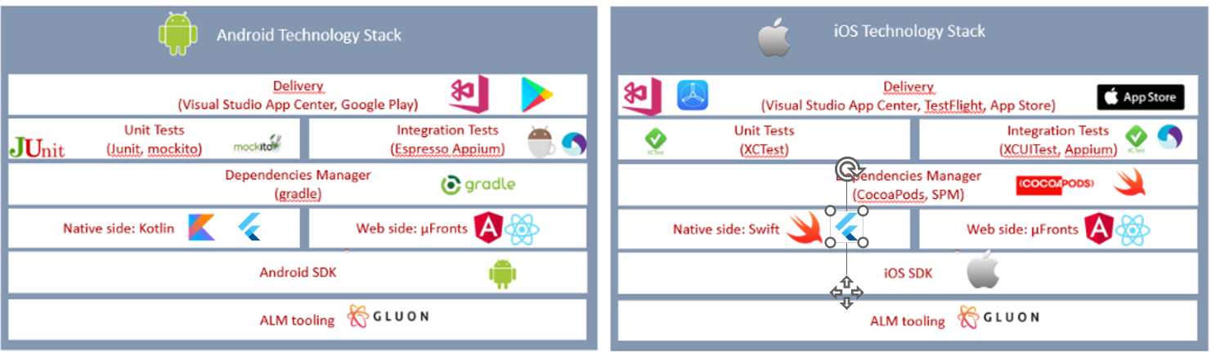

Global Load Balancing & Network

Capabilities
Global Load balancing will help to provide this blueprint a multicloud or multiregion consistent approach.

GTMs exposure APIs capabilities
- API will be exposed as a Common URL
- URL + Domain (URL/domain)
- URL + Product (URL/product)

Health-Check from GTM to API Gateways
- URL Health-check
The URL Health Check is one of the available Problem scenarios. It combines two previous tools, Debug URL and Translate an Akamaized URL.
URL Health Check lets you quickly gather all diagnostic data for a URL required to identify an issue. It combines Request Content (CURL), Get Domain Details (DIG), View Logs (GREP), and Test Network Connectivity (MTR) tools

- Connectivity problems
The Connectivity Problems is one of the available Problem scenarios.
Connectivity Problems lets you quickly gather all diagnostic data for a URL required to identify an issue. It combines Request Content (CURL), View Logs (GREP), and Test Network Connectivity (MTR) tools.
- Content problems
The Content Problems is one of the available Problem scenarios.
Content Problems lets you quickly gather all diagnostic data for a URL required to identify an issue. It combines Request Content (CURL), and View Logs (GREP) tools.

Load Balancer capabilities
- By Application
- By Network Operator
- By Network Latency
- By Packets-Drops
- Weighted
The weights you assign determine the ratio of traffic distribution.
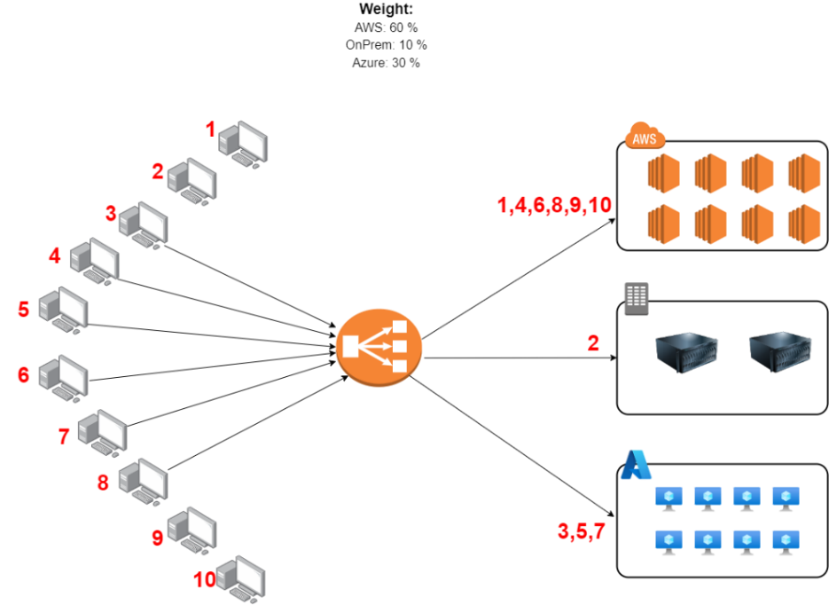

If a data center or server goes down or is taken offline, the traffic is redistributed according to the initial ratio as follow:

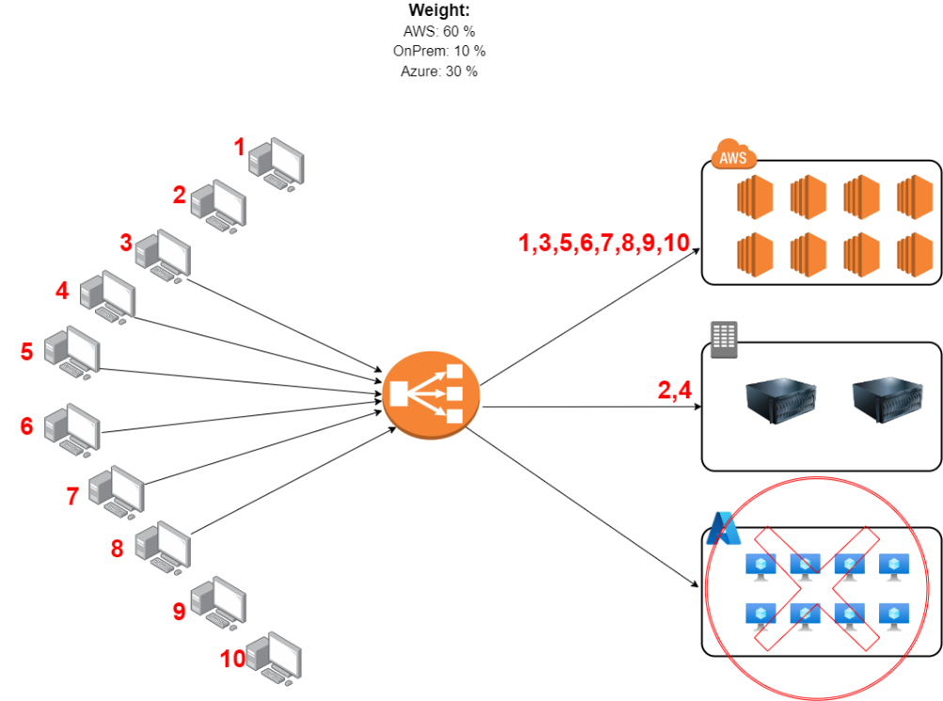

- Geolocation
Geolocation routing lets you choose the resources that serve your traffic based on the geographic location of your users, meaning the location that DNS queries originate from.

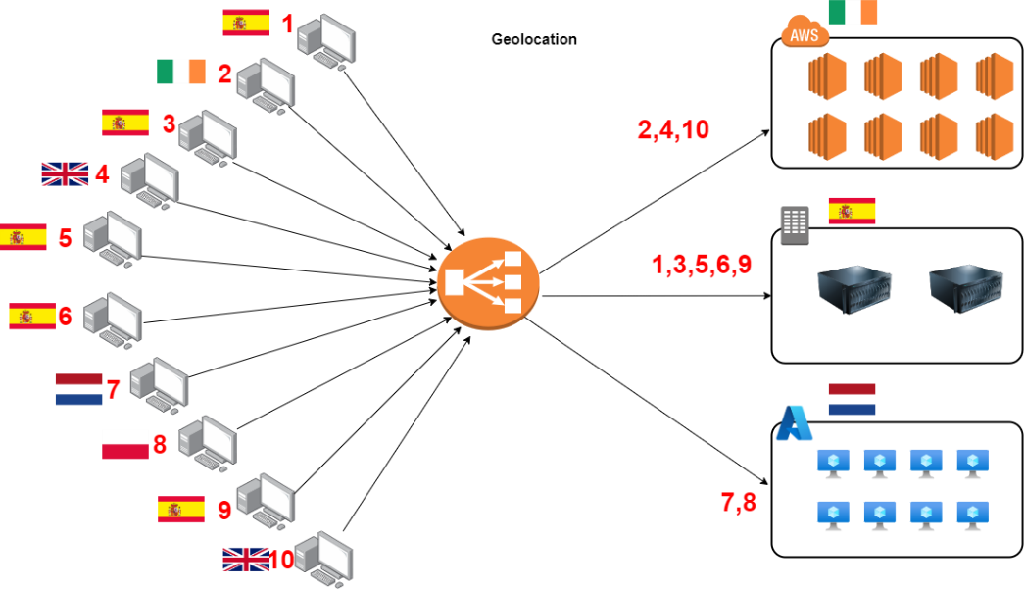

- Round-Robin
Roundrobin load balancing is one of the simplest methods for distributing client requests across a group of servers. Going down the list of servers in the group, the roundrobin load balancer forwards a client request to each server in turn. When it reaches the end of the list, the load balancer loops back and goes down the list again (sends the next request to the first listed server, the one after that to the second server, and so on)

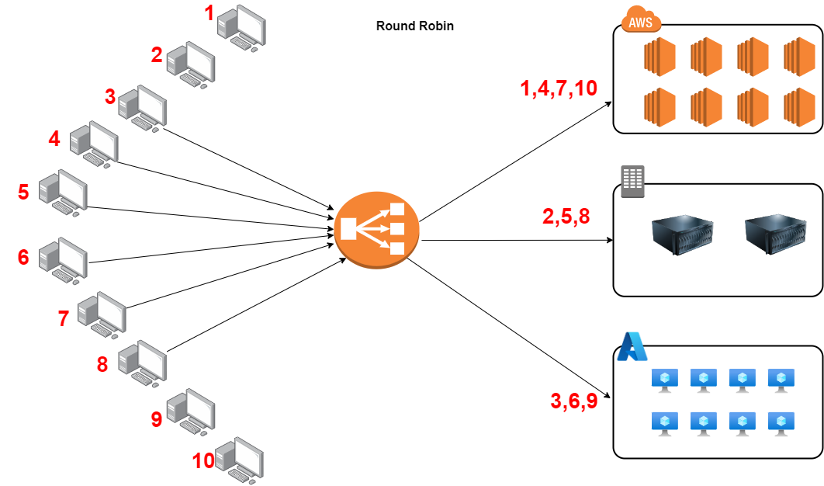

SLAs
Service Level Agreements is an agreement between a service provider and a customer. Aspects of the service – quality, availability, responsibilities – are agreed between the service provider and the service user. Both IaaS services (Akamai & Imperva) offers different SLA per product:

 | DNS SLA | DNS penalties | WAF SLA | WAF penalties
Akamai | 100 % | Customer will be eligible for a service credit of 50% of such subscription fee pro-rated for that month | 99,995 % | Customer will be eligible for a service credit of 50% of such subscription fee pro-rated for that month
Imperva | 100 % | Client will receive a Credit, in the dollar value equal to either (i) one thirtieth (1/30) of the monthly amount due from Client for the specific service that experienced the outage in the caseof a monthly invoice schedule, or (ii) one three hundred and sixty-fifth (1/365) of the annual invoice schedule, | 99,999 % | Client will receive a Credit, in the dollar value equal to either (i) one thirtieth (1/30) of the monthly amount due from Client for the specific service that experienced the outage in the caseof a monthly invoice schedule, or (ii) one three hundred and sixty-fifth (1/365) of the annual invoice schedule,

Building Blocks

DNS
Everyone connected to an enterprise — customers, employees, and partners — expects instant, secure, reliable access to your web applications and APIs, wherever they are, on any device. The domain name system (DNS), which translates human-readable domain names into numerical IP addresses, is a critical component in delivering quality web experiences for your website visitors and application users.
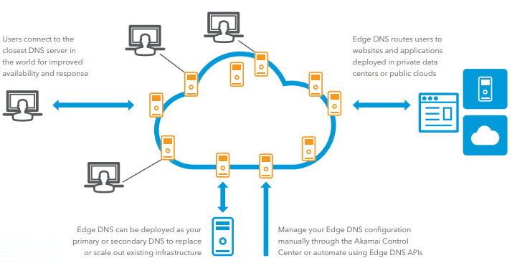

WAF
Web Application Firewall (WAF) is a service designed to protect internet facing assets (IFAs) of Santander Group
This service has to use a global content delivery network to provide web application security, DDoS mitigation, content caching and application delivery.
There are 2 homologated solutions in the group:
Akamai: App & API Protector
App & API Protector - Website Application Protection | Akamai
Imperva: App & API Protection
Imperva Web Application Firewall (WAF) | App & API Protection
Picture below shows a conceptual example with different capabilities of this services:
The product has several modules by which the request will be analysed. In case an anomaly is detected in any of the product capabilities the traffic will not reach the origin
- CDN: The caching rules configured in the policy will be applied.
- L3/4 Scrubbing: Mitigation of DDoS attempts in layer 3/4.
- WAF: Requests will be evaluated by Imperva WAF rules.
- Bot manager: Requests will be evaluated by Bot rules.
- Load Balancer (GTM): The delivery rules configured in the policy will be applied.

GTM
Global Traffic Management (aka GTM) is a cloud-based intelligent traffic manager that supports business continuity and your growing user base and uses load balancing to manage website and mobile performance demands.
GTM helps Internet users access your website or IP applications with greater reliability. It applies an Internet-centric approach to global load balancing to increase site availability and responsiveness to online user requests. GTM service makes intelligent routing decisions. These are based on real-time data center performance health and on global Internet conditions. They transport user requests to the appropriate data center based on a set of policies (Load Balancer Capabilities)

LOCAL LOAD BALANCER
The real power of the Local Load Balancer (aka LTM) is it’s a Full Proxy, allowing you to augment client and server-side connections. All while making informed load balancing decisions on availability, performance, and persistence. “Local” in the name is important, opposed to the GTM, traffic actually flows through the LTM to the servers it balances traffic to. Usually, the servers it’s load balancing sit “locally” in the same data center as the LTM, though that is not a requirement. With SNAT configured on the VIP, if you can route to it you can load balance it – so it’s possible to have servers in different data centers be a part of the same pool in an LTM VIP.
The main configuration element on an LTM is the Virtual IP or VIP for short. There is a plethora of configuration elements that work with VIPs, but at the heart of the technology it’s a VIP they are all a part of. Like a WIP, VIPs equate to the URL you’re load balancing, but at its lowest level. Like a WIP it usually contains a pool with the servers it is load balancing & monitor(s) to measure availability / performance.

Tech-Stack

COMPONENT​ | ONPREM​
Public DNS​
WAF​
GTM​
LTM​ | F5​
Monitoring​

APIs

Capabilities
All the capabilities required for exposing and managing APIs considering both use cases are listed in the following table:

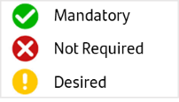
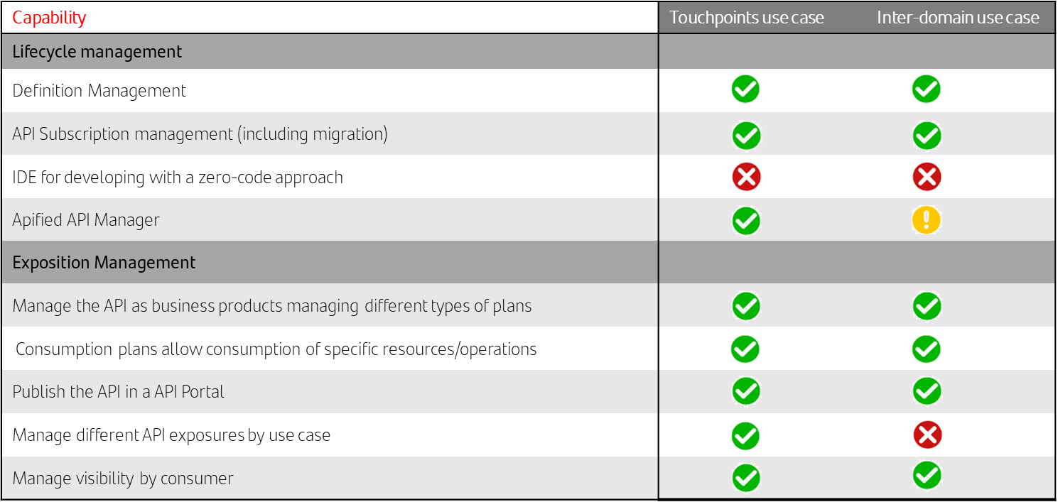
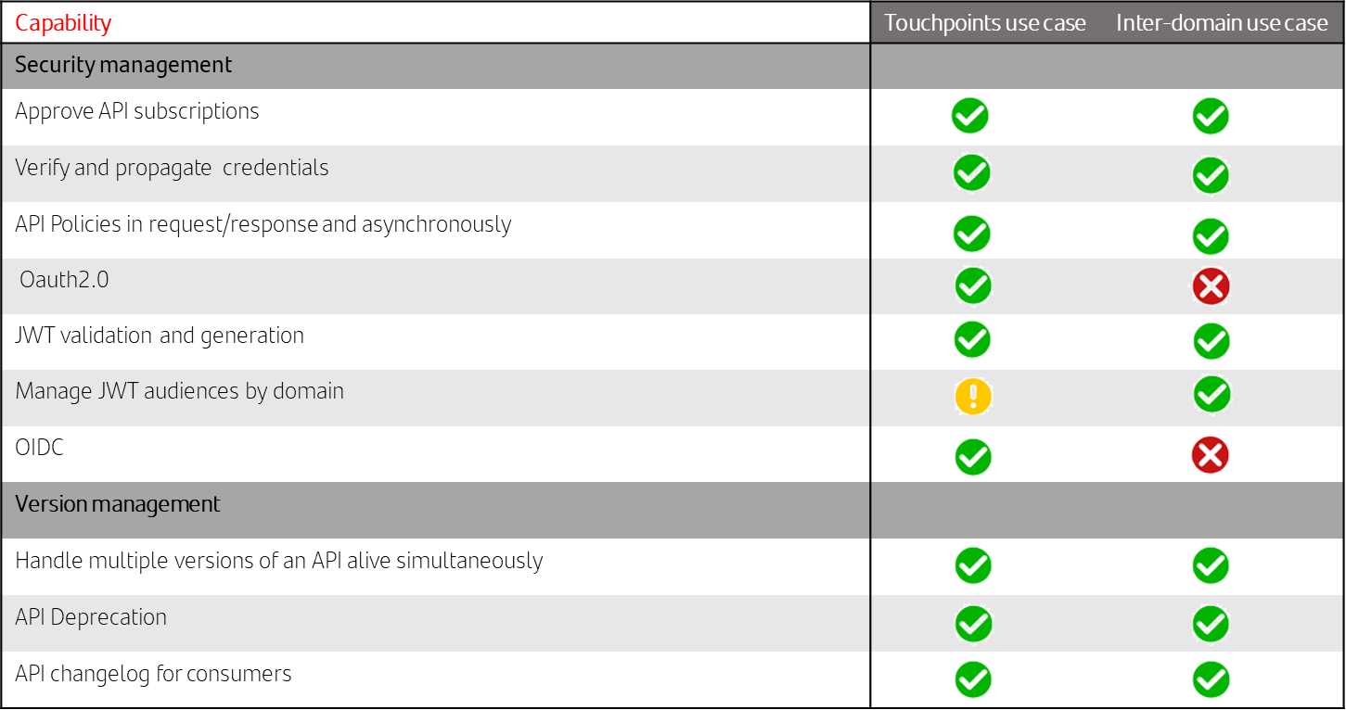
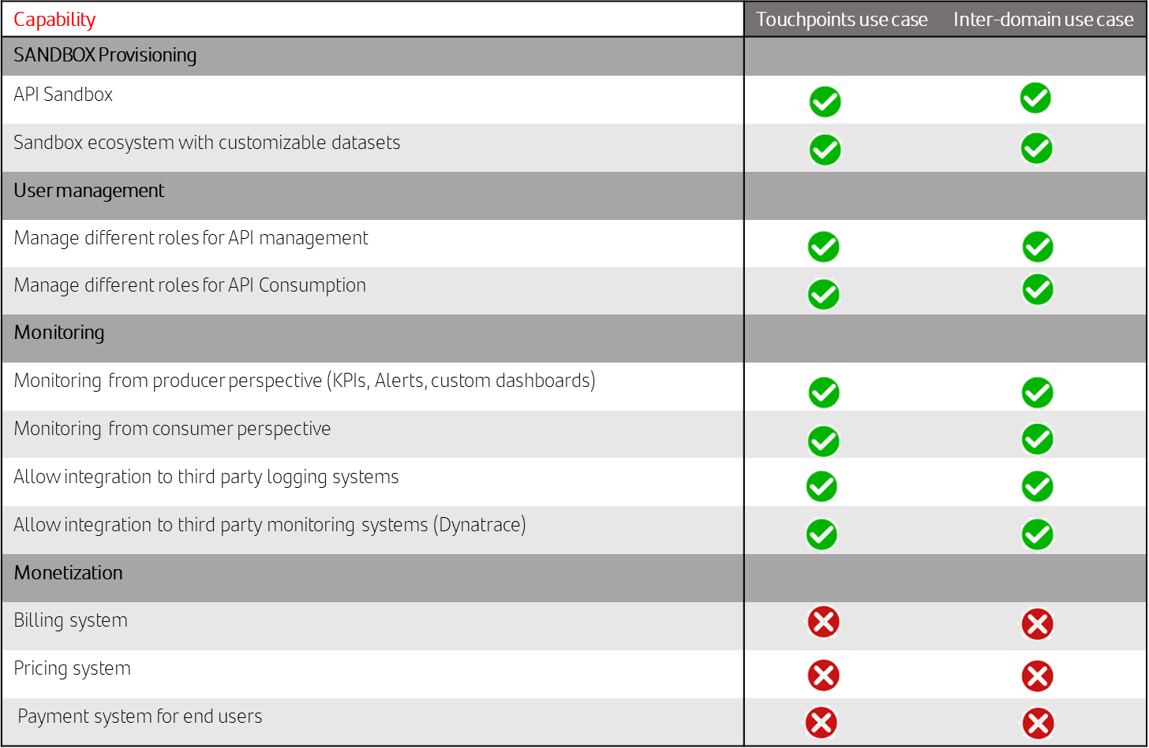
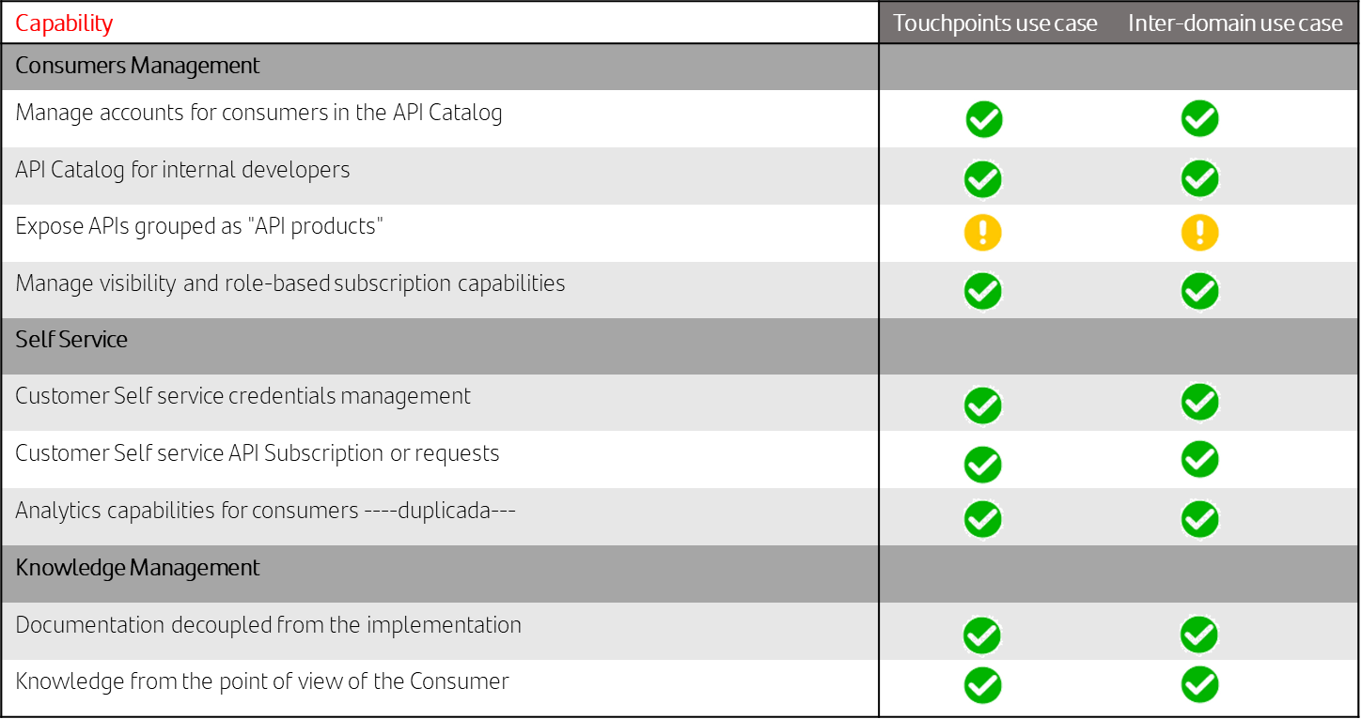
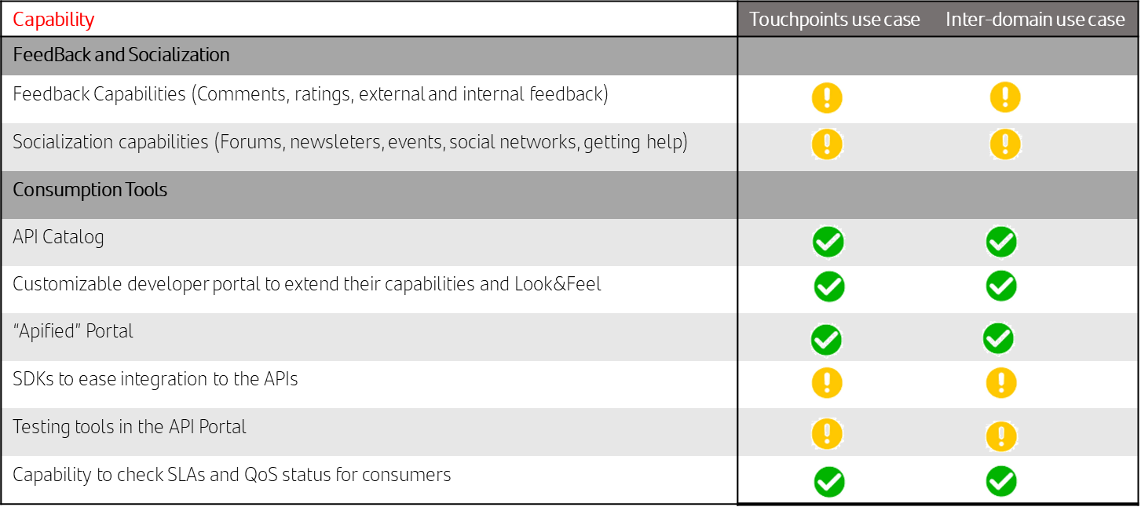
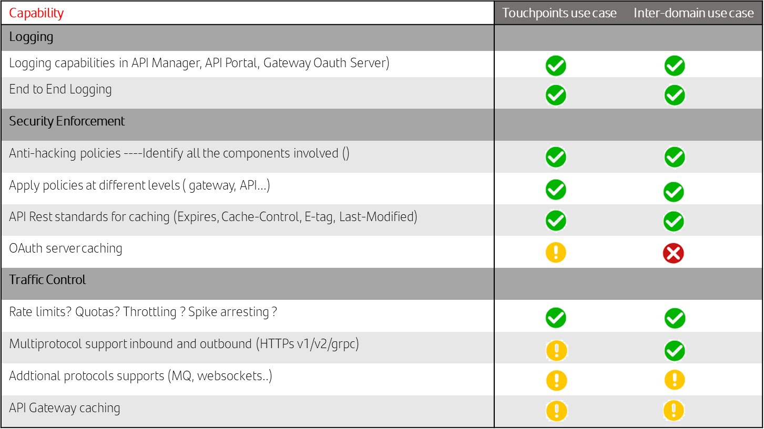
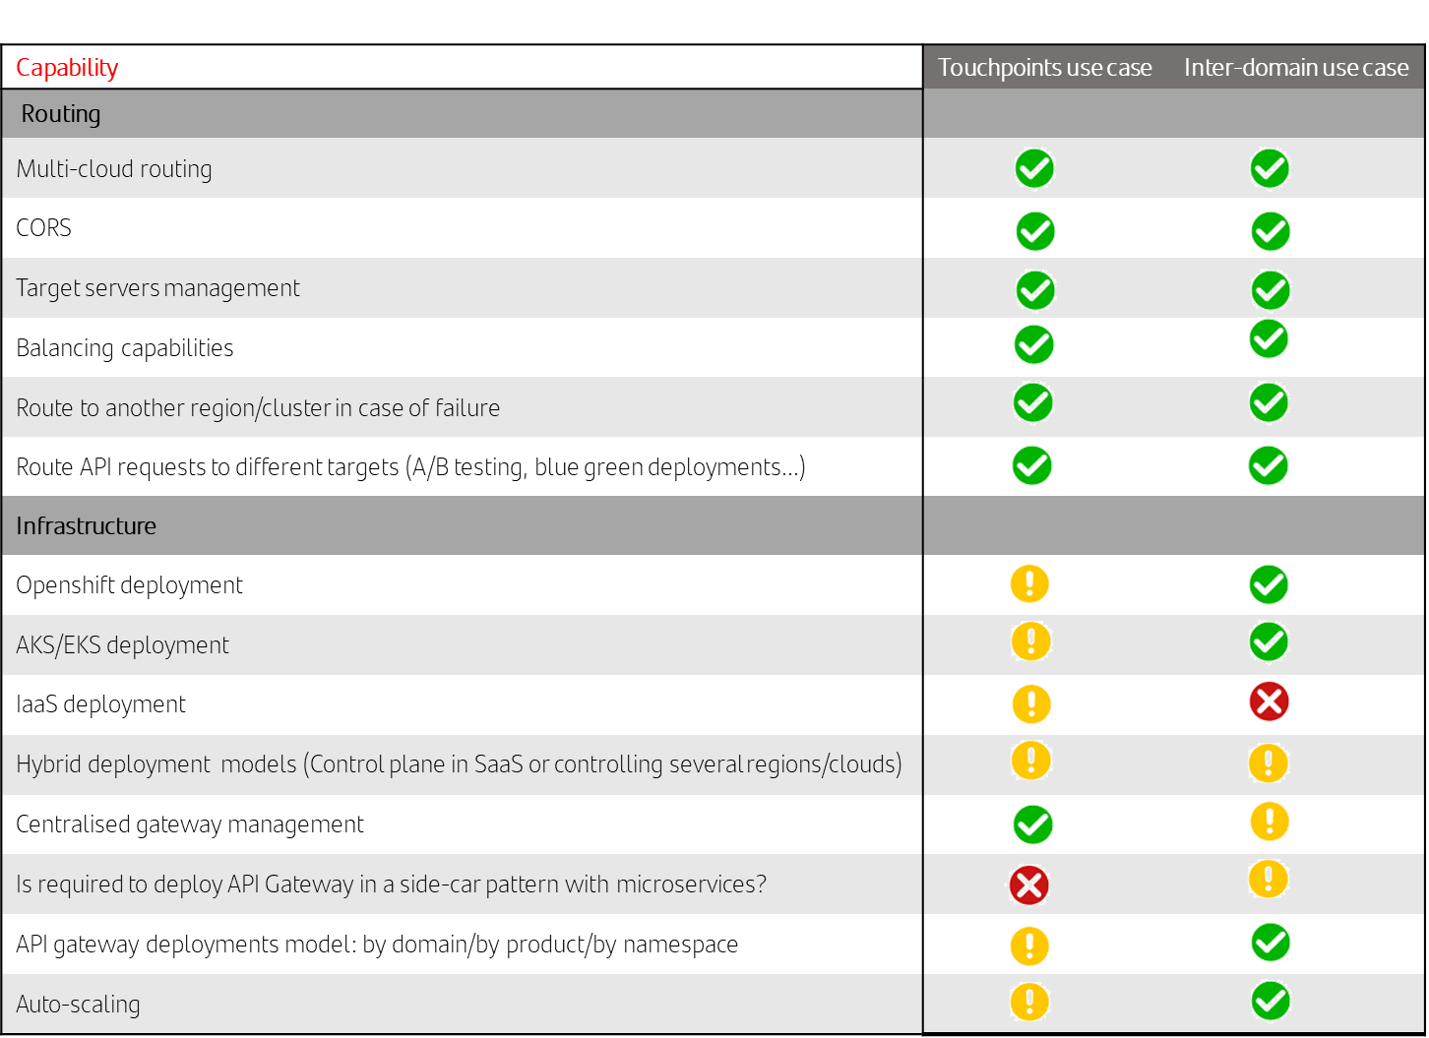

Building Blocks
The main building blocks that cover all the capabilities listed in the previous chapter are the following:
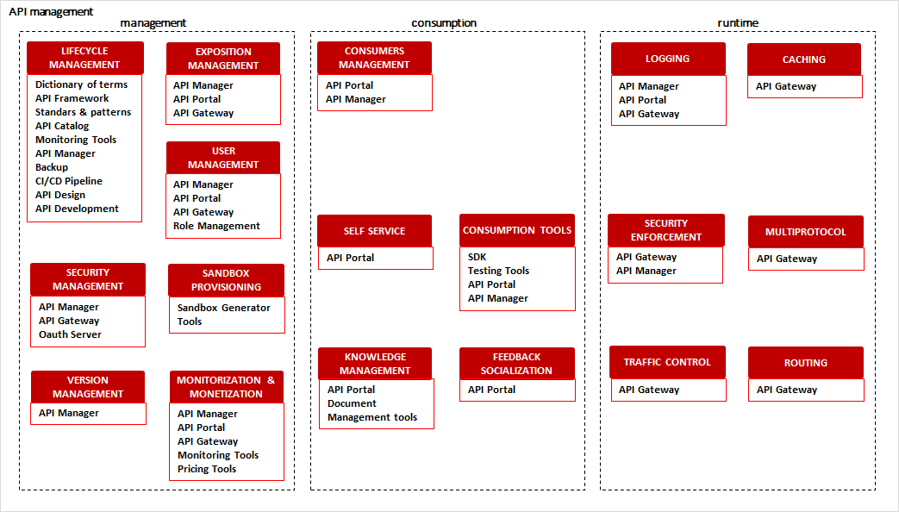

Tech-Stack

API Manager
This building block is covered by all the API Management tools certified by Santander. These products can be classified as follows:
- On premise API Management products:
  - Apigee OPDK v4.52
  - IBM API Connect v10

API Catalog
Santander API strategy establish that there will be only one catalog for all the group. Gluon will provide this building block.

API Gateway
In the same way than API Manager, the same certified products will cover this building block.

API Lightweight Gateway
There are two options that must be analyzed before taking a decision.
- Using certified API Managers [preferred option]: In case of IBM, installing IBM API Connect runtime plane directly in Kubernetes. In case of Apigee, use envoy installed in Kubernetes and manage the APIs from Apigee control plane. Only one gateway would be needed to reach the business logic of an API from a touchpoint (less infrastructure, better performance).
- Providing a Gluon microgateway, based on Spring Cloud Gateway developments currently available in several entities. It means that most of the API management capabilities must be developed. This gateway would not expose APIs to touchpoints, one of the certified gateways would be used to do it, so it means that two gateways would be involved to reach the business logic of an API (more infrastructure, less performance).

Standards & Patterns
https://gluon.corp/community/docs/latest/capabilities/apis/standards/std-generals/

Dictionary of Terms
https://gluon.corp/community/docs/latest/capabilities/apis/tech-components/tools/#dictionary-of-terms

API Definition & Design
https://gluon.corp/community/docs/latest/capabilities/apis/lifecycle/apidefinition/

API Sandbox virtualization tool
See Gluon documentation.

Monitoring
ELK + Dynatrace ->see Observability workstream.

Authorization Server
See Security workstream.

Backup tool
Pending Operative model chapter. To be defined in PoC phase.

Testing
See Gluon documentation.

Microservices

Capabilities
Capability | TouchPoint Use-Case | Inter-Domain Use-Case
Auto-scaling | Mandatory | Mandatory
Multi-Env. Config | Mandatory | Mandatory
REST | Mandatory | Mandatory
gRPC | Not Required | Desired
Rate Limiter | Desired | Desired
Caching | Desired | Desired
Application Structure | Mandatory | Mandatory
Code Style & Nomenclature | Mandatory | Mandatory
Versioning | Mandatory | Mandatory
DDD | Desired | Mandatory
Choreography | Desired | Desired
Orchestration | Desired | Desired
Circuit-Breaker | Mandatory | Mandatory
Messaging | Desired | Desired
Error Management | Mandatory | Mandatory

Building Blocks

Diataxis Documentation
It’s a documentation standard that provides four purposes: practical learning(tutorial), theoretical learning(concepts), practical work reference(how-to) and conceptual work reference(reference).

Framework Library
It's a suite of data and programming code that is used to develop software programs and applications. It is designed to assist both the programmer and the programming language compiler in building and executing software.

Framework Archetype
It's a Maven project templating toolkit. An archetype is defined as an original pattern or model from which all other things of the same kind are made. The name fits as we are trying to provide a system that provides a consistent means of generating Maven projects.

Helm Chart
It's a set of YAML manifests and templates that describes Kubernetes resources (Deployments, Secrets, CRDs, etc.) and defined configurations needed for the Kubernetes application and is also easy to deploy in a Kubernetes cluster or in a single node with just one command.

Tech-Stack

Java
It's a widely-used programming language for coding web applications. It has been a popular choice among developers for over two decades, with millions of Java applications in use today. Java is a multi-platform, object-oriented, and network-centric language that can be used as a platform in itself. It is a fast, secure, reliable programming language for coding everything from mobile apps and enterprise software to big data applications and server-side technologies.

Maven
It's a software project management and comprehension tool. Based on the concept of a project object model (POM), Maven can manage a project's build, reporting and documentation from a central piece of information.

Quarkus
It's a Kubernetes-native Java framework tailored for GraalVM and HotSpot, crafted from best-of-breed Java libraries and standards.

Apache Camel
It's an Open Source integration framework that empowers you to quickly and easily integrate various systems consuming or producing data.

Spring Framework
It's a Java platform that provides comprehensive infrastructure support for developing Java applications. Spring handles the infrastructure so you can focus on your application.

Quarkus Panache
It's a Quarkus-specific library that simplifies the development of your Hibernate-based persistence layer. Like Spring Data JPA, Panache handles most of the repetitive boilerplate code for you. It’s repository implementation provides methods to create, update, and remove records, perform basic queries, and define and execute your own queries.

Spring Data
Spring Data’s mission is to provide a familiar and consistent, Spring-based programming model for data access while still retaining the special traits of the underlying data store. It makes it easy to use data access technologies, relational and non-relational databases, map-reduce frameworks, and cloud-based data services. This is an umbrella project which contains many subprojects that are specific to a given database. The projects are developed by working together with many of the companies and developers that are behind these exciting technologies.

Resillience4j
It's a lightweight fault tolerance library designed for functional programming. Resilience4j provides higher-order functions (decorators) to enhance any functional interface, lambda expression or method reference with a Circuit Breaker, Rate Limiter, Retry or Bulkhead.

Redis
It's an open source (BSD licensed), in-memory data structure store used as a database, cache, message broker, and streaming engine

CheckStyle for Java
It's a development tool to help programmers write Java code that adheres to a coding standard.

Kafka (MSK / Confluent / EventHub)
It's an open-source distributed event streaming platform used by thousands of companies for high-performance data pipelines, streaming analytics, data integration, and mission-critical applications.

Kubernetes

Capabilities
The following table outlines the desired capabilities of the Kubernetes-based infrastructure we will be using to support APIs in Santander.

Component​  ​ | Openshift​
Kubernetes LB​ | Edge​ / AVI​
Ingress​ | Router (HA Proxy) ​  F5 CIS ​
CNI​ | Openshift SDN​  OVN​
DNS | Core DNS​
Storage | NetApp​  Portworx​
OS​ | RHCOS​
Registry​  (OCI Compliant)​ | Harbor​
Secrets​ | Kubernetes Secrets​
Alerting & Monitoring ​ | Dynatrace​
Security​ | Sysdig​
Application Certificates mngt​ | Cert Manager​
Access Management​ | Openshift RBAC​
IAM​ | LDAP​
POD Autoscale​ | HPA​  KEDA​
Infra Autoscale​ | Machineset
Backups​ | Velero​ / AODP

Network policies inter namespaces traffic
Segregation of Duties
Connectivity to common endpoints (backends, authentication, API management engines, etc.)
Persistent Storage
- File
- Disk/Block
- Ephemeral
Distributed Caches (redis)
Compliance
CMDB?
Backups / Restore – needed or redeploys from git?
DNS
Multicluster architecture

Building Blocks

Inbound traffic:
Incoming traffic must be secured, using HTTPS in most cases.
NGINX is the chosen Kubernetes ingress as it is ubiquous, open source, can get support if needed, and checks all the boxes for an ingress.
In OpenShift, the default ingress, based in HAProxy, will be used.
Both solutions implement HTTP1.0 / HTTP1.1 / HTTP2
Kubernetes clusters will also need an external load balancer. This can still be considered part of the K8s cluster and is a L4 balancer that spreads load among the ingress instances. The solution to be used is based on the cloud rather than on the flavour of Kubernetes:
- On-prem: Edge/Avi

Networking:
For Container Network Interface (CNI) providers the standard offers from the 3 solutions have been chosen
- OpenShift: OVN / OpenShift SDN
Until Openshift v4.12, Openshift SDN was the CNI embedded with the product. From OCP 4.14, OVN should be used due to functionality, performance, and roadmap. In OCP 4.12 OVN is too new and should be avoided.
Network control, or micro-segmentation, is needed. OCP’s CNIs should make use of Network Policies to control north-south traffic as well as east-west.
For DNS, CoreDNS will always be used.

Storage:
When deploying microservices within our clusters, it is essential to provide persistent storage. This ensures that critical data and stateful information remail accessible and reliable, even during system events like restarts, failures, or scaling operations.
The chosen technologies are the cloud native offerings for public clouds, but not for on-premises.
- On-prem: NetApp / Portworx
The native offering for on-prem should not be used, as vSAN is not enough performant.

Applications is a must will be
Operadores/Automatizacion para despliegue microGWs
Load Balancing
Automation portal
Images / Registry
Observability solution
- Querremos un log e2e de APIs. ¿Qué se va a usar? ¿C3 CaaS Logging?
- Las piezas OCP microgateway/microservicio logarán a C3 CaaS Logging
  - Se sacan tb a otro log?
Sysdig

DNS

Tech-Stack

On-Prem: OpenShift
IAM:
- Identity: LDAP
- Access management: Openshift RBAC
Networking
- Inbound traffic: Edge/Avi + OCP Routers (HAProxy based, HTTP1.0/HTTP1.1/HTTP2)
- CNI: OpenShift SDN / OVN
- DNS: CoreDNS
- Network Micro-segmentation: Network security groups Ingress / Egress Network Policies
Provisioning:
- Virtualization: VMware
- Private cluster
- OS: RHCOS
- Machinesets
- Persistent Storage (file NetApp|Portworx / block NetApp|Portworx / ephemeral OS)
- Container Images – Registry ==> Harbor/ OCP/Quay (Brasil nonpro) / Artifactory (Brasil pro)
Bootstrap:
- Cluster API metrics: metrics-server
- Node autoscaler: cluster-autoscaler in Azure
- Ingress Controller: router (HAProxy) Ingress controller
- Persistent Storage: Common StorageClasses, NetApp CSI driver, NetApp CSI driver
- Security:
  - Network: TBD Ingress / Egress network policies
  - Controls: Sysdig operator
  - Kubernetes Secrets
  - Certs manager: cert-manager operator, PCA Issuer
- Observability:
  - Router to Micro Gateway Access Logs
  - Micro Gateway App Logs
  - Micro Service App Logs
- Alerting & Monitoring: Dynatrace

Gluon Data Persistence

Capabilities

Relational Databases
- Creation of the relational layer.
  - Platform: OnPrem.
  - Environment: Development, Certification, PreProduction, Production.
  - Service: Iaas, Paas
  - Deployment / Tenant: Shared, Dedicated / VM, Database, Schema
  - Technology: Oracle.
- Naming Standardization for VMs, Instances, Bbdd, Schemas, database objects.
- Common configurations, following best practices and aligned to hardening guides,
- High Availability and Disaster Recovery Architectures.
- Common Security Architecture.
  - User access classification (Admin, Service, Operation, Application)
  - Authentication, Authorization, Secret management, Encryption
- Backup & Restore policies
- Automatic Scale up / Down
- Versioning and patching Lifecycle.
- Data Lifecycle management (retention policies)

Data Dictionary
- Define terms
  - Interface to register new terms
  - Update existing terms
- Ontology and security taxonomy assignment
- Versioning
  - Capability to review previous versions
- Bulk load of terms with API
- Integration with technical catalog and quality
- Federation and segmentation
  - Capability to generate a global catalog and local instances federated with global. This is intended to have specific domain terms or polysemic terms that may be refined by units.
- Approval workflow
  - Exposition of new terms
  - Acceptance of revisions
- Terms relationships
  - Grouping terms
  - Visual representation of terms usage
- Search

Data Modeling Catalog
- Data Model lifecycle.
  - Data model creation
  - Data model versioning
  - Approval workflow
- Data Model and Object Dictionary
- Data Model Deployment.
  - Data base support (depending upon DB priorities)
  - Support
  - Physical data model deployment
- Data Model Bulk Ingestion. Stock management.

Building Blocks

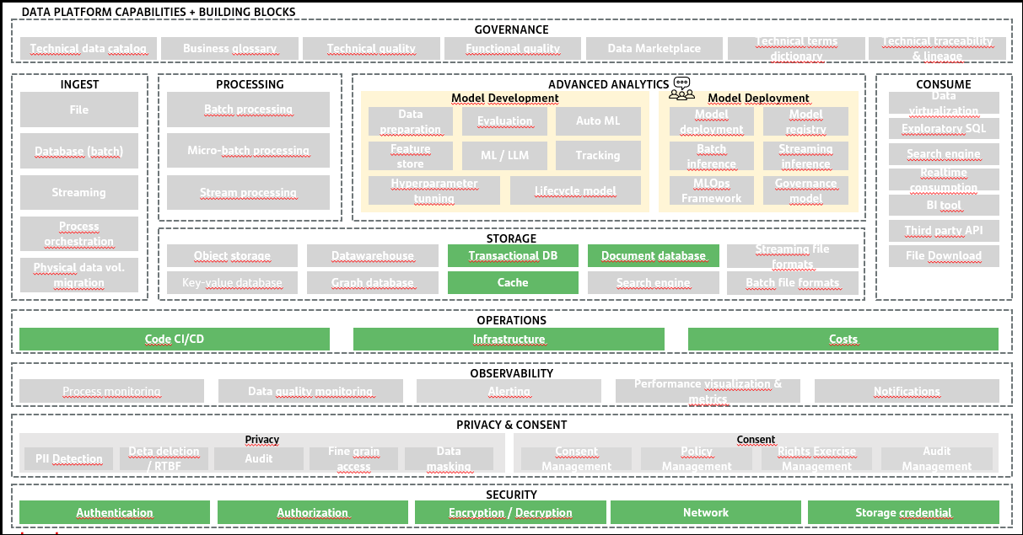

Tech-Stack

 | OnPrem
Relational DBMS | Oracle
Document Store | Convergent Oracle
Key Value Store | Redis
Search Engine | ElasticSearch

Security

Capabilities
The following diagram outlines the capabilities of the E2E security we will be using to support in Santander.

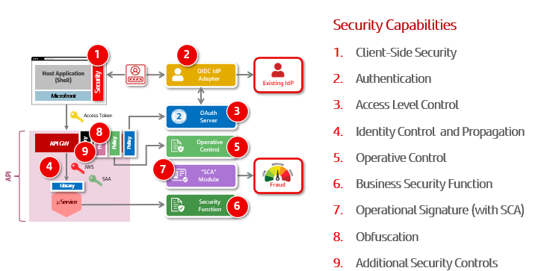
1.- Client-Side Security. Ensures a secure environment in the application that allows isolation of the application from security functionality.
2.- Authentication. Allows users with different levels of authentication to log in.
3.- Access Level Control. Allows applications to access APIs on behalf of the user. Sets access control over APIs.
4.- Identity Control and Propagation. It allows to generate a security context for propagation to microservices.
5.- Operative Control. Enables operational control checks to be performed on API calls.
6.- Business Security Function. Allows business-level authorization controls on incoming requests to be carried out.
7.- Operational Signature. Enables authentication controls to be raised when the operations to be carried out so require.
8.- Obfuscation. Enables the obfuscation of sensitive information in responses to API calls.
9.- Additional Security Controls. It allows for security controls such as anti-hacking controls.

Building Blocks
1.- Security Context Manager (SCM)
Integrated with the Shell to isolate the application (µFronts) from the implementation details of security concerns, making it available in a “front-native” way
Main responsibilities:
User Authentication (log-in)
API Authorization (access token retrieval, custody and HTTP request injection)
Session Management (refresh, inactivity control, and log-out)
Internal architecture will help to integrate “coexistence” scenarios
2.- IDP Adapter
This component has the responsibility to integrate IdPs currently deployed in local environments with the Gluon architecture. For Gluon it will be an authentication provider with OpenID Connect exposure https://openid.net/specs/openid-connect-core-1_0.html. For the deployment of this component, it will have the OAuth Server registered as a client. The IdP adapter will be the application that performs the authentication on the local systems through the technologies provided by these systems.
3.- SCA module
This component has two functionalities. The first is to provide SCA to elevate the level of authentication through a level of risk associated with the environment. The second is to provide SCA for operations that require additional control over customer credentials.
4.- OAuth Server
This component manages the OAuth 2.0 protocol with the applications consuming the Gluon APIs. This component will support the definition of the introspection endpoint, to obtain the information related to the Access Token. To obtain the information of the logged in user, this component shall support the integration with an IdP that supports the OpenID Connect specification. To do so, it shall support:
- OAuth 2.0 compliance with authotization grant with PKCE support (https://datatracker.ietf.org/doc/html/rfc7636).
- Integration with IdP with OpenID Connect support.
- IdToken validation must be supported.
- Clients and scopes supported following the security architecture definition.
- Must support Refresh Token Grant
- Must support both opaque access token and JWS/JWE access token.
- Must expose an Introspection endpoint to validate opaque access tokens.
- Must support the introspection definition defined above.
- Must expose ClientIDs, ClientSecrets and scopes management APIs for integration with the Marketplace. This functionality must be exposed with consumer authentication.
- Must be able to disable user consent on the client application.
- It must be able to support consent management via APIs.
- It must provide the necessary mechanisms for revocation of access tokens and refresh tokens.
- It must guarantee the traceability of the functionality provided.
5.- Antihacking Policies
These components, through policies deployed both in the WAF and in the API gateway, make it possible to establish controls that prevent attacks on API calls. The definition of the anti-hacking policies is published in the following link: https://santandernet.sharepoint.com/sites/SantanderPlatforms/SitePages/API-Security-Policies.aspx
6.- Token Management Policies
These components, through policies deployed in the API gateway, allow the establishment of controls that manage both incoming and outgoing tokens. The definition of the tokens is published in the following link:
https://santandernet.sharepoint.com/sites/SantanderPlatforms/SitePages/API-Security-Policies.aspx
The definition of the functionality of the token management policies are defined in the following link:
https://santandernet.sharepoint.com/sites/SantanderPlatforms/SitePages/API-Security-Policies.aspx
7.- Filters of Microservice
7.1.- Validation
7.2.- Propagation
8.- Gluon Secrets Solution
The definition of the functionality of the Gluon Secret Solution is defined in the following link:
https://github.com/santander-group-gluon/gln-secrets-v1/blob/main/docs/pages/Hashicorp%20Vault/Technical_Solution.md

Tech-Stack
- CIAM. Supported by Customer Identity Platform.
- OAuth Server. Supported by Customer Identity Platform. if CIP is not deployed, the OAuth server must support the requirements presented in building blocks. If they are not supported, the Global OAuth Server (SOS) must be used.
- Microservice validation filter. Spring Boot and NodeJS.
- Microservice propagation filter. Spring Boot.
- API Gateway policies. Apigee and IBM API Connect V10.
- SCA Component. Supported by Customer Identity Platform.

Observability

Capabilities
- Tracing E2E (front – back)
- Logging for Front-end
- Logging for Gateways
- Logging for Services
- Infrastructure Metrics
- Business Metrics
- User experience monitoring
- Alerts and notifications (integrated with ALMA)
- Anomaly detection (integrated with ALMA)
- Sales funnels

Building Blocks
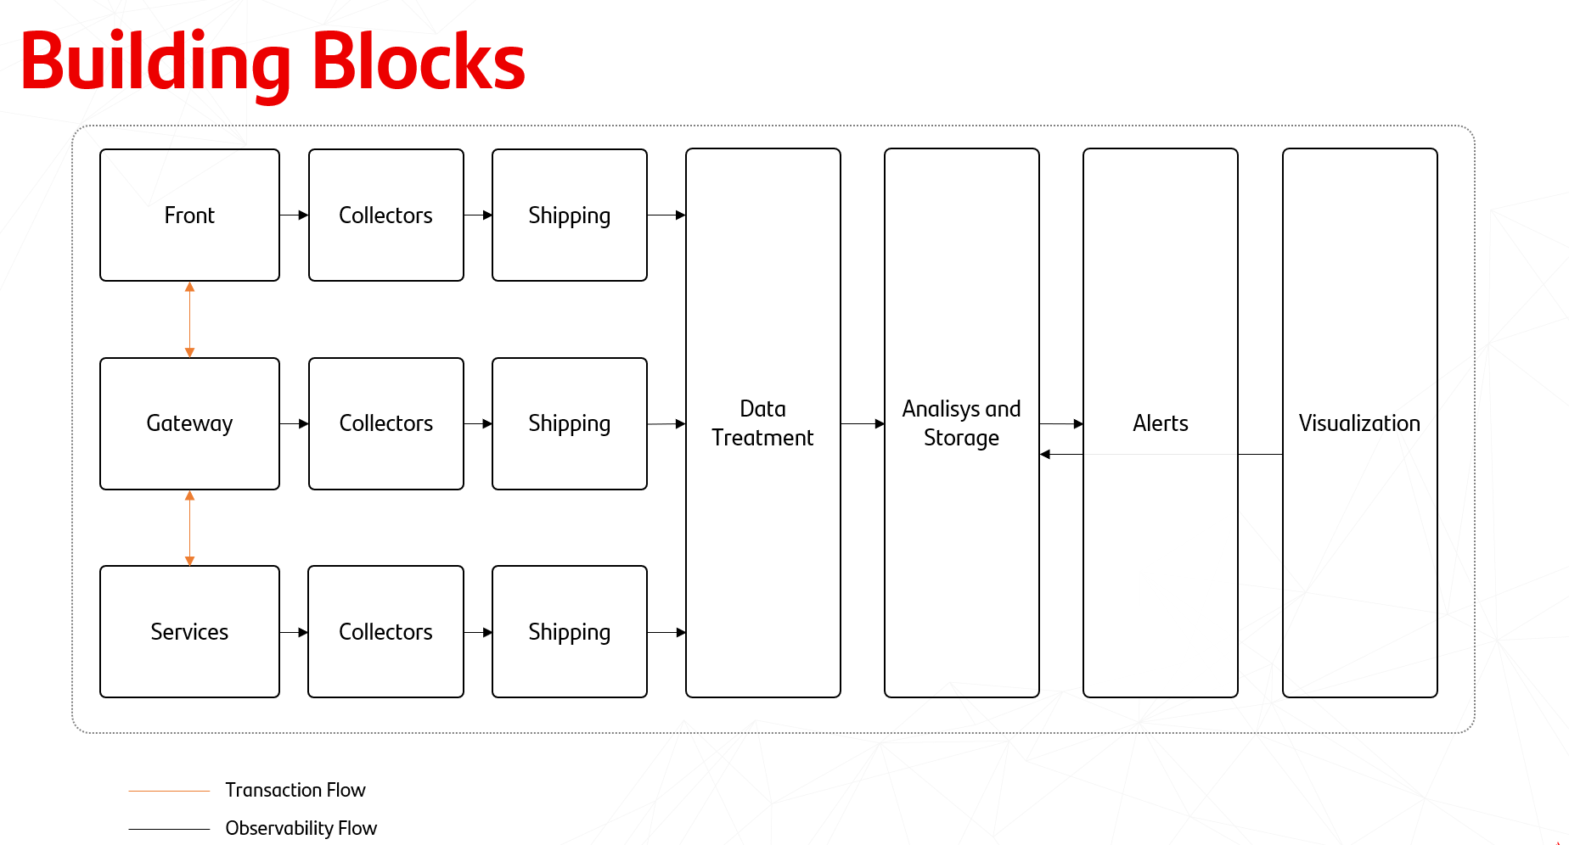

Tech-Stack

General Observability Stack
Product/Tool | Description
Dynatrace | APM (Application Performance Monitoring)
ElasticSearch | Data repository
Logstash | ETL (Extract, Transform, Load)
Kibana | Data visualization and exploration tool

Challenges & Decisions taken in the E2E

MicroFrontEnds

Challenges
- Tokens management: The token to execute the requests is shared by different modules and technologies. The different modules should not know about the complexity of handling the tokens, but at the same time it should be injected in all requests. In a mobile the scenario is more complex as the requests done by the µFronts require the token obtained by the native side.
- UI & UX consistency: The final app (web or mobile) will be set by the shell and a set of microFronts that ideally in a mature organization will be developed by different teams. The user experience should be consistent across the application regardless the team that develops a specific functionality and even, regardless the technology (web or native) used to develop a specific feature.
- Performance:
  - Current mobile applications are majority native, and they load the existing home banking web application for very reduced functionality. The transition to the home banking application requires a SSO and the recreation of the security context which implies a significative reduction of performance. To increase the percentage of web development to be reused in the mobile channel, the transition from mobile to website should be transparent to the user.
  - The web application distributed in different µFronts needs also to speed-up their loading as they are separated bundles that are loaded when the user access to it functionality from the shell.
- Observability: Once the traditional SPA has been split in different microFronts, main priority is to have the app vision and trace together all microFronts. A second step, when organization is mature enough and each development team works individually, they will require separated data per Microfront.
In the case of mobile app, the data generated in the web side should be traced as part of the mobile app, not as web traffic.
- Bidirectional communication: Should the PoC cover events notifications to the Touchpoints? It should be key for digital channels to interact with the customer.

Decisions taken.
- Tokens management: It is required a specific module called SecurityContextManager (SCM) in charge of managing all complexity related to token management. HTTP request will be intercepted by the SCM, and it will inject the security tokens to the request. This way the µFronts developers won’t need to know about security concerns and we guarantee that the tokens are managed in a secure way and consistently across the app.
- UI & UX consistence: A UI library based on Santander Flame design system will guarantee that all developments, mobile or web, apply the same UX&UI design and, therefore, the application design will be consistent.
- Performance in mobile app using µFronts: Using a µFront architecture there is not needed to recreate a security context for the web side: the security model will be the same for mobile and web. Mobile shell will preload the WebView and preload dependencies.
- WebView component: Mobile apps will contain a customized WebView component that guaranties the communication between mobile and web in a secure way and optimize transitions between web and mobile.
- Explore http2 to speed static distribution in an OHE scenario. The protocol can significatively improve the time to load the web due its capacities for multiplexing, headers encryption and push server.
- Native CDN when distributing in Cloud will reduce latency when the browser/WebView access to them. A CDN acts as a cache by replicating and storing the statics from the web app servers and bring them close to the location.
- Observability: It will be required to add a capacity in order the container shell be informed from microFronts.

Global Load Balancing & Network

Challenges

DNS
- High Availability with thousands of DNS servers in more than 1,000 points of presence worldwide, to provide a high level of DNS service availability. In general, DNS services come with a 100% uptime service level agreement (SLA), providing you with confidence that your customers and employees can reliably connect to your website and application servers.
- Fast Responses thanks to directing users to a high-performing DNS server based on network conditions to improve the responsiveness of your DNS infrastructure. The globally distributed anycast network accelerates DNS resolutions for users connecting to your websites and applications from anywhere in the world, and zone apex mapping reduces DNS lookup times.
- Defense Against DDoS Attacks protecting against DDoS attacks that target the DNS infrastructure to disrupt websites and application servers. Edge DNS provides a highly scalable DNS platform with sufficient capacity to absorb the largest DDoS attacks while responding to legitimate user requests, so you can maintain user access to faster online experiences even when you are under attack.

WAF
- Attack signature databases, finding patterns that may indicate malicious traffic, including request types, anomalous server responses, and known malicious IP addresses. WAFs used to rely predominantly on attack pattern databases that were less effective against new or unknown attacks.
- Application profiling analyzing the structure of an application, including the typical requests, URLs, values, and permitted data types, allowing the WAF to identify and block potentially malicious or unauthorized requests.
- Reverse proxy hiding all the servers behind the WAF is useful to add an extra layer of security. The users will not have direct access to any piece of the solution.

GTM
- Improve response time and mitigate traffic impact by addressing real-time Internet conditions.
- Optimize site availability so users can always reach your applications and site by improving load balancing.
- Modify web traffic allocation and new property setup dynamically via greater network visibility and control.
- Increase service availability and avoid potential security threats with built-in reliability and redundancy.

LOCAL LOAD BALANCERS
- Enhanced user experienc due to reduced latency and improved response time.
- Availability by routing traffic to another server in case of failure or overload.
- Improved scalability by allowing you to add or remove servers as needed.
- Reduced costs by optimizing the use of resources and bandwidth.

Decisions taken
- Delegation of a public DNS zone to SaaS Service (Akamai / Imperva) to avoid dependencies with our DataCenters
- The Proof of Concept will be carried out in both Akamai and Imperva
- A specific FQDN will be associated per domain or product:
Example:
api.gluon.com → OK
api.gluon.com/channel -> NOK
- All API Calls must be inspected by WAF service.
- GTM decisions must be done by Domain / Product
- Global Load Balance must be configured by percentage.
- A dedicated URL must be used by Domain / Product
- DNS, WAF, GTM and Local Load Balance services must be fully configured by Automation.
For example, the solution might allow changing the percentage of request to be sent to the configured DataCenters per service via API Calls
- A Local Load Balancer must be used per Security level (DMZ Back / Intranet / Secure Zone)

APIs

Challenges

Standardisation
The APIs architecture must be implemented in the same way by all Santander entities. It means that all API management processes, architecture, patterns and the components that implement the API platform will be almost the same for all the Group.

Multi-Exposition Public & Private Cloud
Santander is on the way to increase the deployments in public cloud, so any entity will have available another infrastructure in addition to private cloud. It enables new exposition alternatives that maximize resilience but also keeping in mind the performance.
An API can be exposed at the same time in public and private cloud sharing the same FQDN, and being balanced by applying different rules that route the traffic to the desired infrastructure.

Decisions taken
- As API experience or BFF are not allowed, APIs exposed to any touchpoint must recognize their consumers and access channel, adapting the behavior and applying the proper operative controls to each of them. In addition, a touchpoint can’t call directly to an API implementation (microservice), any business logic must be consumed through APIs:
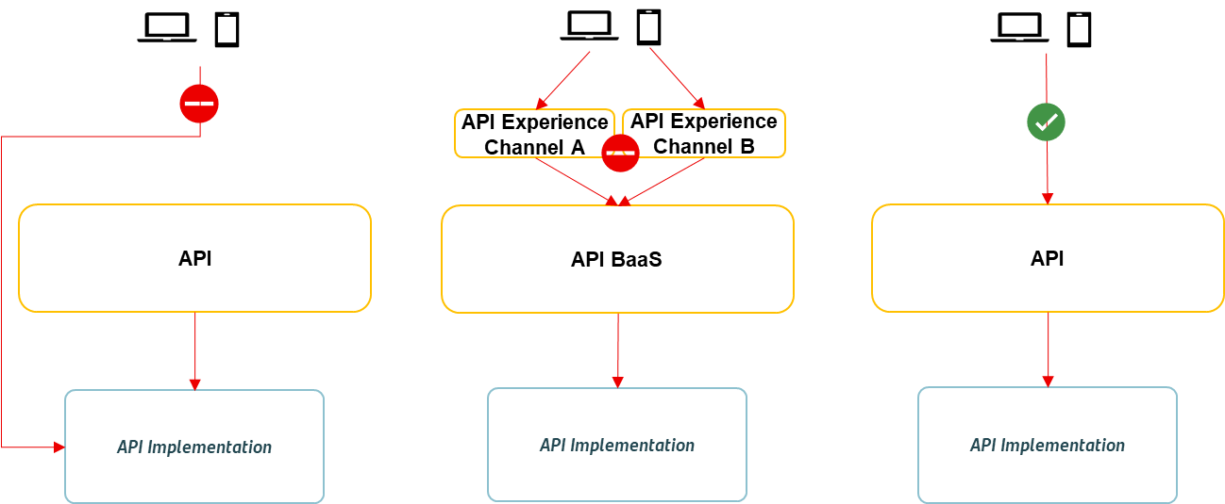

- According to the initial proposal, the APIs exposed to touchpoints must be deployed in a certified API Platform (Apigee OPDK or IBM API Connect v10). On the other hand, the access to microservices outside a namespace must be done through a micro-gateway. This could mean a huge cost in infrastructure, combined with a “double gateway” presence in the same API request that could reduce the overall performance.
As IBM API Connect v10 can be deployed in Kubernetes, and Apigee OPDK can manage APIs exposed in Envoy (also deployable in Kubernetes), it’s decided to also explore this option and test it in the “PoC phase”. It should mean a significant reduction in the number of virtual machines needed, better scalability and less layers, that should result in a better performance.
- Segregation & resilience must be mainly based on domains or products instead of channels, keeping in mind that the server side of a mobile or a web application will be reduced to the bare minimum (static resources… not much more) and any of these applications will access to the same APIs.
- An API can be exposed to touchpoints or/and to other domains. There may be some differences regarding the exposition (in terms of security, network, etc.) but in the end it’s the same API so it means that it must be properly managed irrespective of its exposure.
- A microservice cannot call directly to another microservice from another domain. If a microservice need to consume a functionality from another domain, it must call to an API:
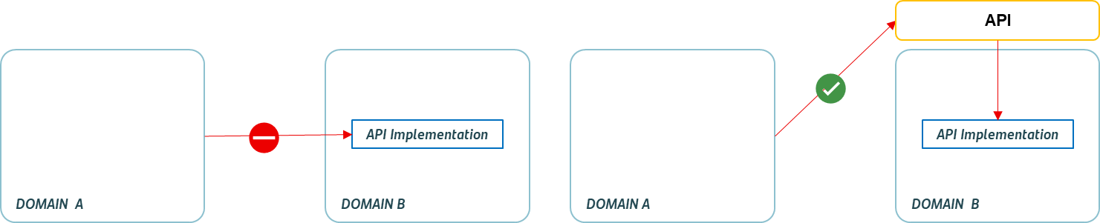

Microservices

Challenges

Auto-scaling

Cost Optimization
If not properly configured and monitored, auto-scaling will increase the cost that means scaling up aggressively or failing to scale down during spikes will result in unnecessary expenses

Resources Limits
Cost optimization is also related to appropriate allocated resources management that leads to the right type and number of cpu and memory resources, this is a crucial task in cloud native environments, without correct tuning can lead to resource contention and inefficiency, affecting the application behavior, is our responsibility to ensure that resource requests accurately reflect the minimum required, if these requests are set too high, it may lead to inefficient resource allocation on cluster nodes, reflecting in a non-efficient cost

Resource Monitoring
Proper and constant monitoring and setting up alerts for resource usage is essential to avoid waste or not resource allocation, without effective monitoring and alerts, it’s challenging to identify and address resource-related issues promptly.

Scaling Strategies Steps
Setting resource limits becomes more complex in a dynamically scaling environment, deciding how to allocate resources as pods scale up or down and implementing auto-scaling policies that consider resource usage can be challenging.

Orchestration

Transaction Management
When we’re using orchestration pattern in this scenario, we can use SAGA to overcome some challenges to keep our subdomains consistent, achieve a consistent ACID will be the most challenger effort, other commons problem can may arise in workflows becoming complex to saga participants, increasing business logic and cyclic dependency, create integration tests will be more complicated due to spread microservices architecture nature

Protocol Translation / Data Normalization
Over the microservice architecture landscape, the orchestrator service must server a correct data structure and well organized even when struggle in scenarios with different protocols and response time, deal with parallel invocations and aggregations, stream and splitting huge data chunks

GRPC

Contract Versioning
Ensuring backward and forward compatibility of gRPC can be a daunting task if not properly controlled, especially when making changes to message types or service definitions. Careful planning and versioning strategies are required to handle these issues and avoid broken service consumers

Security
To avoid mistakes and unnecessary complexity, we’ll mention here that gRPC supports most commons authentication/authorization mechanisms, such as SSL/TLS, OAuth2, and custom token-based authentication. However, configuring and managing these authentication mechanisms correctly can be challenging, writing secure gRPC services requires careful consideration of input validation, output encoding, and other security best practices, we must ensure that data passed between clients and servers is properly validated and sanitized to prevent serialization-related security issues

Traceability
Monitoring and debugging gRPC services can be more challenging than traditional HTTP services, as there may be fewer readily available tools and libraries for this purpose, this will impact directly on troubleshooting tasks

Load Balancing
Load balancing in gRPC can really be a tricky in gRPC landscape, even considering not exposed services, but even over intercommunication we can imagine a scenario client and server, load balancer operates commonly using layer-4/7, gRPC uses sticky reusable and persistent connections, for example, under the K8s cluster gRPC doesn't have the same behavior of Cluster IP REST Service, due to the sticky reusable (websocket similar) behavior of gRPC, the collateral effect of this will be, all the requests will always end up in the same gRPC service, worth mention here that some LBs doesn’t support gRPC and over K8s Cluster some specific strategies must be taken to correct the traffic distribution.

Health-checking
Due to the fact gRPC uses HTTP/2 as its underling protocol, this will bring more complexity than traditional health check protocols, e.g; Kubernetes probe over HTTP/TPC, this check may involve making specific gRPC calls or checking the state of internal components, mainly in a microservices architecture where microservices have several external dependencies on each other

Developer Learning Curve
Developers who are new to RPC concepts need to understand the intricacies of protocol buffers, correct ordering of most used types, RPC streams e all types of gRPC (protobufs) , the gRPC ecosystem may take some time to understand, and at the beginning will be prone to issues, they’re different from traditional Java POJO implementation.

Error Handling
Handling errors in gRPC can be less intuitive than traditional HTTP REST APIs, status codes and error details provided by gRPC may not be as user-friendly as HTTP status codes and error messages.

Performance Overhead
While gRPC is known for its performance, the added complexity of serialization/deserialization and HTTP/2 framing can introduce some performance overhead compared to simpler protocols like HTTP REST.

Choreography

Transaction Management
Managing transactions in a choreography pattern, which is a distributed system design where multiple components or services collaborate to accomplish a task, will be complex mainly due to the lack of centralized control in this architecture, there is no central coordinator that oversees the entire transaction, that is, each participating component must independently make decisions about when and how to initiate, commit, or abort a transaction, we can fall in lack of distributed consistency and atomicity, duplicated information is other concern, distributed deadlocks when multiple services are waiting for each other to release resources and other thinks such long-Running Transactions, Error Handling and compensation tasks.

Traceability
Traceability in a decoupled and transactional architecture will be challenger when we need to monitor the transaction and make correct decisions with troubleshooting issues, unique id to identify/track transactions can help us join the correct information

Multi-Environment Configuration

Hot loading
Microservices load configuration in a static way at startup time, more than one microservices can share configuration data, how microservices synchronize the data when that data changes.

Rate Limiter

Discover Resource Limits
Identifying the appropriate rate limit: determining the appropriate rate limit for a system can be difficult, as it depends on a number of factors, such as the available bandwidth, the number of users, and the type of traffic. Setting the rate limit too high may result in network congestion, while setting it too low may prevent users from accessing the system.
Dealing with bursty traffic: rate limiting is designed to handle steady traffic flows, but it can be challenging to handle bursty traffic, where the rate of traffic can fluctuate rapidly. This can result in some traffic being dropped even when the network is not congested.
Avoiding false positives: Rate limiting algorithms may sometimes flag legitimate traffic as malicious and block it as a result. This can lead to problems for legitimate users, and it may require additional monitoring and adjustments to the rate limiting algorithm to avoid false positives.

Circuit Breaker

Right Fallback Strategy
Breakers on their own are valuable, but clients using them need to react to breaker failures. As with any remote invocation you need to consider what to do in case of failure. Does the operation you're carrying out fail, or are there workarounds you can do? A credit card authorization could be put in a queue to deal with later, failure to get some data may be mitigated by showing some stale data that's good enough to display.

Caching

Caching Invalidation
Determine the appropriate level of caching granularity.
Data consistency, cache invalidation, and cache management. Select a cache invalidation strategy that ensures data consistency when and how to remove data from the cache, based on factors such as time, size, frequency, or priority.
Monitor cache performance using metrics and observability tools. Monitoring and testing cache performance across cache hit rate, cache miss rate, cache latency, cache size, cache throughput, cache errors, cache misses, cache bottlenecks, cache failures, or cache overloads.
Determining the right cache type will optimize performance and reduce backend load, enhancing the overall efficiency of microservices architecture.
Create policies that help to maintain the freshness and relevance of the cached data, as well as to optimize the cache resources and avoid memory overflow.
Tests to evaluate and improve cache reliability, scalability, and resilience.

Decisions taken

Versioning

Semantic Versioning
In the world of software management there exists a dreaded place called “dependency hell.” The bigger your system grows and the more packages you integrate into your software, the more likely you are to find yourself, one day, in this pit of despair.
In systems with many dependencies, releasing new package versions can quickly become a nightmare. If the dependency specifications are too tight, you are in danger of version lock (the inability to upgrade a package without having to release new versions of every dependent package). If dependencies are specified too loosely, you will inevitably be bitten by version promiscuity (assuming compatibility with more future versions than is reasonable). Dependency hell is where you are when version lock and/or version promiscuity prevent you from easily and safely moving your project forward.
As a solution to this problem, use “Semantic Versioning.”, a simple set of rules and requirements that dictate how version numbers are assigned and incremented. These rules are based on but not necessarily limited to pre-existing widespread common practices in use in both closed and open-source software. For this system to work, you first need to declare a public API. This may consist of documentation or be enforced by the code itself. Regardless, it is important that this API be clear and precise. Once you identify your public API, you communicate changes to it with specific increments to your version number. Consider a version format of X.Y.Z (Major.Minor.Patch). Bug fixes not affecting the API increment the patch version, backward compatible API additions/changes increment the minor version, and backward incompatible API changes increment the major version.

DDD

Adapt to BIAN framework
Use Banking Industry Architecture Network (BIAN) as framework for the Domain-Driven Design approach by establishing the relationship between BIAN concepts and models and the corresponding ones in the Domain-Driven Design. BIAN can be used at a strategic design level by providing a unique and consistent way of decomposing the banking business domain into a set of Bounded Contexts. It can also be used at a tactical level where the information models are used as the starting point for designing and constructing domain objects such as Aggregates and Entities.

gRPC

Intra-namespace communication
Usage will be restricted just for intra-namespace communications.

Restrict to high-performance microservice
It's restricted to a microservice that requires 80ms response latency.

Payload Restriction
It's restricted to a microservice contract that has a single entity.
P.S.: all decisions taken over gRPC are based on development complexity vs. high-performance requirements trade-off.

Choreography

Inter-namespace communication with governance
Throughput is not the only concern, but data governance will bring us more security and readability in our system communication, mainly in the inter-namespaces communication approach via APIs exposed in the interdomain gateways.

Orchestration

Enterprise Integration Patterns
Orchestration will help us manage the flow and coordination among components of a distributed system, predominantly in a Microservices architecture, with a correct decomposition, our bounded contexts will operate independently and to join the information in a business workflow we apply the orchestrator idea, the orchestrator does not perform business logic, but only manages complex business by calling decoupled deployed services, handling exceptions, retrying requests, maintaining state, and returning the final response, using Enterprise integration patterns (EIP), concepts and practices for developing systems to integrate new and existing software in a business environment practices for developing systems to integrate new and existing software in a business environment

Multi-Environment Config

Secrets for Sensitive Data
Keep sensitive information on Kubernetes Secrets, it is an object that contains a small amount of sensitive data such as a password, a token, or a key. Such information might otherwise be put in a Pod specification or in a container image.
Using a Secret means that you don't need to include confidential data in your application code.

ConfigMap for Non-sensitive Data
If you have non-sensitive data use a Kubernetes ConfigMap, it is an API object used to store non-confidential data in key-value pairs.
Pods can consume ConfigMaps as environment variables, command-line arguments, or as configuration files in a volume.
A ConfigMap allows you to decouple environment-specific configuration from your container images, so that your applications are easily portable.

Environment variables for all endpoints
Container images are usually built with their configurations externalized to environment variables.
Specifically, the programs would read the predefined environment variables during runtime to obtain any configuration specified by the users like microservices urls, database server and message brokers endpoints.
This makes it easy for users to customize the image without having to rebuild the image whenever we want to change the behaviour of the application.

REST

Exposition
REST exposition for touchpoints and inter-namespace are done via APIs.

Caching

Restrict to querying optimization
Caching for optimization of expensive query results to reduce the number of calls to the backend
To improve the performance, scalability, and reliability of microservices
Distributed caching across instances of microservices

Application Structure

Multi-module for libraries
Libraries must be divided into a structure of multi-modules.

Atomic-project for microservices
Microservices must have an atomic project structure.

Persistence

Repository Pattern
When we have plenty of Database options, we must avoid handling each intrinsic detail of data provider, we must abstract these layers, and keep our efforts in the domain logic, with the repository pattern we can abstract the underlying data storage mechanism, repository pattern provides a clean API that the business logic can write to and read from without worry about the details of where the data is going or how it’s coming back.

Resilience Patterns

Rate Limit / Throttling

Definition
Many services use a throttling pattern to control the number of requests they receive in each timeframe, imposing limits on the rate at which other applications or services can access them. You can use a rate limiting pattern to help you avoid or minimize overloading applications and to help you more accurately predict throughput. A rate limiting pattern is appropriate in many scenarios, but it is particularly helpful for large-scale repetitive automated tasks such as batch processing.

Context and Problem
Performing large numbers of operations using a throttled service can result in increased traffic and throughput, as you'll need to track rejected requests and then retry them. As the number of operations increases, a throttling limit may require multiple passes of resending data, resulting in a larger performance impact. As an example, consider the following naive retry on error process for ingesting data into a database: your application needs to ingest 10,000 records into a database. Each record costs 10 Request Units (RUs) to ingest, requiring a total of 100,000 RUs to complete the job. Your database instance has 20,000 RUs provisioned capacity. You send all 10,000 records. 2,000 records are written successfully, and 8,000 records are rejected. You send the remaining 8,000 records afterwards. 2,000 records are written successfully, and 6,000 records are rejected. You send the remaining 6,000 records. 2,000 records are written successfully, and 4,000 records are rejected. You send the remaining 4,000 records. 2,000 records are written successfully, and 2,000 records are rejected. You send the remaining 2,000 records. Finally, all requests are written. The ingestion job completed successfully, but only after sending 30,000 records to the database even though the entire data set only consisted of 10,000 records. There are other factors to consider in the above example, such as the large numbers of errors which can also result in additional work to log these errors and process the resulting log data. This approach will have handled 20,000 errors, and logging these errors may impose a processing, memory, or storage resource cost. By not knowing the throttling limits of the ingestion service, the naive approach has no way to set expectations for how long data ingestion will take. In this scenario, rate limiting can allow you to calculate the time required for this need.

Solution
Rate limiting can cadence your traffic and potentially improve latency by reducing the number of records received by a service over a given period. A service may throttle based on different metrics over time, such as:
- The number of operations (for example, 20 requests per second).
- The amount of data (for example, 2 GiB per minute).
- The relative cost of operations (for example, 20,000 RUs per second).
Regardless of the metric used for throttling, your rate limiting implementation will involve controlling the number and/or size of operations sent to the service over a specific time period, optimizing your use of the service while not exceeding its throttling capacity.
In scenarios where your APIs can handle requests faster than any throttled ingestion services allow, you'll need to manage how quickly you can use the service. However, only treating the throttling as a data rate mismatch problem, and simply buffering your ingestion requests until the throttled service can catch up, is risky. If your application crashes in this scenario, you risk losing any of this buffered data.
To avoid this risk, consider sending your records to a durable messaging system (a queue, for instance) that can handle your full ingestion rate. You can then use one or more job processors to read the records from the messaging system at a controlled rate that is within the throttled service's limits. Submitting records to the messaging system can save internal memory by allowing you to dequeue only the records that can be processed during a given time interval.
When you're sending records, the period you use for releasing records may be more granular than the period the service throttles on. Systems often set throttles based on timespans you can easily comprehend and work with. However, for the computer running a service, these timeframes may be very long compared to how fast it can process information. For instance, a system might throttle per second or per minute, but commonly the code is processed in the order of nanoseconds or milliseconds.
While not required, it's often recommended to send smaller amounts of records more frequently to improve throughput. So rather than trying to batch things up for a release once a second or once a minute, you can be more granular than that to keep your resource consumption (memory, CPU, network, etc.) flowing at a more even rate, preventing potential bottlenecks due to sudden bursts of requests. For example, if a service allows 100 operations per second, the implementation of a rate limiter may even out requests by releasing 20 operations every 200 milliseconds
In addition, it's sometimes necessary for multiple uncoordinated processes to share a throttled service. To implement rate limiting in this scenario you can logically partition the service's capacity and then use a distributed mutual exclusion system to manage exclusive locks on those partitions. The uncoordinated processes can then compete for locks on those partitions whenever they need capacity. For each partition that a process holds a lock for, it's granted a certain amount of capacity.

For example, if the throttled system allows 500 requests per second, you might create 20 partitions worth 25 requests per second each. If a process needed to issue 100 requests, it might ask the distributed mutual exclusion system for four partitions. The system might grant two partitions for 10 seconds. The process would then rate limit to 50 requests per second, complete the task in two seconds, and then release the lock.
One way to implement this pattern would be to use Azure Storage. In this scenario, you create one 0-byte blob per logical partition in a container. Your applications can then obtain exclusive leases directly against those blobs for a short period of time (for example, 15 seconds). For every lease an application is granted, it will be able to use that partition's worth of capacity. The application then needs to track the lease time so that, when it expires, it can stop using the capacity it was granted. When implementing this pattern, you'll often want each process to attempt to lease a random partition when it needs capacity.
To further reduce latency, you might allocate a small amount of exclusive capacity for each process. A process would then only seek to obtain a lease on shared capacity if it needed to exceed its reserved capacity.
To support this pattern, we will adopt the following technology stack:
- Spring Boot - Resilience4J
- Quarkus - Bucket4J
- Camel DSL

When to use this pattern
Use this pattern to:
- Reduce throttling errors raised by a throttle-limited service.
- Reduce traffic overload applied to a naive retry on error approach.
- Reduce memory consumption by dequeuing records only when there is capacity to process them.

Retry

Definition
Enable an application to handle transient failures when it tries to connect to a service or network resource, by transparently retrying a failed operation. This can improve the stability of the application.

Context and problem
An application that communicates with any other system (either a web service, a queue, or a database, for example) must be to the transient faults that can occur in this environment. Faults include the mom sensitive momentary loss of network connectivity to components and services, the temporary unavailability of a service, or timeouts that occur when a service is busy. These faults are typically self-correcting, and if the action that triggered a fault is repeated after a suitable delay it's likely to be successful. For example, a database service that's processing a large number of concurrent requests can implement a throttling strategy that temporarily rejects any further requests until its workload has eased. An application trying to access the database might fail to connect, but if it tries again after a delay it might succeed.

Solution
Either on the cloud or on-premises, transient faults aren't uncommon and an application should be designed to handle them elegantly and transparently. This minimizes the effects faults can have on the business tasks the application is performing.
If an application detects a failure when it tries to send a request to a remote service, it can handle the failure using the following strategies:
- Cancel. If the fault indicates that the failure isn't transient or is unlikely to be successful if repeated, the application should cancel the operation and report an exception. For example, an authentication failure caused by providing invalid credentials is not likely to succeed no matter how many times it's attempted.
- Retry. If the specific fault reported is unusual or rare, it might have been caused by unusual circumstances such as a network packet becoming corrupted while it was being transmitted. In this case, the application could retry the failing request again immediately because the same failure is unlikely to be repeated and the request will probably be successful.
- Retry after delay. If the fault is caused by one of the more commonplace connectivity or busy failures, the network or service might need a short period while the connectivity issues are corrected or the backlog of work is cleared. The application should wait for a suitable time before retrying the request.
For the more common transient failures, the period between retries should be chosen to spread requests from multiple instances of the application as evenly as possible. This reduces the chance of a busy service continuing to be overloaded. If many instances of an application are continually overwhelming a service with retry requests, it'll take the service longer to recover.
If the request still fails, the application can wait and make another attempt. If necessary, this process can be repeated with increasing delays between retry attempts, until some maximum number of requests have been attempted, also known as maximum redeliveries. The delay can be increased incrementally or exponentially, depending on the type of failure and the probability that it'll be corrected during this time.
The application should wrap all attempts to access a remote service in code that implements a retry policy matching one of the strategies listed above. Requests sent to different services can be subject to different policies. Some vendors provide libraries that implement retry policies, where the application can specify the maximum number of retries, the time between retry attempts, and other parameters.
An application should log the details of faults and failing operations. This information is useful to operators. That being said, in order to avoid flooding operators with alerts on operations where subsequently retried attempts were successful, it is best to log early failures as informational entries and only the failure of the last of the retry attempts as an actual error.
If a service is frequently unavailable or busy, it's often because the service has exhausted its resources. You can reduce the frequency of these faults by scaling out the service. For example, if a database service is continually overloaded, it might be beneficial to partition the database and spread the load across multiple servers.
To support this pattern, we will adopt the following technology stack:
- Spring Boot - Resilience4J
- Quarkus - Smallrye Fault Tolerance
- Camel DSL / Resilience4J

Circuit Breaker

Definition
Handle faults that might take a variable amount of time to recover from, when connecting to a remote service or resource. This can improve the stability and resiliency of an application.

Context and problem
In a distributed environment, calls to remote resources and services can fail due to transient faults, such as slow network connections, timeouts, or the resources being overcommitted or temporarily unavailable. These faults typically correct themselves after a short period of time, and a robust cloud application should be prepared to handle them by using a strategy such as the Retry pattern. However, there can also be situations where faults are due to unanticipated events, and that might take much longer to fix. These faults can range in severity from a partial loss of connectivity to the complete failure of a service. In these situations, it might be pointless for an application to continually retry an operation that is unlikely to succeed, and instead the application should quickly accept that the operation has failed and handle this failure accordingly. Additionally, if a service is very busy, failure in one part of the system might lead to cascading failures. For example, an operation that invokes a service could be configured to implement a timeout and reply with a failure message if the service fails to respond within this period. However, this strategy could cause many concurrent requests for the same operation to be blocked until the timeout period expires. These blocked requests might hold critical system resources such as memory, threads, database connections, and so on. Consequently, these resources could become exhausted, causing failure of other possibly unrelated parts of the system that need to use the same resources. In these situations, it would be preferable for the operation to fail immediately, and only attempt to invoke the service if it's likely to succeed. Note that setting a shorter timeout might help to resolve this problem, but the timeout shouldn't be so short that the operation fails most of the time, even if the request to the service would eventually succeed.

Solution
The Circuit Breaker pattern, popularized by Michael Nygard on his book, Release It! can prevent an application from repeatedly trying to execute an operation that's likely to fail. Allowing it to continue without waiting for the fault to be fixed or wasting CPU cycles while it determines that the fault is long lasting. The Circuit Breaker pattern also enables an application to detect whether the fault has been resolved. If the problem appears to have been fixed, the application can try to invoke the operation. The purpose of the Circuit Breaker pattern is different than the Retry pattern. The Retry pattern enables an application to retry an operation in the expectation that it'll succeed. The Circuit Breaker pattern prevents an application from performing an operation that is likely to fail. An application can combine these two patterns by using the Retry pattern to invoke an operation through a circuit breaker. However, the retry logic should be sensitive to any exceptions returned by the circuit breaker and abandon retry attempts if the circuit breaker indicates that a fault is not transient. A circuit breaker acts as a proxy for operations that might fail. The proxy should monitor the number of recent failures that have occurred and use this information to decide whether to allow the operation to proceed, or simply return an exception immediately. The proxy can be implemented as a state machine with the following states that mimic the functionality of an electrical circuit breaker:
- Closed: The request from the application is routed to the operation. The proxy maintains a count of the number of recent failures, and if the call to the operation is unsuccessful, the proxy increments this count. If the number of recent failures exceeds a specified threshold within a given period, the proxy is placed into the Open state. At this point the proxy starts a timeout timer, and when this timer expires, the proxy is placed into the Half-Open state. The purpose of the timeout timer is to give the system some time to fix the problem that caused the failure before allowing the application to try to perform the operation again.
- Open: The request from the application fails immediately and an exception is returned to the application.
- Half-Open: A limited number of requests from the application are allowed to pass through and invoke the operation. If these requests are successful, it's assumed that the fault that was previously causing the failure has been fixed and the circuit breaker switches to the Closed state (the failure counter is reset). If any request fails, the circuit breaker assumes that the fault is still present, so it reverts to the Open state and restarts the timeout timer to give the system a further period to recover from the failure. The Half-Open state is useful to prevent a recovering service from suddenly being flooded with requests. As a service recovers, it might be able to support a limited volume of requests until the recovery is complete, but while recovery is in progress a flood of work can cause the service to time out or fail again.
How the system recovers are handled externally, possibly by restoring or restarting a failed component or repairing a network connection.
The Circuit Breaker pattern provides stability while the system recovers from a failure and minimizes the impact on performance. It can help to maintain the response time of the system by quickly rejecting a request for an operation that's likely to fail, rather than waiting for the operation to time out, or never return. If the circuit breaker raises an event each time it changes state, this information can be used to monitor the health of the part of the system protected by the circuit breaker, or to alert an administrator when a circuit breaker trips to the Open state.
The pattern is customizable and can be adapted according to the type of possible failure. For example, you can apply an increasing timeout timer to a circuit breaker. You could place the circuit breaker in the Open state for a few seconds initially, and then if the failure hasn't been resolved, increase the timeout to a few minutes, and so on. In some cases, rather than the Open state returning failure and raising an exception, it could be useful to return a default value that is meaningful to the application.

When to use this pattern
Use this pattern:
- To prevent an application from trying to invoke a remote service or access a shared resource if this operation is highly likely to fail.
This pattern isn't recommended:
- For handling access to local private resources in an application, such as in-memory data structure. In this environment, using a circuit breaker would add overhead to your system.
- As a substitute for handling exceptions in the business logic of your applications.

Bulkhead

Definition
The Bulkhead pattern is a type of fault tolerant application design, in which elements of an application are isolated into pools so that if one fails, the others will continue to function. It's named after the sectioned partitions (bulkheads) of a ship's hull. If the hull of a ship is compromised, only the damaged section fills with water, which prevents the ship from sinking.

Context and problem
A cloud-based application may include multiple services, with each service having one or more consumers. Excessive load or failure in a service will impact all consumers of the service.
Moreover, a consumer may send requests to multiple services simultaneously, using resources for each request. When the consumer sends a request to a service that is misconfigured or not responding, the resources used by the client's request may not be freed in a timely manner. As requests to the service continue, those resources may be exhausted, for example, the client's connection pool. At that point, requests by the consumer for other services are affected. Eventually, the consumer can no longer send requests to other services, not just the original unresponsive service.
The same issue of resource exhaustion affects services with multiple consumers. Many requests originating from one client may exhaust available resources in the service. Other consumers are no longer able to consume the service, causing a cascading failure effect.

Solution
A viable solution is to partition service instances into different groups, based on consumer load and availability requirements. This design helps to isolate errors and allows you to sustain service functionality for some consumers, even during an error.
A consumer can also partition resources, to ensure that resources used to call one service don't affect the resources used to call another service. For example, a consumer that calls multiple services may be assigned a connection pool for each service. If a service begins to fail, it only affects the connection pool assigned for that service, allowing the consumer to continue using the other services.
The benefits of this pattern include:
- Isolates consumers and services from cascading failures. An issue affecting a consumer or service can be isolated within its own bulkhead, preventing the entire solution from failing.
- Allows you to preserve some functionality in the event of a service failure. Other services and features of the application will continue to work.
- Allows you to deploy services that offer a different quality of service for consuming applications. A high-priority consumer pool can be configured to use high-priority services.

When to use this pattern
Use this pattern to:
- Isolate resources used to consume a set of backend services, especially if the application can provide some level of functionality even when one of the services is not responding.
- Isolate critical consumers from standard consumers.
- Protect the application from cascading failures.
This pattern may not be suitable when:
- Less efficient use of resources may not be acceptable in the project.
- The added complexity is not necessary

Compensated Transaction

Definition
When you use an eventually consistent operation that is composed of a series of steps, the Compensating Transaction pattern can be useful. Specifically, if one or more of the steps fail, you can use the Compensating Transaction pattern to undo the work that the previous steps performed. Typically, you find operations that follow the eventual consistency model in cloud-hosted applications that implement complex business processes and workflows.

Context and problem
Applications that run in the cloud frequently modify data. This data is sometimes spread across various data sources in different geographic locations. To avoid contention and improve performance in a distributed environment, an application shouldn't try to provide strong transactional consistency. Rather, the application should implement eventual consistency. In the eventual consistency model, a typical business operation consists of a series of separate steps. While the operation performs these steps, the overall view of the system state might be inconsistent. But when the operation finishes and all the steps have run, the system should become consistent again.
A challenge in the eventual consistency model is how to handle a step that fails. After a failure, you might need to undo all the work that previous steps in the operation completed. However, you can't always roll back the data, because other concurrent instances of the application might have changed it. Even in cases where concurrent instances haven't changed the data, undoing a step might be more complex than restoring the original state. It might be necessary to apply various business-specific rules.
If an operation that implements eventual consistency spans several heterogeneous data stores, undoing the steps in the operation requires visiting each data store in turn. To prevent the system from remaining inconsistent, you must reliably undo the work that you performed in every data store.
The data that's affected by an operation that implements eventual consistency isn't always held in a database. For example, consider a service-oriented architecture (SOA) environment. A SOA operation can invoke an action in a service and cause a change in the state that's held by that service. To undo the operation, you also have to undo this state change. This process can involve invoking the service again and performing another action that reverses the effects of the first.

Solution
The solution is to implement a compensating transaction. The steps in a compensating transaction undo the effects of the steps in the original operation. An intuitive approach is to replace the current state with the state the system was in at the start of the operation. But a compensating transaction can't always take that approach, because it might overwrite changes that other concurrent instances of an application have made. Instead, a compensating transaction must be an intelligent process that considers any work that concurrent instances do. This process is usually application-specific, driven by the nature of the work that the original operation performs.
A common approach is to use a workflow to implement an eventually consistent operation that requires compensation. As the original operation proceeds, the system records information about each step, including how to undo the work that the step performs. If the operation fails at any point, the workflow is rewinds back through the steps it has completed. At each step, the workflow performs the work that reverses that step.
Two important points are:
- A compensating transaction might not have to undo the work in the exact reverse order of the original operation.
- It might be possible to perform some of the undo steps in parallel.
A compensating transaction is an eventually consistent operation itself, so it can also fail. The system should be able to resume the compensating transaction at the point of failure and continue. It might be necessary to repeat a step that fails, so you should define the steps in a compensating transaction as idempotent commands.
In some cases, manual intervention might be the only way to recover from a step that has failed. In these situations, the system should raise an alert and provide as much information as possible about the reason for the failure.

When to use this pattern
Use this pattern only for operations that must be undone if they fail. If possible, design solutions to avoid the complexity of requiring compensating transactions.

Saga

Definition
The Saga design pattern is a way to manage data consistency across microservices in distributed transaction scenarios. A saga is a sequence of transactions that updates each service and publishes a message or event to trigger the next transaction step. If a step fails, the saga executes compensating transactions that counteract the preceding transactions.

Context and problem
A transaction is a single unit of logic or work, sometimes made up of multiple operations. Within a transaction, an event is a state change that occurs to an entity, and a command encapsulates all information needed to perform an action or trigger a later event.
Transactions must be atomic, consistent, isolated, and durable (ACID). Transactions within a single service are ACID, but cross-service data consistency requires a cross-service transaction management strategy.
In multi services architectures:
- Atomicity is an indivisible and irreducible set of operations that must all occur or none occur.
- Consistency means the transaction brings the data only from one valid state to another valid state.
- Isolation guarantees that concurrent transactions produce the same data state that sequentially executed transactions would have produced.
- Durability ensures that committed transactions remain committed even in case of system failure or power outage.
A database-per-microservice model provides many benefits for microservices architectures. Encapsulating domain data lets each service use its best data store type and schema, scale its own data store as necessary, and be insulated from other services' failures. However, ensuring data consistency across service-specific databases poses challenges.
Distributed transactions like the two-phase commit (2PC) protocol require all participants in a transaction to commit or roll back before the transaction can proceed. However, some participant implementations, such as NoSQL databases and message brokering, don't support this model.
Another distributed transaction limitation is interprocess communication (IPC) synchronicity and availability. Operating system-provided IPC allows separate processes to share data. For distributed transactions to commit, all participating services must be available, potentially reducing overall system availability. Architectural implementations with IPC or transaction limitations are candidates for the Saga pattern.

Solution
The Saga pattern provides transaction management using a sequence of local transactions. A local transaction is the atomic work effort performed by a saga participant. Each local transaction updates the database and publishes a message or event to trigger the next local transaction in the saga. If a local transaction fails, the saga executes a series of compensating transactions that undo the changes that were made by the preceding local transactions.
In Saga patterns:
- Compensable transactions are transactions that can potentially be reversed by processing another transaction with the opposite effect.
- A pivot transaction is the go/no-go point in a saga. If the pivot transaction commits, the saga runs until completion. A pivot transaction can be a transaction that is neither compensable nor retriable, or it can be the last compensable transaction or the first retriable transaction in the saga.
- Retriable transactions are transactions that follow the pivot transaction and are guaranteed to succeed.
There are two common saga implementation approaches, choreography and orchestration. Each approach has its own set of challenges and technologies to coordinate the workflow.

When to use this pattern
Use the Saga pattern when you need to:
- Ensure data consistency in a distributed system without tight coupling.
- Roll back or compensate if one of the operations in the sequence fails.
The Saga pattern is less suitable for:
- Tightly coupled transactions.
- Compensating transactions that occur in earlier participants.
- Cyclic dependencies.

Sharding

Definition
Divide a data store into a set of horizontal partitions or shards. This can improve scalability when storing and accessing large volumes of data.
Context and problem
A data store hosted by a single server might be subject to the following limitations:
- Storage space. A data store for a large-scale cloud application is expected to contain a huge volume of data that could increase significantly over time. A server typically provides only a finite amount of disk storage, but you can replace existing disks with larger ones, or add further disks to a machine as data volumes grow. However, the system will eventually reach a limit where it isn't possible to easily increase the storage capacity on a given server.
- Computing resources. A cloud application is required to support many concurrent users, each of which runs queries that retrieve information from the data store. A single server hosting the data store might not be able to provide the necessary computing power to support this load, resulting in extended response times for users and frequent failures as applications attempting to store and retrieve data time out. It might be possible to add memory or upgrade processors, but the system will reach a limit when it isn't possible to increase the computer resources any further.
- Network bandwidth. Ultimately, the performance of a data store running on a single server is governed by the rate the server can receive requests and send replies. It's possible that the volume of network traffic might exceed the capacity of the network used to connect to the server, resulting in failed requests.
- Geography. It might be necessary to store data generated by specific users in the same region as those users for legal, compliance, or performance reasons, or to reduce latency of data access. If the users are dispersed across different countries or regions, it might not be possible to store the entire data for the application in a single data store.
Scaling vertically by adding more disk capacity, processing power, memory, and network connections can postpone the effects of some of these limitations, but it's likely to only be a temporary solution. A commercial cloud application capable of supporting large numbers of users and high volumes of data must be able to scale almost indefinitely, so vertical scaling isn't necessarily the best solution.

Solution
Divide the data store into horizontal partitions or shards. Each shard has the same schema, but holds its own distinct subset of the data. A shard is a data store in its own right (it can contain the data for many entities of different types), running on a server acting as a storage node.
This pattern has the following benefits:
- You can scale the system out by adding further shards running on additional storage nodes.
- A system can use off-the-shelf hardware rather than specialized and expensive computers for each storage node.
- You can reduce contention and improve performance by balancing the workload across shards.
- In the cloud, shards can be located physically close to the users that'll access the data.
When dividing a data store up into shards, decide which data should be placed in each shard. A shard typically contains items that fall within a specified range determined by one or more attributes of the data. These attributes form the shard key (sometimes referred to as the partition key). The shard key should be static. It shouldn't be based on data that might change.
Sharding physically organizes the data. When an application stores and retrieves data, the sharding logic directs the application to the appropriate shard. This sharding logic can be implemented as part of the data access code in the application, or it could be implemented by the data storage system if it transparently supports sharding.
Abstracting the physical location of the data in the sharding logic provides a high level of control over which shards contain which data. It also enables data to migrate between shards without reworking the business logic of an application if the data in the shards need to be redistributed later (for example, if the shards become unbalanced). The tradeoff is the additional data access overhead required in determining the location of each data item as it's retrieved.
To ensure optimal performance and scalability, it's important to split the data in a way that's appropriate for the types of queries that the application performs. In many cases, it's unlikely that the sharding scheme will exactly match the requirements of every query. For example, in a multi-tenant system, an application might need to retrieve tenant data using the tenant ID, but it might also need to look up this data based on some other attribute such as the tenant's name or location. To handle these situations, implement a sharding strategy with a shard key that supports the most performed queries.
If queries regularly retrieve data using a combination of attribute values, you can likely define a composite shard key by linking attributes together. Alternatively, use a pattern such as Index Table to provide fast lookup to data based on attributes that aren't covered by the shard key.

When to use this pattern
Use this pattern when a data store is likely to need to scale beyond the resources available to a single storage node (horizontal scaling), or to improve performance by reducing contention in a data store.
The primary focus of sharding is to improve the performance and scalability of a system, but as a by-product it can also improve availability due to how the data is divided into separate partitions. A failure in one partition doesn't necessarily prevent an application from accessing data held in other partitions, and an operator can perform maintenance or recovery of one or more partitions without making the entire data for an application inaccessible.

CQRS

Definition
CQRS stands for Command and Query Responsibility Segregation, a pattern that separates read and write operations for a data store. Implementing CQRS in your application can maximize its performance, scalability, and security. The flexibility created by migrating to CQRS allows a system to better evolve over time and prevents update commands from causing merge conflicts at the domain level.

Context and problem
In tradicional architectures, the same data model is used to query and update a database. That's simple and works well for basic CRUD operations. In more complex applications, however, this approach can become unwieldy. For example, on the read side, the application may perform many different queries, returning data transfer objects (DTOs) with different shapes. Object mapping can become complicated. On the write side, the model may implement complex validation and business logic. As a result, you can end up with an overly complex model that does too much.
Read and write workloads are often asymmetrical, with very different performance and scale requirements.
- There is often a mismatch between the read and write representations of the data, such as additional columns or properties that must be updated correctly even though they aren't required as part of an operation.
- Data contention can occur when operations are performed in parallel on the same set of data.
- The traditional approach can have a negative effect on performance due to load on the data store and data access layer, and the complexity of queries required to retrieve information.
- Managing security and permissions can become complex, because each entity is subject to both read and write operations, which might expose data in the wrong context.

Solution
CQRS separates reads and writes into different models, using commands to write data, and queries to read data.
- Commands should be task-based, rather than data centric. ("Book hotel room", not "set ReservationStatus to Reserved").
- Commands may be placed on a queue for asynchronous processing, rather than being processed synchronously.
- Queries never modify the database. A query returns a DTO that does not encapsulate any domain knowledge.
Having separate query and update models simplifies the design and implementation. However, one disadvantage is that CQRS code can't automatically be generated from a database schema using scaffolding mechanisms such as O/RM tools (however, you will be able to build your customization on top of the generated code).
For greater isolation, you can physically separate the read data from the write data. In that case, the read database can use its own data schema that is optimized for queries. For example, it can store a materialized view of the data, in order to avoid complex joins or complex O/RM mappings. It might even use a different type of data store. For example, the write database might be relational, while the read database is a document database.
If separate read and write databases are used, they must be kept in sync. Typically this is accomplished by having the write model publish an event whenever it updates the database. For more information about using events, see Event-driven architecture style. Since message brokers and databases usually cannot be enlisted into a single distributed transaction, there can be challenges in guaranteeing consistency when updating the database and publishing events. For more information, see the guidance on idempotent message processing.
Some public cloud providers, such as AWS, handle this complex necessity transparently via asynchronous data replication in a matter of milliseconds. With this feature, there is a little eventual consistency time window, but you do not need to worry about application and replication logic by yourself.
The read store can be a read-only replica of the write store, or the read and write stores can have a different structure altogether. Using multiple read-only replicas can increase query performance, especially in distributed scenarios where read-only replicas are located close to the application instances.
Separation of the read and write stores also allows each to be scaled appropriately to match the load. For example, read operations typically encounter a much higher load than write operations.
Some implementations of CQRS use the Event Sourcing pattern. With this pattern, application state is stored as a sequence of events. Each event represents a set of changes to the data. The current state is constructed by replaying the events. In a CQRS context, one benefit of Event Sourcing is that the same events can be used to notify other components — in particular, to notify the read model. The read model uses the events to create a snapshot of the current state, which is more efficient for queries. However, Event Sourcing adds complexity to the design.
Benefits of CQRS include:
- Independent scaling. CQRS allows the read and write workloads to scale independently, and may result in fewer lock contentions.
- Optimized data schemas. The read side can use a schema that is optimized for queries, while the write side uses a schema that is optimized for updates.
- Security. It's easier to ensure that only the right domain entities are performing writes on the data.
- Separation of concerns. Segregating the read and write sides can result in models that are more maintainable and flexible

When to use this pattern
Consider CQRS for the following scenarios:
- Collaborative domains where many users access the same data in parallel. CQRS allows you to define commands with enough granularity to minimize merge conflicts at the domain level, and conflicts that do arise can be merged by the command.
- Task-based user interfaces where users are guided through a series of steps or with complex domain models. The write model has a full command-processing stack with business logic and input validation. The write model may treat a set of associated objects as a single unit for data changes (an aggregate, in DDD terminology) and ensure that these objects are always in a consistent state. The read model has no business logic or validation stack, and just returns a DTO for use in a view model. The read model is eventually consistent with the write model.
- Scenarios where performance of data reads must be fine-tuned separately from performance of data writes, especially when the number of reads is much greater than the number of writes. In this scenario, you can scale out the read model, but run the write model on just a few instances. A small number of written model instances also helps to minimize the occurrence of merger conflicts.
- Scenarios where one team of developers can focus on the complex domain model that is part of the write model, and another team can focus on the read model and the user interfaces.
- Scenarios where the system is expected to evolve over time and might contain multiple versions of the model, or where business rules change regularly.
- Integration with other systems, especially in combination with event sourcing, where the temporal failure of one subsystem shouldn't affect the availability of the others.
This pattern isn't recommended when:
- The domain or the business rules are simple.
- A simple CRUD-style user interface and data access operations are sufficient.
Consider applying CQRS to limited sections of your system where it will be most valuable.
Event Sourcing and CQRS pattern
The CQRS pattern is often used along with the Event Sourcing pattern. CQRS-based systems use separate read and write data models, each tailored to relevant tasks and often located in physically separate stores. When used with the Event Sourcing pattern, the store of events is the write model, and is the official source of information. The read model of a CQRS-based system provides materialized views of the data, typically as highly denormalized views. These views are tailored to the interfaces and display requirements of the application, which helps to maximize both display and query performance.
Using the stream of events as the write store, rather than the actual data at a point in time, avoids update conflicts on a single aggregate and maximizes performance and scalability. The events can be used to asynchronously generate materialized views of the data that are used to populate the read store.
Because the event store is the official source of information, it is possible to delete the materialized views and replay all past events to create a new representation of the current state when the system evolves, or when the read model must change. The materialized views are in effect a durable read-only cache of the data.
When using CQRS combined with the Event Sourcing pattern, consider the following:
- As with any system where the write and read stores are separate, systems based on this pattern are only eventually consistent. There will be some delay between the event being generated and the data store being updated.
- The pattern adds complexity because code must be created to initiate and handle events and assemble or update the appropriate views or objects required by queries or a read model. The complexity of the CQRS pattern when used with the Event Sourcing pattern can make a successful implementation more difficult and requires a different approach to designing systems. However, event sourcing can make it easier to model the domain and makes it easier to rebuild views or create new ones because the intent of the changes in the data is preserved.
- Generating materialized views for use in the read model or projections of the data by replaying and handling the events for specific entities or collections of entities can require significant processing time and resource usage. This is especially true if it requires summation or analysis of values over long periods, because all the associated events might need to be examined. Resolve this by implementing snapshots of the data at scheduled intervals, such as a total count of the number of a specific action that has occurred, or the current state of an entity.

Health Check

Definition
To verify that applications and services are performing correctly, you can use the Health Endpoint Monitoring pattern, also known as Health Checks. This pattern specifies the use of functional checks in an application. External tools can access these checks at regular intervals through exposed endpoints.

Context and problem
It's a good practice to monitor web applications and back-end services. Monitoring helps to ensure that applications and services are available and performing correctly. Business requirements often include monitoring.
It's sometimes more difficult to monitor cloud services than on-premises services. One reason is that you don't have full control of the hosting environment. Another is that the services typically depend on other services that platform vendors and others provide.
Many factors affect cloud-hosted applications. Examples include network latency, the performance and availability of the underlying computer and storage systems, and the network bandwidth between them. A service can fail entirely or partially due to any of these factors. To ensure the required level of availability, you must verify at regular intervals that your service performs correctly. Your service level agreement (SLA) might specify the level that you need to meet.

Solution
Implement health monitoring by sending requests to an endpoint on your application. The application should perform the necessary checks and then return an indication of its status.
A health monitoring check typically combines two factors:
- The checks (if any) that the application or service performs in response to the request to the health verification endpoint
- The analysis of the results by the tool or framework that performs the health verification check
The response code indicates the status of the application. Optionally, the response code also provides the status of components and services that the app uses. The monitoring tool or framework performs the latency or response time check.
The health monitoring code in the application might also run other checks to determine:
- The availability and response time of cloud storage or a database.
- The status of other resources or services that the application uses. These resources and services might be in the application or outside it.
Services and tools can monitor web applications by submitting a request to a configurable set of endpoints. These services and tools then evaluate the results against a set of configurable rules. It's relatively easy to create a service endpoint for the sole purpose of performing some functional tests on a system.
Typical checks that monitoring tools perform include:
- Validating the response code. For example, an HTTP response of 200 (OK) indicates that the application responded without error. The monitoring system might also check for other response codes to give more comprehensive results.
- Checking the content of the response to detect errors, even when the status code is 200 (OK). By checking the content, you can detect errors that affect only a section of the returned web page or service response. For example, you might check the title of a page or look for a specific phrase that indicates that the app returned the correct page.
- Measuring the response time. The value includes the network latency and the time that the application took to issue the request. An increasing value can indicate an emerging problem with the application or network.
- Checking resources or services that are located outside the application. An example is a content delivery network that the application uses to deliver content from global caches.
- Checking for the expiration of TLS certificates.
- Measuring the response time of a DNS lookup for the URL of the application. This check measures DNS latency and DNS failures.
- Validating the URL that a DNS lookup returns. By validating, you can ensure that entries are correct. You can also help prevent malicious request redirection that might result after an attack on your DNS server.
Where possible, it's also useful to run these checks from different on-premises or hosted locations and then compare response times. Ideally, you should monitor applications from locations that are close to customers. Then you get an accurate view of the performance from each location. This practice provides a more robust checking mechanism. The results can also help you make the following decisions:
- Where to deploy your application
- Whether to deploy it in more than one datacenter
To ensure that your application works correctly for all customers, run tests against all the service instances that customers use. For example, if customer storage is spread across more than one storage account, the monitoring process should check each account.

When to use this pattern
This pattern is useful for:
- Monitoring websites and web applications to verify availability.
- Monitoring websites and web applications to check for correct operation.
- Monitoring middle-tier or shared services to detect and isolate failures that can disrupt other applications.
- Complementing existing instrumentation in the application, such as performance counters and error handlers. Health verification checking doesn't replace application requirements for logging and auditing. Instrumentation can provide valuable information for an existing framework that monitors counters and error logs to detect failures or other issues. But instrumentation can't provide information if an application is unavailable.

Read Replica

Definition
Read replica is a pattern used for improving your read capabilities in a datastore, by creating copies of a master database, and using only for retrieving data. The master database is the one responsible for receiving writes and replicates new data to the read replicas via asynchronous events. It is often used in conjunction with the CQRS pattern.

Context and problem
Server specifications are frequently upgraded (that is, the server is scaled-up) when the resources of a database server are overwhelmed by the high frequency of access and operations. When scaling-up becomes difficult or reaches its limit, you can perform scaling-out, to horizontally distribute the database servers. However, scaling out may also be complex. Normally, the proportion of reading from a database is high when compared to writing, so you should distribute the reading processes to improve the performance of the system.

Solution
There are several ways to improve reading performance. You can use this pattern to improve the overall performance through distributing the reading into multiple "Read Replicas" (that is, replicas for reading). By using this pattern, you will not overload the master database, resulting in better performance for writing operations, which are usually more critical than reading operations, assuring it occurs successfully. You can reduce the load on the master by using primarily Read Replicas for reading, where your applications access directly its dedicated servers. Furthermore, this pattern can even avoid the master to be unstable or unavailable, since the operations are less frequent. A Read Replica is synchronized with the master through data replication (which can either occur synchronously or asynchronously). There is a delay between new data inserted into the master and it being replicated to the read replicas, though. This is called eventual consistency, where some data may be outdated for a little while. Beware that if your scenario does not support any replication lag (only supports strong consistency rather than eventual consistency), even if it is in milliseconds, you should consider the read replicas with synchronous replication.

When to use this pattern
Use this pattern when:
- The load in reading from a database is way higher than writing.
- You want to perform a process without placing a load on the master database, in a data analysis application, for example.
- You want to guarantee that write operations, which can be more critical, are successfully executed by not overloading the master database with reads.
Do not use the Read Replica pattern in the following scenarios:
- Ensuring high availability of your master database. The purpose of the Read Replica is to improve performance and scale read capacity, not redundant configuration. If the need is to increase database availability, consider database replication itself in different servers with automatic failover, rather than a Read Replica. In the public cloud world, this can be achieved via multi-AZ deployments.
- Strong consistency applications. If your applications require data to be always up to date in a concurrent scenario, avoid a Read Replica that implements asynchronous replication.

Kubernetes

Challenges

Decisions taken

Gluon Data Persistence

Challenges
- Tech Stack Simplification
- Different Storage Models and technologies used for similar or same use cases
- Detected Nosql technologies for relational use cases
- Avoid data duplication and replication scenarios
- Data Platform deployment transparency for business logic

Decisions taken
- Reduce the actual Software Stack using a unique Technology for each DB model (relational, documental, key Value…)
- Relational DBMS, Oracle in Exadata Platform
- Documental Store, Oracle Converged Database. Elasticsearch for those Exceptions that con not be solved by Oracle.
- Cache/ Key Value Store, Redis.

Security

Challenges
- Disparity of technologies (IdPs, OAuth servers,…) and E2E Security Models.
- Need to establish a harmonised security model in the group while maintaining a common level of compliance and risk appetite.
- Need for interoperability with current security models.

Decisions taken
- Maintain the local idp as long as the Customer Identity Platform is not deployed in the Entity. In that case, the IdP Adapter Component shall be used.
- Maintain the local Oauth Server as long as the Customer Identity Platform is not deployed in the Entity. In that case, the local Oauth Server be not compliance with the requirement, Global SOS Component must be used.

Observability

Challenges

Quality / Standardization of logs
The quality of the ingested information is the foundational structure for good observability. If the generated signals (logs, traces, and metrics) lack a conceptual standard or are inconsistent, there is a chance of making incorrect decisions and actions. For example, if a business error occurs and the application generates a success return code, subsequent flows from that point will assume a successful execution, which may be incorrect for certain situations.

Amount of processed and stored information
The quantity of information to be processed and stored is a point of concern as it directly reflects on financial cost and solution performance. Understanding, learning, testing, and calibrating which information should be stored and for how long will be an ongoing exercise to strike a balance between results and cost.

End-to-End Traceability
With the diversity of frameworks, tools, and cloud providers in the platform, the technological stack combinations in customer transactions will be numerous. To achieve effective end-to-end traceability, it will be necessary to conduct proof of concepts with various tools to select which one or ones will be used.

Incompatibility with Tools
The observability ecosystem solutions will strive to be as comprehensive and agnostic as possible. However, specific tools used in some locations may be incompatible with the proposed architecture. An example is IBM API Connect, which is a closed (blackbox) solution and is not compatible with the traceability of Dynatrace or another market solution.

Coexistence with Legacy Systems
New services in the new standards will be developed on the proposed platform. These services may be part of a legacy application. This leads to a need for coexistence between the solutions, which will need to be handled on a case-by-case basis.

Outstanding Issues with ElasticSearch SaaS
There are two pending issues for the use of Elastic SaaS:
- The implementation and provision of the Bring Your Own Key (BYOK) functionality by ElasticSearch.
- Approval of a reference design by the CISO for integration via Private Link with ElasticSearch. The use of Private Link for information transfer is approved. What is pending is a reference solution for inbound communication via Private Link from a vendor.

Until these issues are resolved, it is possible to use the ElasticSearch solution on Kubernetes.

Decisions taken

Tools/Environments
Dynatrace will be used for infrastructure monitoring and the ElasticSearch stack (Elastic, Logstash, and Kibana) will be used for functional/business monitoring.
Each environment and entity will have its set of Dynatrace/ELK.
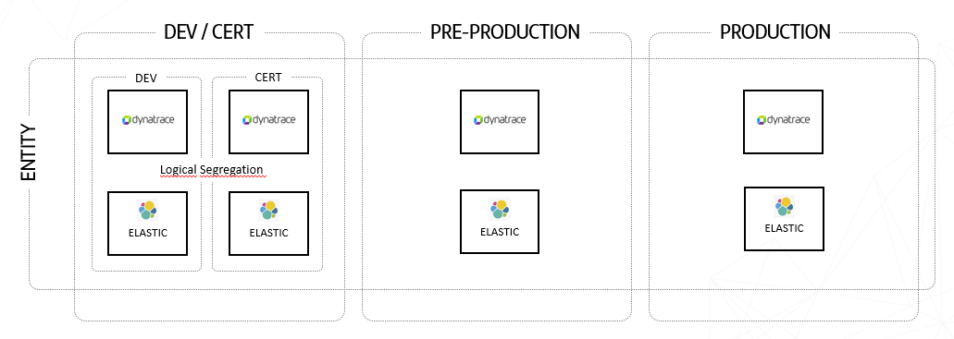
The observability solution should be as technology and cloud-provider agnostic as possible. There are cases where specific tools will need to be used, such as CloudWatch for collecting logs from AWS services (API Gateway or Lambdas). Some of the chosen tools may be new to some entities or may be used in other forms. For example, Dynatrace is proposed as SaaS in the reference architecture and is used as Managed Dynatrace in some entities.

Out of Scope
Observability should not:
- Impact the core function of the transaction. In the event of an error in signal ingestion for observability, the service should continue to execute normally to avoid impacting the customer experience.
- Maintain/control the state/situation of transactions.
- Generate information for audit or regulatory purposes.
- Serve as a SIEM (Security Information and Event Management).

Architecture

Macro-Architecture

Nowadays, most of the entities are managing 3 or 4 separated environments.
In this initiative, Gluon PaaS we are considering the scenario of having 3 physical environments but providing the capability of having 4 logical environments (DEV & CERT are logical divisions of the same physical environment).
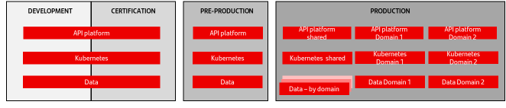
- DEV & CERT environments don’t need high availability and are normally deployed with the minimum required infrastructure. Depending on the number of developers and/or software deployed, it’s recommended to size this environment properly, even implementing high availability in certain components.
- PRE-PRODUCTION should be an identical replica of the PRODUCTION environment. If there are more than one PRO env, PRE must have the same size than the bigger PRO env.
- PRODUCTION environment is the most robust environment. Some components can be segregated by domains to ease scalability and resilience.

Conceptual Architecture

MicroFrontEnds

Sequence Diagram
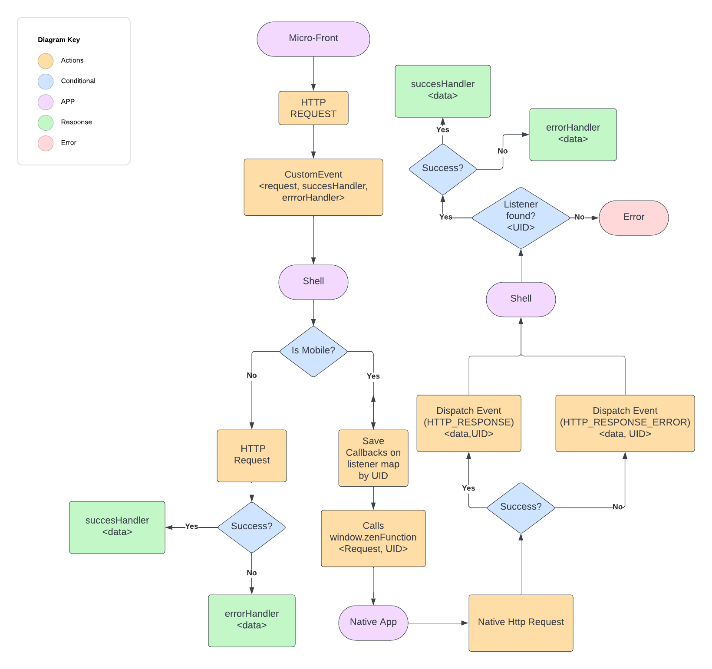

https://crispy-dollop-69krkre.pages.github.io/pages/common/components/architectural/

Global Load Balancing & Network

Sequence Diagram
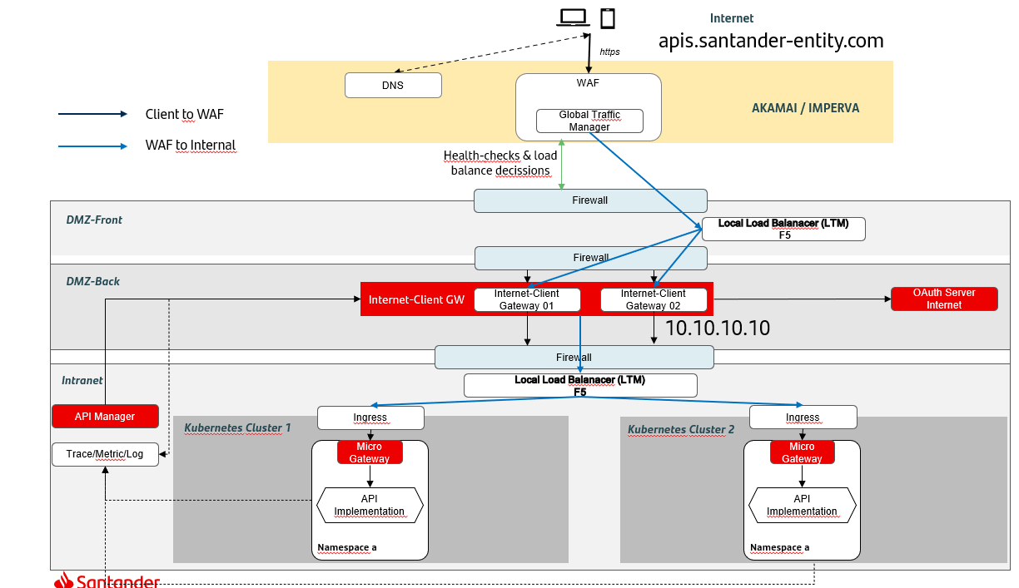

APIs

Sequence Diagram
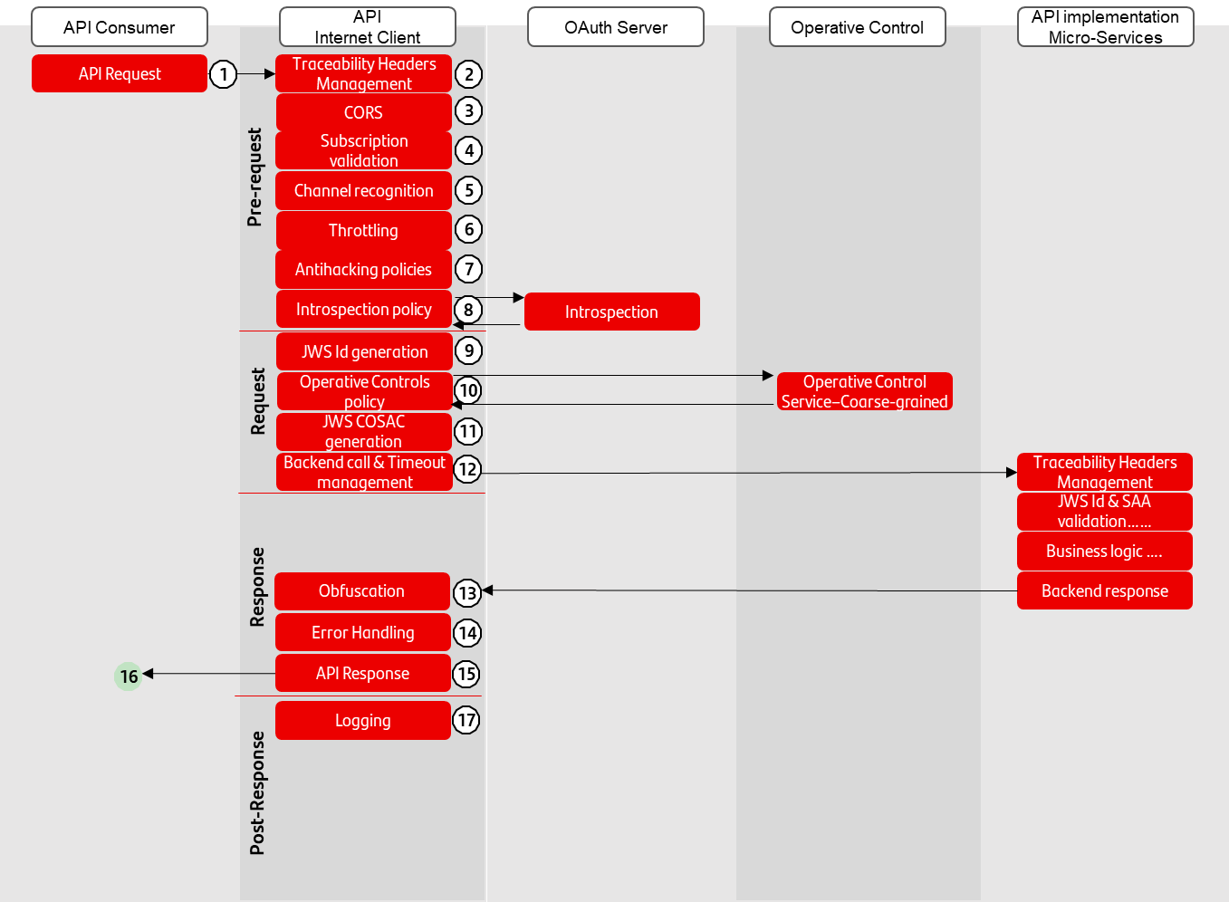
From a technical point of view, an API execution (request/response) can be divided in 4 different phases:
- Pre-Request: It’s the first stage of an API execution. It centralizes most of the security and API management checks before continuing.
- Request: Once the request has passed all the controls done in the previous phase, it prepares all the information required by the backend and call it
- Response: This phase receives the backend execution results, adapt the message if needed and sends the response to the API Consumer
- Post-Response: The last stage can execute some tasks in an asynchronous way, typically sending logs and analytics info to observability systems.
These are the steps that any API request must execute:
- API Request: An API consumer calls the API including the access token obtained previously. More info: Security Technical Solution - Access level control figure
- Traceability Headers Management: It ensures the end2end traceability by the generation & propagation of the proper headers. More info: https://santandernet.sharepoint.com/sites/SantanderPlatforms/SitePages/OBS_Tracing_and_log_correlation_standards_156521085.aspx
- CORS: Policy that manages properly any issue related to interactions between resources from “non-origin-domains”.
- Subscription validation: It verifies if the API consumer is subscribed to a plan that allows to consume the API. This control applies to all APIs, whether they are exposed to touchpoints or to other domains.
- Channel recognition: All the touchpoints will have a channel code that will be propagated to the microservices to adapt their behavior.
- Throttling: This policy controls if the request can be attended according to the number of calls at the API consumer has assigned in a time frame.
- Antihacking policies: See the details here: Input Validation policies
- Introspection: It sends the access token to the Authorization server to verify if the request can be executed and receives all the info related to the application and user. This policy must be configurable by OAuth server. More info: Security Technical Solution - Access level control figure and Authentication and Identity Policies
- JWS Id Generation: Policy in charge of the generation of the internal token that all the microservices will validate, containing all the required information related to identity information received in introspection. More info: JWS Id Token and JWS Id Token claims
- Operative controls: Coarse grain security checks upon general business data, acting as a first line of defense”. It relies on an external security service that implements the required logic. More info: Security Technical Solution - Operative Control figures
- JWS COSAC Generation: This policy generates a JWS linked to JWS Id token, containing more attributes related to security. More info: JWS COSAC and JWS COSAC Claims
- Backend call & Timeout Management: The request is forwarded to the micro-gateway which acts as the single point of access for the business logic. At this point, the operation timeout must be configured & controlled to force an error response in case it’s exceeded.
- Obfuscation (optional): Certain operations may need to hide some data to the consumers. This policy can be added optionally and configured to obfuscate this sensitive data: More info: Security Technical Solution - Obfuscation figure
- Error Handling: In case of receiving any error, it adapts the message body to the standardized format (more info: https://gluon.corp/community/docs/latest/gluon-apis/standards/std-design/):
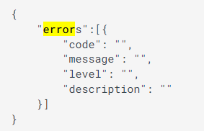
- API response: The response is sent to the API consumer, always using HTTP protocol.
- Logging: It builds and sends the log item to the logging platform. More info: https://santandernet.sharepoint.com/sites/SantanderPlatforms/SitePages/OBS_Log_standards_WIP_169220467.aspx and Observability

Microservices

Sequence Diagram
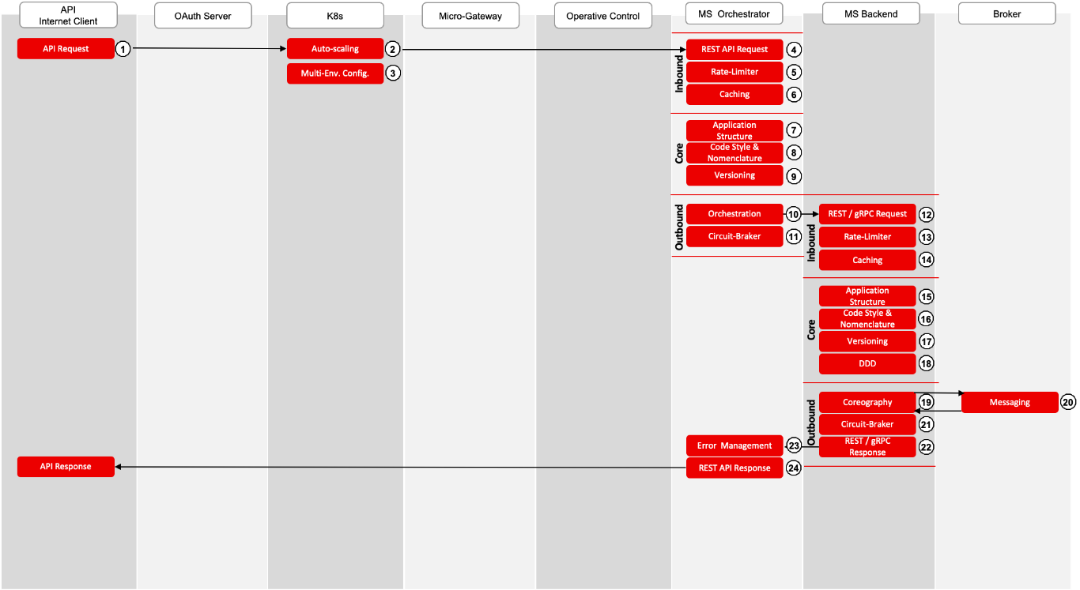

Kubernetes

Sequence Diagram
N/A

Gluon Data Persistence

Sequence Diagram
N/A

Security

Sequence Diagram

When the application calls the API
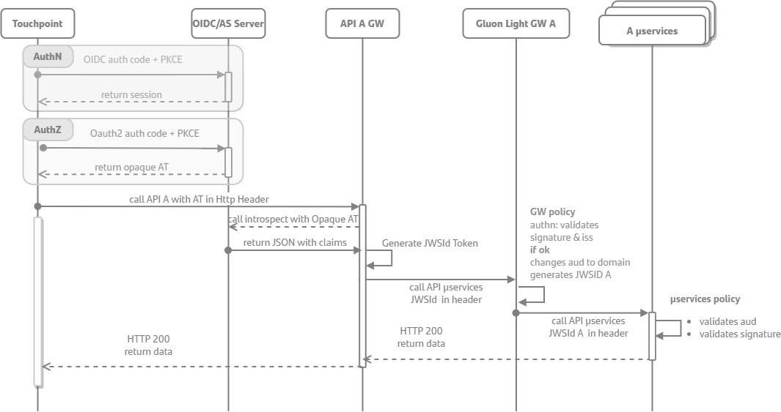

When a Domain A microservice calls Domain B API

Authorization
Will be based on control at microservices level that the audience of the token is for the Domain where the microservices are deployed.
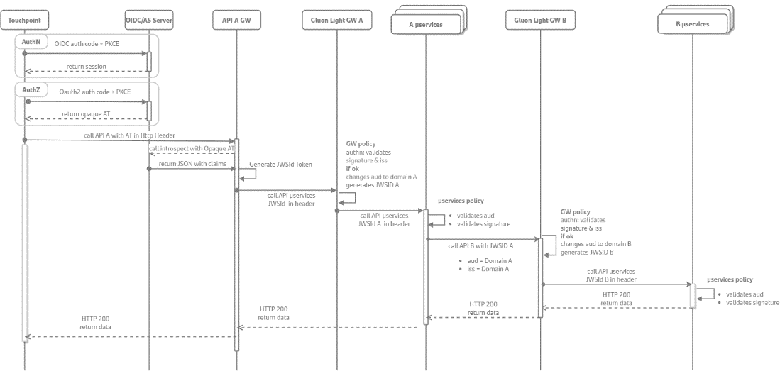

Diagram flow
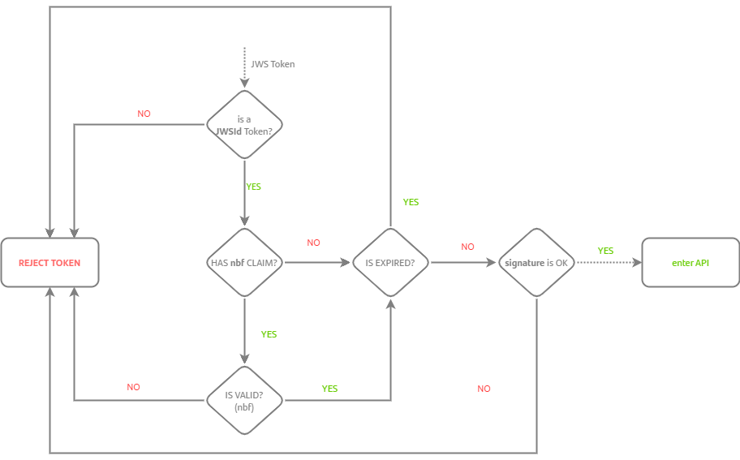

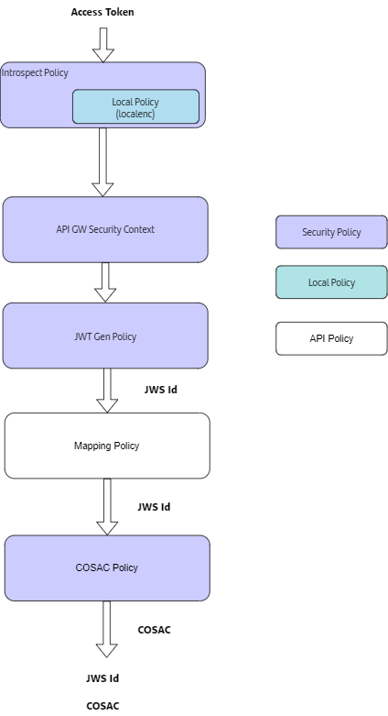

Observability

Sequence Diagram

Technical Architecture

MicroFrontEnds

Technical Solution

Global Load Balancing & Network

Technical Solution
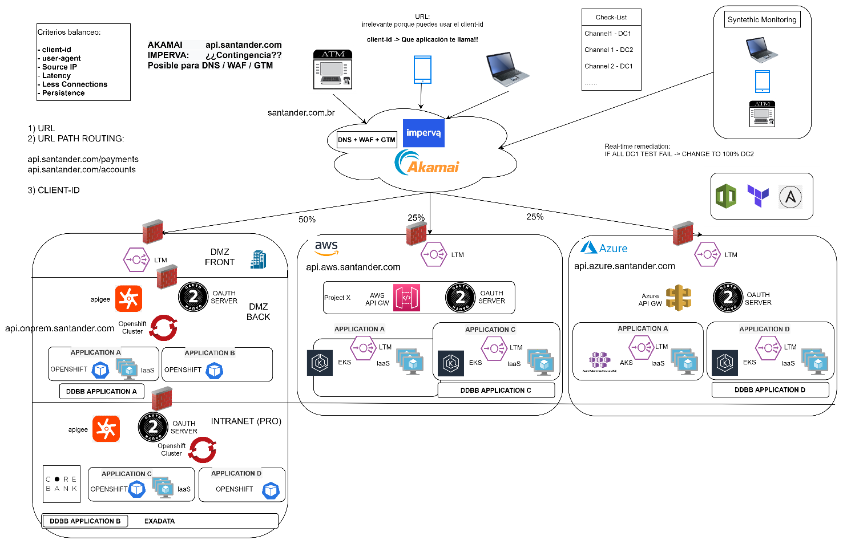

Observability

WAF Service
WIP (Akamai & Imperva OBS)

Local Load Balancing
To ensure the correct functioning of this service, it is considered necessary to monitor the following parameters:

HW Monitoring
- Global CPU -> Under 80%
- Individual CPUs > Under 95%
- License status
- Certifates expiration
- Power Supply status
- Failover status
- Interfaces (status, BW, errors, discards):
  - BW -> Under 90%
  - Errors -> Under 0.2%
  - Discards -> Under 0.5%

Service Monitoring
- Service status
- Backend Status (health-check failure)
- Global active sessions
- Active sessions per service

APIs

Technical Solution
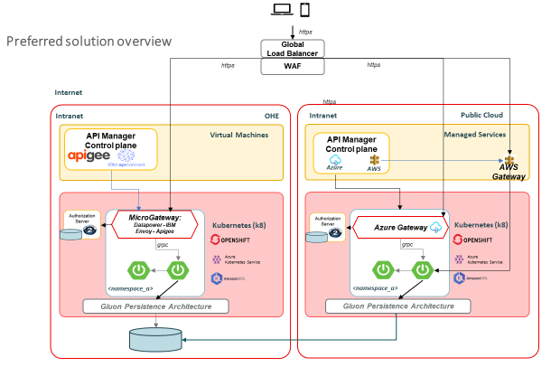
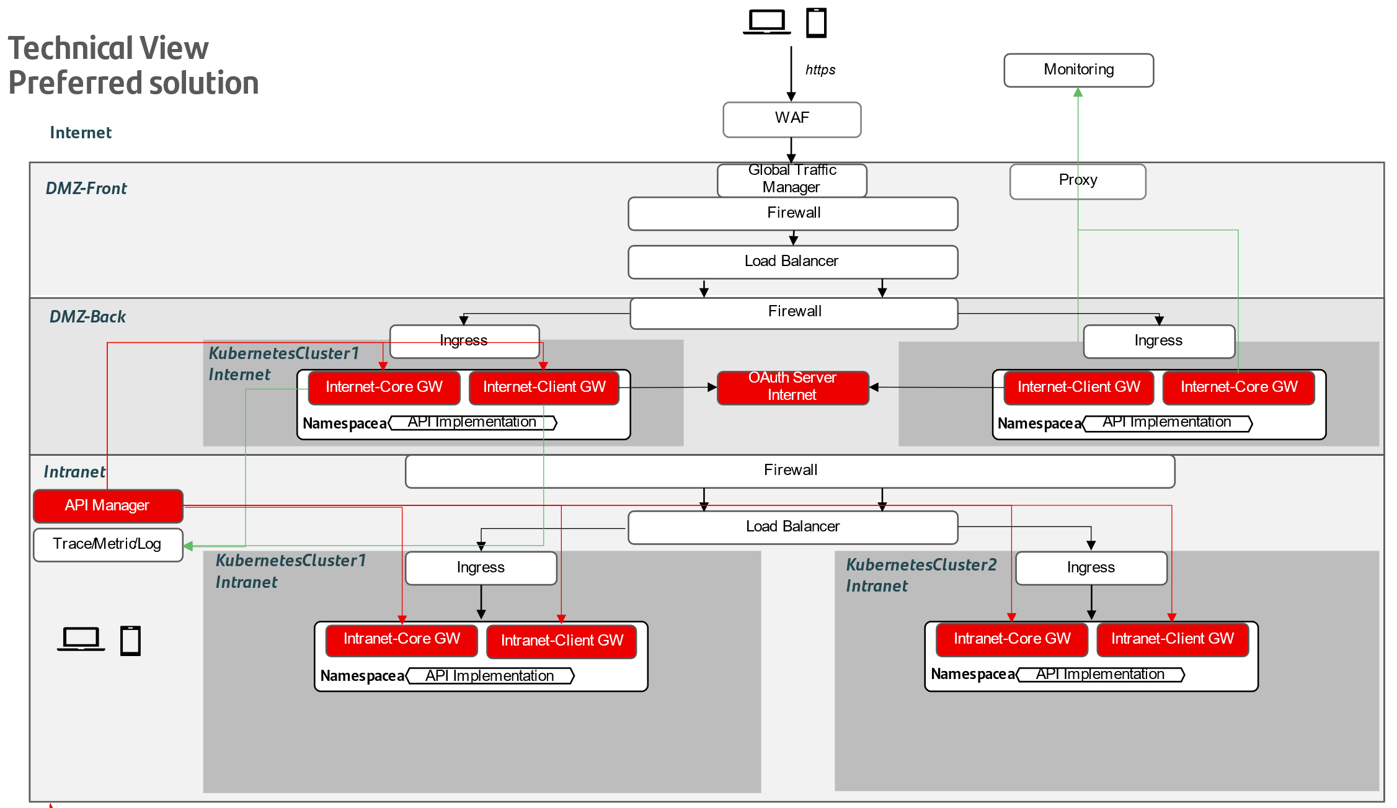
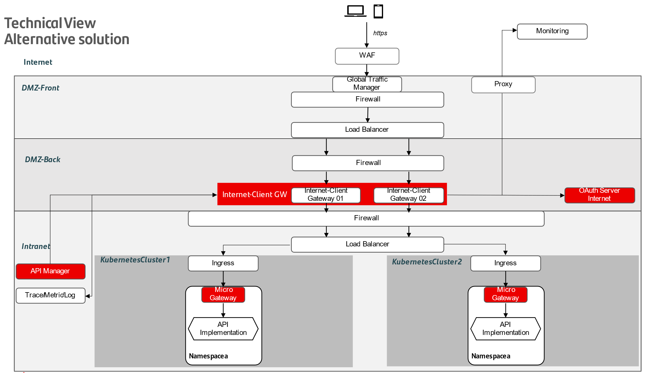

Microservices

Technical Solution
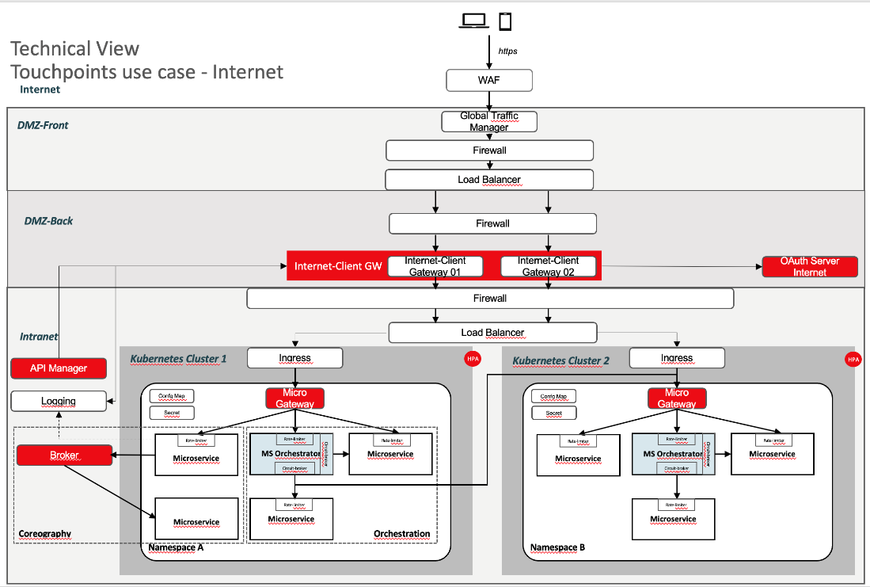
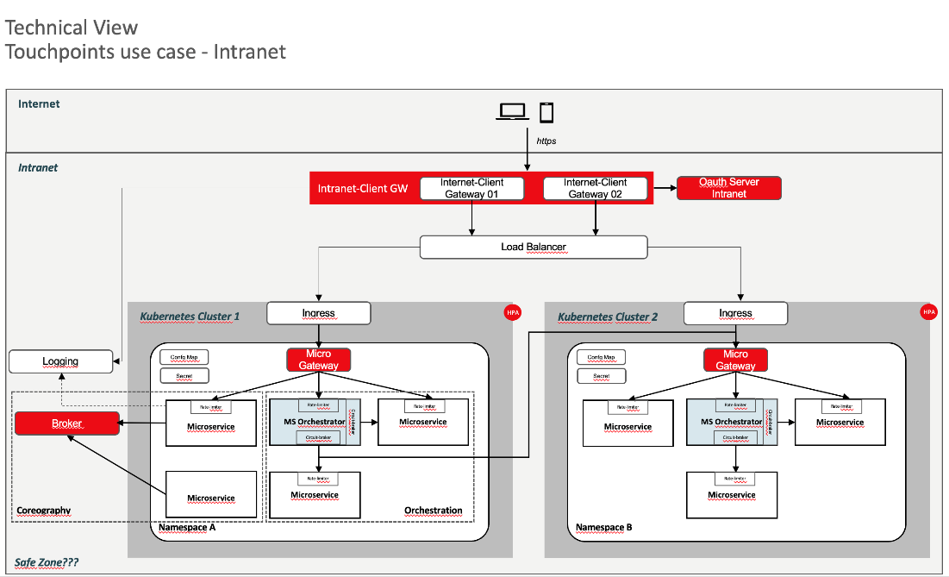

Kubernetes

Technical Solution

On-Prem: OpenShift
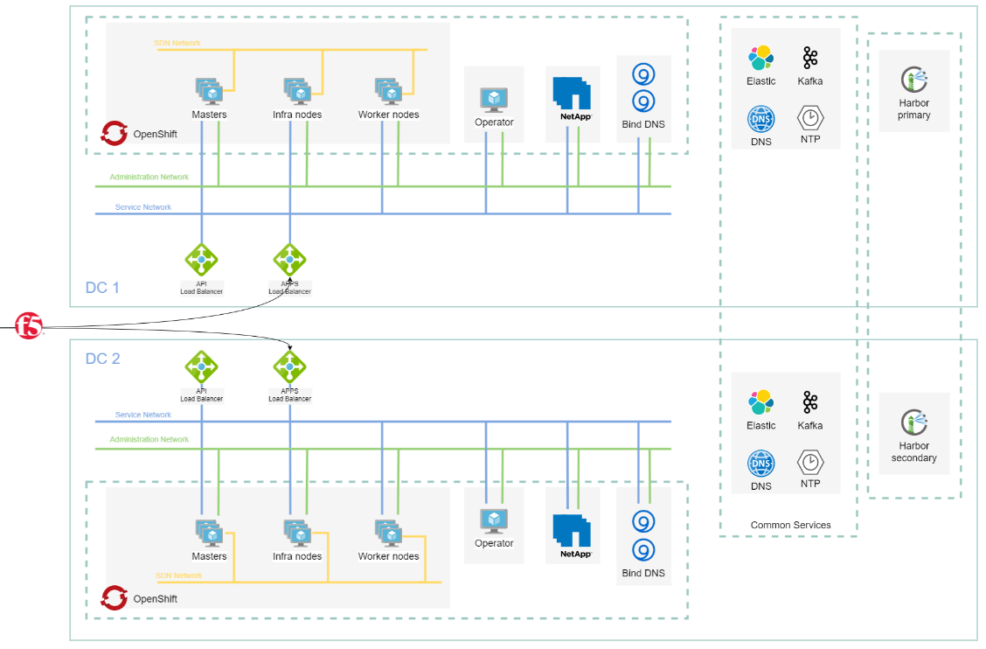

Gluon Data Persistence

Technical Architecture for Relational RDBS - Oracle

On Prem
- Architecture
  - OHE Interconnection and Networking - Interconnect and Networking Architecture v1.pptx
  - Sizing Guide
- SantanderOHE_ExaCC_WS1 - Sizing Guide_v01.pptx
- ExaCC Service - Commercial Consumption Models v2.pptx
  - Resilience $ DR - SantanderOHE_ExaCC_WS1_HLD - Resilence and DR v5.pptx
  - Backup - Workstream 4. Backup - To Be v11.PPTX
  - Isolation Model - ExaCC_IsolationModel_0_5.pptx
- Security and Compliance
  - Network Connectivity and Segmentation - Exadata - T1 - v0.7.pptx
  - Identity and Access Management - Exadata CC - Identity and Access Management (IAM) T2.1 Security requirements.docx
- Operation Model
- Delivery Model
- Installation and Migration

Non-Production Environments
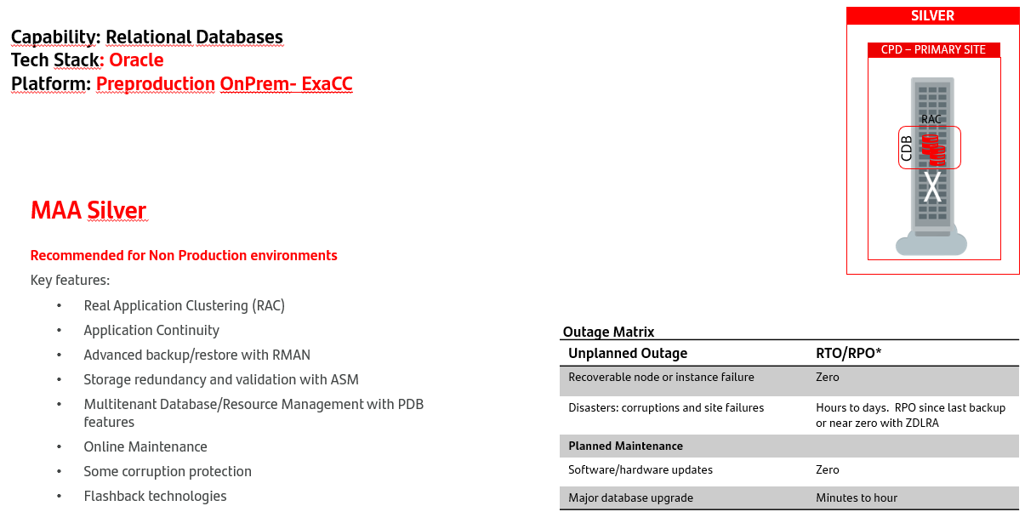

Production Environments
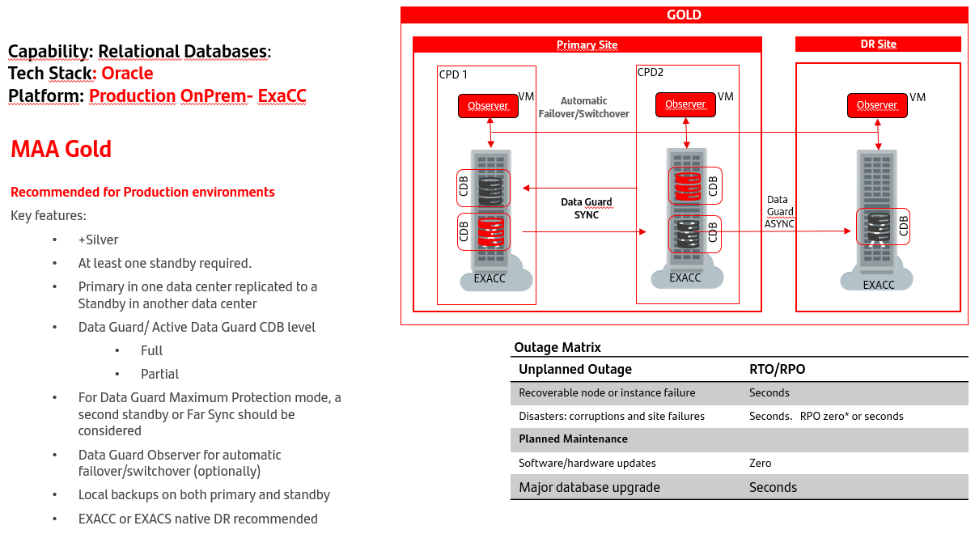

Technical Architecture for Documental Store – Mongodb

On Prem

Non-Production Environments
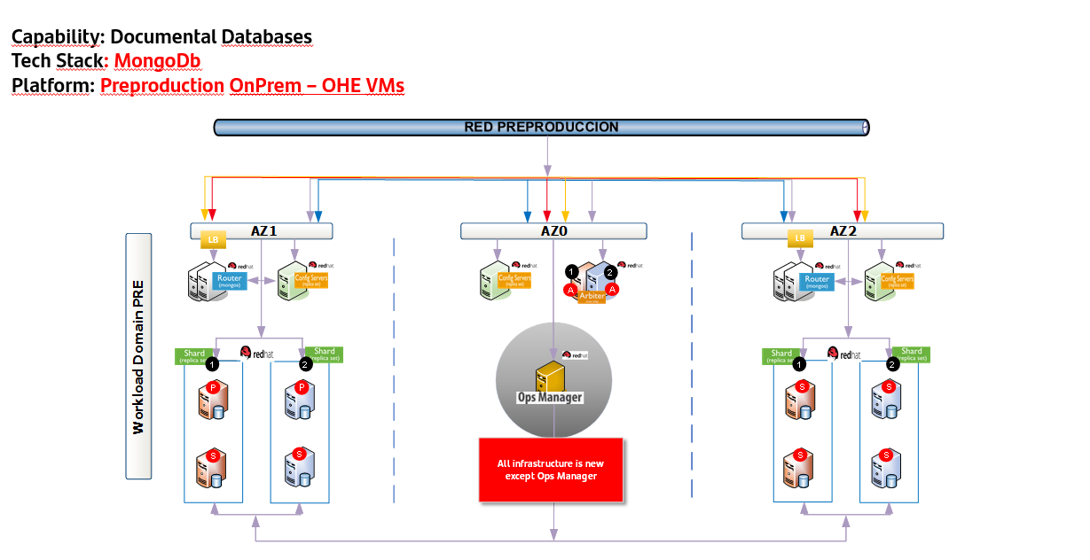

Production Environments
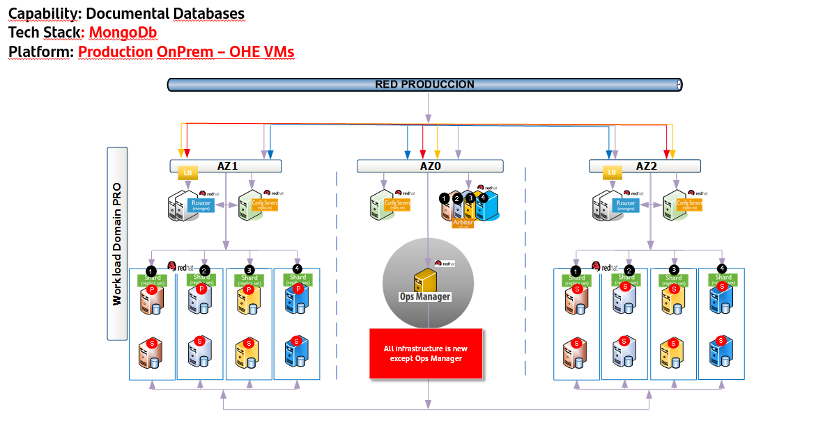

Technical Architecture for Key Value Store – Redis
Arsenal distributed cache library “arsenal-lib-distributed-cache" is the one used in Gluon. For more information check out its documentation

Production Environments
Currently production environments in OHE uses Redis in Kubernetes without synchronization between different clusters.
A distributed deployment with High Availability and multi-cluster synchronization would be necessary for some types of applications. This kind of application will use Redis Distributed Cache implemented in Virtual Machines outside the Kubernetes cluster.

Security

Technical Solution
Context
Explain the technical security architecture for application consumption of APIs.
The following sections show how the APIs are consumed from the touchpoints (web, mobile, etc.) to the secure communication between the APIs themselves (per domain).
https://santandernet.sharepoint.com/sites/SantanderPlatforms/SitePages/Technical-API-Secure-Architecture.aspx 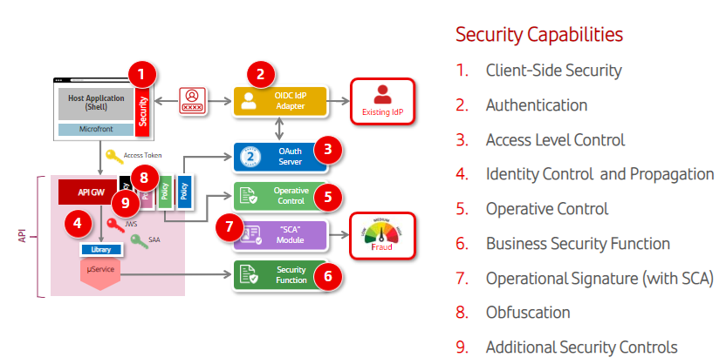

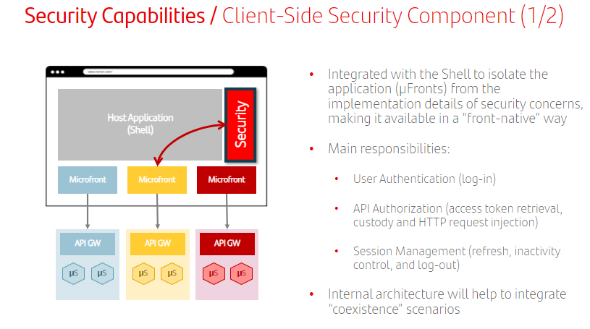
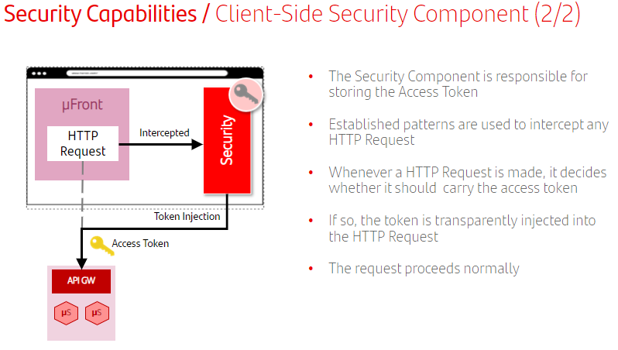

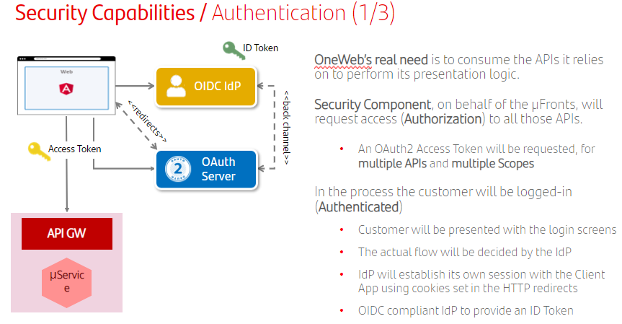

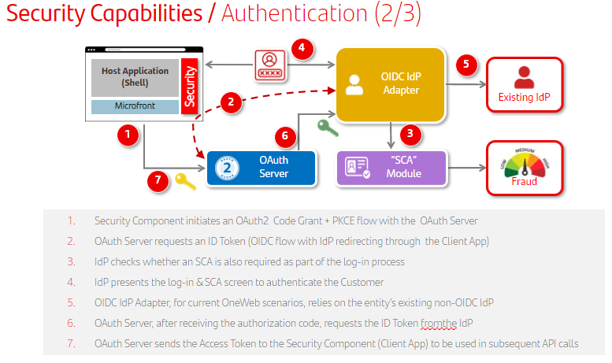
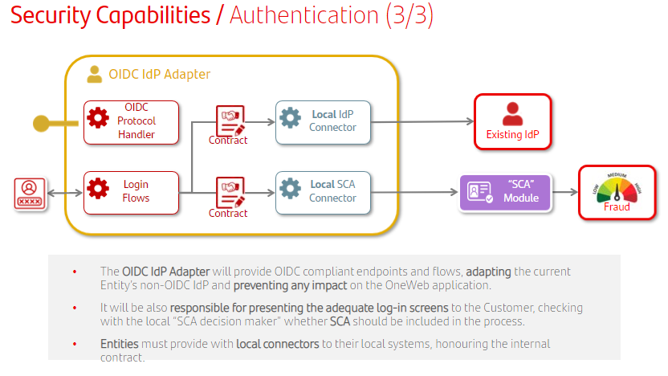

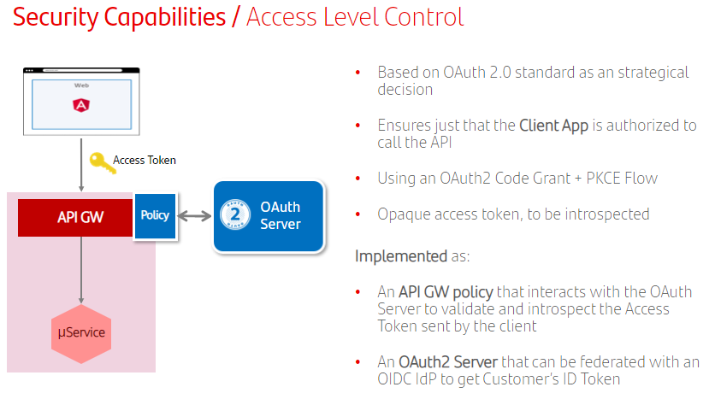

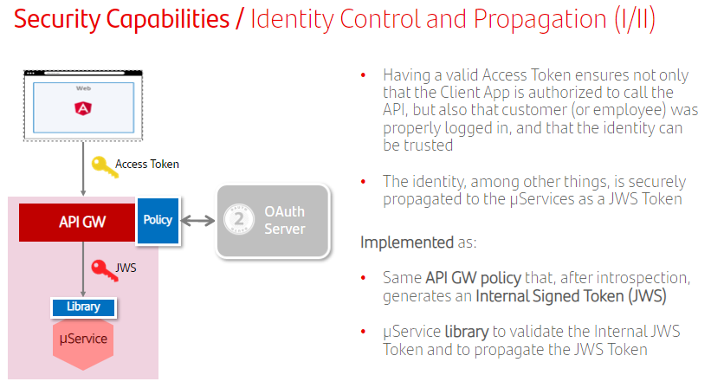
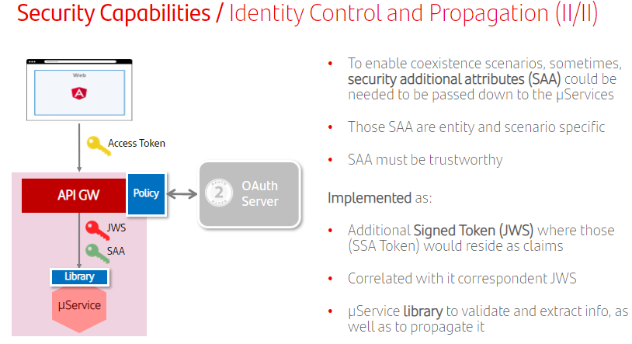

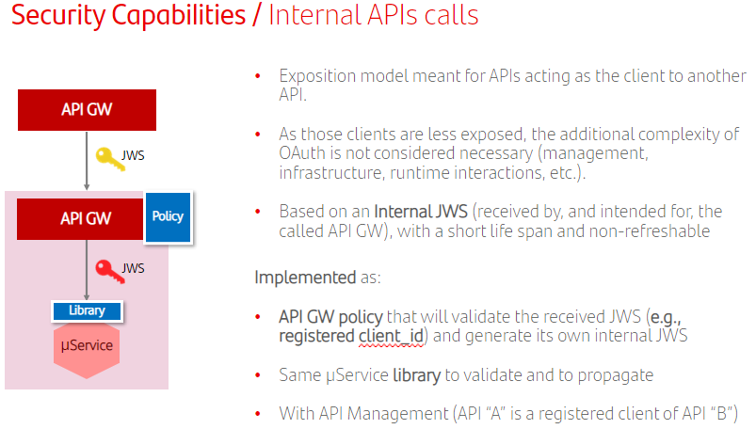

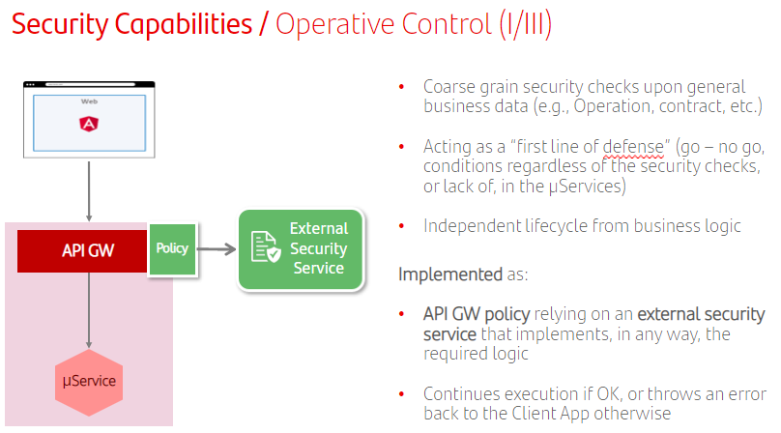
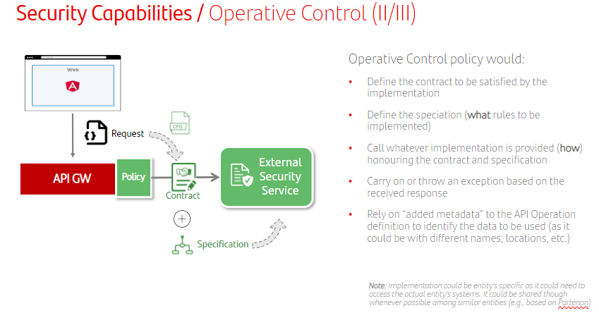

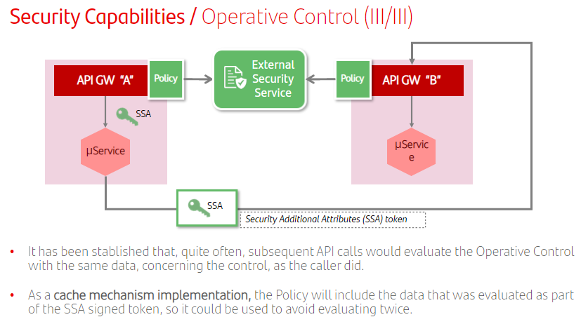

Information on the scope of the operational control component can be found at the following link: https://santandernet.sharepoint.com/sites/SantanderPlatforms/SitePages/Channel-operational-security.aspx
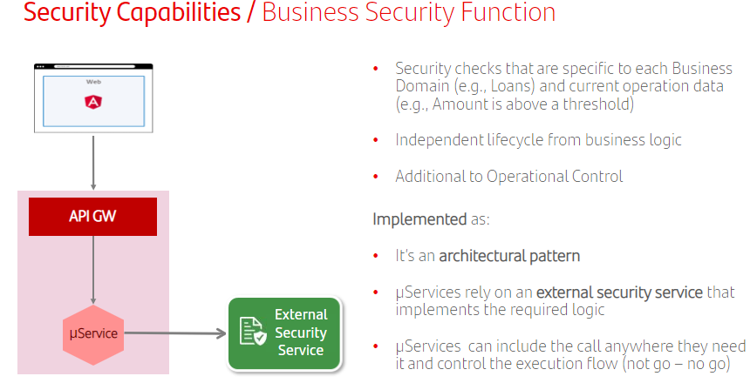
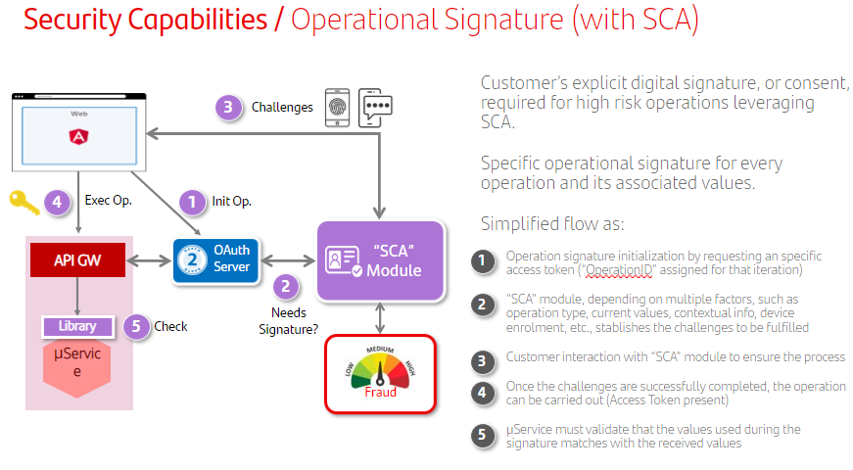

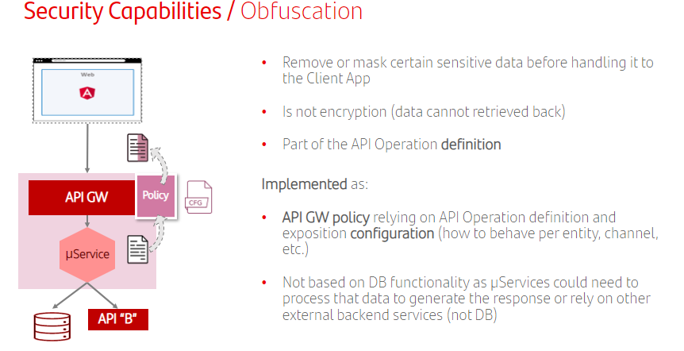

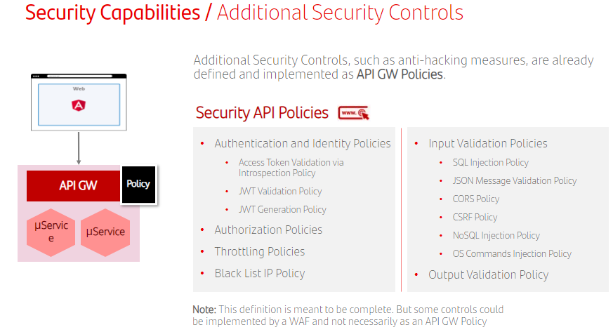

Identity & Channel Operative Security Control JWS claims

Identity
These are the claims included in the JWS Id token, generated or regenerated at External/Internal API GW
https://santandernet.sharepoint.com/sites/SantanderPlatforms/SitePages/Identity-%26-SAA-JWT-claims(1).aspx

Security Policies
https://santandernet.sharepoint.com/sites/SantanderPlatforms/SitePages/API-Security-Policies.aspx

Observability

Technical Solution
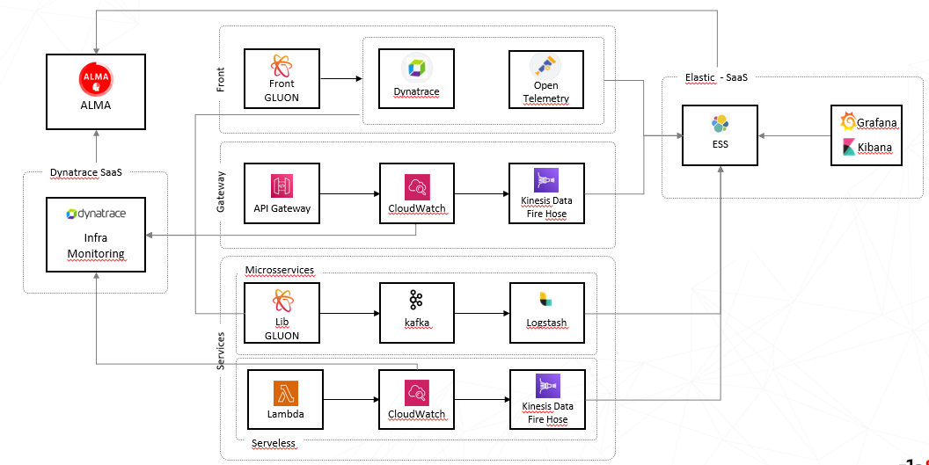

Deployment Architecture
- The first proposed scenario for testing the End2End for API &Microservices in Gluon PaaS is:
  - Global Position App Web or Mobile accessed via Internet.
  - Full deployment in OHE
- According to the technical architecture, the components identified to be deployed are:
- Imperva WAF to expose the touchpoint to internet.
- Local Traffic Managers to Load balance between the two OHE sites
- API Managers to be tested: APIGee and IBM API Connect v10
- Kubernetes clusters to deploy:
  - Structural capabilities:
    - Security for the final users (Oauth Server – SOS – Users PKM)
    - Security for Micros (Micros PKM)
  - Static content for the Touchpoints
  - Touchpoint API implementation (Gw+ Micros)
  - Interdomain/product API implementation (Gw + Micros) (i.e: accounts, cards, etc)
- Data Persistence capabilities:
  - Redis Distributed cache
  - Exadata for Relational / Documental database
- Observability:
  - Dynatrace tenant (management zone)
  - ALMA Elasticsearch for logging

Infrastructure requirements:
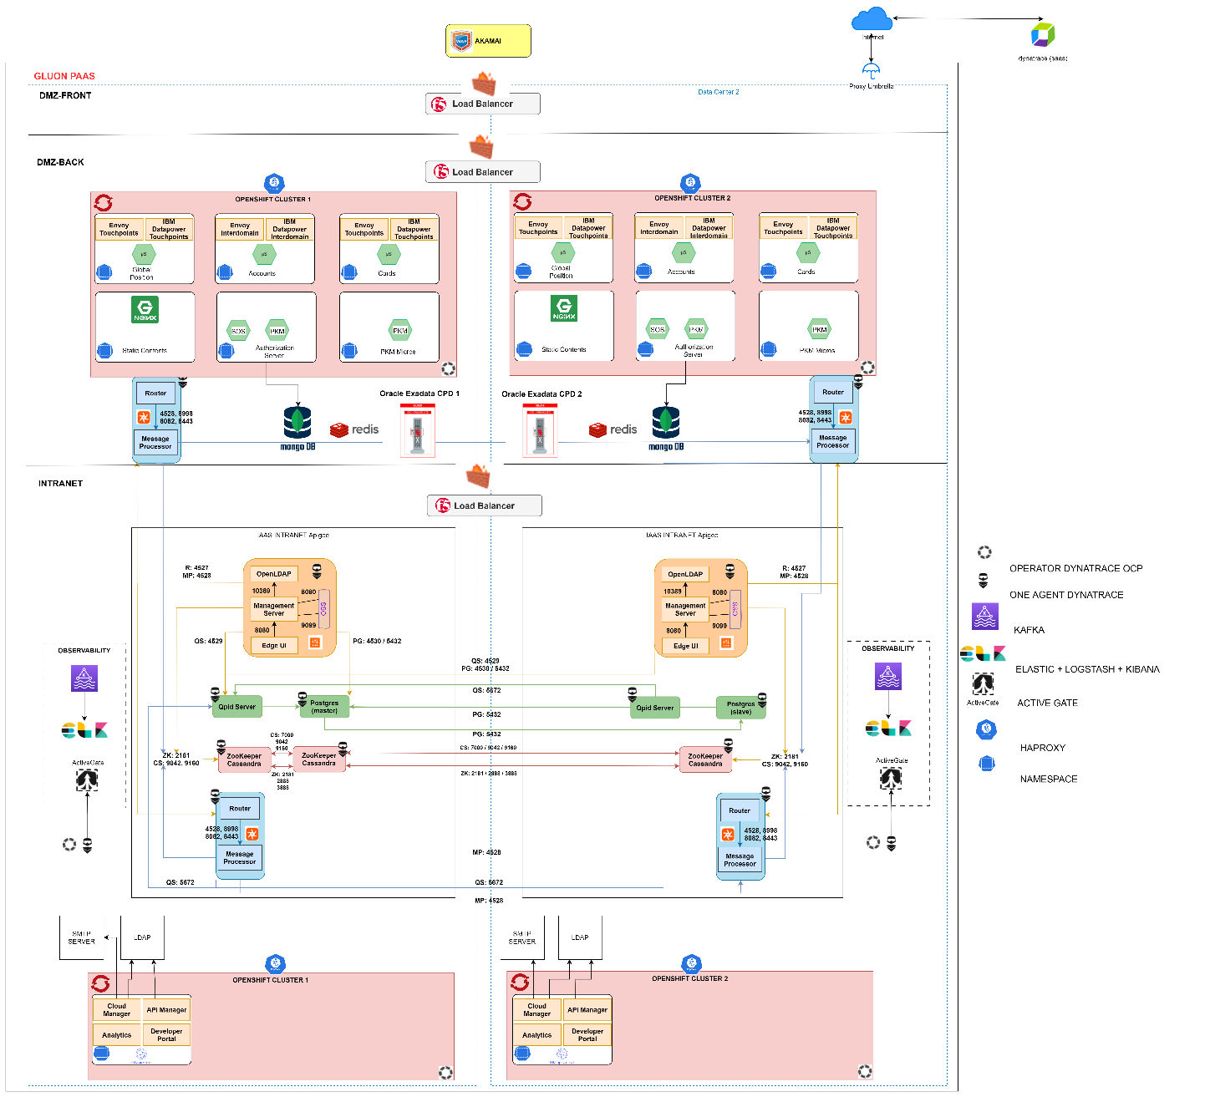

Gluon PaaS – Scenario 1 for µFrontEnd deployment: OHE
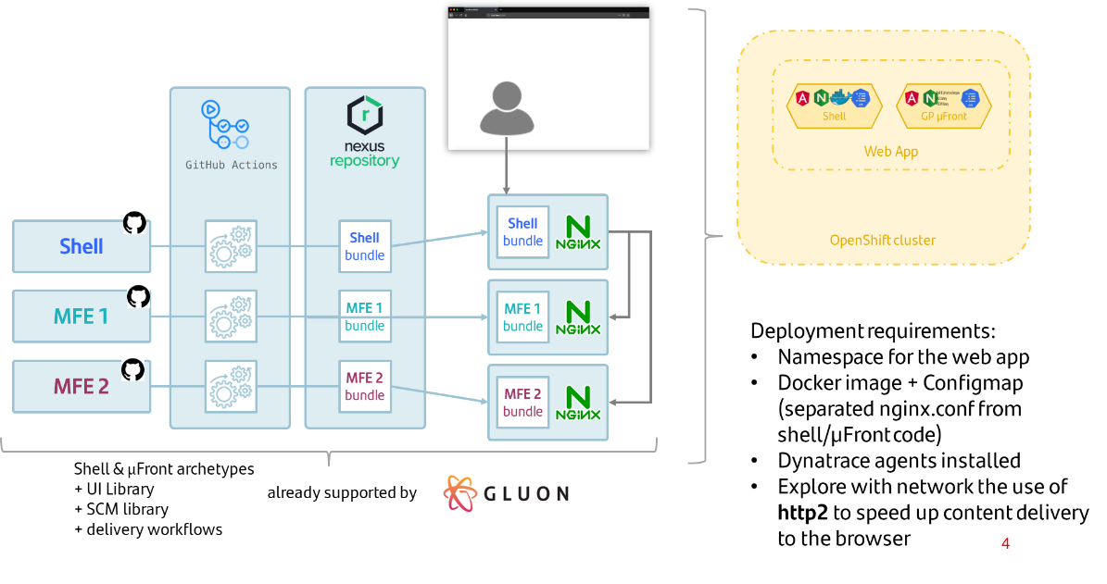
Gluon PaaS – Apigee Requirements
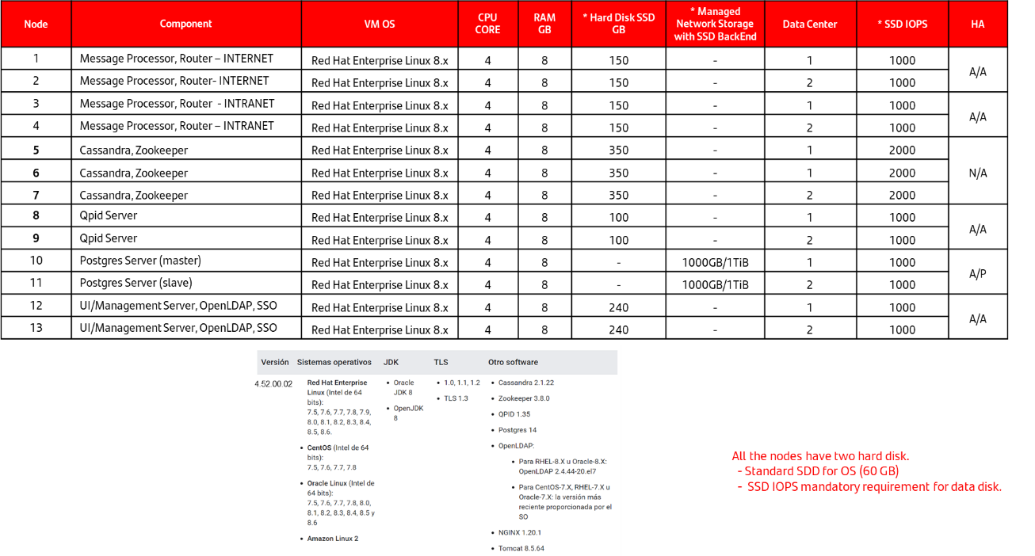
Gluon PaaS – Security Components Requirements
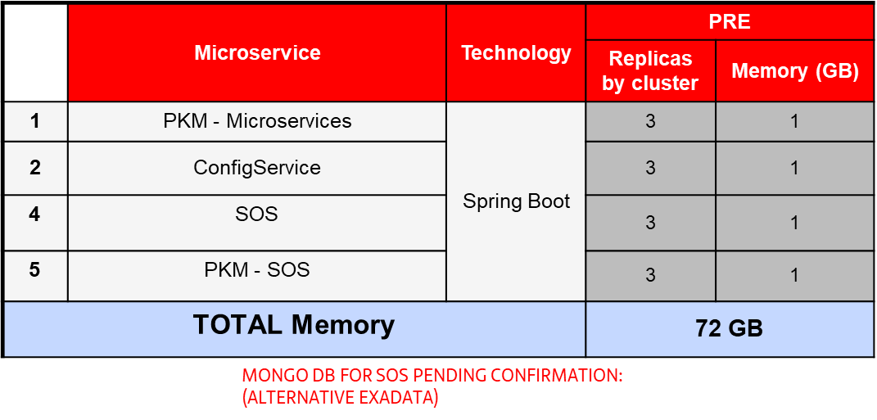

Gluon PaaS – Oracle Exadata Requirements
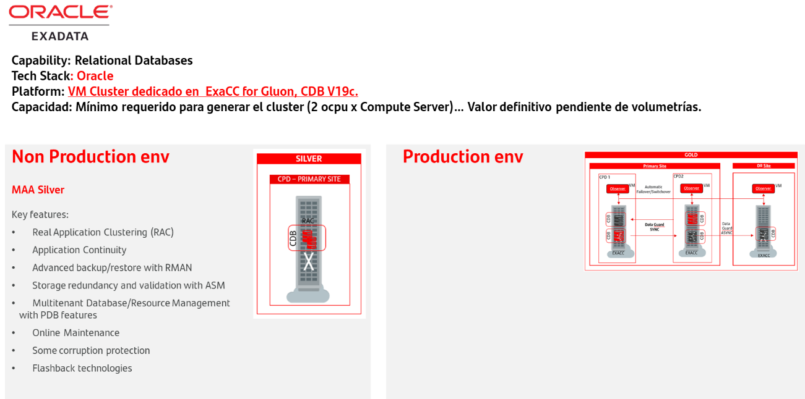

Gluon PaaS – Redis Distributed Cache Requirements
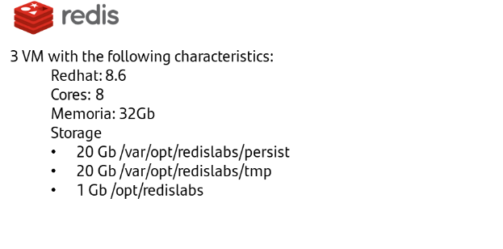
Gluon PaaS – Observability Requirements
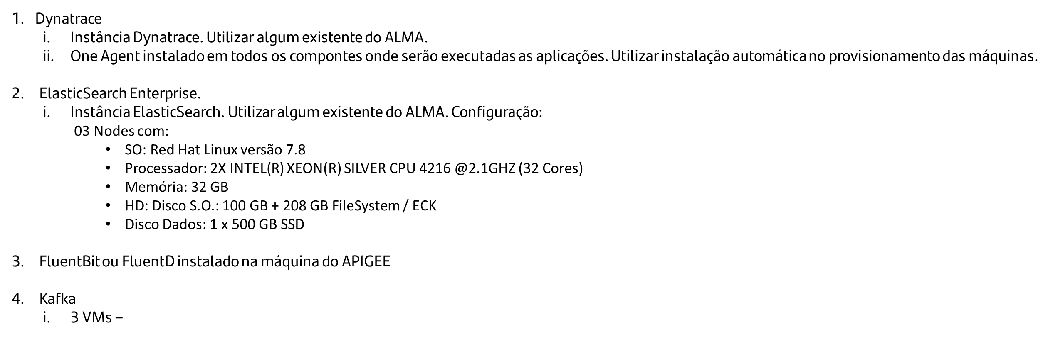


Glossary

Annexes

