Problem: Prediction of Protein Structures in the hydrophilic-hydrophobic model - U-fold algorythm

Solution: The simplest way to fold a string is to find a suitable point to split the string into two strings. These two strings are folded against each other such that they are adjacent in the lattice. This creates a U structure in the lattice model.

Algorithm: Folding-point (selecting the folding point)

Input: A sequence , where each s_{i} {0, 1}.

Output: A folding point of U-fold.

Step 1: Let each block have the form or , where , is a string consisting of only 0 of odd length and . Decompose S into , where , is a string of only 0 of even length and and may consist of even or odd length.

Step 2: Label each block with two categories alternatively: x-block and y-block. So that the sequence can be represented as . Let is the number of 1's in Let X and Y be the number of 1's in all x-blocks and y-blocks, respectively. Notice that , or if then we should start labeling with the y category of blocks, so that the number of x-blocks is greater than or equal to that of y-blocks. For example:
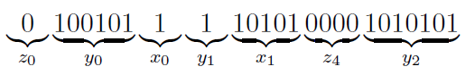
Step 3: Let ,are the number of 1's in x-blocks and the number of 1's in the y-blocks of S, respectively. Threat the protein instance as an alternating sequence of integers that represent the number of 1's in the x- and y-blocks. Iteratively select folding points (a folding point should be between blocks) that partitions S into and such that is maximized.

Algorithm: U-fold (The U-fold alignment)

Input: A sequence , where each s_{i} {0, 1}.

Output: A conformation of U-fold.

Step 1: Use Algorithm Folding-point to find the folding point and then split the strign into two substrings at the folding point.

Step 2: Reverse the second substring and find an optimal alignment betheen the two substrings to get the maximal score. Use Smith-Waterman sequence alignment algorithm. Keep in mind that the gaps should always have an even length (except at the beginning of the substrings) so add two gaps instead of one where necessary.
Step 3: Put the result on the lattice.

An example of the U-fold Algorithm

Input: A given sequence S = 0100101001110101000010.

Output: A conformation of the U-folg.

Step 1: Label the string anf find the folding point by applying Algorithm Folding-Point.
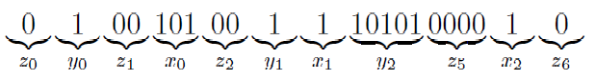
Devide the string into two substrings.
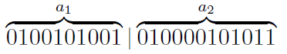
Step 2: Find an optimal alignemnt of the two substrings.
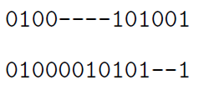
Step 3: Put the result on the lattice.
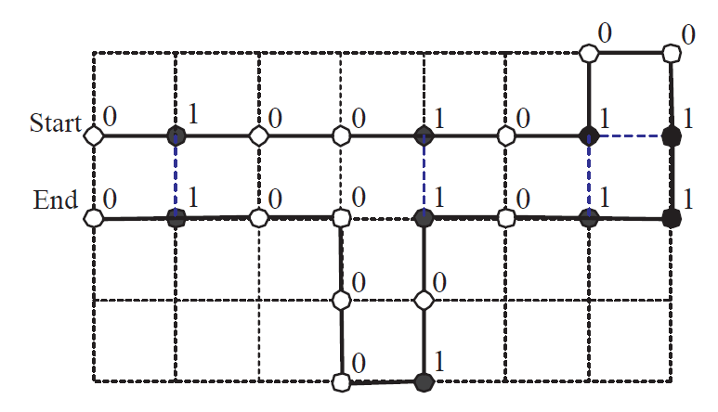
Bibliography

For more information about the HP model and U-fold algorithm see:
[1] Prediction of Protein Structures Based on Curve Alignment, A Thesis Submited to the Faculty of Department of Computer Science and Engineering National Sun Yat-sen University by Yi-Ying Chen, July 12, 2002
[2] W. Hart and S. Istrail, "Fast protein folding in the hydrophobic-hydrophilic model within three-eights of optimal", Journal of Computational Biology, Vol. 3, No. 1, pp. 53-96, 1996.

For more information about Smith-Waterman sequence alignment algorithm see:
[3] http://www.avatar.se/molbioinfo2001/dynprog/adv_dynamic.html

