Assignment Report

Spam Classification of

Text Messages


MTech CSE(AI)

Submitted by: Ranjan Kumar Roll No: 2422118

Supervised by: Prof. Ramanujam Sir

Dataset Used

Dataset Details:
- Total samples: 2,000
- Class Distribution: 1,237 negative (ham), 763 positive (spam)
- Features: 8 features to be extracted from text messages.

Dataset Sample
The first five samples of the final dataset are shown below:

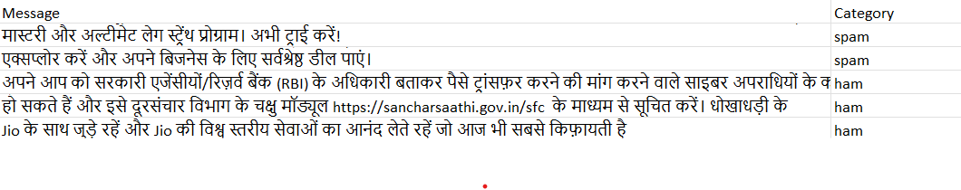 Figure 1: Sample Dataset

Spam Distribution
    - Ham (Negative Messages): 1,237 samples
    - Spam (Positive Messages): 763 samples

Features Extracted
The following features were extracted from the messages:
- message length: The length of the message.
- word count: Total number of words in the message.
- has url: Whether the message contains a URL.
- has phone: Whether the message contains a phone number.
- has money: Whether the message mentions monetary values.
- special char count: Number of special characters in the message.
- spam word count: Number of spam-related words present.
- TF-IDF score: The Term Frequency-Inverse Document Frequency (TF-IDF) score tells the importance of words with respect to a document in a corpus.
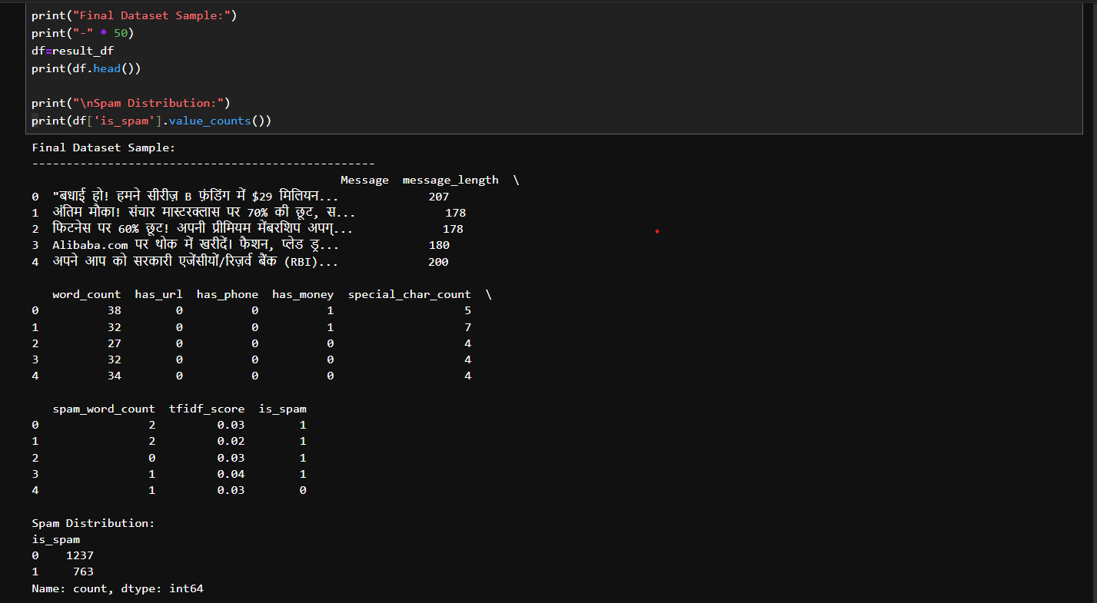
Figure 2: Extracted Features

Classification and Evaluation:
For classification, the Lazy Predict library was used to evaluate various machine learning models. The code and results are as follows:

Code Snippet

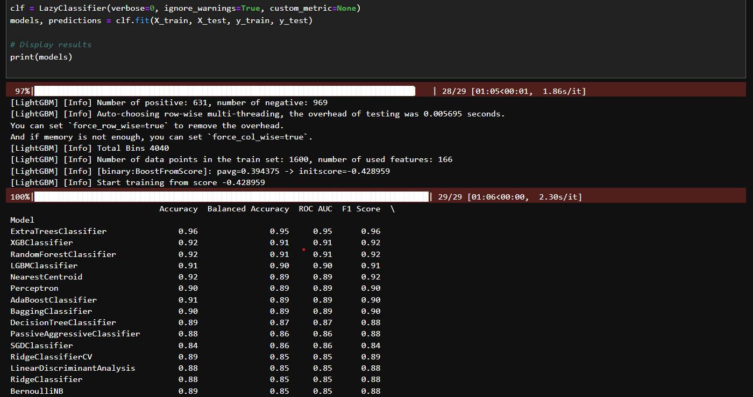
Figure 3: Code Snippet for Lazy Predict Evaluation

Observations
    - The ExtraTreesClassifier achieved the highest accuracy (96%) and balanced ac- curacy (95%).
    - The RandomForestClassifier achieved an accuracy of 92%.

Conclusion
The Lazy Predict evaluation provides a quick benchmarking of models. Based on the results:
- The ExtraTreesClassifier is recommended for its high accuracy and balanced accuracy.
- Future work could include addressing class imbalance and testing ensemble methods.

