Untitled

Ram Ghimire

# **Title**

## Section 1

## # A tibble: 1,704 x 6  
## country continent year lifeExp pop gdpPercap  
## <chr> <chr> <dbl> <dbl> <dbl> <dbl>  
## 1 Afghanistan Asia 1952 28.8 8425333 779.  
## 2 Afghanistan Asia 1957 30.3 9240934 821.  
## 3 Afghanistan Asia 1962 32.0 10267083 853.  
## 4 Afghanistan Asia 1967 34.0 11537966 836.  
## 5 Afghanistan Asia 1972 36.1 13079460 740.  
## 6 Afghanistan Asia 1977 38.4 14880372 786.  
## 7 Afghanistan Asia 1982 39.9 12881816 978.  
## 8 Afghanistan Asia 1987 40.8 13867957 852.  
## 9 Afghanistan Asia 1992 41.7 16317921 649.  
## 10 Afghanistan Asia 1997 41.8 22227415 635.  
## # ... with 1,694 more rows

### Section 2

## # A tibble: 6 x 6  
## country continent year lifeExp pop gdpPercap  
## <chr> <chr> <dbl> <dbl> <dbl> <dbl>  
## 1 Australia Oceania 1982 74.7 15184200 19477.  
## 2 Australia Oceania 1987 76.3 16257249 21889.  
## 3 Australia Oceania 1992 77.6 17481977 23425.  
## 4 Australia Oceania 1997 78.8 18565243 26998.  
## 5 Australia Oceania 2002 80.4 19546792 30688.  
## 6 Australia Oceania 2007 81.2 20434176 34435.

We have 6 rows of Australian data

#### Section 3

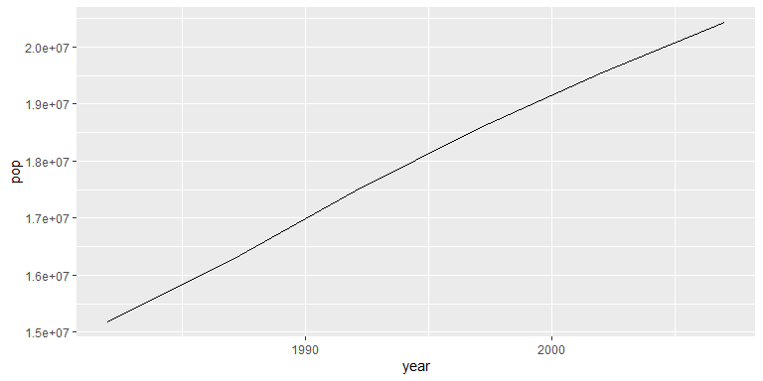

## [1] '3.6.3'

## [1] '1.3.0'