

***Sustainable Impact at Home Majra Guidelines***



***Table of Contents:***

**1.**  **Introduction**

**2.**  **Framework**  
 a. Transforming Waste into Resources: A Guide to Used . Cooking Oil Recycling in the UAE  
 b. Transforming Waste Into Resource: A Guide to Decluttering .

. Households in the UAE  
 c. Transforming Waste Into Resource: A Guide to Responsible . Donations in the UAE  
 d. Contributing Time and Inspiring Others to Volunteer:  
 A Guide to Responsible Volunteering in the UAE

**3.**  **Conclusion**



***Introduction***

Embracing sustainability in our daily lives is vital for the well-being of our planet and future generations.

By adopting sustainable habits, individuals can signifcantly reduce their environmental impact, conserve valuable resources, and contribute to a healthier world.

Inspired by the wise words of His Highness Sheikh Zayed Bin Sultan Al Nahyan, may his soul rest in peace, who said, “On land and in the sea, our forefathers lived and survived in this environment.

They were able to do so because they recognized the need to conserve it, to take from it only what they needed to live, and to preserve it for succeeding generations.”

In alignment with this vision, this guideline aims to provide practical steps for promoting sustainability at home, empowering households to take responsibility for their envi-ronmental footprint and work towards a greener future



***Purpose of this Guideline***

The importance of integrating sustainable practices within our homes cannot be overstated, as it plays a critical role in ad-dressing the environmental challenges we face today.

This guideline, developed with the support of the National CSR Fund, ofers actionable recommendations for households to implement sustainable measures in various aspects of their daily lives.

By following these guidelines, individuals can not only reduce their impact on the environment but also save money and foster a sense of environmental stewardship in their communities.



***Framework***

***Transforming Waste into Resources:***

***A Guide to Used Cooking Oil Recycling in the UAE***

Adopting sustainable practices within households is crucial for mitigating the environmental impact of our daily activities and promoting a greener future.

One often overlooked area of waste management is the proper disposal and recycling of used cooking oil.

In the UAE, Bee'ah Tandeef has initiated a pioneering program to recycle used cooking oil, transforming it into biodiesel and contributing to a zero-waste future.

This guideline aims to raise awareness about the importance of recycling used cooking oil and provide practical steps for households to participate in this innovative initiative.



***Proposed Ideas for Recycling Used Cooking Oil***

1. Participate in Bee'ah Tandeef's Used Cooking Oil Recycling

2. Educate Family Members and Friends about the Importance

Service of Recycling Used Cooking Oil

- **Obtain a used cooking oil collection . bottle by calling 800 TANDEEF**   
**. (826333).**

- **Store used cooking oil in the provided . bottle until full.**

- **Deposit the full bottle at a designated . used oil collection machine in your . community.**

- **Receive a new empty bottle from the . . collection machine forfuture use.**

3. Monitor Your Cooking Oil

- **Share information about the**   
**. environmental benefts of recycling . used cooking oil.**

- **Discuss the harmful efects of improper . disposal, such as clogging plumbing . systems and generating greenhouse . gases.**

- **Encourage others to participate in . Bee'ah Tandeef's used cooking oil . recycling service.**

4. Advocate for the Expansion of

Usage Used Cooking Oil Recycling

Programs

**.**

- **Opt for healthier cooking methods that . require less oil, such as baking,**   
**. steaming, or grilling.**

- **Reuse cooking oil when appropriate . and safe, ensuring it has not become . rancid or contaminated.**

- **Measure the amount of cookingoil . used to prevent waste and minimize . the need for disposal.**

**- Contact local authorities or community . leaders to request the installation of . used oil collection machines in your . area.**

- **Support the rollout of collection . machines in other communities in . Sharjah and across the UAE.**

- **Promote the concept of a circular**   
**. economy by highlighting the benefts . of converting used cooking oil into . biodiesel.**



By implementing these guidelines, households in the UAE can actively contribute to a sustainable future, reduce waste, and support innovative initiatives like Bee'ah Tandeef's used cooking oil recycling service.

We can work towards a cleaner environment and a more circular economy with collective eforts.

***Transforming Waste Into Resource:***

***A Guide to Decluttering Households in the UAE***

In today's fast-paced world, accumulating clutter and unwanted items is a common occurrence for many households.

Decluttering not only helps create a cleaner, more organized living space but also contributes to a more sustainable environment by promoting responsible waste disposal and recycling.

In the UAE, several businesses ofer free junk collection ser-vices, ensuring that reusable items are repurposed or do-nated.

This guideline will provide practical steps for decluttering your home in the UAE and making use of available services to transform waste into valuable resources.



***Proposed Ideas for Decluttering and Responsible Disposal***

1. Assess Your Belongings and

Identify Unwanted Items

- **Regularly evaluate the items in your . home to determine what is no longer . needed or used.**

- **Sort through clothes, furniture,**   
**. appliances, and other possessions, . identifying items for disposal,**   
**. donation, or recycling.**

- **Create separate piles or boxes for items . to be discarded, donated, or recycled.**

3. Make Use of Bee'ah's "You Call

We Haul" Service for Sharjah

Residents

**.**

- **If you are a resident of Sharjah, take . advantage of Bee'ah's free "You Call . We Haul" service for disposing of bulky . waste.**

- **Schedule a pick-up by calling Bee'ah at . 800 WASTE (92783) or using their**   
**. mobile app.**

- **Follow Bee'ah's guidelines for**   
**. preparing your bulky waste items for . collection.**

2. Utilize Free Junk Collection

Services in the UAE

- **Research local businesses that ofer . free junk collection services for your . unwanted items.**

- **Schedule a pick-up for your unwanted . items by contacting the chosen service . provider.**

- **Ensure that items are in a suitable . condition for pick-up, following any . guidelines provided by the service . provider.**

4. Donate and Repurpose Items

to Support Local Communities

**- Consider donating gently used**   
**. clothing, furniture, and appliances to . local charities or individuals in need.**

- **Repurpose or upcycle items to give . them a new life, reducing waste and . promoting resourcefulness.**

- **Support the mission of free junk**   
**. collection services by utilizing their . services for your decluttering needs, as . they often donate reusable items to . underprivileged communities.**

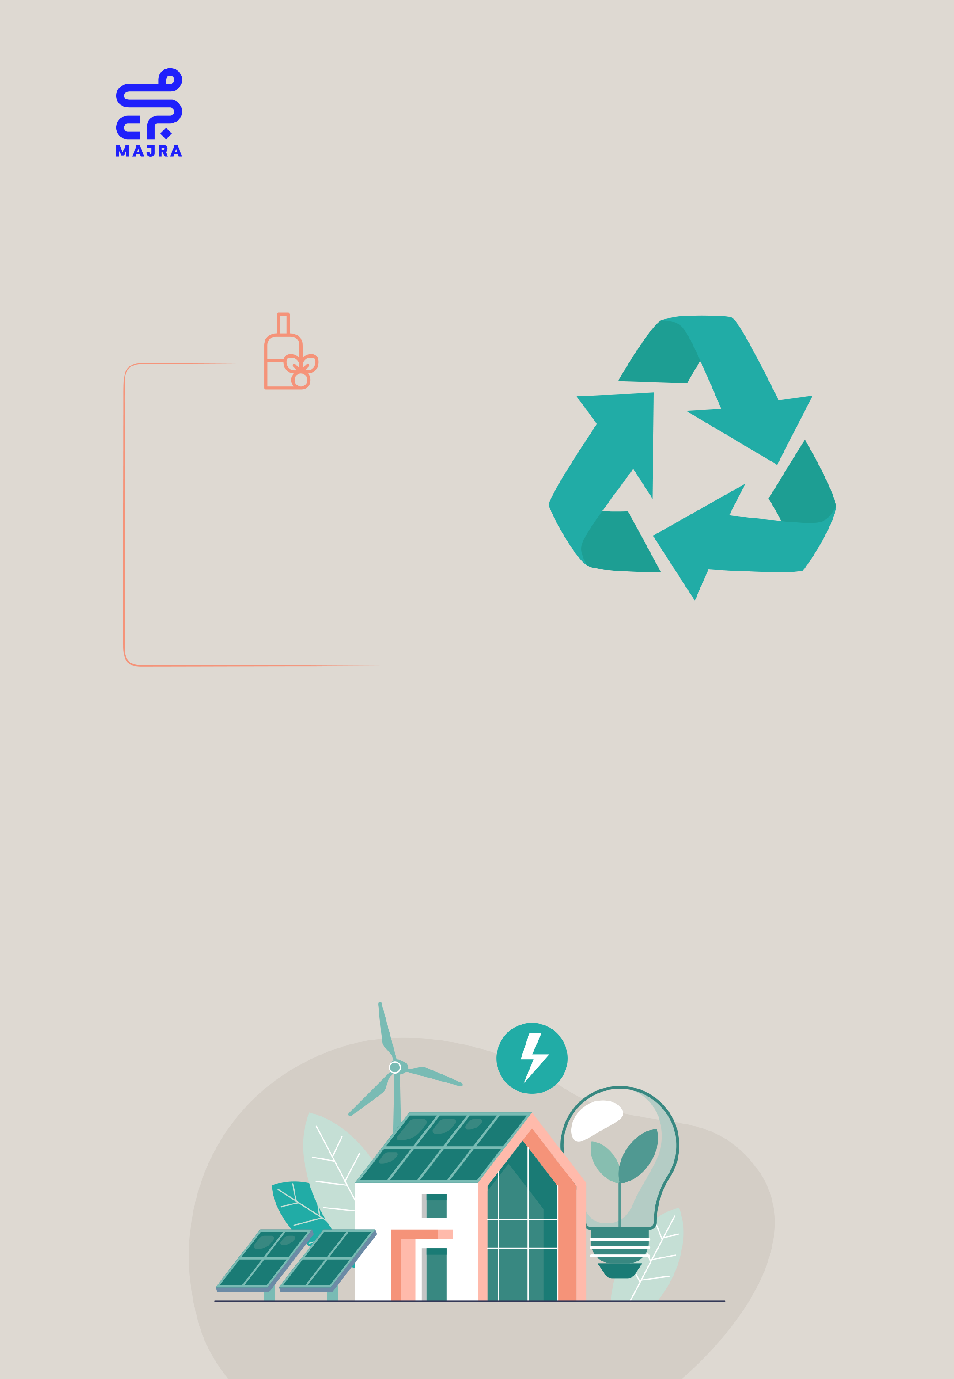

5. Implement Sustainable Habits to

Prevent Future Clutter

- **Adopt a minimalist mindset by**  
 **purchasing only necessary items and**  
 **avoiding impulse buying.**

- **Regularly evaluate your possessions**  
 **and declutter as needed to maintain an**  
 **organized and clutter-free home.**

- **Encourage family members and friends**  
 **to adopt sustainable habits and**  
 **promote the benefts of decluttering**  
 **and responsible waste disposal.**

By following these guidelines, households in the UAE can ac-tively contribute to a cleaner and more sustainable future, while also enjoying the benefts of a decluttered living space. Utilizing available free junk collection services ensures that un-wanted items are responsibly disposed of and repurposed, promoting a more circular economy and supporting local communities.



***Transforming Waste Into Resource:***

***A Guide to Responsible Donations in the UAE***

Donating used items is an excellent way to give new life to be-longings you no longer need while contributing to the well-be-ing of those in need.

In the UAE, charity bins are available in various locations,   
ofering a convenient means of donating used items to local communities.

However, it is essential to ensure that only suitable items are donated and to avoid littering in these bins.

This guideline will provide practical steps for responsibly   
donating your used items through charity bins in Sharjah, Abu Dhabi, and other locations in the UAE.

***Proposed Ideas for Donating Used Items Responsibly***

1. Assess Your Belongings and

Identify Items for Donation

- **Regularly evaluate the items in your . home to determine what you no longer . need or use.**

- **Sort through clothes, furniture,**   
**. appliances, and other possessions, . identifying items suitable for donation.**

- **Ensure that the items you plan to . donate are in good condition, clean, . and functional.**

2. Locate Charity Bins in Your Area

- **Use online resources, local directories, . or community groups to fnd charity . bins in Sharjah, Abu Dhabi, and other . locations in the UAE.**

- **Take note of the specifc locations, . operating hours, and any guidelines . regarding the types of items accepted . by the charity bins.**

- **Contact the charity organization . directly if you have questions or . concerns about donating specifc . items.**

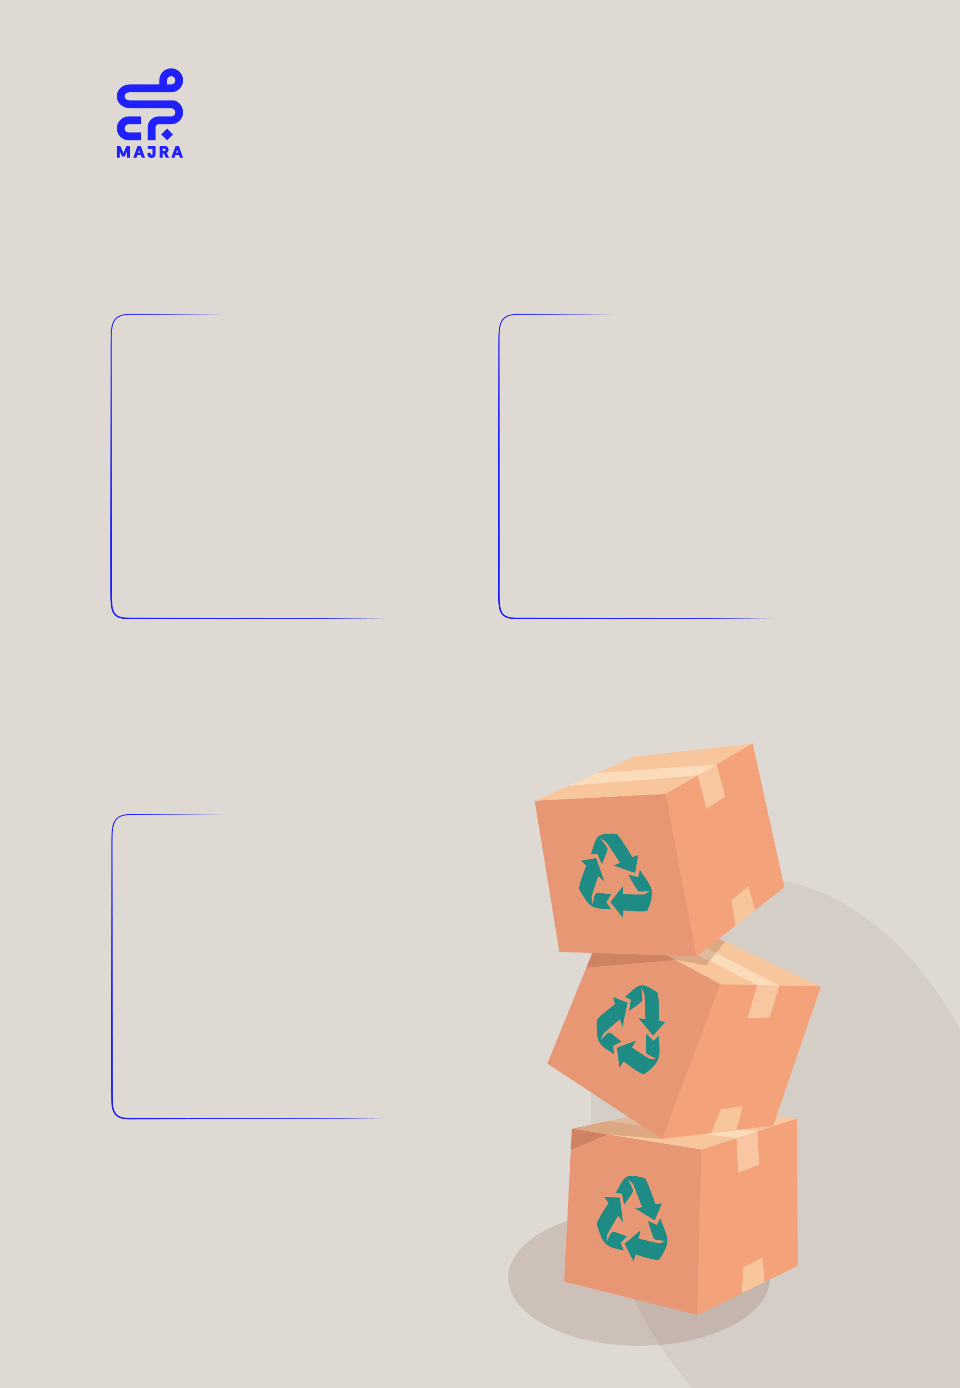

3. Prepare Your Items for Donation

**- Clean and repair any items you plan to donate, ensuring they are in good**  
 **condition and suitable for use by**  
 **others.**

**- Pack your items in durable bags or**  **boxes, clearly labeled as donations.**

**- For large items or appliances, consider contacting the charity organization to inquire about special arrangements for pick-up or drop-of.**

4. Responsibly Donate Items to

Charity Bins

**- Visit the charity bins in your area during their operating hours, ensuring that you adhere to any guidelines or**  
 **restrictions.**

**- Place your donations inside the**  
 **designated bins, avoiding overflling or leaving items outside the bins.**

**- Refrain from dumping litter or**  
 **unsuitable items in the charity bins, as this may create problems for the**  
 **charity organizations and the local environment.**

5. Spread Awareness and Encourage

Others to Donate Responsibly

**- Share your experience and knowledge**   
**about donating used items with friends,**   
**family, and neighbors.**

**- Encourage others to donate**   
**responsibly, emphasizing the**   
**importance of donating only suitable**   
**items and avoiding littering in charity**   
**bins.**

**- Consider volunteering or supporting**   
**local charity organizations to help**   
**promote responsible donation practices**   
**and contribute to the well-being of your**   
**community.**



By following these guidelines, residents in the UAE can efectively transform waste into valuable resources while supporting local communities in need.

Donating used items through charity bins is an impactful way to promote a more circular economy and contribute to a more sustainable future.

However, it is essential to donate responsibly, ensuring that only suitable items are donated, and charity bins remain free from litter and unsuitable items.

***Contributing Time and Inspiring Others to Volunteer:***

***A Guide to Responsible Volunteering in the UAE***

Volunteering your time is a remarkable way to utilize your skills and knowledge for the greater good, while also contributing to your personal growth and societal well-being.

In the UAE, platforms like volunteers.ae provide both online and in-person volunteering opportunities across the country, making it easier than ever to get involved.

However, it is crucial to approach volunteering with purpose, consistency, and dedication to making a genuine impact.

This guideline ofers practical steps for responsibly   
volunteering your time in Dubai, Abu Dhabi, and other regions in the UAE.



***Suggested Steps for Responsible Volunteering***

1. Identify Your Interests and 2. Find Suitable Volunteering

Relevant Skills Opportunities

- **Regularly introspect and identify the . skills and areas of interest you can . leverage for volunteering.**

- **Consider your strengths and passions, . and how these can be used to make . a diference in the community.**

3. Prepare Yourself for Volunteering

**.**

**- Ensure you are ready to commit time . and efort to your chosen cause,**   
**. whether it's environmental**   
**. conservation, education, health, or . social justice.**

- **Plan your schedule to ensure you can . consistently contribute without**   
**. impacting your other responsibilities.**

- **Utilize platforms like volunteers.ae to . fnd volunteering opportunities in . Dubai, Abu Dhabi, and other UAE**   
**. locations.**

- **Take note of the specifc requirements, . timings, and any guidelines regarding . the roles and responsibilities involved.**

- **Consider reaching out directly to the . NGOs for any specifc queries**   
**. regarding the volunteering**   
**. opportunities.**

4. Donate and Repurpose Items

to Support Local Communities

- **Commit to the volunteering**   
**. opportunities you've chosen, ensuring . you adhere to any guidelines or**   
**. expectations set by the organization.**

- **Be punctual, respectful, and**   
**. professional in your volunteering role, . always striving to make a positive and . meaningful impact.**



5. Inspire Others to Volunteer

Responsibly

- **Share your experiences and insights**  
 **about volunteering with friends, family,**  
 **and neighbors.**

- **Encourage others to volunteer**  
 **responsibly, emphasizing the**  
 **importance of consistency, purpose,**  
 **and dedication.**

- **Consider supporting local NGOs, either**  
 **by volunteering or providing resources,**  
 **to promote responsible volunteering**  
 **practices and contribute to the**  
 **well-being of the UAE community.**

By adhering to these guidelines, residents in the UAE can make signifcant contributions to societal well-being through   
responsible volunteering.

Contributing time and skills via platforms like volunteers.ae is an impactful way to foster personal growth and support local communities.

However, it is crucial to   
volunteer responsibly,   
ensuring that actions are   
consistent, purposeful,   
and align with the needs   
of the chosen cause or   
organization.



***Conclusion***

This guideline serves as a blueprint for individuals to actively engage in fostering a sustainable future for the UAE.

From transforming waste into valuable resources to the meaningful contribution of time through responsible volunteering, each aspect amplifes the collective potential of our actions toward sustainability.

Each section, while unique in its focus, underlines a unifed message: the power and responsibility of each individual in shaping a sustainable and prosperous UAE.

By adhering to these guidelines, we are not only mitigating environmental impact but also contributing to societal well-being and economic eficiency.

In sum, the journey towards a sustainable UAE is a shared endeavor. As we engage with these guidelines, we are making a powerful statement about our commitment to a resilient, inclusive, and sustainable future for our nation.