ADF Transformation Project  
  
Business Case:

* User wants to convert the data based on user id into single row of products purchased and the total sales for the products for the respective ID.
* And store the data in a csv file

Flow Chart:



Steps:

1.Created 2 containers (Input and Output) in storage account.

Input container to land the input data from initial source.

Output container is to land the output data after transformation as per business case.

Data has been uploaded to the input container.

2. Go to Data Factory and create a data flow 🡪 click on ‘+’ button and select Add Source

3. To insert the dataset, Click New.

4. Select the Input folder path to move the data to the source as below:

Click on Schema tab and Import schema from Connection/Store

5. Click on Open to preview the data that was added to the Source tab.

Click on ‘Preview Data’

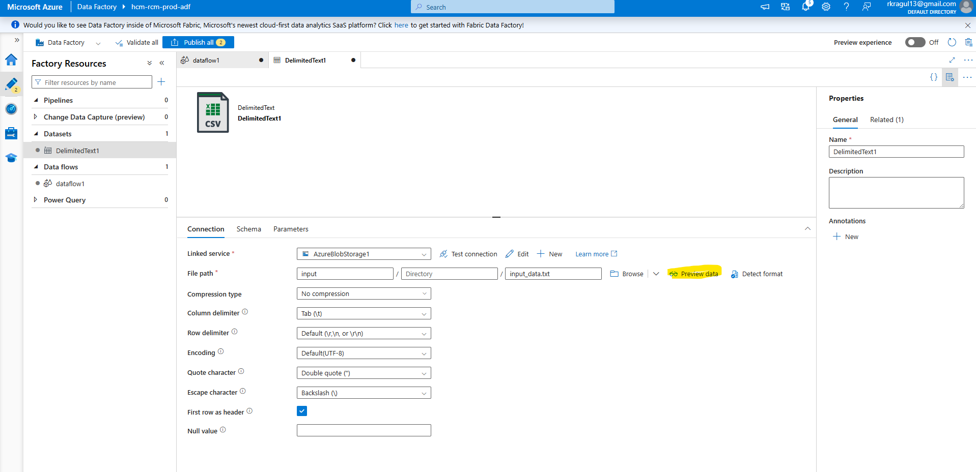

Click on ‘+’ icon and select Pivot

6.Select the below column to transform the data as per use case:

I, Group by ‘Id’

II. Add Product name as Pivot key

III, Using the Dataflow Expression Builder, calculate the sum of total sales as below:

7. Create Sink flow to load the transformed data, click on ‘+’ and select 'Sink’

8. Repeat steps for Source to create Sink flow,

Select the output path to extract the data from Sink

Go to Optimize tab Select ‘Single partition’ so the data will be downloaded in a single file.

9. Go to Pipeline and create a new pipeline and add the dataflow into that,

10.Validate all the steps and Publish it before adding trigger to the pipeline.

11. Once the trigger is activated we can use the, you can see the status of the pipeline in Manage 🡪 Pipeline runs.

12. The pipeline has ran successfully.

13. To view the final output in preview mode, select preview data.

14. The Output container has stored the final data from Sink dataflow.

Output File:

Null values are placed with the blank space.

