**Pre-Requisites:**

1. **Home page:**

1. HTML Structure: The project uses HTML (Hypertext Markup Language) to define the structure of the web page. The document contains a standard HTML5 doctype declaration (`<!DOCTYPE html>`) and an HTML root element (`<html>`) with a specified language attribute (`lang="en"`).

2. CSS Styling: The project includes CSS (Cascading Style Sheets) to apply styles and layout to the web page. CSS is used to control the appearance of various elements on the page, such as colors, fonts, spacing, and responsive design.

3. Meta Tags: The HTML document includes meta tags in the head section. The `charset` meta tag specifies the character encoding used (UTF-8), and the `viewport` meta tag sets the initial scale for responsive design.

4. Title: The web page has a title element (`<title>`) inside the head section that defines the title of the page, which appears on the browser tab or window.

5. Navigation: The project has a navigation bar (`<nav>`) containing links to different pages within the website. The links use anchor tags (`<a>`) with `href` attributes to specify the target pages.

6. Header: The header (`<header>`) section contains the main heading of the web page, which is "Shoe Shopping."

7. Main Content: The main content of the page is enclosed within the `<main>` element. It includes a welcome message (`<h2>`) and two marquees with scrolling text to highlight ongoing sales and promotions.

8. Shoe Categories: The shoe categories are displayed in a flexbox layout using the `<div>` element with a class of "shoe-category." Each shoe category is represented by a `<div>` element with a class of "shoe-category-item." Each category includes an image (`<img>`), heading (`<h3>`), and description (`<p>`), along with a link to the respective category page.

9. Media Queries: The CSS includes media queries that apply different styles based on the device's screen size. It ensures a responsive design, adjusting the width of the shoe category items for different screen widths.

10. Footer: The web page includes a footer section (`<footer>`) with copyright information.

**2.Men’s page:**

1. HTML and CSS Knowledge:Familiarize yourself with HTML and CSS. Understanding the basics of HTML will help you create the structure of the page, while CSS will allow you to style and layout the elements properly.

2. Text Editor:You need a text editor to write and edit your HTML and CSS code. Popular text editors include Visual Studio Code, Sublime Text, Atom, or Notepad++.

3. Images:Prepare the images you want to display on the page. Ensure they are of appropriate size and format (e.g., JPEG, PNG) for the web. Consider using image optimization techniques to reduce file size without compromising quality.

4. File Structure:Organize your project with a clear file structure. Create separate folders for HTML, CSS, and image files to keep things organized and maintainable.

5. Doctype Declaration:Start your HTML file with the proper doctype declaration to ensure the browser interprets the page correctly. For HTML5, use the following: `<!DOCTYPE html>`.

6. Meta Tags:Include meta tags in the head section of your HTML file. These tags define the character encoding, viewport settings, and other metadata for your page.

7. Semantic HTML:Use semantic HTML elements to give meaning and structure to your content. For example, use `<header>`, `<nav>`, `<main>`, `<footer>`, and appropriate heading tags (`<h1>`, `<h2>`, etc.) for improved accessibility and search engine optimization.

8. Responsive Design:Implement responsive design techniques using CSS media queries to ensure your page displays correctly on various devices and screen sizes.

9. Accessibility: Ensure your page is accessible to all users, including those with disabilities. Use alt attributes for images, provide text alternatives, and follow accessibility best practices.

10. Styling:Style your page using CSS to achieve a visually appealing design. Make sure to maintain consistency in colors, fonts, and layout.

11. Navigation:Create a clear and user-friendly navigation menu. Ensure all links are functional and point to the correct destinations.

12. Validation:Validate your HTML and CSS code using online validators to identify and fix any errors or potential issues.

13. Optimize Load Time:Compress and optimize images to reduce load times. Minify your CSS and JavaScript files to decrease the overall page size.

14. Testing:Test your page on various browsers and devices to ensure cross-browser compatibility. Check for any layout issues and functionality problems.

15. Hosting:Choose a reliable web hosting provider to host your website and make it accessible to users.

**3.Women’s page:**

1. Web Browser:To view and interact with the "Shoe Shopping - Women's Shoes Collection" page, you need a modern web browser that supports HTML5, CSS3, and JavaScript. Popular browsers like Google Chrome, Mozilla Firefox, Microsoft Edge, or Safari are recommended.

2. Internet Connection:As this page is hosted online, an active internet connection is required to access the page and load any external resources, such as images or stylesheets.

3. HTML and CSS Knowledge:To create or modify a similar web page, understanding HTML (HyperText Markup Language) and CSS (Cascading Style Sheets) is essential. These technologies are used to structure the page and define its visual appearance, respectively.

4. Image Hosting:The page contains several images of women's shoes. To replicate a similar page, you'll need to host these images on a web server or use image URLs from an external source.

5. Code Editor:If you want to modify the page's content or layout, a text editor or code editor would be beneficial. Popular code editors include Visual Studio Code, Sublime Text, Atom, or Notepad++.

6. Text Alignment:The page uses the "center" tag to horizontally center the navigation bar and the images. However, it's worth noting that the "center" tag is obsolete in HTML5, and it's recommended to use CSS for text alignment instead.

7. Understanding of Semantic Elements:The page could benefit from using semantic HTML elements such as <header>, <nav>, <main>, <footer>, and <h1>-<h6> tags. These elements provide better structure and improve accessibility for users and search engines.

8. Image Sizes:The images on the page have fixed width and height attributes. To maintain responsive design, it's better to use CSS to control the image sizes, especially for different screen sizes.

9. Responsiveness:The page lacks responsiveness, which means it may not adapt well to different screen sizes and devices. To create a user-friendly experience, incorporating responsive design techniques using CSS media queries is recommended.

10. Accessibility Considerations:The page currently lacks accessibility features, such as alt attributes for images, ARIA labels, and proper heading hierarchy. Consider adding these features to make the page more accessible to all users.

11. Link URLs:The page includes anchor (<a>) tags with href attributes linking to other pages. Ensure that the target pages exist and are accessible before deploying the website.

**4.Kid’s page:**

1. Basic HTML Structure:Knowledge of the basic structure of an HTML document with the use of `<!DOCTYPE html>`, `<html>`, `<head>`, and `<body>` tags.

2. HTML Elements:Familiarity with common HTML elements like headings (`<h1>`, `<h2>`, etc.), paragraphs (`<p>`), images (`<img>`), links (`<a>`), lists (`<ul>`, `<ol>`, `<li>`), etc.

3. HTML Attributes:Understanding of HTML attributes and how they are used within various HTML elements, such as `href`, `src`, `width`, `height`, `id`, etc.

4. CSS Styling:Basic knowledge of CSS (Cascading Style Sheets) to apply styles to HTML elements. This includes using selectors, properties, and values to customize the appearance of the web page.

5. Box Model:Understanding of the box model concept in CSS, which defines how elements are rendered and how padding, margins, and borders affect the layout.

6. Responsive Web Design:Familiarity with the concept of responsive web design, making the website adaptable to different screen sizes and devices using media queries and the `viewport` meta tag.

7. Centering Elements:Knowledge of CSS techniques to center elements on the web page both horizontally and vertically, such as `text-align: center`, `margin: 0 auto`, and flexbox or grid layout.

8. Hyperlinks and Anchors:Understanding of how hyperlinks (`<a>`) work and the usage of anchor links with `href="#elementID"` to link to specific sections of the same page.

9. Semantic HTML: Awareness of semantic HTML elements like `<header>`, `<nav>`, `<main>`, and `<footer>` to improve accessibility and structure of the webpage.

10. Image Tag:Ability to work with the `<img>` tag to display images on the web page and specifying attributes like `src`, `alt`, `width`, and `height`.

11. Meta Tags:Understanding of `<meta>` tags, especially the `charset` and `viewport` meta tags used in the provided code to set the character encoding and viewport settings.

12. Block and Inline Elements:Distinguishing between block-level and inline-level elements and their respective default behaviors in the document flow.

By having a solid grasp of these pre-requisites, you can easily understand and modify the provided code for the "Shoe Shopping" website. With these foundational concepts, you can create and style HTML documents effectively.

**5.Common wear page:**

1. Web Browser: Any modern web browser that supports HTML5 and CSS3 is required to view the web page. Popular choices include Google Chrome, Mozilla Firefox, Microsoft Edge, Safari, etc.

2. Internet Connection: An active internet connection is needed to access external resources, such as images or stylesheets, used in the web page. Without an internet connection, the page may not load or display correctly.

3. HTML File: The web page's HTML code, as shown above, must be saved in a file with an ".html" extension (e.g., index.html, commonwear.html). Ensure that the file contains valid HTML markup.

4. Image Resources: The web page relies on external image resources to display the product images. These images should be available at the specified URLs. If any of the images are missing or have incorrect URLs, they may not load on the page.

5. Stylesheet (CSS): The page uses inline CSS for styling, which is embedded within the <style> tags in the HTML document. Ensure that the CSS is correctly written, as any syntax errors may lead to inconsistent or incorrect styles on the page.

6. Meta Tags: The meta tags in the head section of the HTML document help set the character encoding and viewport settings. These tags are essential for proper rendering and responsiveness on various devices.

7. Proper Image Dimensions: The images used on the web page have specified width and height attributes (e.g., width="245" height="300"). To ensure proper rendering, make sure the images are available at the specified dimensions and have the correct aspect ratio.

8. Web Server (Optional): Though not strictly required, deploying the web page on a web server can provide a more consistent and reliable experience. Hosting the page locally may lead to CORS (Cross-Origin Resource Sharing) issues when accessing external resources.

9. Correct File Paths:Ensure that all the file paths (for images, CSS, or other resources) specified in the HTML code are correct and point to the actual locations of the resources on the web server or the local file system.

**6.contact page:**

1. Basic Understanding of HTML and CSS:To work with and customize the contact page provided above, you should have a basic understanding of HTML and CSS. Familiarize yourself with HTML tags, attributes, and CSS styles to make changes to the page layout and design.

2. Web Development Environment:You will need a code editor or integrated development environment (IDE) to make changes to the HTML and CSS files. Popular options include Visual Studio Code, Sublime Text, Atom, or any other editor of your choice.

3. HTML Structure:Understand the basic structure of an HTML page. The code provided above is a complete HTML page with the necessary tags like `<!DOCTYPE html>`, `<html>`, `<head>`, and `<body>`. The content of the page is within the `<body>` tag.

4. HTML Forms:Familiarize yourself with HTML forms and form elements. In the provided code, the contact form is built using form elements such as `<form>`, `<input>`, and `<textarea>`. The form has attributes like `action` and `method` for form submission.

5. CSS Styling:Review the CSS styles provided in the `<style>` section. Understand how CSS is used to apply styles to different elements on the page, like headers, navigation, form elements, and footer. Pay attention to selectors, properties, and values used in the styles.

6. Responsive Web Design:The provided code uses a simple responsive design approach with media queries to adapt the layout for different screen sizes. Learn about responsive design techniques to ensure your modifications maintain a good user experience on various devices.

7. Hosting and Server-side Processing (Optional):The form in the contact page uses the attribute `action="#"`, which means the form submission is not currently connected to any server-side processing. If you want to handle form submissions, you'll need to set up a server, write server-side code (e.g., PHP, Node.js, etc.), and configure the form to submit data to the server.

8. Accessibility Considerations:Consider implementing accessibility best practices in your modifications. This includes using semantic HTML elements, providing alternative text for images, and ensuring the form is navigable and usable for people with disabilities.

9. Testing and Debugging:Regularly test your changes on different browsers and devices to ensure cross-browser compatibility. Use browser developer tools for debugging and resolving any issues that may arise.

10. Version Control (Optional): If you're planning to make significant modifications, consider using version control (e.g., Git) to track changes and collaborate with others effectively.

**Project flow:**

1. **Home Page (index.html):**1.The home page welcomes users to the "Shoe Shopping" website.2.It displays a header with the website's title, "Shoe Shopping."3.A navigation bar (nav) is provided with links to various pages, such as Men's Shoes (mens.html), Women's Shoes (womens.html), Kids' Shoes (kids.html), Common Wear (commonwear.html), and the Contact page (contact.html).4.Below the navigation bar, there is the main content section (main).5.The main content section begins with an h2 heading welcoming users to the website.6.Two marquees are used to display scrolling messages. The first marquee shows: "Discover the latest and most stylish collection of shoes for men, women, and kids." The second marquee displays: "Take advantage of our ongoing sale to get your favorite pair at discounted prices."7.Next, there is a shoe-category section (div with class "shoe-category") containing four shoe categories.8.Each shoe category (div with class "shoe-category-item") consists of:8.1An image of the shoe category (e.g., Men's Shoes, Women's Shoes, Kids' Shoes, Common Wear)8.2A heading (h3) with the name of the shoe category.8.3A brief description (p) about the category.8.4An anchor (a) wrapping the entire shoe category item, linking to the respective category page.

**2.Men’s page:**

1. Overview:The Shoe Shopping website is designed to provide an online platform for customers to explore and purchase men's shoes. The website consists of several sections, including a header, navigation menu, main content area, and footer. The main content area showcases different categories of men's shoes, including casual shoes, formal shoes, sports shoes, boots, and sneakers.2. Header:The header section appears at the top of the page and includes the website's name, "Shoe Shopping."3. Navigation Menu:The navigation menu, placed below the header, enables users to easily navigate through different sections of the website. It contains the following links:3.1Home: Links to the home page (homeindex.html).3.2Men's Shoes: Links to the current page (mens.html) for browsing men's shoe categories.3.3Women's Shoes: Links to a separate page (womens.html) for browsing women's shoe categories.3.4Kids' Shoes: Links to a separate page (kids.html) for browsing kids' shoe categories.3.5Common Wear: Links to a separate page (commonwear.html) for browsing common wear items.3.6Contact: Links to a separate page (contact.html) for contacting the website administrators.4. Main Content Area:The main content area is the central part of the page where all the shoe categories are presented. It consists of the following components:4.1Men's Shoes Heading (h2): Displays the main heading "Men's Shoes."4.2Category Navigation (nav): Contains links to specific shoe categories within the main content area. These links use anchor tags (a) with href attributes pointing to the corresponding category headings' IDs.

4.3Shoe Categories (div.shoe-category): Divided into separate sections for each shoe category, including "Casual Shoes," "Formal Shoes," "Sports Shoes," "Boots," and "Sneakers."4.4Category Items (div.shoe-category-item): Each category section contains multiple shoe items displayed as images. Each shoe item image is represented by an anchor tag (a) with an image tag (img) inside it. The images have links (href) that can be clicked to view detailed information or purchase the shoes.4.5Shoe Images (img): Images of the shoes displayed in each category. They are responsive and adjust their size according to the screen width for better user experience.5. Footer:The footer section appears at the bottom of the page and includes the copyright information, "© 2023 Shoe Shopping. All rights reserved."6. Flow of Interactions:The typical flow of interactions for users visiting the Shoe Shopping website would be as follows:6.1. User enters the website through the home page (homeindex.html).6.2. User clicks on the "Men's Shoes" link in the navigation menu to view men's shoe categories (current page: mens.html).6.3. On the "Men's Shoes" page, the user can use the category navigation to jump to specific sections like "Casual Shoes," "Formal Shoes," "Sports Shoes," "Boots," and "Sneakers."6.4. In each category section, the user sees multiple shoe items displayed as images.6.5. The user can click on any shoe image to view more details or make a purchase.6.6. The user can also navigate to other sections of the website using the links in the navigation menu, such as women's shoes, kids' shoes, common wear, and contact page.6.7. When the user finishes exploring the website, they can find the copyright information in the footer.7. Conclusion:The Shoe Shopping website provides a user-friendly and visually appealing interface for customers to browse and purchase men's shoes. The website's flow allows users to easily navigate through different shoe categories and access relevant information about each product, making it a convenient platform for online shoe shopping.

**3.Women’s page:**

1. Home Page (homeindex.html):

* The user lands on the home page of the "Shoe Shopping" website.
* The header displays the website name "Shoe Shopping."
* The navigation bar (nav) at the center of the page contains links to various sections: "Home," "Men's Shoes," "Women's Shoes," "Kids' Shoes," "Common Wear," and "Contact."

2. Women's Shoes Page (womens.html):

* The user clicks on the "Women's Shoes" link in the navigation bar.
* The header still displays "Shoe Shopping."
* The navigation bar remains the same with links to different sections.
* The main section (main) contains the title "Women's Shoes Collection" and an inline navigation bar (nav) with links to specific shoe categories: "Running Shoes," "Heels," "Sneakers," "Boots," and "Flats."

3. Running Shoes Section:

* The user clicks on the "Running Shoes" link in the inline navigation bar.
* The page scrolls down to the "Running Shoes" section (h3 tag with id="12").
* A brief description of running shoes is displayed.
* Five images of different running shoe models are shown in a row.

4. Heels Section:

* The user clicks on the "Heels" link in the inline navigation bar.
* page scrolls down to the "Heels" section (h3 tag with id="123").
* A brief description of heels is displayed.
* Five images of different heel styles are shown in a row.

5. Sneakers Section:

* The user clicks on the "Sneakers" link in the inline navigation bar.
* The page scrolls down to the "Sneakers" section (h3 tag with id="143").
* A brief description of sneakers is displayed.
* Five images of different sneaker designs are shown in a row.

6. Boots Section:

* The user clicks on the "Boots" link in the inline navigation bar.
* The page scrolls down to the "Boots" section (h3 tag with id="134").
* A brief description of boots is displayed.
* Five images of different boot styles are shown in a row.

7. Flats Section:

* The user clicks on the "Flats" link in the inline navigation bar.
* The page scrolls down to the "Flats" section (h3 tag with id="112").
* A brief description of flats is displayed.
* Five images of different flat shoe designs are shown in a row.

8. Contact Page (contact.html):

* The user clicks on the "Contact" link in the navigation bar.
* The header displays "Shoe Shopping."
* The navigation bar remains the same with links to different sections.
* The main section (main) contains contact information, such as a form or contact details.

9.Footer:The footer section (footer) displays the copyright information for the website: "&copy; 2023 Shoe Shopping. All rights reserved."

**4.Kids page:**

1.HTML Structure:

* The document starts with the <!DOCTYPE html> declaration, specifying the HTML version.
* The <html> tag represents the root element of the document.
* The <head> section contains meta information and links to external resources like stylesheets.
* The <body> section contains the visible content of the webpage.

2.Header Section:

* The <header> tag contains the website's main heading, "Shoe Shopping."
* It is centered and has a dark background color (#333) with white text.

3.Navigation Bar:

* The <nav> tag contains a list of navigation links (<a> tags) to different sections of the website.
* The links include "Home," "Men's Shoes," "Women's Shoes," "Kids' Shoes," "Common Wear," and "Contact."
* The navigation bar has a dark background (#444) with white text.On hover, the link color changes to a lighter shade (#bbb).

4.Main Content:

* The main content is enclosed within the <main> tag.
* The kids' shoes section is represented by an <h2> tag with the text "Kids' Shoes Collection."

5.Category Navigation:

* A sub-navigation bar for specific shoe categories is provided within a centered <center> tag.
* The categories include "Running Shoes," "Heels," "Sneakers," "Boots," and "Flats."

6.Kids' Shoes Categories:

* Each shoe category is represented by an <h3> tag, and an associated description is given in a <p> tag.
* For each category, a <div> with a series of <a> tags is used to display the shoe images.

7.Footer:

* The footer section, enclosed within the <footer> tag, displays the copyright notice.

**5.Common wear page:**

1.HTML Structure:

* The website is built using HTML and follows a standard structure. It consists of the following main elements:
* <!DOCTYPE html>: The document type declaration for an HTML5 document.
* <html lang="en">: The root element of the HTML document, with the language set to English.
* <head>: Contains meta-information about the document and links to external resources like CSS and fonts.
* <body>: The main content of the website, displayed in the browser.

2.Header Section:

* The <header> element contains the website's title, "Shoe Shopping," displayed at the center of the header.

3.Navigation Bar:

* The <nav> element contains a horizontal navigation bar (<a> tags) with links to different sections of the website.
* The navigation links include "Home," "Men's Shoes," "Women's Shoes," "Kids' Shoes," "Common Wear," and "Contact."

4.Main Content:

* The main content is enclosed within the <main> element.
* It starts with a heading (<h2>) titled "Common Wear Shoes" and a brief introductory paragraph.

5.Common Wear Shoes Display:

* The common wear shoes are displayed using multiple <a> tags, each containing an <img> element.
* The <img> elements link to an image URL and display product images of shoes.The product images are displayed in a grid format, with several rows of images.

6.Product Information:

* After each set of product images, a brief description paragraph is provided about the "Common Wear Shoes."

7.Footer Section:

* The footer (<footer>) contains copyright information - "© 2023 Shoe Shopping. All rights reserved."

8.Styling (CSS):

* The website is styled using CSS to control the layout and appearance.
* Fonts: The website uses the "Arial" font-family for text.
* Colors: The background color of the header and footer is "#333," and the navigation bar has a background color of "#444." Text color is set to "#fff" (white) for better contrast with the dark backgrounds.
* Layout: The main content is given padding of 20px, and the header, navigation bar, and footer have some padding to provide spacing.
* Hover Effects: The navigation links change their color to "#bbb" (light gray) when hovered over, giving a visual cue to users.

9.Responsiveness:

* The website has a responsive design (<meta name="viewport" content="width=device-width, initial-scale=1.0">) to adapt to different screen sizes, making it accessible on various devices.

10.Functionality:

* The website appears to be a simple, static webpage with no interactive functionality (e.g., search, add to cart) implemented in the provided code.

**6.Contact page:**

1. User Visits the Contact Page:When a user visits the "Contact" page, they will see a form where they can send a message to the Shoe Shopping team.

2. Header Section:The top section of the page contains the website's header, displaying the title "Shoe Shopping."

3. Navigation Bar:The navigation bar is located just below the header, providing links to various sections of the website, including "Home," "Men's Shoes," "Women's Shoes," "Kids' Shoes," "Common Wear," and "Contact."

4. Contact Us Section:The main content section of the page contains a heading "Contact Us" followed by a contact form.

5. Contact Form:

The contact form consists of the following fields:

* Name: A text input field where the user can enter their name.
* Email: An email input field where the user can enter their email address.
* Message: A textarea input field where the user can type their message.
* Send Message Button: A submit button to send the filled form.

6. Form Submission: When the user clicks on the "Send Message" button, the form will be submitted to a server-side script (specified by the `action="#"` attribute in the form tag). Since the `action` attribute value is set to "#", it means the form data is not being sent to a specific server URL, but rather it will handle the form submission through JavaScript or other means.

7. Form Validation:The form includes HTML5 validation attributes (`required`) on the name, email, and message fields. This means that these fields must be filled out before the form can be submitted. If any of these required fields are empty, the browser will display an error message when the user tries to submit the form.

8. Styling:The contact page is styled with CSS to create a visually appealing and responsive layout. It includes styles for the header, navigation bar, main content, form fields, and footer.

9. Footer:The page footer is located at the bottom and displays the copyright notice: "&copy; 2023 Shoe Shopping. All rights reserved."

**Project structure:**

**1.Home page:­­­­**

**2.Men’s page:**

**3.Women’s page:**

**4.kids page:**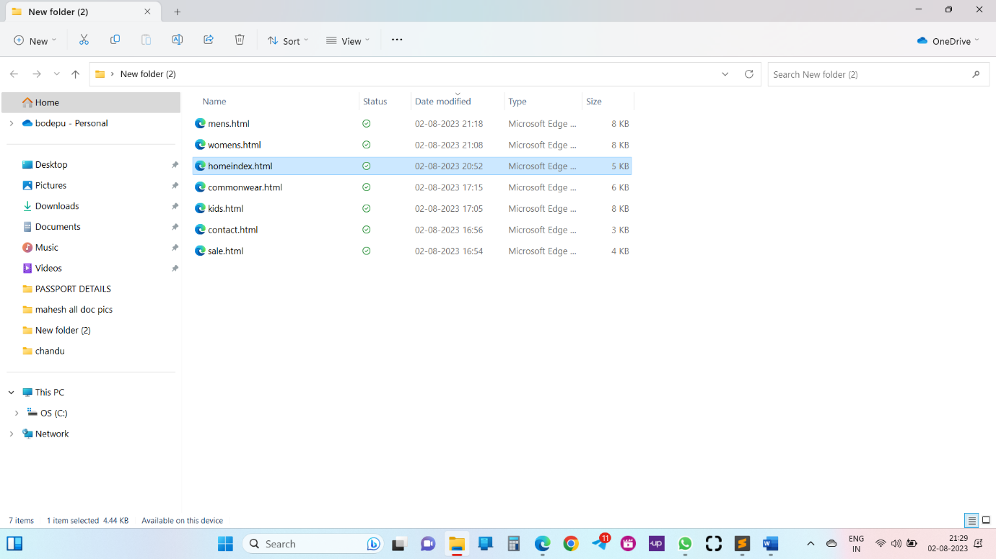

**Set up the project structure:**

**1.Home page:**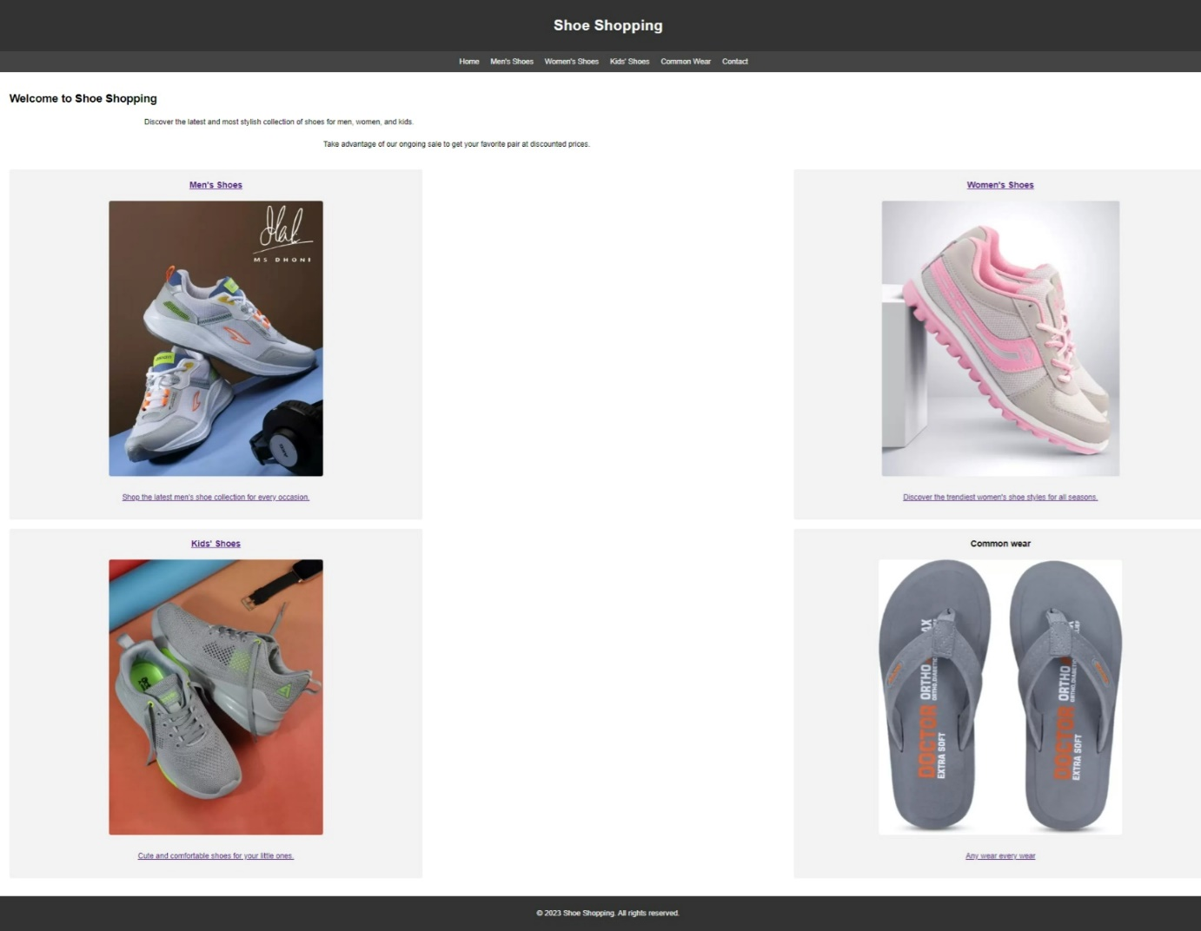

1. Header:

* Contains the website title: "Shoe Shopping".

2. Navigation Bar:

* A horizontal bar with links to different sections of the website, such as "Home," "Men's Shoes," "Women's Shoes," "Kids' Shoes," "Common Wear," and "Contact."

3. Main Content:

* The main content section includes a welcoming heading and two marquee elements.
* The first marquee displays a scrolling text with the message "Discover the latest and most stylish collection of shoes for men, women, and kids."
* The second marquee displays a scrolling paragraph with the message "Take advantage of our ongoing sale to get your favorite pair at discounted prices."

Below the marquee elements, there is a section with four shoe categories:

* "Men's Shoes" category with an image and a short description.
* "Women's Shoes" category with an image and a short description.
* "Kids' Shoes" category with an image and a short description.
* "Common Wear" category with an image and a short description.

4. Footer:Contains the copyright information: "&copy; 2023 Shoe Shopping. All rights reserved."

**2.Men’s page: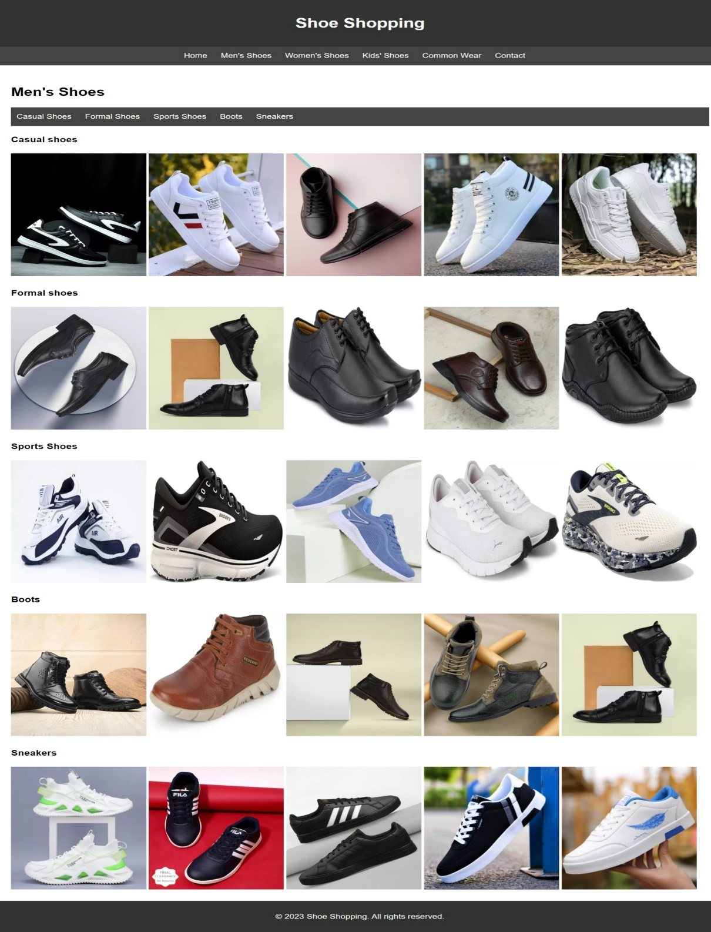**Inside the "shoe_shopping_website" folder, create the following files:index.html: This will be the main entry point of the website, representing the home page.mens.html: This will contain the page for men's shoes, which is currently shown in the provided code.womens.html: Create this file for the women's shoes page (you can add the content later).kids.html: Create this file for the kids' shoes page (you can add the content later).commonwear.html: Create this file for the common wear page (you can add the content later).contact.html: Create this file for the contact page (you can add the content later).Inside the "shoe_shopping_website" folder, create two additional folders:css: This folder will contain the CSS files for styling the web pages.images: This folder will contain the images used on the website.Move the CSS code from the provided HTML file into a separate CSS file. Create a new file called "style.css" inside the "css" folder and paste the CSS code into it.

**3.Women’s page:**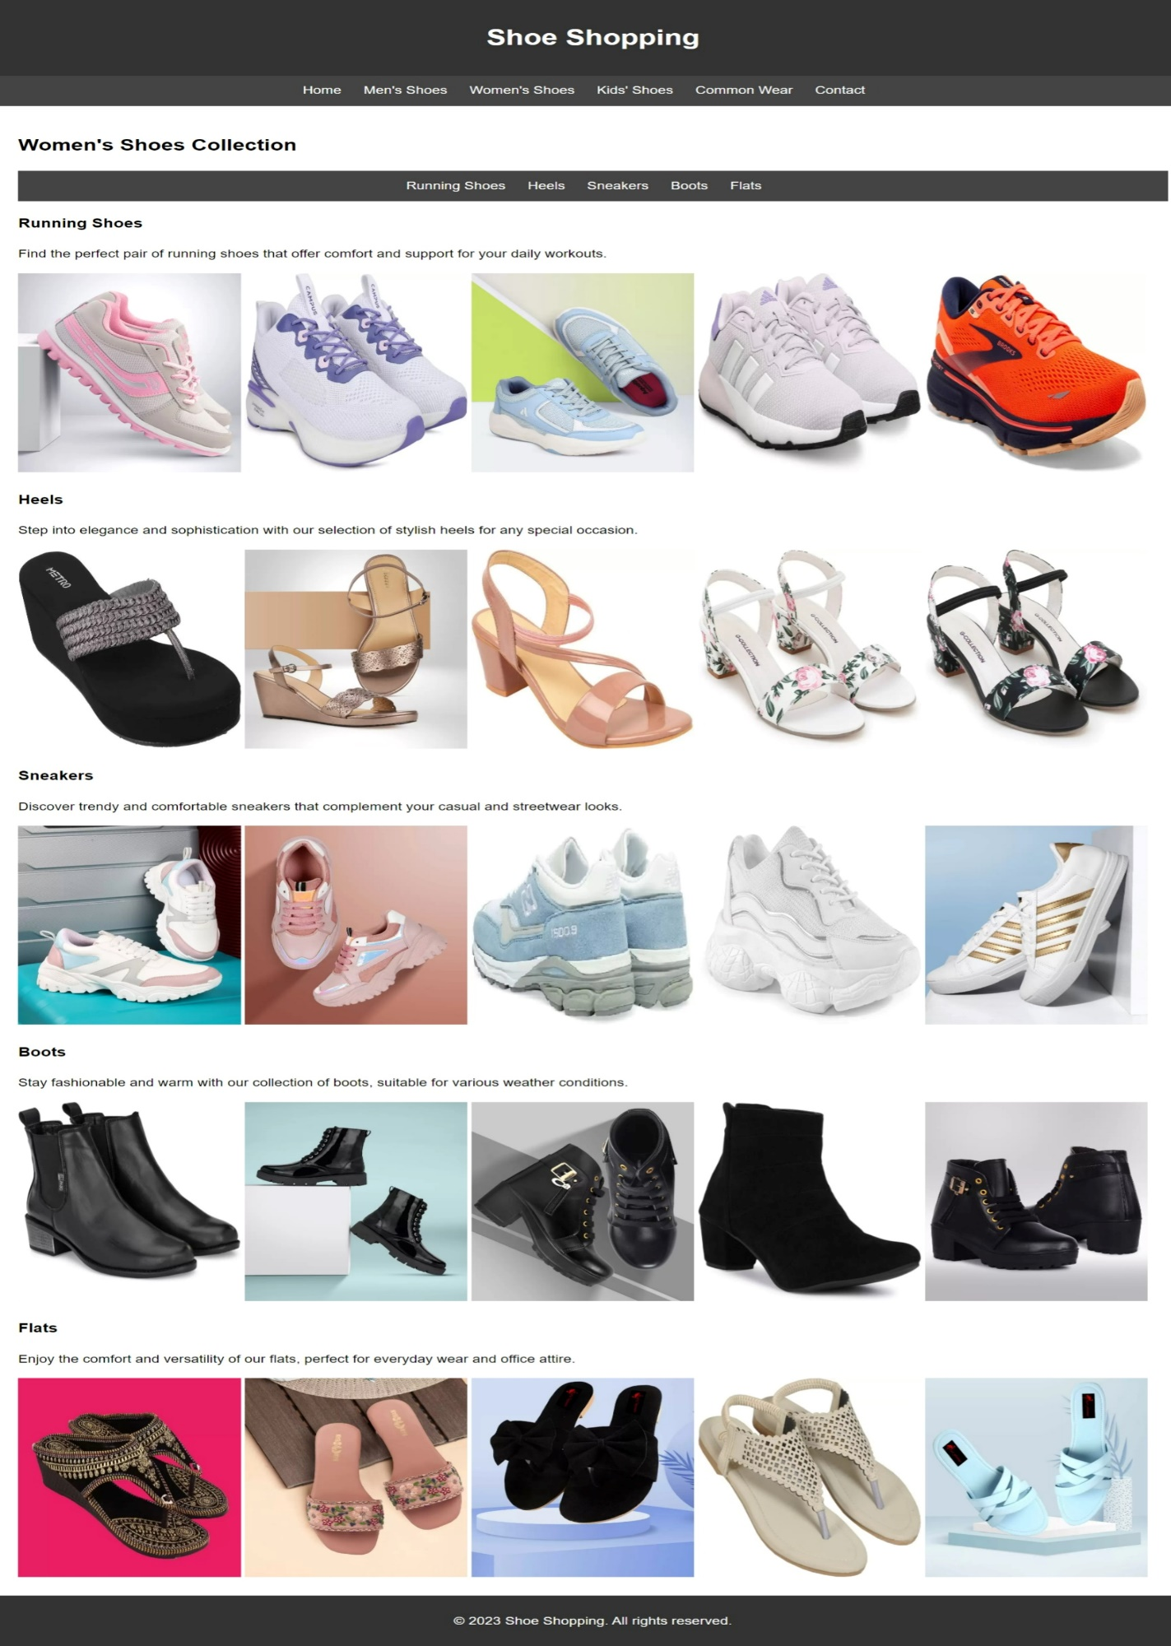

1. HTML Structure:The page is written in HTML, which stands for Hypertext Markup Language. It provides the basic structure and content for the web page.

2. Document Type Declaration:<!DOCTYPE html>` declares that the document type is HTML5, which is the latest version of HTML.

3. Language and Character Encoding:The `<html>` tag has a `lang` attribute set to "en" for English, and the `<head>` section includes a `<meta>` tag specifying the character encoding as UTF-8, which is the standard for encoding characters in web pages.

4. Page Title:The `<title>` tag within the `<head>` section sets the title of the page as "Women's Shoes - Shoe Shopping." This title is displayed on the browser's title bar or tab.

5. CSS Styling:The `<style>` tag within the `<head>` section contains CSS code for styling the elements on the page. It defines various styles for the header, navigation bar, main content, and footer.

6. Header:The `<header>` section contains the main heading of the page, which is "Shoe Shopping."

7.. Navigation Bar:The navigation bar is placed inside a centered `<nav>` section. It consists of links to different pages, such as Home, Men's Shoes, Women's Shoes, Kids' Shoes, Common Wear, and Contact.

8. Main Content:The main content of the page is placed within the `<main>` section. It includes the title "Women's Shoes Collection" followed by subsections for different types of women's shoes, such as Running Shoes, Heels, Sneakers, Boots, and Flats.

9.Image Gallery:Each shoe type is represented by a subsection with an anchor `<a>` tag and a corresponding set of images displayed in a horizontal row. The images are displayed using `<img>` tags with appropriate URLs.

10.Footer:The `<footer>` section contains the copyright information for the website, displaying "&copy; 2023 Shoe Shopping. All rights reserved."

11. Project Structure:Though not explicitly mentioned in the code, a typical project structure for a web application would include separate directories for organizing various files, such as:

* index.html: The main entry point of the website, which may contain an overview or landing page.
* css/: A directory for storing CSS files (e.g., `style.css`) that handle the page's appearance and layout.
* mg/: A directory for storing images used in the web page, such as the shoe images displayed in the image gallery.

**4.Kid’s page:**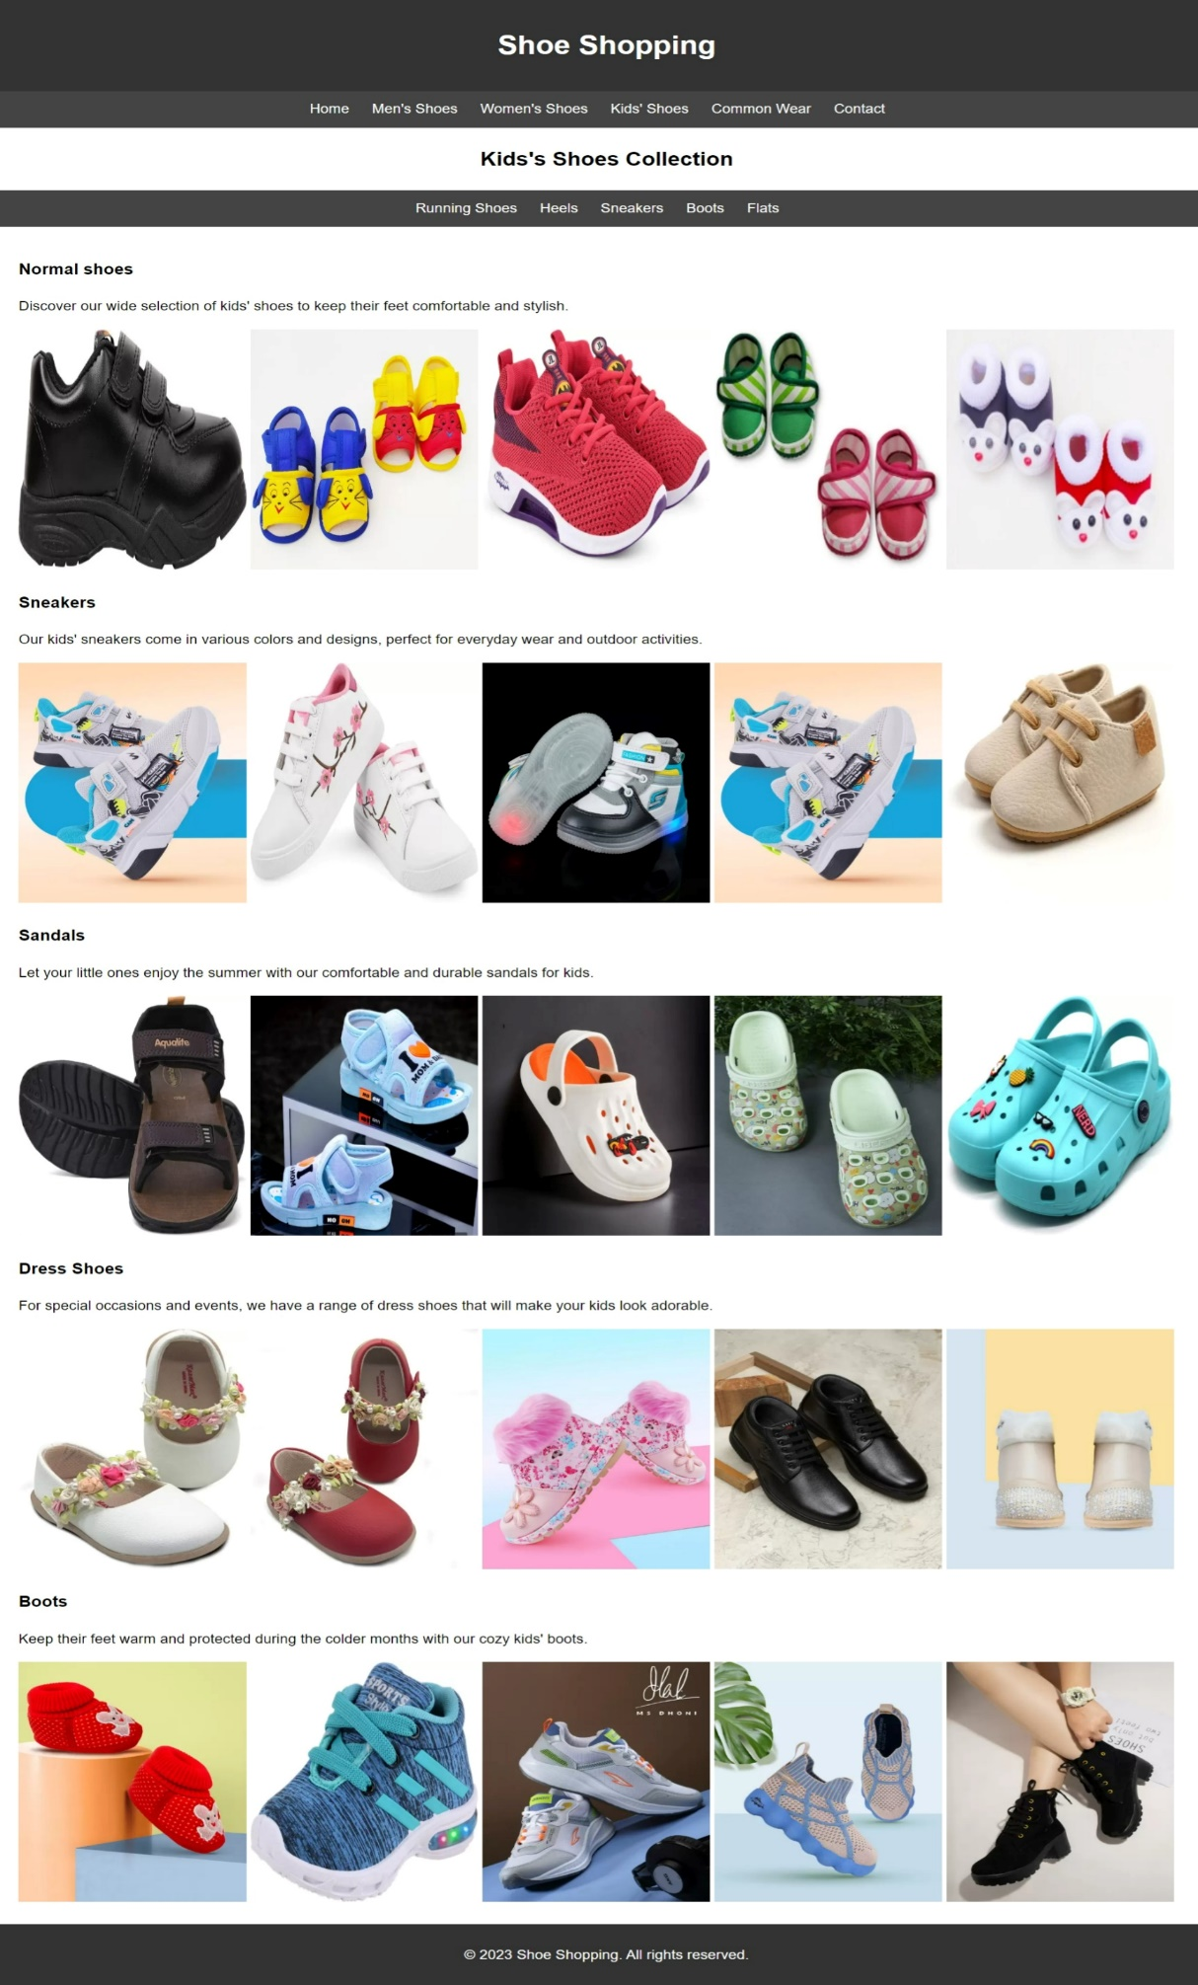

1. index.html: This could be the main landing page or the home page of the website.

2. mens.html: A separate page for men's shoes, if available.

3. womens.html: A separate page for women's shoes, if available.

4. kids.html: The current page, showcasing the collection of kids' shoes.

5. commonwear.html: A page for common wear shoes, such as unisex shoes.

6. contact.html: A contact page where users can get in touch with the store.

7. css: A folder containing all the CSS files for styling the website. It should have a separate file for each page and possibly some shared styles.

8. images: A folder to store all the images used on the website. This includes product images, logos, and other graphical elements.

9. js: If the website includes any interactive features or functionalities, this folder would contain JavaScript files.

10. fonts: If custom fonts are used, they can be stored in this folder.

11. assets: This folder can include any other resources used by the website, like videos or downloadable files.

12. favicon.ico: The website's favicon file that appears in the browser tab.

**5.Common wear:**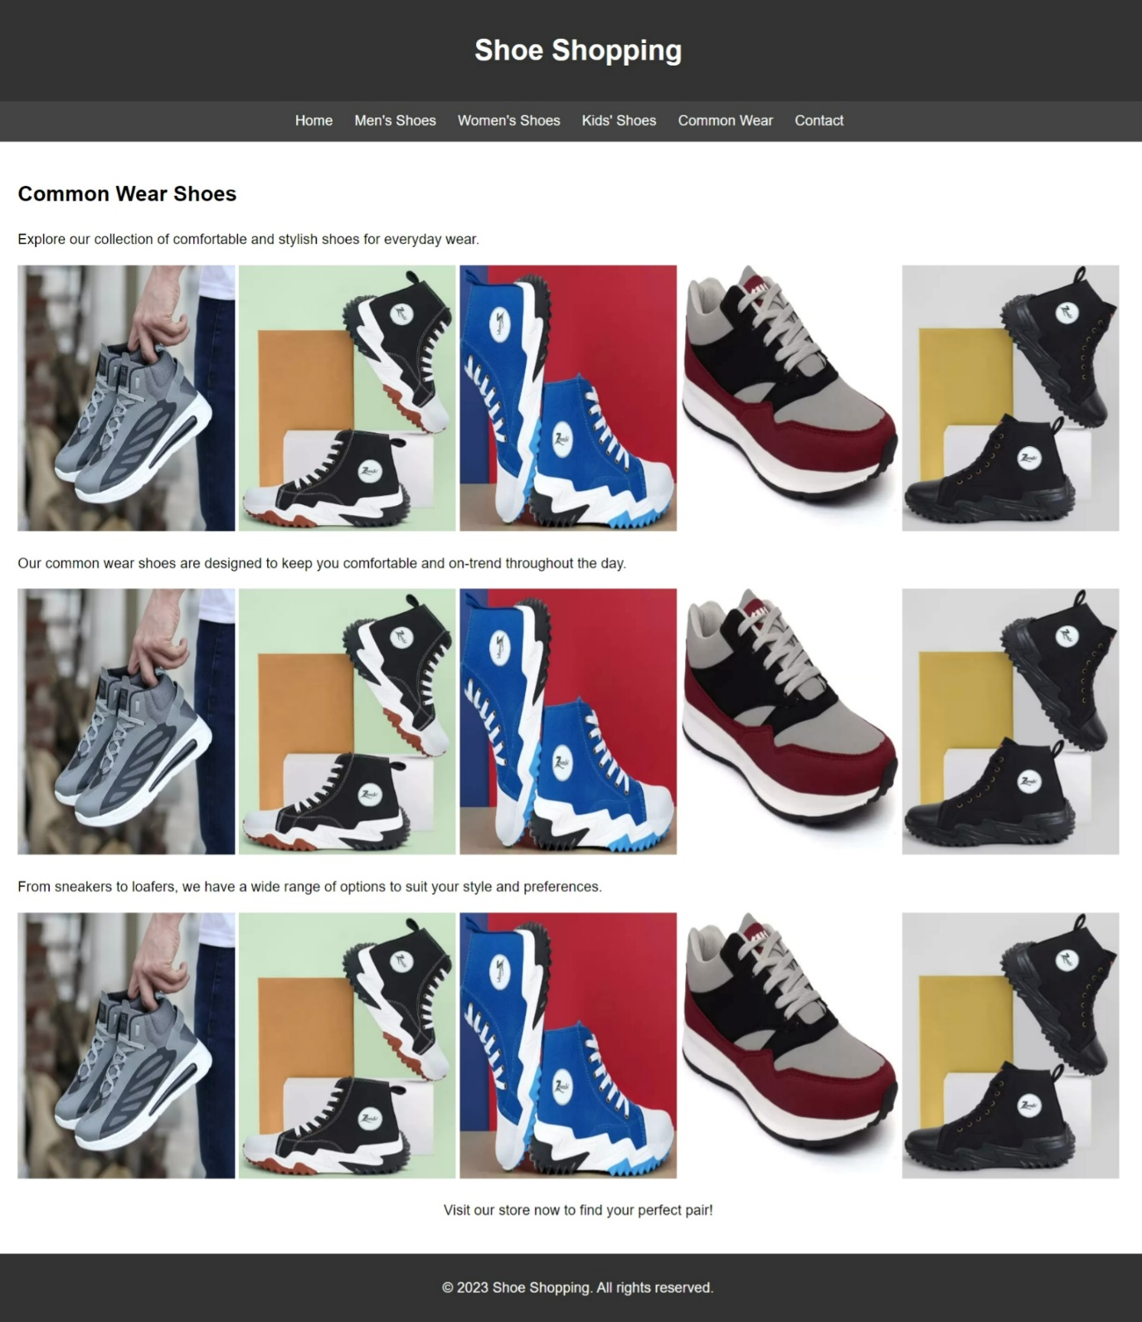

* Create the Project Folder:Start by creating a new folder on your computer, and give it a relevant name, such as "shoe-shopping-website" or any other name of your choice.
* index.html: This will be the main landing page of the website.
* homeindex.html: You can assume this is the home page if you intend to have a separate landing page.
* mens.html: This page would contain men's shoe collection.
* womens.html: This page would contain women's shoe collection.
* kids.html: This page would contain kids' shoe collection.
* commonwear.html: This page would contain the "Common Wear" shoe collection.
* contact.html: This page would be for the contact information of the website.
* assets folder: Create an "assets" folder to store all the necessary resources, such as images, CSS files, and other media files.
* Organize the CSS File:If you have multiple CSS stylesheets, create a separate CSS file for each page or use a single CSS file for the entire website. In this case, you can create a file named "style.css" in the "assets" folder and copy the CSS code from the provided HTML.
* Store Images:Inside the "assets" folder, create a "images" subfolder to store all the images used on the website. You can save the images from the provided HTML code in this folder.

**6.Contact page:**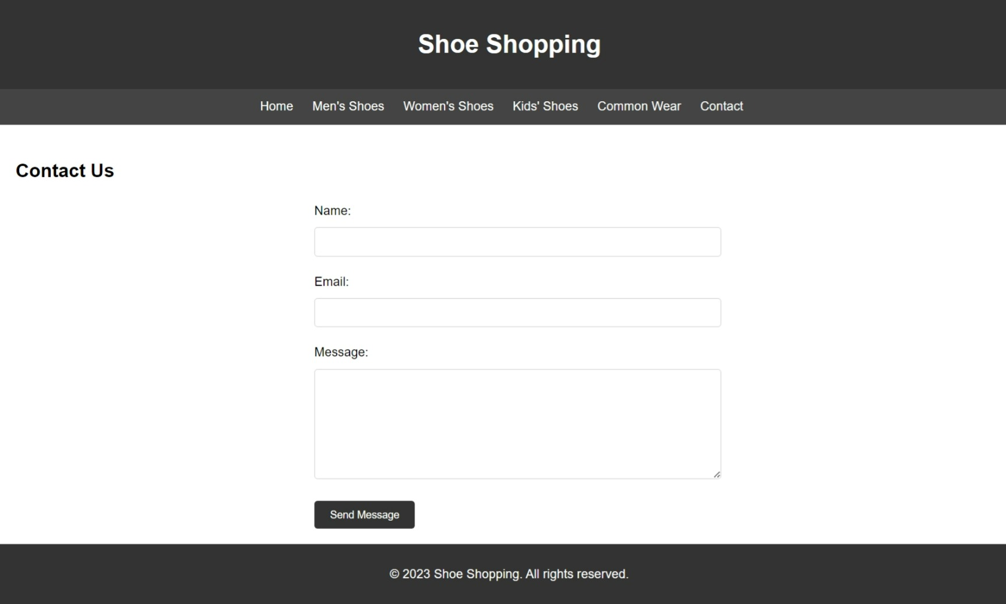

* index.html: This is likely the home page of the website. It is the default landing page when users access the domain without specifying a particular page.
* mens.html: This page is dedicated to men's shoes, likely displaying different types of men's footwear.
* womens.html: This page is dedicated to women's shoes, showcasing various women's footwear.
* kids.html: This page focuses on kids' shoes, displaying a selection of shoes for children.
* commonwear.html: This page might contain common or unisex shoes that can be worn by people of all genders.
* contact.html: The page we see in the provided code is the contact page. It allows users to get in touch with the shoe shopping business by filling out a form and sending a message.
* style.css: This file contains the CSS (Cascading Style Sheets) code for styling the website's elements, layout, and overall appearance.

**Design and implement the user interface:**

**Design:**

1. Overall Layout:

* The website has a header section with the title "Shoe Shopping."
* The navigation bar is centered and contains links to different pages: Home, Men's Shoes, Women's Shoes, Kids' Shoes, Common Wear, and Contact.
* The main content section displays a welcome message, a marquee with scrolling text announcing the latest collection and ongoing sale, and a grid layout of shoe categories.
* The footer section contains a copyright notice.

2. Styles:

* The website uses a global CSS style with some basic formatting, such as font-family, line-height, margin, and padding.
* The header has a dark background color (#333) with white text (#fff) and is centered.
* The navigation bar (nav) has a slightly lighter background color (#444) with white text (#fff) for links. On hover, the link color changes to a lighter gray (#bbb).
* The main content area (main) has a padding of 20px.
* The shoe category items are displayed in a grid layout with three columns on larger screens, two columns on medium screens (max-width: 768px), and one column on smaller screens (max-width: 480px).
* Each shoe category item has a background color (#f2f2f2), padding, margin, and border radius, giving it a card-like appearance. The text is centered, and there is a small image for each category.

3. Responsiveness:

* The website is designed to be responsive and adapt to different screen sizes using media queries.
* The shoe category items adjust their width on different screen sizes to create a visually appealing layout on both desktop and mobile devices.

4. Shoe Category Section:

* The shoe category section showcases four categories: Men's Shoes, Women's Shoes, Kids' Shoes, and Common Wear.
* Each category item displays an image representing the respective shoe category and a brief description of the category.
* The first three categories (Men's, Women's, and Kids' Shoes) have clickable links that presumably lead to their respective product pages. However, the "Common Wear" category does not have a link associated with it.

Overall, the design of the website is simple and straightforward, with a focus on showcasing different shoe categories and encouraging users to explore the collection further. The provided HTML and CSS code together create a visually appealing and responsive web page for shoe shopping.

**Implement the user interface:**

Step 1: Access the Website

Open your web browser and enter the URL of the website "https://www.shoeshopping.com" (hypothetical URL) in the address bar and press Enter. The home page of the "Shoe Shopping" website will load.

Step 2: Navigation

At the top of the home page, you'll see a navigation bar with various links. These links will help you navigate to different sections of the website. The links are as follows:

* Home: Takes you back to the home page.
* Men's Shoes: Clicking on this link will take you to the page displaying the latest collection of men's shoes.
* Women's Shoes: Clicking on this link will take you to the page displaying the trendiest women's shoe styles.
* Kids' Shoes: Clicking on this link will take you to the page with cute and comfortable shoes for kids.
* Common Wear: Clicking on this link will take you to the page displaying shoes for any and every wear.
* Contact: Clicking on this link will take you to the contact page where you can get in touch with the store.

Step 3: Home Page Content

Scroll down on the home page to see the main content of the website. Here, you will find:

* The website header with the title "Shoe Shopping."
* A welcome message with the heading "Welcome to Shoe Shopping."
* Two marquees displaying important messages. The first marquee encourages you to discover the latest shoe collection, and the second marquee informs you about an ongoing sale with discounted prices.

Step 4: Shoe Categories

Below the welcome message, you'll find the shoe categories displayed as cards:

* Men's Shoes: This card shows an image of men's shoes, and you can click on it to explore the latest men's shoe collection.
* Women's Shoes: This card shows an image of women's shoes, and you can click on it to discover the trendiest women's shoe styles.
* Kids' Shoes: This card shows an image of kids' shoes, and you can click on it to find cute and comfortable shoes for kids.
* Common Wear: This card displays shoes for common wear, and you can click on it to explore the collection.

Step 5: Shoe Category Pages

When you click on any of the shoe category cards, it will take you to the respective category page. For example, if you click on "Men's Shoes," you'll be directed to a page showing various men's shoe options. Similarly, for "Women's Shoes," "Kids' Shoes," and "Common Wear."

Step 6: Back to Home

At any point while exploring the website, you can click on the "Home" link in the navigation bar to return to the home page.

Step 7: Footer

At the bottom of the website, you'll find the footer, which contains the copyright information, stating that the content is owned by "Shoe Shopping" and all rights are reserved.