FLYHIGH

Document Information
Document Title | Functional Specification Design Document!
Document Owner | Trinade AI Technologies PVT LTD.
Version | Version – 1.0
Status | Design Level
Date | 23-02-2022

This page is intentionally kept blank

- Brief Description
FlyHigh Website will be acting as the source for Technical solutions of any kind of technical issues raised by End-Users. At one end, there will be Technical experts ( from all fields) signed in to this Portal and always ready to serve the query. At the other end, End-Users will also sign in to the portal and raised their queries. TRINADE, will provide the platform for all types of facility to the experts and users. Users will pay the charges of expert to TRINADE and TRINADE will pay the amount to experts in return. So, everything will be done on the basis of pricing model.
- Features
- Account Creation, login, signup for both Experts and End-users.
- Technical experts profile creation and that will be hidden to End-users.
- Searching for experts on portal by user, categorized search.
- Raising request to connect and completion of it within one day.
- Integration of payment via Razor pay.
- Rating and reviews for both user and technical experts.
- Chat ,voice and video call support (for providing solutions) with monitoring and storage of last one week of data by TRINADE.
- Actors
List of all actors in this application development.
- Dev Team
  - Backend Development
  - Front end Development
- QA Team
- Operations and Delivery Team
- Pre-Conditions
All the resources availability and necessary training provided before development starts.
- All necessary S/W and H/W requirements should be in place
- Need to get the access rights to required webservices.
- Basic Flow
[Ankit and Ashish, please add basic flow algorithms here].
- Alternate/Exception Flows
[Any alternate/exceptional flows will come here]

- Post Conditions
[Post-conditions will be listed here, Ankit and Ashish please if any]

- Additional Requirements
[Supplemental requirements].

- Pricing Model
[ As of now, It will be decided by Ankit, Ashish and Peter and also it will depend on Experts]
Chat | voice | video
Monthly – (5k – 25k ) (depending upon work nature and experience of the user) | Monthly – (12k – 30k) (depending upon work nature and experience of the user) | Monthly – (15k – 35k) (depending upon work nature and experience of the user)
Per day – (.5k – 1.5k) (depending upon work nature and experience of the user) | Per day – (1k – 1.5k) (depending upon work nature and experience of the user) | Per day – (1k – 2k) (depending upon work nature and experience of the user)
Yearly – (45k – 2.5L) (depending upon work nature and experience of the user) | Yearly – (50k – 3L) (depending upon work nature and experience of the user) | Yearly – (70k – 3.5L) (depending upon work nature and experience of the user)

- Visual Model
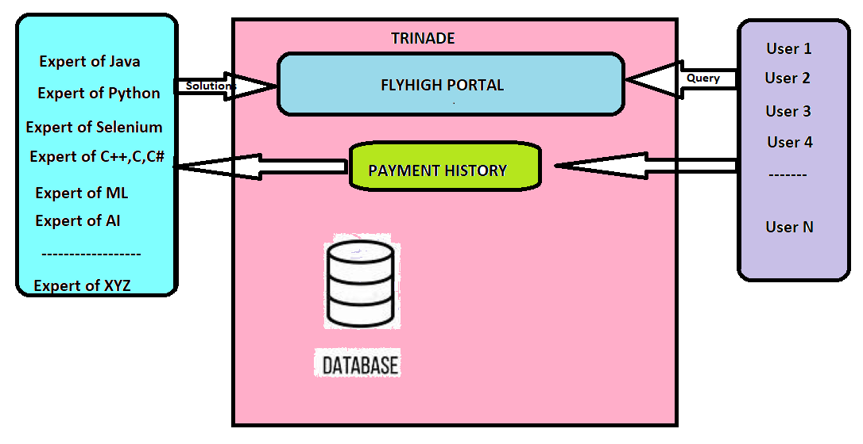

Revision History
V. | Date | Author | Description | Status
1 | 23-Feb-2022 | Ramnarayan | FlyHigh Functional Specification Design Doc | Design Level

