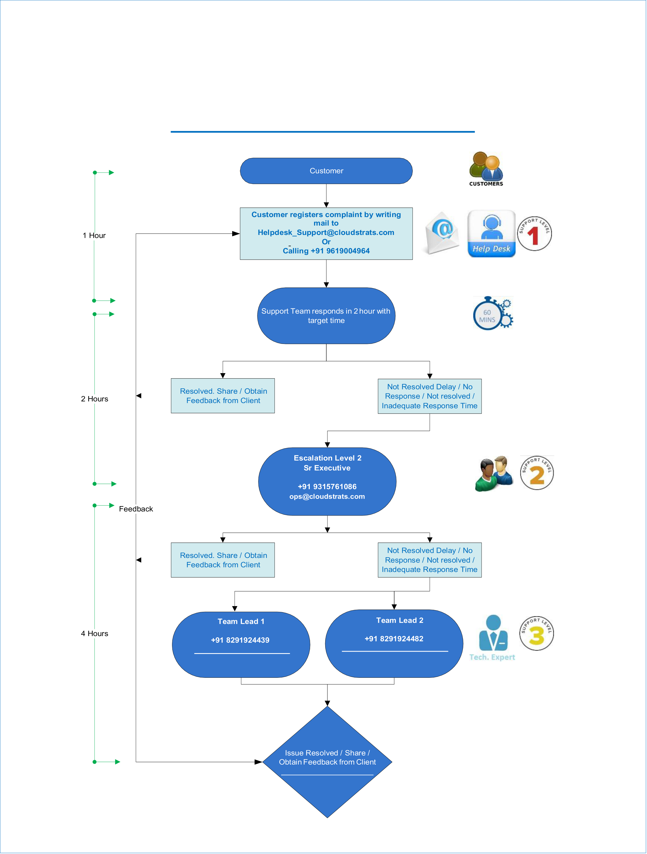

**Cloudstrats**   
**Cloudstrats Helpdesk Escalation Process**

**nocleads@cloudstrats.com**  **Tech_Leads@cloudstrats.com**

[Feedback@cloudstrats.com](mailto:Feedback@cloudstrats.com)

|  |  |  |  |  |  |  |  |  |  |  |  |  |  |  |  |  |  |  |  |  |
| --- | --- | --- | --- | --- | --- | --- | --- | --- | --- | --- | --- | --- | --- | --- | --- | --- | --- | --- | --- | --- |
| |  |  |  |  | | --- | --- | --- | --- | | **Escalation Matrix** | **Level 1** | **Level 2** | **Level 3** | | **Name** | **Helpdesk 1** | **Helpdesk 2** | **Team Lead** | | **Contact No** | **+91 8093534237** | **+91 9768924439** | **+91 9619004964** | | **Email ID** | **[Helpdesk_Support@cloudstrats.com](mailto:Helpdesk_Support@cloudstrats.com)** | **ops@cloudstrats.com** | Team_Leads@cloudstrats.com | | **Feedback** | **[Feedback@Cloudstrats.com](mailto:Feedback@Cloudstrats.com)** | | | |