KAJAL BANE   
11, L.b.S Road, Bhimnagar , Mumbai , Maharashtra   
91 7045575753   
banekajal29@gmail.com

Dear Sir/madam

Thank you for taking the time to review my resume.

I sincerely declare that the facts provided in this resume are true and correct to the best of my knowledge. I hereby confirm that all the details furnished above are authentic and accurate to the best of my belief.

Sincerely,

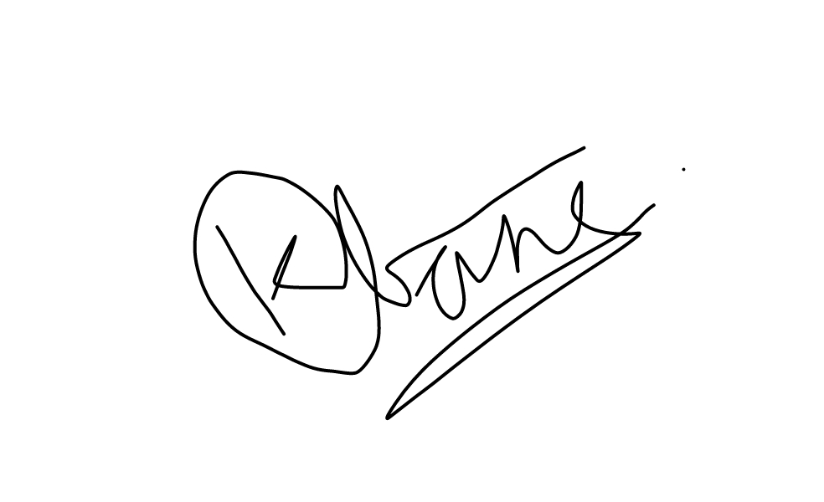

KAJAL BANE

|  |  |  |  |  |  |
| --- | --- | --- | --- | --- | --- |
|  | | KAJAL BANE | |  | 91 7045575753 |
|  | banekajal29@gmail.co |
| m |
| 11, V. M. Pawar Chawl |
|  |
| L.b.S Road, Bhimnagar |
| , Ghatkopar West |
|  | EXPERIENCE | | | | |
| Wipro Limited AIROLI | | | Wipro Limited is a leading global information technology, consulting | | |
| 29/01/2021 - 31/08/2022 | | | and business process services company. | | |

Airoli/Navi Mumbai (Mindspace)  
 Wipro Limited is a leading global information technology, consulting and business process services company.

Handling health care process as a Reconciliation Analyst.

Researched and analyzed packages dealing with big problems.

Personally, research and shut off some Package Successfully.

Worked on different queues and process with different Problematic statement.

|  |  |
| --- | --- |
| New Snehadeeep Eyes | As Receptionist |

|  |  |  |
| --- | --- | --- |
|  | And Skin Clinic | I have four year's experience as receptionist in the new snehadeep eye |
| 2016 - 2020 | and skin clinic. |
| EDUCATION |
|  |  | Bachelor In Commerce |
| Mumbai University |

I have completed my bcom from Mumbai University with CGPI 6.38 Apart from this I have knowledge about computer and internet surfing

|  |  |  |
| --- | --- | --- |
|  | PROJECTS | Worked On Special Projects As Per Member Request. |
| Wipro Ltd |

Dealing package as per the customer request.

•Work on different queues and various state base(calliforania, washington etc) project

|  |  |  |  |
| --- | --- | --- | --- |
|  | OTHER INFO | Skills | Languages |
| quick learners, hardworking, | English, Hindi and Marathi |

|  |  |
| --- | --- |
| Interest | Awards |

listening to music, traveling

|  |
| --- |
|  |



KAJAL BANE