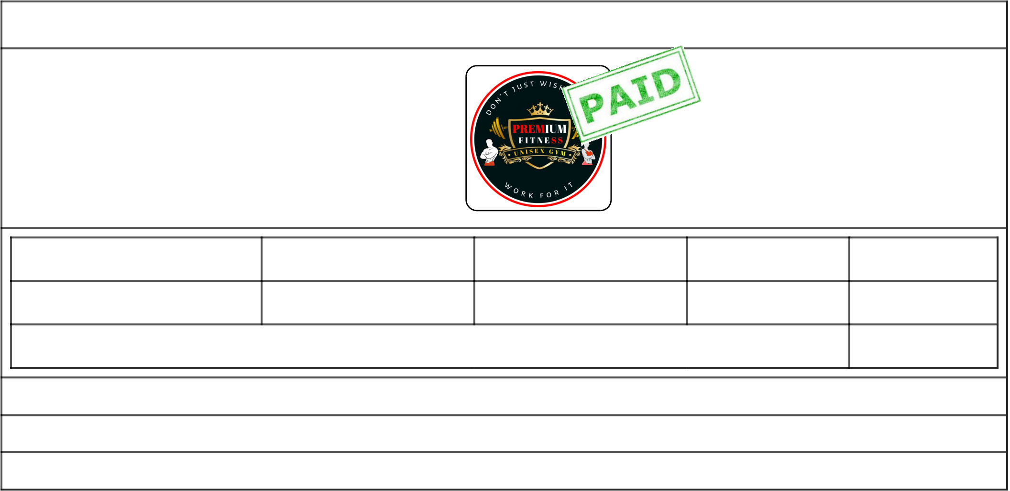

**Invoice**

|  |  |  |  |  |
| --- | --- | --- | --- | --- |
| To, | **From Date** | Date :  13 December 2021  12:00:00 AM  Invoice No. :  PFR/22-23/151 | | |
| **RECEIVER (BILL TO)** Name : **Sonu Sharma**  Member Id : **PFM146** |
| **Subscription Name** |
| **To Date** | **Duration** | **Amount** |
| 1 Year Plan | 13 December 2021 | 12 December 2022 | 12 Month | 3500 |
| Payment Mode : **Cash** | **Payment :** | | 2500 |
| **For Premium Fitness** | Created By : **Prem Vaity** || Councellor : **Prem Vaity** | | |

Mauli building 1st floor digvijay soc. New union bank,kalher bhiwandi thane Maharashtra 421302   
Email: premiumfitness1231@gmail.com || Mobile: 7977751118 **Powered by : PayPer Software**

**Rules and Regulations**

|  |  |
| --- | --- |
|  | The GYM is open to all communities of cast or creed.  Fees once paid are not refundable and are required to be paid in advance at the times of Enrollment. Parental approval strictly required at the time of admission for the minors.  Equipments are required to be use carefully and placed at proper place after use damage or Breakage or loss of any equipment shall be made good by the member concerned at his/her cost and without delay.  In case any member conducts himself in any misbehaviour or improper manner causes any muisance/ harassment to any other member or staff the management reserves the right to cancle his/her membership.  Person with prior medical history should consult hsi/her doctor before joining the fitness club.  Any member desiring to discontinue his/her membership will promply inform the management one month in advance.  Member shall avail of the facilities at his own risk and liabilities and the institution will not be liabale for any loss or damage to a person in case of accident in fitness center.  The management reserved the rights to amend or add to these regulations or to adopt new regulation as it may be necessary for proper institution`s management  A Member is officialy entitled to use the fitness center facilities only once a day or on days design by the management a session in the fitness center facility allows 30 to 90 minutes at your disposal to carry your routine heathcare program.  Member should not keep any valuable in the locker and submit the keys while checkout. |