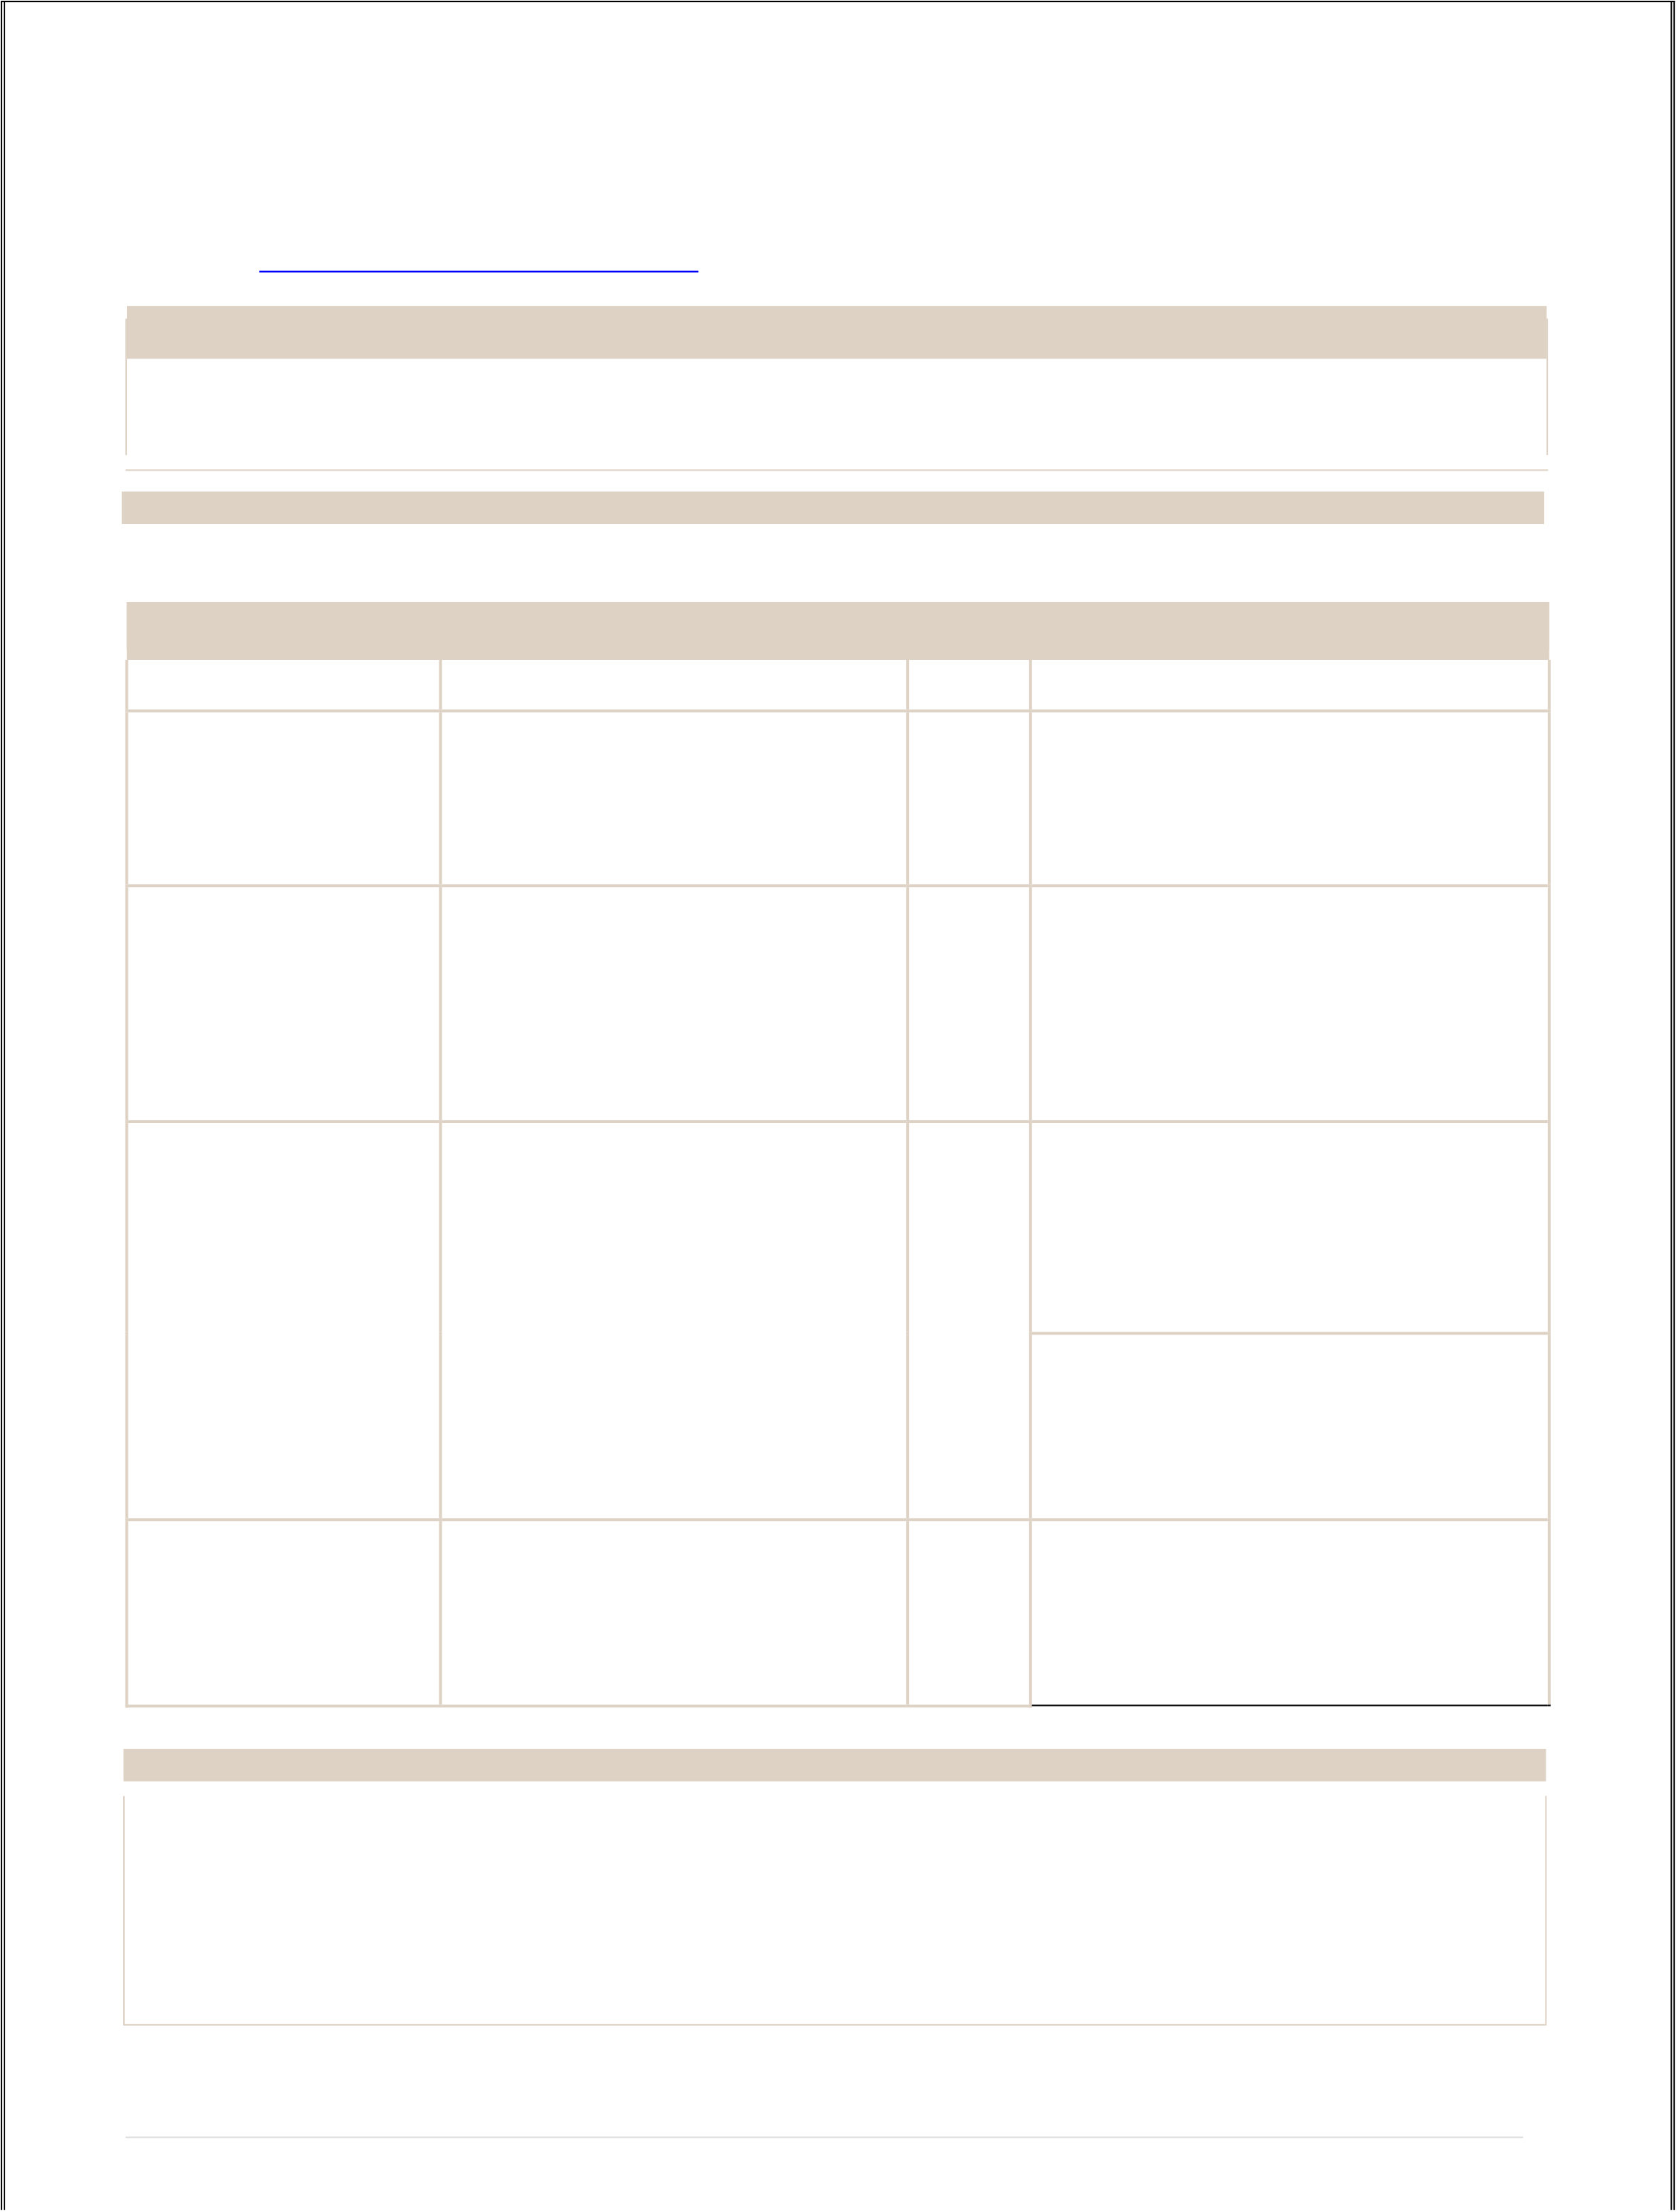

**Ritesh Vidyasagar Prajapati**   
Room No.-137, Near Hanuman Mandir, Subhash Nagar, MIDC Road, Digha, Navi Mumbai- 400708.

Contact no - +91 – 9867548932.

Email – [riteshprajapati30@gmail.com](mailto:riteshprajapati30@gmail.com)

OBJECTIVE

To solve problems in a creative and effective manner in a challenging position.

ABOUT MYSELF

I am always energetic and eager to learn new skills.

EDUCATION

|  |  |  |  |
| --- | --- | --- | --- |
| **Diploma/Degree** | **Institution** | **Year** | **Mark Obtained** |
| S.S.C | Shri Vivekanand Hindi High | 2013 | First Class with 68.80 % |
| School, Digha(East), Navi Mumbai, |
| From Maharashtra State Board. |

SMT. Sushiladevi vidyalaya &

|  |  |  |  |
| --- | --- | --- | --- |
| H.S.C | Jr. college.  Airoli, Navi Mumbai. | 2015 | Aggregate of 44.62 % |

From Maharashtra State Board.

Final Year Aggregate CGPI of 5.98

|  |  |  |
| --- | --- | --- |
| B. S.C in  Computer Science | MCT SD Degree college. Airoli, Navi Mumbai.  From Mumbai University. | 2018 |

Overall Aggregate CGPI of 5.87

|  |  |  |  |
| --- | --- | --- | --- |
| MCA | ASM Institute of Management & | 2021 | Overall Aggregate CGPI of 7.78 |
| Computer studies,Thane |

SOFTWARE SKILLS

|  |  |
| --- | --- |
| • • • • | Programming Languages known are JavaScript, Node JS, Express, React JS and GitHub Have an intermediate knowledge about HTML, CSS, JQuery and Bootstrap.  Database languages known are Mongo DB, SQL Server 2008 and My SQL.  Have an intermediate knowledge of Windows XP/7/8/9/10 and MS Office. |

1 | P a g e

|  |  |
| --- | --- |
| |  | | --- | | ACADEMIC PROJECTS | |

|  |  |
| --- | --- |
| **Degree Project** | |
| Name | Online Pro-Shop System   (Web Application) |
| Language of Implementation   • Front End : React JS   • Back End : Node JS and Express   • Database : Mongo DB | |
| Description | The Online Pro-Shop System is a web application made to manage order, products and user data easily. To provide easy and affordable services to mid-scale businesses who sell their products on different social media sites. With this web application they can grow their business as well as manage their business easily. |
| Project [Link](https://shoppingeasier.herokuapp.com/)  • <https://shoppingeasier.herokuapp.com/>  • [https://itsclassaes.netlify.app](https://itsclassaes.netlify.app/) | |
| Work Experience:   • Done 6 Months Internship from Digiqt Technolabs As Software Engineer.  (Project : Hylo (Technology - React Js, Node Js, Express Js, Mongo DB, Redis and AWS)  • 3 Months in Chic Infotech Pvt. Ltd. As Web Designer (Technology: HTML, CSS, Bootsrap)  • Done 5 Months Internship from Maxgen technologies Pvt. Ltd. (Technology : Android) | |
| Certification: Complete Web Designer | |
| PERSONAL PROFILE | |
| Date of Birth: | 15th Oct 1998. |
| Nationality: | Indian. |
| Gender: | Male. |
| Marital Status | Unmarried. |
| Hobbies: | Plying the cricket and listening to music. |

|  |
| --- |
| DECLARATION |

I hereby declare that the above-mentioned information is correct up to my knowledge. And I bear the responsibility for the correctness of the above information.

Place: Airoli, Navi Mumbai.

(Ritesh Prajapati)   
 2 | P a g e