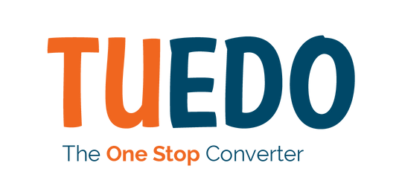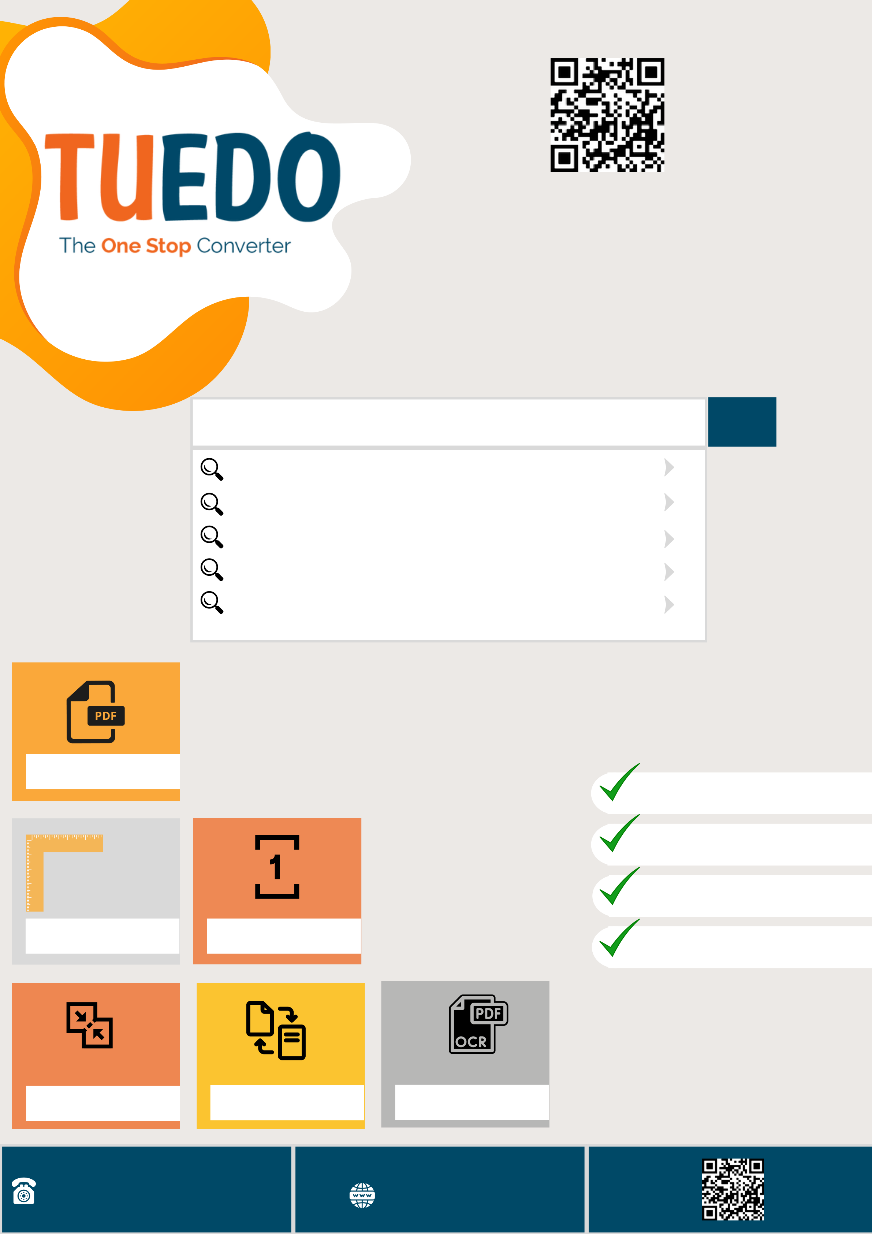

Try now

Single destination for Poppin' Fresh   
Conversions needs of all your documents

PDF to Go!

PDF Editing tools   
 PDF Conversion tools Image Conversion tools Media Conversion tools QR generator   
Features

Whats More ?

Batch Processing   
 100% Privacy

Free Download

Protected files

|  |  |  |  |
| --- | --- | --- | --- |
| Layout Settings | Page Range Selection | OCR | No Watermark |
| Merge files | Compress Large files |

1800 257 3265 || bd@cloudstrats.com https://tuedo.com