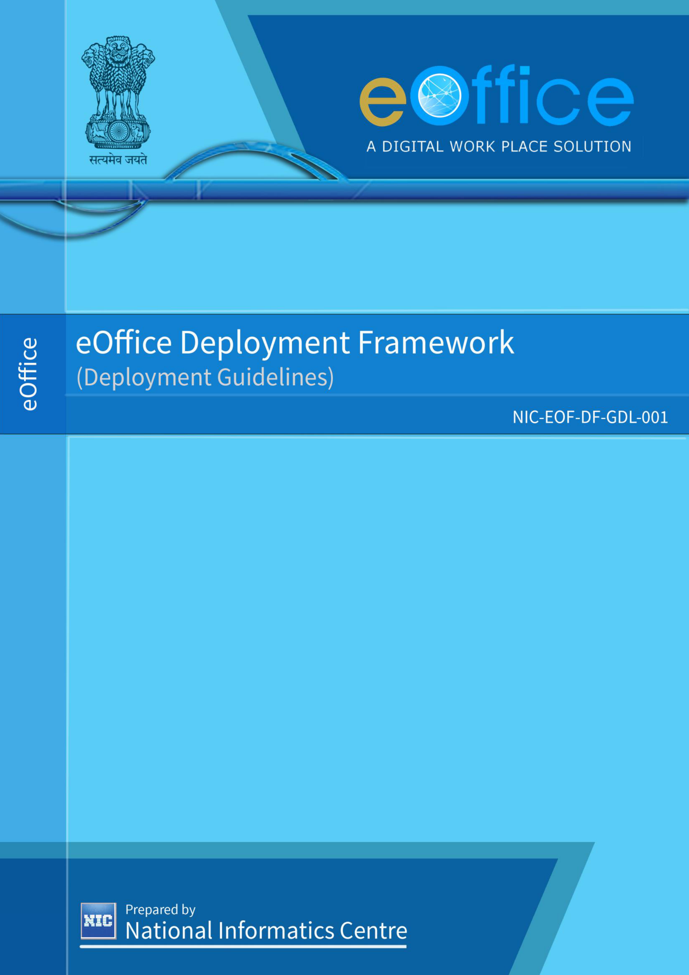

1



|  |
| --- |
| **CONTENTS** |

1. Purpose of the document ................................................................................................................................................... 5 2. eOffice Deployment Framework ..................................................................................................................................... 6 3. Type I Deployment Guidelines ........................................................................................................................................ 7 4. Type II Deployment Guidelines ....................................................................................................................................... 8 Annexure–A (REQUIREMENTS FOR EOFFICE) .............................................................................................................. 9 1. Hardware Requirements ........................................................................................................................................... 9 Data Redundancy ....................................................................................................................................................... 17 2.

3. Software ........................................................................................................................................................................ 18 4. Minimum OS Partitioning ....................................................................................................................................... 18 5. Other requirements .................................................................................................................................................. 18 Disaster Recovery ...................................................................................................................................................... 18 6.

ANNEXURE–B (CHECK LISTS) BEFORE GO-LIVE ...................................................................................................... 19 1. Check List – Type I eOffice Deployments ......................................................................................................... 19 2. Check List – Type II eOffice Deployments ........................................................................................................ 21 ANNEXURE–C (CHECK LISTS) AFTER GO-LIVE .......................................................................................................... 23 Check List – Type I eOffice Deployments ......................................................................................................... 23 1.

2. Check List – Type II eOffice Deployments ........................................................................................................ 24 ANNEXURE–D (ROLES AND RESPONSIBILITIES) ..................................................................................................... 25 1. Roles and Responsibilities for Type I Deployments .................................................................................... 25 2. Roles and Responsibilities for Type II Deployments ................................................................................... 26 ANNEXURE-E (EOFFICE DEPLOYMENT READY RECKONER) ............................................................................... 28

2



**Abbreviations**

|  |  |
| --- | --- |
| **CRL** | **Certificate Revocation List** |
| **DC** | **Data Centre** |
| **DR** | **Disaster Recovery** |
| **DNS** | **Domain Name Server** |
| **DSC** | **Digital Signature Certificate** |
| **ESA** | **eOffice Systems Administrators** |
| **LDAP** | **Lightweight Directory Access Protocol** |
| **LDC** | **Local Data Centre** |
| **LR** | **Logical Replication (PostgreSQL Database)** |
| **NDC** | **National Data Centre** |
| **NTP** | **Network Time Protocol** |
| **PITR** | **Point In Time Recovery** |
| **RAID** | **Redundant Array of Independent Disks** |
| **SAN** | **Storage Area Network** |
| **SDC** | **State Data Centre** |
| **SSL** | **Secure Socket Layer** |
| **SR** | **Streaming Replication (PostgreSQL Database)** |
| **VM** | **Virtual Machine** |

|  |  |
| --- | --- |
|  | 3 |



**Amendment History**

|  |  |  |  |  |  |
| --- | --- | --- | --- | --- | --- |
| **S.No.** | **Version** | **Date of Release** | **Date of**  **Amendment** | **Amended By** | **Amendments** |
| 1. | 1.0 | 19-01-2014 |  |  |  |
| 2. | 1.1 | 12-12-2014 | 11-12-2014 | eOffice  Division | •Specifications revised in **Annexure – A:**  Requirements for eOffice Premium  edition.  •Specifications revised in **Annexure – A:**  Requirements for eOffice Lite edition. |
| 3. | 2.0 | 01-06-2016 | 01-06-2016 | eOffice  Division | •Revision of categories based on user base revised in **Annexure – A**.  •eOffice deployment types based on   |  |  |  |  | | --- | --- | --- | --- | | products revised in **Annexure – A**. | | | in | | •Hardware | requirements | revised |   **Annexure – A**. |
| 4. | 3.0 | 26-03-2018 | 26-03-2018 | eOffice  Division | •Revision in eOffice deployment types. •Revision in Hardware and Software requirements in **Annexure - A**.  •Deletion of “PERFORMA FOR FORMAL HANDING OVER AND TAKING OVER OF EOFFICE SERVERS” |
| 5. | 4.0 | 07-11-2019 | 07-11-2019 | eOffice  Division | •Revision in Section 2 (**Pre-requisites for**   |  |  |  |  |  |  |  | | --- | --- | --- | --- | --- | --- | --- | | **eOffice Deployment**) | | | | | (**Type** | **I** | | •Revision | in | Section | | 3 | | **Deployment Guidelines**) | | | | | (**Type** | **II** | | •Revision | in | Section | 4 | |   **Deployment Guidelines**)  •Revision in “Hardware Requirements” and “Software” in **Annexure – A**.  •Addition of “**Data Redundancy**” and “**Minimum OS Partitioning**” sections in **Annexure – A**.  •Revision in Check Lists for Type I and Type II Deployments (**Annexure – B** and **Annexure – C)** •Revision in Roles and Responsibilities for Type I and Type II Deployments (**Annexure – D)** |
| 6. | 5.0 | 15-05-2020 | 14-05-2020 | eOffice  Division | •Revision in Section 1 **(Purpose of the**  **Document)** •Revision in Section 2 (**Pre-requisites for**  **eOffice Deployment**)  •Revision in “Hardware Requirements” in   |  |  |  |  | | --- | --- | --- | --- | | **Annexure – A** | | Annexure–E | **(eOffice** | | •Revision | in |   **Deployment Ready Reckoner)** |

4



|  |
| --- |
| **1. PURPOSE OF THE DOCUMENT** |

The eOffice Product is being implemented across the Government levels of Centre, States, Districts, PSUs, etc. The deployment of eOffice product can be done in eOffice Cloud, NIC/NICSI Data Centres, State Data Centres (SDC), Local Data Centres (LDC) or in any other data centre / cloud environment.

Establishing an eOffice Deployment Framework is important and the areas to be included in framework for ensuring effective deployment management and sustainability of eOffice are as follows:

•Deployment Strategy   
•Approach & Model for Deployment   
•Defining the Responsibility Matrix   
•Process and Guidelines   
•Availability of Deployment Infrastructure

This document includes all the above factors.

5



|  |
| --- |
| **2. EOFFICE DEPLOYMENT FRAMEWORK** |

The eOffice Deployment Framework categorizes eOffice deployment into two broad types and for each type, the check lists & roles and responsibilities matrix is defined.

**Deployment Types:**

•**Type I: Deployment of eOffice in eOffice Cloud**   
Under this type, only the ministries, departments and apex bodies of GOI are deployed in eOffice Cloud.

•**Type II: Deployment in NIC/NICSI Data Centres / State Data Centres (SDC) / Local Data Centres (LDC) / any other data centre or cloud environment**   
Under this type, the deployment is done in NIC/NICSI Data Centres / State Data Centres (SDC) / Local Data Centres (LDC) / any other data centre or cloud environment. The data centres may not be fully fledged data centres but subject to fulfilling of eOffice pre-requisites, the eOffice deployment is done. The access to eOffice in these departments is strictly made available as per the department’s / data centre’s rules & regulations.

**Pre-requisites for eOffice Deployment**

eOffice Project Division has prepared the server (or compute) and storage requirements based primarily on the total numbers of users and eOffice version. These requirements are arrived at by the deployment experience gathered over the years, inputs from the Data Centre teams and also on the basis of performance testing of eOffice application. **(Ref: Annexure-A)**

As eOffice data is very critical and the implementing organizations are increasingly dependent on eOffice services, therefore, there is a strong need of data redundancy mandatorily at Primary Data Centre. Apart from this, data redundancy is strongly recommended to be built at Remote Data Centre also. The data redundancy has been achieved by bringing in additional infrastructure by configuring the following:   
 a)Database replication is through DB SR and also by storing the PITR logs.

b)Replication of documents and configurations is achieved by rsync in provisioned Backup Server.

In order to identify security breaches and data tempering, if any, in eOffice applications; recording the access trails and transactions of all the applications and servers is necessary. For storing these audit logs, Logs Server is required to be provisioned along with its backup mandatorily at the Primary Data Centre. Apart from this, Logs Backup Server is strongly recommended to be configured at Remote Data Centre also.

The requirements will be mildly on the higher side keeping in view the horizon of 2-3 years. Further, the requirements are kept higher by a factor of 20% as a best practice. It is expected that requirements are defined in such a manner that it will be convenient for IT heads or decision makers as incremental additions to infrastructure is not only difficult in terms of internal approvals but also inconvenient for technical teams to add new infrastructure on routine basis without disrupting the services and other impacts known and unknown.

6



|  |
| --- |
| **3. TYPE I DEPLOYMENT GUIDELINES** |

The Type I deployment is essentially meant for the Central Government Ministries, Departments and Apex Bodies and will start once the approval for hosting is received by eOffice Project Division.

**The steps involved in deployment are as follows:**

1.Based on the eOffice version (Premium or Lite), the necessary provisioning will be done as per the details mentioned in**Annexure-A.**

2.The DNS will be registered under the sub-domain **eoffice.gov.in**   
3.eOffice instance will be setup as per the eOffice Setup instructions provided time to time.

4.The eOffice is restricted to NICNET/NKN and check at firewall level may be ascertained. 5.The user authentication happens through NIC/GOI email-id. The LDAP forms etc. are to be submitted by concerned departments directly to Mail services group. The departments must also obtain the LDAP bind string from Mail services group and shared it with ESA.

6.All eOffice sites have to be mandatorily SSL enabled. The SSL certificate must be obtained for each eOffice instance and configured.

7.Sync the server timings with NDC NTP server. This is critical activity and must be doubly assured.

8.Register the site with Data Centre monitoring tools like Nagios, Zabbix, etc. so that it comes under monitoring dashboard.

9.Ensure that all the forms for scheduling the offline backups are submitted to NDC.

10.Ensure that DB replication and PITR are running.

11.Ensure that Logs along with their backup are being maintained.

12.The eOffice System Administrator must fill the check list provided in **Annexure-B**and ensure that all the activities are checked before going live. The duly signed and stamped check list must also be submitted by NIC official looking after eOffice System Administration to eOffice PMU for records.

13.The eOffice System Administrator must fill the check list provided in **Annexure-C** and ensure that all the activities are checked after Go-Live of eOffice. The duly signed and stamped check list must also be submitted by NIC official looking after eOffice System Administration to eOffice PMU for records on quarterly basis i.e. before 7th of April, July, October and January. 14.The duly signed and stamped check lists provided in **Annexure-B** and **Annexure-C** are required to be mandatorily submitted by NIC official looking after eOffice System Administration to eOffice PMU for compliance towards eOffice Data Redundancy.

15.The eOffice System Administration must prepare the Deployment Document.

16.The roles and responsibilities for Type I deployment need to be strictly followed **(Ref:**  **Annexure-D)**.

7



|  |
| --- |
| **4. TYPE II DEPLOYMENT GUIDELINES** |

Under this type, the deployment is done either in NIC/NICSI Data Centres / State Data Centres (SDC) / Local Data Centres (LDC) / any other data centre or cloud environment, as the case may be.

**The steps involved in deployment are as follows:**

1.Based on the eOffice version (Premium or Lite), the necessary provisioning is made available by the concerned department as per **Annexure-A.**

2.DNS registration as per department policy.

3.Training to be provided to the system admin team of department.

4.eOffice instance will be setup by local admin team under the supervision of eOffice team as per the eOffice setup instructions provided time to time.

5.The user authentication mechanism will be done through LDAP.

6.SSL certificate is mandatory.

7.Sync the server timings with NTP server.

8.Department may register their eOffice instance with local monitoring tools, if available. 9.Schedule the offline backups as per DC/Department policy. It is mandatory to identify storage & backup servers for copying of configuration files, uploaded documents and logs data other than offline backup.

10.Setup the DB replication. PITR is mandatory and for this additional storage will be required.

11.For DSC signing, a separate CRL server may be established at data centre, if required. 12.For availing eSign facility, department may contact empanelled eSign Service Providers and sign an agreement with them as ASP (Application Service Provider). Department may also provision the necessary infrastructure at data centre, if required.

13.For SMS & Email alerts services, necessary configuration and port opening will be the responsibility of department / data centre.

14.For Inter-departmental file exchange, a separate server for running ActiveMQ service may be established at data centre, if required.

15.[For verification of](https://eoffice.gov.in/) eOffice Activation Key, ports (80, 443) of Application Server to [https://eoffice.gov.in](https://eoffice.gov.in/) are required to be opened.

16.The eOffice System Administrator identified by department must fill the check list provided in **Annexure-B**and ensure that all the activities are checked before going live. The duly signed and stamped check list must also be submitted by eOffice Nodal Coordinator of the department to eOffice PMU for records.

17.The eOffice System Administrator identified by department must fill the check list provided in **Annexure-C** and ensure that all the activities are checked after Go-Live of eOffice. The duly signed and stamped check list must also be submitted by eOffice Nodal Coordinator of the department to eOffice PMU for records on quarterly basis i.e. before 7th of April, July, October and January.

18.The duly signed and stamped check lists provided in **Annexure-B** and **Annexure-C** are required to be mandatorily submitted by eOffice Nodal Coordinator of the department to eOffice PMU for compliance towards eOffice Data Redundancy.

19.The eOffice System Administrator identified by department, in coordination with eOffice System Administration Team, must prepare the Deployment Document and share it with eOffice PMU. As and when any revision is made in the Deployment Document, the same may be again shared with eOffice PMU for records.

20.The roles and responsibilities for Type II deployment need to be strictly followed **(Ref:**  **Annexure-D)**.

8

|  |
| --- |
| **ANNEXURE–A (REQUIREMENTS FOR EOFFICE)** |

|  |  |
| --- | --- |
| 1.HARDWARE REQUIREMENTS | |
| **1.1** | **eOffice Premium** |

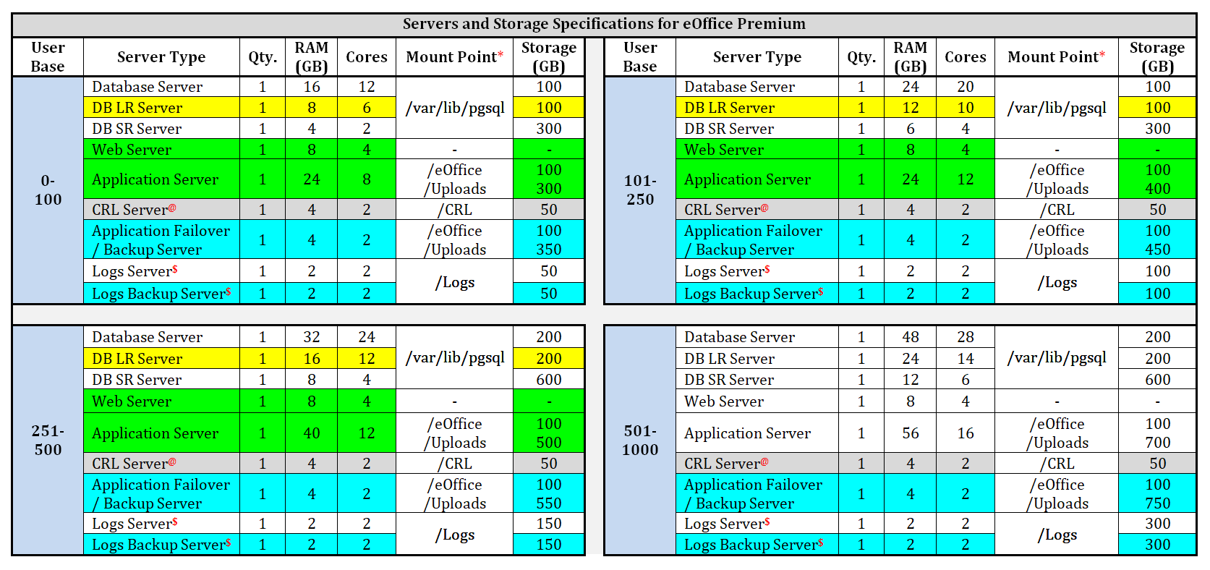

9

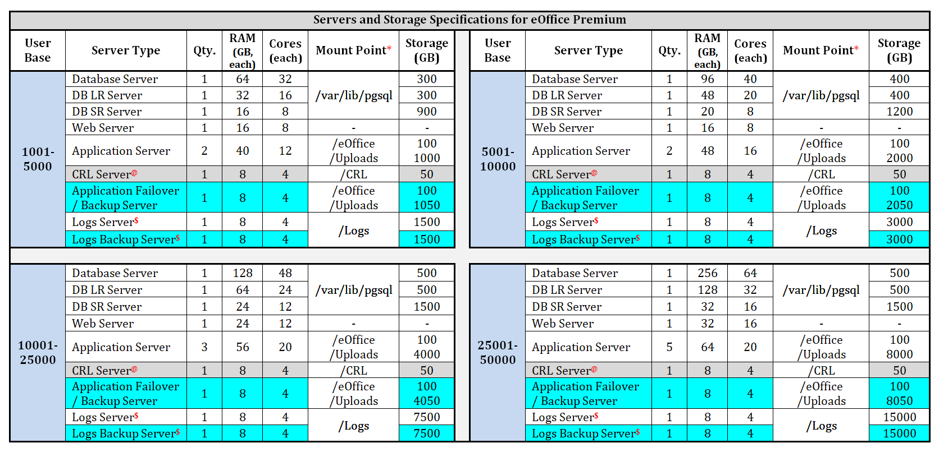

a)*/eOffice must be mounted to each application server and /Uploads must be mounted to only one application server as per the storage defined in above table. b)SAN is the recommended storage media.

c)Storage (GB) is the additional storage required at Mount Point after minimum OS partitioning as specified in Point No. 4 at Page 18.

d)Whenever services are required to run from DB SR Server / Application Failover Server, then the resources of DB SR Server / Application Failover Server to be made equivalent to Database Server / Application Server.

e)In DB SR Server, PITR is required to be configured.

f) **$**Storage for Logs (including PITR) has been calculated for a period of two years keeping in view that the approximate compression level is 80%.

g)@CRL Server is required in case department is using DSC signing.

h)Logs Backup Server, if required, can be minimized by mounting the Storage required for Logs Backup with Application Failover/ Backup Server. By doing this, additional data redundancy of logs is ensured and also the cost of additional Server/ VM for Logs Backup Server is saved for the concerned user department.

10