|  |  |
| --- | --- |
|  | **We recommend you to try the PREMIUM AI-900 Dumps From Exambible** https://www.exambible.com/AI-900-exam/ (85 Q&As) |



**Microsoft**

**Exam Questions AI-900**

Microsoft Azure AI Fundamentals (beta)

*Your Partner of IT Exam*  *visit - https://www.exambible.com*



**About Exambible**

***Your Partner of IT Exam***

**Found in 1998**

Exambible is a company specialized on providing high quality IT exam practice study materials, especially Cisco CCNA, CCDA, CCNP, CCIE, Checkpoint CCSE, CompTIA A+, Network+ certification practice exams and so on. We guarantee that the candidates will not only pass any IT exam at the first attempt but also get profound understanding about the certificates they have got. There are so many alike companies in this industry, however, Exambible has its unique advantages that other companies could not achieve.

**Our Advances**

* 99.9% Uptime   
 All examinations will be up to date.

* 24/7 Quality Support   
 We will provide service round the clock.

* 100% Pass Rate   
 Our guarantee that you will pass the exam.

* Unique Gurantee   
If you do not pass the exam at the first time, we will not only arrange FULL REFUND for you, but also provide you another exam of your claim, ABSOLUTELY FREE!

*Your Partner of IT Exam*  *visit - https://www.exambible.com*



**NEW QUESTION 1**  
- (Exam Topic 1)   
You are designing an AI system that empowers everyone, including people who have hearing, visual, and other impairments. This is an example of which Microsoft guiding principle for responsible AI?

A. fairness   
B. inclusiveness   
C. reliability and safety   
D. accountability

**Answer:** B

**Explanation:**   
Inclusiveness: At Microsoft, we firmly believe everyone should benefit from intelligent technology, meaning it must incorporate and address a broad range of human needs and experiences. For the 1 billion people with disabilities around the world, AI technologies can be a game-changer.

Reference:   
https://docs.microsoft.com/en-us/learn/modules/responsible-ai-principles/4-guiding-principles

**NEW QUESTION 2**  
- (Exam Topic 1)   
You are building an AI system.

Which task should you include to ensure that the service meets the Microsoft transparency principle for responsible AI?

A. Ensure that all visuals have an associated text that can be read by a screen reader. B. Enable autoscaling to ensure that a service scales based on demand.   
C. Provide documentation to help developers debug code.

D. Ensure that a training dataset is representative of the population.

**Answer:** C

**Explanation:**   
Reference:   
https://docs.microsoft.com/en-us/learn/modules/responsible-ai-principles/4-guiding-principles

**NEW QUESTION 3**  
- (Exam Topic 1)   
A company employs a team of customer service agents to provide telephone and email support to customers. The company develops a webchat bot to provide automated answers to common customer queries.

Which business benefit should the company expect as a result of creating the webchat bot solution?

A. increased sales   
B. a reduced workload for the customer service agents   
C. improved product reliability

**Answer:** B

**NEW QUESTION 4**  
- (Exam Topic 1)   
To complete the sentence, select the appropriate option in the answer area.

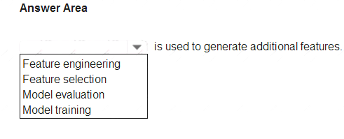

A. Mastered   
B. Not Mastered

**Answer:** A

**Explanation:**   
Reference:   
https://docs.microsoft.com/en-us/azure/machine-learning/team-data-science-process/create-features

**NEW QUESTION 5**  
- (Exam Topic 1)   
You build a machine learning model by using the automated machine learning user interface (UI). You need to ensure that the model meets the Microsoft transparency principle for responsible AI. What should you do?

*Your Partner of IT Exam*  *visit - https://www.exambible.com*



A. Set Validation type to Auto.

B. Enable Explain best model.

C. Set Primary metric to accuracy.   
D. Set Max concurrent iterations to 0.

**Answer:** B

**Explanation:**   
Model Explain Ability.

Most businesses run on trust and being able to open the ML “black box” helps build transparency and trust. In heavily regulated industries like healthcare and banking, it is critical to comply with regulations and best practices. One key aspect of this is understanding the relationship between input variables (features) and model output. Knowing both the magnitude and direction of the impact each feature (feature importance) has on the predicted value helps better understand and explain the model. With model explain ability, we enable you to understand feature importance as part of automated ML runs.

Reference:   
https://azure.microsoft.com/en-us/blog/new-automated-machine-learning-capabilities-in-azure-machine-learning

**NEW QUESTION 6**  
- (Exam Topic 1)   
To complete the sentence, select the appropriate option in the answer area.

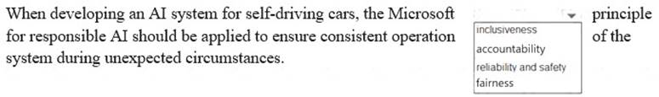

A. Mastered   
B. Not Mastered

**Answer:** A

**Explanation:**   
Reliability and safety: To build trust, it's critical that AI systems operate reliably, safely, and consistently under normal circumstances and in unexpected conditions.

These systems should be able to operate as they were originally designed, respond safely to unanticipated conditions, and resist harmful manipulation.

Reference:   
https://docs.microsoft.com/en-us/learn/modules/responsible-ai-principles/4-guiding-principles

**NEW QUESTION 7**  
- (Exam Topic 1)   
For each of the following statements, select Yes if the statement is true. Otherwise, select No. NOTE: Each correct selection is worth one point.

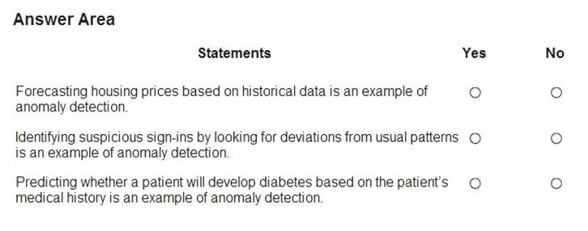

A. Mastered   
B. Not Mastered

**Answer:** A

**Explanation:**   
Box 1: No   
Box 2: Yes   
Box 3: Yes   
Anomaly detection encompasses many important tasks in machine learning: Identifying transactions that are potentially fraudulent. Learning patterns that indicate that a network intrusion has occurred. Finding abnormal clusters of patients.

Checking values entered into a system. Reference:   
https://docs.microsoft.com/en-us/azure/machine-learning/studio-module-reference/anomaly-detection

**NEW QUESTION 8**  
- (Exam Topic 1)   
To complete the sentence, select the appropriate option in the answer area.

*Your Partner of IT Exam*  *visit - https://www.exambible.com*



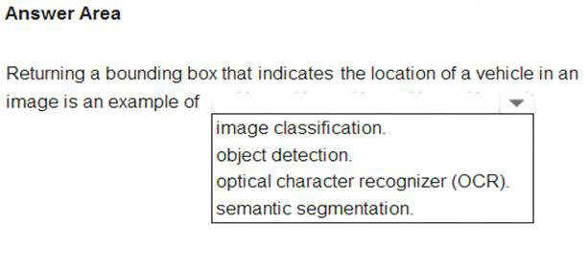

A. Mastered   
B. Not Mastered

**Answer:** A

**Explanation:**   
Reference:   
https://docs.microsoft.com/en-us/azure/cognitive-services/computer-vision/concept-object-detection

**NEW QUESTION 9**  
- (Exam Topic 1)   
What are three Microsoft guiding principles for responsible AI? Each correct answer presents a complete solution. NOTE: Each correct selection is worth one point.

A. knowledgeability   
B. decisiveness   
C. inclusiveness   
D. fairness   
E. opinionatedness   
F. reliability and safety

**Answer:** CDF

**Explanation:**   
Reference:   
https://docs.microsoft.com/en-us/learn/modules/responsible-ai-principles/4-guiding-principles

**NEW QUESTION 10**  
- (Exam Topic 1)   
Match the types of AI workloads to the appropriate scenarios.

To answer, drag the appropriate workload type from the column on the left to its scenario on the right. Each workload type may be used once, more than once, or not at all.

NOTE: Each correct selection is worth one point.

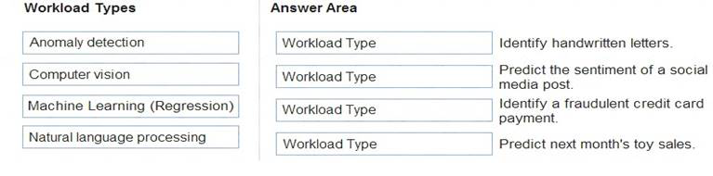

A. Mastered   
B. Not Mastered

**Answer:** A

**Explanation:**   
Reference:   
https://docs.microsoft.com/en-us/learn/paths/get-started-with-artificial-intelligence-on-azure/

**NEW QUESTION 10**  
- (Exam Topic 2)   
Which two components can you drag onto a canvas in Azure Machine Learning designer? Each correct answer presents a complete solution. NOTE: Each correct selection is worth one point.

*Your Partner of IT Exam*  *visit - https://www.exambible.com*



A. dataset   
B. compute   
C. pipeline   
D. module

**Answer:** AD

**Explanation:**   
You can drag-and-drop datasets and modules onto the canvas. Reference:   
https://docs.microsoft.com/en-us/azure/machine-learning/concept-designer

**NEW QUESTION 12**  
- (Exam Topic 2)   
You need to predict the income range of a given customer by using the following dataset.

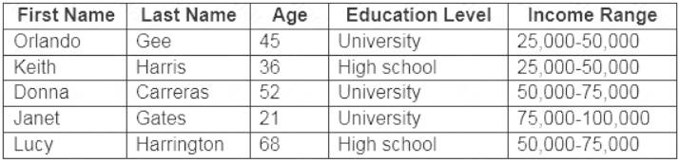

Which two fields should you use as features? Each correct answer presents a complete solution. NOTE: Each correct selection is worth one point.

A. Education Level   
B. Last Name   
C. Age   
D. Income Range   
E. First Name

**Answer:** AC

**Explanation:**   
First Name, Last Name, Age and Education Level are features. Income range is a label (what you want to predict). First Name and Last Name are irrelevant in that they have no bearing on income. Age and Education level are the features you should use.

**NEW QUESTION 15**   
......

*Your Partner of IT Exam*  *visit - https://www.exambible.com*



**Relate Links**   
**100% Pass Your AI-900 Exam with Exambible Prep Materials**   
<https://www.exambible.com/AI-900-exam/>

**Contact us**   
**We are proud of our high-quality customer service, which serves you around the clock 24/7.**

**Viste -** <https://www.exambible.com/>

*Your Partner of IT Exam*  *visit - https://www.exambible.com*