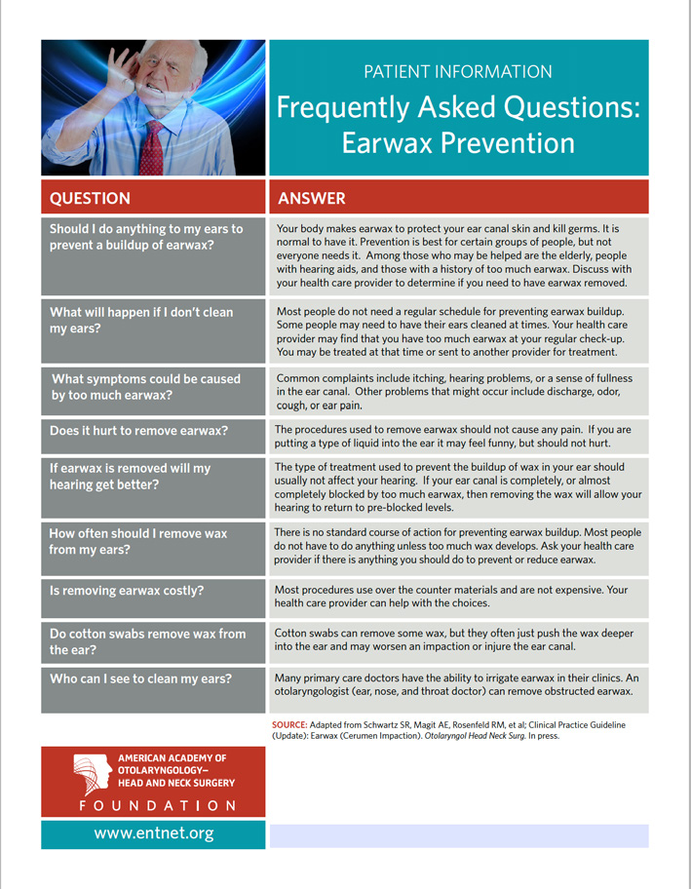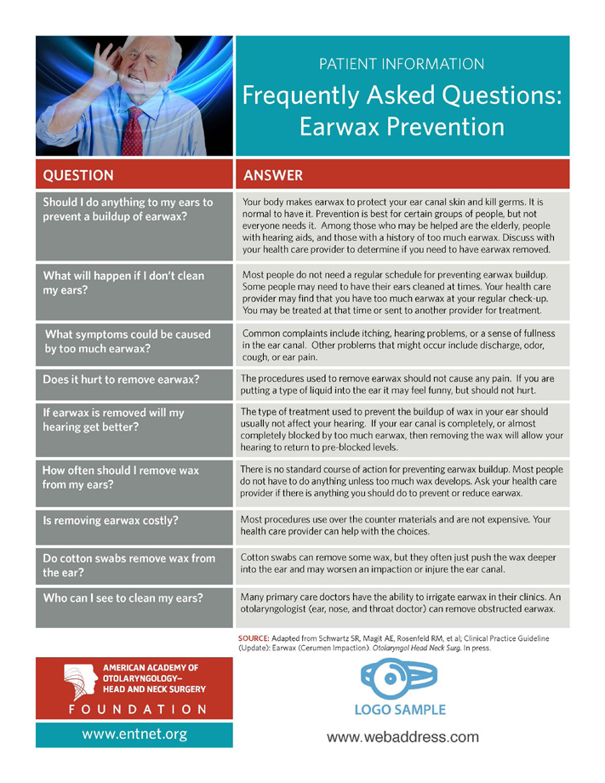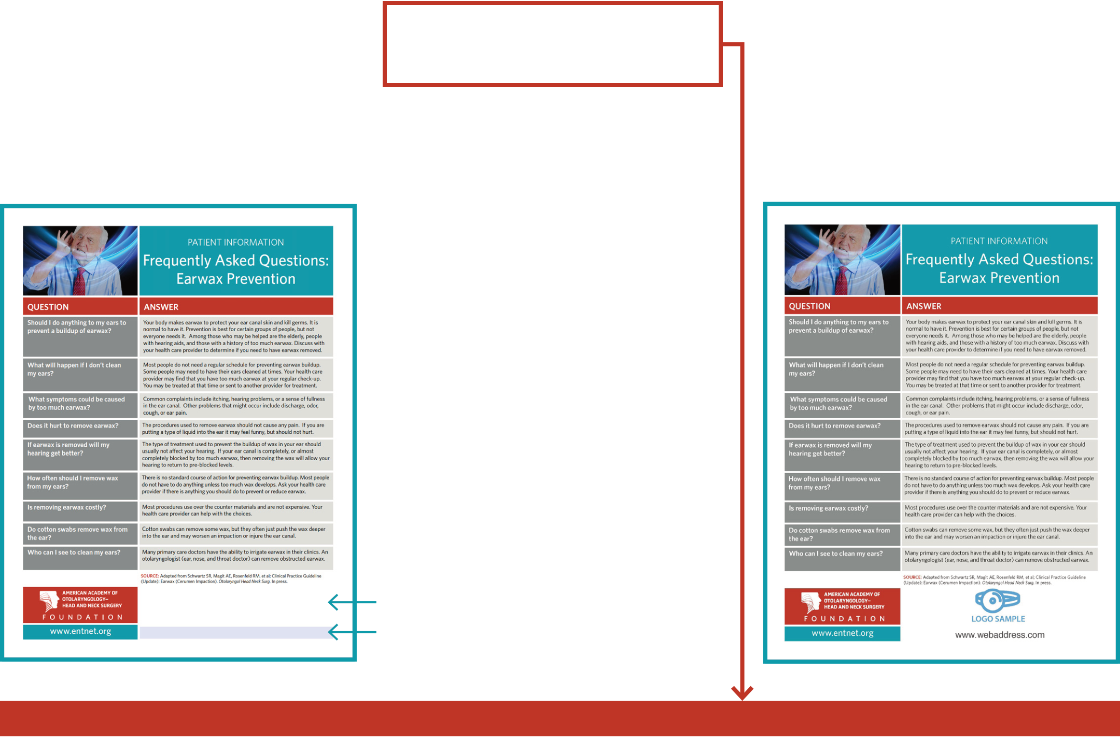

**Instructions for Adding Your Logo & Address to AAO-HNSF Patient Handouts**

**CO-BRANDING AAO-HNSF PATIENT HANDOUTS IS AS EASY AS 1-2-3!**

|  |  |  |  |  |  |
| --- | --- | --- | --- | --- | --- |
| **1** | **Download & Save Patient Handout** | **2** | **Upload Your Logo & Address** | **3** | **You’re Ready to Print!** |
| Download the patient handout | | **Your image *must* be saved as a .pdf file!** | | Save your file. | |
| You will need Adobe Acrobat Reader. | | Make sure to save your file before you close | |
| **For additional information on how to** | |
| You can install it for free here: | | the document to ensure your logo and/ | |
| **save your logo/address as a .pdf file,** | |
| **get.adobe.com/reader** | | or address will be there the next time you | |
| **please see the instructions below.** | |
| open up the document. | |
| Save it to your computer | | *You will not be able to upload your personal* | |
| You are now ready to print! | |
| Remember where you save it; you will | | *information to the patient handout if the file* | |
| *is not saved in the .pdf format.* | | *Example of a co-branded Patient Handout:* | |
| need to access it in the following steps. | |
| Open the saved patient handout document | |

Click in the white space at the bottom of   
 the page.

Within the **Select Icon** window,   
**Browse** to the .pdf file you would   
like to **Insert** and then click, **OK**.

The logo and/or address file will resize   
appropriately for the box.

Type your web address in the blue   
 rectangle below the white image field.

Click in this white space to upload your logo

Click in this blue area to type your web address

**CONVERT YOUR LOGO TO .PDF**

**Open a new Microsoft Word document.**

Remember where you save it; you will need to access it when uploading your logo/address to the Patient Handout.

|  |  |  |
| --- | --- | --- |
| **Insert Your Image** | **Resize Your Image** | **Add Text Next to Your Image** |
| Click the location in your Word document | **To include contact information next to your** | **Following these instructions will allow you to** |
| where you want to insert your image. | **logo, you may need to resize your image.** | **add multiple lines of text to the right of your** |
| Click the **Insert** tab, click **Pictures**. | Click on the image you want to resize. | **image. Please see the example below.** |
| Browse to the image you want to insert, | To increase or decrease the size of the | Click on the image. |
| select it, and then click **Insert**. | Click the **Pictures Tools** or **Drawing Tools** |
| logo, drag the sizing handle away from or |
| Your image will most likely be your logo. | towards the center. | **Format** tab. |
| If your image contains all of the | To maintain the proportions, press and | Under the **Arrange** group, click **Wrap Text**. |
| information you would like to include, you | hold **Shift** while you drag the sizing handle. | Choose the **Square** style of wrapping. |
| are ready to export/save as a .pdf. |
| Add your text. |

**Export/Save As .PDF from Microsoft Word**   
**Once your image contains all of the information you would like to include in the image field of your co-branded Patient Handout, you’re ready to save as a .pdf!**

From the **File** menu, click **Export** or **Save As**. Change the file format to **PDF**, and click **Save**.

*Example of a logo and address to be uploaded to the co-branded Patient Handouts:*

|  |
| --- |
|  |