5/1/22, 7:50 PM Appointment Reciept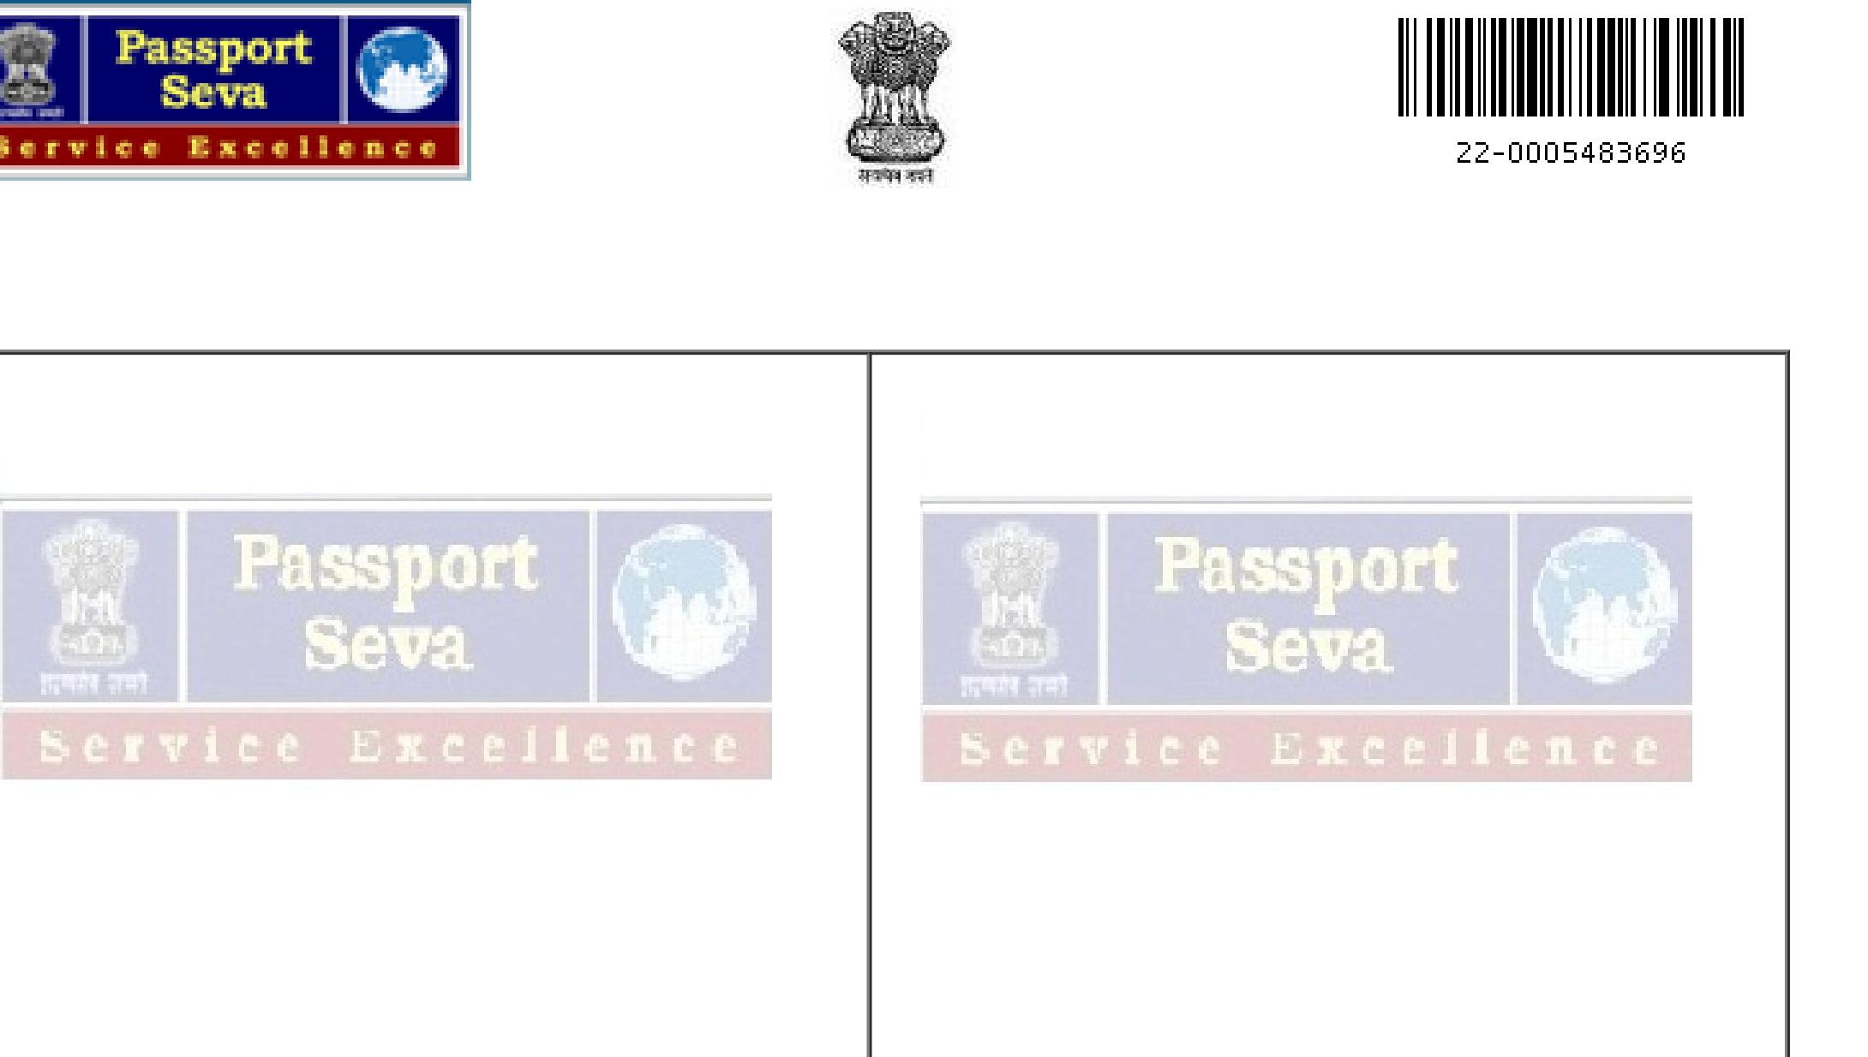

**िवदेशमं�ालयभारतसरकार**

**Ministry of External Affairs, Government of India**

**Online Appointment Receipt**

|  |  |  |  |
| --- | --- | --- | --- |
| **Applicant Details:**   |  |  | | --- | --- | | Application Reference No.  (ARN)  Service Type  Type of Application Given Name  Surname  Gender  Father's Name  Mother's Name  Date of Birth  Place of Birth  Marital Status  Employment Type | 22-0005483696  FRESH  NORMAL  SHIVAM RAMCHANDRA  DHUMAL  MALE  RAMCHANDRA NAMDEO DHUMAL MANISHA RAMCHANDRA DHUMAL 16/10/2000  MUMBAI,THANE CITY,MAHARASHTRA SINGLE  NOT EMPLOYED |   [Application Submitted Date 17/04/2022](https://portal1.passportindia.gov.in/AppOnlineProject/secure/openPdfForApplReciept#)  Present Residential AJINKYATARA CHS,A-8,0-14,SECTOR-Address 18,NERUL, NAVI MUMBAI, Navi Mumbai, 400706, Maharashtra, INDIA | **[Payment Details](https://portal1.passportindia.gov.in/AppOnlineProject/secure/openPdfForApplReciept#)**[#](https://portal1.passportindia.gov.in/AppOnlineProject/secure/openPdfForApplReciept#)  [Total Fee (Rs.)](https://portal1.passportindia.gov.in/AppOnlineProject/secure/openPdfForApplReciept#)  [1500.00](https://portal1.passportindia.gov.in/AppOnlineProject/secure/openPdfForApplReciept#)  [Paid Fee (Rs.)](https://portal1.passportindia.gov.in/AppOnlineProject/secure/openPdfForApplReciept#)  [1500.00](https://portal1.passportindia.gov.in/AppOnlineProject/secure/openPdfForApplReciept#)  [Date and Time](https://portal1.passportindia.gov.in/AppOnlineProject/secure/openPdfForApplReciept#)  [17/04/2022 08:44 AM](https://portal1.passportindia.gov.in/AppOnlineProject/secure/openPdfForApplReciept#)  [Transaction Id](https://portal1.passportindia.gov.in/AppOnlineProject/secure/openPdfForApplReciept#)  [CPABORQCG5](https://portal1.passportindia.gov.in/AppOnlineProject/secure/openPdfForApplReciept#)  **[Appointment Details:](https://portal1.passportindia.gov.in/AppOnlineProject/secure/openPdfForApplReciept#)**  [Passport Seva](https://portal1.passportindia.gov.in/AppOnlineProject/secure/openPdfForApplReciept#)  [THANE II,](https://portal1.passportindia.gov.in/AppOnlineProject/secure/openPdfForApplReciept#)  [Kendra Address](https://portal1.passportindia.gov.in/AppOnlineProject/secure/openPdfForApplReciept#)  [PASSPORT SEVA KENDRA,DOSTI](https://portal1.passportindia.gov.in/AppOnlineProject/secure/openPdfForApplReciept#)  [PINNACLE,UNIT NO G1,PLOT NO E7,RO](https://portal1.passportindia.gov.in/AppOnlineProject/secure/openPdfForApplReciept#)AD  [NO 22,WAGLE INDUSTRIAL ESTATE,THA](https://portal1.passportindia.gov.in/AppOnlineProject/secure/openPdfForApplReciept#)NE  [WEST](https://portal1.passportindia.gov.in/AppOnlineProject/secure/openPdfForApplReciept#)  **[Appointment Id](https://portal1.passportindia.gov.in/AppOnlineProject/secure/openPdfForApplReciept#)**  **[100021377863122](https://portal1.passportindia.gov.in/AppOnlineProject/secure/openPdfForApplReciept#)**  **[Appointment](https://portal1.passportindia.gov.in/AppOnlineProject/secure/openPdfForApplReciept#)**  **[02/05/2022 & 10:15 AM](https://portal1.passportindia.gov.in/AppOnlineProject/secure/openPdfForApplReciept#)**  **[Date and Time](https://portal1.passportindia.gov.in/AppOnlineProject/secure/openPdfForApplReciept#)**  **[Reporting Date](https://portal1.passportindia.gov.in/AppOnlineProject/secure/openPdfForApplReciept#)**  **02/05/2022 & 10:00 AM**  **and Time**  **Sequence No. 24**  **Batch**  **8** |

**Please Read Carefully:**

Please reach Passport Seva Kendra (PSK) at **10:00 AM** as mentioned above and you dont need to carry the printed copy of appointment receipt. An SMS

|  |  |
| --- | --- |
| with your appointment details is also accepted as proof of appointment during your visit to Passport Office.  Check **Document Advisor** on website **'www.passportindia.gov.in'** to know the documents required at PSK.Carry original documents and their self attested photocopies. Final decision with regard to documents required is at the discretion of RPO staff at PSK.  In case of minor applicants (below 4 years of age), carry the recent passport size photograph (4.5 X 3.5 cm) with white background.Please Click here for photograph guidelines.  Only applicant is allowed inside the PSK. However, in case of exceptions such as Senior Citizen / Physically Challenged / Illiterate / Minor applicants, one person from the family may be allowed to accompany inside PSK.  At PSK, a paper token will be issued to you after checking of documents.Your application will be processed at Counter A followed by counters B and C. At all stages, please be alert and watch the token display screens to know the counter at which your application will be processed. After your visit to PSK, please login to Passport Portal to download acknowledgement slip. Also,you are requested to fill the feedback form at the exit counter.  Corrosive substances, explosives, weapons and any sharp objects are not allowed inside the PSK. Please co-operate with security staff for frisking before entry in PSK. Your security is our primary concern.  Take care of your belongings inside the PSK.  Keep your mobile in silent mode inside PSK. Also video / photography is not allowed inside.  Thanks for showing your interest in 'Passport Seva SMS Services' enrolment. Please pay Rs 50/- (FIFTY ONLY) in cash as the Enrolment Charges during your visit to Passport Seva Kendra.  Balance fee (if applicable) after editing the submitted form will be payable in cash at the Passport Seva Kendra.  ATM facility available at PSK for all Bank Cards.  **Help us to serve you better.**  **# Details as per the Payment Date. Payment once made for availing passport services will not be refunded.**  **We are delighted to offer attractive passport covers manufactured using quality leather and PU. You can choose from the available options at PSK.**  The Following documents needs to be furnished at PSK/PO for verification:  Aadhaar Card/E-Aadhaar  Aadhaar Card (Address Proof) | |
| file:///C:/Users/dhuma/OneDrive/Desktop/Appointment Reciept.html | 1/3 |