**GitHub Details:**

**GitHub Repositories: VishwaGuru, Payroll**

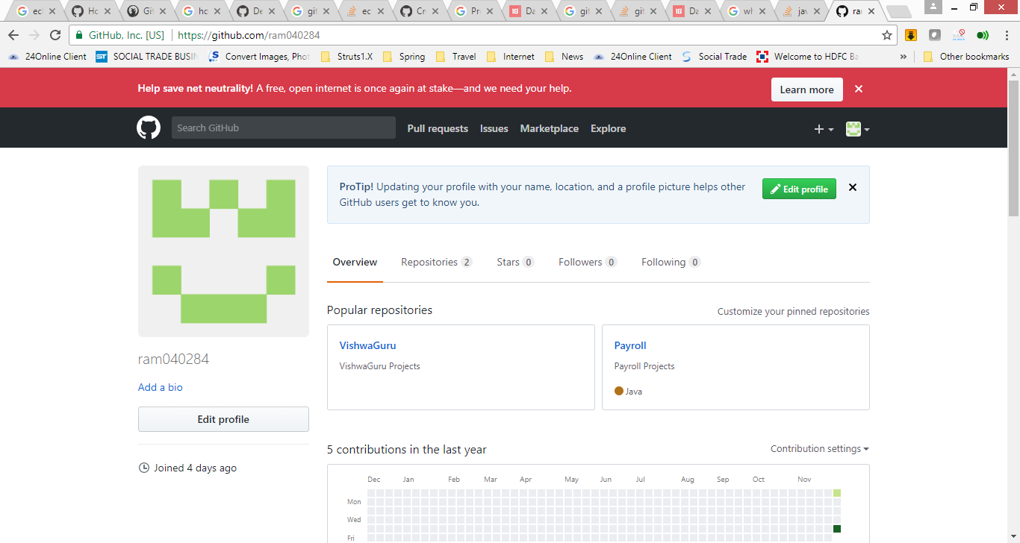

**Repository: Payroll**

**Branch: Development**

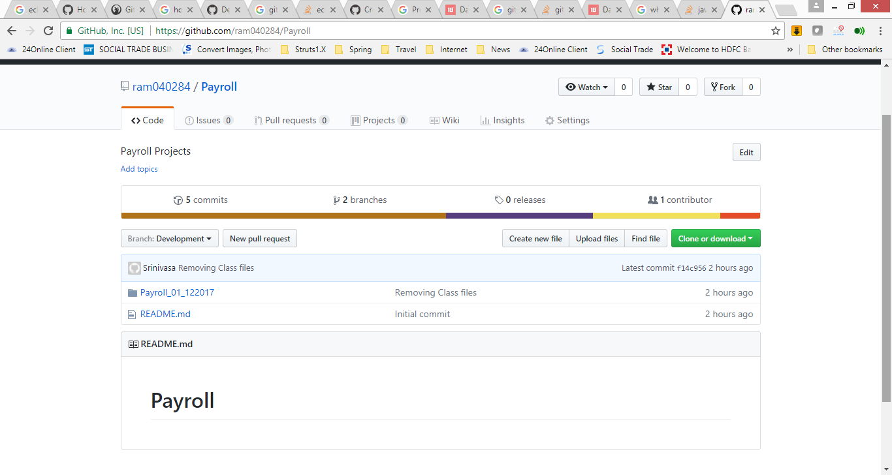

**Project: Payroll_01_122017**

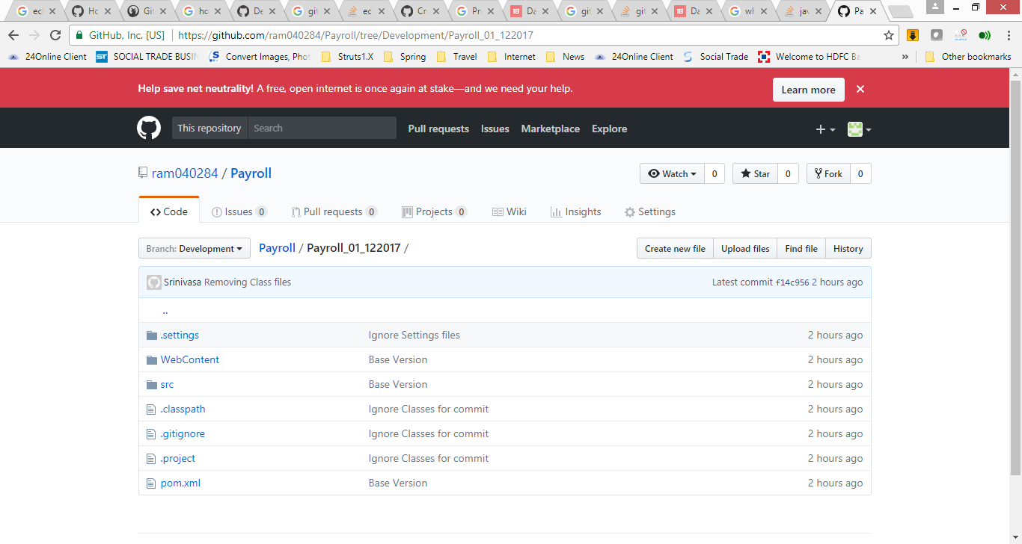

**Clone URL for Payroll: https://github.com/ram040284/Payroll.git**

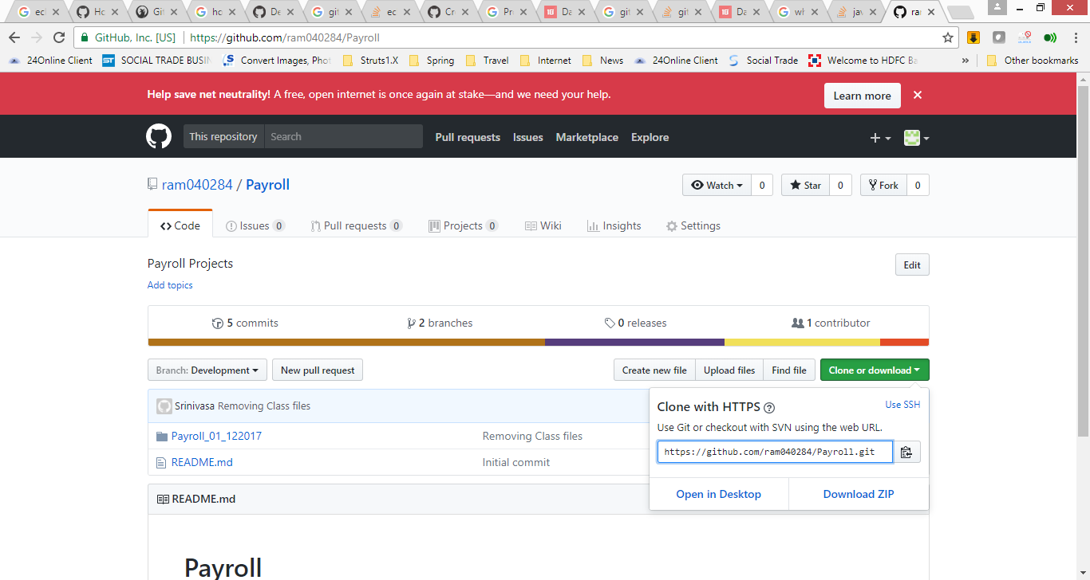

**GitHub project setup in Eclipse:**

**Create new eclipse workspace**

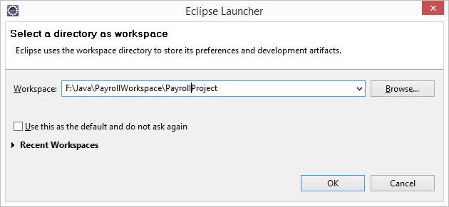

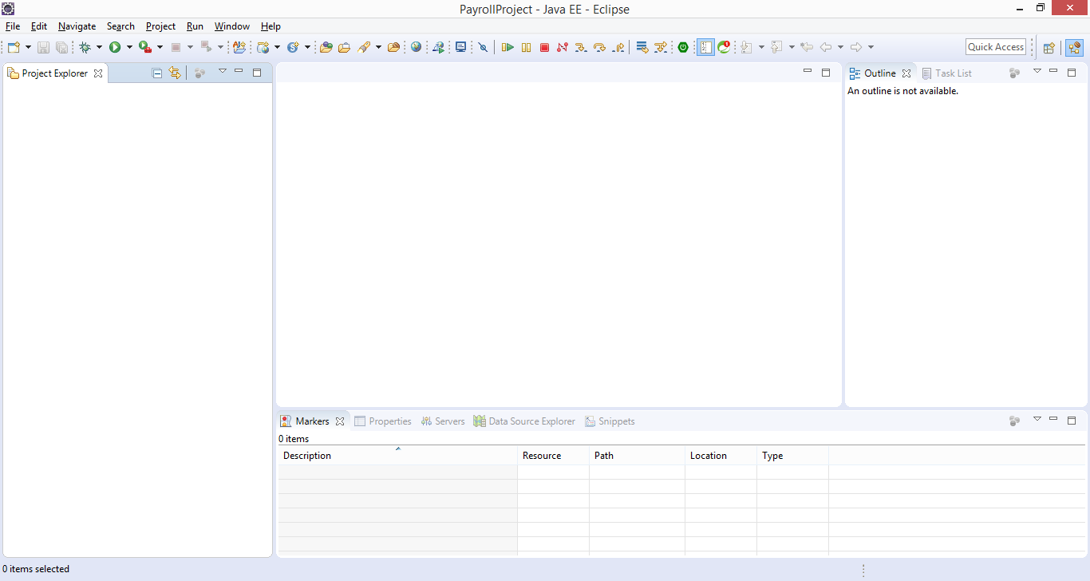

**Open GIT Perspective**

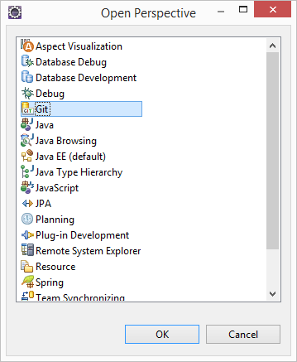

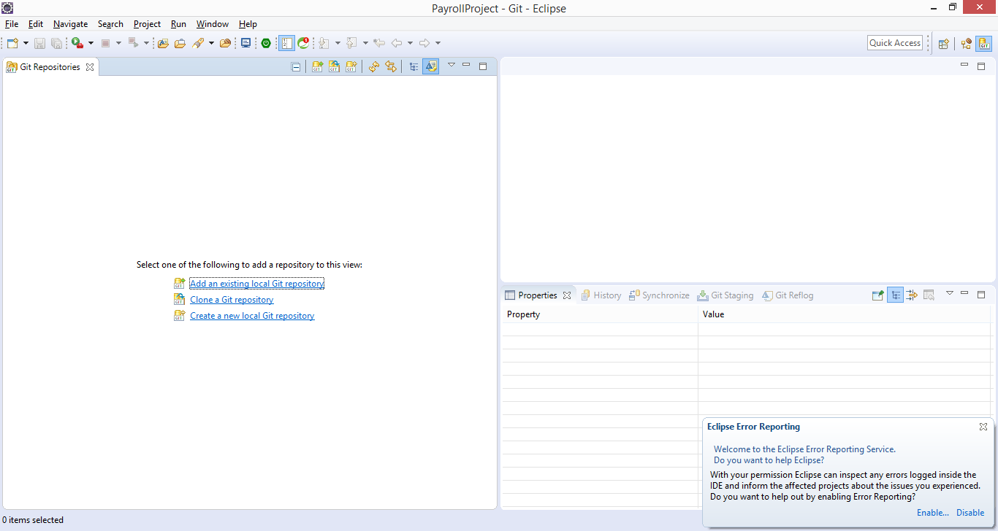

**Click on Clone a Git Repository link**

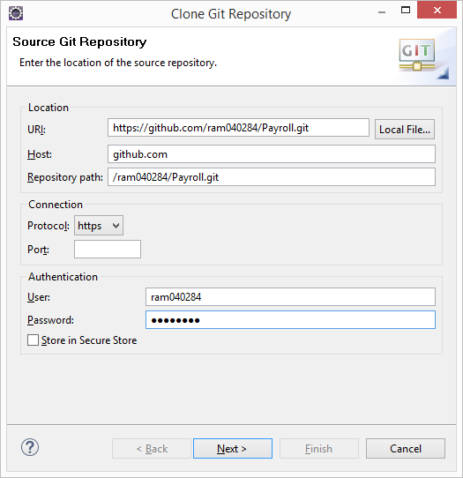

**Provide following URI in eclipse window https://github.com/ram040284/Payroll.git**

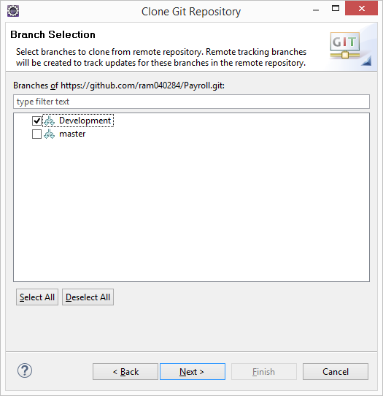

**Select Development Branch**

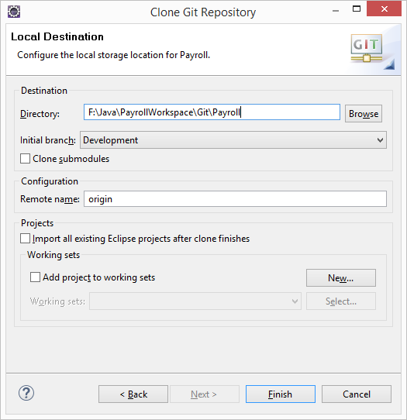

Give Local Storage location to store Development branch projects

Click on Finish

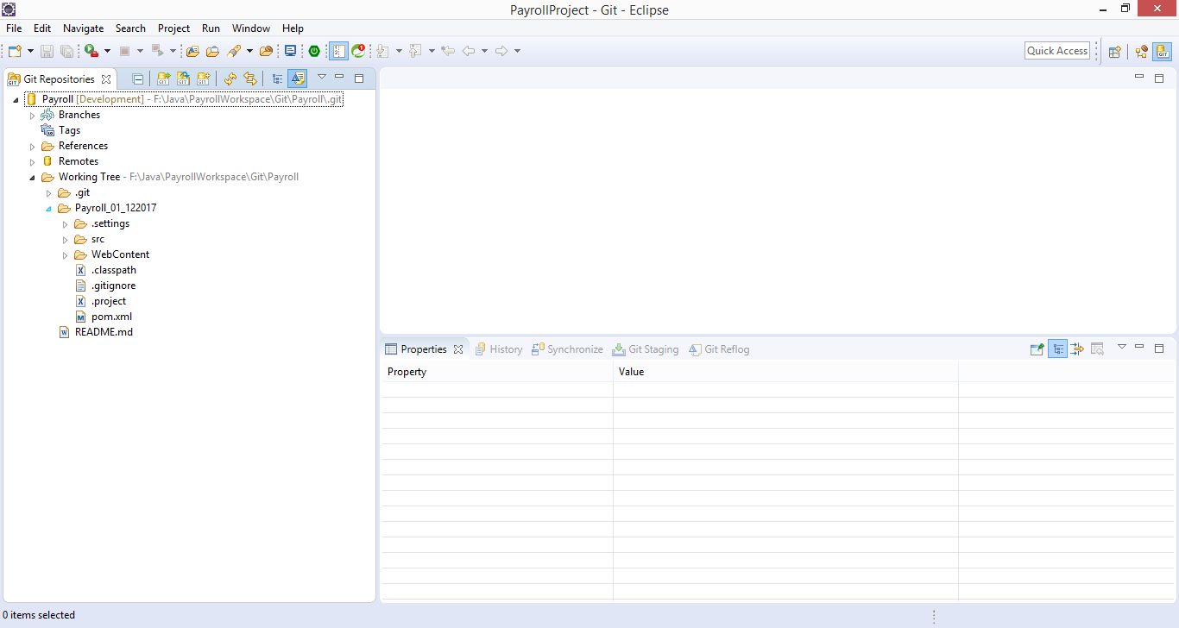

Open Java / J2EE Perspective

Create a new java project

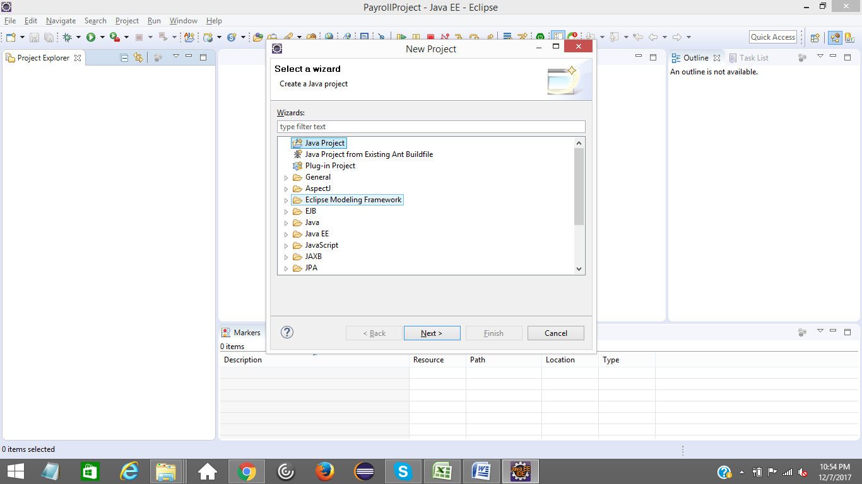

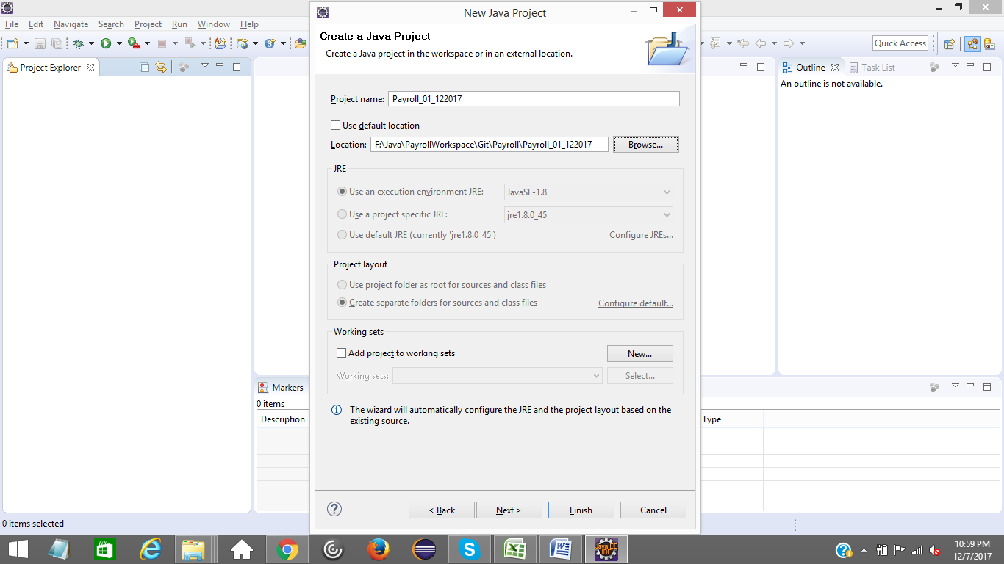

uncheck Default location and select local GIT project path like above

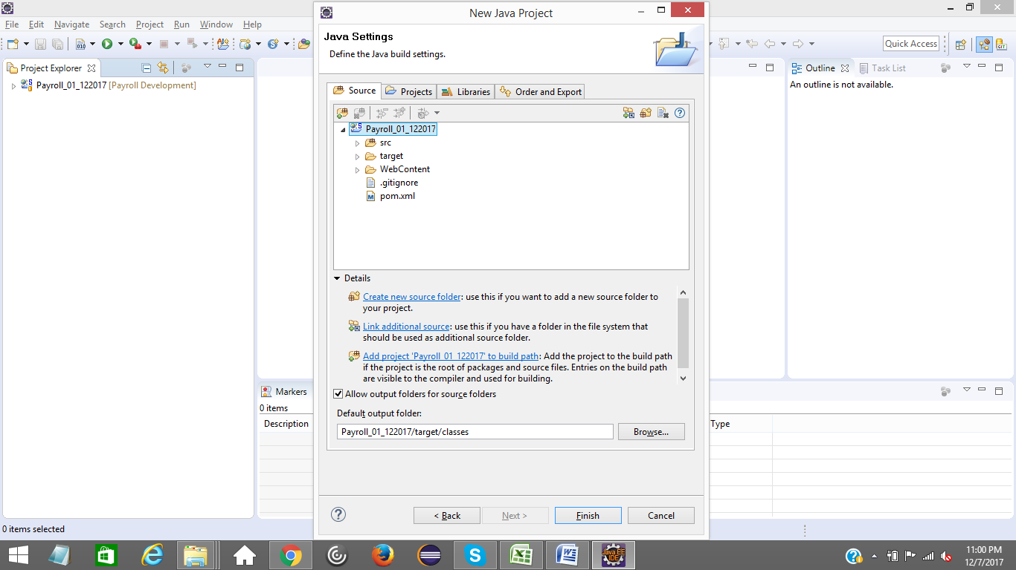

Click on Finish Button

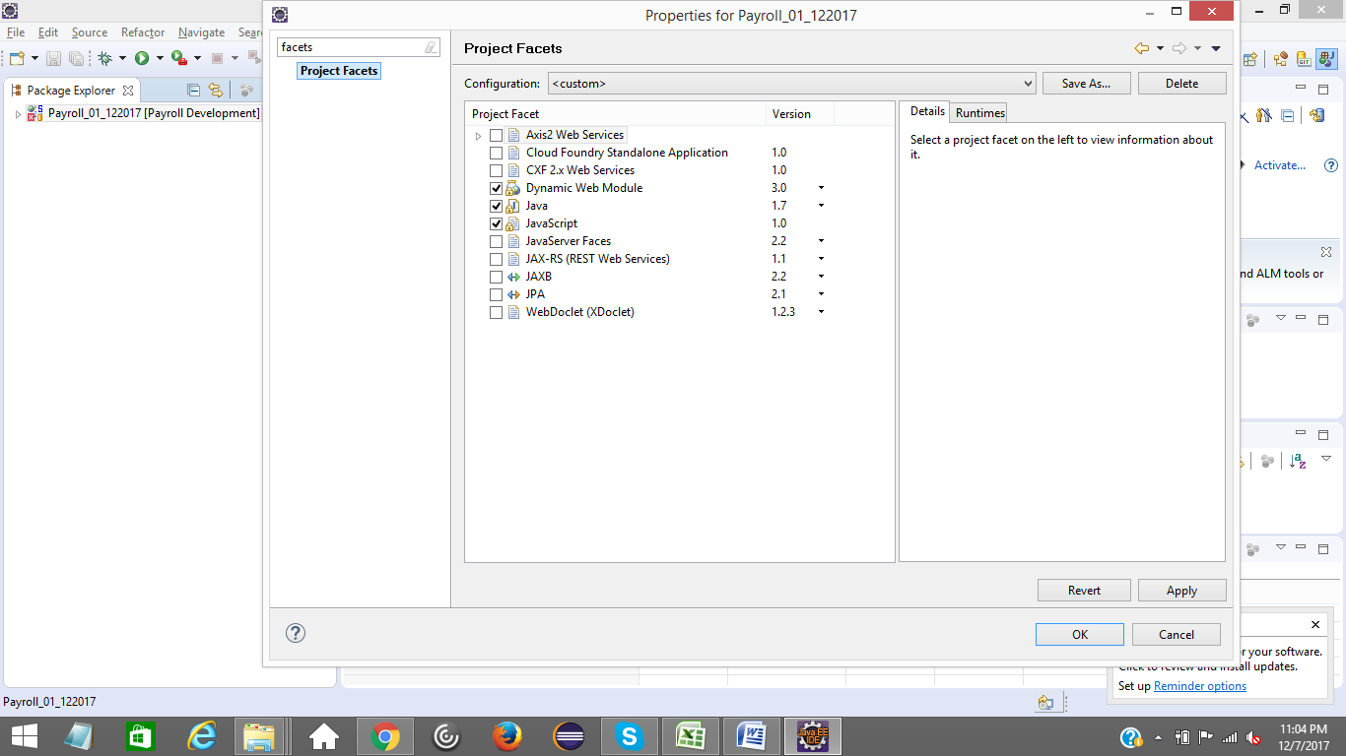

choose project facets like above

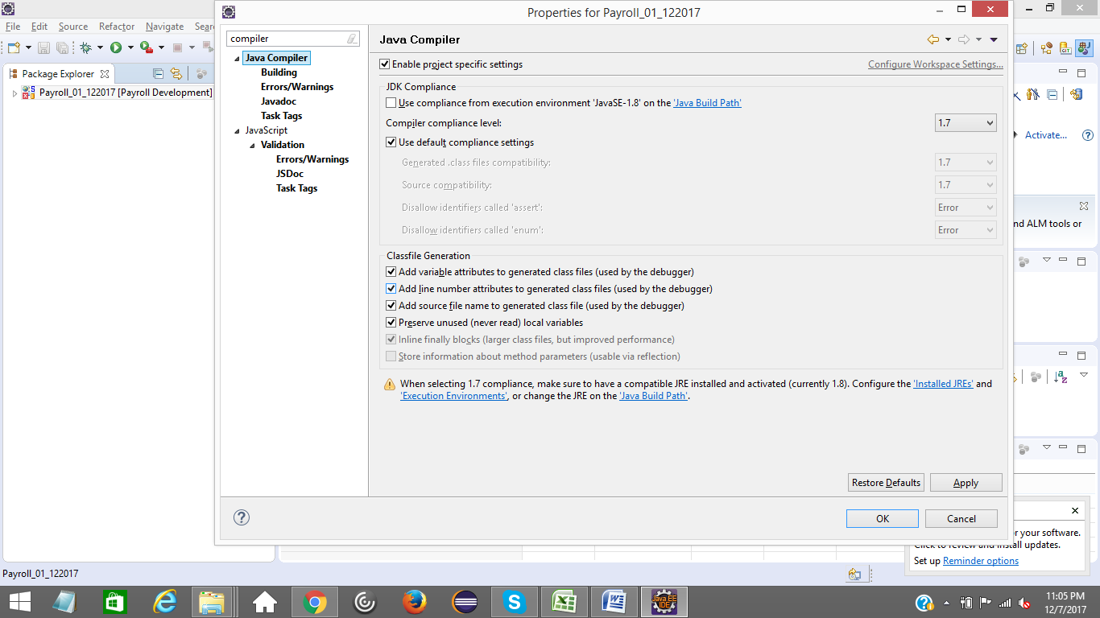

Compiler set to Java 1.7

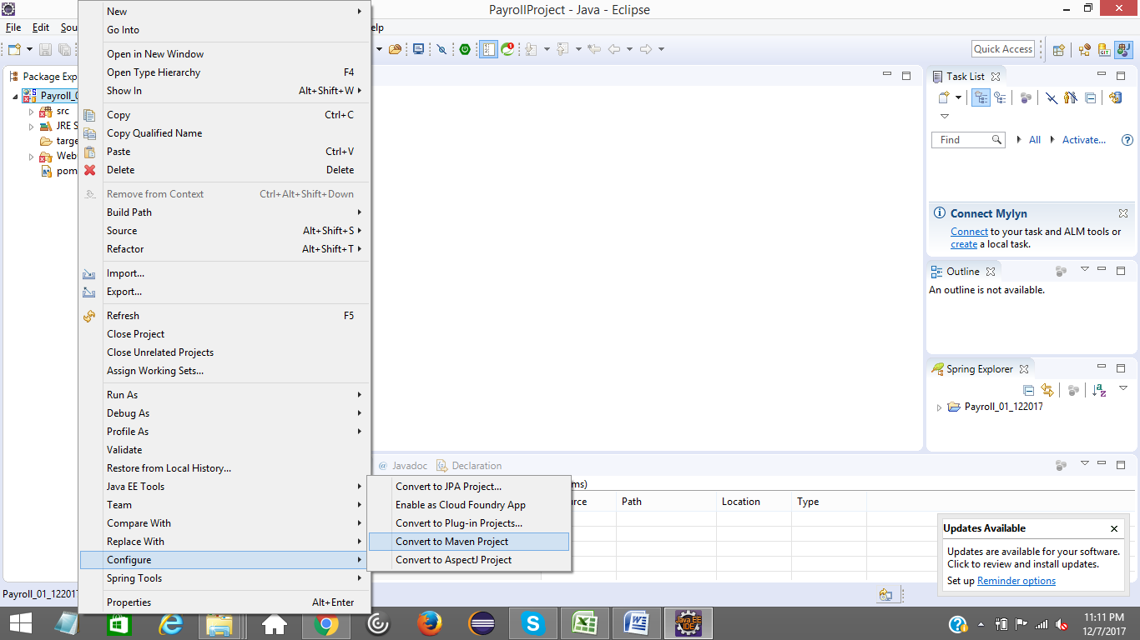

Convert to Maven Project

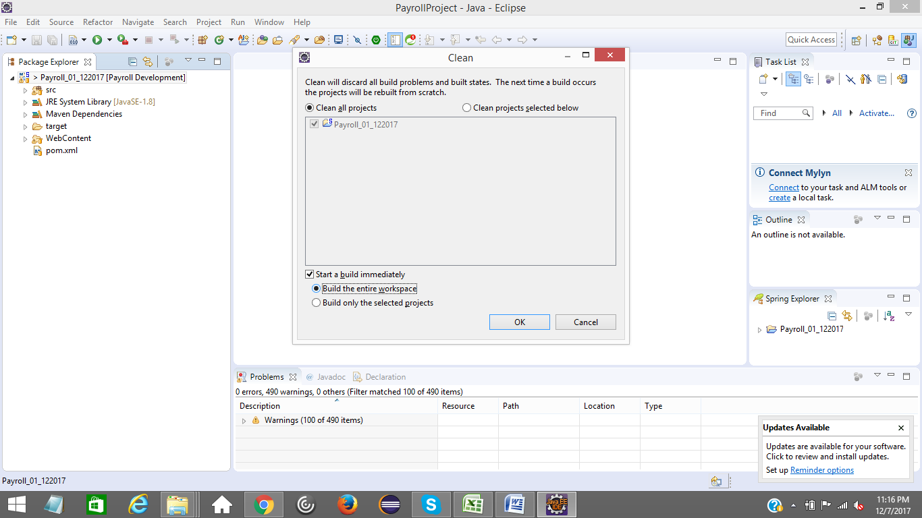

Clean Build the project

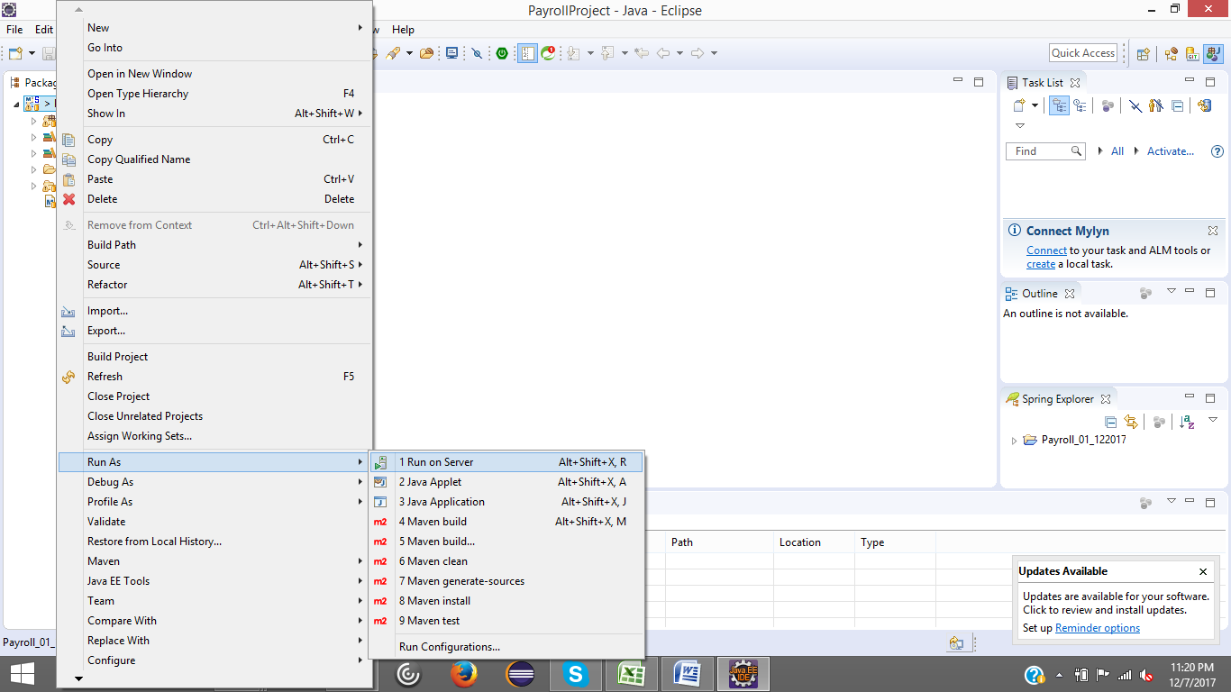

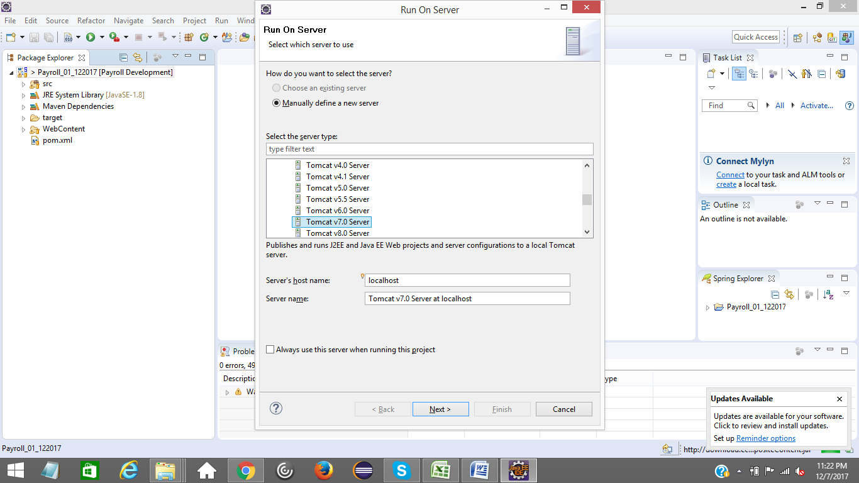Add Tomcat Serrver

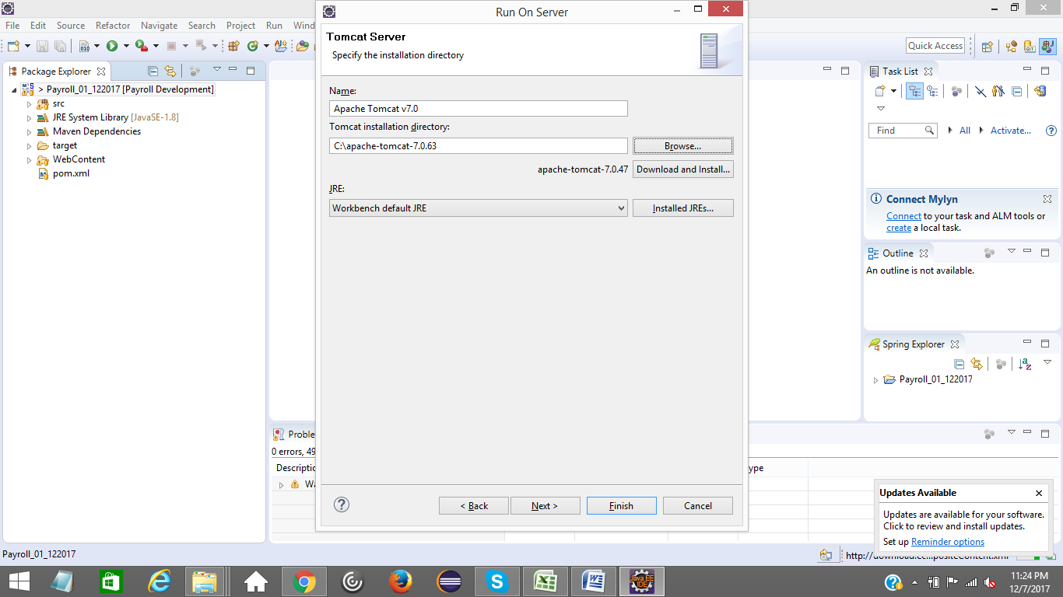

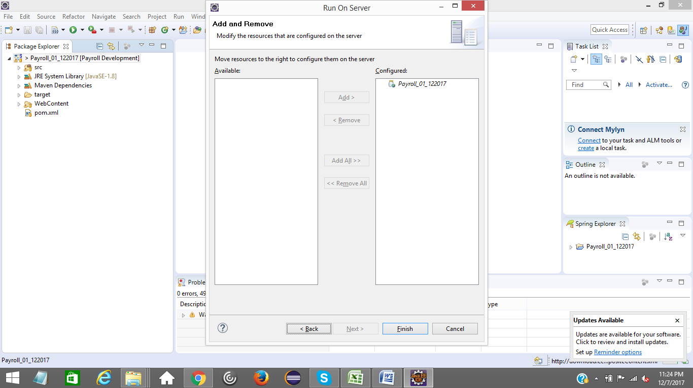

Click on Finish Button

If any compilation errors are there after clean build, please verify facets, compiler settings again

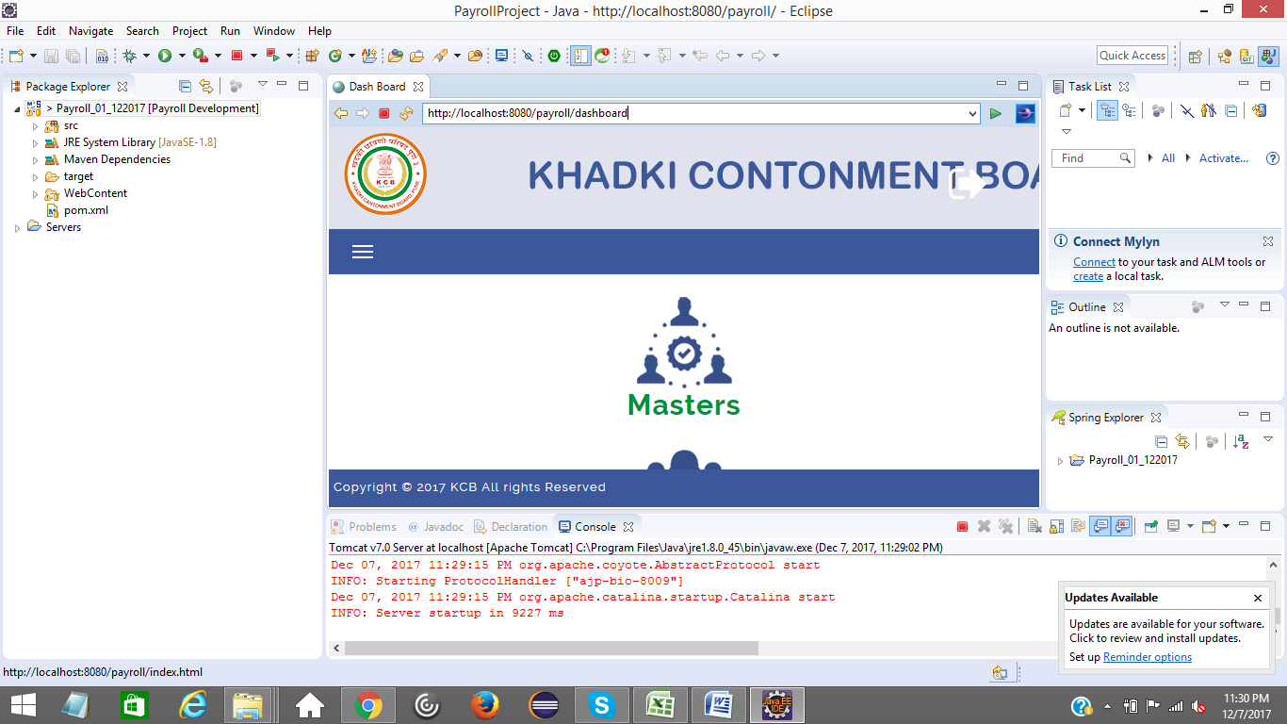

Run http://localhost:8080/dashboard in browser window.