

Department of Physics & Astrophysics

PhD Thesis

## *Search For New Phenomena In High Energy Interactions*

by Ram Krishna Sharma  
Advisor: Dr. Md. Naimuddin

# The LHC and CMS Machine

In this chapter, the working and the design parameters of lhc and its one of main purpose detector, Compact Muon Solenoid (CMS), are briefly described.

## The Large Hadron Collider

The famous quote “history repeats itself" applies well to the hep experiments. The starting point of experimental particle physics is the Rutherford $α$-particle scattering, which is suggested by Ernest Rutherford and carried out by the two assistant Hans Geiger and Ernest Marsden in early 20th century. In this experiment Rutherford suggested to aim the beam of $α$-particles to the thin gold foil and using the experimental findings they suggested the well known structure of today’s atom, in which the most of mass centered at core of atom which is known as nucleus and the electrons rotates around the nucleus. Even now we are doing the same thing just the method changed from “natural accelerator"[1] to the “man-made" accelerator that can accelerate particles with the velocity close to the speed of light. The design and working of the accelerator has changed a lot over a period of time in going from MeV to GeV and in the TeV range. Now, these machines are not only used in hep experiments, but also extends their arenas to treating human beings from cancer therapy, radioisotope production, 3-D x-ray, also to the industry for uses like material processing, sterilization, security scan, water treatment, and many more.

The lhc is a hadron collider which can accelerate two proton beams, moving in opposite direction, to a maximum of 14 TeV energy in a 26.6 km long tunnel which is about 100 m underground. The lhc is the latest and most-powerful accelerator everbuilt. It is a proton-proton collider built to improve our understanding of fundamental physics. It started on 21 ${}^{st}$ October 2008 and is positioned in the samee tunnel that earlier had Large Electron Positron Collider (LEP). The LEP collaboration decided to switch to hadron collider because of following advantages:

* Hadron collider can reach a higher Center Of Mass (COM) energy, because of much lower synchrotron radiation[2] emitted by hadrons as compared to electrons. Synchrotron radiation loss is directly proportional to $(Energy/mass)^{4}$.
* As hadrons are composite particles, they allow us to scan over wide range of energies.

For any particle accelerator, there are mainly three components. In case of LHC, they are:

* Beam pipes
* Accelerating structure
* Magnet system

### Beam Pipes

At LHC, there are two beam pipes each with diameter $≈$ 6.3 cm in which proton beams travel in opposite directions. To avoid beam instability and loss of beam particles due to collision with gas molecules; the beam pipes are kept at ultra-high vacuum[3] bar pressure.

### Accelerating Structure

Another main part of any particle accelerator is its accelerating structure. A accelerator in the TeV range can not start from rest and go to the TeV range in one go; it should go into several stages depending on the energy. At LHC, the journey of proton starts with grabbing the proton from Hydrogen gas and subsequently going into 5 different stages. The stages can be decreased but could not be decreased to just one. Here, at LHC there are five different stages before reaching to LHC and in between it serves several other experiments at each stage, which are shown pictorially in Figure [fig:OtherExpAtAccStructure]. The stages for proton acceleration are:

* Grab proton source: The source of proton is Duoplasmatron[4](Schindl et al. 2004). This feeds protons to LINAC2.
* LINAC2 (Linear accelerator-2): It is the starting point of proton’s journey in the LHC accelerator complex. Here, protons reaches to an energy of 50 $MeV$ using the radio-frequency (RF) cavities[5] where they also gains 5% in mass. LINAC2 further feeds to the Proton Synchrotron Booster (PSB).
* PSB: It takes 50 $MeV$ proton beams from LINAC2 and accelerate them to 1.4 $GeV$ for injection into Proton Synchrotron (PS).
* PS: It is one of key component in the LHC accelerator complex. It increases the energy of protons up-to 25 $GeV$ and feeds to super proton synchrotron.
* Super Proton Synchrotron (SPS): It has a circumference of 7 $km$ where protons are accelerated to an energy of 450 $GeV$. Then via two transmission line protons are then injected into LHC ring.
* LHC: It grabs two proton beams from SPS which are injected into opposite directions in parallel pipes. In LHC, proton beams can be accelerated up-to 7 $TeV$.

The CERN accelerator complex is shown in Figure [fig:CERN-accelerator-complex].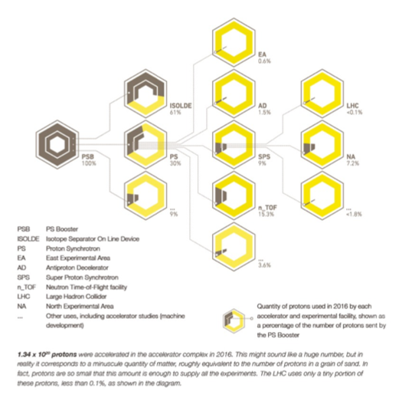

Other experiments at the LHC accelerating chain (“Other Experiments at Lhc Acclerating Chain,” n.d.)

LHC accelerator chain along with all its other experiments which uses proton beam from other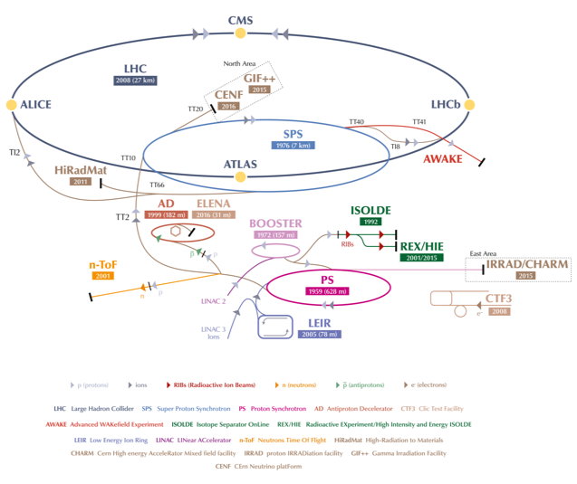 part of accelerator either from PSB, PS or SPS(Mobs 2016)

### Magnet System

As the LHC is a circular collider; magnet system is one of the core parts and gives particles a circular trajectory in the LHC beam pipes. To be economical LHC has been made in eight arcs and eight straight sections instead of a perfect circle. Apart from bending the beam, it is also necessary to focus the beam as the same charge protons try to diverge. To focus the beam a pair of quadrapole magnets is used. One focuses the beam width while other focuses the beam height. Quadrapole magnet geometry is shown in Figure [fig:QuadrupoleMagnet]. A total of 858 quadrupole magnets are installed in LHC to keep the beam focused. Sextupole magnets are also used for proper focusing as every proton in the beam is not exactly with the same energy and on thee same path. Several other magnetic multi-poles are used to keep the beam focused in case the beam suffers from gravitational interactions over protons, electromagnetic interactions among bunches, electron clouds from pipe wall, and so on. Different types of magnets used in LHC are listed here (“LHC Magnet Types,” n.d.). Besides, there are eight sets of “inner triplets" used at the four interaction points (IPs) to focus the beams while colliding to increase the luminosity. Here the size of bunch goes from 0.2 mm to 17 $μm$ at the interaction point of ATLAS or CMS. At the interaction point of ALICE or LHCb it is 71 $μm$. Summary of important parameters of LHC is given in Table [table:LHC-parameters].

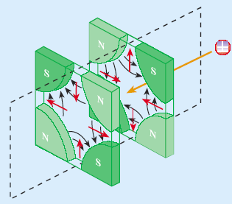

Pair of quadrupole magnets.

LHC technical parameters for proton-proton collisions: nominal, 2012 and 2016 values.(Bruce et al. 2016; Schörner-Sadenius 2015; Lamont 2016; Bruning et al. 2004).

|  |  |
| --- | --- |
| **Parameters** | **Value** |
| Circumference of LHC ring | 26658.883 m |
| Maximum dipole magnetic field | 8.33 T |
| Dipole operating temperature | 1.9 K |
| Maximum stored energy per beam (nominal) | 362 MJ |
| Maximum stored energy per beam (2012) | 143 MJ |
| Maximum stored energy per beam (2016) | 266 MJ |
| Beam energy at Injection | 450 GeV |
| Beam energy at collision (nominal) | 7 TeV |
| Beam energy at collision (2012) | 4 TeV |
| Beam energy at collision (2016) | 6.5 TeV |
| Maximum instantaneous luminosity (nominal) | ${10}^{34}$ cm ${}^{−}2$ s ${}^{−1}$ |
| Maximum instantaneous luminosity (2012) | $7.7×{10}^{33}$ cm ${}^{−}2$ s ${}^{−1}$ |
| Maximum instantaneous luminosity (2016) | $1.4×{10}^{34}$ cm ${}^{−}2$ s ${}^{−1}$ |
| Number of bunches per proton beam (nominal) | 2808 |
| Number of bunches per proton beam (2012) | 1380 |
| Number of bunches per proton beam (2016) | 2076 |
| Maximum number of protons per bunch | $$1.6×{10}^{11}$$ |
| Protons/bunch (average at start of collision) (nominal) | $$1.15×{10}^{11}$$ |
| Protons/bunch (average at start of collision) (2012) | $$1.5×{10}^{11}$$ |
| Protons/bunch (average at start of collision) (2016) | $$1.1×{10}^{11}$$ |
| Bunch collision frequency (nominal) | 40 MHz |
| Bunch collision frequency (2012) | 20 MHz |
| Bunch collision frequency (2016) | 40 MHz |
| Bunch length (at injection) | 1.7 ns |
| Bunch length (at collision) | 1.05 ns |
| Energy spread (at injection) | 1.9 $×{10}^{−3}$ |
| Energy spread (at collision) | 0.45 $×{10}^{−3}$ |
| Half crossing angle (nominal) | 143 $μrad$ |
| Half crossing angle (2012) | 146 $μrad$ |
| Half crossing angle (2016) | 185 $μrad$ |
| $β*$ (nominal) | 0.55 m |
| $β*$ (2012) | 0.6 m |
| $β*$ (2016) | 0.4 m |
| RMS beam size at IP1 & IP5 | 17 $μm$ |
| RMS beam size at IP2 & IP8 | 71 $μm$ |
| $ϵ_{n}$ (transverse emittance, rms, normalized) (at injection) | 3.5 $μ$ m |
| $ϵ_{n}$ (transverse emittance, rms, normalized) (at collision point) | 3.75 $μ$ m |
| total longitudinal emittance (at injection) | 1.0 eVs |
| total longitudinal emittance (at collision) | 2.5 eVs |
| Average mean pile-up (nominal) |  |
| Average mean pile-up (2012) | ?? |
| Average mean pile-up (2016) | ?? |
| Energy loss per turn at 14 TeV | 7 keV |
| Energy loss per turn for electrons |  |

### Few key requirements

The HEP collider is mainly characterized by the two parameters: center of mass (COM) energy and the luminosity. The production rate of heavier particles like Higgs increases with COM energy. The luminosity is proportional to the number of events per second so it should be maximized. Luminosity is defined as:

$$L=\frac{k_{b}N_{b}^{2}f_{rev}γ}{4πϵ_{n}β^{*}}$$

where, $k_{b}$ 
 is the number of bunches per ring, $N_{b}$ 
 is the number of protons per bunch, $f_{rev}$ 
 the revolution frequency, $ϵ_{n}$ 
 is the normalized RMS transverse beam emittance (same in both ) $β^{*}$ 
 is the beta-function at the interaction point  
Based on the definition of luminosity, we can maximize it by following means:

* By decreasing beam emittance, $ϵ_{n}$.
* By improving the cryogenic system. As the factor $k_{b}.N_{b}$ is limited by thermal energy produced by synchrotron radiation.
* By decreasing beam-beam effect. As it scales with $N_{b}/ϵ_{n}$ which causes the spread in betatron tunes.
* Also, the space charge scales with $N_{b}/ϵ_{n}$.

## Experiments at the LHC

In LHC there are four IPs where two proton beams are made to collide. At every IP one detector is placed. They are ATLAS, CMS, ALICE, and LHCb as shown in Figure [fig:LHCgeometry]. Also, there are two more small detectors LHCf and TOTEM installed close to the IP of the two main detectors ATLAS and CMS respectively.

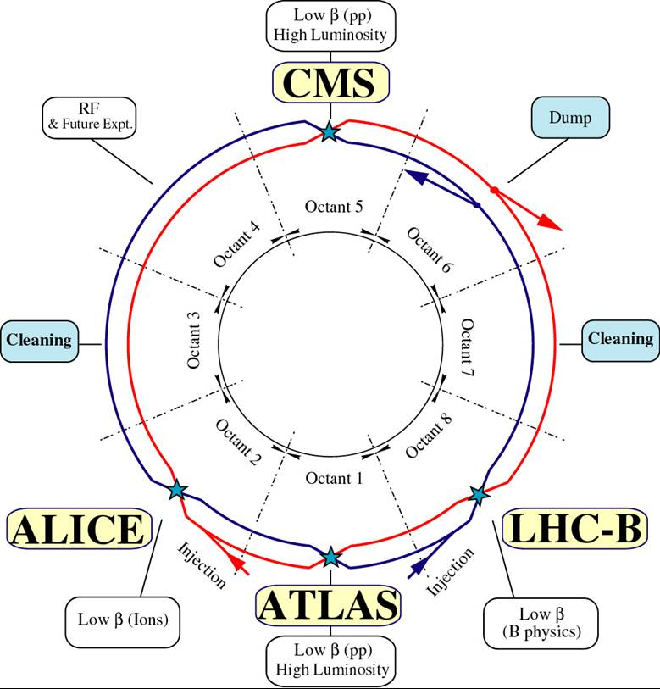

LHC geometry with arcs and straight sections.

(A Toroidal LHC Apparatus) and **CMS** (Compact Muon Solenoid) are large general-purpose detectors having similar design and similar goal. CMS detector will be described in detail in Section 1.3. The main difference in the two is in their magnet systems. One additional choice that affects this is the momentum resoultion for muons. The momentum resolution for muons, $Δp_{T}/p_{T}$, are proportional to $B^{−1}L^{−2}$, where B is magnetic field and L is distance of momentum measurement from the IP of detector. So, To imporve the momentum resoltuion there are two possible choices.

1. Increase the magnetic field with compact design, or
2. Work with low magnetic field with long lever arm, L

There is also a third possibility to improve the momentum resolution by increasing the leaver arm as well as magnetic field, but it increases the cost of the detector by several factors. So, CMS chooses the first point, i.e., to increase the magnetic field with compact design[6] while ATLAS chooses the design with low magnetic field with logn lever arm.

**ALICE** (A Large Ion Collider Experiment) is a heavy-ion detector. It is specially designed for the study of strongly interacting matter at high densities in quark-gluon plasma phase.

**LHCb** (Large Hadron Collider beauty) is made asymmetrically with respect to the IP of the detector. It is made specially to study the slight differences between the matter-antimatter through the study of b-quarks.

**LHCf** (Large Hadron Collider forward) and **TOTEM** (TOTal cross-section, Elastic scattering and diffraction dissociation Measurement at the LHC) are located near ATLAS and CMS respectively, for the study of forward physics.

## CMS Experiment

The CMS is a general-purpose detector at the LHC. It is built around a huge solenoid magnet. This takes the form of a cylindrical coil of superconducting cable that generates a field of 4 Tesla, about 100,000 times the magnetic field of the Earth. The field is confined by a steel “yoke” that forms the bulk of the detector’s 12,500-tonne weight. The complete detector is 21 meters long, 15 meters wide and 15 meter high.

## Bibliography

Bruce, Roderik, Gianluigi Arduini, Hannes Bartosik, Riccardo De Maria, Massimo Giovannozzi, Giovanni Iadarola, John Jowett, et al. 2016. “LHC Run 2: Results and Challenges.” *Proceedings of the 57th ICFA Advanced Beam Dynamics Workshop on High-Intensity and High-Brightness Hadron Beams, HB2016, Malmö, Sweden*. JACoW, Geneva, Switzerland. <https://doi.org/10.18429/jacow-hb2016-moam5p50>.

Bruning, Oliver S., P. Collier, P. Lebrun, S. Myers, R. Ostojic, J. Poole, and P. Proudlock. 2004. “LHC Design Report Vol.1: The LHC Main Ring.” Technical report CERN-2004-003-V1, CERN-2004-003, CERN-2004-003-V-1. CERN. <https://cds.cern.ch/record/782076>.

Lamont, Mike. 2016. “LHC Performance 2016.” CERN. July 2016. <https://lhc-commissioning.web.cern.ch/lhc-commissioning/performance/2016-performance.htm>.

“LHC Magnet Types.” n.d. CERN; http://lhc-machine-outreach.web.cern.ch. <http://lhc-machine-outreach.web.cern.ch/lhc-machine-outreach/components/magnets/types_of_magnets.htm>.

Mobs, Esma Anais. 2016. “The Cern Accelerator Complex.” *CERN-Cds*, nos. OPEN-PHO-ACCEL-2016-013 (October). <https://cds.cern.ch/record/2225847>.

“Other Experiments at Lhc Acclerating Chain.” n.d. CERN; https://home.cern. <https://home.cern/about/updates/2017/07/accelerating-particles-not-just-lhc>.

Schindl, Karlheinz, Paul Collier, John Poole, V Mertens, and Michael Benedikt. 2004. “LHC Design Report Vol.3: The Lhc Injector Chain.” CERN. <https://doi.org/10.5170/cern-2004-003-v-3>.

Schörner-Sadenius, Thomas, ed. 2015. *The Large Hadron Collider*. Springer International Publishing. <https://doi.org/10.1007/978-3-319-15001-7>.

1. radioactivity and cosmic rays
2. The radiation emitted by a charged particle during acceleration in a circular path is known as synchrotron radiation. As the particles loses energy in emission of this radiation an additional energy must be provided to keep the beam at constant energy.
3. At LHC, three different vacuum systems are used. First one is used for beam pipe; second one for insulating the cryogenically cooled magnets and third one is used for insulating the helium distribution. In the latter two it just acts as a thermal insulator as the cryogenic parts are kept at 1.9 K ($\ang{-271.3}C$)
4. It strips electron from hydrogen gas and creates a plasma of protons, electrons and molecular ions. This plasma expands towards the extraction electrodes and a proton beam is formed
5. A RF cavity is an metallic cavity that accelerates the charged particles using the electromagnetic field.
6. This is why there is word **compact** in the name of CMS.