Investor Dashboard — Architecture & Infrastructure
Oct 3, 2026 · @Ram Prasad Vellamsetti

Summary
Run the whole system serverless on AWS: EventBridge Scheduler wakes one Python Lambda per batch job, the jobs land data as Parquet files in S3, and a static dashboard on CloudFront reads small precomputed JSON files. There is no server or database running 24/7, so the expected bill is about $0.25 a month including monitoring and alerts (≈$1.60 with a custom domain), nearly all of it inside AWS free tiers.
- Why it fits: the catalog's 15 batch jobs make about 8,200 API calls and roughly 1,200 job runs a month. That is a tiny, bursty workload — the shape serverless is cheapest at.
- Why no database server: the data is small (well under 2 GB after a year) and append-only. Parquet on S3, queried with DuckDB, does the job of a warehouse at storage prices.
- Why static pages: nothing changes faster than hourly, so the browser checks one small manifest file each minute instead of holding a live connection.
- Upgrade path: if you later want ad-hoc SQL from many tools or sub-hourly data, add a small managed Postgres (≈$15/mo, approximate) without changing the collectors.
Chosen baseline: FedRAMP Moderate. Adding the Moderate security, audit and reliability controls brings the total to about $21–35 a month (typically ~$27). The section "FedRAMP Moderate alignment" has the details and the Terraform starter. Multi-user sign-in, preferences and the trend jobs add about $1.20 a month (see "Users, preferences and trend analytics").

Requirements and constraints
The design works to the limits set in the data-source catalog: free data tiers only, nothing polled more than hourly, no runs on weekends or holidays.
Requirement | Value | Design consequence
Sources | 84 catalogued, about 60 collected | One adapter per source, driven by a config file
Batch jobs | 15 (H1–H3, D1–D5, W1, M1, C1, Q1, A1, O1, F1) | One scheduled function per job
API calls | ~8,200 a month, ~270 a day | Fits every provider's free limit; a rate limiter per provider keeps it there
Freshest data | Hourly (prices, news, filings) | No streaming, no websockets
Holiday rules | NYSE, SIFMA, US federal, China, Netherlands calendars | A calendar check runs before every job
Release-day jobs | CPI, PCE, trade, FOMC days | One-off schedules created from the D1 calendar pull
Users | One (you), maybe a few family viewers | Static site with login, no app server
Data budget | $0 | Hosting must also stay near zero

Architecture overview
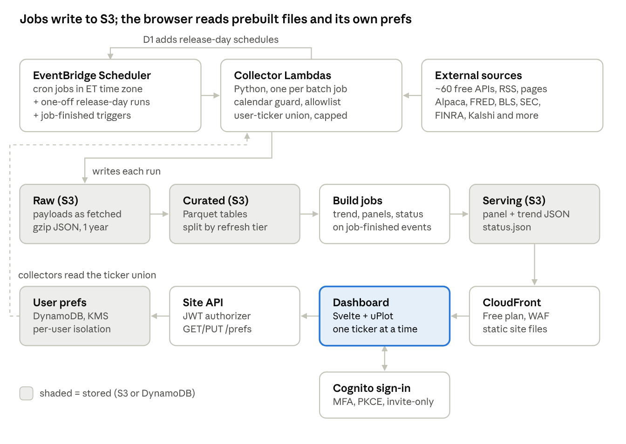
architecture · collection, storage and serving
Data moves one way: the scheduler starts a collector, the collector writes raw and curated files, a build step turns them into panel files, and the browser reads only those. Because the browser never queries the lake directly, the page stays fast and nothing needs to run between jobs.

Design patterns
Eight patterns cover the whole system; each one solves a specific problem in the catalog.
Pattern | Where | Problem it solves
Config-driven registry | sources.yaml built from the catalog | Adding or moving a source is a config change, not a code change
Adapter (strategy) per source | fetch(since) → raw, parse(raw) → records | 60 sources with JSON, RSS, CSV, XLSX and HTML formats share one job runner
Calendar guard | Decorator on every job | Skips NYSE, SIFMA, federal, China and Netherlands holidays in one place
Watermark catch-up | Last-success timestamp per source | The first run after a weekend or outage pulls everything missed
Idempotent upsert | Natural keys (ticker + bar time, series + date, URL hash) | Retries and catch-ups never create duplicates
Failover chain + circuit breaker | Primary → F1 backups (e.g. Alpaca → Massive → Finnhub) | A failing source is skipped after 3 errors and a backup fills in
Token-bucket rate limiter | Per provider, counter in S3 | Stays under limits like Alpha Vantage 25/day and SAM.gov 10/day
Medallion layers + read model (CQRS) | raw → curated → serving | Raw payloads can be replayed; the dashboard reads small, precomputed files only
Release days use one more pattern: scheduled triggers from data. Job D1 reads the BLS, BEA and Fed calendars and creates one-off EventBridge schedules for 08:35 ET on each release day.

Data model
Tables are grouped by how often they change, and that sets their file layout: hourly tables split by month, daily by year, slower ones as one file. Every row carries source_id (DS-xx), fetched_at and run_id, so any number on the dashboard traces back to its source call.
Raw layer — s3://…/raw/source=DS-02/date=2026-10-03/run=…json.gz. Payloads exactly as fetched, kept 1 year, then moved to Glacier.
Curated layer — Parquet, written by the job that fetched it:
Table | Tier | Key | Main columns | Partition | Filled by
prices_hourly | Hourly | ticker, bar_ts | open, high, low, close, volume, feed; covers the user-ticker union and index ETFs SPY, DIA, QQQ, IWM, XLY, ITA, SMH | year/month | H1, F1
prices_daily | Daily | ticker, date | close, adj_close, volume, source_id | ticker | D4 close check, backfill (DS-05)
news_articles | Hourly | url_hash | published_at, tickers[], title, source, sentiment, topics[] | year/month | H2
events | Hourly / daily | event_id | event_ts, category, subcategory, title, url, entities[], severity | year/month | H3, D2, W1
filings | Hourly | accession_no | cik, form, filed_at, url | year | H3
macro_daily | Daily | series_id, obs_date | value, unit, vintage_date | year | D1, D3, D4
rate_odds | Daily | source, meeting_or_horizon, as_of, outcome | probability, yes_bid, yes_ask, volume (Kalshi); Atlanta Fed and Cleveland Fed rows by column/measure | year | D1 (DS-88), D4 (DS-89, DS-90)
short_interest | Twice monthly | ticker, settlement_date | short_interest, previous_short_interest, avg_daily_volume, days_to_cover | settlement_date | short_interest (DS-91)
options_daily | Daily | ticker, date | put_call_volume_ratio, call_volume, put_volume, iv30, iv30_expiration, iv_available | date | options_daily (DS-92, off until confirmed)
contracts | Daily | award_id, mod_no | agency, obligated_usd, action_date, description | year | D5
launches | Daily | ll2_id | net_ts, vehicle, mission, status, outcome | year | H3, D2
robotaxi_fleet | Weekly | jurisdiction, as_of | permit_type, vehicles, cities[] | none | D2, W1, A1
risk_indices | Weekly | index, obs_date | value | none | W1, D1
releases | On release | series_id, ref_period | actual, nowcast, surprise, release_ts | none | M1
fundamentals_quarterly | Quarterly | ticker, metric, fiscal_quarter | release_date, value, unit, source_id; metrics gross_margin_gaap, revenue_gaap, gross_profit_gaap, deliveries, fsd_subscribers | none | q1_fundamentals (DS-11 XBRL, DS-12 manual)
calendar_days | Monthly | calendar, date | is_open, close_time | none | C1, A1
ingestion_runs | Every run | run_id | job, source_id, status, rows, error, duration_ms | year/month | all jobs
user_prefs (DynamoDB) | On change | user_sub | tickers[], pinned[] (max 6), display.time_zone, display.updown_palette, version, updated_at | n/a | prefs API
Serving layer — JSON files built for the screen, one per dashboard panel (e.g. serving/panel/rates.json), plus manifest.json listing each panel's version and last update.
- Macro series use one long table (series_id, obs_date, value) so a new FRED or BLS series needs no schema change.
- events is the one table every timeline reads; news, filings, tariffs, launches and permits all map into it with a category.
- Each job writes its own small file per run, so jobs never write over each other. A nightly compaction merges a month's small files into one.

Users, preferences and trend analytics
The dashboard now serves several signed-in users, each with their own ticker list. Collectors cover the union of those lists (capped to stay within free tiers), and three new build outputs feed the UI: trend metrics, quarterly fundamentals and a refresh-status feed. Together these add about $1.20 a month (range $0.70–$2.00).

Sign-in and preferences
- Sign-in: invite-only Cognito user pool (Plus tier for threat protection), MFA required, 15-character passwords. The site uses the authorization-code flow with PKCE through Cognito's hosted UI, with no Amplify. Tokens last 1 hour and refresh for up to 12 hours (AC-12).
- Preferences store: DynamoDB table invdash-user-prefs, one item per user keyed by Cognito sub (user_sub). On-demand billing, encrypted with the data key, point-in-time recovery, deletion protection.
- Site API: GET and PUT /prefs on an HTTP API with a Cognito JWT authorizer. PUT needs the version it last read (a stale version returns 409). Adding a ticker nobody else follows triggers a 5-year history backfill.
Who can reach the preferences table:
Principal | Allowed | Enforced by
Site API function | Nothing on the table directly; may assume the per-user role and publish TickerAdded events | Its role policy
Per-user role (assumed per request, tagged sub = the JWT's sub) | Get, put, update, delete only the item whose user_sub equals that tag | dynamodb:LeadingKeys = ${aws:PrincipalTag/sub}
Collectors (trend metrics, short interest, options, and H1/H2/D4 when built) | Scan returning only user_sub and tickers | dynamodb:Select = SPECIFIC_ATTRIBUTES and dynamodb:Attributes
Everyone else | Nothing | No grant
Why session tags rather than a Cognito variable: IAM can't read a Cognito user-pool sub directly. The ${cognito-identity.amazonaws.com:sub} policy variable is an identity-pool ID, a different value. So the API function passes the verified JWT sub as a session tag, and IAM enforces the isolation even if the function code has a bug.

Ticker universe and free-tier limits
Collectors cover TSLA and SPCX plus users' tickers ranked by how many users follow them, capped at 25 (max_user_tickers). The seven index ETF proxies are collected separately. Tickers over the cap are logged as dropped.
Provider | Cost of each extra ticker | Free limit | At the 25-ticker cap
Alpaca bars (H1, D4) | None: one call covers up to 100 symbols | 200 calls/min | No change
Finnhub company news (H2) | 1 call per run | 60 calls/min | 27 calls per hourly run, fits
Massive daily close check (D4) | 1 call per day | 5 calls/min | 34 calls, about 7 minutes, fits the 15-minute timeout
Alpha Vantage sentiment (H2) | Not covered: see below | 25 calls/day | Stays at 16 calls/day
FINRA short interest | None: one query for all tickers | 1,200 calls/min | 1 call a day
Alpaca options (if enabled) | 1–5 chain pages | 200 calls/min | Fits
Yahoo backfill | 1 call, once per new ticker | Unofficial, no SLA | Fits
Correction to the source catalog: DS-40 assumed one Alpha Vantage call covers TSLA and SPCX together. Alpha Vantage's multi-ticker filter matches articles that mention all listed tickers (per its API documentation; worth confirming on the first run). So each call now covers one ticker: 6 for TSLA, 6 for SPCX, and 4 rotating daily through other users' tickers.

Trend metrics
The trend-metrics job runs when D4 (daily close) or M1 (release day) finishes successfully. It measures how each macro driver is moving and how strongly it has tracked each ticker. Drivers: Treasury yields and spreads, real yield, breakevens, fed funds, EFFR, SOFR, VIX, dollar index, oil, the policy-uncertainty index, CPI/core CPI/PCE YoY, and the seven ETF proxies.
Column | Definition
chg_1w, chg_1m, chg_3m | Change over 5, 21 and 63 trading days: percent for prices and indices, level change for rates and spreads
z_1w, z_1m, z_3m | That change against its own trailing 252-day mean and standard deviation
range_pct_1y | Where today's value sits in its 1-year high–low range, 0–100
trend_state, days_in_state | up if z_1m > 0.5, down if < −0.5, else flat; and how many days it has held
corr_30d, corr_90d | Rolling correlation of the driver's daily change with the ticker's daily return
effect | corr_90d × z_1m
net_pressure | tanh(sum of effect across drivers ÷ 3), the same value on every row of a ticker and date
Monthly series hold their last released value until the next release. Output goes to serving/trend_metrics/ticker=<T>/trend_metrics.parquet (full history) and serving/trend_metrics/latest/<T>.json (last trading day, for the trend cards).

Quarterly fundamentals
- Gross margin: total GAAP gross margin = GrossProfit ÷ Revenues from SEC XBRL company facts (DS-11). release_date is the SEC filing date. Q4 = full year minus Q1–Q3, because Q4 isn't filed on its own.
- Deliveries and FSD subscribers: not in XBRL, so they come from a reviewed manual file. scripts/add_fundamental.py validates each row and appends it to manual/fundamentals/fundamentals_manual.csv. A later row for the same quarter replaces the earlier one.
- Schedule: Monday 08:30 ET as a safety net, plus a one-off run the day after earnings, scheduled by D1.
- Fiscal quarters assume a calendar fiscal year (true for Tesla); SPCX's must be confirmed from its 10-K.

New jobs and schedules
Job | When (ET) | Source | Writes
trend-metrics | After D4 or M1 succeeds | curated prices and macro | serving/trend_metrics/
q1-fundamentals | Mon 08:30 + day after earnings | SEC XBRL (DS-11), manual file (DS-12) | curated/ and serving/fundamentals_quarterly.json
short-interest | 18:30 Mon–Fri; stores only new settlement dates, so data lands twice a month on FINRA's publication days | FINRA (DS-91, OAuth keys in SSM) | curated/short_interest/
options-daily | 16:50 Mon–Fri, after D4 | Alpaca indicative options (DS-92) | curated/options_daily/; off until a manual run confirms the free feed and whether it includes IV
backfill | When a user adds a ticker nobody followed, and once at setup (O1) | Yahoo (DS-05) | curated/prices_daily/
status-feed | After every job | Job Finished events | serving/status.json
H1, D4 (extended) | Existing schedules | Alpaca bars | ETF proxies and the user-ticker union added to the same calls
D1, D4 (extended) | Existing schedules | Atlanta Fed (DS-88), Kalshi (DS-89), Cleveland Fed (DS-90) | rate_odds
Each job has its own role: read and write only its listed lake prefixes, read only its own API keys, publish only invdash.jobs events, and send failures to the dead-letter queue. Kalshi's documented host is now external-api.kalshi.com. The Atlanta and Cleveland Fed pages have no documented data API, so those adapters save the raw file first and find columns by header text. A layout change fails loudly and can be re-parsed from raw/.

Refresh status and outbound allowlist
- Status feed (serving/status.json, behind sign-in): for each job, its name, status (ok, partial, failed, never_run), last_run, last_outcome, failed_sources and next_run. next_run skips weekends and NYSE or federal holidays. Updates use S3 conditional writes, so concurrent jobs can't overwrite each other.
- Allowlist: the jobs' HTTP client (app/http_client.py) refuses any host not in the source catalog. It now includes Kalshi, the Atlanta and Cleveland Feds, FINRA and the Alpaca options host. This is the software control listed under the accepted VPC risk.

Added cost
Item | Basis | Est. $/month
Site API (HTTP API) | ~15,000 requests at $1.00 per million (pricing) | 0.02
DynamoDB prefs table | On-demand $0.625/M writes, $0.125/M reads; storage under the 25 GB free tier; PITR $0.20/GB-month on <1 MB (pricing) | 0.01
New job runs and events | ~1,500 Lambda runs (free tier); ~1,500 custom events at $1/M | 0.01
Inspector on the API function | $0.30 per zip-packaged function | 0.30
Security Hub and Config on ~40 new resources | More checks and configuration items | 0.50–1.20
One more alarm, KMS requests, larger image | API 5xx alarm $0.10; KMS and ECR | 0.15–0.40
Total |  | ~1.20 (0.70–2.00)

Names that differ from the UI brief
- The table key is user_sub; display settings live under display.time_zone and display.updown_palette (green-red, red-green, blue-orange). Order is the order of tickers and pinned, not a separate field.
- Fundamentals use fiscal_quarter as in the brief, with metric IDs gross_margin_gaap, deliveries and fsd_subscribers, plus revenue_gaap and gross_profit_gaap as inputs.
- net_pressure is stored on every row of a ticker and date, not in a separate table.
- The data-refresh feed is serving/status.json (separate from the canary's public health.json).

Compute and storage resources
Everything runs in one AWS region (us-east-1, closest to the ET-based release times) with no always-on compute.
Resource | Service | Size and settings | Expected load
Scheduler | EventBridge Scheduler | ~15 recurring schedules (America/New_York time zone) + one-off release-day schedules | ~1,200 runs a month
Collector jobs | Lambda, Python 3.12, arm64, container image | 1 GB memory, 5 min timeout; 2 GB for PDF/XLSX parsing (DS-51, DS-53, DS-88) | ~24,000 GB-seconds a month (about 6% of the free tier)
Build jobs | Lambda (same image) | 2 GB, 10 min: serving JSON after each run, impact analytics after D4, nightly compaction | ~60 runs a month
Retry and dead letters | SQS dead-letter queue + Lambda retries (2) | Failed runs kept 14 days | A handful a month
Data lake | S3 Standard, versioning on | raw/, curated/, serving/ prefixes; raw moves to Glacier after 1 year | Under 2 GB after year 1
Dashboard hosting | S3 + CloudFront (flat-rate Free plan) | Static site, gzip/brotli, 60 s cache on manifest | Far under 1M requests and 100 GB a month
Login | Cognito user pool | Hosted sign-in in front of CloudFront | 1–5 users
Secrets | SSM Parameter Store, SecureString | 12 provider credentials (Alpaca, FRED, Finnhub, BLS, BEA, Census, SAM.gov, FCC, Alpha Vantage, Massive, ACLED); see API key rotation | Read once per run
Container images | ECR | One image, keep last 5 tags | ~0.5 GB
Logs and alarms | CloudWatch Logs (400-day retention), 6 metrics, 8 alarms, 1 dashboard, SNS email | See Operations | Under 1 GB logs a month
Why a container image: pyarrow, DuckDB, pandas and exchange_calendars together exceed Lambda's 250 MB zip limit; images allow up to 10 GB.
Why not Fargate or EC2: a t4g.small or Fargate task running 24/7 costs more than the whole serverless stack and sits idle about 98% of the time.

Cost estimate
The full stack, including monitoring, alerting and health dashboards, costs about $0.25 a month, or about $1.60 with a custom domain. Prices are us-east-1 list prices from AWS pricing pages, checked on 3 Oct 2026; usage figures are estimates from the catalog's call counts.
This table is the base stack. With the FedRAMP Moderate controls the total is about $21–35 a month; see "Cost of the Moderate controls".
Component | Price and free allowance | Our monthly use | Est. $/month
Collection and hosting
Lambda (collectors + builds) | 1M requests + 400,000 GB-s free each month (pricing) | ~1,300 requests, ~24,000 GB-s | 0.00
EventBridge Scheduler | 14M invocations free (pricing) | ~1,300 | 0.00
S3 storage | $0.023/GB-month (pricing) | <2 GB in year 1, ~6 GB by year 3 | 0.05 (0.14 in year 3)
S3 requests | $0.005 per 1,000 PUTs, $0.0004 per 1,000 GETs | ~15,000 PUTs, ~50,000 GETs | 0.10
CloudFront | Flat-rate Free plan, $0: 1M requests, 100 GB, WAF, DNS (pricing) | <20,000 requests | 0.00
Sign-in check at the edge (Lambda@Edge) | $0.60 per 1M requests, no free tier (pricing) | ~15,000 requests | 0.01
Cognito sign-in | 10,000 monthly users free (pricing) | 1–5 users | 0.00
SSM Parameter Store (API keys) | Standard parameters free (pricing) | 12 keys | 0.00
SQS dead-letter queue | 1M requests free (pricing) | <100 | 0.00
ECR container image | $0.10/GB-month; 500 MB free for 12 months on new accounts (pricing) | ~0.5 GB | 0.00–0.05
Monitoring and alerting
CloudWatch Logs | 5 GB a month free (ingest, storage, Logs Insights scans) (pricing) | ~0.1 GB a month, 400-day retention (stays under the free 5 GB) | 0.00
CloudWatch custom metrics | 10 free, then $0.30 each | 6 | 0.00
CloudWatch alarms | 10 free, then $0.10 each | 8 | 0.00
CloudWatch ops dashboard | 3 free, then $3.00 each (Vantage handbook) | 1 | 0.00
SNS email alerts | 1,000 emails free, then $2.00 per 100,000 (FAQ) | <50 | 0.00
AWS Budgets alert | Budget alerts free (pricing) | 1 budget at $5 | 0.00
CloudTrail audit trail | First copy of management events free; pay S3 storage only | <50 MB | <0.01
Data-health panel in the dashboard | Built from ingestion_runs by the build job | — | included above
Optional
Custom domain (.com on Route 53) | $16/year since July 2026 (Classmethod); DNS included in the CloudFront plan | 1 domain | 1.33
Total |  |  | ~0.25 (≈1.60 with domain)
What keeps this accurate:
- Use a Paid-plan AWS account. Accounts on the new Free plan close after 6 months; the always-free allowances above apply on both plans (AWS Free Tier).
- Free allowances are per account. If this account runs other workloads, they share the same Lambda, CloudWatch and SNS limits.
- The $5 budget alert emails you if the bill drifts, so an estimate error shows up within a month.
Cost traps the design avoids:
Avoided choice | Cost if used | What we do instead
Lambdas inside a VPC with a NAT gateway | ~$33/month ($0.045/hour, plus $0.045/GB) (pricing) | Lambdas run outside a VPC; there is nothing private to reach
A CloudWatch metric per source (~60) | ~$15/month (50 over the free 10 × $0.30) | Per-source health lives in ingestion_runs; 6 summary metrics
Secrets Manager for 12 API keys | ~$4/month ($0.40 per secret) (pricing) | SSM standard SecureString with the data KMS key, plus rotation reminders
Logs kept forever | Grows every month at $0.03/GB | 400-day retention in CloudWatch; long history in S3
More than 3 CloudWatch dashboards | $3.00 each | One ops dashboard; data health lives in the app
Options considered and not chosen:
Option | Est. $/month | Why not now
Managed Postgres (RDS db.t4g.micro) instead of S3 Parquet | ~15 (approximate) | Runs 24/7 for a workload that is busy ~2% of the time; free tier lapses after 12 months
Fargate or EC2 running a cron container | ~6–15 (approximate) | Same idle-time waste, plus patching
Grafana Cloud or Streamlit Cloud for the UI | 0 on free tiers | Less control over a dense, custom layout; Streamlit needs a running server
Cloudflare Workers + R2 | ~0 | Also cheap, but Python data libraries (pyarrow, DuckDB, exchange_calendars) don't run well there

Languages and frameworks
Python for everything that touches data, TypeScript for the browser, Terraform for the infrastructure.
Layer | Choice | Why
Collectors and builds | Python 3.12 | The calendar libraries in the catalog (exchange_calendars, holidays) and most data SDKs are Python
HTTP and parsing | httpx (with retries), feedparser, selectolax, openpyxl, pdfplumber | Covers REST, RSS, HTML, XLSX and PDF sources
Data | Polars + pyarrow for transforms, DuckDB for SQL over S3 Parquet | Fast in small memory; no database server
Validation | Pydantic models per table | Bad payloads fail loudly instead of writing wrong numbers
Front end | TypeScript, Vite, Svelte | Small bundle, compiles to static files
Charts | uPlot for time series, Apache ECharts for heatmaps | uPlot draws dense multi-series charts and sparklines very fast; ECharts covers the rest
Infrastructure as code | Terraform, state in S3 | Your daily tool; every resource is reproducible
CI/CD | GitHub Actions with OIDC role into AWS | No long-lived AWS keys; free minutes cover a project this size
Tests | pytest with recorded responses per adapter | Catches a source changing its format before it reaches the dashboard
The dashboard layout follows the project brief: dense small multiples rather than a few big charts. A top row of sparklines (TSLA, SPCX, 2Y, 10Y, 10Y–2Y, fed funds, CPI YoY, VIX), then price charts with event markers from events, then compact tables for upcoming releases, launches and permit changes.

Operations
The system watches itself through the ingestion_runs table, and a data-health panel on the dashboard shows when each source last succeeded.
Monitoring is sized to stay inside CloudWatch's free 10 metrics, 10 alarms and 3 dashboards:
Tool | What it covers | Count | Free limit
Custom metrics | Failed runs, stale P1 sources, stale sources (all), lowest rate-limit headroom %, manifest age (minutes), rows written | 6 | 10
Alarms → SNS email | Lambda errors (all functions), Lambda throttles, dead-letter queue not empty, 2 failed runs in a row, any stale P1 source, rate-limit headroom under 20%, manifest older than 90 min in market hours, bill over $5 | 8 | 10
CloudWatch ops dashboard | Lambda runs, errors and duration; the 6 metrics; S3 size; CloudFront requests | 1 | 3
Data-health panel (in the app) | Last success, age and error for every source, from ingestion_runs | 1 | not CloudWatch
AWS Budgets | Email at 80% and 100% of $5 a month | 1 | free
- Freshness rules: each source has a max age (hourly sources 2 h on trading days, daily 30 h, weekly 8 days). A stale source turns its panel amber.
- Logs: structured JSON with run_id and source_id, kept 400 days in CloudWatch (audit records 30 months in S3); ingestion_runs keeps the long history in S3.
- Secrets: API keys in SSM Parameter Store, encrypted with the data KMS key and rotated on a schedule (see API key rotation); the SEC User-Agent email is config, not code.
- Backups: S3 versioning; old versions expire after 7 days under serving/ and 90 days elsewhere. Any curated table can be rebuilt from the raw layer.
- Schema changes: adapters have recorded-response tests; a parse failure saves the raw file but no curated rows, so nothing wrong reaches the screen.
- Deploys: pushing to main runs tests, builds the image, then terraform apply; the front end deploys to S3 with a CloudFront invalidation.
- Yearly upkeep: upgrade exchange_calendars and holidays each December (catalog job A1) and re-check free-tier limits.

FedRAMP Moderate alignment
Meeting the FedRAMP Moderate technical controls (NIST SP 800-53 Rev 5) raises the monthly bill from about $0.25 to about $21–35 (typically ~$27). Most of that is Security Hub, Inspector, AWS Config, encryption keys and an external health check. The Terraform starter below sets all of it up.
What changes from the base design:
- Security monitoring: GuardDuty, Security Hub with the NIST 800-53 Rev 5 standard, Inspector, AWS Config, and CloudTrail data events with Insights.
- Encryption keys: customer-managed KMS keys (data, audit, DR replica) replace AWS-managed keys. This reverses the base design's "cost trap" choice, because SC-12 and SC-28 call for keys you control.
- Audit records: kept 30 months in an Object-Locked bucket. That is 12 months searchable plus 18 months cold.
- Disaster recovery: the data lake is replicated to us-west-2.
- Sign-in: people sign in to AWS through IAM Identity Center with MFA, and dashboard sign-in requires MFA too. The 12 provider API keys rotate every 90–365 days, with emailed reminders.
Scope notes:
- Technical controls only. A FedRAMP authorization also needs a System Security Plan, policies, a 3PAO assessment and monthly continuous-monitoring reports. Those don't apply to a personal system.
- Region: in us-east-1 every service used is FedRAMP Moderate authorized, except Security Hub and Budgets. AWS lists those two as "FedRAMP not required" management tools; they hold no dashboard data. CloudFront is listed with an exclusion for Embedded PoPs (AWS services in scope).
- Log retention: FedRAMP's AU-11 parameter points to OMB M-21-31 (12 months active, 18 months cold) (AU-11). OMB M-26-14, signed 22 May 2026, replaced M-21-31 with 6 months searchable plus 12 months cold. Keeping 30 months meets both.

Observability
Every signal carries the same run_id and source_id, so one job run can be followed from schedule to log line to trace to the dashboard's data-health panel.
Signal | What is collected | Where it goes | Kept
App logs | JSON lines with UTC time, job, run_id, source_id, outcome, rows, duration, X-Ray trace id, error type (AU-3, AU-8) | CloudWatch Logs, encrypted with the audit key; 3 saved Logs Insights queries | 400 days
Metrics | 6 custom: FailedRuns, RowsWritten, StaleP1Sources, StaleSources, FreshP1Ratio, RateLimitHeadroomPct (one service dimension only) | CloudWatch | 15 months
Traces | One X-Ray segment per job, one subsegment per source call | X-Ray (within free 100,000 traces) | 30 days
External check | Synthetics canary every 15 min fetches health.json through CloudFront: HTTP 200, data under 90 min old in market hours, no stale P1 source | CloudWatch Synthetics | Artifacts 31 days
API audit trail | All management events, lake object reads and writes, Lambda invocations; integrity-validated log files; Insights on unusual call or error rates | CloudTrail → Object-Locked S3 | 30 months
Configuration history | Every resource change, continuously | AWS Config → audit bucket | 30 months
Threats and vulnerabilities | GuardDuty findings (incl. malware scans of raw/), Inspector CVEs, Security Hub NIST 800-53 control results | Security Hub | 90 days of findings
Alerts go to two email topics: ops for reliability and security for incident response.
- Ops (8–11 CloudWatch alarms): Lambda errors, throttles, dead-letter queue not empty, failed runs, stale P1 source, quota headroom under 20%, freshness SLO burn, canary failing, availability SLO fast and slow burn, CloudFront 5xx.
- Security (8 EventBridge rules, free): GuardDuty findings rated medium or higher, high or critical Security Hub and Inspector findings, attempts to stop or weaken logging, monitoring or keys, S3 exposure changes, IAM changes, root or no-MFA sign-ins, and any API key change.
- AWS Health events go to the ops topic.
- Dashboards: two CloudWatch dashboards, ops and SLO. Data health per source stays in the app's own panel.

Reliability
Three service-level objectives (SLOs) set the alert thresholds, and burn-rate alarms fire before a month's error budget runs out.
SLO | Target (30 days) | Measured by | Error budget | Alarms
Availability | 99.5% of health checks pass | Synthetics canary success % | ~3.6 hours | Fast burn: under 92.8% over 1 h. Slow burn: under 97% over 6 h
Freshness | 99% of P1 sources within max age, business hours | FreshP1Ratio from the build job | ~1% of P1 checks | Slow burn: under 94% over 6 h
Release capture | Every CPI, PCE and FOMC release stored within 15 min | releases table vs D1 calendar | Zero | Each miss gets a written review
Recovery targets (CP-2, CP-9, CP-10):
Failure | Recovery point (RPO) | Recovery time (RTO) | How
Bad data or deleted file | 0 (every version kept 90 days) | 30 min | Restore the prior S3 object version, rebuild serving files
Source outage | 0 (watermark catch-up) | Next run | Failover chain to backup source; catch-up when the primary returns
Bad deploy | 0 | 10 min | Re-point Lambda aliases to the previous immutable image tag
us-east-1 regional outage | Minutes (replication lag) | 4 h | terraform apply with region set to us-west-2, using the replica bucket and replica key
Practices built into the jobs:
- Retries with backoff and jitter, then 2 Lambda retries, then the dead-letter queue.
- Bulkheads: a failing source is logged and counted, and the job carries on with its other sources.
- Idempotent writes and watermarks, so replays and catch-ups are safe.
- Reserved concurrency on every function caps runaway loops and cost.
- Timeouts on every HTTP call (10 s connect, 30 s read).
Testing (CP-4):
- Quarterly game day: disable a primary source, delete a curated file and restore it, redrive the dead-letter queue.
- Yearly regional drill: rebuild from the replica in us-west-2.
- Each drill and each incident ends with a short written review, kept in the project.

API key rotation
Twelve provider credentials are rotated on a fixed schedule, and a daily check emails a reminder before each one is due (IA-5). The source of truth is each key's last-changed date in SSM; the Status column below is for your own tracking.
Key (SSM name) | Provider | Used by | Rotate every | Why | Status
sam-gov | SAM.gov | DS-68, DS-69 | 90 days | Provider expires personal keys every 90 days | Not stored yet
alpaca-key-id | Alpaca | DS-02, DS-82 | 180 days | Account-level key; use paper-trading keys only | Not stored yet
alpaca-secret-key | Alpaca | DS-02, DS-82 | 180 days | Rotated together with the key ID | Not stored yet
bls | BLS | DS-21 | 365 days | Provider requires yearly renewal | Not stored yet
fred | FRED | DS-15, DS-16, DS-26, DS-39, DS-45, DS-23 | 365 days | Policy; key never expires | Not stored yet
finnhub | Finnhub | DS-41, DS-13, DS-04 | 365 days | Policy | Not stored yet
alpha-vantage | Alpha Vantage | DS-40, DS-03 | 365 days | Policy | Not stored yet
massive | Massive (Polygon) | DS-01, DS-42 | 365 days | Policy | Not stored yet
bea | BEA | DS-24 | 365 days | Policy | Not stored yet
census | Census | DS-34 | 365 days | Policy | Not stored yet
api-data-gov | api.data.gov (FCC) | DS-74 | 365 days | Policy | Not stored yet
acled-password | ACLED (myACLED login) | DS-36 | 365 days | Policy; the app trades it for 24-hour tokens | Not stored yet
Sources for provider rules: SAM.gov 90-day expiry (Edgrapi, HHS simpler-grants issue); BLS API FAQ; ACLED token lifetimes (ACLED docs).
How reminders work (Terraform module api_keys, about $0 a month):
- Each key is an SSM SecureString under /invdash/api-keys/, encrypted with the data KMS key and tagged with its rotation period. Terraform creates a placeholder and never holds the real value.
- Every day at 8:00 PT a small Lambda reads only metadata and tags, never the key values. It emails the security topic 14, 7, 3, 1 and 0 days before a key is due, daily once a key is overdue, and on Mondays while a key has never been stored.
- Every change to a key triggers an api-key-changed security alert, and CloudTrail keeps the change for 30 months.
- Jobs read keys with a 5-minute cache, so a new key takes effect without a redeploy.
To rotate a key:
- Regenerate it at the provider (the email links there). If the provider allows two keys at once, create the new one first.
- Run scripts/rotate-key.sh <key> and paste the value. It never touches shell history or the process list.
- After the next job run succeeds, revoke the old key at the provider.
- Rotate right away, off schedule, if a key may have leaked.
Why SSM instead of Secrets Manager: both are FedRAMP Moderate authorized and both meet IA-5, SC-28, AC-6 and AU-2 here. Secrets Manager's automatic rotation can't help, because none of these providers has a rotation API. The daily check supplies the last-rotated evidence that Secrets Manager would show, without its ~$5 a month for 12 secrets.

Accepted risk: job Lambdas outside a VPC
The job Lambdas stay outside a VPC as a documented accepted risk. They can reach any internet host, which falls short of SC-7(5) (deny outbound traffic unless allowed) and AC-4 (information flow enforcement). What's at stake is public market data and free API keys, and closing the gap would at least double the monthly bill.
Compensating controls:
- Least privilege: each job role can write only its own lake prefix and read only the keys it uses.
- Network monitoring: GuardDuty Lambda Protection watches network activity of functions outside a VPC too, which keeps SI-4 covered (AWS docs).
- Code checks: Inspector scans the image and functions; pip-audit and Checkov run in CI.
- Software allowlist: the jobs' HTTP client refuses hosts that aren't in the source catalog (built: app/http_client.py).
Options if the risk is no longer acceptable:
Option | Extra $/month | What it covers
Keep as is (this decision) | 0 | Gap covered by the controls above
VPC + NAT gateway + Route 53 DNS Firewall allowlist of ~60 provider domains + free S3 gateway endpoint | ~33 | Blocks by domain name; doesn't stop connections made straight to an IP address
VPC + AWS Network Firewall (NAT charges waived when paired) | ~290 | Enforces SC-7(5) as written (pricing)
Revisit this decision if the system ever holds non-public data or a trading credential with real-money access. Running the jobs off AWS (on a home machine or another cloud) is not an option: it would pull that machine into what has to be secured and lose the controls AWS covers.

Base-design choices revisited
Two cost-saving choices from the base design fall short of Moderate and are changed; one is kept as an accepted risk; the rest don't affect any control.
Base-design choice | Effect under FedRAMP Moderate | Resolution
Logs kept 14 days in CloudWatch | Yes: falls short of AU-11 retention | Changed: 400 days in CloudWatch, 30 months in S3
AWS-managed KMS keys | Partly: SC-28 is met, but SC-12 key control and AU-9(4) audit-log separation need your own keys | Changed: data, audit and DR replica keys
Lambdas outside a VPC, no NAT gateway | Yes: SC-7(5), AC-4 | Kept as an accepted risk (above)
SSM Parameter Store instead of Secrets Manager | No, provided keys use your KMS key and follow a rotation schedule | Kept, with the data key and the rotation reminders
Six summary metrics instead of one per source | No: SI-4 and AU-6 need the monitoring, not that kind of metric; ingestion_runs and logs cover each source | Kept
Few CloudWatch dashboards | No | Kept; Moderate adds an SLO dashboard (2 of the 3 free)
Parquet on S3 instead of a database server | No: versioned, encrypted S3 meets SC-28 and CP-9 | Kept

Control mapping
The table maps each relevant Moderate control to how it is met and where it is built. "App" means the job, CloudFront or Cognito code, which comes outside this starter.
Control | Requirement | How it is met | Built in
AC-2(4) | Automated audit of account changes | EventBridge alert on IAM user, key, policy and MFA changes | alerting
AC-3, SC-7 | Access enforcement, boundary protection | Account-wide S3 public-access block; TLS-only bucket policies; WAF on CloudFront; job Lambda outbound traffic unrestricted (accepted risk) | security_services, data_lake, app
AC-6 | Least privilege | One IAM role per job; Access Analyzer flags external access; per-user DynamoDB isolation through a session-tagged role and dynamodb:LeadingKeys | security_services, app
AC-7, AC-8, AC-12 | Lockout, sign-in banner, session end | Cognito lockout and Plus-tier threat protection; banner; 1-hour tokens, 12-hour refresh | app
AU-2, AU-12 | Event logging | CloudTrail management, lake data and Lambda events; app logs | audit_logging, observability
AU-3, AU-8 | Record content, time stamps | JSON schema: who, what, when (UTC), source, outcome, run_id | app/observability.py
AU-5 | Response to logging failure | Alert on StopLogging, DeleteTrail, recorder stop, key disable | alerting
AU-6 | Review and analysis | Security Hub, CloudTrail Insights, saved Logs Insights queries, weekly review | security_services, audit_logging, observability
AU-9, AU-9(4) | Protect audit records | Object Lock; separate audit key; deny-delete policy; log-file validation | audit_logging, kms
AU-11 | Retention | 400 days in CloudWatch; 30 months in S3 | audit_logging, observability
CA-7 | Continuous monitoring | Security Hub NIST 800-53 Rev 5 standard over AWS Config data | security_services
CM-2, CM-3, CM-6 | Baseline, change control, settings | Terraform; pull request + CI + approval gate; Checkov policy scan | all modules, ci.yml
CM-8 | Component inventory | AWS Config continuous recording | audit_logging
CP-2, CP-4 | Contingency plan and testing | SLOs, recovery table, quarterly game days, yearly regional drill | observability, this doc
CP-6, CP-9, CP-10 | Alternate storage, backup, recovery | Versioning; cross-region replica with replica key; immutable images | data_lake, kms
IA-2(1), IA-2(2) | MFA | IAM Identity Center MFA for AWS; invite-only Cognito pool with MFA required for the dashboard | account setup, app
IA-5 | Authenticator management | No long-lived CI keys (OIDC); API keys in SSM with the data key, rotated every 90–365 days with daily reminders; IAM password policy | ci.yml, security_services, api_keys
IR-4, IR-5, IR-6 | Incident handling and reporting | GuardDuty + EventBridge → security email; review template | alerting, security_services
RA-5, SI-2 | Vulnerability scanning, flaw fixes | Inspector on image and functions; pip-audit and Checkov in CI | security_services, ci.yml
SC-8 | Encryption in transit | TLS 1.2+ enforced on S3, SQS, SNS; CloudFront TLS 1.2 policy | data_lake, alerting, app
SC-12, SC-13, SC-28 | Keys, FIPS crypto, encryption at rest | Customer-managed KMS keys rotated yearly; FIPS endpoints for app calls | kms, outputs
SI-3 | Malicious code protection | GuardDuty Malware Protection scans downloads in raw/ | security_services
SI-4 | System monitoring | GuardDuty, alarms, external canary, AWS Health events | security_services, observability, alerting
SI-7 | Integrity | CloudTrail digest validation; immutable image tags | audit_logging, data_lake
SI-11 | Error handling | Dead-letter queue; errors logged by type without secrets | data_lake, app

Cost of the Moderate controls
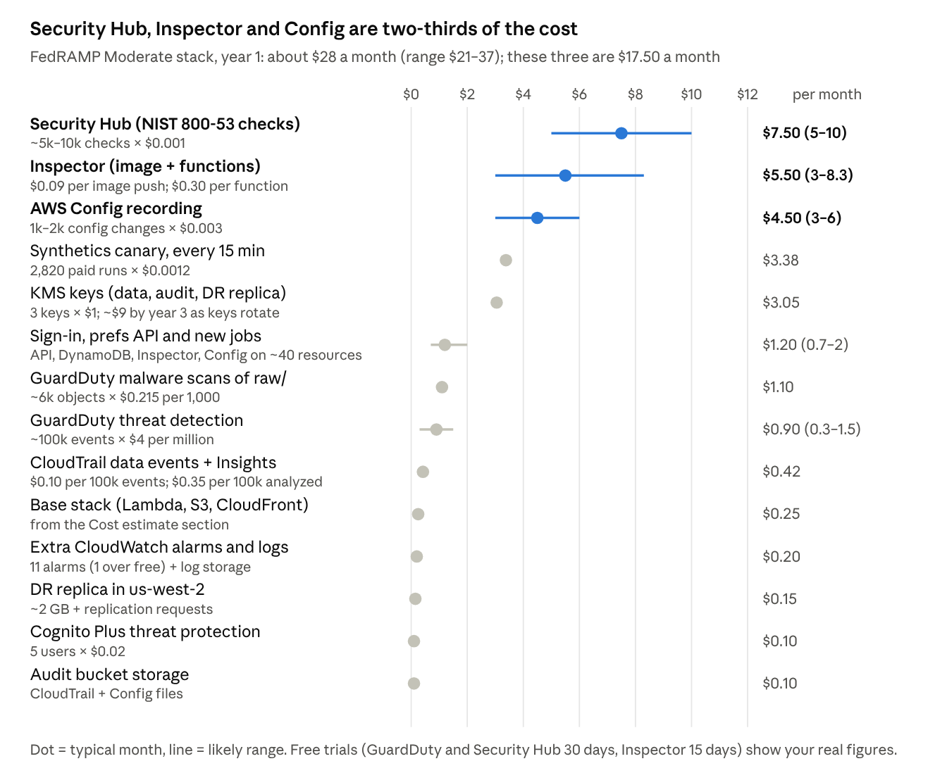
AWS list prices, us-east-1, checked 3 Oct 2026 · usage estimated from the data catalog
Security Hub and Config costs scale with how often resources change, so batching deploys keeps them near the low end. Updated levers: hourly canary checks save ~$2.50; turning off malware scanning saves ~$1.10 but leaves an SI-3 gap. The $40 budget alert gives headroom above the high estimate.
Price sources: GuardDuty, Security Hub CSPM, Config, Inspector, KMS, CloudTrail, Synthetics, X-Ray, EventBridge, Cognito.

Terraform starter
The starter (investor-dashboard-infra.zip, AWS provider 6.x) deploys everything in this section except the CloudFront site and the H1–A1 collector Lambdas (their adapters are in `app/collectors/`). Those plug into its outputs.
Module or file | Creates
kms | Data key (multi-Region, with a us-west-2 replica) and a separate audit key, rotated yearly
data_lake | Lake bucket with versioning, KMS and TLS-only access, replicated to us-west-2; job dead-letter queue; ECR repo with immutable tags
audit_logging | CloudTrail with data events, validation and Insights; AWS Config; Object-Locked audit bucket
security_services | GuardDuty with S3, Lambda and malware protection; Security Hub NIST 800-53 Rev 5; Inspector; Access Analyzer; account guardrails
alerting | Encrypted ops and security topics; 9 EventBridge rules, including API key changes
observability | Log groups, saved queries, alarms with SLO burn rates, 2 dashboards, canary, $40 budget
api_keys | 14 SSM SecureStrings with rotation periods (now including FINRA); daily 8:00 PT check that emails reminders
site_auth | Invite-only Cognito user pool (Plus, MFA required) and PKCE web client
user_prefs | DynamoDB prefs table, site API (GET/PUT /prefs, JWT authorizer), per-user isolation role, collector read policy, 5xx alarm
jobs | Six container-image job Lambdas with their own roles, schedules (ET), event triggers and DLQ; created once jobs_image_uri is set
app/ | Observability, API key reader, HTTP allowlist, ticker universe, lake helpers, status feed, collectors (Alpaca, FINRA, Kalshi, Fed sources, Yahoo)
functions/ | trend_metrics, q1_fundamentals, short_interest, options_daily, backfill, status_feed, prefs_api, key_rotation_check
Dockerfile, requirements-jobs.txt | One arm64 job image
tests/ | 39 pytest tests: trend formulas, XBRL quarters, prefs isolation and validation, collector parsers, status feed, allowlist
scripts/ | rotate-key.sh, add_fundamental.py
.github/workflows/ci.yml | fmt, validate, Checkov, ruff, pytest, shellcheck, pip-audit; arm64 image build; approval-gated apply through OIDC
Before the first apply:
- Use a Paid-plan AWS account and sign in through IAM Identity Center with MFA.
- Import any existing Config recorder, GuardDuty detector or Security Hub account; only one of each is allowed per region.
- Run terraform fmt -recursive and terraform validate. I couldn't download the Terraform binary in my workspace, so the code was checked with an HCL parser, a cross-reference script and a smoke test of the Python helper.
- Set alert_emails, apply, and confirm the subscription emails. Add health_url once the site is live to turn on the canary.
Expect security alerts during your own deploys (key policy and trail updates count as changes); that is the change-control audit trail working.

Roadmap and scaling path
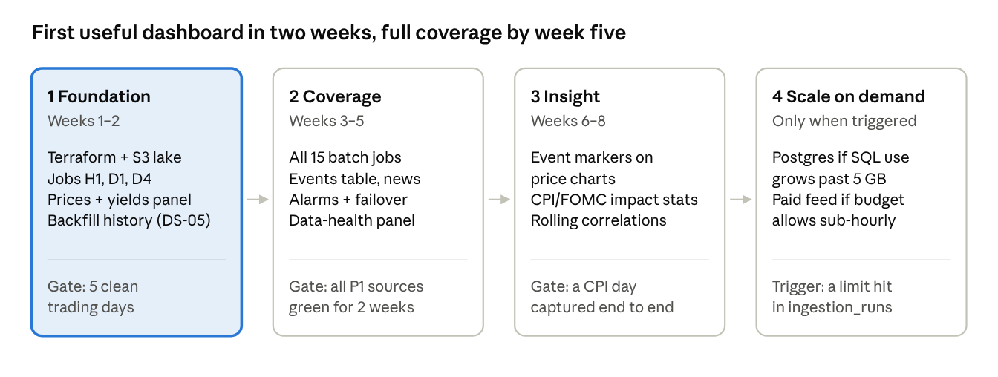
phased roadmap · weeks from start, not to scale
Each phase ships something you can use, and phase 4 happens only if a measured limit is hit. Collectors and the data model stay the same through every phase; scaling swaps the storage or a feed, not the design.
Open questions:
- Will anyone besides you view the dashboard? That decides whether Cognito sign-in is needed or a simpler private link is enough.
- Do you want a custom domain (about $1 a month), or is the CloudFront address fine?

