RESUME

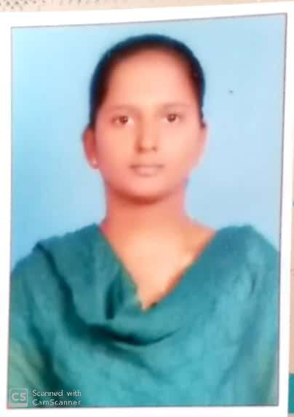
Damancherla Geethavani
D.no: 36/51,
Chinnachowk post office street,
Kadapa,
Andhra Pradesh, India

Email :damancherlageethavani@gmail.com
Contact : +91 7288938379

Career Objective

To be associated with an organization that gives scope to apply my knowledge and skills and be a part of a team that dynamically works towards the growth of the organization and personal advancement.
Profile

- A detail oriented, hard working professional with exceptional programming skills possesses Master in computer application degree in Computer.
- Skilled in programming languages and using them for software developing.
- Proficient in maintaining the existing program with implementation of new techniques.
- skilled in leading the team from the front.
- Remarkable ability in executing the plan with precision
Personal Qualities

- Smart Worker
- Adaptability, Knowledge and Focus on work.
- Excellent communication skills in written and verbal both.
- Keep myself calm in pressure situation.
Certifications

- Certification course in Python.
Qualifications

- Master of Computer Application with an aggregation of 71%.
- Degree in Bachelor Of Computer Science with an aggregation of 75%.
- Intermediate from Board of Intermediate Education with aggregation of 77%.
- SSC from Board of secondary education with aggregation of 68%.

Project Undertaken

Project Name: Inventory Management System
Environment:
- .NET Frame work.
- MS SQL Server 2008.

Team size: 4
Project Description :
Maintaining the stock necessary to meet customer’s needs, deliver on quality expectations and to minimize the numerous costs associated with holding inventory. The three primary objectives of controlling inventory are to manage levels, safe guard inventory and to report it correctly on financial statements.

Technical Skills

- Programming Languages : JAVA,PHYTHON
- Packages : MS OFFICE
- Operating Systems : Windows 7, Windows 8.1,

Strengths

- Having good communication, presentation skills and pleasing personality.
- Quick learner and easily adaptable to any kind of technologies & environment
- Easy to work in a team environment with tight schedules and capable of working efficiently even under pressure.
Personal Details

Languages : English and Telugu
Hobbies : Cooking, Listening stories.
Declaration

I hereby declare that the above mentioned particulars are true to the best of my knowledge and belief.

PLACE:
DATE:

(D.GEETHAVANI)

