

Customer Retention

Submitted by:

Ram kumar

**ACKNOWLEDGMENT**

I have taken efforts in this project. However, it would not have been possible without the kind support and help of many individuals. We would like to extend my sincere thanks to SME. Khushboo Garg.

We are highly indebted to Flip Robo technology for their guidance and constant supervision as well as for providing necessary information regarding the project & also for their support in completing the project.

I thanks and appreciations also go to our colleague in developing the project and people who have willingly helped us out with their abilities.

Thanks all.

Ram kumar

**INTRODUCTION**

* Customer satisfaction has emerged as one of the most important factors that guarantee the success of online store; it has been posited as a key stimulant of purchase, repurchase intentions and customer loyalty.
* A comprehensive review of the literature, theories and models have been carried out to propose the models for customer activation and customer retention. Five major factors that contributed to the success of an e-commerce store have been identified as: service quality, system quality, information quality, trust and net benefit.
* The research furthermore investigated the factors that influence the online customers repeat purchase intention. The combination of both utilitarian value and hedonistic values are needed to affect the repeat purchase intention (loyalty) positively.
* The data is collected from the Indian online shoppers. Results indicate the e-retail success factors, which are very much critical for customer satisfaction.

**Analytical Problem Framing**

* Import library and load the dataset.

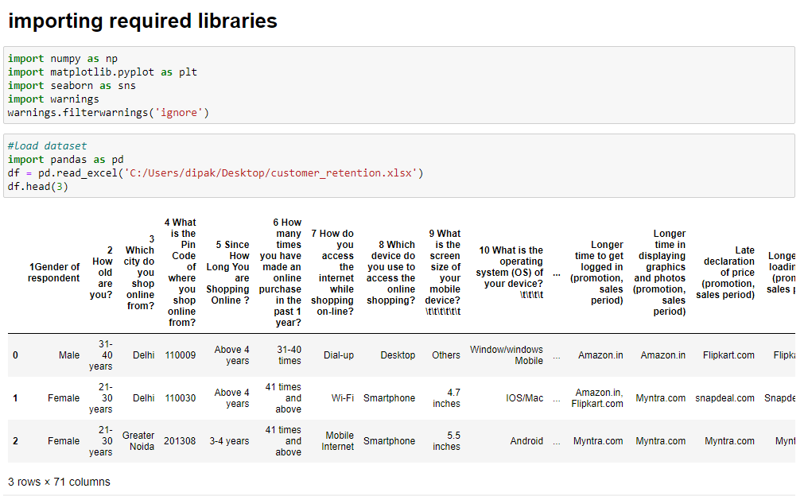

* Display all column name of dataset.

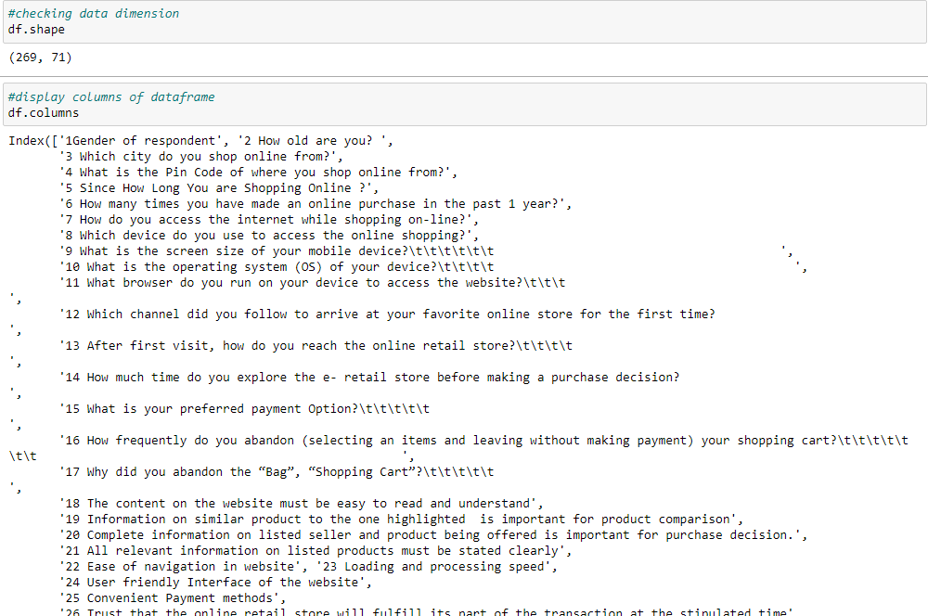

* Display datatypes and sum of null values.

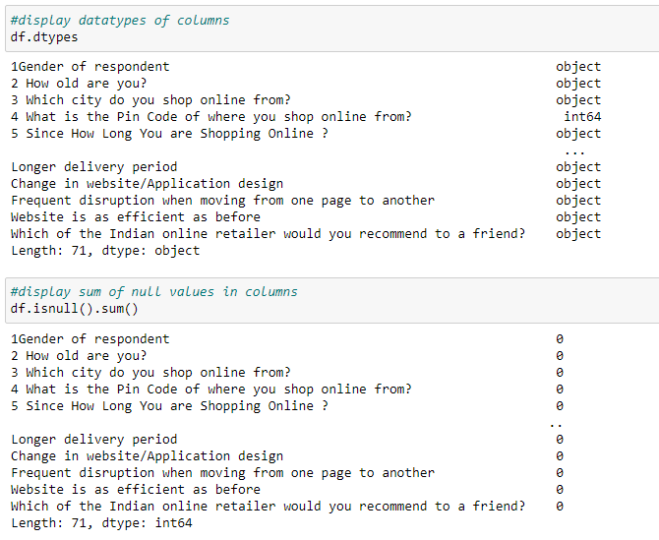

* Display null values of columns using heatmap.

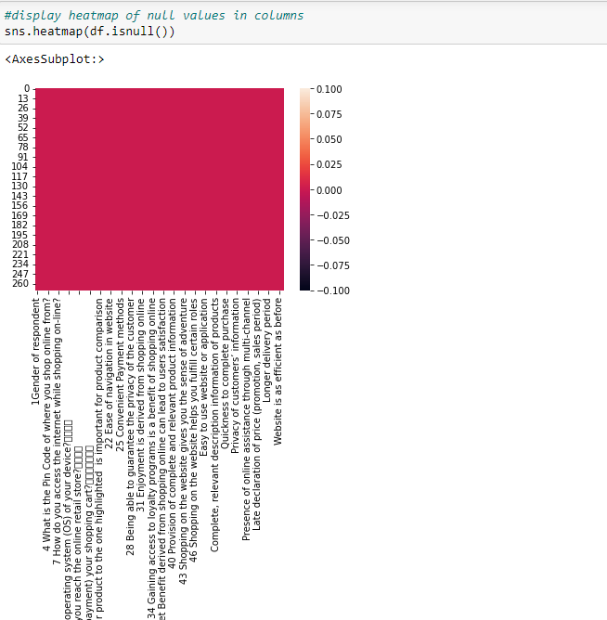

* Display correlation of columns using heatmap.

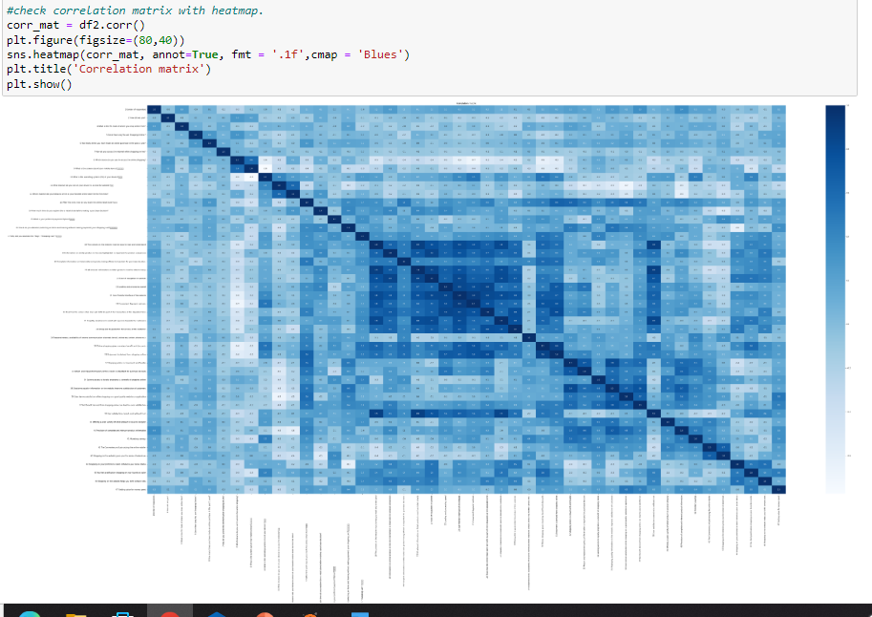

* Display barplot of all columns.

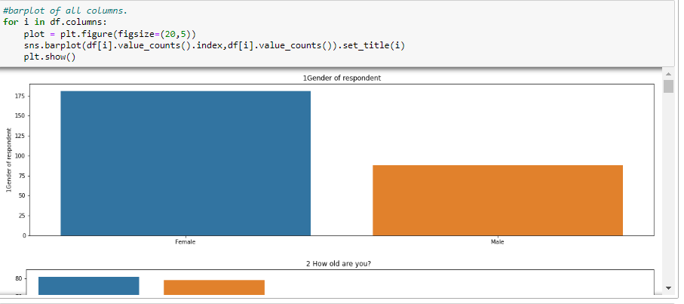

* Display histplot of city pincode column.

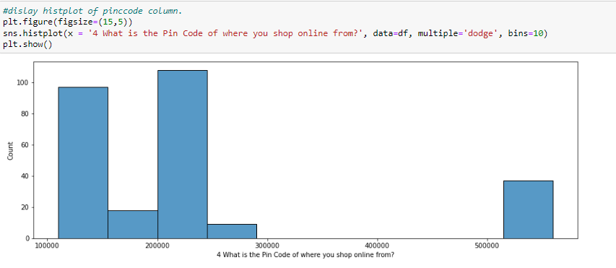

* Display countplot of two categorical variables.

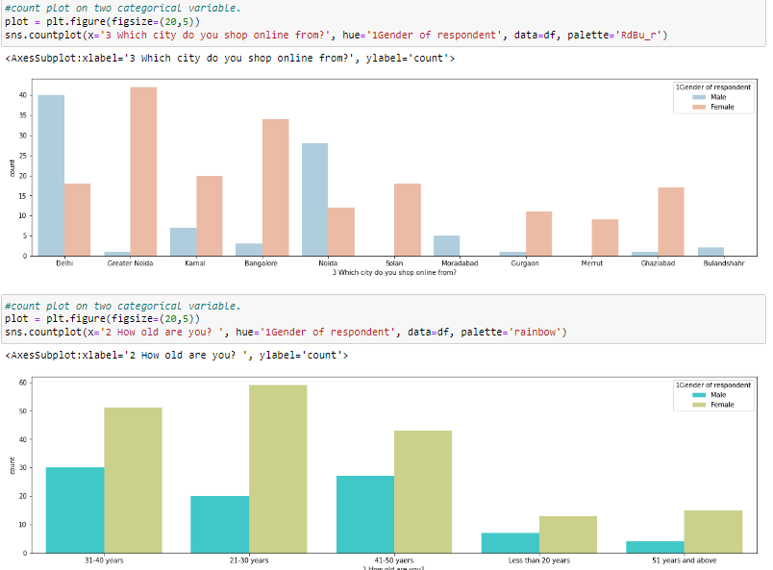

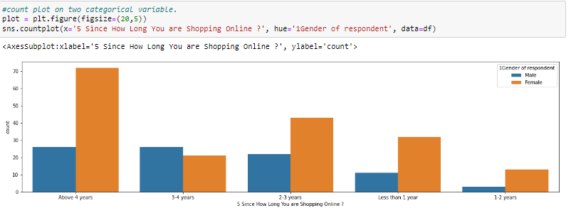

* Display pie chart of longer delivery variable.

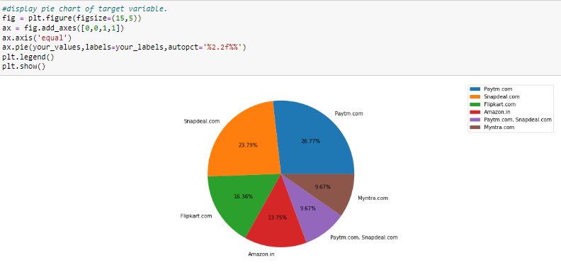

* Display pie chart of which Indian online retailer recommend to a friend (target) variable.

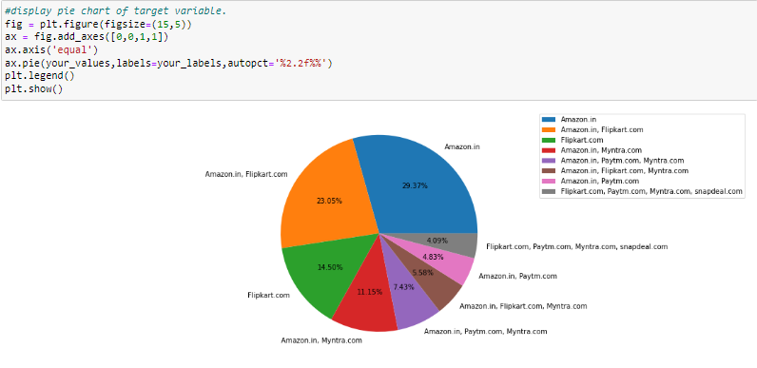

* Hardware and Software Requirements and Tools Used
* **Language :-** Python
* **Tool:-** Jupyter
* **OS:-** Windows 10
* **RAM:-** 8gb

**CONCLUSION**

* As per visualization and analysis Amazon and Flipkart are best Indian online retailer to recommend as a friend because of delivery speed, reliability trustworthy in customer privacy, security, wild variety of product, user friendly content and graphics etc.