# Literature Review

## CHAPTER 1

### 1. 1 Overview of HIV/AIDS

Human Immunodeficiency Virus (HIV) is a human pathogenic virus that cause AIDS (Acquired Immunodeficiency Syndrome). HIV/AIDS has been global pandemic for over the last three decades and is depicted as the modern day plague [1]. The United Nations Acquired Immune Deficiency Syndrome (UNAIDS) global report 2012 estimates that by the end of 2011 approximately 34 million people are living with HIV by the end of 2011 (WHO factsheet Number 360 (<http://www.who.int/mediacentre/factsheets/fs360/en/>)); over 95% of them are living in low and middle in come countries [2]. There is a significant variation in HIV prevalence among the countries around the globe (Figure 1.1). UNAIDS 2012 report shows that although the global trend of new HIV infections and HIV-related deaths per year is declining, the current number of HIV infections is the highest since 1990 (Figure 1.2). The sub-Saharan region of Africa is the region most aggravated by the virus with 23.5 million people living with HIV [3]. UNAIDS estimates that approximately 1 in every 20 adults is HIV infected in this region [3]. This is 25 or more times the HIV prevalence in any other region of the world. Countries in Sub-Saharan Africa also have varying HIV prevalence with South Africa at the top followed by Nigeria [2]. The next severely affected regions, besides African continent, are Asia (China, Thailand, Indonesia), Caribbean and Eastern Europe, North America, western and central Europe [2].

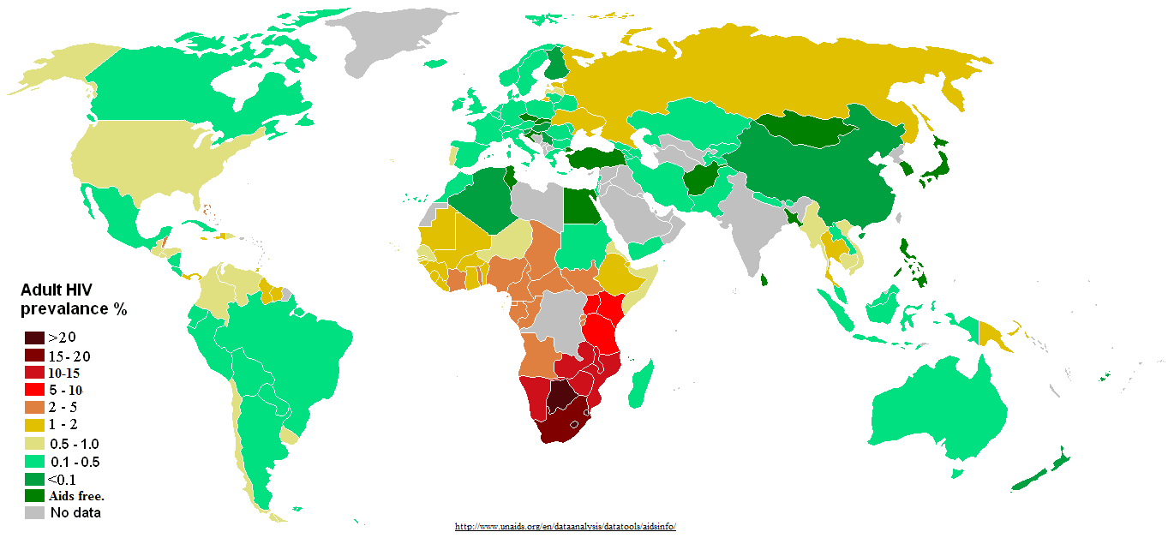

Figure 1.1: Distribution of HIV prevalence in adults around the world.

Source: http://www.unadis.org/en/dataanalysis/datatools/aidsinfo/

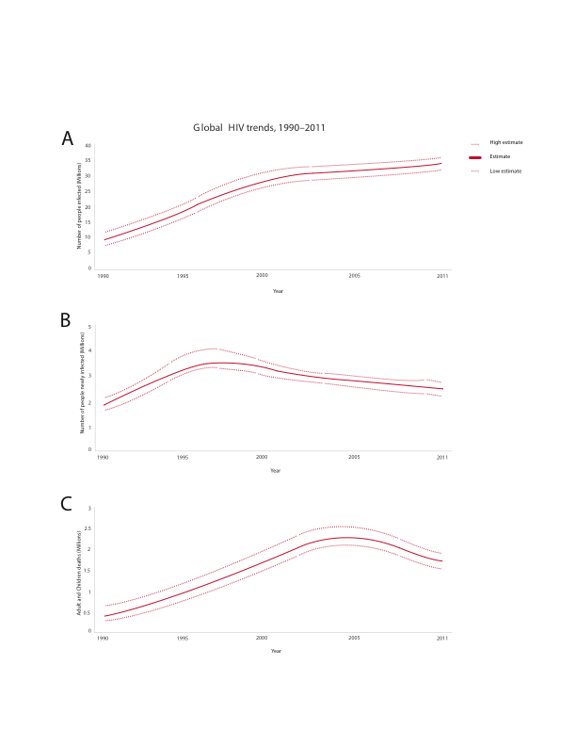

Figure 1.2: Global trend of new HIV infections from 1990 to 2011. The number of people living with HIV globally is increasing (A) while the number of people newly infected with HIV (B) and the number of Adults and child deaths due to HIV are decreasing (C) globally in the time period. This scenario can be attributed to global scale up of drugs while infected people continue transmitting the virus to uninfected people [4]. (Source: modified from UNAIDS 2012)

### 1.2 Discovery and characterization of HIV

As early as 1959, HIV infection cases had been documented but were unreported [5, 6]. Curious doctors at that time collected patient blood samples and kept frozen, which were later shown to have HIV antibodies [7]. In June 1981, a case of acute immune depletion associated secondary infection was reported in some homosexuals in the USA [8, 9]. Their infection was coupled with no lymphocyte proliferation [10]. Until 1983, the causative agent responsible for the severe immune depletion, named AIDS (Acquired Immunodeficiency Syndrome), was unknown [11, 12], when Luc Montagnier’s group at “Institut Pasteur” in Paris isolated the virus, which was initially named Human T-cell Leucamia Virus (HTLC) and later named as Human Immunodeficiency Virus (HIV) [5]. Jay Levy’s group in San Francisco, USA also subsequently found the virus confirming the discovery in Paris [13]. They found HIV was a lentivirus from Group VI retrovirus with two single strand RNA molecules [14]; unique to any other previously isolated viruses and the virus can transmit from infected to healthy people [15, 16], mother to child through umbilical cord [12, 17].

Very soon, scientists around the world focused on this transmissible retrovirus. Complete sequencing of HIV genome in 1985 [18] led scientists to know more insights of HIV including its origin, genes/proteins and life cycle [19].

## 1.3 Origin and evolution of HIV

Exploration of the retrovirus led researchers to identify similarities between HIV and a retrovirus in African non-human primates that were then called as Simian Immunodeficiency Virus (SIV) [20]. About 40 different primates, in Africa, are infected with SIV and some are harboring multiple strain of SIVs [21]. Phylogenetic analysis of SIV from African non-human primates and HIV in human provided remarkable understanding of viral transmission as zoonotic [22] and evolution of the virus in human after transmission [23].

HIV is divided into two groups – HIV-1 and HIV-2 [23]. Each group is an independent cross species transmission from different African non-human primates to human [24]. Discovered in 1986, HIV-2 is transmitted from sooty mangabey monkeys (Cercocebus atys) [25] and its prevalence is also high in the geographical location of these monkeys in West Africa [26]. Sooty mangabey monkeys are naturally infected by a strain of SIV [25]. The phylogenetic analysis of HIV-2 strains shows that they closely group with the SIVsmm strain [25] that are non-pathogentic to its host monkeys [27]. SIVsmm evolved in its host to produce multiple strains and subsequent multiple zoonotic transmissions from sooty mangabey monkeys to human [28] gave rise to different subtypes of HIV-2. Although HIV-2 subtypes A to G are identified in human, it is assumed that more subtypes were introduced into human [29] but are lost for low adaptation fitness [30].

HIV-1 is the result of at least three cross species transmission events from chimpanzees (Pan troglodytes troglodytes (Ptt)) to human [31, 32]. Phylogenetic analysis of HIV-1 sequences has shown that three independent cross transmission of the virus in to the human population, each giving rises to three sub groups: group M (Major), group O (Outlier) and group N (Non M or Non O) [28, 33]. Recently a new HIV-1 strain, classified as group P, distinct from the previous three groups, has been discovered in a patient in Cameroon [34].

Group M is the most prevalent and accounts for 98% of all infections (reviewed in [24]). Its epicenter is thought to be Kinshasha of present day Democratic Republic of Congo [24, 35]. Site stripping for clock detection method shows that group M and its closest simian relative branched out from their common ancestor in 17th century [36] whereas molecular clock analysis of group M shows that its radiating evolution dates back to late 1920s [37]. By 1960, long before human discovered its presence, HIV-1 group M had already diversified substantially [38].

Group O and group N are rare and geographically confined to West African regions such as Cameroon and neighboring countries [23]. It is still not understood about the non-pandemic characteristics of group O and N HIV-1 virus after the first zoonotic transmission [39]. It has been suggested that reduced replication capacity and transmission fitness are keys to their low prevalence[39]. Group O strain has at least 50% genetic identity with group M [29, 40] and the molecular clock model of this group also showed that its origin dates back to 1920s [41]. Group N was supposed to be introduced into human population in 1960s [42]. Phylogenetic analysis using genetic sequence under evolutionary pressure shows its close grouping with SIV from Chimpanzee [23, 43]. This indicates that group N might be a recombinant strain of SIV and HIV-1 group [42].

Group P is transmitted from gorilla as it is closely related to its SIV [34]. Population level study of this new group virus, at its discovered region in Cameroon, shows its prevalence at 0.06% in the area but can still be pandemic as it can adapt in human [44].

### 1.4 HIV-1 Diversity

**1.4.1 HIV-1 subtypes**

HIV-1 group M is highly diversified and it is classified into nine subtypes: A, B, C, D, F, G, H, J and K (Figure 1.3) [45]. The subtype classification is based on the phylogenetic and sequence distance analyses using gene sequence data forming major clades [45]. “At least three epidemiologically unlinked sequences are required for defining a subtype” [46].

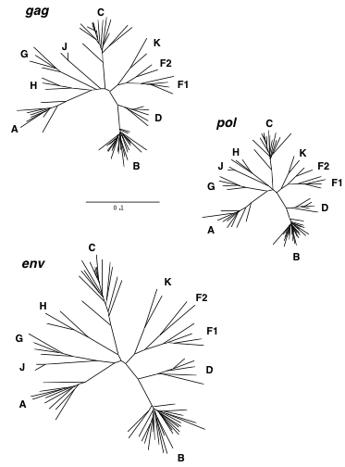

Figure 1.3: Phylogenetic tree showing HIV-1 group M diversification to subtypes A-D, F-H, J and K, inferred from nucleotide sequence alignments of gag, pol and env genes. Source: Robertson et al 2000 [46]

The classification of new subtype should also follow the same rule as “roughly equidistant from all previously characterized subtypes in all regions of the genome with a distinct pre-subtype branch similar to those of other subtypes” [45]. The predominating group M subtypes are A, B, C and D (reviewed in [47]). Geographical locations of group M subtypes epidemic are show in Figure 1.4. The analysis from HIV samples collected from 70 countries in 2004 shows that “subtype C accounts for 50% of all infections worldwide” while subtypes A, B, G and D are found in decreasing order 12%, 10%, 6% and 3% respectively [48]. Subtypes F, H, J and K are found very scarce and on overall, accounts for only 0.94% infections [48]. The range of amino acid variation within a subtype and between subtypes differs from 15%– 20% and 25% - 35% respectively [49].

Subtypes are further classified to sub-subtype based on a distinct sister clade formation [50] within a clade with the same rule of phylogenetic and distant analyses but not justifiable to call a subtype due to low genetic distance [45]. Only subtypes A and F exhibit distinct sister clades [50]. Subtype A has sub-subtypes A1 and A2 (A3 and A4 are mentioned by Taylor et al 2008[51]); Subtype F has sub-subtypes F1 and F2 (Figure 1.3); sub-subtype F3 mentioned by Taylor et al 2008 [51].

The lower diversity observed in Group N [52], O [53] and P [44] correlate to low prevalence and geographical confinement to Western African countries such as Cameroon. It is still unclear if group O can be sub divided into subtypes [54]. Group N as well does not show distinct sub clade within itself (Figure 1.5).

**1.4.2 HIV-1 recombination**

Initially, HIV-1 group M subtypes E [55-57] and I (Figure 1.5) were also classified (reviewed in [47]). With availability of complete HIV genome sequence and phylogenetic analysis from it, the subtypes E and I were reclassified as circular

### 

Figure 1.4: HIV diversity around the globe, its level of prevalence in the area and number of genome sequenced. Source: McCutchan 2006

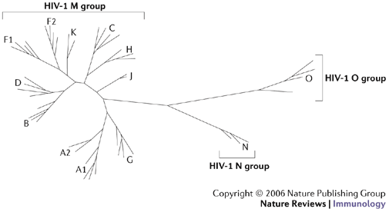

Figure 1.5: Neighboring joining phylogenetic tree showing HIV-1 group M, N and O. Group M shows distinct nine subtypes A-D, F-H, J, K while no specific subtype is observed in group N and O. Source: Letvin 2006 [58]

recombinant forms CRF01_AE (recombinant form of subtype A and E) and CRF04_cpx (recombinant form of more than two subtypes, designated by “cpx”) respectively (reviewed in [47]). The same criterion of epidemiological unlinked isolates from three or more people applies for classification as a circular recombinant form (CRF) [46]. A recombinant isolate discovered in single patient is termed as Unique Recombinant Form (URF) (reviewed in [47]). There are 55 CRFs listed in Los Alamos National Laboratory database for HIV sequences (<http://www.hiv.lanl.gov/content/sequence/HIV/CRFs/CRFs.html>) as on July 22, 2013. The recombination breakpoints to shuffle HIV genome [59-62] from different strains of the virus are listed in <http://www.hiv.lanl.gov/content/sequence/HIV/CRFs/breakpoints.html>, each appeared in a publication. CRFs account for at least 20% of all the HIV infections [46, 63, 64]. CRF02_AG is the most prevalent circulating recombinant form infecting over 9 million people on the whole [65] and geographically epidemic in the West African region (Figure 1.5). CRF01_AE is the dominant circulating recombinant form in South-East Asia (Figure 1.5) [51].

**1.4.3 Intra-patient HIV diversity**

HIV infection initiates mostly with a single virion [66, 67]. Evidences of multiple HIV variants transmission are also recorded [68, 69]. Generally, HIV is genetically homogenous for a short post infection time [70, 71]. In the long-term post infection period, virus replicates rapidly to produce genetically heterogeneous population [68]. This heterogeneous viral population consisting swarm of highly similar virus but genetically non-identical HIV virus is called HIV quasispecies (reviewed in [47]). It is observed that the diversity at a gene in viral quasispecies can be approximately 30% [72]. Factors that contribute to high genetic heterogeneity in viral quasispecies are higher replication rate and turnover [73], viral genome recombination [74-76], higher mutation rate by erroneous reverse transcriptase [77, 78], and host immune selection [79, 80]. On the whole, HIV replication (discussed in section 1.6) is the overall source of genetic heterogeneity in the viral population (reviewed in [81]).

Intra patientHIV genome recombination is a common event [76, 82]. Two genomes from different viral strains can be co-packed into single virion during replication [83]. In the subsequent HIV replication, the ability of reverse transcriptase to switch between the two template genomes produces a recombined genome [84, 85]. Genetic recombination allows rapid and efficient shuffling of advantageous genes and removing deleterious mutations, thus, increasing the viral fitness in the host (reviewed in [81]). Co infection by different HIV subtypes and subsequently co-packed and co-expressed in to a single virion generates Unique Recombinant Forms (URFs) (reviewed in [51]). Successful transmission of URFs with high viral fitness to three or more people and circulates in human population establishes Circulating Recombinant Forms (CRFs) (reviewed in [86]).

### 1.5 HIV genome and proteins – structures and functions

HIV has nine genes and produces 15 proteins [87]. The genes are broadly grouped as accessory (vif, vpr, vpu and nef), structural (*pol*, *gag* and *env*) and regulatory (*tat* and rev). The higher number of proteins than genes is a result of post - transcriptional proteolysis of the products of structural genes [87].

**1.5.1 Accessory genes:**

Vif promotes the viral infectivity to the host, but has no role in viral production [88]. Vif is produced in the late stage of viral production [89, 90] to suppress the innate antiviral immunity of host [91, 92]. It is observed that vif is expressed only when the virus infects immune cells that express cytidine deaminase APOBEC3G [93]. The reason is that Vif protein prevents APOBEC3 proteins from hyper mutating HIV reverse transcripts as a mechanism of defense [94-104].

Vpr protein is packed in to nascent virions during budding out [105]. Vpr is essential for viral core to enter and localize in the host cell nucleus after infecting the cell [106]. Vpr arrests the cell cycle during the transfer from G2 to M phase [107, 108] by preventing the activation of the human p34cdc2/cyclin B complex [109]. Vpr is also important for efficient viral replication in monocyte or macrophage cells, but T-cells [105].

Vpu is a protein unique to HIV-1 [110] and is 16 kilo Dalton, 81 amino acids long [111]. Biological functions of vpu protein include degradation of CD4 in endoplasmic reticulum [112], interference of host immune cell MHC class II antigen presentation on the cell surface allowing the virus for host immune escape [113, 114] and viral maturation and release from host cell membrane [115].

Nef has no role in viral infectivity but plays a role during the biogenesis of viral particles [116] and virulence [117, 118]. Nef down regulates the production of major histocompatibility complex type I (MHC type I) in the host cell [119-121]. This impairs the function of cytotoxic T lymphocyte cells to clear the infected cells [122-126]. Nef also down regulates CD4 on host cell surface [127, 128] and modulates cellular activation to evade host immune system [123, 126].

**1.5.2 Structural genes and proteins**

The Gag gene produces a precursor polyprotein (pr55gag) of ~ 500 amino acids long and weighs 55 kilodalton [129]. The Gag precursor has all the building blocks to form a fully infectious virion, even in the absence of other viral products [130]. A proteolytic cleavage of gag precursor yields the structural proteins – matrix, capsid, nucleocapsid and p6 (Figure 1.6) [131]. The cleavage takes place in the nascent virus after budding out from host cell [132]. The matrix protein is at the N-terminal and p6 at the C-terminal of gag precursor [131, 133].

All gag proteins play role at “post assembly and post processing stages in viral infectivity” [130]. In the HIV replication cycle, matrix domain of gag plays role in targeting gag precursor to the plasma membrane of the host cell and the viral assembly at the site [130, 134-136]. The highly basic region in matrix mediates electrostatic association with phospholipids in plasma membrane during assembly [137, 138]. The capsid is a curved and closed shell consisting 250 hexamers and 12 pentamers (reviewed in [139]). Capsid packs viral proteins, nucleocapsid and viral genome during assembly to pass on to new HIV particles [140]. Nucleocapsid plays role in efficient viral assembly by making pr55–pr55 inter-protein contacts [135, 136] and localization of viral proteins [141]. P6 protein plays role in detaching and releasing the newly formed HIV particles [142].

The *pol* polyprotein is produced by translational frame shift [143] (Figure 1.5), such that, as much as 241 nucleotides at 5’ region of the gene overlaps with 3’ region of *gag* gene [18, 144]. The proteolytic cleavage of *pol* precursor produces essential viral replication enzymes – protease (PR), reverse transcriptase (RT) and integrase (IN). The protease enzyme cleaves the *gag* and *pol* polyprotein to form the viral structure proteins and functional enzymes respectively [145-147]. The reverse transcriptase enzyme produces a cDNA from the viral RNA after infecting host cell [148, 149]. The RNase H domain in RT degrades the viral RNA molecule following cDNA production [150]. The integrase enzyme removes two bases from 3’ DNA molecule and functions strand transfer during the process of integrating the proviral DNA into the host genome [151].

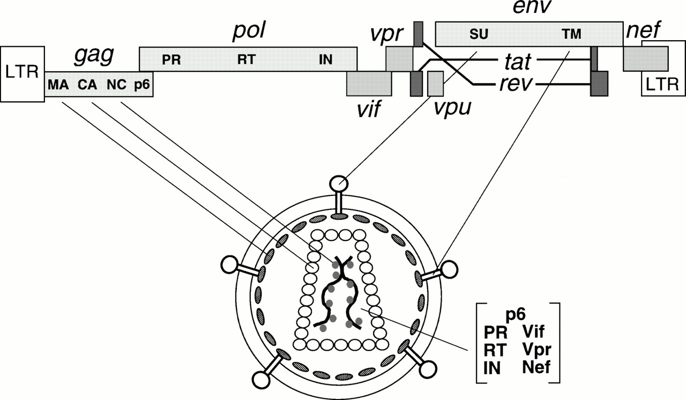

Figure 1.6: HIV genes and proteins positions in the viral genome and their viral parts. Source: Frankel and Young 1998 [87]

*Env* gene produces a precursor glycopolyprotein (gp160) that is processed at post-translational by human convertase enzymes - PC1 and furin to produce glycoprotein 120 (gp120, HIV-1 SU) and glycoprotein 41 (gp41, HIV-1 TM) [152]. Gp120 is a non-covalent complex of external protein and gp41 is a trans-membrane protein; both play vital role for initial steps in viral infection [153]. Three gp120 molecules bound with three gp41 molecules to form envelop spikes [154]. They are organized to form trimeric complexes on the surface of HIV and mediate HIV entry into the host cell [155]. The exposed external complex gp120 binds to the CD4 receptor on the host immune cell [156]. This triggers a conformational shift of trimeric complex that enables a conserved gp120 region binding to a chemokine receptor, either CCR5 or CXCR4, to facilitate fusion of the viral and host membranes [156-159]. The gp120-CD4 complex also triggers conformational change in gp41 trans-membrane protein from native non-fusion state to fusion state [153, 160]. Gp41 plays role in the viral fusion and release of viral contents in to the host cell [161, 162],. The gp41 consists of heptad repeats - HR1 and HR2 that play role in fusion process [161, 163]. HR1 is a bundle of three helical motifs and HR2 is trimeric coiled coil struture [164]. During fusion process, HR2 makes numerous contacts with HR1 to form stable six helical bundles [165].

**1.5.3 Regulator Genes:**

*Tat* is a trans-activating factor localized in the nucleus for HIV gene expression [166, 167]. The HIV proviral genome integrated in to the host genome is regulated by cellular as well as the viral transcription regulatory factors [168, 169]. Tat is the primary transcriptional regulatory factor [170]. An example of Tat action is the control of RNA polymerase II elongation during transcription, which otherwise disengages from the template DNA strand, terminating the transcription prematurely [171-173]. Sodroski *et al*. (1985) first explained the function of Tat [174].

Rev is a 19 kilo Dalton phosphoprotein [175] trans-activating factor for HIV gene expression [166]. Like Tat, it is also mainly localized in the nucleus of host cell [176], but cycles rapidly between the nucleus and cytoplasm as it promotes nuclear export of the transcriptional products [177-180]. Rev binds at the Rev Responsive Element (RRE), which is an RNA element encoded within the *env* region of the virus [181, 182].

### 1.6 HIV replication

There are major 11 events in HIV replication cycle (as numbered in Figure 1.7). The initial step of viral entry (Figure 1.7 step 1) in to a host immune cell is explained in section 1.5.2.

Following the fusion, the viral core enters in to the cytoplasm of host cell. The RT enzyme reverse transcribes the RNA molecule to cDNA (Figure 1.7 step 2) in the intact capsid of the viral core [183]. Subsequently the capsid is dissembled, termed as uncoating (Figure 1.7 step 3) [183], assisted by host importin β member protein transportin 3 (TNPO3) [184]. The uncoating process can take an hour or less since time of post infection [185]. Uncoating process releases ribonucleoprotein complex in to the cytosol of the host cell [186]. The capsid and nucleocapsid proteins dissociate from cDNA but the reverse transcription complex remains intact along with viral matrix, integrase, vpr and human protein high mobility group I (HMG I (Y)) forming preintegration complex (PIC) [187-189]. The PIC protects cDNA from endonuclease degradation [189]. In an ATP dependent process [190], PIC is transported on host microtubules towards the nuclear membrane [183]. Some studies initially suggested that formation of central DNA flap [191], vpr, and matrix mediate nuclear import (Figure 1.7 step 4) of PIC [192], however, the no any clear evidence of these factors have been described as such for nuclear import [193]. Integrase assists in nuclear import in association with nuclear import machinery like importin [194] and transportin-SR2 [195]. It is now established that central polypurine tract-central termination sequence (cPPT-CTS) plays role in kinetics of nuclear import [193].

Post-nuclear entry, integrase processes the viral DNA for integration [196] (Figure 1.7 step 5) into host genome as explained in section 1.5.2. Host transcriptional co-factor LEDGF/p75 and HIV integrase interact to tether to the host chromosome during the integration process [197].

The integrated HIV provirus hijacks the host cell transcriptional machinery for viral genes to transcribe (Figure 1.7 step 6) [198]. HIV protein Tat promotes the transcription of the viral DNA [199, 200]. The viral transcriptome encodes structural proteins, accessory proteins and viral enzymes necessary for a complete functional HIV (reviewed in [201]).

The viral Rev protein facilitates exporting (Figure 1.7 step 7) of the unprocessed viral transcriptome to cytoplasm for translation [179]. HIV has no translation system of its own; the host translational machinery is exploited for translation (Figure 1.7 step 8) of the viral transcriptome to its proteome [202, 203].

Upon translation of all viral proteins, viral *gag* initiates virion assembly (Figure 1.7 step 9) at the cell membrane [204-206]. The complete assembled virion particles bud out and are released (Figure 1.7 step 10) from the plasma membrane by the host ESCRT machinery involving Tsg101 and ALIX regulatory proteins [207-209]. The maturation (Figure 1.7 step 11) of the nascent HIV virions begins concomitantly with budding out [115, 210]. *Gag* and *Pol* polyproteins are proteolytically cleaved by protease enzyme in the maturation step [211, 212].

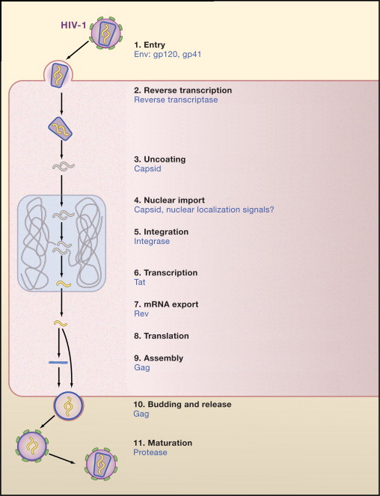

Figure 1.7: The HIV replication cycle showing major stages. Viral proteins that play role in each event are colored blue. (Source: modified from Ho and Bieniasz 2008) [213]

Each HIV replication cycle releases new infectious virions in the order of 109 per day [214]. The number of new infecting HIV determines the replication rate of the virus [215]. A long post infection period shows higher turnover rate associated with CD4+ cell depletion and viral population expansion [214].

### 1.7 HIV Treatment

Different inhibitory drugs have been designed that interfere with the viral protein normal function at different stages of its replication cycle. Currently available drugs classified on the basis of its target in HIV replication are: Reverse Transcriptase Inhibitors, Protease Inhibitors, Integrase Inhibitors and cell entry Inhibitors (reviewed in [216-218]). The prescribed drug regimen usually consists of drugs from reverse transcriptase inhibitors and protease inhibitors [219]. The World Health Organization (WHO) has classified HIV infection to different clinical stages depending upon progression to AIDS [220]. The WHO has developed guidelines on usage of anti retro viral drugs to prevent HIV and care infected people (<http://www.who.int/hiv/pub/guidelines/en/>). The WHO guidelines are produced based on the clinical stage of HIV infection, CD4+ count in blood, adult/breast feeding mother and presence of secondary infections (<http://www.who.int/hiv/pub/guidelines/en/>) [221]. According to the guideline, patient at clinical stage 3 or 4 having CD4+ count less than 500 per micro liter (μL) should start the treatment whereas CD4+ count less than 350 μL are highly recommended to start the treatment immediately [221]. HIV treatment with combination of triple anti retroviral drugs, also called Highly Active Anti Retroviral Therapy (HAART) is done under the guidance of a clinician. The effectiveness of ART treatment and emergence of drug resistant viral variants are monitored.

**1.7.1 Reverse Transcriptase Inhibitors**

1. **NRTIs**

NRTIs are analogs of normal nucleotides but without 3’ hydroxyl group (reviewed in [222]). The drug is taken in unphosphorylated form, which cytokinases phosphorylates to form 5’ triophosphates (reviewed in [216, 223]). It leads to incomplete termination of cDNA synthesis [224]. There are eight NRTI drugs currently used in ART drug regimen (Figure 1.8).

1. **NNRTIs:** Non-nucleoside and non-nucleotide reverse transcriptase inhibitors (NNRTIs) specifically bind at an allosteric site 10 [Å](http://en.wikipedia.org/wiki/%C3%85) from polymerase active site of the HIV-1 reverse transcriptase [149, 225], close to substrate-binding site. The binding induces conformational change in the enzyme, which distorts the catalytic aspartate triad of active site and inhibits the function of the enzyme [226, 227]. NNRTIs drug are administered along with NRTI drugs in ART at non-toxic concentration to human cells [228]. NNRTIs drugs from first generation have inherent disadvantageous characteristics like cross-resistance and low genetic barrier (require only one mutation to select) [229]. There are six NNRTIs drugs used in ART drug regimen (Figure 1.9)

**1.7.2 Protease Inhibitors (PR)**

Protease inhibitor is added to second line ART therapy on drug failure to first line therapy [230]. Protease Inhibitors interfere with *gag*-*pol* polypeptide [231] as competitive peptidomimetic inhibitors and have hydroxyethylene core, which prohibits cleavage activity of the HIV-1 protease [232, 233]. However, as adverse side effect, patients consuming the inhibitors have developed lipodystrophy and hyperlipidemia [234-240]. Besides inhibiting protease enzyme, it also inhibits degradation and secretion of apolipoprotein B; but in the presence of oleic acid,

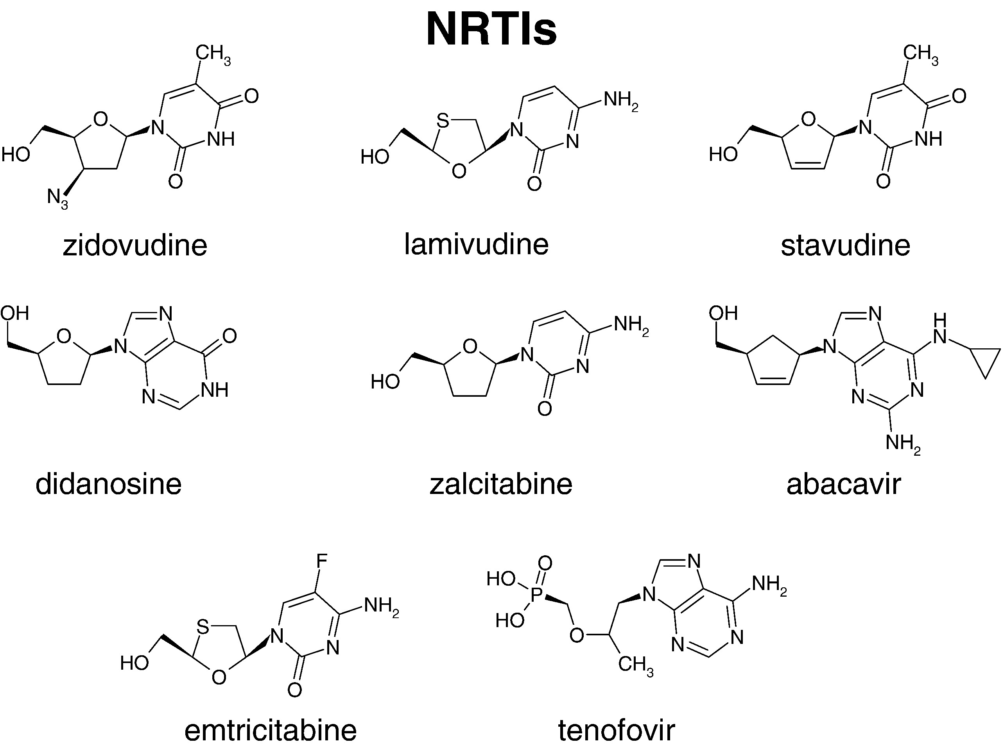

Figure 1.8: Molecular structures of NRTI drugs. Source: Sarafianos et al 2009 [149]

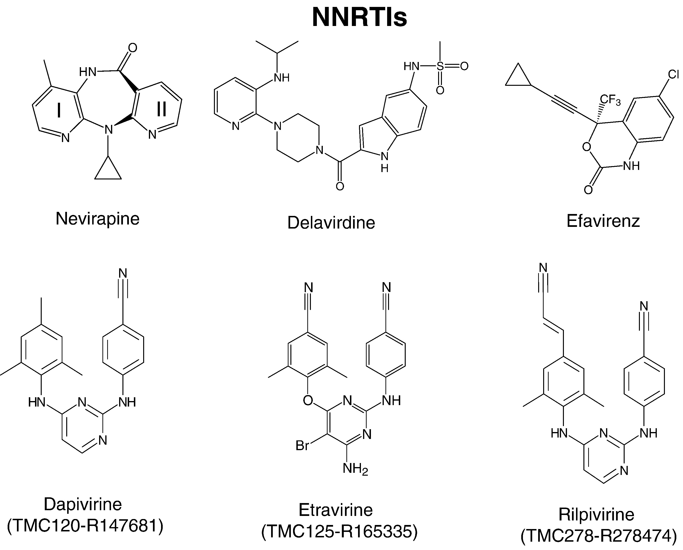

Figure 1.9: Molecular structures of NNRTI drugs. Source: Sarafianos et al 2009 [149]



Figure 1.10: Molecular Chemical structures of Protease Inhibitors. Source: Chow et al 2009 [241]

protease inhibitor increases the secretion of apolipoprotein B [238]. There are nine protease inhibitors approved for clinical use shown in Figure 1.10.

**1.7.3 Integrase Inhibitors**

Although the triple anti retroviral drugs therapy could suppress the viral replication, its expensive, leads to multiple drug resistance and requires high adherence [242]. This has diverted the search for drugs that target third enzyme, the integrase. Some of the integrase inhibitors are shown in Figure 1.11. The feasibility and efficacy of integrase inhibitors have been tested in Rhesus Macaques [243]. Most of the Integrase inhibitors target strand transfer function of the enzyme [244-248]. X-ray structure of the integrase enzyme has revealed the active site model of the enzyme complexes with the DNA [249]. Diketo acids (DKA) and its derivatives (like L-708,906, S-1360, and V-165 (Fikkert et al 2003)) are the highly potent integrase inhibitors for strand transfer inhibition [246]. Low concentration of DKA is sufficient for effective integrase inhibitor (reviewed in [250]).

**1.7.4 Cell entry inhibitors**

1. **Co receptor inhibitors or entry inhibitors:**

Early entry inhibitors are designed to target the unglycosylated cavity formed during gp120-CD4 complex ([251, 252], reviewed in [253]). Some of the molecules that inhibit gp120-CD4 binding are: PRP-542 [254], TNX-355[255], CADA [256, 257], BMS-806 [251].

Another target of entry inhibitor is the host immune cell surface co-receptors either CCR5 or CXCR4. Co receptor antagonists are designed that binds specifically to targeted co receptors, making it unavailable to HIV gp120 binding (reviewed in [258]).

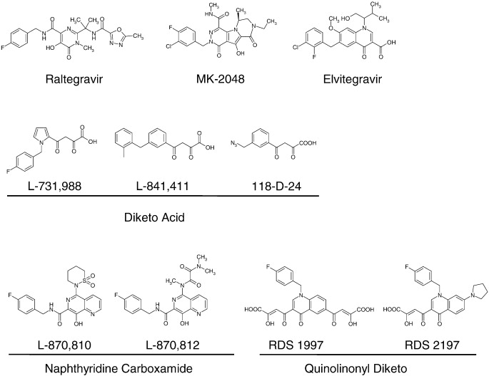

Figure 1.11: Chemical structure of different integrase inhibitors. Structures with similar chemical properties are grouped together. Source: Bera et al 2011 [244]

Some of the CCR5 antagonists developed are TAK-779 [259], TAK-652 [260], vicriviroc [261-263], AD101 (SCH-350581) [264], Maravirok (UK-427857) [217, 265-269], Aplaviroc (GW-873140) [270, 271], PRO-140 [272].

Some of the CXCR4 antagonists are AMD3100 [273], AMD070 [274, 275], KRH-1636 [276] and KRH-2731 [277, 278].

1. **Fusion Inhibitors**

Fusion inhibitor design is based on targeting the heptad regions HR1 or HR2 of gp41 disabling the virus to make fusion pore (reviewed in [279]). Enfuvirtide [280, 281] is a synthetic peptide, approved for clinical use in 2003 [282], which can bind to gp41 HR1 region [283]. The fusion inhibitor T-1249 also targets HR1 region [284]. T-1249 is active against Enfuvirtide resistant viral strains but discontinued in 2004 for clinical use [253, 285]. Sifuvirtide is another HIV fusion inhibitor peptide under research [286].

### 1.8 HIV Drug Resistance

Triple anti retroviral drug therapy has been successful at controlling HIV replication to low viral load within a host [287]. The therapy has been compromised by the emergence of resistant HIV viral variants through constant evolution (reviewed in [288]). Selective pressure in new environments like presence of anti retro viral drugs and host immune system drive the evolution of resistant virus (reviewed in [289, 290]). HIV drug resistance can occur with accumulation of mutations that increase the viral fitness in the presence of anti retro viral drugs (reviewed in [288, 291]). Mutations that confer evolutionary advantage to virus and escape drug effect are selected [292]. Transmission of resistant virus also confers drug resistance in drug naïve patients [293-295]. Although drug resistant mutations escape drugs effect, they confer decrease in viral fitness and replication rate at certain level [296]. Other mutations counteract the effect of drug resistant mutations to increase fitness and replication rate [297].

ART drugs are designed based on three dimension structures of the viral proteins to bind at specific active region of the proteins and interfere with its normal function. Mutations at specific positions of HIV genes change the three-dimensional shape of the proteins rendering no drug binding (Figure 1.12). These drug resistant mutations have been well documented with associated drug and resistance level [298]. The viral quasispecies sequence information can be used to align against the reference sequence and infer the presence of any drug resistant mutation [299].

**1.8.1 Mechanisms of drug resistance**

HIV gains drug resistance against nucleoside reverse transcriptase inhibitors with substitution mutations close to the nucleotide-binding site [300, 301]. The substituted amino acids either fold over the triphosphate group of the incoming nucleotide analog [302] or exerts steric clash with the oxathiolane ring of the inhibitors and interferes with its binding [303]. Another mechanism of gaining resistance to NRTIs is hydrolytic removal of analog inhibitors mediated by nucleotide excision mutations [304]. Mutations in RT (M41L, L210W, T215F/Y and K219Q/E) remove NRTIs from the elongating nucleotide chain through phosphorolysis mediated either ATP or pyrophosphate [305-307].

NNRTI drugs interacts with reverse transcriptase enzyme residues and forms electrostatic forces, van der waals forces and hydrogen bonds (reviewed in [308]). Mutations in p66 and p51 subunits of the enzyme hinder drug interactions and bond formation [309], rendering drug resistance. A single mutation confers viral resistance 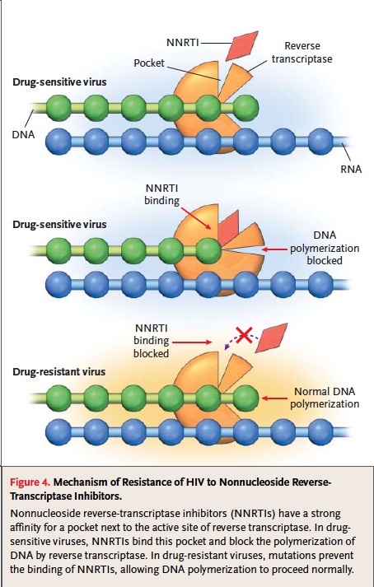

Figure 1.12: Development of HIV drug resistance. Accumulation of Drug resistant mutations changes three-dimensional confirmation of a viral protein, disabling drug binding and carrying out its normal function.

to NNRTI drugs nevirapine and delavirdine [301] whereas two mutations are required for resistance against NNRTI drugs efavirenz and capravirine [310] showing lower and higher genetic barrier respectively.

Low pharmacokinetics of protease inhibitors in plasma is responsible for emergence of resistance HIV variants [311]. Suboptimal therapy in which a PI is combined with reverse transcriptase inhibitors suffers low pharmacokinetics as protease inhibitors are eliminated by cytochrome P450 from plasma [312]. PI doses are kept high in plasma, with adminstration of low dose of ritonavir that suppress cytochrome P450 activity [311, 313-315]. This delays the emergence of resistant viruses [316, 317]. HIV also attains protease inhibitor resistance with mutations at cleavage site of *gag* polyprotein [316].

Integrase inhibitors are characterized as low genetic barrier drugs and a mutation can cause high level of resistance [318]. Integrase inhibitors engage divalent metal ions Mg++ and Mn++ at the integrase active site [319]. Mutations at the active site of integrase interfere the available space for chelating moieties rendering unsuccessful engagement of the metals [320]. However, some mutations are distal to the metal binding active site and resistance exhibited by these mutations suggests inhibitor-enzyme interactions may extend beyond the active site of integrase enzyme [321]. HIV is able to switch between the resistance pathways (N155H pathway to Q148H/G140S pathway in case of drug raltegravir) to escape the drug [322].

A reason to CCR5 co receptor antagonist resistance development is that HIV switch the use of co receptor to CXCR4 at late post infection [323, 324].

The resistance mechanism of HIV against CCR5 mechanism is explained as either competitive or non-competitive [325-327]. In competitive resistance mechanism, HIV gp120 changes the confirmation that has high affinity for inhibitor-free CCR5 co receptors as it can only bind to the co receptor at non-saturating concentration of the inhibitor [328, 329]. Increasing the drug concentration might overcome the competitive resistance [330]. In non-competitive resistance, HIV gp120 acquires the ability to bind to inhibitor bound co receptor but less efficiently than free co receptor [326]. The resistance mechanism of non-competitive resistance is still under cover [157, 264, 331]. The binding of CCR5 antagonist alters the confirmations of binding site in the co receptor that is not recognized by the incoming HIV gp120 [332]. Resistant HIV changes gp120 confirmation that recognizes the new confirmation of inhibitor bound co receptor (reviewed in [253]).

Mutations at heptad region at N-terminal of gp41 confer resistance to entry inhibitor, Enfuvirtide [333, 334]. The highly variable regions in gp120/gp41 are also responsible for resistance against fusion inhibitor [321, 335]. Viruses displaying fast fusion kinetics to CD4 and higher affinity to co receptor show reduced susceptibility to fusion inhibitor than the viruses with lower fusion kinetics to CD4 and lower affinity to co receptor [321, 336].

### 1.9 Conventional Population Based HIV Drug Resistance Genotyping

The primary cause of virologic failure of anti retro viral therapy is the evolution of HIV variants resistant against the selected drugs regimen [337]. The pattern of drug resistant mutations in HIV has strong relation with virologic failure [338-344]. The application of HIV genotype information on therapy optimization has shown virologic benefits in clinical settings [345-347]. Conventional HIV genotyping involves Sanger dideoxy termination sequencing method [348-350]. The method produces a chromatogram that represents the sequence of the viral population in the host [351].

Conventional population based sequencing method has limited sensitivity for detecting viral variants of frequency greater or equal to 20%; low prevalent variants go undetected [352, 353]. Thus, sequencing technology underestimates the total variants in the viral population [354]. Undetected low frequency HIV variants are clinically relevant for designing salvage therapy, as they are usually drug resistant. Those minor variants rebound in the presence of drugs, leading to ultimate virologic failure. This necessitates improved and highly sensitive sequencing technologies able to detect minor HIV variants in the population.

**Bibliography**

1. Quinn TC. Global burden of the HIV pandemic, Lancet 1996;348:99-106.

2. Esparza J, Bhamarapravati N. Accelerating the development and future availability of HIV-1 vaccines: why, when, where, and how?, Lancet 2000;355:2061-2066.

3. UNAIDS. Global Report 2012: UNAIDS Report on the Global AIDS Epidemic. ebookpartnership. com.

4. Zaidi J, Grapsa E, Tanser F et al. Dramatic increases in HIV prevalence after scale-up of antiretroviral treatment: a longitudinal population-based HIV surveillance study in rural kwazulu-natal, AIDS;27:000-000.

5. Nahmias A, Weiss J, Yao X et al. Evidence for human infection with an HTLV III/LAV-like virus in Central Africa, 1959, The Lancet 1986;327:1279-1280.

6. Corbitt G, Bailey A, Williams G. HIV infection in Manchester, 1959, The Lancet 1990;336:51.

7. Zhu T, Korber BT, Nahmias AJ et al. An African HIV-1 sequence from 1959 and implications for the origin of the epidemic, Nature 1998;391:594-597.

8. Friedman-Kien AE. Disseminated Kaposi's sarcoma syndrome in young homosexual men, Journal of the American Academy of Dermatology 1981;5:468–471.

9. Friedman-Kien AE, Laubenstein L, Marmor M et al. Kaposi’s sarcoma and Pneumocystis pneumonia among homosexual men—New York City and California, MMWR 1981;30:305–308.

10. Gottlieb MS, Schroff R, Schanker HM et al. \textitPneumocystis carinii Pneumonia and Mucosal Candidiasis in Previously Healthy Homosexual Men, New England Journal of Medicine 1981;305:1425-1431.

11. Francis DP, Curran JW, Essex M. Epidemic acquired immune deficiency syndrome: epidemiologic evidence for a transmissible agent, Journal of the National Cancer Institute 1983;71:5–9.

12. Gallo RC, Sarin PS, Gelmann EP et al. Isolation of human T-cell leukemia virus in acquired immune deficiency syndrome (AIDS), Science (New York, N.Y.) 1983;220:865-867.

13. Levy JA, Hoffman AD, Kramer SM et al. Isolation of lymphocytopathic retroviruses from San Francisco patients with AIDS, Science 1984;225:840-842.

14. Baltimore D. Expression of animal virus genomes., Bacteriological Reviews 1971;35:235.

15. Wofsy C, Hauer L, Michaelis B et al. Isolation of AIDS-associated retrovirus from genital secretions of women with antibodies to the virus, The Lancet 1986;327:527–529.

16. Rogers MF, Thomas PA, Starcher ET et al. Acquired Immunodeficiency Syndrome in Children: Report of the Centers for Disease Control National Surveillance, 1982 to 1985, Pediatrics 1987;79:1008-1014.

17. Ziegler J, Johnson R, Cooper D et al. Postnatal transmission of AIDS-associated retrovirus from mother to infant, The Lancet 1985;325:896–898.

18. Ratner L, Haseltine W, Patarca R et al. Complete nucleotide sequence of the AIDS virus, HTLV-III 1985.

19. Wain-Hobson S, Sonigo P, Danos O et al. Nucleotide sequence of the AIDS virus, LAV, Cell 1985;40:9–17.

20. Gao F, Yue L, Robertson DL et al. Genetic diversity of human immunodeficiency virus type 2: evidence for distinct sequence subtypes with differences in virus biology., Journal of virology 1994;68:7433–7447.

21. Apetrei C, Robertson DL, Marx PA. The history of SIVS and AIDS: epidemiology, phylogeny and biology of isolates from naturally SIV infected non-human primates (NHP) in Africa, Frontiers in bioscience: a journal and virtual library 2004;9:225-254.

22. Bailes E, Chaudhuri RR, Santiago ML et al. (2002), 'The Evolution of Primate Lentiviruses and the Origins of AIDS', *The Molecular Epidemiology of Human Viruses*, Springer US, pp. 65-96.

23. Gao F, Bailes E, Robertson DL et al. Origin of HIV-1 in the chimpanzee Pan troglodytes troglodytes, Nature 1999;397:436-441.

24. Sharp PM, Hahn BH. The evolution of HIV-1 and the origin of AIDS, Philosophical Transactions of the Royal Society B: Biological Sciences 2010;365:2487-2494.

25. Hirsch VM, Olmsted RA, Murphey-Corb M et al. An African primate lentivirus (SIVsmclosely related to HIV-2 1989.

26. Santiago ML, Range F, Keele BF et al. Simian immunodeficiency virus infection in free-ranging sooty mangabeys (Cercocebus atys atys) from the Tai Forest, Cote d'Ivoire: implications for the origin of epidemic human immunodeficiency virus type 2, Journal of virology 2005;79:12515–12527.

27. Gao F, Yue L, White AT et al. Human infection by genetically diverse SIVSM-related HIV-2 in West Africa, Nature 1992;358:495-499.

28. Hahn BH, Shaw GM, De KM et al. AIDS as a zoonosis: scientific and public health implications, Science 2000;287:607–614.

29. Gürtler L. [Zoonotic infections stimulation], Bundesgesundheitsblatt, Gesundheitsforschung, Gesundheitsschutz 2004;47:609-610.

30. Damond F, Worobey M, Campa P et al. Identification of a highly divergent HIV type 2 and proposal for a change in HIV type 2 classification, AIDS research and human retroviruses 2004;20:666–672.

31. Peeters M, Honoré C, Huet T et al. Isolation and partial characterization of an HIV-related virus occurring naturally in chimpanzees in Gabon, AIDS 1989;3:625–630.

32. Huet T, Cheynier R, Meyerhans A et al. Genetic organization of a chimpanzee lentivirus related to HIV-1 1990.

33. Keele BF, Heuverswyn FV, Li Y et al. Chimpanzee Reservoirs of Pandemic and Nonpandemic HIV-1, Science 2006;313:523-526.

34. Plantier JC, Leoz M, Dickerson JE et al. A new human immunodeficiency virus derived from gorillas, Nat Med 2009;15:871-872.

35. Sharp PM, Hahn BH. The evolution of HIV-1 and the origin of AIDS, Philosophical Transactions of the Royal Society B: Biological Sciences;365:2487-2494.

36. Salemi M, Strimmer K, Hall WW et al. Dating the common ancestor of SIVcpz and HIV-1 group M and the origin of HIV-1 subtypes using a new method to uncover clock-like molecular evolution, FASEB J 2001;15:276-278.

37. Korber B, Muldoon M, Theiler J et al. Timing the ancestor of the HIV-1 pandemic strains, Science 2000;288:1789-1796.

38. Worobey M, Gemmel M, Teuwen DE et al. Direct evidence of extensive diversity of HIV-1 in Kinshasa by 1960, Nature 2008;455:661-664.

39. Ariën KK, Abraha A, Quiñones-Mateu ME et al. The Replicative Fitness of Primary Human Immunodeficiency Virus Type 1 (HIV-1) Group M, HIV-1 Group O, and HIV-2 Isolates, Journal of Virology 2005;79:8979-8990.

40. VANDEN HAESEVELDE MM, Peeters M, JANNES G et al. Sequence analysis of a highly divergent HIV-1-related lentivirus isolated from a wild captured chimpanzee, Virology 1996;221:346–350.

41. Lemey P, Pybus OG, Rambaut A et al. The Molecular Population Genetics of HIV-1 Group O, Genetics 2004;167:1059-1068.

42. Simon F, Mauclère P, Roques P et al. Identification of a new human immunodeficiency virus type 1 distinct from group M and group O, Nature Medicine 1998;4:1032-1037.

43. Corbet S, Müller-Trutwin MC, Versmisse P et al. env sequences of simian immunodeficiency viruses from chimpanzees in Cameroon are strongly related to those of human immunodeficiency virus group N from the same geographic area, Journal of virology 2000;74:529–534.

44. Vallari A, Holzmayer V, Harris B et al. Confirmation of Putative HIV-1 Group P in Cameroon, Journal of Virology 2011;85:1403-1407.

45. Robertson DL, Anderson JP, Bradac JA et al. HIV-1 nomenclature proposal, Science 2000;288:55-56.

46. Robertson DL, Anderson JP, Bradac JA et al. HIV-1 nomenclature proposal, Science 2000;288:55–55.

47. McCutchan FE. Global epidemiology of HIV, Journal of Medical Virology 2006;78:S7–S12.

48. Hemelaar J, Gouws E, Ghys PD et al. Global and regional distribution of HIV-1 genetic subtypes and recombinants in 2004, AIDS 2006;20:W13-W23.

49. Korber B, Gaschen B, Yusim K et al. Evolutionary and immunological implications of contemporary HIV-1 variation, British Medical Bulletin 2001;58:19-42.

50. Gao F, Vidal N, Li Y et al. Evidence of Two Distinct Subsubtypes within the HIV-1 Subtype A Radiation, AIDS Research and Human Retroviruses 2001;17:675-688.

51. Taylor BS, Sobieszczyk ME, McCutchan FE et al. The Challenge of HIV-1 Subtype Diversity, New England Journal of Medicine 2008;358:1590-1602.

52. Ayouba A, Souquieres S, Njinku B et al. HIV-1 group N among HIV-1-seropositive individuals in Cameroon, AIDS 2000;14:2623-2625.

53. Lemey P, Pybus OG, Rambaut A et al. The molecular population genetics of HIV-1 group O, Genetics 2004;167:1059-1068.

54. Roques P, Robertson DL, Souquière S et al. Phylogenetic Analysis of 49 Newly Derived HIV-1 Group O Strains: High Viral Diversity but No Group M-like Subtype Structure, Virology 2002;302:259-273.

55. Artenstein AW, Coppola J, Brown AE et al. Multiple introductions of HIV-1 subtype E into the western hemisphere, Lancet 1995;346:1197-1198.

56. Tovanabutra S, Robison V, Wongtrakul J et al. Male viral load and heterosexual transmission of HIV-1 subtype E in northern Thailand, J Acquir Immune Defic Syndr 2002;29:275-283.

57. Wasi C, Herring B, Raktham S et al. Determination of HIV-1 subtypes in injecting drug users in Bangkok, Thailand, using peptide-binding enzyme immunoassay and heteroduplex mobility assay: evidence of increasing infection with HIV-1 subtype E, AIDS 1995;9:843-849.

58. Letvin NL. Progress and obstacles in the development of an AIDS vaccine, Nature Reviews Immunology 2006;6:930-939.

59. Archer J, Pinney JW, Fan J et al. Identifying the important HIV-1 recombination breakpoints, PLoS computational biology 2008;4:e1000178.

60. McCutchan FE, Carr JK, Murphy D et al. Precise mapping of recombination breakpoints suggests a common parent of two BC recombinant HIV type 1 strains circulating in China, AIDS research and human retroviruses 2002;18:1135–1140.

61. Zhang M, Foley B, Schultz AK et al. The role of recombination in the emergence of a complex and dynamic HIV epidemic, Retrovirology 2010;7:25.

62. Salminen MO, Carr JK, Burke DS et al. Identification of breakpoints in intergenotypic recombinants of HIV type 1 by bootscanning, AIDS Res Hum Retroviruses 1995;11:1423-1425.

63. Robertson DL, Sharp PM, McCutchan FE et al. Recombination in HIV-1, Nature 1995;374:124-126.

64. Sharp PM, Robertson DL, Hahn BH. Cross-Species Transmission and Recombination of 'AIDS' Viruses, Philosophical Transactions: Biological Sciences 1995;349:41-47.

65. McCutchan FE. Understanding the genetic diversity of HIV-1, AIDS 2000;14 Suppl 3:S31-44.

66. Keele BF, Giorgi EE, Salazar-Gonzalez JF et al. Identification and characterization of transmitted and early founder virus envelopes in primary HIV-1 infection, Proc Natl Acad Sci U S A 2008;105:7552-7557.

67. Fischer W, Ganusov VV, Giorgi EE et al. Transmission of single HIV-1 genomes and dynamics of early immune escape revealed by ultra-deep sequencing, PLoS One;5:e12303.

68. Long EM, Martin HL, Jr., Kreiss JK et al. Gender differences in HIV-1 diversity at time of infection, Nat Med 2000;6:71-75.

69. Ping LH, Cohen MS, Hoffman I et al. Effects of genital tract inflammation on human immunodeficiency virus type 1 V3 populations in blood and semen, J Virol 2000;74:8946-8952.

70. Delwart E, Magierowska M, Royz M et al. Homogeneous quasispecies in 16 out of 17 individuals during very early HIV-1 primary infection, AIDS 2002;16:189-195.

71. Haase AT. Targeting early infection to prevent HIV-1 mucosal transmission, Nature;464:217-223.

72. Fouchier RA, Groenink M, Kootstra NA et al. Phenotype-associated sequence variation in the third variable domain of the human immunodeficiency virus type 1 gp120 molecule, J Virol 1992;66:3183-3187.

73. Ho DD, Neumann AU, Perelson AS et al. Rapid turnover of plasma virions and CD4 lymphocytes in HIV-1 infection, Nature 1995;373:123-126.

74. Gu Z, Gao Q, Faust EA et al. Possible involvement of cell fusion and viral recombination in generation of human immunodeficiency virus variants that display dual resistance to AZT and 3TC, J Gen Virol 1995;76 ( Pt 10):2601-2605.

75. Lole KS, Bollinger RC, Paranjape RS et al. Full-length human immunodeficiency virus type 1 genomes from subtype C-infected seroconverters in India, with evidence of intersubtype recombination, J Virol 1999;73:152-160.

76. Fang G, Weiser B, Kuiken C et al. Recombination following superinfection by HIV-1, AIDS 2004;18:153-159.

77. Roberts JD, Bebenek K, Kunkel TA. The accuracy of reverse transcriptase from HIV-1, Science 1988;242:1171-1173.

78. Bebenek K, Abbotts J, Roberts JD et al. Specificity and mechanism of error-prone replication by human immunodeficiency virus-1 reverse transcriptase, J Biol Chem 1989;264:16948-16956.

79. Price DA, Goulder PJ, Klenerman P et al. Positive selection of HIV-1 cytotoxic T lymphocyte escape variants during primary infection, Proc Natl Acad Sci U S A 1997;94:1890-1895.

80. Borrow P, Lewicki H, Wei X et al. Antiviral pressure exerted by HIV-1-specific cytotoxic T lymphocytes (CTLs) during primary infection demonstrated by rapid selection of CTL escape virus, Nat Med 1997;3:205-211.

81. Smyth RP, Davenport MP, Mak J. The origin of genetic diversity in HIV-1, Virus Res;169:415-429.

82. Neher RA, Leitner T. Recombination rate and selection strength in HIV intra-patient evolution, PLoS Comput Biol;6:e1000660.

83. Stuhlmann H, Berg P. Homologous recombination of copackaged retrovirus RNAs during reverse transcription, J Virol 1992;66:2378-2388.

84. Ben-Artzi H, Shemesh J, Zeelon E et al. Molecular analysis of the second template switch during reverse transcription of the HIV RNA template, Biochemistry 1996;35:10549-10557.

85. Kostrikis LG, Touloumi G, Karanicolas R et al. Quantitation of human immunodeficiency virus type 1 DNA forms with the second template switch in peripheral blood cells predicts disease progression independently of plasma RNA load, J Virol 2002;76:10099-10108.

86. Perrin L, Kaiser L, Yerly S. Travel and the spread of HIV-1 genetic variants, Lancet Infect Dis 2003;3:22-27.

87. Frankel AD, Young JAT. HIV-1: Fifteen Proteins and an RNA, Annual Review of Biochemistry 1998;67:1-25.

88. Jager S, Kim DY, Hultquist JF et al. Vif hijacks CBF-beta to degrade APOBEC3G and promote HIV-1 infection, Nature;481:371-375.

89. von Schwedler U, Song J, Aiken C et al. Vif is crucial for human immunodeficiency virus type 1 proviral DNA synthesis in infected cells, Journal of virology 1993;67:4945-4955.

90. Sheehy AM, Gaddis NC, Choi JD et al. Isolation of a human gene that inhibits HIV-1 infection and is suppressed by the viral Vif protein, Nature 2002;418:646-650.

91. Simon JHM, Gaddis NC, Fouchier RAM et al. Evidence for a newly discovered cellular anti-HIV-1 phenotype, Nature Medicine 1998;4:1397-1400.

92. Madani N, Kabat D. An endogenous inhibitor of human immunodeficiency virus in human lymphocytes is overcome by the viral Vif protein, Journal of virology 1998;72:10251-10255.

93. Navarro F, Landau NR. Recent insights into HIV-1 Vif, Current Opinion in Immunology 2004;16:477-482.

94. Conticello SG, Harris RS, Neuberger MS. The Vif Protein of HIV Triggers Degradation of the Human Antiretroviral DNA Deaminase APOBEC3G, Current Biology 2003;13:2009-2013.

95. Mangeat B, Turelli P, Caron G et al. Broad antiretroviral defence by human APOBEC3G through lethal editing of nascent reverse transcripts, Nature 2003;424:99–103.

96. Mariani R, Chen D, Schröfelbauer B et al. Species-specific exclusion of APOBEC3G from HIV-1 virions by Vif, Cell 2003;114:21–31.

97. Marin M, Rose KM, Kozak SL et al. HIV-1 Vif protein binds the editing enzyme APOBEC3G and induces its degradation, Nature medicine 2003;9:1398–1403.

98. Mehle A, Strack B, Ancuta P et al. Vif overcomes the innate antiviral activity of APOBEC3G by promoting its degradation in the ubiquitin-proteasome pathway, Journal of Biological Chemistry 2004;279:7792–7798.

99. Schafer A, Bogerd HP, Cullen BR. Specific packaging of APOBEC3G into HIV-1 virions is mediated by the nucleocapsid domain of the gag polyprotein precursor, Virology 2004;328:163-168.

100. Sheehy AM, Gaddis NC, Malim MH. The antiretroviral enzyme APOBEC3G is degraded by the proteasome in response to HIV-1 Vif, Nature medicine 2003;9:1404–1407.

101. Simon V, Zennou V, Murray D et al. Natural variation in Vif: differential impact on APOBEC3G/3F and a potential role in HIV-1 diversification, PLoS pathogens 2005;1:e6.

102. Stopak K, de Noronha C, Yonemoto W et al. HIV-1 Vif blocks the antiviral activity of APOBEC3G by impairing both its translation and intracellular stability, Molecular cell 2003;12:591–601.

103. Wiegand HL, Doehle BP, Bogerd HP et al. A second human antiretroviral factor, APOBEC3F, is suppressed by the HIV-1 and HIV-2 Vif proteins, The EMBO Journal 2004;23:2451-2458.

104. Zhang H, Yang B, Pomerantz RJ et al. The cytidine deaminase CEM15 induces hypermutation in newly synthesized HIV-1 DNA, Nature 2003;424:94-98.

105. Connor RI, Chen BK, Choe S et al. Vpr Is Required for Efficient Replication of Human Immunodeficiency Virus Type-1 in Mononuclear Phagocytes, Virology 1995;206:935-944.

106. Cohen EA, Subbramanian RA, Gottlinger HG. Role of auxiliary proteins in retroviral morphogenesis, Curr Top Microbiol Immunol 1996;214:219-235.

107. Jowett JB, Planelles V, Poon B et al. The human immunodeficiency virus type 1 vpr gene arrests infected T cells in the G2+ M phase of the cell cycle., Journal of virology 1995;69:6304–6313.

108. Rogel ME, Wu LI, Emerman M. The human immunodeficiency virus type 1 vpr gene prevents cell proliferation during chronic infection., Journal of virology 1995;69:882–888.

109. He J, Choe S, Walker R et al. Human immunodeficiency virus type 1 viral protein R (Vpr) arrests cells in the G2 phase of the cell cycle by inhibiting p34cdc2 activity., Journal of Virology 1995;69:6705-6711.

110. Cohen EA, Terwilliger EF, Sodroski JG et al. Identification of a protein encoded by the vpu gene of HIV-1, Nature 1988;334:532-534.

111. Strebel K, Klimkait T, Martin MA. A novel gene of HIV-1, vpu, and its 16-kilodalton product, Science 1988;241:1221-1223.

112. Willey RL, Maldarelli F, Martin MA et al. Human immunodeficiency virus type 1 Vpu protein induces rapid degradation of CD4., Journal of Virology 1992;66:7193-7200.

113. Hussain A, Wesley C, Khalid M et al. Human immunodeficiency virus type 1 Vpu protein interacts with CD74 and modulates major histocompatibility complex class II presentation, Journal of virology 2008;82:893–902.

114. Nomaguchi M, Fujita M, Adachi A. Role of HIV-1 Vpu protein for virus spread and pathogenesis, Microbes and Infection 2008;10:960–967.

115. Klimkait T, Strebel K, Hoggan MD et al. The human immunodeficiency virus type 1-specific protein vpu is required for efficient virus maturation and release., Journal of Virology 1990;64:621-629.

116. Laguette N, Benichou S, Basmaciogullari S. Human Immunodeficiency Virus Type 1 Nef Incorporation into Virions Does Not Increase Infectivity, Journal of Virology 2009;83:1093-1104.

117. Simmons A, Aluvihare V, McMichael A. Nef triggers a transcriptional program in T cells imitating single-signal T cell activation and inducing HIV virulence mediators, Immunity 2001;14:763-777.

118. Lenassi M, Cagney G, Liao M et al. HIV Nef is secreted in exosomes and triggers apoptosis in bystander CD4+ T cells, Traffic;11:110-122.

119. Lewis MJ, Lee P, Ng HL et al. Immune Selection In Vitro Reveals Human Immunodeficiency Virus Type 1 Nef Sequence Motifs Important for Its Immune Evasion Function In Vivo, Journal of Virology 2012;86:7126-7135.

120. Blagoveshchenskaya AD, Thomas L, Feliciangeli SF et al. HIV-1 Nef downregulates MHC-I by a PACS-1- and PI3K-regulated ARF6 endocytic pathway, Cell 2002;111:853-866.

121. Greenberg ME, Iafrate AJ, Skowronski J. The SH3 domain-binding surface and an acidic motif in HIV-1 Nef regulate trafficking of class I MHC complexes, EMBO J 1998;17:2777-2789.

122. Adnan S, Balamurugan A, Trocha A et al. Nef interference with HIV-1–specific CTL antiviral activity is epitope specific, Blood 2006;108:3414-3419.

123. Baur AS, Sawai ET, Dazin P et al. HIV-1 Nef leads to inhibition or activation of T cells depending on its intracellular localization, Immunity 1994;1:373-384.

124. Collins KL, Chen BK, Kalams SA et al. HIV-1 Nef protein protects infected primary cells against killing by cytotoxic T lymphocytes, Nature 1998;391:397-401.

125. Couillin I, Culmann-Penciolelli B, Gomard E et al. Impaired cytotoxic T lymphocyte recognition due to genetic variations in the main immunogenic region of the human immunodeficiency virus 1 NEF protein., The Journal of Experimental Medicine 1994;180:1129-1134.

126. Sawai ET, Baur A, Struble H et al. Human immunodeficiency virus type 1 Nef associates with a cellular serine kinase in T lymphocytes., Proceedings of the National Academy of Sciences 1994;91:1539-1543.

127. Garcia JV, Miller AD. Serine phosphorylation-independent downregulation of cell-surface CD4 by nef, Nature 1991;350:508–511.

128. Lama J, Mangasarian A, Trono D. Cell-surface expression of CD4 reduces HIV-1 infectivity by blocking Env incorporation in a Nef- and Vpu-inhibitable manner, Current biology: CB 1999;9:622-631.

129. Briggs JA, Simon MN, Gross I et al. The stoichiometry of Gag protein in HIV-1, Nat Struct Mol Biol 2004;11:672-675.

130. Wang C-T, Barklis E. Assembly, processing, and infectivity of human immunodeficiency virus type 1 gag mutants., Journal of virology 1993;67:4264–4273.

131. Wiegers K, Rutter G, Kottler H et al. Sequential steps in human immunodeficiency virus particle maturation revealed by alterations of individual Gag polyprotein cleavage sites, J Virol 1998;72:2846-2854.

132. Göttlinger HG, Sodroski JG, Haseltine WA. Role of capsid precursor processing and myristoylation in morphogenesis and infectivity of human immunodeficiency virus type 1, Proceedings of the National Academy of Sciences 1989;86:5781-5785.

133. Borsetti A, Ohagen A, Gottlinger HG. The C-terminal half of the human immunodeficiency virus type 1 Gag precursor is sufficient for efficient particle assembly, J Virol 1998;72:9313-9317.

134. Gheysen D, Jacobs E, de Foresta F et al. Assembly and release of HIV-1 precursor Pr55gag virus-like particles from recombinant baculovirus-infected insect cells, Cell 1989;59:103-112.

135. Zhang Y, Qian H, Love Z et al. Analysis of the Assembly Function of the Human Immunodeficiency Virus Type 1 Gag Protein Nucleocapsid Domain, Journal of Virology 1998;72:1782-1789.

136. Dawson L, Yu X-F. The Role of Nucleocapsid of HIV-1 in Virus Assembly, Virology 1998;251:141-157.

137. Chukkapalli V, Oh SJ, Ono A. Opposing mechanisms involving RNA and lipids regulate HIV-1 Gag membrane binding through the highly basic region of the matrix domain, Proc Natl Acad Sci U S A;107:1600-1605.

138. Zhou W, Resh MD. Differential membrane binding of the human immunodeficiency virus type 1 matrix protein, J Virol 1996;70:8540-8548.

139. Briggs JA, Krausslich HG. The molecular architecture of HIV, J Mol Biol;410:491-500.

140. Ganser-Pornillos BK, von Schwedler UK, Stray KM et al. Assembly properties of the human immunodeficiency virus type 1 CA protein, J Virol 2004;78:2545-2552.

141. Larsen LS, Beliakova-Bethell N, Bilanchone V et al. Ty3 nucleocapsid controls localization of particle assembly, J Virol 2008;82:2501-2514.

142. Demirov DG, Orenstein JM, Freed EO. The late domain of human immunodeficiency virus type 1 p6 promotes virus release in a cell type-dependent manner, J Virol 2002;76:105-117.

143. Karacostas V, Wolffe EJ, Nagashima K et al. Overexpression of the HIV-1 gag-pol polyprotein results in intracellular activation of HIV-1 protease and inhibition of assembly and budding of virus-like particles, Virology 1993;193:661–671.

144. Jacks T, Power MD, Masiarz FR et al. Characterization of ribosomal frameshifting in HIV-1 gag-pol expression, Nature 1988;331:280-283.

145. Darke PL, Nutt RF, Brady SF et al. HIV-1 protease specificity of peptide cleavage is sufficient for processing of gag and pol polyproteins, Biochem Biophys Res Commun 1988;156:297-303.

146. Nutt RF, Brady SF, Darke PL et al. Chemical synthesis and enzymatic activity of a 99-residue peptide with a sequence proposed for the human immunodeficiency virus protease, Proc Natl Acad Sci U S A 1988;85:7129-7133.

147. ERICKSON-VIITANEN S, MANFREDI J, VIITANEN P et al. Cleavage of HIV-1 gag polyprotein synthesized in vitro: sequential cleavage by the viral protease, AIDS research and human retroviruses 1989;5:577–591.

148. Jacobo-Molina A, Arnold E. HIV reverse transcriptase structure-function relationships, Biochemistry 1991;30:6351–6361.

149. Sarafianos SG, Marchand B, Das K et al. Structure and Function of HIV-1 Reverse Transcriptase: Molecular Mechanisms of Polymerization and Inhibition, Journal of molecular biology 2009;385:693-713.

150. Davies JF, Hostomska Z, Hostomsky Z et al. Crystal structure of the ribonuclease H domain of HIV-1 reverse transcriptase, Science 1991;252:88-95.

151. Pruss D, Reeves R, Bushman FD et al. The influence of DNA and nucleosome structure on integration events directed by HIV integrase., Journal of Biological Chemistry 1994;269:25031-25041.

152. Decroly E, Vandenbranden M, Ruysschaert JM et al. The convertases furin and PC1 can both cleave the human immunodeficiency virus (HIV)-1 envelope glycoprotein gp160 into gp120 (HIV-1 SU) and gp41 (HIV-I TM). Journal of Biological Chemistry 1994;269:12240-12247.

153. Chan DC, Fass D, Berger JM et al. Core Structure of gp41 from the HIV Envelope Glycoprotein, Cell 1997;89:263-273.

154. Pancera M, Majeed S, Ban YE et al. Structure of HIV-1 gp120 with gp41-interactive region reveals layered envelope architecture and basis of conformational mobility, Proc Natl Acad Sci U S A;107:1166-1171.

155. Liu J, Bartesaghi A, Borgnia MJ et al. Molecular architecture of native HIV-1 gp120 trimers, Nature 2008;455:109-113.

156. Rizzuto CD, Wyatt R, Hernandez-Ramos N et al. A conserved HIV gp120 glycoprotein structure involved in chemokine receptor binding, Science 1998;280:1949-1953.

157. Huang C-c, Lam SN, Acharya P et al. Structures of the CCR5 N Terminus and of a Tyrosine-Sulfated Antibody with HIV-1 gp120 and CD4, Science 2007;317:1930-1934.

158. Wu L, Gerard NP, Wyatt R et al. CD4-induced interaction of primary HIV-1 gp120 glycoproteins with the chemokine receptor CCR-5, Nature 1996;384:179-183.

159. Wu L, LaRosa G, Kassam N et al. Interaction of Chemokine Receptor CCR5 with its Ligands: Multiple Domains for HIV-1 gp120 Binding and a Single Domain for Chemokine Binding, The Journal of Experimental Medicine 1997;186:1373-1381.

160. Kliger Y, Aharoni A, Rapaport D et al. Fusion peptides derived from the HIV type 1 glycoprotein 41 associate within phospholipid membranes and inhibit cell-cell Fusion. Structure-function study, J Biol Chem 1997;272:13496-13505.

161. Furuta RA, Wild CT, Weng Y et al. Capture of an early fusion-active conformation of HIV-1 gp41, Nature Structural & Molecular Biology 1998;5:276-279.

162. Melikyan GB. Common principles and intermediates of viral protein-mediated fusion: the HIV-1 paradigm, Retrovirology 2008;5:111.

163. Tan K, Liu J-h, Wang J-h et al. Atomic structure of a thermostable subdomain of HIV-1 gp41, Proceedings of the National Academy of Sciences 1997;94:12303-12308.

164. Dwyer JJ, Hasan A, Wilson KL et al. The hydrophobic pocket contributes to the structural stability of the N-terminal coiled coil of HIV gp41 but is not required for six-helix bundle formation, Biochemistry 2003;42:4945-4953.

165. Melikyan GB, Markosyan RM, Hemmati H et al. Evidence That the Transition of HIV-1 Gp41 into a Six-Helix Bundle, Not the Bundle Configuration, Induces Membrane Fusion, The Journal of Cell Biology 2000;151:413-424.

166. Rosen CA, Pavlakis GN. Tat and Rev: positive regulators of HIV gene expression, AIDS 1990;4:499-509.

167. Roy S, Delling U, Chen CH et al. A bulge structure in HIV-1 TAR RNA is required for Tat binding and Tat-mediated trans-activation, Genes Dev 1990;4:1365-1373.

168. Gaynor R. Cellular transcription factors involved in the regulation of HIV-1 gene expression, AIDS 1992;6:347-363.

169. Cullen BR. Regulation of HIV-1 gene expression, FASEB J 1991;5:2361-2368.

170. Marcello A, Zoppe M, Giacca M. Multiple modes of transcriptional regulation by the HIV-1 Tat transactivator, IUBMB Life 2001;51:175-181.

171. Bourgeois CF, Kim YK, Churcher MJ et al. Spt5 cooperates with human immunodeficiency virus type 1 Tat by preventing premature RNA release at terminator sequences, Mol Cell Biol 2002;22:1079-1093.

172. He N, Zhou Q. New insights into the control of HIV-1 transcription: when Tat meets the 7SK snRNP and super elongation complex (SEC), J Neuroimmune Pharmacol;6:260-268.

173. Chou S, Upton H, Bao K et al. HIV-1 Tat recruits transcription elongation factors dispersed along a flexible AFF4 scaffold, Proc Natl Acad Sci U S A;110:E123-131.

174. Sodroski J, Rosen C, Wong-Staal F et al. Trans-acting transcriptional regulation of human T-cell leukemia virus type III long terminal repeat, Science 1985;227:171-173.

175. Malim MH, Bohnlein S, Hauber J et al. Functional dissection of the HIV-1 Rev trans-activator--derivation of a trans-dominant repressor of Rev function, Cell 1989;58:205-214.

176. Rosen CA, Pavlakis GN. Tat and Rev: positive regulators of HIV gene expression, AIDS 1990;4:A51.

177. Fischer U, Meyer S, Teufel M et al. Evidence that HIV-1 Rev directly promotes the nuclear export of unspliced RNA, EMBO J 1994;13:4105-4112.

178. Fischer U, Huber J, Boelens WC et al. The HIV-1 Rev activation domain is a nuclear export signal that accesses an export pathway used by specific cellular RNAs, Cell 1995;82:475-483.

179. Malim MH, Hauber J, Le S-Y et al. The HIV-1 rev trans-activator acts through a structured target sequence to activate nuclear export of unspliced viral mRNA, Nature 1989;338:254–257.

180. Henderson BR, Percipalle P. Interactions between HIV Rev and nuclear import and export factors: the Rev nuclear localisation signal mediates specific binding to human importin-beta, J Mol Biol 1997;274:693-707.

181. Daly TJ, Cook KS, Gray GS et al. Specific binding of HIV-1 recombinant Rev protein to the Rev-responsive element in vitro, Nature 1989;342:816-819.

182. Malim MH, Cullen BR. HIV-1 structural gene expression requires the binding of multiple Rev monomers to the viral RRE: implications for HIV-1 latency, Cell 1991;65:241-248.

183. McDonald D, Vodicka MA, Lucero G et al. Visualization of the intracellular behavior of HIV in living cells, The Journal of Cell Biology 2002;159:441-452.

184. Shah VB, Shi J, Hout DR et al. The host proteins transportin SR2/TNPO3 and cyclophilin A exert opposing effects on HIV-1 uncoating, J Virol 2013;87:422-432.

185. Hulme AE, Perez O, Hope TJ. Complementary assays reveal a relationship between HIV-1 uncoating and reverse transcription, Proc Natl Acad Sci U S A 2011;108:9975-9980.

186. Dismuke DJ, Aiken C. Evidence for a functional link between uncoating of the human immunodeficiency virus type 1 core and nuclear import of the viral preintegration complex, J Virol 2006;80:3712-3720.

187. Bukrinsky MI, Sharova N, McDonald TL et al. Association of integrase, matrix, and reverse transcriptase antigens of human immunodeficiency virus type 1 with viral nucleic acids following acute infection, Proc Natl Acad Sci U S A 1993;90:6125-6129.

188. Farnet CM, Haseltine WA. Determination of viral proteins present in the human immunodeficiency virus type 1 preintegration complex, J Virol 1991;65:1910-1915.

189. Miller MD, Farnet CM, Bushman FD. Human immunodeficiency virus type 1 preintegration complexes: studies of organization and composition., Journal of Virology 1997;71:5382-5390.

190. Bukrinsky MI, Sharova N, Dempsey MP et al. Active nuclear import of human immunodeficiency virus type 1 preintegration complexes, Proceedings of the National Academy of Sciences 1992;89:6580-6584.

191. Zennou V, Petit C, Guetard D et al. HIV-1 Genome Nuclear Import Is Mediated by a Central DNA Flap, Cell 2000;101:173-185.

192. Popov S, Rexach M, Ratner L et al. Viral Protein R Regulates Docking of the HIV-1 Preintegration Complex to the Nuclear Pore Complex, Journal of Biological Chemistry 1998;273:13347-13352.

193. Riviere L, Darlix JL, Cimarelli A. Analysis of the viral elements required in the nuclear import of HIV-1 DNA, J Virol;84:729-739.

194. Fassati A, Gorlich D, Harrison I et al. Nuclear import of HIV-1 intracellular reverse transcription complexes is mediated by importin 7, EMBO J 2003;22:3675-3685.

195. Christ F, Thys W, De Rijck J et al. Transportin-SR2 imports HIV into the nucleus, Curr Biol 2008;18:1192-1202.

196. LaFemina RL, Schneider CL, Robbins HL et al. Requirement of active human immunodeficiency virus type 1 integrase enzyme for productive infection of human T-lymphoid cells., Journal of Virology 1992;66:7414-7419.

197. Emiliani S, Mousnier A, Busschots K et al. Integrase Mutants Defective for Interaction with LEDGF/p75 Are Impaired in Chromosome Tethering and HIV-1 Replication, Journal of Biological Chemistry 2005;280:25517-25523.

198. Davey NE, Travé G, Gibson TJ. How viruses hijack cell regulation, Trends in Biochemical Sciences 2011;36:159-169.

199. Ott M, Geyer M, Zhou Q. The Control of HIV Transcription: Keeping RNA Polymerase II on Track, Cell Host & Microbe 2011;10:426-435.

200. Razooky BS, Weinberger LS. Mapping the architecture of the HIV-1 Tat circuit: A decision-making circuit that lacks bistability and exploits stochastic noise, Methods 2011;53:68-77.

201. Karn J, Stoltzfus CM. Transcriptional and posttranscriptional regulation of HIV-1 gene expression, Cold Spring Harbor Perspectives in Medicine;2.

202. Cherry S, Doukas T, Armknecht S et al. Genome-wide RNAi screen reveals a specific sensitivity of IRES-containing RNA viruses to host translation inhibition, Genes Dev 2005;19:445-452.

203. Thompson SR, Sarnow P. Regulation of host cell translation by viruses and effects on cell function, Curr Opin Microbiol 2000;3:366-370.

204. Nermut MV, Hockley DJ, Bron P et al. Further evidence for hexagonal organization of HIV gag protein in prebudding assemblies and immature virus-like particles, J Struct Biol 1998;123:143-149.

205. Saad JS, Miller J, Tai J et al. Structural basis for targeting HIV-1 Gag proteins to the plasma membrane for virus assembly, Proc Natl Acad Sci U S A 2006;103:11364-11369.

206. Dong X, Li H, Derdowski A et al. AP-3 directs the intracellular trafficking of HIV-1 Gag and plays a key role in particle assembly, Cell 2005;120:663-674.

207. Saksena S, Sun J, Chu T et al. ESCRTing proteins in the endocytic pathway, Trends Biochem Sci 2007;32:561-573.

208. Garrus JE, von Schwedler UK, Pornillos OW et al. Tsg101 and the vacuolar protein sorting pathway are essential for HIV-1 budding, Cell 2001;107:55-65.

209. Fujii K, Hurley JH, Freed EO. Beyond Tsg101: the role of Alix in'ESCRTing'HIV-1, Nature Reviews Microbiology 2007;5:912–916.

210. Schubert U, Ott DE, Chertova EN et al. Proteasome inhibition interferes with gag polyprotein processing, release, and maturation of HIV-1 and HIV-2, Proc Natl Acad Sci U S A 2000;97:13057-13062.

211. Pettit SC, Lindquist JN, Kaplan AH et al. Processing sites in the human immunodeficiency virus type 1 (HIV-1) Gag-Pro-Pol precursor are cleaved by the viral protease at different rates, Retrovirology 2005;2:66.

212. Darke PL, Nutt RF, Brady SF et al. HIV-1 protease specificity of peptide cleavage is sufficient for processing of gag and pol polyproteins, Biochemical and Biophysical Research Communications 1988;156:297-303.

213. Ho DD, Bieniasz PD. HIV-1 at 25, Cell 2008;133:561-565.

214. Ho DD, Neumann AU, Perelson AS et al. Rapid turnover of plasma virions and CD4 lymphocytes in HIV-1 infection, Nature 1995;373:123–126.

215. Tersmette M, Gruters RA, Wolf Fd et al. Evidence for a role of virulent human immunodeficiency virus (HIV) variants in the pathogenesis of acquired immunodeficiency syndrome: studies on sequential HIV isolates., Journal of Virology 1989;63:2118-2125.

216. De Clercq E. Strategies in the design of antiviral drugs, Nature Reviews Drug Discovery 2002;1:13-25.

217. De Clercq E. Emerging anti-HIV drugs 2005.

218. De Clercq E. Anti-HIV drugs: 25 compounds approved within 25 years after the discovery of HIV, International journal of antimicrobial agents 2009;33:307–320.

219. charles G, Marco V. Antiretroviral therapy for HIV infection in adults and adolescents: recommendations for a public health approach, Geneva : World Health Organization 2006.

220. Gilks CF, Crowley S, Ekpini R et al. The WHO public-health approach to antiretroviral treatment against HIV in resource-limited settings, Lancet 2006;368:505–510.

221. WHO U. UNAIDS. 2011. Global HIV/AIDS response: Epidemic update and health sector progress towards universal access (Progress Report 2011), World Health Organization, Geneva, Switzerland.

222. Sarafianos SG, Hughes SH, Arnold E. Designing anti-AIDS drugs targeting the major mechanism of HIV-1 RT resistance to nucleoside analog drugs, The International Journal of Biochemistry & Cell Biology 2004;36:1706-1715.

223. Ilina T, Parniak MA (2008), 'Inhibitors of HIV‐1 Reverse Transcriptase', *Advances in Pharmacology*, Academic Press, pp. 121-167.

224. Sluis-Cremer N, Arion D, Parniak* MA. Molecular mechanisms of HIV-1 resistance to nucleoside reverse transcriptase inhibitors (NRTIs), Cellular and Molecular Life Sciences CMLS 2000;57:1408-1422.

225. Himmel DM, Sarafianos SG, Dharmasena S et al. HIV-1 reverse transcriptase structure with RNase H inhibitor dihydroxy benzoyl naphthyl hydrazone bound at a novel site, ACS Chem Biol 2006;1:702-712.

226. Esnouf R, Ren J, Ross C et al. Mechanism of inhibition of HIV-1 reverse transcriptase by non-nucleoside inhibitors, Nature Structural & Molecular Biology 1995;2:303–308.

227. Balzarini J. Current Status of the Non-nucleoside Reverse Transcriptase Inhibitors of Human Immunodeficiency Virus Type 1, Current Topics in Medicinal Chemistry 2004;4:921-944.

228. De Clercq E. Non-nucleoside reverse transcriptase inhibitors (NNRTIs) for the treatment of human immunodeficiency virus type 1 (HIV-1) infections: Strategies to overcome drug resistance development, Medicinal Research Reviews 1996;16:125–157.

229. Adams J, Patel N, Mankaryous N et al. Nonnucleoside Reverse Transcriptase Inhibitor Resistance and the Role of the Second-Generation Agents, The Annals of Pharmacotherapy 2010;44:157-165.

230. Pujades-Rodriguez M, O'Brien D, Humblet P et al. Second-line antiretroviral therapy in resource-limited settings: the experience of Medecins Sans Frontieres, AIDS 2008;22:1305-1312.

231. Seelmeier S, Schmidt H, Turk V et al. Human immunodeficiency virus has an aspartic-type protease that can be inhibited by pepstatin A, Proc Natl Acad Sci U S A 1988;85:6612-6616.

232. Vacca JP, Dorsey BD, Schleif WA et al. L-735,524: an orally bioavailable human immunodeficiency virus type 1 protease inhibitor, Proceedings of the National Academy of Sciences 1994;91:4096-4100.

233. Vacca JP, Guare JP, deSolms SJ et al. L-687,908, a potent hydroxyethylene-containing HIV protease inhibitor, J Med Chem 1991;34:1225-1228.

234. Carr A, Miller J, Law M et al. A syndrome of lipoatrophy, lactic acidaemia and liver dysfunction associated with HIV nucleoside analogue therapy: contribution to protease inhibitor-related lipodystrophy syndrome, AIDS 2000;14:F25-32.

235. Carr A, Samaras K, Burton S et al. A syndrome of peripheral lipodystrophy, hyperlipidaemia and insulin resistance in patients receiving HIV protease inhibitors, AIDS 1998;12:F51-58.

236. Carr A, Samaras K, Chisholm DJ et al. Abnormal fat distribution and use of protease inhibitors, Lancet 1998;351:1736.

237. Carr A, Samaras K, Chisholm DJ et al. Pathogenesis of HIV-1-protease inhibitor-associated peripheral lipodystrophy, hyperlipidaemia, and insulin resistance, Lancet 1998;351:1881-1883.

238. Liang J-S, Distler O, Cooper DA et al. HIV protease inhibitors protect apolipoprotein B from degradation by the proteasome: A potential mechanism for protease inhibitor-induced hyperlipidemia, Nature Medicine 2001;7:1327-1331.

239. Miller J, Carr A, Smith D et al. Lipodystrophy following antiretroviral therapy of primary HIV infection, AIDS 2000;14:2406-2407.

240. Tsiodras S, Mantzoros C, Hammer S et al. Effects of protease inhibitors on hyperglycemia, hyperlipidemia, and lipodystrophy: a 5-year cohort study, Arch Intern Med 2000;160:2050-2056.

241. Chow WA, Jiang C, Guan M. Anti-HIV drugs for cancer therapeutics: back to the future?, The Lancet Oncology 2009;10:61-71.

242. Cohen J. Confronting the Limits of Success, Science 2002;296:2320-2324.

243. Hazuda DJ, Anthony NJ, Gomez RP et al. A naphthyridine carboxamide provides evidence for discordant resistance between mechanistically identical inhibitors of HIV-1 integrase, Proceedings of the National Academy of Sciences of the United States of America 2004;101:11233-11238.

244. Bera S, Pandey KK, Vora AC et al. HIV-1 Integrase Strand Transfer Inhibitors Stabilize an Integrase–Single Blunt-Ended DNA Complex, Journal of molecular biology 2011;410:831-846.

245. Espeseth AS, Felock P, Wolfe A et al. HIV-1 integrase inhibitors that compete with the target DNA substrate define a unique strand transfer conformation for integrase, Proc Natl Acad Sci U S A 2000;97:11244-11249.

246. Hazuda DJ, Felock P, Witmer M et al. Inhibitors of Strand Transfer That Prevent Integration and Inhibit HIV-1 Replication in Cells, Science 2000;287:646-650.

247. McColl DJ, Chen X. Strand transfer inhibitors of HIV-1 integrase: Bringing IN a new era of antiretroviral therapy, Antiviral Research 2010;85:101-118.

248. Pannecouque C, Pluymers W, Van Maele B et al. New Class of HIV Integrase Inhibitors that Block Viral Replication in Cell Culture, Current Biology 2002;12:1169-1177.

249. Chen X, Tsiang M, Yu F et al. Modeling, Analysis, and Validation of a Novel HIV Integrase Structure Provide Insights into the Binding Modes of Potent Integrase Inhibitors, Journal of molecular biology 2008;380:504-519.

250. Pommier Y, Johnson AA, Marchand C. Integrase inhibitors to treat HIV/Aids, Nature Reviews Drug Discovery 2005;4:236-248.

251. Madani N, Perdigoto AL, Srinivasan K et al. Localized Changes in the gp120 Envelope Glycoprotein Confer Resistance to Human Immunodeficiency Virus Entry Inhibitors BMS-806 and \#155, Journal of Virology 2004;78:3742-3752.

252. Kwong PD, Wyatt R, Robinson J et al. Structure of an HIV gp120 envelope glycoprotein in complex with the CD4 receptor and a neutralizing human antibody, Nature 1998;393:648-659.

253. Briz V, Poveda E, Soriano V. HIV entry inhibitors: mechanisms of action and resistance pathways, Journal of Antimicrobial Chemotherapy 2006;57:619-627.

254. Jacobson JM, Lowy I, Fletcher CV et al. Single-Dose Safety, Pharmacology, and Antiviral Activity of the Human Immunodeficiency Virus (HIV) Type 1 Entry Inhibitor PRO 542 in HIV-Infected Adults, Journal of Infectious Diseases 2000;182:326-329.

255. Kuritzkes DR, Jacobson J, Powderly WG et al. Antiretroviral Activity of the Anti-CD4 Monoclonal Antibody TNX-355 in Patients Infected with HIV Type 1, Journal of Infectious Diseases 2004;189:286-291.

256. Vermeire K, Zhang Y, Princen K et al. CADA Inhibits Human Immunodeficiency Virus and Human Herpesvirus 7 Replication by Down-modulation of the Cellular CD4 Receptor, Virology 2002;302:342-353.

257. Vermeire K, Bell TW, Choi H-J et al. The Anti-HIV Potency of Cyclotriazadisulfonamide Analogs Is Directly Correlated with Their Ability to Down-Modulate the CD4 Receptor, Molecular Pharmacology 2003;63:203-210.

258. Schols D. HIV co-receptors as targets for antiviral therapy, Curr Top Med Chem 2004;4:883-893.

259. Baba M, Nishimura O, Kanzaki N et al. A small-molecule, nonpeptide CCR5 antagonist with highly potent and selective anti-HIV-1 activity, Proceedings of the National Academy of Sciences 1999;96:5698-5703.

260. Baba M, Takashima K, Miyake H et al. TAK-652 Inhibits CCR5-Mediated Human Immunodeficiency Virus Type 1 Infection In Vitro and Has Favorable Pharmacokinetics in Humans, Antimicrobial agents and chemotherapy 2005;49:4584-4591.

261. Gulick RM, Su Z, Flexner C et al. Phase 2 Study of the Safety and Efficacy of Vicriviroc, a CCR5 Inhibitor, in HIV-1-Infected, Treatment-Experienced Patients: AIDS Clinical Trials Group 5211, Journal of Infectious Diseases 2007;196:304-312.

262. Schürmann D, Fätkenheuer G, Reynes J et al. Antiviral activity, pharmacokinetics and safety of vicriviroc, an oral CCR5 antagonist, during 14-day monotherapy in HIV-infected adults, AIDS 2007;21:1293–1299.

263. Strizki JM, Tremblay C, Xu S et al. Discovery and Characterization of Vicriviroc (SCH 417690), a CCR5 Antagonist with Potent Activity against Human Immunodeficiency Virus Type 1, Antimicrobial agents and chemotherapy 2005;49:4911-4919.

264. Tsamis F, Gavrilov S, Kajumo F et al. Analysis of the Mechanism by Which the Small-Molecule CCR5 Antagonists SCH-351125 and SCH-350581 Inhibit Human Immunodeficiency Virus Type 1 Entry, Journal of Virology 2003;77:5201-5208.

265. De Clercq E. New Approaches toward Anti-HIV Chemotherapy‡, Journal of Medicinal Chemistry 2005;48:1297-1313.

266. Fätkenheuer G, Pozniak AL, Johnson MA et al. Efficacy of short-term monotherapy with maraviroc, a new CCR5 antagonist, in patients infected with HIV-1, Nature Medicine 2005;11:1170-1172.

267. Rosario MC, Jacqmin P, Dorr P et al. A pharmacokinetic-pharmacodynamic disease model to predict in vivo antiviral activity of maraviroc, Clinical Pharmacology & Therapeutics 2005;78:508-519.

268. Rosario MC, Poland B, Sullivan J et al. A pharmacokinetic-pharmacodynamic model to optimize the phase IIa development program of maraviroc, JAIDS Journal of Acquired Immune Deficiency Syndromes 2006;42:183–191.

269. Wheeler J, McHale M, Jackson V et al. Assessing theoretical risk and benefit suggested by genetic association studies of CCR5: experience in a drug development programme for maraviroc, Antiviral therapy 2007;12:233.

270. Nichols WG, Steel HM, Bonny T et al. Hepatotoxicity Observed in Clinical Trials of Aplaviroc (GW873140), Antimicrobial agents and chemotherapy 2008;52:858-865.

271. Latinovic O, Heredia A, Gallo RC et al. Rapamycin enhances aplaviroc anti-HIV activity: Implications for the clinical development of novel CCR5 antagonists, Antiviral Research 2009;83:86-89.

272. Trkola A, Ketas TJ, Nagashima KA et al. Potent, Broad-Spectrum Inhibition of Human Immunodeficiency Virus Type 1 by the CCR5 Monoclonal Antibody PRO 140, Journal of Virology 2001;75:579-588.

273. Donzella GA, Schols D, Lin SW et al. AMD3100, a small molecule inhibitor of HIV-1 entry via the CXCR4 co-receptor, Nature Medicine 1998;4:72-77.

274. Schols D, Claes S, Hatse S et al. Anti-HIV activity profile of AMD070, an orally bioavailable CXCR4 antagonist. last accessed).

275. Stone ND, Dunaway SB, Flexner C et al. Multiple-Dose Escalation Study of the Safety, Pharmacokinetics, and Biologic Activity of Oral AMD070, a Selective CXCR4 Receptor Inhibitor, in Human Subjects, Antimicrobial agents and chemotherapy 2007;51:2351-2358.

276. Ichiyama K, Yokoyama-Kumakura S, Tanaka Y et al. A duodenally absorbable CXC chemokine receptor 4 antagonist, KRH-1636, exhibits a potent and selective anti-HIV-1 activity, Proceedings of the National Academy of Sciences 2003;100:4185-4190.

277. Murakami E, Yoshida A, Kumakura S (2004), 'KRH-2731: an orally bioavailable CXCR4 antagonist in vivo', *Fifteenth International AIDS Conference, Bangkok, Thailand, 11–16 July 2004*.

278. Murakami T, Yoshida A, Kumakura S (2004), 'KRH-2731-5HCL: a new potent and orally bioavailable X4 HIV-1 inhibiting CXCR4 antagonist in vivo', *15th International Conference on AIDS*.

279. Baldwin CE, Sanders RW, Berkhout B. Inhibiting HIV-1 entry with fusion inhibitors, Curr Med Chem 2003;10:1633-1642.

280. Duffalo ML, James CW. Enfuvirtide: A Novel Agent for the Treatment of HIV-1 Infection, The Annals of Pharmacotherapy 2003;37:1448-1456.

281. Poveda E, Briz V, Soriano V. Enfuvirtide, the first fusion inhibitor to treat HIV infection, AIDS Rev 2005;7:139–147.

282. Robertson D. US FDA approves new class of HIV therapeutics, Nature Biotechnology 2003;21:470-471.

283. Wild C, Greenwell T, Matthews T. A synthetic peptide from HIV-1 gp41 is a potent inhibitor of virus-mediated cell-cell fusion, AIDS research and human retroviruses 1993;9:1051-1053.

284. Kilby JM, Eron JJ. Novel Therapies Based on Mechanisms of HIV-1 Cell Entry, New England Journal of Medicine 2003;348:2228-2238.

285. Melby T, Demasi R, Cammack N et al. Evolution of Genotypic and Phenotypic Resistance during Chronic Treatment with the Fusion Inhibitor T-1249, AIDS Research and Human Retroviruses 2007;23:1366-1373.

286. Wang R-R, Yang L-M, Wang Y-H et al. Sifuvirtide, a potent HIV fusion inhibitor peptide, Biochemical and Biophysical Research Communications 2009;382:540-544.

287. Rosenberg ES, Altfeld M, Poon SH et al. Immune control of HIV-1 after early treatment of acute infection, Nature 2000;407:523-526.

288. Clavel F, Hance AJ. HIV Drug Resistance, New England Journal of Medicine 2004;350:1023-1035.

289. zur Wiesch PA, Kouyos R, Engelstädter J et al. Population biological principles of drug-resistance evolution in infectious diseases, The Lancet infectious diseases;11:236-247.

290. Rambaut A, Posada D, Crandall KA et al. The causes and consequences of HIV evolution, Nature Reviews Genetics 2004;5:52-61.

291. Bangsberg DR, Charlebois ED, Grant RM et al. High levels of adherence do not prevent accumulation of HIV drug resistance mutations, AIDS 2003;17:1925.

292. Leslie AJ, Pfafferott KJ, Chetty P et al. HIV evolution: CTL escape mutation and reversion after transmission, Nature Medicine 2004;10:282-289.

293. Yerly S, Kaiser L, Race E et al. Transmission of antiretroviral-drug-resistant HIV-1 variants, The Lancet 1999;354:729.

294. Boden D, Markowitz M. Resistance to Human Immunodeficiency Virus Type 1 Protease Inhibitors, Antimicrobial agents and chemotherapy 1998;42:2775-2783.

295. Wensing AMJ, Vijver DAvd, Angarano G et al. Prevalence of Drug-Resistant HIV-1 Variants in Untreated Individuals in Europe: Implications for Clinical Management, Journal of Infectious Diseases 2005;192:958-966.

296. Lucas GM. Antiretroviral adherence, drug resistance, viral fitness and HIV disease progression: a tangled web is woven, Journal of Antimicrobial Chemotherapy 2005;55:413-416.

297. Nijhuis M, Schuurman R, de Jong D et al. Increased fitness of drug resistant HIV-1 protease as a result of acquisition of compensatory mutations during suboptimal therapy, AIDS 1999;13:2349–2359.

298. Shafer Robert W. Rationale and Uses of a Public HIV Drug‐Resistance Database, The Journal of Infectious Diseases 2006;194:S51-S58.

299. Kuiken C, Korber B, Shafer RW. HIV sequence databases, AIDS reviews 2003;5:52.

300. Miller V, Larder BA. Mutational patterns in the HIV genome and cross-resistance following nucleoside and nucleotide analogue drug exposure, Antiviral therapy 2000;6:25-44.

301. Hsiou Y, Ding J, Das K et al. The Lys103Asn mutation of HIV-1 RT: a novel mechanism of drug resistance, Journal of molecular biology 2001;309:437-445.

302. Huang H, Chopra R, Verdine GL et al. Structure of a Covalently Trapped Catalytic Complex of HIV-1 Reverse Transcriptase: Implications for Drug Resistance, Science 1998;282:1669-1675.

303. Sarafianos SG, Das K, Clark AD et al. Lamivudine (3TC) resistance in HIV-1 reverse transcriptase involves steric hindrance with β-branched amino acids, Proceedings of the National Academy of Sciences 1999;96:10027-10032.

304. Nikolenko GN, Palmer S, Maldarelli F et al. Mechanism for nucleoside analog-mediated abrogation of HIV-1 replication: balance between RNase H activity and nucleotide excision, Proc Natl Acad Sci U S A 2005;102:2093-2098.

305. Arion D, Parniak MA. HIV resistance to zidovudine: the role of pyrophosphorolysis, Drug Resistance Updates 1999;2:91-95.

306. Boyer PL, Sarafianos SG, Arnold E et al. Nucleoside Analog Resistance Caused by Insertions in the Fingers of Human Immunodeficiency Virus Type 1 Reverse Transcriptase Involves ATP-Mediated Excision, Journal of Virology 2002;76:9143-9151.

307. Mas A, Parera M, Briones C et al. Role of a dipeptide insertion between codons 69 and 70 of HIV-1 reverse transcriptase in the mechanism of AZT resistance, The EMBO Journal 2000;19:5752-5761.

308. Menéndez-Arias L. Targeting HIV: antiretroviral therapy and development of drug resistance, Trends in Pharmacological Sciences 2002;23:381-388.

309. Tantillo C, Ding J, Jacobo-Molina A et al. Locations of anti-AIDS drug binding sites and resistance mutations in the three-dimensional structure of HIV-1 reverse transcriptase. Implications for mechanisms of drug inhibition and resistance, J Mol Biol 1994;243:369-387.

310. Ren J., Nichols C., Bird L. et al. Structural Mechanisms of Drug Resistance for Mutations at Codons 181 and 188 in HIV-1 Reverse Transcriptase and the Improved Resilience of Second Generation Non-nucleoside Inhibitors, Journal of molecular biology 2001;312:795-805.

311. Kempf DJ, Marsh KC, Kumar G et al. Pharmacokinetic enhancement of inhibitors of the human immunodeficiency virus protease by coadministration with ritonavir, Antimicrob Agents Chemother 1997;41:654-660.

312. Dresser GK, Spence JD, Bailey DG. Pharmacokinetic-pharmacodynamic consequences and clinical relevance of cytochrome P450 3A4 inhibition, Clin Pharmacokinet 2000;38:41-57.

313. Danner SA, Carr A, Leonard JM et al. A short-term study of the safety, pharmacokinetics, and efficacy of ritonavir, an inhibitor of HIV-1 protease. European-Australian Collaborative Ritonavir Study Group, N Engl J Med 1995;333:1528-1533.

314. van Heeswijk RP, Veldkamp AI, Hoetelmans RM et al. The steady-state plasma pharmacokinetics of indinavir alone and in combination with a low dose of ritonavir in twice daily dosing regimens in HIV-1-infected individuals, AIDS 1999;13:F95-99.

315. Sham HL, Kempf DJ, Molla A et al. ABT-378, a Highly Potent Inhibitor of the Human Immunodeficiency Virus Protease, Antimicrobial agents and chemotherapy 1998;42:3218-3224.

316. Zhang YM, Imamichi H, Imamichi T et al. Drug resistance during indinavir therapy is caused by mutations in the protease gene and in its Gag substrate cleavage sites., Journal of Virology 1997;71:6662-6670.

317. Molla A, Korneyeva M, Gao Q et al. Ordered accumulation of mutations in HIV protease confers resistance to ritonavir, Nature Medicine 1996;2:760-766.

318. Fikkert V, Maele BV, Vercammen J et al. Development of Resistance against Diketo Derivatives of Human Immunodeficiency Virus Type 1 by Progressive Accumulation of Integrase Mutations, Journal of Virology 2003;77:11459-11470.

319. Grobler JA, Stillmock K, Hu B et al. Diketo acid inhibitor mechanism and HIV-1 integrase: Implications for metal binding in the active site of phosphotransferase enzymes, Proceedings of the National Academy of Sciences 2002;99:6661-6666.

320. Hazuda DJ, Young SD, Guare JP et al. Integrase Inhibitors and Cellular Immunity Suppress Retroviral Replication in Rhesus Macaques, Science 2004;305:528-532.

321. Miller MD, Hazuda DJ. HIV resistance to the fusion inhibitor enfuvirtide: mechanisms and clinical implications, Drug Resistance Updates 2004;7:89-95.

322. Mukherjee R, Jensen ST, Male F et al. Switching between raltegravir resistance pathways analyzed by deep sequencing, AIDS 2011;25:1951-1959.

323. Regoes RR, Bonhoeffer S. The HIV coreceptor switch: a population dynamical perspective, Trends in Microbiology 2005;13:269-277.

324. Moncunill G, Armand-Ugon M, Pauls E et al. HIV-1 escape to CCR5 coreceptor antagonism through selection of CXCR4-using variants in vitro, AIDS 2008;22:23–31.

325. Kuhmann SE, Pugach P, Kunstman KJ et al. Genetic and Phenotypic Analyses of Human Immunodeficiency Virus Type 1 Escape from a Small-Molecule CCR5 Inhibitor, Journal of Virology 2004;78:2790-2807.

326. Pugach P, Marozsan AJ, Ketas TJ et al. HIV-1 clones resistant to a small molecule CCR5 inhibitor use the inhibitor-bound form of CCR5 for entry, Virology 2007;361:212-228.

327. Moncunill G, Armand-Ugon M, Pauls E et al. HIV-1 escape to CCR5 coreceptor antagonism through selection of CXCR4-using variants in vitro, AIDS 2008;22:23-31.

328. Gorry PR, Taylor J, Holm GH et al. Increased CCR5 Affinity and Reduced CCR5/CD4 Dependence of a Neurovirulent Primary Human Immunodeficiency Virus Type 1 Isolate, Journal of Virology 2002;76:6277-6292.

329. Koning FA, Kwa D, Boeser-Nunnink B et al. Decreasing Sensitivity to RANTES (Regulated on Activation, Normally T Cell–Expressed and –Secreted) Neutralization of CC Chemokine Receptor 5–Using, Non–Syncytium-Inducing Virus Variants in the Course of Human Immunodeficiency Virus Type 1 Infection, Journal of Infectious Diseases 2003;188:864-872.

330. Trkola A, Kuhmann SE, Strizki JM et al. HIV-1 escape from a small molecule, CCR5-specific entry inhibitor does not involve CXCR4 use, Proc Natl Acad Sci U S A 2002;99:395-400.

331. Cormier EG, Dragic T. The Crown and Stem of the V3 Loop Play Distinct Roles in Human Immunodeficiency Virus Type 1 Envelope Glycoprotein Interactions with the CCR5 Coreceptor, Journal of Virology 2002;76:8953-8957.

332. Kondru R, Zhang J, Ji C et al. Molecular interactions of CCR5 with major classes of small-molecule anti-HIV CCR5 antagonists, Mol Pharmacol 2008;73:789-800.

333. Rimsky LT, Shugars DC, Matthews TJ. Determinants of Human Immunodeficiency Virus Type 1 Resistance to gp41-Derived Inhibitory Peptides, Journal of Virology 1998;72:986-993.

334. Wei X, Decker JM, Liu H et al. Emergence of Resistant Human Immunodeficiency Virus Type 1 in Patients Receiving Fusion Inhibitor (T-20) Monotherapy, Antimicrobial agents and chemotherapy 2002;46:1896-1905.

335. Blair WS, Lin P-F, Meanwell NA et al. HIV-1 entry – an expanding portal for drug discovery, Drug Discovery Today 2000;5:183-194.

336. Reeves JD, Gallo SA, Ahmad N et al. Sensitivity of HIV-1 to entry inhibitors correlates with envelope/coreceptor affinity, receptor density, and fusion kinetics, Proceedings of the National Academy of Sciences 2002;99:16249-16254.

337. Hirsch MS CB. Antiretroviral drug resistance testing in adults with hiv infection: Implications for clinical management, JAMA 1998;279:1984-1991.

338. Lorenzi P, Opravil M, Hirschel B et al. Impact of drug resistance mutations on virologic response to salvage therapy. Swiss HIV Cohort Study, AIDS 1999;13:F17-21.

339. Zolopa AR, Shafer RW, Warford A et al. HIV-1 genotypic resistance patterns predict response to saquinavir-ritonavir therapy in patients in whom previous protease inhibitor therapy had failed, Ann Intern Med 1999;131:813-821.

340. van Leeuwen R, Katlama C, Kitchen V et al. Evaluation of safety and efficacy of 3TC (lamivudine) in patients with asymptomatic or mildly symptomatic human immunodeficiency virus infection: a phase I/II study, J Infect Dis 1995;171:1166-1171.

341. Larder BA, Kemp SD. Multiple mutations in HIV-1 reverse transcriptase confer high-level resistance to zidovudine (AZT), Science 1989;246:1155-1158.

342. Condra JH, Schleif WA, Blahy OM et al. In vivo emergence of HIV-1 variants resistant to multiple protease inhibitors, Nature 1995;374:569-571.

343. Molla A, Korneyeva M, Gao Q et al. Ordered accumulation of mutations in HIV protease confers resistance to ritonavir, Nat Med 1996;2:760-766.

344. Larder BA, Darby G, Richman DD. HIV with reduced sensitivity to zidovudine (AZT) isolated during prolonged therapy, Science 1989;243:1731-1734.

345. Baxter JD, Mayers DL, Wentworth DN et al. A randomized study of antiretroviral management based on plasma genotypic antiretroviral resistance testing in patients failing therapy. CPCRA 046 Study Team for the Terry Beirn Community Programs for Clinical Research on AIDS, AIDS 2000;14:F83-93.

346. Durant J, Clevenbergh P, Halfon P et al. Drug-resistance genotyping in HIV-1 therapy: the VIRADAPT randomised controlled trial, Lancet 1999;353:2195-2199.

347. Van Vaerenbergh K. Study of the impact of HIV genotypic drug resistance testing on therapy efficacy, Verhandelingen - Koninklijke Academie voor Geneeskunde van België 2001;63:447-473.

348. Ewing B, Hillier L, Wendl MC et al. Base-calling of automated sequencer traces using phred. I. Accuracy assessment, Genome Res 1998;8:175-185.

349. Sanger F, Nicklen S, Coulson AR. DNA sequencing with chain-terminating inhibitors, Proc Natl Acad Sci U S A 1977;74:5463-5467.

350. Metzker ML. Emerging technologies in DNA sequencing, Genome Res 2005;15:1767-1776.

351. Struck D, Wallis CL, Denisov G et al. Automated sequence analysis and editing software for HIV drug resistance testing, J Clin Virol;54:30-35.

352. Ji H, Li Y, Graham M et al. Next-generation sequencing of dried blood spot specimens: a novel approach to HIV drug-resistance surveillance, Antivir Ther;16:871-878.

353. Johnson JA, Geretti AM. Low-frequency HIV-1 drug resistance mutations can be clinically significant but must be interpreted with caution, J Antimicrob Chemother;65:1322-1326.

354. Palmer S, Kearney M, Maldarelli F et al. Multiple, linked human immunodeficiency virus type 1 drug resistance mutations in treatment-experienced patients are missed by standard genotype analysis, J Clin Microbiol 2005;43:406-413.