CHAPTER 2

# QTrim – A Novel Algorithm for Quality Trimming Tool

## Introduction

The invention of ultra deep high throughput next generation sequencing (NGS) technologies (see Chapter 1 for details on NGS), like Roche/454 pyrosequencing, has revolutionized the field of virology (Antonelli, 2013). The current 454 pyrosequencing technology allows for the generation of as many as one million high quality sequence reads with read lengths of up to 1000 base pairs. This technology therefore provides unprecedented sampling depth to study highly heterogeneous HIV quasispecies (Beerenwinkel and Zagordi, 2011). Since large volumes of sequence data are produced, the data quality has to be high because the manual curation of quality and sequencing errors, as could be done with traditional Sanger sequencing, is no longer feasible. The large amount of data, resulting in higher coverage per base, compensates for the lower quality bases to a certain level. However, sequencing from a sample of HIV quasispecies would mean that every sequence read could represent a unique variant. One of the major limitations of pyrosequencing is that sequence quality is not consistent, either within a read or between reads generated in the same sequencing run (Huse et al., 2007) and, thus, downstream analysis of such data may be compromised as a result of low quality data (Mardis, 2008). The quality scores for the current generation 454 sequencing platforms are similar to PHRED scores (Ewing and Green, 1998) and represent the probability of a base call error at each individually base in a read (Brockman et al., 2008). These quality scores range from 0 to 40 and are log-scaled (Cock et al., 2010), meaning that scores of 30 and 40 represent a probability of an incorrect base call of 1 in 1000 and 1 in 10000 respectively. As with most sequencing approaches, the quality of sequence data generated using 454 pyrosequencing decreases linearly across a sequence read (Figure 2.1) (Huse et al., 2007; Suzuki et al., 2011). The identification of a true base with a high quality score is pertinent, particularly in HIV drug resistance studies where low quality sequence data might represent artificial viral mutations (Kunin et al., 2009) affecting resistance test on the whole. Thus, in many instances it is imperative to undertake quality filtering of 454 sequence data to remove those low scored bases prior to subsequent analysis.

Quality trimming generally entails some form of iterative removal from one or both ends of a sequence read with the primary goal to ensure that the resultant read is of high quality. Quality trimming tools range from strict approaches that have zero tolerance of low quality base calls in the output reads through to averaging approaches that maximize read length by allowing the inclusion of a proportion of low quality base calls within an output read (Chou and Holmes, 2001b). Here, we describe a quality trimming algorithm (QTrim) that uses a novel averaging approach to maximize the output of high quality reads from 454 sequence data. To enable its use by a broad range of researchers, QTrim is available as a standalone python executable script for individuals with computational expertise and as a web-interface for individuals with little, or no, bioinformatics experience.

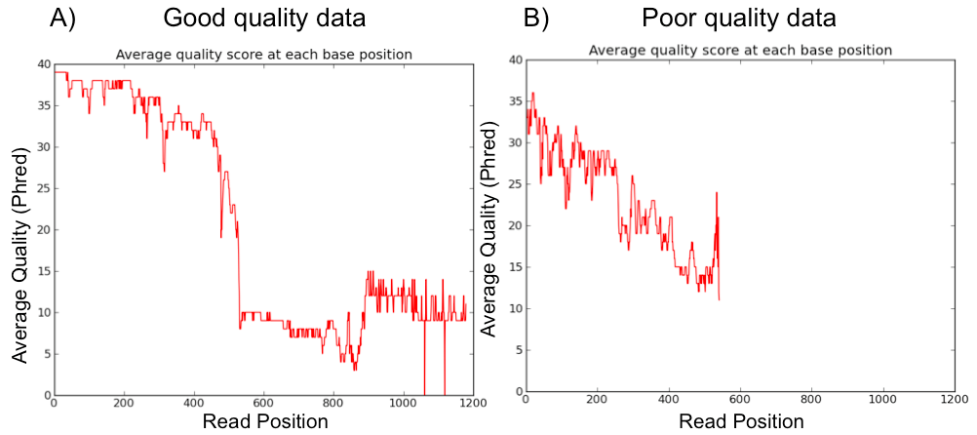

Fig 2.1: Graphical representation of the average quality across the sequence reads in good quality data (data with mostly good quality bases) and poor quality data (data with mostly poor quality bases). The quality scores of called bases are inconsistent across a read. A) Quality scores drop slowly in good quality data. B) Quality scores drop quickly in poor quality data

### Methods and Materials

QTrim is a script written in Python and takes as input a fastq file or a fasta file with its associated quality (.qual) file, and provides as quality trimmed output fastq or fasta with its associated quality file (Figure 2.2). QTrim does not filter singleton reads or duplicated reads and does not check or trim out adaptor sequence.

QTrim takes into account various aspects of the sequencing results and the user may select to run the default version, or adjust the input parameters to obtain a desired result. These parameters include quality scores, ambiguous bases and trimming, and are discussed further below.

Sequence data, within the input file, generated from NGS technology may contain undetermined ambiguous bases (“N”). These ambiguous bases, with quality scores of zero, do not contribute to the data analysis, and thus, QTrim users have an option to remove these bases before initiation of quality trimming. Although the quality of the bases decrease towards the end of sequence reads, this is not always the case since the sequencing results may begin with low quality bases. QTrim provides an option to quality trim from both the 5’ and 3’ ends of a sequence read. These user options are provided as four different modes of quality trimming in QTrim.

1. Mode 1: Trimming from 3’ end with removal of ambiguous ‘N’ bases in the middle of reads.
2. Mode 2: Trimming from 3’ end without removing ambiguous ‘N’ bases in the middle of reads. This is the default mode.
3. Mode 3: Trimming from 5’ and 3’ ends with removal of ambiguous ‘N’ bases in the middle of reads.
4. Mode 4: Trimming from 5’ and 3’ ends without removing ambiguous ‘N’ bases in the middle of reads.

QTrim execution requires three further parameters to be set by the user:

1. Mean quality score: The threshold value that each trimmed read must satisfy.
2. Minimum read length: The minimum permitted read length (base pairs) a read is allowed reach during trimming before being discarded.
3. Sliding window size: The size of a sub-sequence that slides inward from the ends of a sequence during trimming. If no window size is defined at the input the default value is set to the user-defined minimum allowed read length. This parameter is therefore optional.

::QTrim:BMCBioinformatics 2:FiguresAndTables:Figure1.pdf

Fig 2.2: Systematic work flow of QTrim

The execution of QTrim begins with the removal of the trailing ambiguous ‘N’ bases at the 3’ end of a sequence read and, depending upon the mode chosen, the ‘N’ bases between high quality bases across a sequence reads are either removed or left unchanged.

The QTrim algorithm comprises three sequential steps (Figure 2.2) with the first step iteratively trimming single nucleotides from the 3’ end of a read until its mean quality score satisfies the quality threshold (Figure 2.3 A). The second step is a sliding window approach that evaluates the mean quality score of the last ‘n’ number of nucleotides at 3’ end (‘n’ is equal to the window size). If the mean quality score of the bases within the window is not satisfied, a single base is deleted from the 3’ end and the window is reset (Figure 2.3 B). Once the quality threshold within the window is satisfied the final step iteratively trims all nucleotides from the 3’ end until the quality score of the last nucleotide in the read ≥ quality threshold value (Figure 2.3 C). If the length of the resulting trimmed read is less than the minimum allowed read length the read is discarded. Depending upon the mode chosen, QTrim enables trimming to occur simultaneously at both the 5’ and 3’ ends.

### Graphical plots in QTrim

QTrim also includes an option to generate graphical plots of the input data. The plots are generated for each dataset before and after quality trimming states, which allows direct observation and comparison of the dataset at both states. The plots illustrate the quality score at every tenth base position across sequence reads (Figure 2.4), read length distribution (Figure 2.5) and average read length (Figure 2.6).

QTrim_sequential_steps.pdf

Fig 2.3: Sequential steps describing the trimming process in QTrim. A) Iterative trimming with mean across sequence. B) Iterative trimming with mean in window. C) Iterative trimming with mean in last nucleotide. At step C, the last nucleotide has a score of 25, which satisfies the user mean and QTrim therefore does no further trimming. The final read length is also greater than the user-specified read length. Therefore, the sequence is written to an output file.

:Figures_for_thesis:qtrim_quality_score_trend.pdf

Fig 2.4: QTrim generated plot showing the average quality score across the sequence reads at every 10th base (Bin size: 10) in (A) a good quality dataset and (B) a poor quality dataset. The green line represents the total number of sequences (represented by the secondary axis) for evaluating the average quality score.

qtrim_readlength_distribution.pdf

Fig 2.5: QTrim generated plot showing the distribution of sequence reads with read lengths (A) before trimming and (B) after trimming.

:Figures_for_thesis:qtrim_mean_score.pdf

Fig 2.6: QTrim generated plot showing the distribution of sequence reads with specific mean scores; (A) before trimming and (B) after trimming.

## Test Data

Two sequence datasets with large differences in the untrimmed quality scores, which we define as good quality and poor quality, were used for testing the efficiency and the sensitivity of QTrim as a quality trimming tool. The good quality 454 sequence dataset included sequence reads with consistently high quality scores (q≥20) at all bases up to approximately 400bp (Figure 2.4 A). The poor quality data, on the other hand, exhibited low quality calls (q<20) spread throughout the entire read for all generated sequence reads (Figure 2.4 B). The presumed poor quality data was obtained from amplicon based ultra deep sequencing of the HIV reverse transcriptase gene. The original study aimed to characterize the emergence and persistence of drug resistant mutations in HIV-1 subtype C infected individuals from the Karonga district in Malawi (Bansode et al., 2013). (ADD THE DETAILS OF GOOD QUALITY DATA.)

### Software used

The QTrim algorithm is fully coded within the Python high level programming language. The Biopython package ([www.biopython.org](http://www.biopython.org)) is used for reading nucleotide sequences and their quality. The plots are generated using the Python plotting modules Matplotlib (Hunter, 2007) and NumPy ([www.numpy.org](http://www.numpy.org)).

### Results

The details on total reads, average read length and number of poor quality bases of the two selected test datasets are shown in Table 2.1. QTrim was used to trim both the datasets with the parameters set as follows: mean quality in sequence reads of 20 (Q20) and 30 (Q30) with a constant minimum read length of 50. The data sets

Table 2.1 Total reads, mean read length and number of poor bases in the test data.

|  |  |  |  |
| --- | --- | --- | --- |
| Test Data | Total Reads | Mean read length | Number of bases with q<20 |
| Good Quality Data | 15868 | 484 | 687945 |
| Poor Quality Data | 33022 | 583 | 11256293 |

were also trimmed with other widely used tools, including PRINSEQ (Schmieder and Edwards, 2011), the Modified-Mott algorithm implemented in Geneious (Kearse et al., 2012), 454/Roche Newbler v2.6, FASTX (Blankenberg et al., 2010) and the Lucy algorithm (Chou and Holmes, 2001a; Li and Chou, 2004) implemented in clean\_reads (Blanca et al., 2011). Apart from Newbler, which only trims at Q20, all other tools were executed at Q20 and Q30 with a constant minimum read length of 50. The collective results for the poor quality data (Table 2.2) and for the good quality data (Table 2.3) were tabulated for comparison. The performance of QTrim was to the above mentioned tools on the basis of the total number of reads in the output, longest average read length in the output, number of poor quality bases, and time of execution. We assume that the best tool should generate the highest number of cleaned sequence reads with the longest average read length.

When applied to the good quality dataset, our observation showed that QTrim and PRINSEQ performed at an equivalent level (Figure 2.7 A and C; Table 2.2 Q20 and Table 2.3) and outperformed all the other tools (Figure 2.7 A and C). A total of 15829 trimmed reads with a mean length of 448 nucleotides was produced by QTrim and 15825 trimmed reads with a mean length of 450 nucleotides was produced by PRINSEQ in the Q20 threshold analysis. In the more stringent Q30 analysis, the number of produced reads remained similar to that of the Q20 analysis (Table 2.2 and Table 2.3) however the mean read length reduced to 422 and 426 nucleotides for QTrim and PRINSEQ respectively. For both the Q20 and Q30 analysis all of the other approaches produced a comparable number of trimmed reads to QTrim and PRINSEQ, however the average read lengths were significantly shorter (Figure 2.7 A and C).

Table 2.2: Quality trimming of the poor quality data with QTrim and other tested tools at a mean quality of 20 (Q20) and 30 (Q30) and minimum read length of 50.

|  |  |  |  |  |  |  |
| --- | --- | --- | --- | --- | --- | --- |
|  | Total output reads | | Mean read length | | Total # of bases with quality scores < 20 | |
| Q20 | Q30 | Q20 | Q30 | Q20 | Q30 |
| QTrim | 32818 | 23321 | 273 | 162 | 2107979 | 251894 |
| Clean\_reads | 31379 | 16940 | 157 | 89 | 536342 | 535 |
| PRINSEQ | 32381 | 20717 | 282 | 176 | 2281685 | 300029 |
| FASTX | 1242 | 279 | 154 | 139 | 11460 | 681 |
| Geneious | 29142 | 13218 | 178 | 90 | 436947 | 231 |
| Roche’s Newbler | 32047 | NA | 252 | NA | 1743863 | NA |

Table 2.3: Quality trimming of the good quality data with QTrim and other tested tools at a mean quality of 20 (Q20) and 30 (Q30) and minimum read length of 50.

|  |  |  |  |  |  |  |
| --- | --- | --- | --- | --- | --- | --- |
|  | Total output reads | | Mean read length | | Total # of bases with quality scores <20 | |
| Q20 | Q30 | Q20 | Q30 | Q20 | Q30 |
| QTrim | 15829 | 15450 | 448 | 422 | 300135 | 115302 |
| Clean\_reads | 15781 | 15267 | 417 | 315 | 140302 | 1464 |
| PRINSEQ | 15825 | 15471 | 450 | 426 | 324949 | 143736 |
| FASTX | 13176 | 9787 | 466 | 450 | 129765 | 38340 |
| Geneious | 15709 | 15113 | 428 | 338 | 134715 | 5410 |
| Roche’s Newbler | 15788 | NA | 437 | NA | 195610 | NA |

:Figures_for_thesis:qtrim_results.pdf

Fig 2.7: Comparison of QTrim with other tools taking into account the total number of produced reads and mean read length of produced reads using two datasets. The good quality data is presented in A and C, and the poor quality data in B and D. The top panel (A and B) display the results at a mean threshold quality score of 20, whereas the bottom panel shows the results at a mean threshold of 30.

When applied to the poor quality data, PRINSEQ and QTrim were, by far, the two best performing approaches (Figure 2.7 B and D). A total of 32818 trimmed reads with a mean length of 273 nucleotides was produced by QTrim and 32381 trimmed reads with a mean length of 282 nucleotides was produced by PRINSEQ in the Q20 threshold analyses. The lower quality of this data is reflected in the much shorter trimmed reads produced from this analysis when compared to the trimmed read lengths produced during the analysis of the good quality data. The performance was further evident when the stringent Q30 analysis of the poor quality data was undertaken. The average trimmed read length reduced from 273 nucleotides (Q20) to 162 nucleotides (Q30) for QTrim and from 282 nucleotides (Q20) to 176 nucleotides (Q30) for PRINSEQ. Further, the dramatic reduction in the number of reads produced for all methods in the Q30 analysis (ranging from a 29% reduction in the number of high quality reads for the Q20 and Q30 analysis in QTrim, to a 77% reduction in FASTX), indicates that, for many reads, the sequences were of too low quality to pass the minimum read length threshold.

Upon comparison with all other approaches, QTrim performs equally as well as the best of these methods (PRINSEQ). The trimmed reads produced by PRINSEQ are, on average, slightly longer than those from QTrim (Figure 3). Upon further examination, however, this is as a result of PRINSEQ allowing a higher number of low quality bases (quality score < 20) at the 3’ end of its trimmed reads. For example, PRINSEQ generates 8% more low quality bases than QTrim in the Q20 trimming of both datasets tested here, and 17% and 25% more low quality bases in the Q30 trimming analyses of the poor quality and good quality datasets respectively. We find that this is the case in all of the methods that use an averaging approach for quality trimming. As soon as the minimum quality score in a read satisfies the quality threshold, the read is defined as trimmed without any further analysis. In QTrim, however, we employ two further steps, which ensure that low quality bases at the 3’ end of quality trimmed reads are removed. Thus, while the reads may be slightly shorter than those produced by PRINSEQ, users can be confident that the quality of the generated reads is consistent across the length of the quality trimmed data produced by QTrim.

Finally, QTrim is twice as fast as PRINSEQ (379372 versus 189966 bases trimmed per second) on a standard desktop computer with a 2 GHz Intel**®** Core**™** Duo CPU and 2GB of RAM.

### Discussion

QTrim is a novel algorithm implementing an averaging approach for sensitive quality trimming of 454 sequence data.

We compared QTrim quality trimming performance with other widely used tools and our observation shows that QTrim is equivalent to the best performing tool (PRINSEQ) among the other tested methods at quality trimming a good quality dataset while outperforms all the tools at quality trimming poor quality dataset.

Most widely used tools have many options that confuse users to optimize their output. The QTrim options are simple to use with less parameters to define. If a user does not have experience with quality trimming there is an option to run QTrim with the default, optimized, settings. QTrim is standalone executable file, which allows for easy installation. The executables are available for Linux and MacOSX and is downloadable from <https://hiv.sanbi.ac.za/software/qtrim>. This may be a drawback for many of the commonly available quality trimming tools, which require secondary software that can be difficult to install and configure. Although QTrim requires Biopython, Matplotlib and NumPy, these are packed within the executable file and therefore do not need to be configured.

## Conclusion

QTrim is a fast, highly sensitive and accurate algorithm that outperforms all available approaches for quality trimming of 454 sequence data. A noteworthy feature is that it enables sensitive trimming of sub-optimal sequence data thereby enabling researchers to undertake downstream analysis on lesser quality sequence data that otherwise may have been discarded. The command line Python version of QTrim can be easily incorporated into sequence analysis pipelines, while the web interface (Figure 2.8, 2.9) maintained at <https://hiv.sanbi.ac.za/software/qtrim> enables users with little or no bioinformatics experience to undertake quality trimming of their high-throughput sequencing data. QTrim is free for all academic researchers. Commercial users can obtain a license by contacting [simon@sanbi.ac.za](mailto:simon@sanbi.ac.za).

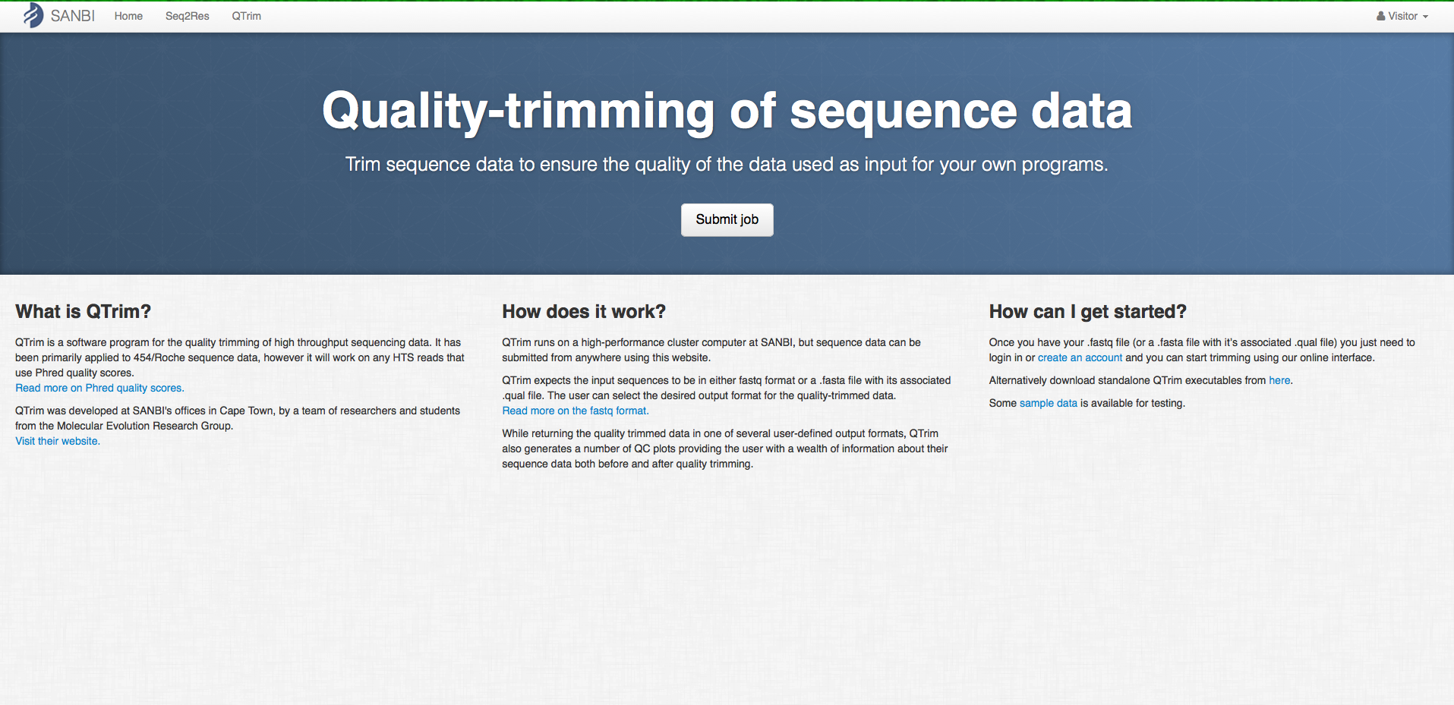

Fig 2.8: Online QTrim home page. Users might need to be registered to access and submit sequence file for quality trimming with QTrim.

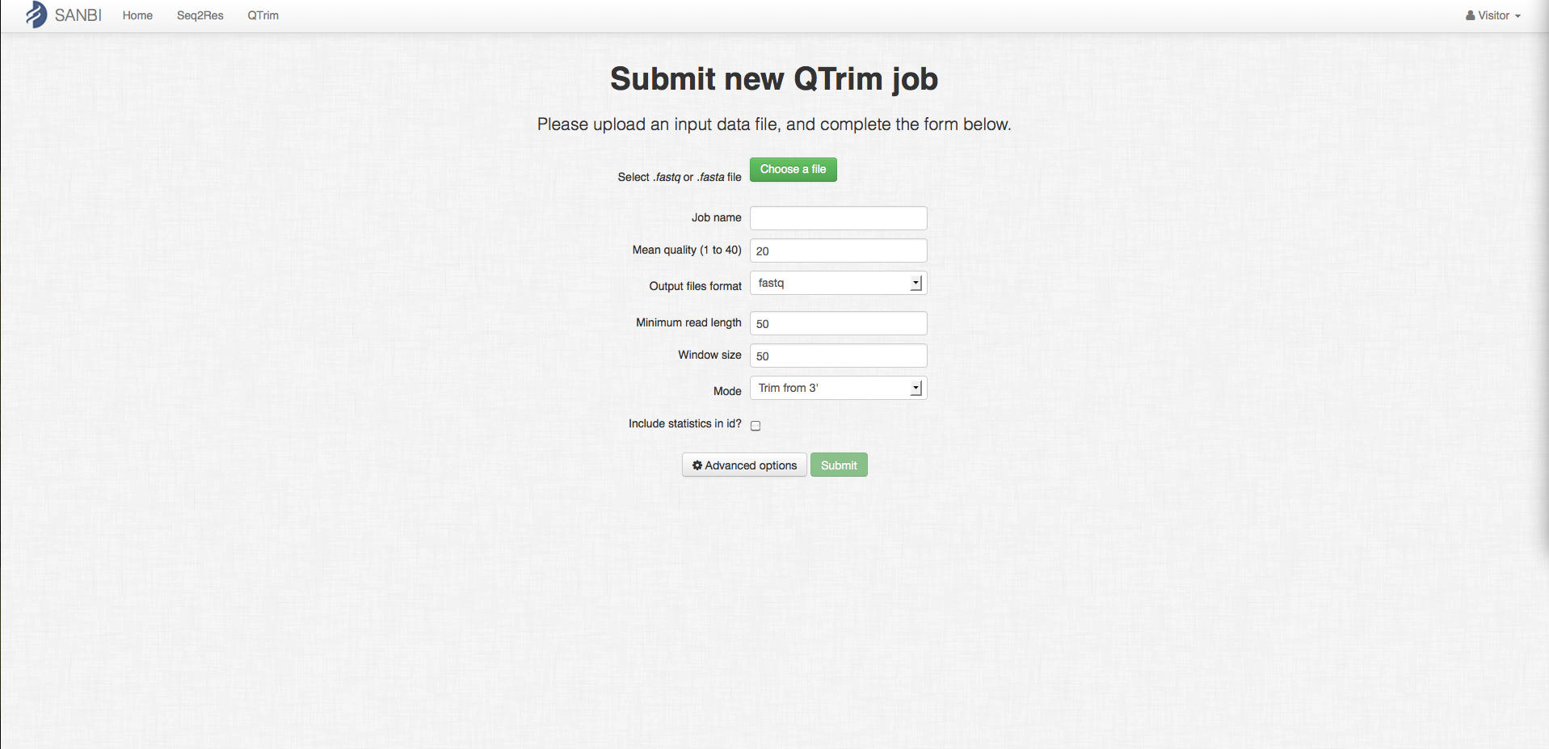

Fig 2.9: Online QTrim job submission page. Sequence file can be uploaded and required parameters can be set before running QTrim online.

**Bibliography**

Antonelli, G (2013) Emerging new technologies in clinical virology. *Clin Microbiol Infect* **19**: 8-9.

Bansode, V, McCormack, GP, Crampin, AC, Ngwira, B, Shrestha, RK, French, N, Glynn, JR, Travers, SA (2013) Characterizing the emergence and persistence of drug resistant mutations in HIV-1 subtype C infections using 454 ultra deep pyrosequencing. *BMC Infect Dis* **13**: 52.

Beerenwinkel, N, Zagordi, O (2011) Ultra-deep sequencing for the analysis of viral populations. *Curr Opin Virol* **1**: 413-418.

Blanca, JM, Pascual, L, Ziarsolo, P, Nuez, F, Cañizares, J (2011) ngs\\_backbone: a pipeline for read cleaning, mapping and SNP calling using Next Generation Sequence. *BMC Genomics* **12**: 285.

Blankenberg, D, Gordon, A, Kuster, GV, Coraor, N, Taylor, J, Nekrutenko, A (2010) Manipulation of FASTQ data with Galaxy. *Bioinformatics* **26**: 1783-1785.

Brockman, W, Alvarez, P, Young, S, Garber, M, Giannoukos, G, Lee, WL, Russ, C, Lander, ES, Nusbaum, C, Jaffe, DB (2008) Quality scores and SNP detection in sequencing-by-synthesis systems. *Genome research* **18**: 763-770.

Chou, H-H, Holmes, MH (2001a) DNA sequence quality trimming and vector removal. *Bioinformatics* **17**: 1093–1104.

Chou, HH, Holmes, MH (2001b) DNA sequence quality trimming and vector removal. *Bioinformatics* **17**: 1093-1104.

Cock, PJA, Fields, CJ, Goto, N, Heuer, ML, Rice, PM (2010) The Sanger FASTQ file format for sequences with quality scores, and the Solexa/Illumina FASTQ variants. *Nucleic Acids Research* **38**: 1767-1771.

Ewing, B, Green, P (1998) Base-Calling of Automated Sequencer Traces UsingPhred. II. Error Probabilities. *Genome Research* **8**: 186-194.

Hunter, JD (2007) Matplotlib: A 2D Graphics Environment. *Computing in Science and Engineering* **9**: 90-95.

Huse, SM, Huber, JA, Morrison, HG, Sogin, ML, Welch, DM (2007) Accuracy and quality of massively parallel DNA pyrosequencing. *Genome biology* **8**: R143.

Kearse, M, Moir, R, Wilson, A, Stones-Havas, S, Cheung, M, Sturrock, S, Buxton, S, Cooper, A, Markowitz, S, Duran, C, Thierer, T, Ashton, B, Meintjes, P, Drummond, A (2012) Geneious Basic: An integrated and extendable desktop software platform for the organization and analysis of sequence data. *Bioinformatics* **28**: 1647-1649.

Kunin, V, Engelbrektson, A, Ochman, H, Hugenholtz, P (2009) Wrinkles in the rare biosphere: pyrosequencing errors can lead to artificial inflation of diversity estimates. *Environ Microbiol* **12**: 118-123.

Li, S, Chou, H-H (2004) LUCY2: an interactive DNA sequence quality trimming and vector removal tool. *Bioinformatics* **20**: 2865–2866.

Mardis, ER (2008) The impact of next-generation sequencing technology on genetics. *Trends in genetics* **24**: 133.

Schmieder, R, Edwards, R (2011) Quality control and preprocessing of metagenomic datasets. *Bioinformatics* **27**: 863-864.

Suzuki, S, Ono, N, Furusawa, C, Ying, B-W, Yomo, T (2011) Comparison of Sequence Reads Obtained from Three Next-Generation Sequencing Platforms. *PLoS ONE* **6**: e19534.