# Literature Review

## CHAPTER 1

### 1. 1 Overview of HIV/AIDS

Human Immunodeficiency Virus (HIV) is the human pathogenic virus that cause AIDS (Acquired Immunodeficiency Syndrome). HIV/AIDS has been global pandemic for over the last three decades and is depicted as the modern day plague (1). The United Nations Acquired Immune Deficiency Syndrome (UNAIDS) global report 2012 estimates that by the end of 2011 a total of 34 million people worldwide are living with HIV by the end of 2011 (WHO factsheet Number 360 (<http://www.who.int/mediacentre/factsheets/fs360/en/>)); over 95% of them are living in low and middle in come countries (2). There is a significant variation in HIV prevalence among the countries around the globe (Figure 1.1). UNAIDS 2012 report shows that although the global trend of new HIV infections and HIV-related deaths per year is declining, the current number of HIV infections is the highest since 1990 (Figure 1.2). The sub-Saharan region of Africa is the region most aggravated by the virus with 23.5 million people living with HIV (3). UNAIDS estimates that approximately 1 in every 20 adults are HIV infected in this region (3). This is 25 or more times the HIV prevalence in any other region of the world. Countries in Sub-Saharan Africa also have varying HIV prevalence with South Africa at the top followed by Nigeria (2). The next severely affected regions, besides African continent, are Asia (China, Thailand, Indonesia), Caribbean and Eastern Europe, North America, western and central Europe (2).

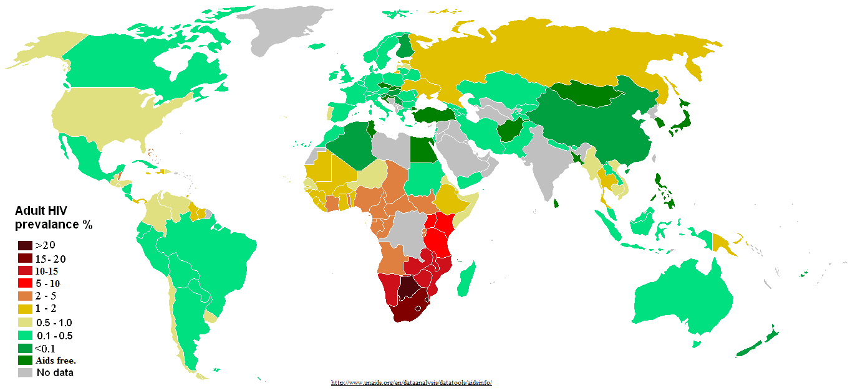

Figure 1.1: Distribution of HIV prevalence in adults around the world.

Source: http://www.unadis.org/en/dataanalysis/datatools/aidsinfo/

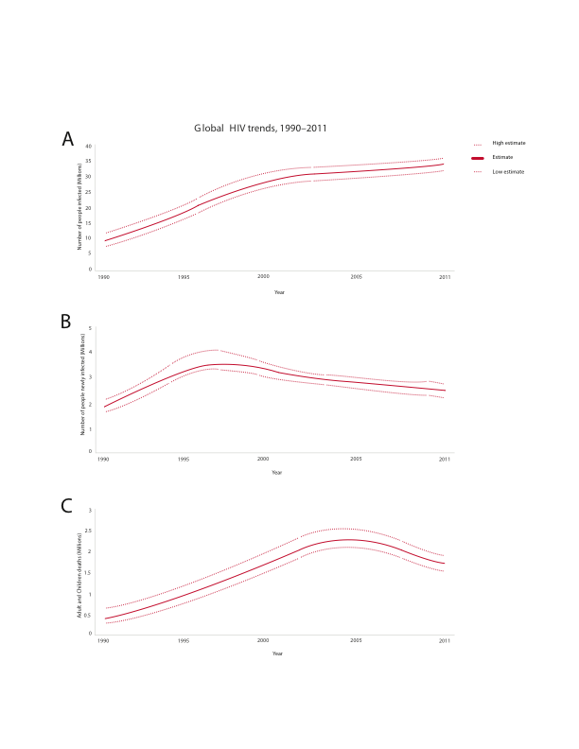

Figure 1.2: Global trend of new HIV infections from 1990 to 2011. The number of people living with HIV globally is increasing (A) while the number of people newly infected with HIV (B) and the number of Adults and child deaths due to HIV are decreasing (C) globally in the time period. This scenario can be attributed to global scale up of drugs while infected people continue transmitting the virus to uninfected people (4). (Source: modified from UNAIDS 2012)

### 1.2 Discovery and characterization of HIV

As early as 1959, HIV infection cases had been documented but were unreported (5, 6). Curious doctors at that time collected patient blood samples and kept frozen, which were later were later shown to have HIV antibodies (7). In June 1981, a case of acute immune depletion associated secondary infection was reported in some homosexuals in the USA (8, 9). Their infection was coupled with no lymphocyte proliferation (10). Until 1983, the causative agent responsible for the severe immune depletion, named AIDS (Acquired Immunodeficiency Syndrome), was unknown (11, 12), when Luc Montagnier’s group at “Institut Pasteur” in Paris isolated the virus, which was initially named Human T-cell Leucamia Virus (HTLC) and later named as Human Immunodeficiency Virus (HIV) (5). Jay Levy’s group in San Francisco, USA also subsequently found the virus confirming the discovery in Paris (13). They found HIV was a lentivirus from Group VI retrovirus with two single strand RNA molecules (14); unique to any other previously isolated viruses and the viral transmissions were possible from infected to healthy people (15, 16), mother to child through umbilical cord (12, 17).

Very soon, scientists around the world focused on this transmissible retrovirus. Complete sequencing of HIV genome in 1985 (18) led scientists to know more insights of HIV including its origin, genes/proteins and life cycle (19).

## 1.3 Origin and evolution of HIV

Exploration of the retrovirus led researchers to identify similarities between HIV and a retrovirus in African non-human primates that were then called as Simian Immunodeficiency Virus (SIV) (20). About 40 different primates, in Africa, are infected with SIV and some are harboring multiple strain of SIVs (21). Phylogenetic analysis of SIV from African non-human primates and HIV in human provided remarkable understanding of viral transmission as zoonotic (22) and evolution of the virus as HIV in human after transmission (23).

HIV is divided into two groups – HIV-1 and HIV-2 (23). Each group is an independent cross species transmission from different African non-human primates to human (24). Discovered in 1986, HIV-2 is transmitted from sooty mangabey monkeys (Cercocebus atys) (25) and its prevalence is also high in the geographical location of these monkeys in West Africa (26). Sooty mangabey monkeys are naturally infected by a strain of SIV (25). The phylogenetic analysis of HIV-2 strains show that they closely group with the SIVsmm strain (25) that are non-pathogentic to its host monkeys (27). SIVsmm evolved in its host to produce multiple strains and subsequent multiple zoonotic transmissions from sooty mangabey monkeys to human (28) gave rise to different subtypes of HIV-2. Although HIV-2 subtypes A to G are identified in human, it is assumed that more subtypes were introduced into human (29) but are lost for low adaptation fitness (30).

HIV-1 is the result of at least three cross species transmission events from chimpanzees (Pan troglodytes troglodytes (Ptt)) to human (31, 32). Phylogenetic analysis of HIV-1 sequences has shown that three independent cross transmission of the virus in to the human population, each giving rises to three sub groups: group M (Major), group O (Outlier) and group N (Non M or Non O) (28, 33). Recently a new HIV-1 strain, classified as group P, distinct from the previous three groups, has been discovered in a patient in Cameroon (34).

Group M is the most prevalent and accounts for 98% of all infections (reviewed in (24)). Its epicenter is thought to be Kinshasha of present day Democratic Republic of Congo (24, 35). Site stripping for clock detection method shows that group M and its closest simian relative branched out from their common ancestor in 17th century (36) whereas molecular clock analysis of group M shows that its radiating evolution dates back to late 1920s (37). By 1960, long before human discovered its presence, HIV-1 group M had already diversified substantially (38).

Group O and group N are rare and geographically confined to West African regions such as Cameroon and neighboring countries (23). It is still not understood about the non-pandemic characteristics of group O and N HIV-1 virus after the first zoonotic transmission (39). It has been suggested that reduced replication capacity and transmission fitness are keys to their low prevalence(39). Group O strain has 50% identity at env region of group M (29, 40) and the molecular clock model of this group also showed that its origin dates back to 1920s (41). Group N was supposed to be introduced into human population in 1960s (42). Phylogenetic analysis of envelope sequence shows its close grouping with SIV from Chimpanzee (23, 43). This indicates that group N might be a recombinant strain of SIV and HIV-1 group (42).

Group P is transmitted from gorilla as it is closely related to its SIV (34). Population level study of this new group virus, at its discovered region in Cameroon, shows its prevalence at 0.06% in the area but can still be pandemic as it can adapt in human (44).

### 1.4 HIV-1 Diversity

**HIV-1 subtypes**

HIV-1 group M is highly diversified and it is classified into nine subtypes: A, B, C, D, F, G, H, J and K (Figure 1.3) (45). The subtype classification is based on the phylogenetic and sequence distance analyses using gene sequence data forming major clades (45). “At least three epidemiologically unlinked sequences are required for defining a subtype” (46).

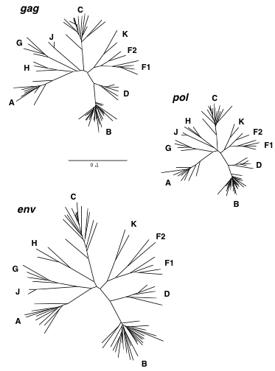

Figure 1.3: Phylogenetic tree showing HIV-1 group M diversification to subtypes A-D, F-H, J and K, inferred from nucleotide sequence alignments of gag, pol and env genes. Source: Robertson et al 2000 (46)

The classification of new subtype should also follow the same rule as “roughly equidistant from all previously characterized subtypes in all regions of the genome with a distinct pre-subtype branch similar to those of other subtypes” (45). The predominating group M subtypes are A, B, C and D (reviewed in (47)). Geographical locations of group M subtypes epidemic are show in Figure 1.4. The analysis from HIV samples collected from 70 countries in 2004 shows that “subtype C accounts for 50% of all infections worldwide” while subtypes A, B, G and D are found in decreasing order 12%, 10%, 6% and 3% respectively (48). Subtypes F, H, J and K are found very scarce and on overall, accounts for only 0.94% infections (48). The range of amino acid variation within a subtype and between subtypes differs from 15%– 20% and 25% - 35% respectively (49).

Subtypes are further classified to sub-subtype based on a distinct sister clade formation (50) within a clade with the same rule of phylogenetic and distant analyses but not justifiable to call a subtype due to low genetic distance (45). Only subtypes A and F exhibit distinct sister clades (50). Subtype A has sub-subtypes A1 and A2 (A3 and A4 are mentioned by Taylor et al 2008(51)); Subtype F has sub-subtypes F1 and F2 (Figure 1.3); sub-subtype F3 mentioned by Taylor et al 2008 (51).

The lower diversity observed in Group N (52), O (53) and P (44) correlate to low prevalence and geographical confinement to Western African countries such as Cameroon. It is still unclear if group O can be sub divided into subtypes (54). Group N as well does not show distinct sub clade within itself (Figure 1.5).

**HIV-1 recombination**

Initially, HIV-1 group M subtypes E (55-57) and I (Figure 1.5) were also classified (reviewed in (47)). With availability of complete HIV genome sequence and phylogenetic analysis from it, the subtypes E and I were reclassified as circular

### 

Figure 1.4: HIV diversity around the globe, its level of prevalence in the area and number of genome sequenced. Source: McCutchan 2006

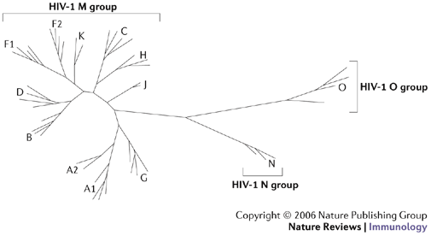

Figure 1.5: Neighboring joining phylogenetic tree showing HIV-1 group M, N and O. Group M shows distinct nine subtypes A-D, F-H, J, K while no specific subtype is observed in group N and O. Source: Letvin 2006 (58)

recombinant forms CRF01_AE (recombinant form of subtype A and E) and CRF04_cpx (recombinant form of more than two subtypes, designated by “cpx”) respectively (reviewed in (47)). The same criterion of epidemiological unlinked isolates from three or more people applies for classification as a circular recombinant form (CRF) (46). The recombinant isolate discovered in single patient is termed as Unique Recombinant Form (URF) (reviewed in (47)). There are 55 CRFs listed in Los Alamos National Laboratory database for HIV sequences (<http://www.hiv.lanl.gov/content/sequence/HIV/CRFs/CRFs.html>) as on July 22, 2013. The recombination breakpoints to shuffle HIV genome (59-62) from different strains of the virus are listed in <http://www.hiv.lanl.gov/content/sequence/HIV/CRFs/breakpoints.html>, each appeared in a publication. CRFs account for at least 20% of all the HIV infections (46, 63, 64). CRF02_AG is the most prevalent circulating recombinant form infecting over 9 million people on the whole (65) and geographically epidemic in the West African region (Figure 1.5). CRF01_AE is the dominant circulating recombinant form in South-East Asia (Figure 1.5) (51).

**Intra-patient HIV diversity**

HIV infection initiates mostly with a single virion (66, 67). Evidences of multiple HIV variants transmission are also recorded (68, 69). Generally, HIV is genetically homogenous for a short post infection time (70, 71). In the long-term post infection period, virus replicates rapidly to produce genetically heterogeneous population (68). This heterogeneous viral population consisting swarm of highly similar virus but genetically non-identical HIV virus is called HIV quasispecies (reviewed in (47)). It is observed that the diversity at a gene in viral quasispecies can be approximately 30% (72). Factors that contribute to high genetic heterogeneity in viral quasispecies are higher replication rate and turnover (73), viral genome recombination (74-76), higher mutation rate by erroneous reverse transcriptase (77, 78), and host immune selection (79, 80). On the whole, HIV replication (discussed in section 1.6) is the overall source of genetic heterogeneity in the viral population (reviewed in (81)).

Intra patientHIV genome recombination is a common event (76, 82). Two genomes from different viral strains can be co-packed into single virion during replication (83). In the subsequent HIV replication, the ability of reverse transcriptase to switch between the two template genomes produces a recombined genome (84, 85). Genetic recombination allows rapid and efficient shuffling of advantageous genes and removing deleterious mutations, thus, increasing the viral fitness in the host (reviewed in (81)). Co infection by different HIV subtypes and subsequently co-packed and co-expressed in to a single virion generates Unique Recombinant Forms (URFs) (reviewed in (51)). Successful transmission of URFs with high viral fitness to three or more people and circulates in human population establishes Circulating Recombinant Forms (CRFs) (reviewed in (86)).

### 1.5 HIV genome and proteins – structures and functions

HIV has nine genes and produces 15 proteins (87). The genes are broadly grouped as accessory (vif, vpr, vpu and nef), structural (*pol*, *gag* and *env*) and regulatory (*tat* and rev). The higher number of proteins than genes is a result of post - transcriptional proteolysis of the products of structural genes (87).

**1.5.1 Accessory genes:**

Vif promotes the viral infectivity to the host, but has no role in viral production (88). Vif is produced in the late stage of viral production (89, 90) to suppress the innate antiviral immunity of host (91, 92). It is observed that vif is expressed only when the virus infects immune cells that express cytidine deaminase APOBEC3G (93). The reason is that Vif protein prevents APOBEC3 proteins from hyper mutating HIV reverse transcripts as a mechanism of defense from the retrovirus (94-104).

Vpr protein is packed in to nascent virions during budding out (105). Vpr is essential for viral core to enter and localize in the host cell nucleus after infecting the cell (106). Vpr arrests the cell cycle during the transfer from G2 to M phase (107, 108) by preventing the activation of the human p34cdc2/cyclin B complex (109). Vpr is also important for efficient viral replication in monocyte or macrophage cells, but T-cells (105).

Vpu is a protein unique to HIV-1 (110) and is 16 kiloDalton, 81 amino acids long (111). Biological functions of vpu protein include degradation of CD4 in endoplasmic reticulum (112), interference of host immune cell MHC class II antigen presentation on the cell surface allowing the virus for host immune escape (113, 114) and viral maturation and release from host cell membrane (115).

Nef has no role in viral infectivity but plays a role during the biogenesis of viral particles (116) and virulence (117, 118). Nef down regulates the production of major histocompatibility complex type I (MHC type I) in the host cell (119-121). This impairs the function of cytotoxic T lymphocyte cells to clear the infected cells (122-126). Nef also down regulates CD4 on host cell surface (127, 128) and modulates cellular activation to evade host immune system (123, 126).

**1.5.2 Structural genes and proteins**

The Gag gene produces a precursor polyprotein (pr55gag) of ~ 500 amino acids long and weighs 55 kilodalton (129). The Gag precursor has all the building blocks to form a fully infectious virion, even in the absence of other viral products (130). A proteolytic cleavage of gag precursor yields the structural proteins – matrix, capsid, nucleocapsid and p6 (Figure 1.6) (131). The cleavage takes place in the nascent virus after budding out from host cell (132). The matrix protein is at the N-terminal and p6 at the C-terminal of gag precursor (131, 133).

All gag proteins play role at “post assembly and post processing stages in viral infectivity” (130). In the HIV replication cycle, matrix domain of gag plays role in targeting gag precursor to the plasma membrane of the host cell and the viral assembly at the site (130, 134-136). The highly basic region in matrix mediates electrostatic association with phospholipids in plasma membrane during assembly (137, 138). The capsid is a curved and closed shell consisting 250 hexamers and 12 pentamers (reviewed in (139)). Capsid packs viral proteins, nucleocapsid and viral genome during assembly to pass on to new HIV particles (140). Nucleocapsid plays role in efficient viral assembly by making pr55–pr55 interprotein contacts (135, 136) and localization of viral proteins (141). P6 protein plays role in detaching and releasing the newly formed HIV particles (142).

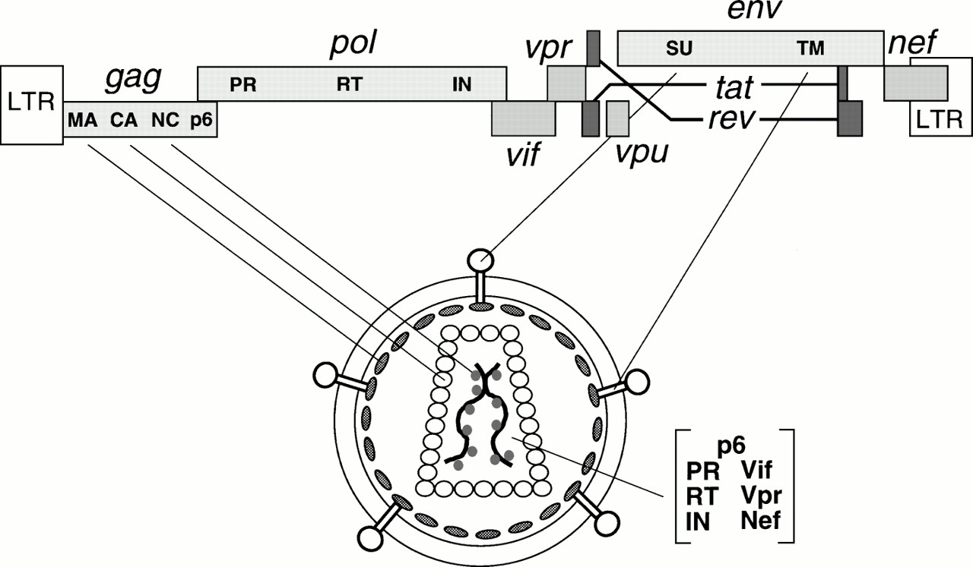

Figure 1.6: HIV genes and proteins positions in the viral genome and their viral parts. Source: Frankel and Young 1998

The *pol* polyprotein is produced by translational frame shift (143) (Figure 1.5), such that, as much as 241 nucleotides at 5’ region of the gene overlaps with 3’ region of *gag* gene (18, 144). The proteolytic cleavage of *pol* precursor produces essential viral replication enzymes – protease (PR), reverse transcriptase (RT) and integrase (IN). The protease enzyme cleaves the *gag* and *pol* polyprotein to form the viral structure proteins and functional enzymes respectively (145-147). The reverse transcriptase enzyme produces a cDNA from the viral RNA after infecting host cell (148, 149). The RNase H domain in RT degrades the viral RNA molecule following cDNA production (150). The integrase enzyme removes two bases from 3’ DNA molecule and functions strand transfer during the process of integrating the proviral DNA into the host genome (151).

*Env* gene produces a precursor glycopolyprotein (gp160) that is processed post-translationally by human convertase enzymes - PC1 and furin to produce glycoprotein 120 (gp120, HIV-1 SU) and glycoprotein 41 (gp41, HIV-1 TM) (152). Gp120 is a non-covalent complex of external protein and gp41 is a trans-membrane protein; both play vital role for initial steps in viral infection (153). Three gp120 molecules bound with three gp41 molecules to form envelop spikes (154). They are organized to form trimeric complexes on the surface of HIV and mediate HIV entry into the host cell [184-186]. The exposed external complex gp120 binds to the CD4 receptor on the host immune cell [187-189]. This triggers a conformational shift of trimeric complex that enables a conserved gp120 region binding to a chemokine receptor, either CCR5 or CXCR4, to facilitate fusion of the viral and host membrane [190-196]. The gp120-CD4 complex also triggers conformational change in gp41 trans-membrane protein, which plays role in the viral fusion and release of viral contents in to the host cell (155, 156), from native non-fusion state to fusion state [181, 189, 196]. The gp41 consists of heptad repeats - HR1 and HR2 that play role in fusion process . HR1 is a bundle of three helical motifs and HR2 is trimeric coiled coil struture (157). During fusion process, HR2 makes numerous contacts with HR1 to form stable six helical bundles [200].

**1.5.3 Regulator Genes:**

*Tat* is a trans-activating factor localized in the nucleus for HIV gene expression [201, 202]. The HIV proviral genome integrated in to the host genome is regulated by cellular as well as the viral transcription regulatory factors [203, 204]. Tat is the primary transcriptional regulatory factor (158). An example of Tat action is the control of RNA polymerase II elongation during transcription, which otherwise disengages from the template DNA strand, terminating the transcription prematurely [206-209]. Sodroski *et al*. (1985) first explained the function of Tat [201, 210].

Rev is a 19 kilo Dalton phosphoprotein (159) trans-activating factor for HIV gene expression [212, 213]. Like Tat, it is also mainly localized in the nucleus of host cell (160), but cycles rapidly between the nucleus and cytoplasm as it promotes nuclear export of the transcriptional products [215-217]. Rev binds at the Rev Responsive Element (RRE), which is an RNA element encoded within the *env* region of the virus [218, 219].

### 1.6 HIV replication

There are major 11 events in HIV replication cycle (as numbered in Figure 1.7). The initial step of viral entry (Figure 1.7 step 1) in to a host immune cell is explained in section 1.5.2.

Following the fusion, the viral core enters in to the cytoplasm of host cell. The RT enzyme reverse transcribes the RNA molecule to cDNA (Figure 1.7 step 2) in the intact capsid of the viral core (161). Subsequently the capsid is dissembled, termed as uncoating (Figure 1.7 step 3) (161), assisted by host importin β member protein transportin 3 (TNPO3) (162). The uncoating process can take an hour or less from post infection [222]. Uncoating process releases ribonucleoprotein complex in to the cytosol of the host cell (163). The capsid and nucleocapsid proteins dissociate from cDNA but the reverse transcription complex remains intact along with viral matrix, integrase, vpr and human protein high mobility group I (HMG I (Y)) forming preintegration complex (PIC) [224-227]. The PIC protects cDNA from endonuclease degradation (164). In an ATP dependent process (165), PIC is transported on host microtubules towards the nuclear membrane (161). Some studies initially suggested that formation of central DNA flap (166), vpr, and matrix mediate nuclear import (Figure 1.7 step 4) of PIC (167), however, the no any clear evidence of these factors have been described as such for nuclear import (168). Integrase assists in nuclear import in association with nuclear import machinery like importin [232, 233] and transportin-SR2 (169). It is now established that central polypurine tract-central termination sequence (cPPT-CTS) plays role in kinetics of nuclear import (168).

Post-nuclear entry, integrase processes the viral DNA for integration (170) (Figure 1.7 step 5) into host genome as explained in section 1.5.2. Host transcriptional co-factor LEDGF/p75 and HIV integrase interact to tether to the host chromosome during the integration process (171).

The integrated HIV provirus hijacks the host cell transcriptional machinery for viral genes to transcribe (Figure 1.7 step 6) (172). HIV protein Tat promotes the transcription of the viral DNA (173, 174). The viral transcriptome encodes structural proteins, accessory proteins and viral enzymes necessary for a complete functional HIV (reviewed in (175)).

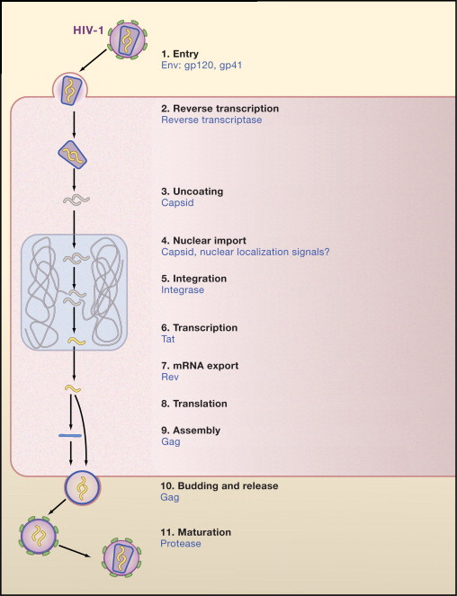

Figure 1.7: The HIV replication cycle showing major stages. Viral proteins that play role in each event are colored blue. (Source: modified from Ho and Bieniasz 2008) (176)

The viral Rev protein facilitates exporting (Figure 1.7 step 7) of the unprocessed viral transcriptome to cytoplasm for translation (177). HIV has no translation system of its own; the host translational machinery is exploited for translation (Figure 1.7 step 8) of the viral transcriptome to its proteome.

Upon translation of all viral proteins, viral *gag* initiates virion assembly (Figure 1.7 step 9) at the cell membrane [154, 243, 244]. The complete assembled virion particles bud out and are released (Figure 1.7 step 10) from the plasma membrane by the host ESCRT machinery involving Tsg101 and ALIX regulatory proteins [172, 245-247]. The maturation (Figure 1.7 step 11) of the nascent HIV virions begins concomitantly with budding out [129, 248]. *Gag* and *Pol* polyproteins are proteolytically cleaved by protease enzyme in the maturation step [173, 249-251].

Each HIV replication cycle releases new infectious virions in the order of 109 per day (178). The number of new infecting HIV determines the replication rate of the virus (179). With increasing time period of infection, higher turnover rate is observed in both immune cell depletion and viral population expansion (178).

### HIV Treatment

Different inhibitory drugs have been designed that interfere with the viral protein normal function at different stages of its replication cycle. Currently available drugs classified on the basis of its target in HIV replication are: Reverse Transcriptase Inhibitors, Protease Inhibitors, Integrase Inhibitors and cell entry Inhibitors. The prescribed drug regimen usually consists of drugs from reverse transcriptase inhibitors and protease inhibitors (180). The World Health Organization (WHO) has classified HIV infection to different clinical stages depending upon progression to AIDS. The WHO has developed guidelines on usage of anti retro viral drugs to prevent HIV and care infected people (<http://www.who.int/hiv/pub/guidelines/en/>). The WHO guidelines are produced based on the clinical stage of HIV infection, CD4+ count in blood, adult/breast feeding mother and presence of secondary infections (<http://www.who.int/hiv/pub/guidelines/en/>) (181). According to the guideline, patient at clinical stage 3 or 4 having CD4+ count less than 500 per micro liter (μL) should start the treatment whereas CD4+ count less than 350 μL are highly recommended to start the treatment immediately (181). HIV treatment with combination of triple anti retroviral drugs, also called Highly Active Anti Retroviral Therapy (HAART) is done under the guidance of a clinician. The effectiveness of ART treatment and emergence of drug resistant viral variants are monitored.

**Reverse Transcriptase Inhibitors**

1. **NRTIs**

Nucleoside Reverse Transcriptase Inhibitors (NRTIs) are the major drugs in ART treatment [255, 256]. NRTIs are analogs of normal nucleotides but without 3’ hydroxyl group (reviewed in (182)). The drug is taken as unphosphorylated form, which cytokinases phosphorylates to form 5’ triophosphates (reviewed in (183, 184)). It leads to incomplete termination of cDNA synthesis (185). There are eight NRTI drugs currently used in ART drug regimen (Figure 1.8).

1. **NNRTIs:** Non-nucleoside and non-nucleotide reverse transcriptase inhibitors (NNRTIs) specifically bind at an allosteric site 10 [Å](http://en.wikipedia.org/wiki/%C3%85) from polymerase active site of the HIV-1 reverse transcriptase [261-263], close to substrate-binding site. The binding induces conformational change in the enzyme, which distorts the catalytic aspartate triad and inhibits the function of the enzyme (186, 187). NNRTIs drug are administered along with NRTI drugs in ART at non-toxic concentration to human cells (188). NNRTIs drugs from first generation have inherent disadvantageous characteristics like cross-resistance and low genetic barrier (require only one mutation to select) (189). There are six NNRTIs drugs used in ART drug regimen (Figure 1.9)

**Protease Inhibitors (PR)**

Protease inhibitor is added to second line ART therapy on drug failure to first line therapy has resolved many AIDS defining illness [267]. Protease Inhibitors interfere with *gag*-*pol* polypeptide cleavage activity of HIV enzyme protease [268, 269]. There are nine protease inhibitors approved for clinical use shown in Figure 1.10. Protease inhibitors are competitive peptidomimetic inhibitors and have hydroxyethylene core, which prohibits cleavage activity of the HIV-1 protease [270-275]. However, as adverse side effect, patients consuming the inhibitors have developed lipodystrophy and hyperlipidemia [276-280]. Besides inhibiting protease enzyme, it also inhibits degradation and secretion of apolipoprotein B; but in the presence of oleic acid, protease inhibitor increases the secretion of apolipoprotein B (190).

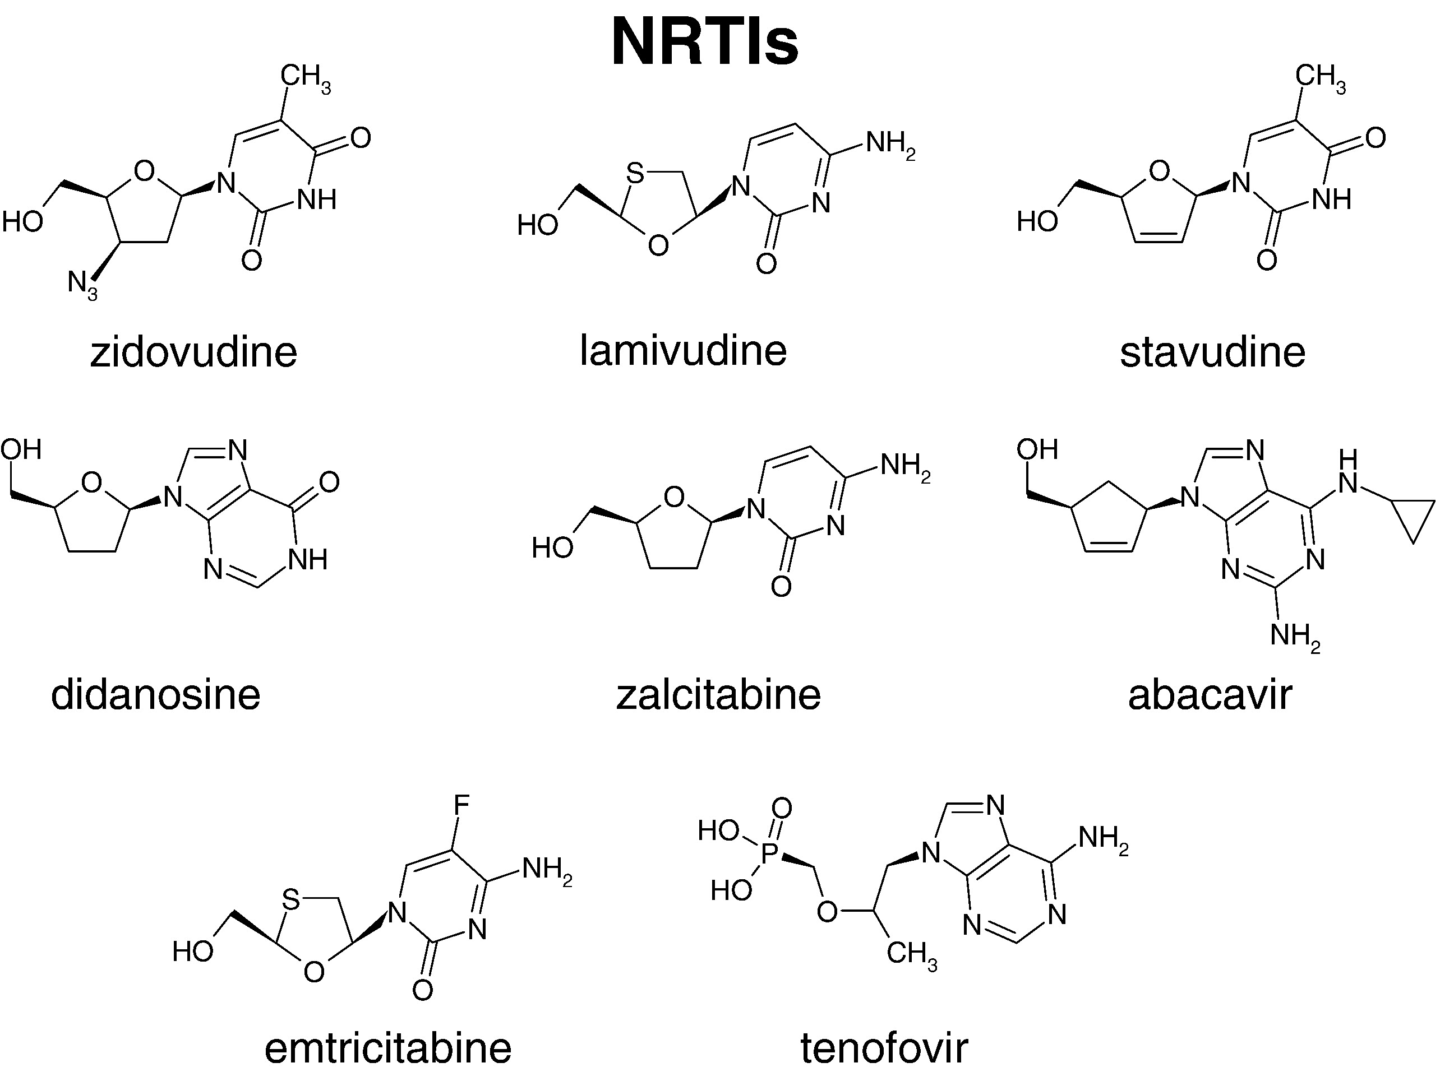

Figure 1.8: Molecular structures of NRTI drugs. Source: Sarafianos et al 2009 (149)

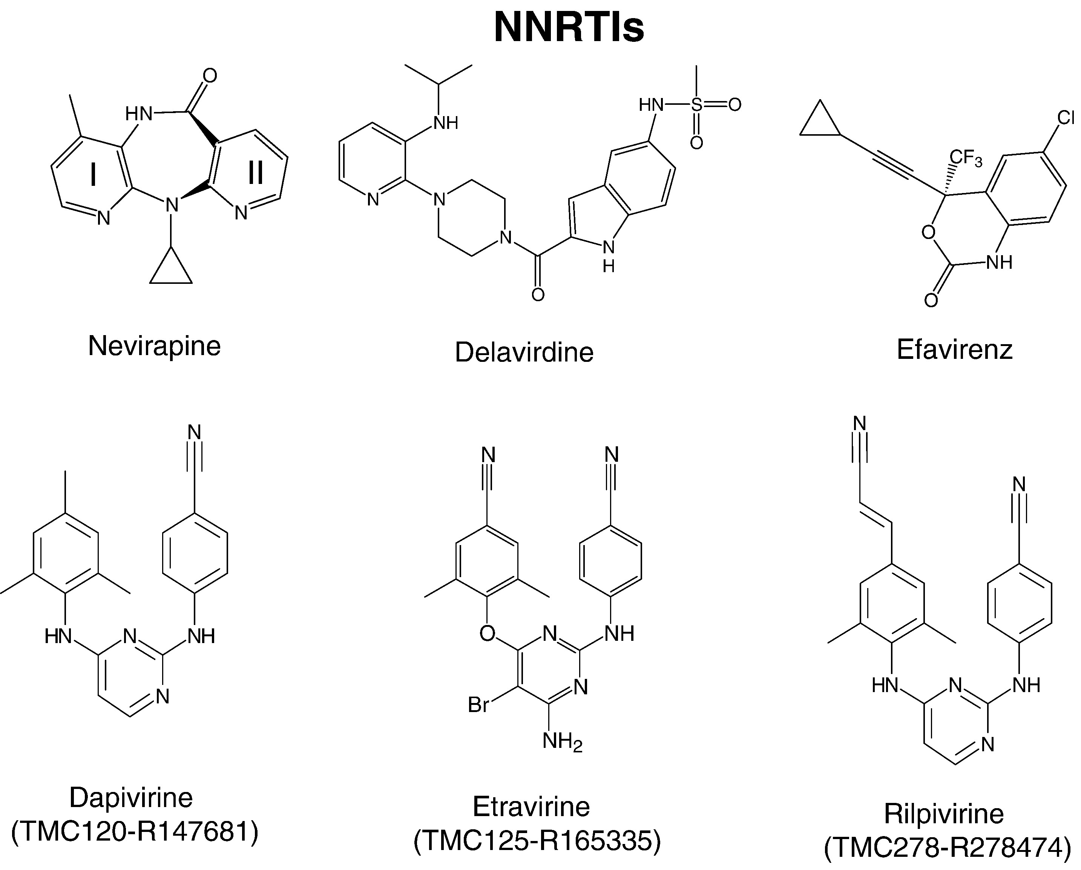

Figure 1.9: Molecular structures of NNRTI drugs. Source: Sarafianos et al 2009 (149)



Figure 1.10: Molecular Chemical structures of Protease Inhibitors. Source: Chow et al 2009 (191)

**Integrase Inhibitors**

Although the triple anti retroviral drugs therapy could suppress the viral replication, its expensive, leads to multiple drug resistance and requires high adherence (192). This has diverted the search for drugs that target third enzyme, the integrase. Some of the integrase inhibitors are shown in Figure 1.11. The feasibility and efficacy of integrase inhibitors have been tested in Rhesus Macaques (193). Most of the Integrase inhibitors target strand transfer function of the enzyme [285, 286]. X-ray structure of the integrase enzyme has revealed the active site model of the enzyme complexes with the DNA (194). Diketo acids (DKA) and its derivatives (like L-708,906, S-1360, and V-165 (Fikkert et al 2003)) are the highly potent integrase inhibitors for strand transfer inhibition (195). Low concentration of DKA is sufficient for effective integrase inhibitor (reviewed in (196)).

**Cell entry inhibitors**

1. **Co receptor inhibitors or entry inhibitors:**

Early entry inhibitors are designed to target the unglycosylated cavity formed during gp120-CD4 complex [188, 289-291]. Some of the molecules that inhibit gp120-CD4 binding are: PRP-542 (197), TNX-355 [293, 294], CADA [295, 296], BMS-806 [289, 297, 298].

Another target of entry inhibitor is the host immune cell surface co-receptors CCR5 or CXCR4. For CCR5 using virus, gp120 recognizes the N-terminal domain or the second extracellular loop of CCR5 co receptor [299-301] whereas for CXCR4 using virus, the gp120 only recognizes the second extracellular loop (198). Co receptor antagonists are designed that binds specifically to targeted co receptors, making it unavailable to HIV gp120 binding (reviewed in (199)).

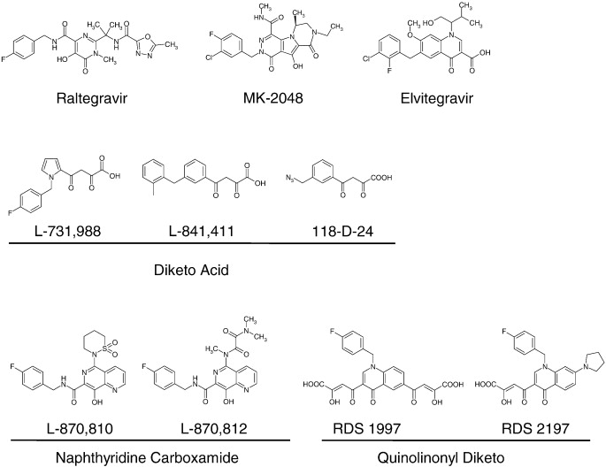

Figure 1.11: Chemical structure of different integrase inhibitors. Structures with similar chemical properties are grouped together. Source: Bera et al 2011 (200)

Some of the CCR5 antagonists developed are TAK-779 (201), TAK-652 (202), vicriviroc (203-205), AD101 (SCH-350581) (206), Maravirok (UK-427857) (207-212), Aplaviroc (GW-873140) (213, 214), PRO-140 (215).

Some of the CXCR4 antagonists are AMD3100 (216), AMD070 (217, 218), KRH-1636 (219) and KRH-2731 (220, 221).

1. **Fusion Inhibitors**

Fusion inhibitor design is based on targeting the heptad regions HR1 or HR2 of gp41 disabling the virus to make fusion pore (reviewed in (222)). Enfuvirtide (223, 224) is a synthetic peptide, approved for clinical use in 2003 (commercial name-Fuzeon) (225), which can bind to gp41 HR1 region (226). The fusion inhibitor T-1249 also targets HR1 region (227). T-1249 is active against Enfuvirtide resistant viral strains but discontinued in 2004 for clinical use (228, 229). Sifuvirtide is another HIV fusion inhibitor peptide under research (230).

### HIV Drug Resistance

Triple anti retroviral drug therapy has been successful at controlling HIV replication to low viral load within a host (231). The therapy has been compromised by the emergence of resistant HIV viral variants through constant evolution (reviewed in (232)). Selective pressure from new environments like presence of anti retro viral drugs and host immune system drive the evolution of resistant virus (reviewed in (233, 234)). HIV drug resistance can occur with accumulation of mutations that increase the viral fitness in the presence of anti retro viral drugs (reviewed in (232, 235)). Mutations that confer evolutionary advantage to virus and escape drug effect are selected (236). Transmission of resistant virus also confers drug resistance in drug naïve patients (237-239). Although drug resistant mutations escape drugs effect, they confer decrease in viral fitness and replication rate at certain level (240). Other mutations counteract the effect of drug resistant mutations to increase fitness and replication rate (241).

ART drugs are designed based on three dimension structures of the viral proteins to bind at specific active region of the proteins and interfere with its normal function. Mutations at specific positions of HIV genes change the three-dimensional shape of the proteins rendering no drug binding (Figure 1.12). These drug resistant mutations have been well documented with associated drug and resistance level (242). The viral quasispecies sequence information can be used to align against the reference sequence and infer the presence of any drug resistant mutation (243).

**Mechanisms of drug resistance**

HIV gains drug resistance against nucleoside reverse transcriptase inhibitors with substitution mutations close to the nucleotide-binding site (244, 245). The substituted amino acids either fold over the triphosphate group of the incoming nucleotide analog (246) or exerts steric clash with the oxathiolane ring of the inhibitors and interferes with its binding (247). Another mechanism of gaining resistance to NRTIs is hydrolytic removal of analog inhibitors mediated by nucleotide excision mutations (248). Mutations in RT (M41L, L210W, T215F/Y and K219Q/E) remove NRTIs from the elongating nucleotide chain through phosphorolysis mediated either ATP or pyrophosphate (249-251).

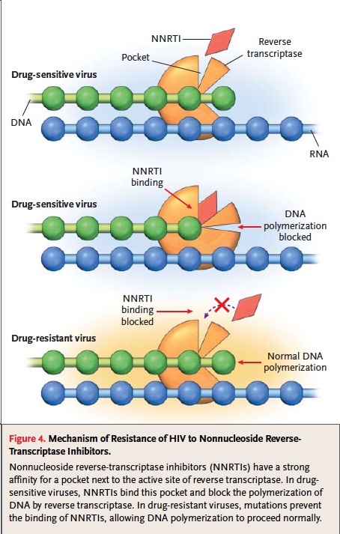

Figure 1.12: Development of HIV drug resistance. Accumulation of Drug resistant mutations changes three-dimensional confirmation of viral protein, disabling drug binding and carrying out its normal function.

1. Quinn TC. Global burden of the HIV pandemic. Lancet. 1996 Jul 13;348(9020):99-106.

2. Esparza J, Bhamarapravati N. Accelerating the development and future availability of HIV-1 vaccines: why, when, where, and how? Lancet. 2000 Jun 10;355(9220):2061-6.

3. UNAIDS. Global Report 2012: UNAIDS Report on the Global AIDS Epidemic: ebookpartnership. com.

4. Zaidi J, Grapsa E, Tanser F, Newell M-L, Bärnighausen T. Dramatic increases in HIV prevalence after scale-up of antiretroviral treatment: a longitudinal population-based HIV surveillance study in rural kwazulu-natal. AIDS.27:000-.

5. Nahmias A, Weiss J, Yao X, Lee F, Kodsi R, Schanfield M, et al. Evidence for human infection with an HTLV III/LAV-like virus in Central Africa, 1959. The Lancet. 1986;327(8492):1279-80.

6. Corbitt G, Bailey A, Williams G. HIV infection in Manchester, 1959. The Lancet. 1990;336(8706):51.

7. Zhu T, Korber BT, Nahmias AJ, Hooper E, Sharp PM, Ho DD. An African HIV-1 sequence from 1959 and implications for the origin of the epidemic. Nature. 1998;391(6667):594-7.

8. Friedman-Kien AE. Disseminated Kaposi's sarcoma syndrome in young homosexual men. Journal of the American Academy of Dermatology. 1981;5(4):468–71.

9. Friedman-Kien AE, Laubenstein L, Marmor M, Hymes K, Green J, Ragaz A, et al. Kaposi’s sarcoma and Pneumocystis pneumonia among homosexual men—New York City and California. MMWR. 1981;30(25):305–8.

10. Gottlieb MS, Schroff R, Schanker HM, Weisman JD, Fan PT, Wolf RA, et al. \textitPneumocystis carinii Pneumonia and Mucosal Candidiasis in Previously Healthy Homosexual Men. New England Journal of Medicine. 1981 December;305(24):1425-31.

11. Francis DP, Curran JW, Essex M. Epidemic acquired immune deficiency syndrome: epidemiologic evidence for a transmissible agent. Journal of the National Cancer Institute. 1983;71(1):5–9.

12. Gallo RC, Sarin PS, Gelmann EP, Robert-Guroff M, Richardson E, Kalyanaraman VS, et al. Isolation of human T-cell leukemia virus in acquired immune deficiency syndrome (AIDS). Science (New York, NY). 1983 May;220(4599):865-7.

13. Levy JA, Hoffman AD, Kramer SM, Landis JA, Shimabukuro JM, Oshiro LS. Isolation of lymphocytopathic retroviruses from San Francisco patients with AIDS. Science. 1984 August;225(4664):840-2.

14. Baltimore D. Expression of animal virus genomes. Bacteriological Reviews. 1971 September;35(3):235.

15. Wofsy C, Hauer L, Michaelis B, Cohen J, Padian N, Evans L, et al. Isolation of AIDS-associated retrovirus from genital secretions of women with antibodies to the virus. The Lancet. 1986;327(8480):527–9.

16. Rogers MF, Thomas PA, Starcher ET, Noa MC, Bush TJ, Jaffe HW. Acquired Immunodeficiency Syndrome in Children: Report of the Centers for Disease Control National Surveillance, 1982 to 1985. Pediatrics. 1987 June;79(6):1008-14.

17. Ziegler J, Johnson R, Cooper D, Gold J. Postnatal transmission of AIDS-associated retrovirus from mother to infant. The Lancet. 1985;325(8434):896–8.

18. Ratner L, Haseltine W, Patarca R, Livak KJ, Starcich B, Josephs SF, et al. Complete nucleotide sequence of the AIDS virus, HTLV-III. 1985.

19. Wain-Hobson S, Sonigo P, Danos O, Cole S, Alizon M. Nucleotide sequence of the AIDS virus, LAV. Cell. 1985;40(1):9–17.

20. Gao F, Yue L, Robertson DL, Hill SC, Hui H, Biggar RJ, et al. Genetic diversity of human immunodeficiency virus type 2: evidence for distinct sequence subtypes with differences in virus biology. Journal of virology. 1994;68(11):7433–47.

21. Apetrei C, Robertson DL, Marx PA. The history of SIVS and AIDS: epidemiology, phylogeny and biology of isolates from naturally SIV infected non-human primates (NHP) in Africa. Frontiers in bioscience: a journal and virtual library. 2004;9:225-54.

22. Bailes E, Chaudhuri RR, Santiago ML, Bibollet-Ruche F, Hahn BH, Sharp PM. The Evolution of Primate Lentiviruses and the Origins of AIDS. The Molecular Epidemiology of Human Viruses. 2002 January;Sect. 65-96.

23. Gao F, Bailes E, Robertson DL, Chen Y, Rodenburg CM, Michael SF, et al. Origin of HIV-1 in the chimpanzee Pan troglodytes troglodytes. Nature. 1999;397(6718):436-41.

24. Sharp PM, Hahn BH. The evolution of HIV-1 and the origin of AIDS. Philosophical Transactions of the Royal Society B: Biological Sciences. 2010 August;365(1552):2487-94.

25. Hirsch VM, Olmsted RA, Murphey-Corb M, Purcell RH, Johnson PR. An African primate lentivirus (SIVsmclosely related to HIV-2. 1989.

26. Santiago ML, Range F, Keele BF, Li Y, Bailes E, Bibollet-Ruche F, et al. Simian immunodeficiency virus infection in free-ranging sooty mangabeys (Cercocebus atys atys) from the Tai Forest, Cote d'Ivoire: implications for the origin of epidemic human immunodeficiency virus type 2. Journal of virology. 2005;79(19):12515–27.

27. Gao F, Yue L, White AT, Pappas PG, Barchue J, Hanson AP, et al. Human infection by genetically diverse SIVSM-related HIV-2 in West Africa. Nature. 1992 August;358(6386):495-9.

28. Hahn BH, Shaw GM, De KM, Sharp PM. AIDS as a zoonosis: scientific and public health implications. Science. 2000;287(5453):607–14.

29. Gürtler L. [Zoonotic infections stimulation]. Bundesgesundheitsblatt, Gesundheitsforschung, Gesundheitsschutz. 2004 July;47(7):609-10.

30. Damond F, Worobey M, Campa P, Farfara I, Colin G, Matheron S, et al. Identification of a highly divergent HIV type 2 and proposal for a change in HIV type 2 classification. AIDS research and human retroviruses. 2004;20(6):666–72.

31. Peeters M, Honoré C, Huet T, Bedjabaga L, Ossari S, Bussi P, et al. Isolation and partial characterization of an HIV-related virus occurring naturally in chimpanzees in Gabon. Aids. 1989;3(10):625–30.

32. Huet T, Cheynier R, Meyerhans A, Roelants G, Wain-Hobson S. Genetic organization of a chimpanzee lentivirus related to HIV-1. 1990.

33. Keele BF, Heuverswyn FV, Li Y, Bailes E, Takehisa J, Santiago ML, et al. Chimpanzee Reservoirs of Pandemic and Nonpandemic HIV-1. Science. 2006 July;313(5786):523-6.

34. Plantier JC, Leoz M, Dickerson JE, De Oliveira F, Cordonnier F, Lemee V, et al. A new human immunodeficiency virus derived from gorillas. Nat Med. 2009 Aug;15(8):871-2.

35. Sharp PM, Hahn BH. The evolution of HIV-1 and the origin of AIDS. Philosophical Transactions of the Royal Society B: Biological Sciences.365(1552):2487-94.

36. Salemi M, Strimmer K, Hall WW, Duffy M, Delaporte E, Mboup S, et al. Dating the common ancestor of SIVcpz and HIV-1 group M and the origin of HIV-1 subtypes using a new method to uncover clock-like molecular evolution. FASEB J. 2001 Feb;15(2):276-8.

37. Korber B, Muldoon M, Theiler J, Gao F, Gupta R, Lapedes A, et al. Timing the ancestor of the HIV-1 pandemic strains. Science. 2000 Jun 9;288(5472):1789-96.

38. Worobey M, Gemmel M, Teuwen DE, Haselkorn T, Kunstman K, Bunce M, et al. Direct evidence of extensive diversity of HIV-1 in Kinshasa by 1960. Nature. 2008 Oct 2;455(7213):661-4.

39. Ariën KK, Abraha A, Quiñones-Mateu ME, Kestens L, Vanham G, Arts EJ. The Replicative Fitness of Primary Human Immunodeficiency Virus Type 1 (HIV-1) Group M, HIV-1 Group O, and HIV-2 Isolates. Journal of Virology. 2005 July;79(14):8979-90.

40. VANDEN HAESEVELDE MM, Peeters M, JANNES G, JANSSENS W, VAN DER GROEN G, SHARP PM, et al. Sequence analysis of a highly divergent HIV-1-related lentivirus isolated from a wild captured chimpanzee. Virology. 1996;221(2):346–50.

41. Lemey P, Pybus OG, Rambaut A, Drummond AJ, Robertson DL, Roques P, et al. The Molecular Population Genetics of HIV-1 Group O. Genetics. 2004 July;167(3):1059-68.

42. Simon F, Mauclère P, Roques P, Loussert-Ajaka I, Müller-Trutwin MC, Saragosti S, et al. Identification of a new human immunodeficiency virus type 1 distinct from group M and group O. Nature Medicine. 1998 September;4(9):1032-7.

43. Corbet S, Müller-Trutwin MC, Versmisse P, Delarue S, Ayouba A, Lewis J, et al. env sequences of simian immunodeficiency viruses from chimpanzees in Cameroon are strongly related to those of human immunodeficiency virus group N from the same geographic area. Journal of virology. 2000;74(1):529–34.

44. Vallari A, Holzmayer V, Harris B, Yamaguchi J, Ngansop C, Makamche F, et al. Confirmation of Putative HIV-1 Group P in Cameroon. Journal of Virology. 2011 February;85(3):1403-7.

45. Robertson DL, Anderson JP, Bradac JA, Carr JK, Foley B, Funkhouser RK, et al. HIV-1 nomenclature proposal. Science. 2000 Apr 7;288(5463):55-6.

46. Robertson DL, Anderson JP, Bradac JA, Carr JK, Foley B, Funkhouser RK, et al. HIV-1 nomenclature proposal. Science. 2000;288(5463):55–.

47. McCutchan FE. Global epidemiology of HIV. Journal of Medical Virology. 2006;78(S1):S7–S12.

48. Hemelaar J, Gouws E, Ghys PD, Osmanov S. Global and regional distribution of HIV-1 genetic subtypes and recombinants in 2004. AIDS. 2006 October;20(16):W13-W23.

49. Korber B, Gaschen B, Yusim K, Thakallapally R, Kesmir C, Detours V. Evolutionary and immunological implications of contemporary HIV-1 variation. British Medical Bulletin. 2001 September;58(1):19-42.

50. Gao F, Vidal N, Li Y, Trask SA, Chen Y, Kostrikis LG, et al. Evidence of Two Distinct Subsubtypes within the HIV-1 Subtype A Radiation. AIDS Research and Human Retroviruses. 2001 May;17(8):675-88.

51. Taylor BS, Sobieszczyk ME, McCutchan FE, Hammer SM. The Challenge of HIV-1 Subtype Diversity. New England Journal of Medicine. 2008;358(15):1590-602.

52. Ayouba A, Souquieres S, Njinku B, Martin PM, Muller-Trutwin MC, Roques P, et al. HIV-1 group N among HIV-1-seropositive individuals in Cameroon. AIDS. 2000 Nov 10;14(16):2623-5.

53. Lemey P, Pybus OG, Rambaut A, Drummond AJ, Robertson DL, Roques P, et al. The molecular population genetics of HIV-1 group O. Genetics. 2004 Jul;167(3):1059-68.

54. Roques P, Robertson DL, Souquière S, Damond F, Ayouba A, Farfara I, et al. Phylogenetic Analysis of 49 Newly Derived HIV-1 Group O Strains: High Viral Diversity but No Group M-like Subtype Structure. Virology. 2002 October;302(2):259-73.

55. Artenstein AW, Coppola J, Brown AE, Carr JK, Sanders-Buell E, Galbarini E, et al. Multiple introductions of HIV-1 subtype E into the western hemisphere. Lancet. 1995 Nov 4;346(8984):1197-8.

56. Tovanabutra S, Robison V, Wongtrakul J, Sennum S, Suriyanon V, Kingkeow D, et al. Male viral load and heterosexual transmission of HIV-1 subtype E in northern Thailand. J Acquir Immune Defic Syndr. 2002 Mar 1;29(3):275-83.

57. Wasi C, Herring B, Raktham S, Vanichseni S, Mastro TD, Young NL, et al. Determination of HIV-1 subtypes in injecting drug users in Bangkok, Thailand, using peptide-binding enzyme immunoassay and heteroduplex mobility assay: evidence of increasing infection with HIV-1 subtype E. AIDS. 1995 Aug;9(8):843-9.

58. Letvin NL. Progress and obstacles in the development of an AIDS vaccine. Nature Reviews Immunology. 2006 December;6(12):930-9.

59. Archer J, Pinney JW, Fan J, Simon-Loriere E, Arts EJ, Negroni M, et al. Identifying the important HIV-1 recombination breakpoints. PLoS computational biology. 2008;4(9):e1000178.

60. McCutchan FE, Carr JK, Murphy D, Piyasirisilp S, Gao F, Hahn B, et al. Precise mapping of recombination breakpoints suggests a common parent of two BC recombinant HIV type 1 strains circulating in China. AIDS research and human retroviruses. 2002;18(15):1135–40.

61. Zhang M, Foley B, Schultz AK, Macke JP, Bulla I, Stanke M, et al. The role of recombination in the emergence of a complex and dynamic HIV epidemic. Retrovirology. 2010;7:25.

62. Salminen MO, Carr JK, Burke DS, McCutchan FE. Identification of breakpoints in intergenotypic recombinants of HIV type 1 by bootscanning. AIDS Res Hum Retroviruses. 1995 Nov;11(11):1423-5.

63. Robertson DL, Sharp PM, McCutchan FE, Hahn BH. Recombination in HIV-1. Nature. 1995 March;374(6518):124-6.

64. Sharp PM, Robertson DL, Hahn BH. Cross-Species Transmission and Recombination of 'AIDS' Viruses. Philosophical Transactions: Biological Sciences. 1995 July;349(1327):41-7.

65. McCutchan FE. Understanding the genetic diversity of HIV-1. AIDS. 2000;14 Suppl 3:S31-44.

66. Keele BF, Giorgi EE, Salazar-Gonzalez JF, Decker JM, Pham KT, Salazar MG, et al. Identification and characterization of transmitted and early founder virus envelopes in primary HIV-1 infection. Proc Natl Acad Sci U S A. 2008 May 27;105(21):7552-7.

67. Fischer W, Ganusov VV, Giorgi EE, Hraber PT, Keele BF, Leitner T, et al. Transmission of single HIV-1 genomes and dynamics of early immune escape revealed by ultra-deep sequencing. PLoS One.5(8):e12303.

68. Long EM, Martin HL, Jr., Kreiss JK, Rainwater SM, Lavreys L, Jackson DJ, et al. Gender differences in HIV-1 diversity at time of infection. Nat Med. 2000 Jan;6(1):71-5.

69. Ping LH, Cohen MS, Hoffman I, Vernazza P, Seillier-Moiseiwitsch F, Chakraborty H, et al. Effects of genital tract inflammation on human immunodeficiency virus type 1 V3 populations in blood and semen. J Virol. 2000 Oct;74(19):8946-52.

70. Delwart E, Magierowska M, Royz M, Foley B, Peddada L, Smith R, et al. Homogeneous quasispecies in 16 out of 17 individuals during very early HIV-1 primary infection. AIDS. 2002 Jan 25;16(2):189-95.

71. Haase AT. Targeting early infection to prevent HIV-1 mucosal transmission. Nature. Mar 11;464(7286):217-23.

72. Fouchier RA, Groenink M, Kootstra NA, Tersmette M, Huisman HG, Miedema F, et al. Phenotype-associated sequence variation in the third variable domain of the human immunodeficiency virus type 1 gp120 molecule. J Virol. 1992 May;66(5):3183-7.

73. Ho DD, Neumann AU, Perelson AS, Chen W, Leonard JM, Markowitz M. Rapid turnover of plasma virions and CD4 lymphocytes in HIV-1 infection. Nature. 1995 Jan 12;373(6510):123-6.

74. Gu Z, Gao Q, Faust EA, Wainberg MA. Possible involvement of cell fusion and viral recombination in generation of human immunodeficiency virus variants that display dual resistance to AZT and 3TC. J Gen Virol. 1995 Oct;76 ( Pt 10):2601-5.

75. Lole KS, Bollinger RC, Paranjape RS, Gadkari D, Kulkarni SS, Novak NG, et al. Full-length human immunodeficiency virus type 1 genomes from subtype C-infected seroconverters in India, with evidence of intersubtype recombination. J Virol. 1999 Jan;73(1):152-60.

76. Fang G, Weiser B, Kuiken C, Philpott SM, Rowland-Jones S, Plummer F, et al. Recombination following superinfection by HIV-1. AIDS. 2004 Jan 23;18(2):153-9.

77. Roberts JD, Bebenek K, Kunkel TA. The accuracy of reverse transcriptase from HIV-1. Science. 1988 November;242(4882):1171-3.

78. Bebenek K, Abbotts J, Roberts JD, Wilson SH, Kunkel TA. Specificity and mechanism of error-prone replication by human immunodeficiency virus-1 reverse transcriptase. J Biol Chem. 1989 Oct 5;264(28):16948-56.

79. Price DA, Goulder PJ, Klenerman P, Sewell AK, Easterbrook PJ, Troop M, et al. Positive selection of HIV-1 cytotoxic T lymphocyte escape variants during primary infection. Proc Natl Acad Sci U S A. 1997 Mar 4;94(5):1890-5.

80. Borrow P, Lewicki H, Wei X, Horwitz MS, Peffer N, Meyers H, et al. Antiviral pressure exerted by HIV-1-specific cytotoxic T lymphocytes (CTLs) during primary infection demonstrated by rapid selection of CTL escape virus. Nat Med. 1997 Feb;3(2):205-11.

81. Smyth RP, Davenport MP, Mak J. The origin of genetic diversity in HIV-1. Virus Res. Nov;169(2):415-29.

82. Neher RA, Leitner T. Recombination rate and selection strength in HIV intra-patient evolution. PLoS Comput Biol. Jan;6(1):e1000660.

83. Stuhlmann H, Berg P. Homologous recombination of copackaged retrovirus RNAs during reverse transcription. J Virol. 1992 Apr;66(4):2378-88.

84. Ben-Artzi H, Shemesh J, Zeelon E, Amit B, Kleiman L, Gorecki M, et al. Molecular analysis of the second template switch during reverse transcription of the HIV RNA template. Biochemistry. 1996 Aug 13;35(32):10549-57.

85. Kostrikis LG, Touloumi G, Karanicolas R, Pantazis N, Anastassopoulou C, Karafoulidou A, et al. Quantitation of human immunodeficiency virus type 1 DNA forms with the second template switch in peripheral blood cells predicts disease progression independently of plasma RNA load. J Virol. 2002 Oct;76(20):10099-108.

86. Perrin L, Kaiser L, Yerly S. Travel and the spread of HIV-1 genetic variants. Lancet Infect Dis. 2003 Jan;3(1):22-7.

87. Frankel AD, Young JAT. HIV-1: Fifteen Proteins and an RNA. Annual Review of Biochemistry. 1998 June;67(1):1-25.

88. Jager S, Kim DY, Hultquist JF, Shindo K, LaRue RS, Kwon E, et al. Vif hijacks CBF-beta to degrade APOBEC3G and promote HIV-1 infection. Nature. Jan 19;481(7381):371-5.

89. von Schwedler U, Song J, Aiken C, Trono D. Vif is crucial for human immunodeficiency virus type 1 proviral DNA synthesis in infected cells. Journal of virology. 1993 August;67(8):4945-55.

90. Sheehy AM, Gaddis NC, Choi JD, Malim MH. Isolation of a human gene that inhibits HIV-1 infection and is suppressed by the viral Vif protein. Nature. 2002 August;418(6898):646-50.

91. Simon JHM, Gaddis NC, Fouchier RAM, Malim MH. Evidence for a newly discovered cellular anti-HIV-1 phenotype. Nature Medicine. 1998 December;4(12):1397-400.

92. Madani N, Kabat D. An endogenous inhibitor of human immunodeficiency virus in human lymphocytes is overcome by the viral Vif protein. Journal of virology. 1998 December;72(12):10251-5.

93. Navarro F, Landau NR. Recent insights into HIV-1 Vif. Current Opinion in Immunology. 2004 August;16(4):477-82.

94. Conticello SG, Harris RS, Neuberger MS. The Vif Protein of HIV Triggers Degradation of the Human Antiretroviral DNA Deaminase APOBEC3G. Current Biology. 2003 November;13(22):2009-13.

95. Mangeat B, Turelli P, Caron G, Friedli M, Perrin L, Trono D. Broad antiretroviral defence by human APOBEC3G through lethal editing of nascent reverse transcripts. Nature. 2003;424(6944):99–103.

96. Mariani R, Chen D, Schröfelbauer B, Navarro F, König R, Bollman B, et al. Species-specific exclusion of APOBEC3G from HIV-1 virions by Vif. Cell. 2003;114(1):21–31.

97. Marin M, Rose KM, Kozak SL, Kabat D. HIV-1 Vif protein binds the editing enzyme APOBEC3G and induces its degradation. Nature medicine. 2003;9(11):1398–403.

98. Mehle A, Strack B, Ancuta P, Zhang C, McPike M, Gabuzda D. Vif overcomes the innate antiviral activity of APOBEC3G by promoting its degradation in the ubiquitin-proteasome pathway. Journal of Biological Chemistry. 2004;279(9):7792–8.

99. Schafer A, Bogerd HP, Cullen BR. Specific packaging of APOBEC3G into HIV-1 virions is mediated by the nucleocapsid domain of the gag polyprotein precursor. Virology. 2004 Oct 25;328(2):163-8.

100. Sheehy AM, Gaddis NC, Malim MH. The antiretroviral enzyme APOBEC3G is degraded by the proteasome in response to HIV-1 Vif. Nature medicine. 2003;9(11):1404–7.

101. Simon V, Zennou V, Murray D, Huang Y, Ho DD, Bieniasz PD. Natural variation in Vif: differential impact on APOBEC3G/3F and a potential role in HIV-1 diversification. PLoS pathogens. 2005;1(1):e6.

102. Stopak K, de Noronha C, Yonemoto W, Greene WC. HIV-1 Vif blocks the antiviral activity of APOBEC3G by impairing both its translation and intracellular stability. Molecular cell. 2003;12(3):591–601.

103. Wiegand HL, Doehle BP, Bogerd HP, Cullen BR. A second human antiretroviral factor, APOBEC3F, is suppressed by the HIV-1 and HIV-2 Vif proteins. The EMBO Journal. 2004 June;23(12):2451-8.

104. Zhang H, Yang B, Pomerantz RJ, Zhang C, Arunachalam SC, Gao L. The cytidine deaminase CEM15 induces hypermutation in newly synthesized HIV-1 DNA. Nature. 2003 July;424(6944):94-8.

105. Connor RI, Chen BK, Choe S, Landau NR. Vpr Is Required for Efficient Replication of Human Immunodeficiency Virus Type-1 in Mononuclear Phagocytes. Virology. 1995 February;206(2):935-44.

106. Cohen EA, Subbramanian RA, Gottlinger HG. Role of auxiliary proteins in retroviral morphogenesis. Curr Top Microbiol Immunol. 1996;214:219-35.

107. Jowett JB, Planelles V, Poon B, Shah NP, Chen M-L, Chen IS. The human immunodeficiency virus type 1 vpr gene arrests infected T cells in the G2+ M phase of the cell cycle. Journal of virology. 1995;69(10):6304–13.

108. Rogel ME, Wu LI, Emerman M. The human immunodeficiency virus type 1 vpr gene prevents cell proliferation during chronic infection. Journal of virology. 1995;69(2):882–8.

109. He J, Choe S, Walker R, Marzio PD, Morgan DO, Landau NR. Human immunodeficiency virus type 1 viral protein R (Vpr) arrests cells in the G2 phase of the cell cycle by inhibiting p34cdc2 activity. Journal of Virology. 1995 November;69(11):6705-11.

110. Cohen EA, Terwilliger EF, Sodroski JG, Haseltine WA. Identification of a protein encoded by the vpu gene of HIV-1. Nature. 1988 Aug 11;334(6182):532-4.

111. Strebel K, Klimkait T, Martin MA. A novel gene of HIV-1, vpu, and its 16-kilodalton product. Science. 1988 Sep 2;241(4870):1221-3.

112. Willey RL, Maldarelli F, Martin MA, Strebel K. Human immunodeficiency virus type 1 Vpu protein induces rapid degradation of CD4. Journal of Virology. 1992 December;66(12):7193-200.

113. Hussain A, Wesley C, Khalid M, Chaudhry A, Jameel S. Human immunodeficiency virus type 1 Vpu protein interacts with CD74 and modulates major histocompatibility complex class II presentation. Journal of virology. 2008;82(2):893–902.

114. Nomaguchi M, Fujita M, Adachi A. Role of HIV-1 Vpu protein for virus spread and pathogenesis. Microbes and Infection. 2008;10(9):960–7.

115. Klimkait T, Strebel K, Hoggan MD, Martin MA, Orenstein JM. The human immunodeficiency virus type 1-specific protein vpu is required for efficient virus maturation and release. Journal of Virology. 1990 February;64(2):621-9.

116. Laguette N, Benichou S, Basmaciogullari S. Human Immunodeficiency Virus Type 1 Nef Incorporation into Virions Does Not Increase Infectivity. Journal of Virology. 2009 January;83(2):1093-104.

117. Simmons A, Aluvihare V, McMichael A. Nef triggers a transcriptional program in T cells imitating single-signal T cell activation and inducing HIV virulence mediators. Immunity. 2001 Jun;14(6):763-77.

118. Lenassi M, Cagney G, Liao M, Vaupotic T, Bartholomeeusen K, Cheng Y, et al. HIV Nef is secreted in exosomes and triggers apoptosis in bystander CD4+ T cells. Traffic. Jan;11(1):110-22.

119. Lewis MJ, Lee P, Ng HL, Yang OO. Immune Selection In Vitro Reveals Human Immunodeficiency Virus Type 1 Nef Sequence Motifs Important for Its Immune Evasion Function In Vivo. Journal of Virology. 2012 July;86(13):7126-35.

120. Blagoveshchenskaya AD, Thomas L, Feliciangeli SF, Hung CH, Thomas G. HIV-1 Nef downregulates MHC-I by a PACS-1- and PI3K-regulated ARF6 endocytic pathway. Cell. 2002 Dec 13;111(6):853-66.

121. Greenberg ME, Iafrate AJ, Skowronski J. The SH3 domain-binding surface and an acidic motif in HIV-1 Nef regulate trafficking of class I MHC complexes. EMBO J. 1998 May 15;17(10):2777-89.

122. Adnan S, Balamurugan A, Trocha A, Bennett MS, Ng HL, Ali A, et al. Nef interference with HIV-1–specific CTL antiviral activity is epitope specific. Blood. 2006 November;108(10):3414-9.

123. Baur AS, Sawai ET, Dazin P, Fantl WJ, Cheng-Mayer C, Peterlin BM. HIV-1 Nef leads to inhibition or activation of T cells depending on its intracellular localization. Immunity. 1994 August;1(5):373-84.

124. Collins KL, Chen BK, Kalams SA, Walker BD, Baltimore D. HIV-1 Nef protein protects infected primary cells against killing by cytotoxic T lymphocytes. Nature. 1998 January;391(6665):397-401.

125. Couillin I, Culmann-Penciolelli B, Gomard E, Choppin J, Levy JP, Guillet JG, et al. Impaired cytotoxic T lymphocyte recognition due to genetic variations in the main immunogenic region of the human immunodeficiency virus 1 NEF protein. The Journal of Experimental Medicine. 1994 September;180(3):1129-34.

126. Sawai ET, Baur A, Struble H, Peterlin BM, Levy JA, Cheng-Mayer C. Human immunodeficiency virus type 1 Nef associates with a cellular serine kinase in T lymphocytes. Proceedings of the National Academy of Sciences. 1994 February;91(4):1539-43.

127. Garcia JV, Miller AD. Serine phosphorylation-independent downregulation of cell-surface CD4 by nef. Nature. 1991;350(6318):508–11.

128. Lama J, Mangasarian A, Trono D. Cell-surface expression of CD4 reduces HIV-1 infectivity by blocking Env incorporation in a Nef- and Vpu-inhibitable manner. Current biology: CB. 1999 June;9(12):622-31.

129. Briggs JA, Simon MN, Gross I, Krausslich HG, Fuller SD, Vogt VM, et al. The stoichiometry of Gag protein in HIV-1. Nat Struct Mol Biol. 2004 Jul;11(7):672-5.

130. Wang C-T, Barklis E. Assembly, processing, and infectivity of human immunodeficiency virus type 1 gag mutants. Journal of virology. 1993;67(7):4264–73.

131. Wiegers K, Rutter G, Kottler H, Tessmer U, Hohenberg H, Krausslich HG. Sequential steps in human immunodeficiency virus particle maturation revealed by alterations of individual Gag polyprotein cleavage sites. J Virol. 1998 Apr;72(4):2846-54.

132. Göttlinger HG, Sodroski JG, Haseltine WA. Role of capsid precursor processing and myristoylation in morphogenesis and infectivity of human immunodeficiency virus type 1. Proceedings of the National Academy of Sciences. 1989 August;86(15):5781-5.

133. Borsetti A, Ohagen A, Gottlinger HG. The C-terminal half of the human immunodeficiency virus type 1 Gag precursor is sufficient for efficient particle assembly. J Virol. 1998 Nov;72(11):9313-7.

134. Gheysen D, Jacobs E, de Foresta F, Thiriart C, Francotte M, Thines D, et al. Assembly and release of HIV-1 precursor Pr55gag virus-like particles from recombinant baculovirus-infected insect cells. Cell. 1989 Oct 6;59(1):103-12.

135. Zhang Y, Qian H, Love Z, Barklis E. Analysis of the Assembly Function of the Human Immunodeficiency Virus Type 1 Gag Protein Nucleocapsid Domain. Journal of Virology. 1998 March;72(3):1782-9.

136. Dawson L, Yu X-F. The Role of Nucleocapsid of HIV-1 in Virus Assembly. Virology. 1998 November;251(1):141-57.

137. Chukkapalli V, Oh SJ, Ono A. Opposing mechanisms involving RNA and lipids regulate HIV-1 Gag membrane binding through the highly basic region of the matrix domain. Proc Natl Acad Sci U S A. Jan 26;107(4):1600-5.

138. Zhou W, Resh MD. Differential membrane binding of the human immunodeficiency virus type 1 matrix protein. J Virol. 1996 Dec;70(12):8540-8.

139. Briggs JA, Krausslich HG. The molecular architecture of HIV. J Mol Biol. Jul 22;410(4):491-500.

140. Ganser-Pornillos BK, von Schwedler UK, Stray KM, Aiken C, Sundquist WI. Assembly properties of the human immunodeficiency virus type 1 CA protein. J Virol. 2004 Mar;78(5):2545-52.

141. Larsen LS, Beliakova-Bethell N, Bilanchone V, Zhang M, Lamsa A, Dasilva R, et al. Ty3 nucleocapsid controls localization of particle assembly. J Virol. 2008 Mar;82(5):2501-14.

142. Demirov DG, Orenstein JM, Freed EO. The late domain of human immunodeficiency virus type 1 p6 promotes virus release in a cell type-dependent manner. J Virol. 2002 Jan;76(1):105-17.

143. Karacostas V, Wolffe EJ, Nagashima K, Gonda MA, Moss B. Overexpression of the HIV-1 gag-pol polyprotein results in intracellular activation of HIV-1 protease and inhibition of assembly and budding of virus-like particles. Virology. 1993;193(2):661–71.

144. Jacks T, Power MD, Masiarz FR, Luciw PA, Barr PJ, Varmus HE. Characterization of ribosomal frameshifting in HIV-1 gag-pol expression. Nature. 1988 January;331(6153):280-3.

145. Darke PL, Nutt RF, Brady SF, Garsky VM, Ciccarone TM, Leu CT, et al. HIV-1 protease specificity of peptide cleavage is sufficient for processing of gag and pol polyproteins. Biochem Biophys Res Commun. 1988 Oct 14;156(1):297-303.

146. Nutt RF, Brady SF, Darke PL, Ciccarone TM, Colton CD, Nutt EM, et al. Chemical synthesis and enzymatic activity of a 99-residue peptide with a sequence proposed for the human immunodeficiency virus protease. Proc Natl Acad Sci U S A. 1988 Oct;85(19):7129-33.

147. ERICKSON-VIITANEN S, MANFREDI J, VIITANEN P, TRIBE DE, TRITCH R, HUTCHISON III CA, et al. Cleavage of HIV-1 gag polyprotein synthesized in vitro: sequential cleavage by the viral protease. AIDS research and human retroviruses. 1989;5(6):577–91.

148. Jacobo-Molina A, Arnold E. HIV reverse transcriptase structure-function relationships. Biochemistry. 1991;30(26):6351–61.

149. Sarafianos SG, Marchand B, Das K, Himmel DM, Parniak MA, Hughes SH, et al. Structure and Function of HIV-1 Reverse Transcriptase: Molecular Mechanisms of Polymerization and Inhibition. Journal of Molecular Biology. 2009 January;385(3):693-713.

150. Davies JF, Hostomska Z, Hostomsky Z, Jordan, Matthews DA. Crystal structure of the ribonuclease H domain of HIV-1 reverse transcriptase. Science. 1991 April;252(5002):88-95.

151. Pruss D, Reeves R, Bushman FD, Wolffe AP. The influence of DNA and nucleosome structure on integration events directed by HIV integrase. Journal of Biological Chemistry. 1994 October;269(40):25031-41.

152. Decroly E, Vandenbranden M, Ruysschaert JM, Cogniaux J, Jacob GS, Howard SC, et al. The convertases furin and PC1 can both cleave the human immunodeficiency virus (HIV)-1 envelope glycoprotein gp160 into gp120 (HIV-1 SU) and gp41 (HIV-I TM). Journal of Biological Chemistry. 1994 April;269(16):12240-7.

153. Chan DC, Fass D, Berger JM, Kim PS. Core Structure of gp41 from the HIV Envelope Glycoprotein. Cell. 1997 April;89(2):263-73.

154. Pancera M, Majeed S, Ban YE, Chen L, Huang CC, Kong L, et al. Structure of HIV-1 gp120 with gp41-interactive region reveals layered envelope architecture and basis of conformational mobility. Proc Natl Acad Sci U S A. Jan 19;107(3):1166-71.

155. Furuta RA, Wild CT, Weng Y, Weiss CD. Capture of an early fusion-active conformation of HIV-1 gp41. Nature Structural & Molecular Biology. 1998 April;5(4):276-9.

156. Melikyan GB. Common principles and intermediates of viral protein-mediated fusion: the HIV-1 paradigm. Retrovirology. 2008 December;5(1):111.

157. Dwyer JJ, Hasan A, Wilson KL, White JM, Matthews TJ, Delmedico MK. The hydrophobic pocket contributes to the structural stability of the N-terminal coiled coil of HIV gp41 but is not required for six-helix bundle formation. Biochemistry. 2003 May 6;42(17):4945-53.

158. Marcello A, Zoppe M, Giacca M. Multiple modes of transcriptional regulation by the HIV-1 Tat transactivator. IUBMB Life. 2001 Mar;51(3):175-81.

159. Malim MH, Bohnlein S, Hauber J, Cullen BR. Functional dissection of the HIV-1 Rev trans-activator--derivation of a trans-dominant repressor of Rev function. Cell. 1989 Jul 14;58(1):205-14.

160. Rosen CA, Pavlakis GN. Tat and Rev: positive regulators of HIV gene expression. AIDS. 1990 Aug;4(8):A51.

161. McDonald D, Vodicka MA, Lucero G, Svitkina TM, Borisy GG, Emerman M, et al. Visualization of the intracellular behavior of HIV in living cells. The Journal of Cell Biology. 2002 November;159(3):441-52.

162. Shah VB, Shi J, Hout DR, Oztop I, Krishnan L, Ahn J, et al. The host proteins transportin SR2/TNPO3 and cyclophilin A exert opposing effects on HIV-1 uncoating. J Virol. 2013 Jan;87(1):422-32.

163. Dismuke DJ, Aiken C. Evidence for a functional link between uncoating of the human immunodeficiency virus type 1 core and nuclear import of the viral preintegration complex. J Virol. 2006 Apr;80(8):3712-20.

164. Miller MD, Farnet CM, Bushman FD. Human immunodeficiency virus type 1 preintegration complexes: studies of organization and composition. Journal of Virology. 1997 July;71(7):5382-90.

165. Bukrinsky MI, Sharova N, Dempsey MP, Stanwick TL, Bukrinskaya AG, Haggerty S, et al. Active nuclear import of human immunodeficiency virus type 1 preintegration complexes. Proceedings of the National Academy of Sciences. 1992 July;89(14):6580-4.

166. Zennou V, Petit C, Guetard D, Nerhbass U, Montagnier L, Charneau P. HIV-1 Genome Nuclear Import Is Mediated by a Central DNA Flap. Cell. 2000 April;101(2):173-85.

167. Popov S, Rexach M, Ratner L, Blobel G, Bukrinsky M. Viral Protein R Regulates Docking of the HIV-1 Preintegration Complex to the Nuclear Pore Complex. Journal of Biological Chemistry. 1998 May;273(21):13347-52.

168. Riviere L, Darlix JL, Cimarelli A. Analysis of the viral elements required in the nuclear import of HIV-1 DNA. J Virol. Jan;84(2):729-39.

169. Christ F, Thys W, De Rijck J, Gijsbers R, Albanese A, Arosio D, et al. Transportin-SR2 imports HIV into the nucleus. Curr Biol. 2008 Aug 26;18(16):1192-202.

170. LaFemina RL, Schneider CL, Robbins HL, Callahan PL, LeGrow K, Roth E, et al. Requirement of active human immunodeficiency virus type 1 integrase enzyme for productive infection of human T-lymphoid cells. Journal of Virology. 1992 December;66(12):7414-9.

171. Emiliani S, Mousnier A, Busschots K, Maroun M, Maele BV, Tempé D, et al. Integrase Mutants Defective for Interaction with LEDGF/p75 Are Impaired in Chromosome Tethering and HIV-1 Replication. Journal of Biological Chemistry. 2005 July;280(27):25517-23.

172. Davey NE, Travé G, Gibson TJ. How viruses hijack cell regulation. Trends in Biochemical Sciences. 2011 March;36(3):159-69.

173. Ott M, Geyer M, Zhou Q. The Control of HIV Transcription: Keeping RNA Polymerase II on Track. Cell Host & Microbe. 2011 November;10(5):426-35.

174. Razooky BS, Weinberger LS. Mapping the architecture of the HIV-1 Tat circuit: A decision-making circuit that lacks bistability and exploits stochastic noise. Methods. 2011 January;53(1):68-77.

175. Karn J, Stoltzfus CM. Transcriptional and posttranscriptional regulation of HIV-1 gene expression. Cold Spring Harbor Perspectives in Medicine.2(2).

176. Ho DD, Bieniasz PD. HIV-1 at 25. Cell. 2008 May 16;133(4):561-5.

177. Malim MH, Hauber J, Le S-Y, Maizel JV, Cullen BR. The HIV-1 rev trans-activator acts through a structured target sequence to activate nuclear export of unspliced viral mRNA. Nature. 1989;338(6212):254–7.

178. Ho DD, Neumann AU, Perelson AS, Chen W, Leonard JM, Markowitz M. Rapid turnover of plasma virions and CD4 lymphocytes in HIV-1 infection. Nature. 1995;373(6510):123–6.

179. Tersmette M, Gruters RA, Wolf Fd, Goede REd, Lange JM, Schellekens PT, et al. Evidence for a role of virulent human immunodeficiency virus (HIV) variants in the pathogenesis of acquired immunodeficiency syndrome: studies on sequential HIV isolates. Journal of Virology. 1989 May;63(5):2118-25.

180. charles G, Marco V. Antiretroviral therapy for HIV infection in adults and adolescents: recommendations for a public health approach. Geneva : World Health Organization. 2006.

181. WHO U. UNAIDS. 2011. Global HIV/AIDS response: Epidemic update and health sector progress towards universal access (Progress Report 2011). World Health Organization, Geneva, Switzerland.

182. Sarafianos SG, Hughes SH, Arnold E. Designing anti-AIDS drugs targeting the major mechanism of HIV-1 RT resistance to nucleoside analog drugs. The International Journal of Biochemistry & Cell Biology. 2004 September;36(9):1706-15.

183. De Clercq E. Strategies in the design of antiviral drugs. Nature Reviews Drug Discovery. 2002 January;1(1):13-25.

184. Ilina T, Parniak MA. Inhibitors of HIV‐1 Reverse Transcriptase. Advances in Pharmacology. 2008;Sect. 121-67.

185. Sluis-Cremer N, Arion D, Parniak* MA. Molecular mechanisms of HIV-1 resistance to nucleoside reverse transcriptase inhibitors (NRTIs). Cellular and Molecular Life Sciences CMLS. 2000 September;57(10):1408-22.

186. Esnouf R, Ren J, Ross C, Jones Y, Stammers D, Stuart D. Mechanism of inhibition of HIV-1 reverse transcriptase by non-nucleoside inhibitors. Nature Structural & Molecular Biology. 1995;2(4):303–8.

187. Balzarini J. Current Status of the Non-nucleoside Reverse Transcriptase Inhibitors of Human Immunodeficiency Virus Type 1. Current Topics in Medicinal Chemistry. 2004 May;4(9):921-44.

188. De Clercq E. Non-nucleoside reverse transcriptase inhibitors (NNRTIs) for the treatment of human immunodeficiency virus type 1 (HIV-1) infections: Strategies to overcome drug resistance development. Medicinal Research Reviews. 1996;16(2):125–57.

189. Adams J, Patel N, Mankaryous N, Tadros M, Miller CD. Nonnucleoside Reverse Transcriptase Inhibitor Resistance and the Role of the Second-Generation Agents. The Annals of Pharmacotherapy. 2010 January;44(1):157-65.

190. Liang J-S, Distler O, Cooper DA, Jamil H, Deckelbaum RJ, Ginsberg HN, et al. HIV protease inhibitors protect apolipoprotein B from degradation by the proteasome: A potential mechanism for protease inhibitor-induced hyperlipidemia. Nature Medicine. 2001 December;7(12):1327-31.

191. Chow WA, Jiang C, Guan M. Anti-HIV drugs for cancer therapeutics: back to the future? The Lancet Oncology. 2009 January;10(1):61-71.

192. Cohen J. Confronting the Limits of Success. Science. 2002 June;296(5577):2320-4.

193. Hazuda DJ, Anthony NJ, Gomez RP, Jolly SM, Wai JS, Zhuang L, et al. A naphthyridine carboxamide provides evidence for discordant resistance between mechanistically identical inhibitors of HIV-1 integrase. Proceedings of the National Academy of Sciences of the United States of America. 2004 August;101(31):11233-8.

194. Chen X, Tsiang M, Yu F, Hung M, Jones GS, Zeynalzadegan A, et al. Modeling, Analysis, and Validation of a Novel HIV Integrase Structure Provide Insights into the Binding Modes of Potent Integrase Inhibitors. Journal of Molecular Biology. 2008 July;380(3):504-19.

195. Hazuda DJ, Felock P, Witmer M, Wolfe A, Stillmock K, Grobler JA, et al. Inhibitors of Strand Transfer That Prevent Integration and Inhibit HIV-1 Replication in Cells. Science. 2000 January;287(5453):646-50.

196. Pommier Y, Johnson AA, Marchand C. Integrase inhibitors to treat HIV/Aids. Nature Reviews Drug Discovery. 2005 March;4(3):236-48.

197. Jacobson JM, Lowy I, Fletcher CV, O'Neill TJ, Tran DNH, Ketas TJ, et al. Single-Dose Safety, Pharmacology, and Antiviral Activity of the Human Immunodeficiency Virus (HIV) Type 1 Entry Inhibitor PRO 542 in HIV-Infected Adults. Journal of Infectious Diseases. 2000 July;182(1):326-9.

198. Picard L, Wilkinson DA, McKnight Á, Gray PW, Hoxie JA, Clapham PR, et al. Role of the Amino-Terminal Extracellular Domain of CXCR-4 in Human Immunodeficiency Virus Type 1 Entry. Virology. 1997 April;231(1):105-11.

199. Schols D. HIV co-receptors as targets for antiviral therapy. Curr Top Med Chem. 2004;4(9):883-93.

200. Bera S, Pandey KK, Vora AC, Grandgenett DP. HIV-1 Integrase Strand Transfer Inhibitors Stabilize an Integrase–Single Blunt-Ended DNA Complex. Journal of Molecular Biology. 2011 July;410(5):831-46.

201. Baba M, Nishimura O, Kanzaki N, Okamoto M, Sawada H, Iizawa Y, et al. A small-molecule, nonpeptide CCR5 antagonist with highly potent and selective anti-HIV-1 activity. Proceedings of the National Academy of Sciences. 1999 May;96(10):5698-703.

202. Baba M, Takashima K, Miyake H, Kanzaki N, Teshima K, Wang X, et al. TAK-652 Inhibits CCR5-Mediated Human Immunodeficiency Virus Type 1 Infection In Vitro and Has Favorable Pharmacokinetics in Humans. Antimicrobial Agents and Chemotherapy. 2005 November;49(11):4584-91.

203. Gulick RM, Su Z, Flexner C, Hughes MD, Skolnik PR, Wilkin TJ, et al. Phase 2 Study of the Safety and Efficacy of Vicriviroc, a CCR5 Inhibitor, in HIV-1-Infected, Treatment-Experienced Patients: AIDS Clinical Trials Group 5211. Journal of Infectious Diseases. 2007 July;196(2):304-12.

204. Schürmann D, Fätkenheuer G, Reynes J, Michelet C, Raffi F, Van Lier J, et al. Antiviral activity, pharmacokinetics and safety of vicriviroc, an oral CCR5 antagonist, during 14-day monotherapy in HIV-infected adults. Aids. 2007;21(10):1293–9.

205. Strizki JM, Tremblay C, Xu S, Wojcik L, Wagner N, Gonsiorek W, et al. Discovery and Characterization of Vicriviroc (SCH 417690), a CCR5 Antagonist with Potent Activity against Human Immunodeficiency Virus Type 1. Antimicrobial Agents and Chemotherapy. 2005 December;49(12):4911-9.

206. Tsamis F, Gavrilov S, Kajumo F, Seibert C, Kuhmann S, Ketas T, et al. Analysis of the Mechanism by Which the Small-Molecule CCR5 Antagonists SCH-351125 and SCH-350581 Inhibit Human Immunodeficiency Virus Type 1 Entry. Journal of Virology. 2003 May;77(9):5201-8.

207. De Clercq E. New Approaches toward Anti-HIV Chemotherapy‡. Journal of Medicinal Chemistry. 2005 March;48(5):1297-313.

208. De Clercq E. Emerging anti-HIV drugs. 2005.

209. Fätkenheuer G, Pozniak AL, Johnson MA, Plettenberg A, Staszewski S, Hoepelman AIM, et al. Efficacy of short-term monotherapy with maraviroc, a new CCR5 antagonist, in patients infected with HIV-1. Nature Medicine. 2005 November;11(11):1170-2.

210. Rosario MC, Jacqmin P, Dorr P, van der Ryst E, Hitchcock C. A pharmacokinetic-pharmacodynamic disease model to predict in vivo antiviral activity of maraviroc. Clinical Pharmacology & Therapeutics. 2005 November;78(5):508-19.

211. Rosario MC, Poland B, Sullivan J, Westby M, van der Ryst E. A pharmacokinetic-pharmacodynamic model to optimize the phase IIa development program of maraviroc. JAIDS Journal of Acquired Immune Deficiency Syndromes. 2006;42(2):183–91.

212. Wheeler J, McHale M, Jackson V, Penny M. Assessing theoretical risk and benefit suggested by genetic association studies of CCR5: experience in a drug development programme for maraviroc. Antiviral therapy. 2007;12(2):233.

213. Nichols WG, Steel HM, Bonny T, Adkison K, Curtis L, Millard J, et al. Hepatotoxicity Observed in Clinical Trials of Aplaviroc (GW873140). Antimicrobial Agents and Chemotherapy. 2008 March;52(3):858-65.

214. Latinovic O, Heredia A, Gallo RC, Reitz M, Le N, Redfield RR. Rapamycin enhances aplaviroc anti-HIV activity: Implications for the clinical development of novel CCR5 antagonists. Antiviral Research. 2009 July;83(1):86-9.

215. Trkola A, Ketas TJ, Nagashima KA, Zhao L, Cilliers T, Morris L, et al. Potent, Broad-Spectrum Inhibition of Human Immunodeficiency Virus Type 1 by the CCR5 Monoclonal Antibody PRO 140. Journal of Virology. 2001 January;75(2):579-88.

216. Donzella GA, Schols D, Lin SW, Esté JA, Nagashima KA, Maddon PJ, et al. AMD3100, a small molecule inhibitor of HIV-1 entry via the CXCR4 co-receptor. Nature Medicine. 1998 January;4(1):72-7.

217. Schols D, Claes S, Hatse S, Princen K, Vermeire K, De Clercq E, et al. Anti-HIV activity profile of AMD070, an orally bioavailable CXCR4 antagonist. 2003.

218. Stone ND, Dunaway SB, Flexner C, Tierney C, Calandra GB, Becker S, et al. Multiple-Dose Escalation Study of the Safety, Pharmacokinetics, and Biologic Activity of Oral AMD070, a Selective CXCR4 Receptor Inhibitor, in Human Subjects. Antimicrobial Agents and Chemotherapy. 2007 July;51(7):2351-8.

219. Ichiyama K, Yokoyama-Kumakura S, Tanaka Y, Tanaka R, Hirose K, Bannai K, et al. A duodenally absorbable CXC chemokine receptor 4 antagonist, KRH-1636, exhibits a potent and selective anti-HIV-1 activity. Proceedings of the National Academy of Sciences. 2003 April;100(7):4185-90.

220. Murakami E, Yoshida A, Kumakura S. KRH-2731: an orally bioavailable CXCR4 antagonist in vivo. Fifteenth International AIDS Conference, Bangkok, Thailand, 11–16 July 20042004.

221. Murakami T, Yoshida A, Kumakura S. KRH-2731-5HCL: a new potent and orally bioavailable X4 HIV-1 inhibiting CXCR4 antagonist in vivo. 15th International Conference on AIDS2004.

222. Baldwin CE, Sanders RW, Berkhout B. Inhibiting HIV-1 entry with fusion inhibitors. Curr Med Chem. 2003 Sep;10(17):1633-42.

223. Duffalo ML, James CW. Enfuvirtide: A Novel Agent for the Treatment of HIV-1 Infection. The Annals of Pharmacotherapy. 2003 October;37(10):1448-56.

224. Poveda E, Briz V, Soriano V. Enfuvirtide, the first fusion inhibitor to treat HIV infection. Aids Rev. 2005;7(3):139–47.

225. Robertson D. US FDA approves new class of HIV therapeutics. Nature Biotechnology. 2003 May;21(5):470-1.

226. Wild C, Greenwell T, Matthews T. A synthetic peptide from HIV-1 gp41 is a potent inhibitor of virus-mediated cell-cell fusion. AIDS research and human retroviruses. 1993 November;9(11):1051-3.

227. Kilby JM, Eron JJ. Novel Therapies Based on Mechanisms of HIV-1 Cell Entry. New England Journal of Medicine. 2003;348(22):2228-38.

228. Briz V, Poveda E, Soriano V. HIV entry inhibitors: mechanisms of action and resistance pathways. Journal of Antimicrobial Chemotherapy. 2006 April;57(4):619-27.

229. Melby T, Demasi R, Cammack N, Miralles GD, Greenberg ML. Evolution of Genotypic and Phenotypic Resistance during Chronic Treatment with the Fusion Inhibitor T-1249. AIDS Research and Human Retroviruses. 2007 November;23(11):1366-73.

230. Wang R-R, Yang L-M, Wang Y-H, Pang W, Tam S-C, Tien P, et al. Sifuvirtide, a potent HIV fusion inhibitor peptide. Biochemical and Biophysical Research Communications. 2009 May;382(3):540-4.

231. Rosenberg ES, Altfeld M, Poon SH, Phillips MN, Wilkes BM, Eldridge RL, et al. Immune control of HIV-1 after early treatment of acute infection. Nature. 2000;407(6803):523-6.

232. Clavel F, Hance AJ. HIV Drug Resistance. New England Journal of Medicine. 2004;350(10):1023-35.

233. zur Wiesch PA, Kouyos R, Engelstädter J, Regoes RR, Bonhoeffer S. Population biological principles of drug-resistance evolution in infectious diseases. The Lancet infectious diseases.11(3):236-47.

234. Rambaut A, Posada D, Crandall KA, Holmes EC. The causes and consequences of HIV evolution. Nature Reviews Genetics. 2004;5(1):52-61.

235. Bangsberg DR, Charlebois ED, Grant RM, Holodniy M, Deeks SG, Perry S, et al. High levels of adherence do not prevent accumulation of HIV drug resistance mutations. Aids. 2003;17(13):1925.

236. Leslie AJ, Pfafferott KJ, Chetty P, Draenert R, Addo MM, Feeney M, et al. HIV evolution: CTL escape mutation and reversion after transmission. Nature Medicine. 2004 March;10(3):282-9.

237. Yerly S, Kaiser L, Race E, Bru J-P, Clavel F, Perrin L. Transmission of antiretroviral-drug-resistant HIV-1 variants. The Lancet. 1999 August;354(9180):729.

238. Boden D, Markowitz M. Resistance to Human Immunodeficiency Virus Type 1 Protease Inhibitors. Antimicrobial Agents and Chemotherapy. 1998 November;42(11):2775-83.

239. Wensing AMJ, Vijver DAvd, Angarano G, Åsjö B, Balotta C, Boeri E, et al. Prevalence of Drug-Resistant HIV-1 Variants in Untreated Individuals in Europe: Implications for Clinical Management. Journal of Infectious Diseases. 2005 September;192(6):958-66.

240. Lucas GM. Antiretroviral adherence, drug resistance, viral fitness and HIV disease progression: a tangled web is woven. Journal of Antimicrobial Chemotherapy. 2005 April;55(4):413-6.

241. Nijhuis M, Schuurman R, de Jong D, Erickson J, Gustchina E, Albert J, et al. Increased fitness of drug resistant HIV-1 protease as a result of acquisition of compensatory mutations during suboptimal therapy. Aids. 1999;13(17):2349–59.

242. Shafer Robert W. Rationale and Uses of a Public HIV Drug‐Resistance Database. The Journal of Infectious Diseases. 2006 September;194(s1):S51-S8.

243. Kuiken C, Korber B, Shafer RW. HIV sequence databases. AIDS reviews. 2003;5(1):52.

244. Miller V, Larder BA. Mutational patterns in the HIV genome and cross-resistance following nucleoside and nucleotide analogue drug exposure. Antiviral therapy. 2000;6:25-44.

245. Hsiou Y, Ding J, Das K, Clark Jr AD, Boyer PL, Lewi P, et al. The Lys103Asn mutation of HIV-1 RT: a novel mechanism of drug resistance. Journal of molecular biology. 2001;309(2):437-45.

246. Huang H, Chopra R, Verdine GL, Harrison SC. Structure of a Covalently Trapped Catalytic Complex of HIV-1 Reverse Transcriptase: Implications for Drug Resistance. Science. 1998 November;282(5394):1669-75.

247. Sarafianos SG, Das K, Clark AD, Ding J, Boyer PL, Hughes SH, et al. Lamivudine (3TC) resistance in HIV-1 reverse transcriptase involves steric hindrance with β-branched amino acids. Proceedings of the National Academy of Sciences. 1999 August;96(18):10027-32.

248. Nikolenko GN, Palmer S, Maldarelli F, Mellors JW, Coffin JM, Pathak VK. Mechanism for nucleoside analog-mediated abrogation of HIV-1 replication: balance between RNase H activity and nucleotide excision. Proc Natl Acad Sci U S A. 2005 Feb 8;102(6):2093-8.

249. Arion D, Parniak MA. HIV resistance to zidovudine: the role of pyrophosphorolysis. Drug Resistance Updates. 1999 April;2(2):91-5.

250. Boyer PL, Sarafianos SG, Arnold E, Hughes SH. Nucleoside Analog Resistance Caused by Insertions in the Fingers of Human Immunodeficiency Virus Type 1 Reverse Transcriptase Involves ATP-Mediated Excision. Journal of Virology. 2002 September;76(18):9143-51.

251. Mas A, Parera M, Briones C, Soriano V, Martínez MA, Domingo E, et al. Role of a dipeptide insertion between codons 69 and 70 of HIV-1 reverse transcriptase in the mechanism of AZT resistance. The EMBO Journal. 2000 November;19(21):5752-61.