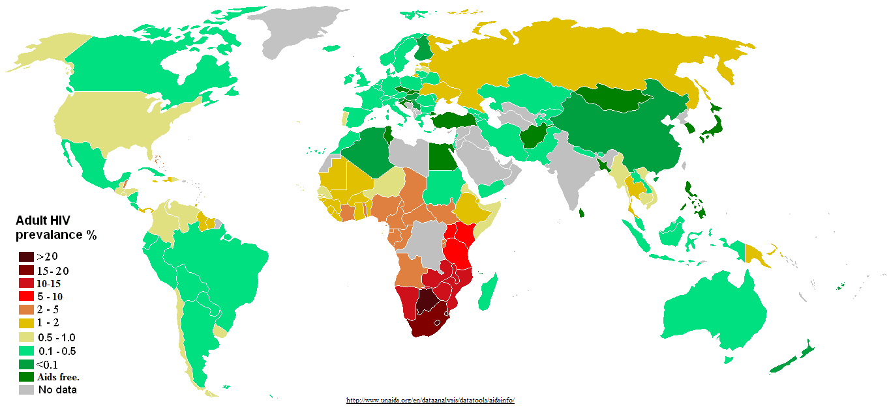

Figure 1. : Distribution of HIV prevalence in adults around the world.

Source: <http://www.unadis.org/en/dataanalysis/datatools/aidsinfo/>

hiv global trend.pdf

Figure 1. 2: Global trend of new HIV infections from 1990 to 2011. The number of people living with HIV globally is increasing (A) while the number of people newly infected with HIV (B) and the number of Adults and child deaths due to HIV are decreasing (C) globally in the time period. This scenario can be attributed to global scale up of drugs while infected people continue transmitting the virus to uninfected people (Zaidi et al.). (Source: modified from UNAIDS 2012)



Figure 1. : Phylogenetic tree showing HIV-1 group M diversification to subtypes A-D, F-H, J and K, inferred from nucleotide sequence alignments of *gag*, *pol* and *env* genes. Source: Robertson et al 2000 (Robertson et al., 2000a)



Figure 1. : Figure 1.4: HIV diversity around the globe, its level of prevalence in the area and number of genome sequenced. Source: McCutchan 2006

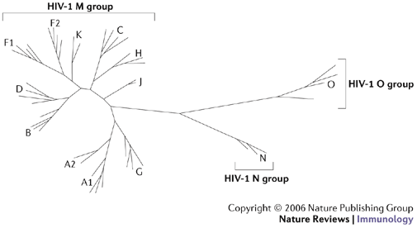

Figure 1. 5: Neighboring joining phylogenetic tree showing HIV-1 group M, N and O. Group M shows distinct nine subtypes A-D, F-H, J, K while no specific subtype is observed in group N and O. Source: Letvin 2006 (Letvin, 2006)

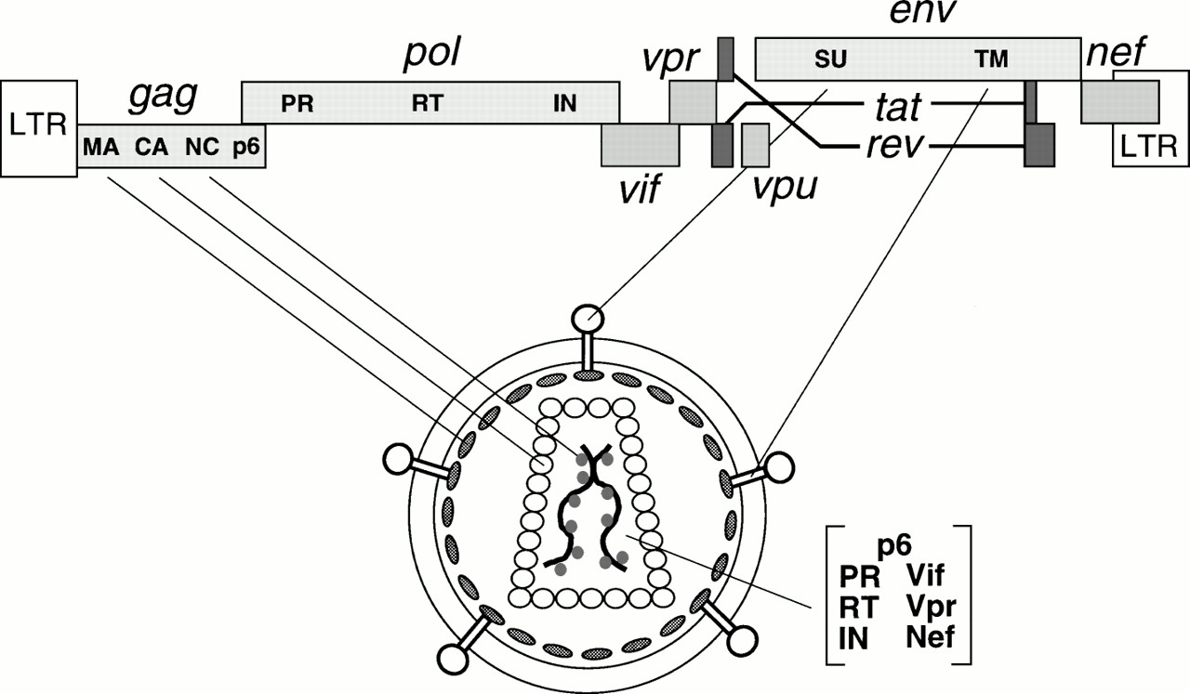

Figure 1. : HIV genes and proteins positions in the viral genome and their viral parts. Source: Frankel and Young 1998 (Frankel and Young, 1998)

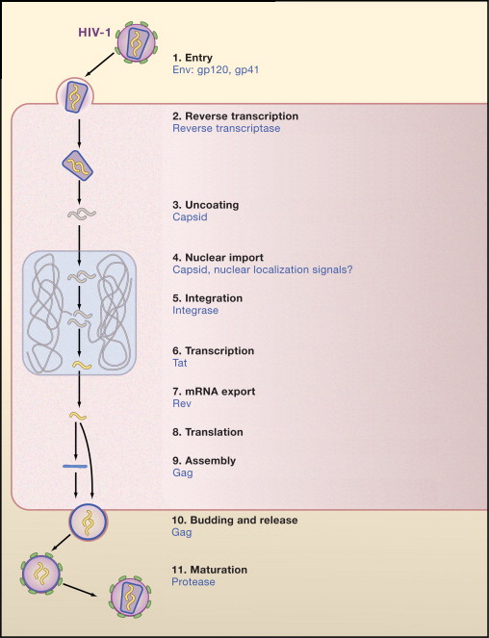

Figure 1. : The HIV replication cycle showing major stages. Viral proteins that play role in each event are colored blue. (Source: modified from Ho and Bieniasz 2008) (Ho and Bieniasz, 2008)

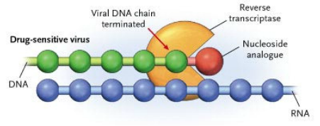

Figure 1. 8: Mechanisms of NRTI drug to inhibit reverse transcriptase. Nucleoside analogs lacking 3’ hydroxyl group is incorporated in growing chain of drug sensitive virus resulting in incomplete termination of viral cDNA. Source: Adapted from (Clavel and Hance, 2004)

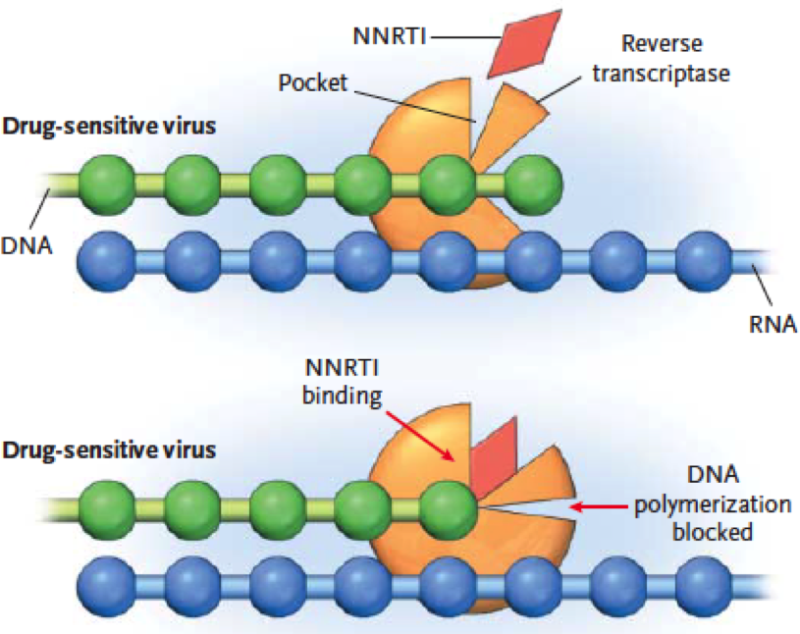

Figure 1. 9: Mechanism of NNRTI drugs to inhibit reverse transcriptase. The drugs bind to drug sensitive viral reverse transcriptase disabling its function. Source: Adapted from (Clavel and Hance, 2004)



Figure 1. : The time line of approved HIV antiretroviral drugs. Source: (Palmisano and Vella, 2011)

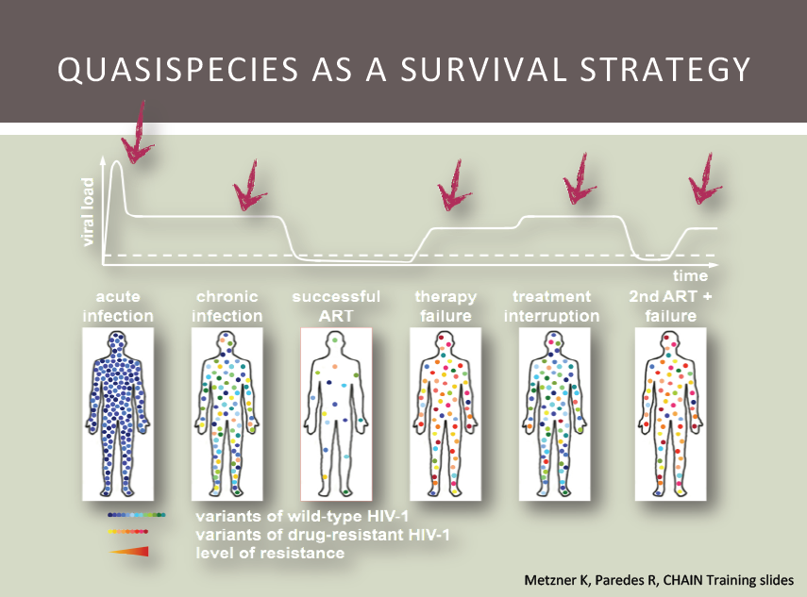

Figure 1. : Dynamics of HIV viral load within an infected patient. The viral load peaks at acute infection followed by a significant drop due to a lower CD4+ count. The introduction of highly active cocktail of anti retroviral drugs arrest the viral replication cycle and decreases the viral load to safe level. Spontaneous mutations give rise to resistant viruses that replicate with high turnover increasing the viral load and the therapy fails. The interruption of drugs contributes to a higher viral load. The introduction of second line anti retroviral drugs suppresses the viral load back to safe levels again and the cycle of viral load repeats itself. Source: Roger Paredes personal communication

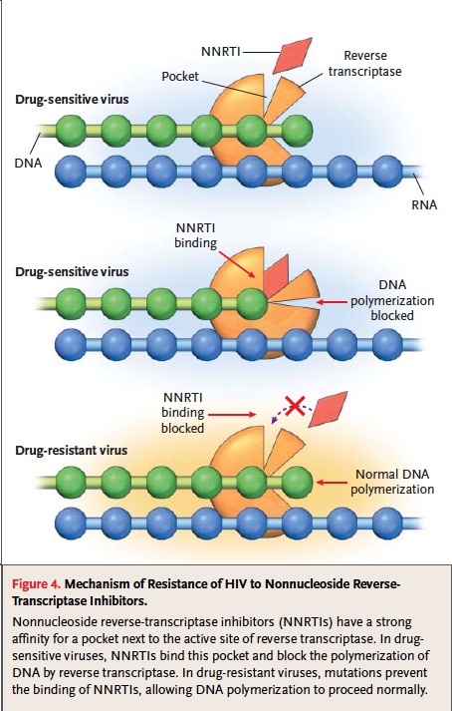

Figure 1. : Development of HIV drug resistance against NNRTI. The accumulation of drug resistant mutations changes three-dimensional confirmation of a viral protein, disabling drug binding and carrying out its normal function. Source: (Clavel and Hance, 2004)



Figure 1. : Mutations in HIV-1 reverse transcriptase gene by codon positions that is associated with resistance to reverse transcriptase inhibitors. Source: Adapted from Johnson et al 2013 (Johnson et al., 2013)



Figure 1. : Figure 1.14: Mutations in HIV-1 protease gene by codon positions that is associated with resistance to protease inhibitors. Source: Adapted from Johnson et al 2013 (Johnson et al., 2013)

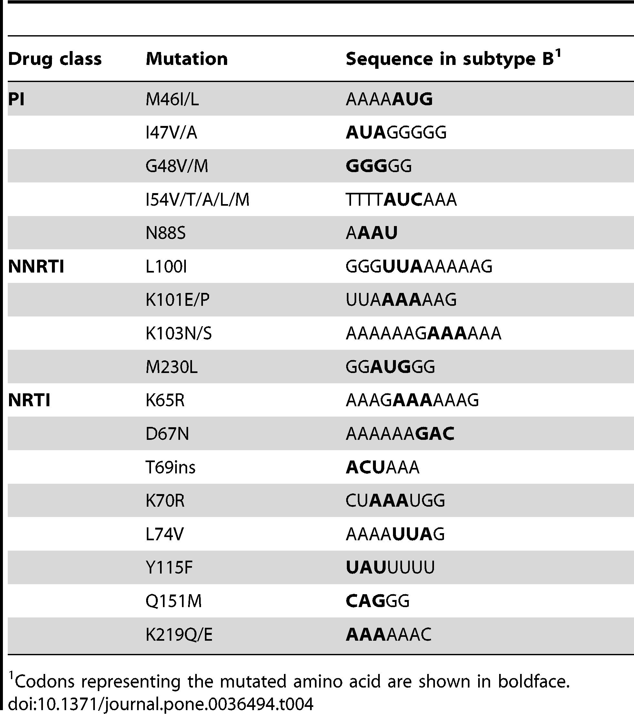

Figure 1. : HIV-1 drug resistant positions at homopolymer regions. Source: Dudley et al 2012 (Dudley et al., 2012)