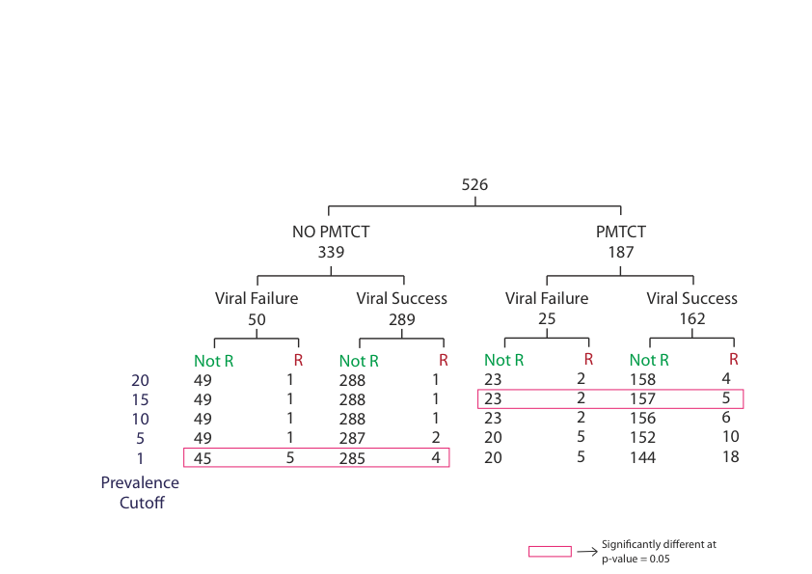

Figure 5.1: Resistance call to at least one drug in baseline regimen at different prevalence levels for the PMTCT and Non-PMTCT exposed baseline samples sequenced using FLX technology. The data in red rectangle showed significant difference (p-value <0.05) using two-tailed t test.

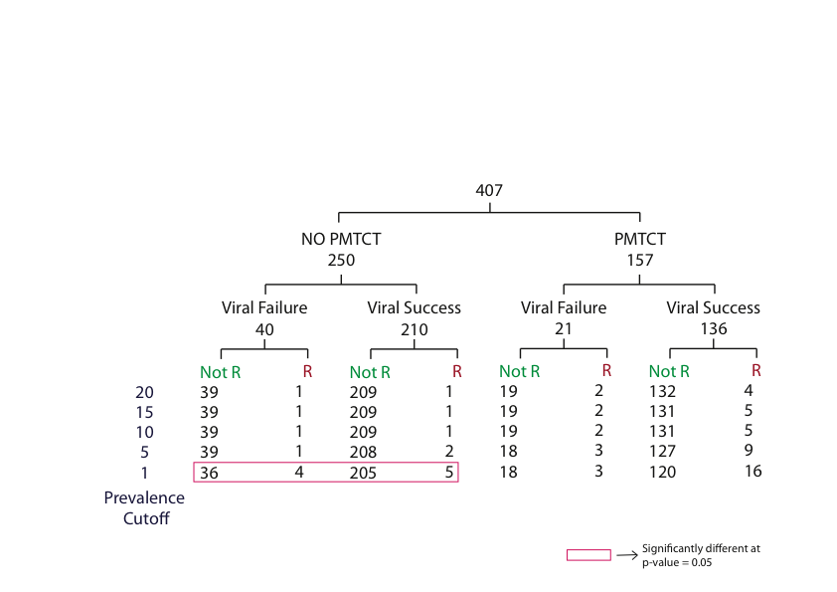

Figure 5.2: Resistance call to at least one drug in baseline regimen at different prevalence cutoffs for PMTCT and non-PMTCT exposed baseline samples sequenced using Junior technology. The data in red rectangle showed significant difference (p-value <0.005) using two-tailed T test.

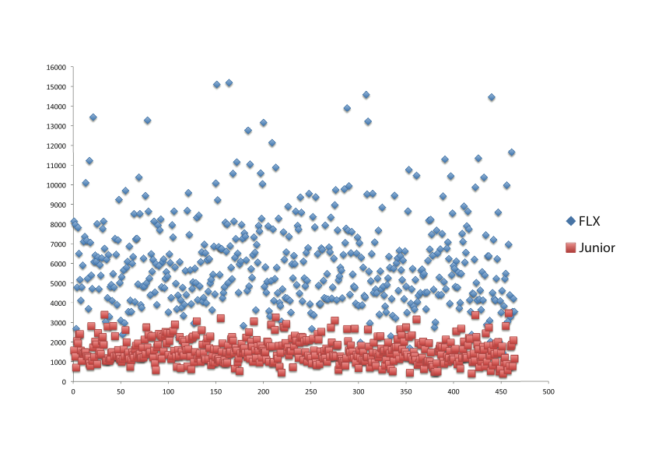

Figure 5. : Comparison of the number of reads generated for the baseline samples sequenced on both FLX and Junior 454 pyrosequencing.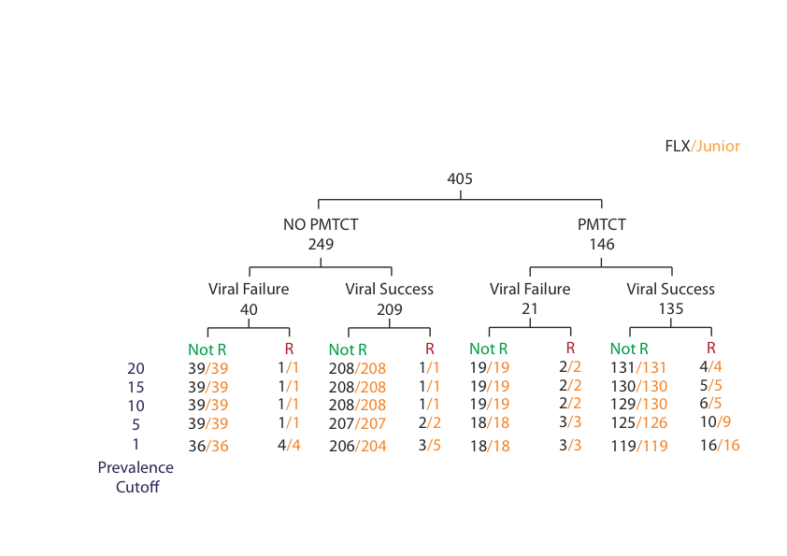

Figure 5.4: Resistance call to at least one drug in baseline regimen at different prevalence cutoffs for PMTCT and non-PMTCT exposed baseline samples sequenced using both FLX and Junior. The sequenced viral population in the samples sequenced using FLX and Junior that are called as resistant to at least one drug in baseline regimen are shown in Black and Orange respectively.

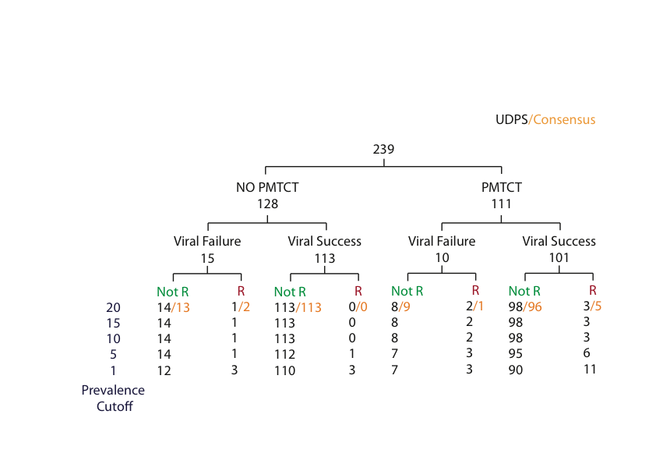

Figure 5.5: Comparison of the number of samples with the amplified and sequenced viral population predicted as resistant or non-resistant sequenced using UDPS and population based Sanger method at the prevalence cutoff 20%. A sequenced viral population in a sample was called resistant if any one drug in baseline regimen was resistant to it. Samples called as resistant to at least a baseline drug by HTS and population based Sanger method are shown in Black and orange respectively.

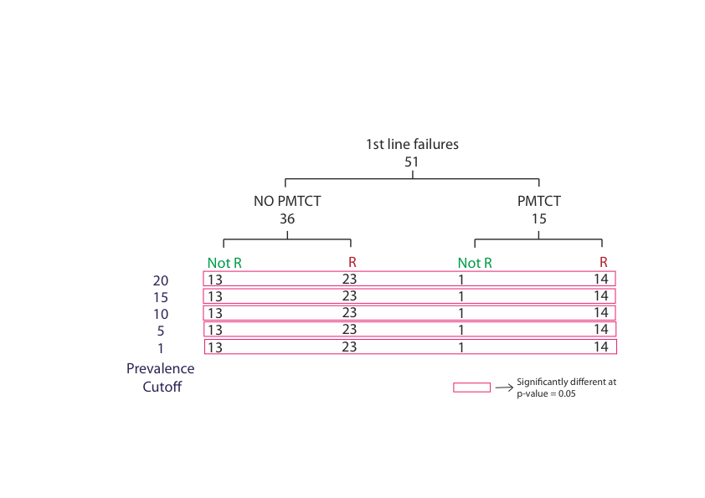

Figure 5.6: Number of samples with sequenced viral population showing predicted resistance and non-resistance to a drug using Roche/454 FLX platform, in no previous PMTCT therapy and with PMTCT therapy that had virologic failure at first line ART. Significant difference (p-value <0.05) was observed at all prevalence cutoffs.

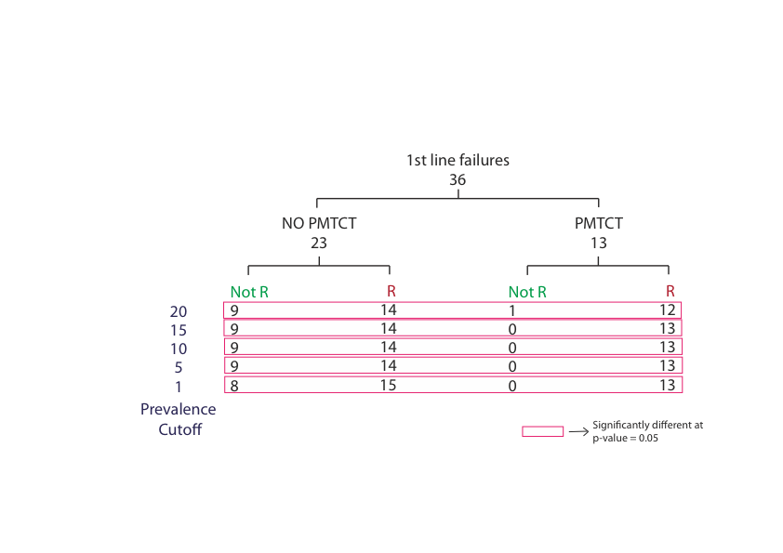

Figure 5.7: Number of samples with sequenced viral population showing predicted resistance and non-resistance to a drug using Roche/454 Junior platform, in no previous PMTCT therapy and with PMTCT therapy that had virologic failure at first line ART. Significant difference (p-value <0.05) was observed at all prevalence cutoffs.

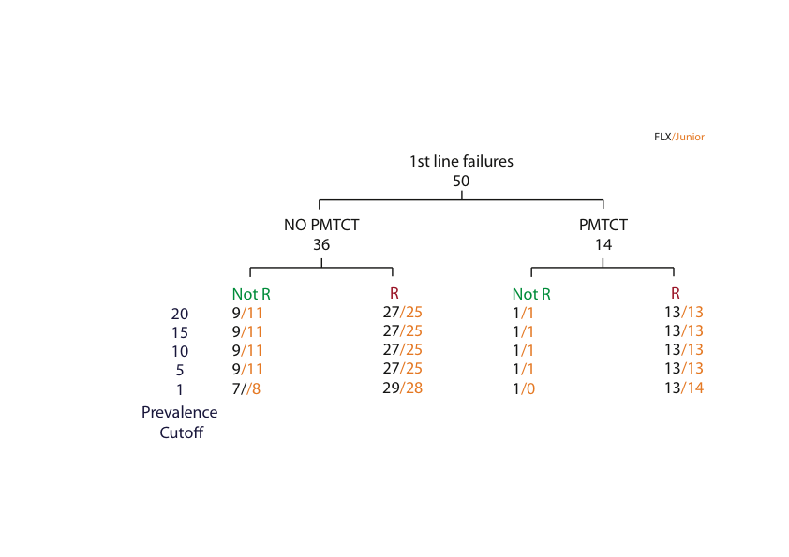

Figure 5. : Number of samples with sequenced viral population showing predicted resistance and non-resistance to a drug using Roche/454 FLX and Roche/454 Junior platforms, in no previous PMTCT therapy and with PMTCT therapy that had virologic failure at first line ART. No Significant difference (p-value <0.05) was observed at all prevalence cutoffs.

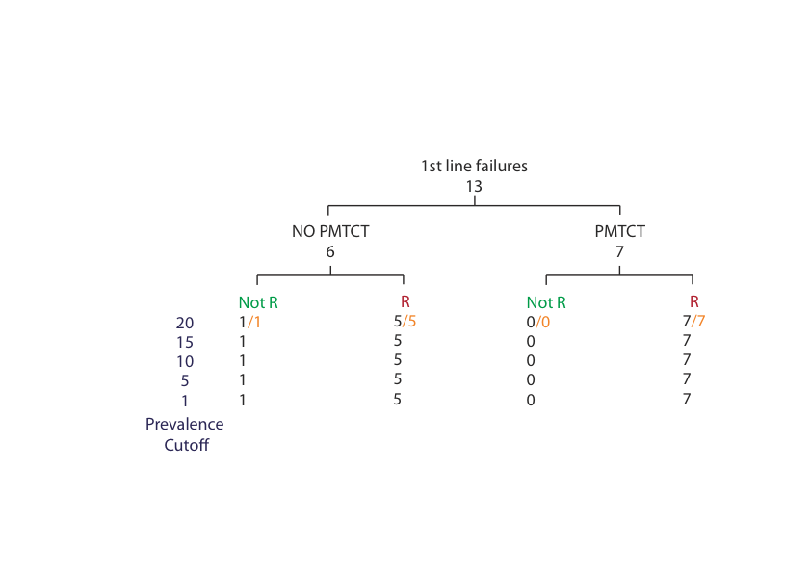

Figure 5.9: Comparison of the number of resistant and non-resistant samples that had first line ART failure, sequenced using Roche/454 Junior and population based Sanger method at the prevalence cutoff 20%. The sequenced viral population in a sample was called resistant if a drug in baseline regimen was resistant to it. Samples called as resistant to at least a baseline drug by FLX and population based Sanger method are shown in Black and orange respectively.

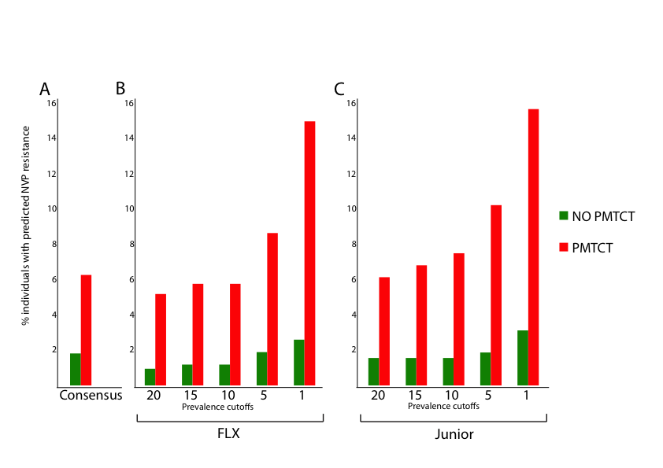

Figure 5.10: The percentage of non-PMTCT exposed and PMTCT exposed baseline samples from patients with predicted NVP resistance sequenced using A) conventional method B) Roche/454 FLX at prevalence cutoffs 20%, 15%, 10%, 5% and 1% C) Roche/454 Junior at prevalence cutoffs 20%, 15%, 10%, 5%and 1%.