**Eye Disease Classification**

*PHASE: I*

Architecture: mobilenet

Version:3

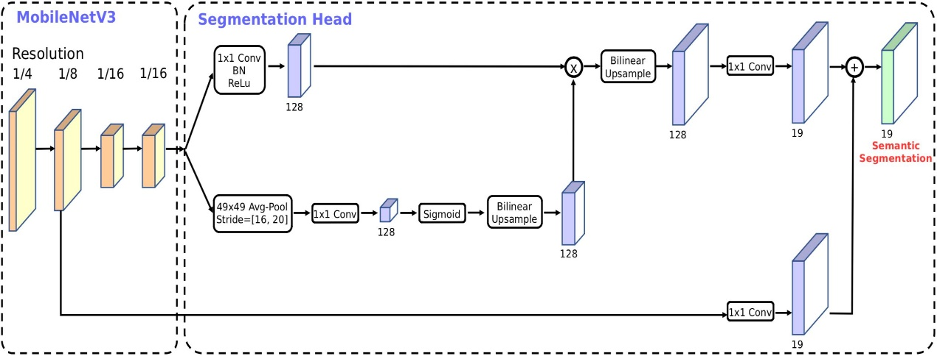

Activation function: Sigmoid

Layer: Dense

Optimizer: root mean square prop

Loss function: Binary cross entropy

Classes: 2

Epoch: 10

Accuracy: 0.86

Loss: 0.33

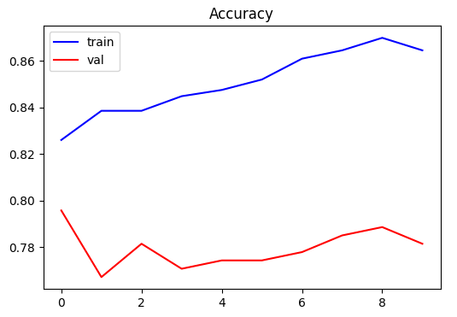Train test validation: