**Skin Disease Classification**

*PHASE: I*

Architecture: efficientnet

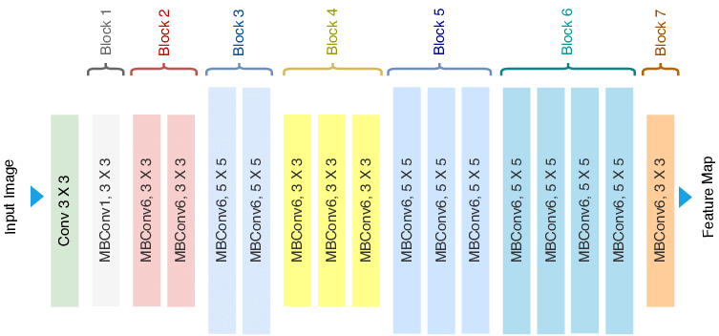

Activation function: Sigmoid

Layer: cnn, maxpooling, Dense

Optimizer: root mean square prop

Loss function: sparse_categorical_crossentropy

Classes: 8

Epoch: 50

Accuracy: 0.56

Loss: 0.44

Train test validation:

