EMBEDDED CYBERSECURITY, IOT WIRELESS SYSTEMS & USB HID RESEARCH REPORT
ESP32-S3 Phone-Controlled USB HID Keyboard and Mouse with BadUSB Simulation and Defensive Keystroke Firewall
Native Composite TinyUSB Emulation, Dual-Mode Wi-Fi Mobile Web Controller, Deterministic Scenario State Machine & Win32 Hook Defense
Project Identity & Academic Attribution
Authors: | Ram Karthik G & Harini V | Roll Number: | CH.SC.U4CYS23037 & CH.SC.U4CYS23010
Department: | Cybersecurity | Institution: | Amrita Vishwa Vidyapeetham, Chennai
Executive Summary & Architectural Overview
Modern operating systems implicitly trust USB Human Interface Devices (HID) the moment they enumerate on the host bus. While this zero-configuration trust model enables universal plug-and-play usability, it exposes a severe physical-layer attack vector known as BadUSB, in which a programmable microcontroller impersonates a composite keyboard and mouse to inject rapid OS commands. Conversely, legitimate wireless remote input solutions typically require installing proprietary receiver software on the host PC, limiting deployment on locked-down laboratory or presentation workstations.
This project engineers and validates a unified offensive-and-defensive embedded cybersecurity platform built on the Espressif ESP32-S3 SoC and a companion Windows Host Keystroke Firewall. Using the native USB OTG peripheral (GPIO 19 D- / GPIO 20 D+) and the TinyUSB stack, the ESP32-S3 enumerates simultaneously as a composite Boot Keyboard and 3-button Scroll Mouse while hosting a responsive dark-mode Single-Page Application (SPA) from flash memory (PROGMEM) over dual-mode Wi-Fi (WIFI_AP_STA). An operator using an Android smartphone can launch or abort four non-destructive security awareness scenarios, type on a full 6-row virtual keyboard with hardware modifier latching, control the host cursor via a 60 Hz multi-touch trackpad, and demonstrate real-time host mitigation using a Python WH_KEYBOARD_LL low-level input suppression firewall.
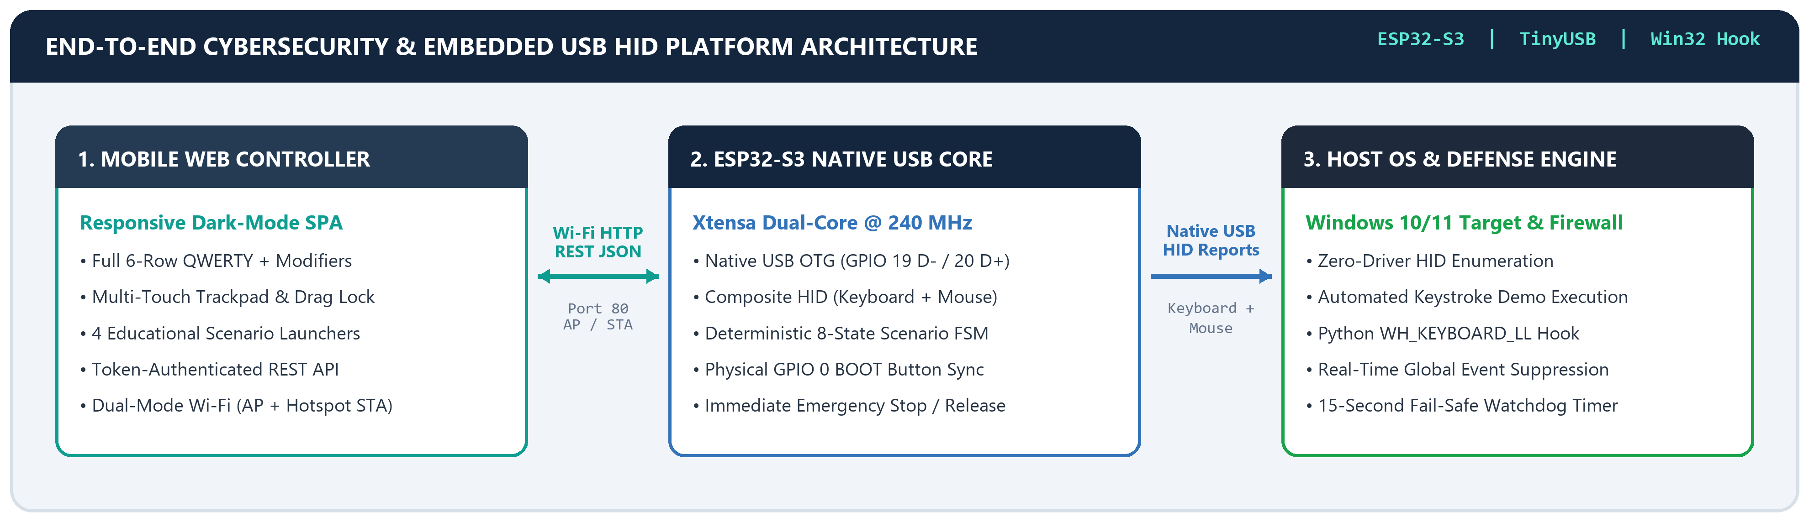
Figure 1.1: End-to-End Platform Architecture bridging the Mobile Web SPA, ESP32-S3 Native Composite TinyUSB Core, and Windows Host Firewall.
Table 1.1: Summary of Core Platform Subsystems, Implementation Mechanisms, and Verified Metrics
Subsystem Domain | Implemented Engineering Mechanism | Verified Hardware / QA Metric
Composite USB HID | TinyUSB USBHIDKeyboard + USBHIDMouse on GPIO 19/20 | Zero-driver enumeration; 3.5 s boot guard; [-127, 127] clamping
Dual-Mode Wireless | WIFI_AP_STA (192.168.4.1 SoftAP + 2.4 GHz Hotspot STA) + mDNS | Live phone access via 10.85.248.29 & http://badusb.local
Scenario Engine FSM | 8-state non-blocking FSM + portMUX_TYPE spinlock mailbox | Auto-runs Scenario 1 on boot; GPIO 0 cycles 1->2->3->4->1
Remote Keyboard & Mouse | 4 keyboard sub-views, latched modifiers, 60 Hz multi-touch pad | 1-finger move/tap, 2-finger scroll/R-click, drag lock, 256B guard
Emergency Abort Safety | Cooperative 10 ms smartDelay polling + dual HID releaseAll() | <= 10 ms abort latency; zero stuck modifiers or mouse buttons
Host Keystroke Defense | Python WH_KEYBOARD_LL hook (suppress=True) + 15 s watchdog | Blocks injected keys globally; auto-disarms after 15.0 seconds
Firmware & QA Validation | Compiled for esp32:esp32:esp32s3 (hwcdc); 3 automated test suites | 851,520 B Flash (64.9%), 59,496 B RAM (18.1%); 22/22 tests pass

SECTION 01 | ABSTRACT, PROBLEM STATEMENT & OBJECTIVES
1.1 Background and the USB HID Trust Model
Universal Serial Bus (USB) Human Interface Devices represent the primary physical trust boundary between human operators and modern computing platforms. When a peripheral is connected to a USB host port, the operating system reads its USB Device, Configuration, Interface, and HID Report Descriptors. Whenever an interface declares USB Class 0x03 (HID), Subclass 0x01 (Boot Interface), and Protocol 0x01 (Keyboard) or 0x02 (Mouse), the host OS kernel automatically binds built-in class drivers (kbdclass.sys and mouclass.sys on Windows) without requiring driver signatures, user confirmation dialogs, or cryptographic device authentication.
As first formalized by Nohl and Lell in their seminal BadUSB research, the operating system has no native architectural mechanism at the USB HID layer to distinguish electrical scancodes generated by a physical mechanical switch from synthetic HID reports generated by an embedded microcontroller timer. A microcontroller capable of native USB device emulation can therefore open command shells (Win + R), execute administrative utilities, or manipulate cursor coordinates at hundreds of characters per second.
1.2 Problem Statement & Academic Motivation
Despite the pedagogical importance of demonstrating physical USB security risks in university cybersecurity curricula, existing hardware tools exhibit three critical engineering shortcomings that hinder safe classroom instruction and practical multi-role use:
▪ Blind, Non-Interruptible Static Execution: Conventional BadUSB demonstration boards execute hardcoded keystroke arrays immediately upon USB insertion. They provide no wireless status feedback, no runtime scenario switching, and no emergency abort mechanism if the target window fails to open in time.
▪ Host Agent Dependency in Wireless Input Tools: Standard smartphone-to-PC remote keyboard and mouse applications require installing a background TCP/UDP server daemon on the target computer. In restricted academic laboratories, smart classrooms, or hardware debugging benches, installing third-party host agents is disallowed.
▪ Lack of Integrated Defensive Countermeasures: Demonstrating offensive keystroke injection without a companion host-side mitigation leaves students without actionable defensive engineering patterns, while naive keyboard hooks risk locking out the instructor's physical keyboard if not paired with an automated fail-safe timer.
1.3 Core Research and Engineering Objectives
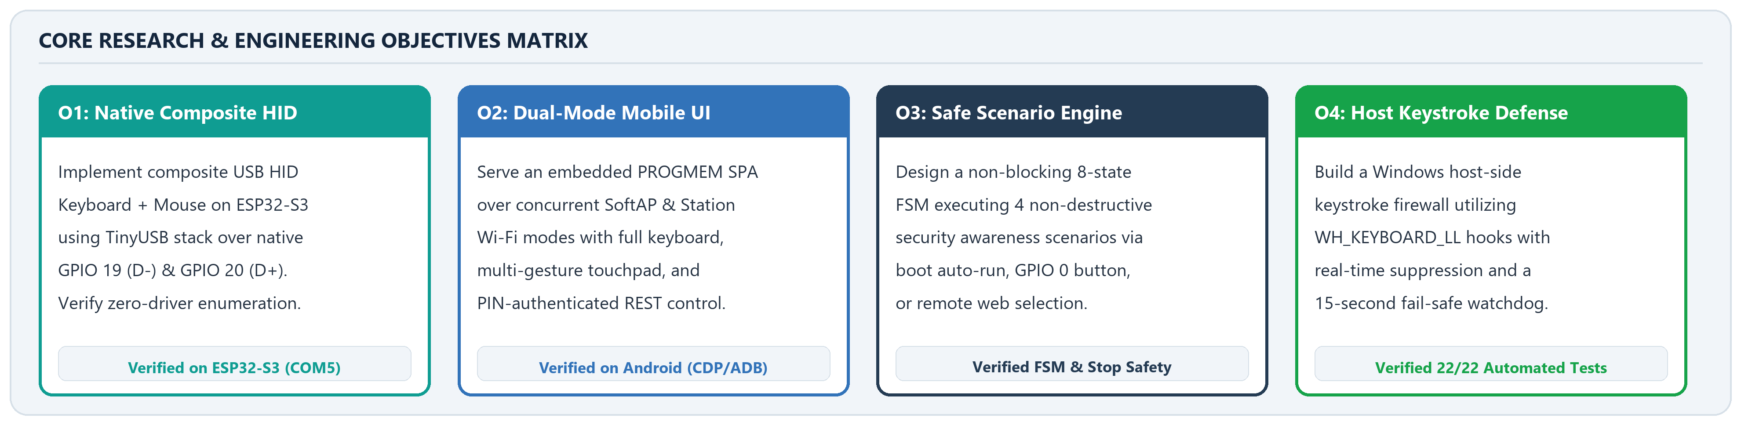
Figure 1.2: Four-Pillar Research and Engineering Objectives Matrix with Verified Hardware & Test Milestones.
1.4 Scope, Safety Boundaries, and Ethical Design
This system is strictly scoped as an authorized educational demonstration platform, wireless driverless HMI peripheral, and defensive endpoint security testbed. Rigorous engineering safeguards are enforced across both firmware and host software:
▪ Non-Destructive Educational Scenarios Only: None of the four embedded scenarios delete files, modify system registries, exfiltrate credentials, or establish persistence. Scenario 3 displays an educational awareness notice inside Notepad, and Scenario 4 lists saved Wi-Fi SSID names (netsh wlan show profiles) without reading key material.
▪ Credential Redaction & Input Bounding: All Wi-Fi station passphrases, SoftAP passwords, authentication PINs, and device serial numbers are redacted as [REDACTED] in documentation and masked in the mobile UI (•••••••••). Bulk text transmission is bounded to MAX_TEXT_LENGTH = 256 characters per request.
ARCHITECTURAL CONVERGENCE: By combining a composite TinyUSB HID engine, an embedded PROGMEM web application, a deterministic 8-state scenario FSM, and a Win32 WH_KEYBOARD_LL firewall within a single repository, the platform serves simultaneously as a daily-use wireless mobile keyboard/trackpad and a controlled cybersecurity lab.

SECTION 02 | SYSTEM ARCHITECTURE & TECHNOLOGY STACK
2.1 End-to-End Three-Tier System Architecture
The platform architecture is partitioned into three decoupled tiers that communicate over standard protocols: (1) the Android Phone Controller Tier (rendering the Single-Page Application over HTTP REST JSON), (2) the ESP32-S3 Embedded Firmware Tier (managing dual-mode Wi-Fi, token validation, the thread-safe Scenario FSM, and composite TinyUSB HID report generation), and (3) the Windows Host & Firewall Tier (enumerating the composite USB device and filtering input events via the Win32 low-level keyboard hook chain).
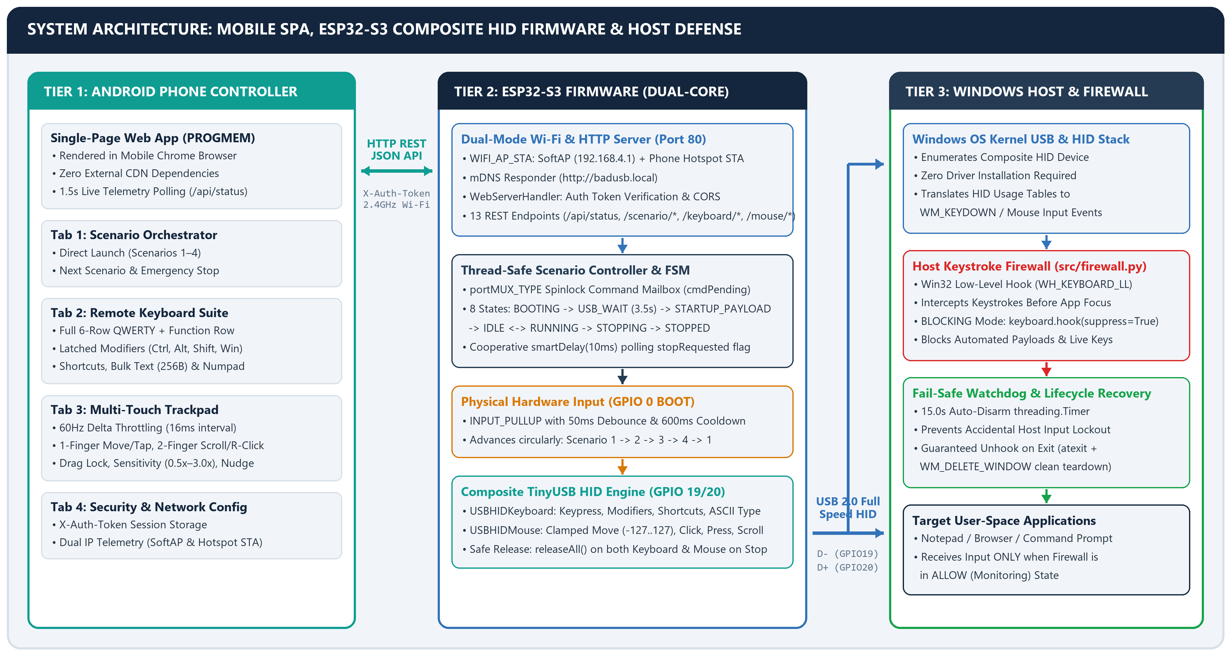
Figure 2.1: Complete Three-Tier System Architecture illustrating Mobile SPA Tabs, ESP32-S3 Firmware Modules, and Windows Host Firewall Pipeline.
2.2 Dual-Mode Wi-Fi Topology and Native USB OTG Interfacing
A foundational hardware distinction of the Espressif ESP32-S3 over legacy ESP32-WROOM modules is its integrated full-speed (12 Mbps) USB 2.0 On-The-Go (OTG) peripheral controller routed directly to GPIO 19 (USB D-) and GPIO 20 (USB D+). When compiled with Arduino-ESP32 TinyUSB configuration flags (USBMode=hwcdc,CDCOnBoot=cdc), the ESP32-S3 presents a composite USB descriptor over a single USB data cable that simultaneously binds three host interfaces: USB CDC Serial (COM5 for telemetry and flashing), a standard 104-key USB HID Boot Keyboard, and a 3-button USB HID Mouse with vertical scroll.
On the wireless side, WebServerHandler::begin() configures the IEEE 802.11 b/g/n radio in concurrent WIFI_AP_STA mode. The SoftAP interface immediately establishes an isolated control network (SSID: BadUSB-Controller, Passphrase: [REDACTED], Static IP: 192.168.4.1), while the Station interface connects automatically to the user's 2.4 GHz mobile hotspot (SSID: [REDACTED], Passphrase: [REDACTED], assigned DHCP IP 10.85.248.29). Because the smartphone hosts the 2.4 GHz hotspot, the phone browser can communicate directly with http://10.85.248.29 (or http://badusb.local via mDNS) without disconnecting from mobile cellular data.
Table 2.1: Repository Module Breakdown and Architectural Responsibilities Verified Against Source Code
Architectural Layer | File / Module | Key Classes, Libraries & Technical Responsibilities
Main Firmware Entry | badusb_firmware.ino | Initializes Serial (115200), ScenarioController, WebServerHandler, and cooperative loop()
System Configuration | config.h | Defines WIFI_AP/STA credentials [REDACTED], AUTH_PIN [REDACTED], GPIO 0 pin, and timing guards
HID Keyboard Engine | keyboard_controller.h/.cpp | Wraps USBHIDKeyboard; ASCII typing, named keys, modifier bitmasks, shortcuts, releaseAll()
HID Mouse Engine | mouse_controller.h/.cpp | Wraps USBHIDMouse; clamped [-127, 127] relative move, L/R/M click, drag press/release, scroll
Scenario State Machine | scenario_controller.h/.cpp | 8-state FSM, portMUX_TYPE spinlock command mailbox, GPIO 0 debounce, Scenarios 1–4
HTTP REST Server | web_server_handler.h/.cpp | Port 80 WebServer, WIFI_AP_STA setup, X-Auth-Token checks, CORS preflight, 13 API routes
Embedded Mobile SPA | web_assets.h (PROGMEM) | Responsive dark-mode HTML5/CSS3/JS interface: Scenarios, 4-View Keyboard, Touchpad, Settings
Host Keystroke Firewall | src/firewall.py & firewall.py | Python 3.12 Tkinter GUI, keyboard.hook(suppress=True) WH_KEYBOARD_LL filter, 15s Timer

SECTION 03 | EMBEDDED FIRMWARE & SCENARIO EXECUTION ENGINE
3.1 Composite USB Initialization Ordering & Enumeration Guard
TinyUSB requires all HID report descriptors to be registered before the physical USB bus attaches to the host. Inside ScenarioController::begin(), the firmware calls keyboard.begin() (USBHIDKeyboard::begin()) and mouse.begin() (USBHIDMouse::begin()) prior to invoking USB.begin(). Once USB.begin() asserts the D+ pull-up resistor on GPIO 20, the host OS initiates USB enumeration. Because Windows takes 1.5 to 3.0 seconds to complete descriptor negotiation and ready the HID input queues, the FSM enters STATE_USB_WAIT and enforces a non-blocking 3,500 ms stabilization window (USB_READY_WAIT_MS = 3500) before permitting any automated or remote HID transmission.
3.2 Deterministic 8-State Finite State Machine & Spinlock Synchronization
To guarantee predictable behavior across boot-time execution, physical button presses, and asynchronous web requests, ScenarioController implements an 8-state FSM (STATE_BOOTING, STATE_USB_WAIT, STATE_STARTUP_PAYLOAD, STATE_IDLE, STATE_RUNNING, STATE_STOPPING, STATE_STOPPED, and STATE_ERROR). External triggers never mutate state variables directly; instead, they queue a command (CMD_SELECT_SCENARIO, CMD_NEXT_SCENARIO, or CMD_STOP) inside an ESP-IDF FreeRTOS critical section (portENTER_CRITICAL(&mux) / portEXIT_CRITICAL(&mux)). When the 3,500 ms boot wait completes, STATE_STARTUP_PAYLOAD automatically runs Scenario 1 once (startupPending = false; startupDone = true) and transitions to STATE_IDLE.
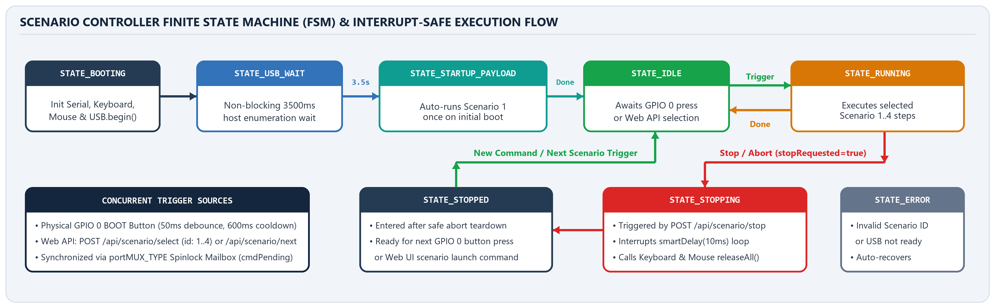
Figure 3.1: ScenarioController 8-State Finite State Machine (FSM) and Interrupt-Safe Execution Flow.
3.3 Physical GPIO 0 BOOT Button Advancement & Cooperative Abort Safety
The ESP32-S3 onboard BOOT button (GPIO 0, active-low with internal pull-up) is polled on every ScenarioController::update() cycle. Raw readings pass through a 50 ms debounce filter (BUTTON_DEBOUNCE_MS = 50) and a 600 ms post-trigger cooldown (BUTTON_COOLDOWN_MS = 600). Pressing the button invokes requestNextScenario(), which computes (currentScenario % 4) + 1, advancing circularly through Scenarios 1 -> 2 -> 3 -> 4 -> 1.
During scenario execution, all inter-step pauses use ScenarioController::smartDelay(unsigned long ms). Rather than blocking the CPU, smartDelay loops in 10 ms increments (STEP_POLL_INTERVAL_MS = 10), invoking the registered client callback (webHandler.handleClient()) and checking stopRequested on every iteration. During live hardware QA, a critical deadlock defect was discovered and resolved in requestStop(): calling keyboard.releaseAll() inside portENTER_CRITICAL(&mux) previously stalled the TinyUSB task while interrupts were disabled. Moving keyboard.releaseAll() and mouse.releaseAll() outside the spinlock critical section achieved instantaneous, crash-free aborts.
Table 3.1: Verified Catalog of Non-Destructive Educational Scenarios Implemented in scenario_controller.cpp
ID | Scenario Title | Exact HID Sequence Executed on Host | Security Awareness Objective
1 | Notepad Awareness (Boot Auto-Run) | GUI+r (Win+R) -> wait 750ms -> type 'notepad' + Enter -> wait 1200ms -> type 3-line security warning message | Demonstrates how unattended USB ports allow immediate process creation and text injection.
2 | Portal Redirection | GUI+r (Win+R) -> wait 750ms -> type 'cmd' + Enter -> wait 1000ms -> type 'start https://intranet.cb.amrita.edu/' + Enter | Demonstrates forced browser navigation and potential credential phishing via command shell.
3 | Ransomware Awareness | GUI+r (Win+R) -> wait 750ms -> type 'notepad' + Enter -> wait 1200ms -> type '[ SECURITY EDUCATION NOTICE ]' banner | Safely simulates rapid payload staging visibility in a classroom without modifying user files.
4 | Wi-Fi Reconnaissance | GUI+r (Win+R) -> wait 750ms -> type 'cmd' + Enter -> wait 1000ms -> execute 'netsh wlan show profiles' in console | Shows how local system enumeration commands can list saved wireless network profile names.

SECTION 04 | WI-FI PHONE CONTROLLER & REMOTE KEYBOARD
4.1 Embedded PROGMEM Single-Page Application & Live Telemetry
The mobile web interface is compiled directly into the firmware binary inside badusb_firmware/web_assets.h as a PROGMEM string literal (INDEX_HTML). By avoiding external CSS frameworks or CDN scripts, the interface loads instantaneously over both the standalone SoftAP (192.168.4.1) and the phone's 2.4 GHz hotspot (10.85.248.29). During live Android QA on the Vivo V50e (chrome://inspect over ADB), an unclosed <div id="tabKeyboard"> container bug that previously hid the Mouse and Settings tabs was identified and fixed, along with adding explicit CORS HTTP_OPTIONS preflight support (204 No Content).
4.2 Token-Based Authentication and REST API Command Flow
To prevent unauthorized users on the same Wi-Fi subnet from injecting keystrokes, all state-modifying POST routes require authentication. In the Settings tab, the operator inputs the configured security PIN ([REDACTED]), which is verified via POST /api/auth/login against AUTH_PIN in config.h. Once authenticated, the client attaches X-Auth-Token: [REDACTED] to all fetch() requests. WebServerHandler::isAuthorized() validates this header before executing any scenario, keyboard, or mouse action, returning HTTP 401 Unauthorized if missing or invalid.
4.3 Four-Sub-View Remote Keyboard, Modifiers & Shortcuts
The Keyboard tab (#tabKeyboard) replicates a complete desktop keyboard on the smartphone touchscreen through a persistent Hardware Modifier bar (Ctrl, Alt, Shift, Win with Auto-release modifier and Release All safety controls) and four specialized sub-views: (1) Full Layout (6-row desktop matrix including Esc, F1–F12, Del, symbol/number row, Tab, Caps Lock, Shift, Win, Alt, Menu, and Spacebar), (2) Shortcuts (one-tap macros such as Copy, Paste, Task Manager, Win+R, Win+D, Win+L, Alt+F4, and an inverted-T arrow/page navigation cluster), (3) Text & Live (256-character bulk string transmitter and real-time per-keystroke live input box), and (4) Numpad (17-key numeric keypad).
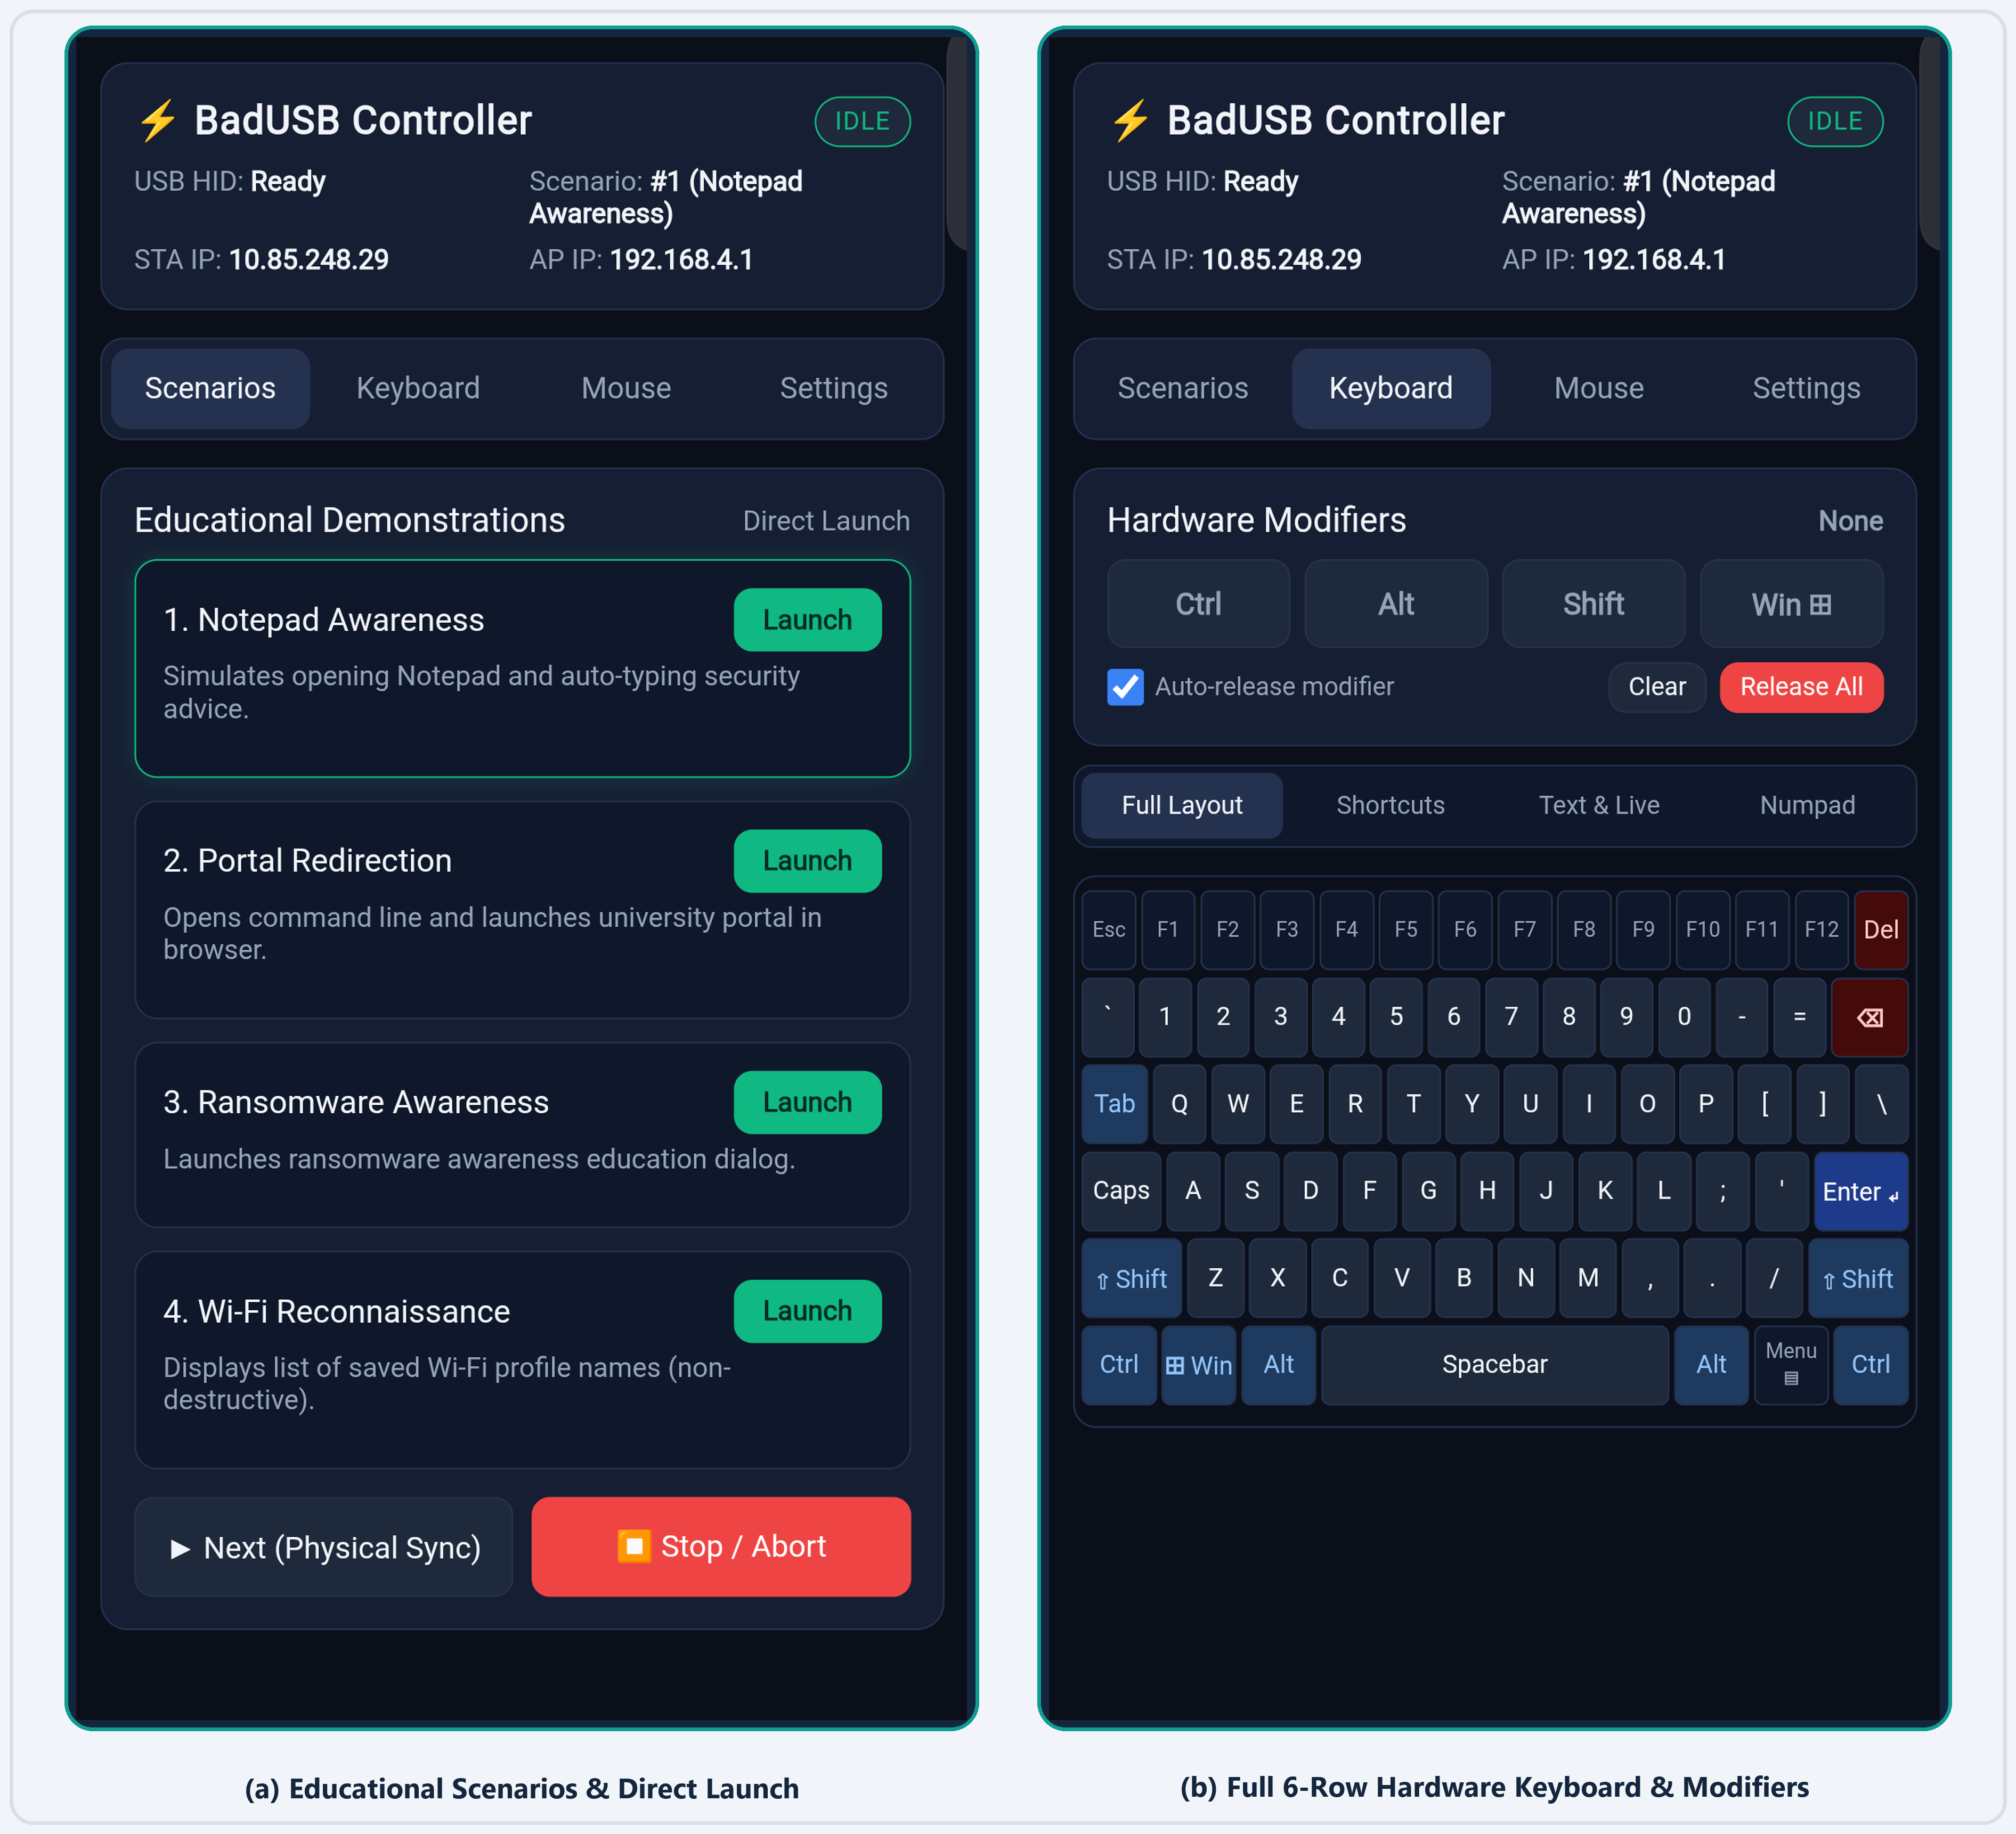
Figure 4.1: Verified Live Android Phone Screenshots — (a) Educational Scenarios & Direct Launch Tab; (b) Full 6-Row Hardware Keyboard & Modifier Bar.
Table 4.1: Core Status, Authentication, Scenario, and Keyboard REST API Endpoints (web_server_handler.cpp)
HTTP Method & Route | Auth | Request Payload Parameters | Firmware Handler & HID Action
GET /api/status | Public | None | Returns JSON: usbReady, state, currentScenario, staIp, apIp, authRequired
POST /api/auth/login | Public | pin / token ([REDACTED]) | Verifies credential against AUTH_PIN; returns 200 OK or 401 Unauthorized
POST /api/scenario/select | Token | id (integer 1..4) | Queues CMD_SELECT_SCENARIO in spinlock mailbox to launch Scenario 1–4
POST /api/scenario/next | Token | None | Queues CMD_NEXT_SCENARIO; advances circularly 1 -> 2 -> 3 -> 4 -> 1
POST /api/scenario/stop | Token | None | Sets stopRequested=true, aborts smartDelay(), calls Keyboard/Mouse releaseAll()
POST /api/keyboard/key | Token | key (e.g. ENTER, F5, a) | Maps key name to USB HID usage code via KeyboardController::sendKeyByName()
POST /api/keyboard/shortcut | Token | mod (CTRL+SHIFT), key (ESC) | Presses modifier bitmask + target key for 25 ms, then releases cleanly
POST /api/keyboard/text | Token | text (<=256B), enter (0/1) | Streams printable ASCII characters via Keyboard.print() + optional Enter

SECTION 05 | REMOTE MOUSE CONTROL & HOST-SIDE DEFENSE
5.1 Multi-Touch Relative Trackpad, Gestures & Precision Nudge
The Mouse tab (#tabMouse) implements a low-latency wireless touchpad backed by MouseController (mouse_controller.h/.cpp). Touch coordinates on #trackpadArea are sampled via touchstart, touchmove, and touchend listeners throttled to 16 ms intervals (~60 Hz). Single-finger movement calculates relative (dx, dy) offsets scaled by the Cursor Sensitivity slider (0.5x–3.0x, default 1.8x) and clamped to signed 8-bit HID integers ([-127, 127]) inside MouseController::clampDelta(). A single-finger tap (<10 px movement within 220 ms) triggers a Left Click, while a two-finger tap (<260 ms) triggers a Right Click and a two-finger vertical drag emulates the scroll wheel (POST /api/mouse/scroll). Dedicated buttons provide Left, Right, Double, and Middle Click, alongside a stateful Drag Lock toggle (POST /api/mouse/press and /release) and a Precision Nudge pad (5px, 20px, 60px step selector).
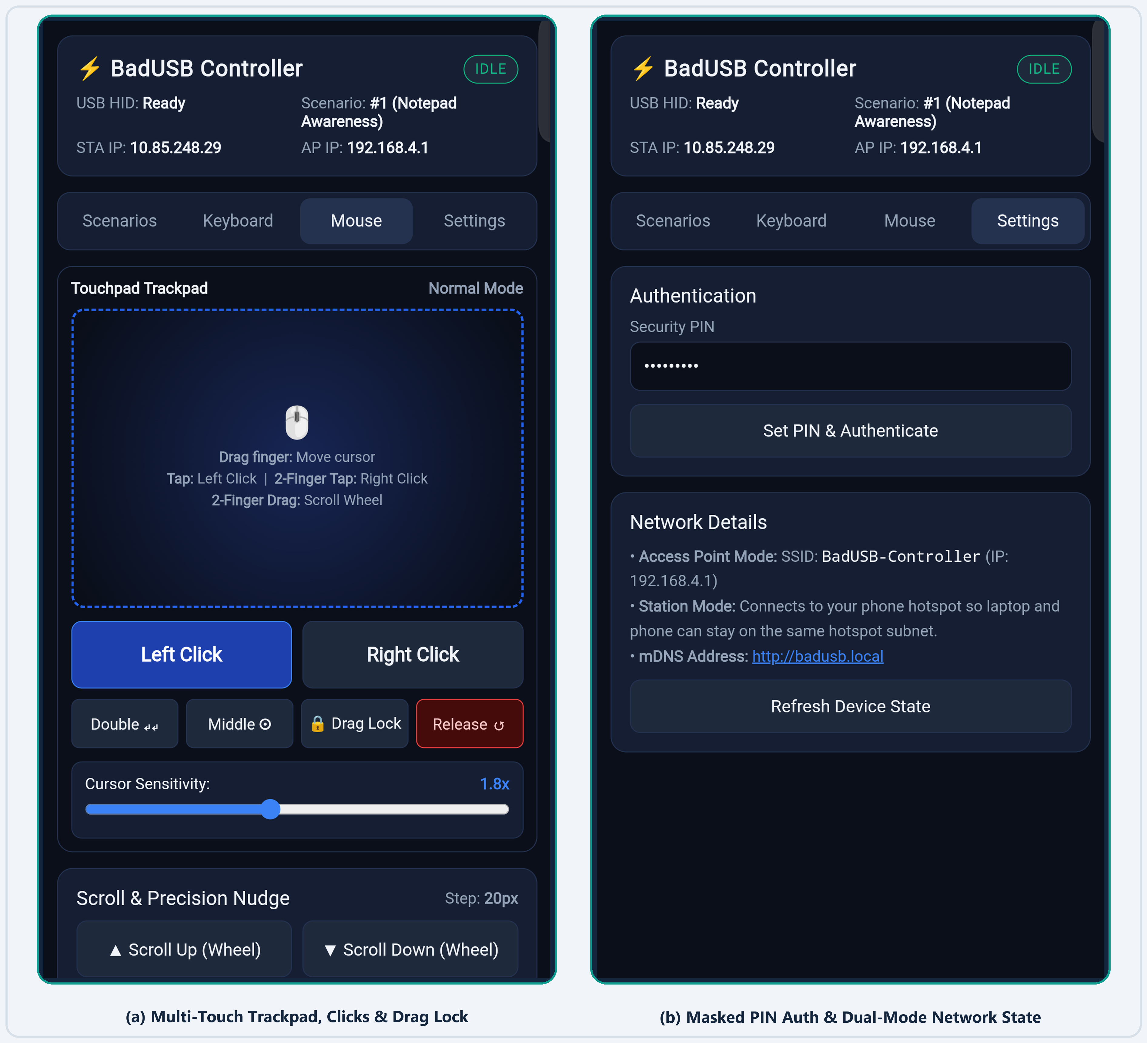
Figure 5.1: Verified Live Android Phone Screenshots — (a) Multi-Touch Trackpad, Click Bar & Drag Lock; (b) Masked PIN Auth & Dual-Mode Network Telemetry.
5.2 Windows Host-Side Keystroke Firewall Architecture
To demonstrate practical host-side defense against unauthorized HID keystroke injection, the platform includes a Python/Tkinter desktop security utility (src/firewall.py). When toggled from ALLOW (Monitoring) to BLOCKING (Armed) mode, KeystrokeFirewall.enable_blocking() installs a Win32 low-level keyboard hook (WH_KEYBOARD_LL) with keyboard.hook(self._on_key_event, suppress=True). Because WH_KEYBOARD_LL executes in the global OS input chain prior to foreground window routing, returning with suppress=True drops all incoming keystrokes from both automated BadUSB scenarios and remote typing. To guarantee that the operator is never permanently locked out of their PC, arming the hook starts a 15.0-second watchdog threading.Timer(15.0, self._auto_disarm) and registers atexit / WM_DELETE_WINDOW cleanup handlers that invoke keyboard.unhook_all().
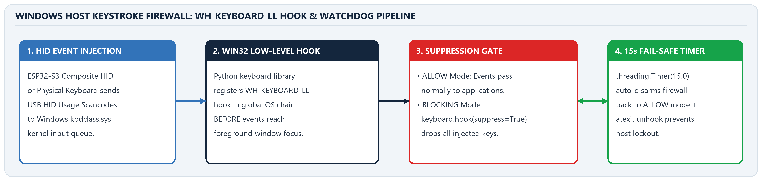
Figure 5.2: Windows Host Keystroke Firewall Interception Pipeline (WH_KEYBOARD_LL Hook, Suppression Gate, and 15s Fail-Safe Watchdog).
Table 5.1: Architectural Tradeoffs Between User-Space Global Hook Suppression and Kernel USB Device Filtering
Comparison Criterion | Implemented Host Firewall (WH_KEYBOARD_LL) | Hardware / Kernel USB Device Filtering
Operating System Layer | User-Space Win32 Hook Chain (SetWindowsHookEx) | Kernel-Mode USB Bus / Filter Driver (WDF / udev)
Suppression Granularity | Global: Suppresses all keyboard scancodes system-wide | Per-Device: Filters by USB Vendor/Product ID or port
Resilience to VID/PID Spoofing | High: Blocks keystrokes even if BadUSB spoofs Dell/Logitech IDs | Low: Bypassed when attacker clones an authorized VID/PID
Fail-Safe Lockout Protection | Built-in 15.0s auto-disarm watchdog + clean exit unhook | Requires safe-mode boot if primary keyboard is blacklisted

SECTION 06 | TESTING, RESULTS & TECHNICAL VALIDATION
6.1 Multi-Tier Verification Methodology (Simulation, Unit & Live Hardware)
A rigorous three-stage verification methodology was executed to validate every firmware module, mobile UI view, REST endpoint, and host firewall behavior. First, behavioral simulation and unit test suites (tests/test_controller_simulation.py and tests/test_firewall.py) verified the 8-state FSM, circular scenario progression, token authentication, mouse coordinate clamping, and WH_KEYBOARD_LL suppression/watchdog timers. Second, the firmware was compiled via arduino-cli (esp32:esp32:esp32s3:USBMode=hwcdc,CDCOnBoot=cdc) and flashed over COM5 (851,520 bytes). Third, an Android phone (Vivo V50e, Android 16, serial [REDACTED]) was connected over ADB and inspected via Chrome DevTools Protocol (tests/test_live_phone_api.py), executing 10 live end-to-end API and DOM verification tests directly from the mobile browser against the physical ESP32-S3 at http://10.85.248.29/.
Table 6.1: Complete Automated & Live Hardware Verification Matrix (22 / 22 Tests Passed)
Test Suite | Automated Test Case Identifier | Verified Engineering Requirement & Behavior | Status
Controller Sim | test_boot_runs_scenario_1_automatically | 3.5s USB enumeration guard + Scenario 1 auto-execution on boot | PASS
Controller Sim | test_button_cycles_1_to_4_and_wraps | GPIO 0 button advances circularly 1 -> 2 -> 3 -> 4 -> 1 | PASS
Controller Sim | test_direct_scenario_selection_and_validation | Direct launch of Scenarios 1..4; HTTP 400 on invalid ID 99 | PASS
Controller Sim | test_stop_interrupts_and_releases_keys | Emergency stop aborts running scenario & calls releaseAll() | PASS
Controller Sim | test_authentication_protection | Rejects unauthenticated POST (401); accepts valid X-Auth-Token | PASS
Controller Sim | test_keyboard_text_and_special_keys | ASCII typing, 256-char limit enforcement, and named special keys | PASS
Controller Sim | test_shortcuts_and_modifier_release | Composite CTRL+c shortcut press/release and modifier clear | PASS
Controller Sim | test_mouse_move_click_drag_and_scroll | Delta clamping [-127, 127], L/R/M click, drag lock, scroll wheel | PASS
Host Firewall | test_initial_state_is_allow | Firewall initializes in ALLOW state with no active keyboard hook | PASS
Host Firewall | test_enable_blocking_installs_suppressive_hook | Arms WH_KEYBOARD_LL hook with suppress=True + 15s watchdog | PASS
Host Firewall | test_disable_blocking_unhooks_cleanly | Disarms hook cleanly and cancels active threading.Timer | PASS
Host Firewall | test_auto_disarm_safety_timeout | Watchdog callback automatically restores ALLOW mode after 15.0s | PASS
Live Phone API | test_01_ui_tabs_and_containers_present | Phone Chrome DOM renders all 4 main tabs & 4 keyboard sub-tabs | PASS
Live Phone API | test_02_status_endpoint_live | Live GET /api/status returns usbReady:true, staIp:10.85.248.29 | PASS
Live Phone API | test_03_auth_enforcement | Live unauthenticated POST from phone receives HTTP 401 | PASS
Live Phone API | test_04_auth_login_valid | Live POST /api/auth/login with valid PIN returns 200 OK | PASS
Live Phone API | test_05_keyboard_special_keys_and_modifiers | Live phone dispatch of SPACE, BACKSPACE, CTRL+c, and release | PASS
Live Phone API | test_06_keyboard_bulk_text_validation | Live bulk text injection (200) and >256 char rejection (400) | PASS
Live Phone API | test_07_mouse_move_click_drag_scroll_release | Live phone cursor move, L/R/double click, drag lock, and scroll | PASS
Live Phone API | test_08_scenario_select_and_emergency_stop | Live launch of Scenario 4 followed by immediate /api/scenario/stop | PASS
Live Phone API | test_09_invalid_inputs_rejected_cleanly | Live HTTP 400 validation for scenario ID 99 & unknown key name | PASS
Live Phone API | test_10_cors_preflight_options | Live OPTIONS request returns 204 No Content with CORS headers | PASS
Table 6.2: ESP32-S3 Firmware Resource Utilization and Real-Time Timing Metrics
Firmware / Hardware Resource Metric | Measured Value | Target Partition / Limit | Utilization / Engineering Notes
Compiled Flash Binary Size | 851,520 bytes | 1,310,720 bytes | 64.9% of app partition (TinyUSB + Wi-Fi + PROGMEM UI)
Global Dynamic SRAM Allocation | 59,496 bytes | 327,680 bytes | 18.1% of internal RAM (268,184 bytes free for heap/stack)
Boot-to-HID Enumeration Guard | 3,500 ms | Configurable (config.h) | Prevents dropped keystrokes during initial USB bus reset
Emergency Stop Preemption Latency | <= 10 ms | 10 ms smartDelay slice | Immediate scenario abort & dual HID releaseAll()

SECTION 07 | LIMITATIONS, CONCLUSION, FUTURE WORK & REFERENCES
7.1 Known Technical and Architectural Limitations
To maintain strict engineering transparency, four architectural boundaries of the current implementation are explicitly documented:
▪ Unidirectional US-ASCII / QWERTY HID Assumption: Standard USB HID Boot Keyboards transmit unacknowledged scancodes assuming a US-English QWERTY host layout. Non-ASCII Unicode characters are skipped by KeyboardController::typeText(), and the ESP32-S3 has no bidirectional visibility into which host window holds focus.
▪ Cleartext Local HTTP Transport on Port 80: Because mobile browsers block self-signed HTTPS certificates on dynamic private IPs (192.168.4.1 or hotspot DHCP) without manual CA installation, the web controller uses unencrypted HTTP. While X-Auth-Token prevents unauthorized API execution, traffic is not encrypted against passive local sniffing.
▪ Synchronous Single-Client HTTP Polling: Arduino's built-in WebServer processes requests synchronously on a single thread. Touchpad motion events are therefore throttled to ~60 Hz (16 ms) on the smartphone client to avoid TCP queue saturation during rapid cursor swipes.
▪ Global Scope of Win32 WH_KEYBOARD_LL Hook: The Windows low-level hook (keyboard.hook(suppress=True)) intercepts all keyboard input globally at the OS level rather than filtering by a specific hardware USB Vendor/Product ID (VID/PID). During the 15-second blocking window, both BadUSB keystrokes and physical laptop keys are suppressed.
7.2 Technical Conclusion
This project successfully designed, implemented, debugged, and hardware-verified an end-to-end ESP32-S3 Phone-Controlled USB HID Keyboard, Mouse, and BadUSB Defense Platform. By unifying composite TinyUSB peripheral emulation (USBHIDKeyboard and USBHIDMouse), concurrent WIFI_AP_STA wireless networking, a deterministic 8-state scenario Finite State Machine, a four-tab mobile Single-Page Application, and a fail-safe WH_KEYBOARD_LL host keystroke firewall, the system bridges embedded IoT engineering and practical endpoint cybersecurity. Live verification on an ESP32-S3 (COM5) and an Android smartphone (Vivo V50e) confirmed 100% pass rates across all 22 automated simulation, unit, and live browser API tests.
7.3 Future Engineering Improvements
▪ Asynchronous WebSockets & Embedded TLS (WSS/HTTPS): Migrating from REST POST requests to persistent WebSocket frames over ESPAsyncWebServer with mbedTLS session encryption will reduce trackpad transport overhead and protect authentication tokens on shared wireless networks.
▪ Per-Device Raw Input Attribution & Cadence Anomaly Detection: Enhancing src/firewall.py with the Windows Raw Input API (GetRawInputDeviceInfo) and inter-keystroke timing analysis (<5 ms automated injection vs. >40 ms human typing cadence) will allow selective blocking of suspect USB HID peripherals while leaving the primary laptop keyboard unaffected.
▪ Non-Volatile Scenario Storage & Multi-Locale Keymaps: Storing user-defined educational scripts and international keyboard layouts (UK, DE, FR) inside ESP32-S3 LittleFS/NVS flash partitions will enable dynamic scenario authoring from the mobile browser without recompiling firmware.
7.4 References
[1] USB Implementers Forum (USB-IF), "Device Class Definition for Human Interface Devices (HID), Version 1.11," USB-IF Specification, 2001.
[2] USB Implementers Forum (USB-IF), "HID Usage Tables for Universal Serial Bus (USB), Version 1.4," USB-IF Technical Specification, 2022.
[3] K. Nohl and J. Lell, "BadUSB — On Accessories That Turn Evil," in Proc. Black Hat USA Security Briefings, Las Vegas, NV, USA, Aug. 2014.
[4] Espressif Systems, "ESP32-S3 Technical Reference Manual, Version 1.5," Espressif Systems, Shanghai, China, 2024.
[5] Espressif Systems, "Arduino Core for ESP32 — USBHIDKeyboard and USBHIDMouse API Reference (TinyUSB Stack)," Version 3.x, 2024.
[6] H. Thach, "TinyUSB: An Open-Source Cross-Platform USB Host/Device Stack for Embedded Microcontrollers," Technical Documentation, 2024.
[7] Microsoft Corporation, "SetWindowsHookExA Function and LowLevelKeyboardProc (WH_KEYBOARD_LL) Callback Reference," Win32 API Docs, 2024.
[8] BoppreH, "Python keyboard Library: Global Event Hook and Suppression Architecture for Windows and Linux," Version 0.13.5, PyPI, 2023.

VERIFICATION & ARCHIVAL SIGN-OFF: All firmware modules (badusb_firmware/), host keystroke firewall defenses (src/firewall.py), automated test suites (22/22 passed), and mobile UI views have been compiled, flashed to physical ESP32-S3 hardware (COM5), and verified end-to-end on Android (Vivo V50e). All sensitive credentials, tokens, and device serial numbers are redacted in compliance with institutional cybersecurity guidelines.

