Forensic Analysis of Unauthorized Access Using Authentication Logs

Submitted by

Ram Karthik G
CH.SC.U4CYS23037
&
Harini V
CH.SC.U4CYS23010

in partial fulfillment for the award of the degree of
BACHELOR OF TECHNOLOGY IN COMPUTER SCIENCE AND ENGINEERING

Under the guidance of
Prof. K. Geetha (CSE-CYS Dept.)
Submitted to


AMRITA VISHWA VIDYAPEETHAM AMRITA SCHOOL OF COMPUTING CHENNAI – 601103

March 2026



BONAFIDE CERTIFICATE

This is Certify that this project report entitled is the bonafide work of, who carried out the project work under my supervision.

SIGNATURE

Ms. K Geetha
Supervisor
Assistant Professor (Si. Grade)
Department of CSE-CYS Amrita School of Computing Chennai.

INTERNAL EXAMINER EXTERNAL EXAMINER

CHAPTER 1

INTRODUCTION

1.1 PROBLEM DOMAIN
In modern computing environments, authentication systems are widely used to control access to networks, servers, and applications. Every login attempt made by users or attackers is recorded in authentication logs, which include information such as timestamps, IP addresses, usernames, and login results. These logs are an important source of information for identifying security incidents and performing digital forensic investigations.
However, the analysis of authentication logs is often performed manually. As systems generate a large number of log entries daily, manually examining these logs becomes time-consuming and inefficient. Security analysts may need to go through thousands of log records to identify suspicious activities such as repeated failed login attempts, unusual login times, or potential unauthorized access. This manual process is also prone to human errors, which may result in important security incidents being missed.
In addition, raw log data is typically unstructured and difficult to interpret without proper tools. Investigators must spend significant effort extracting relevant information and identifying patterns that indicate possible attacks. This creates a challenge in quickly detecting security threats and responding to incidents effectively.
Therefore, the problem domain of this project lies in the field of digital forensics and cybersecurity, specifically focusing on the automated analysis of authentication logs. The goal is to develop a system that can process large volumes of log data, detect suspicious access patterns, and convert raw log information into meaningful forensic insights that assist investigators in identifying and understanding unauthorized access attempts.

1.2 PROBLEM DESCRIPTION
Authentication logs record login attempts in computer systems and are important for detecting unauthorized access and security incidents. However, modern systems generate a large volume of log data, making manual analysis difficult and time-consuming. Security analysts must examine numerous log entries to identify suspicious patterns such as repeated failed logins or unusual login times. Manual log analysis is also prone to human errors, which may cause important security incidents to be missed. Therefore, there is a need for an automated system that can efficiently analyze authentication logs, detect suspicious activities, and convert raw log data into meaningful forensic information for investigators.

1.3 SCOPE
The scope of this project is to develop an automated forensic analysis tool that processes authentication logs to detect suspicious login activities. The system focuses on identifying patterns such as brute-force login attempts, unusual login times, and possible account compromise based on authentication log data.
The tool parses log files, analyzes login events, and applies detection rules to identify potential security threats. It also generates structured forensic reports and visualizations to help investigators understand attack patterns and reconstruct timelines.
The system is designed to assist security analysts and investigators by converting raw authentication logs into meaningful forensic insights. However, the project is limited to analyzing authentication logs and does not include real-time monitoring or analysis of other types of system logs.

1.4 CONTRIBUTION
The main contribution of this project is the development of an automated forensic analysis tool that helps investigators analyze authentication logs efficiently. The system reduces the need for manual log examination by automatically parsing log files and identifying suspicious login activities. The project introduces multi-layer detection techniques to identify patterns such as brute-force attempts, unusual login times, and potential account compromise. It also implements a threat scoring mechanism to classify the severity of detected activities. In addition, the system provides a user-friendly graphical interface, visual analytics, and structured forensic reports, making it easier for investigators and security analysts to interpret log data and reconstruct attack timelines. These features improve the efficiency and accuracy of digital forensic investigations.

1.5 SWOT ANALYSIS
STRENGTHS | WEAKNESSES
- Automates the analysis of authentication logs, reducing manual effort for investigators.  - Multi-layer detection mechanism identifies brute-force attempts, suspicious login times, and compromise patterns.  - Threat scoring model helps prioritize security incidents based on severity levels.  - Graphical dashboard with visualizations improves understanding of attack patterns.  - CSV export enables easy generation of forensic evidence reports. | - System depends on specific authentication log formats for accurate parsing.  - Performance may decrease when processing very large log files.  - Possibility of false positives if detection thresholds are not properly tuned.
OPPORTUNITIES | THREATS
- Can be extended to support multiple log formats from different operating systems and servers.  - Potential integration with Security Information and Event Management (SIEM) platforms.  - Can be enhanced with machine learning for intelligent anomaly detection.  - Useful for digital forensic investigators, SOC analysts, and cybersecurity teams. | - Advanced security monitoring tools with AI-based detection may outperform rule-based systems.  - Attackers may modify attack techniques to bypass simple detection rules.  - Changes in system log structures may affect parsing accuracy.  - Misinterpretation of results could occur if users lack security analysis knowledge.
Table 1.1 SWOT analysis

1.6 PESTLE ANALYSIS

1.6.1 Political
Government cybersecurity policies and national digital security initiatives encourage organizations to monitor and investigate unauthorized access attempts. Regulations promoting stronger cyber defense and digital forensics capabilities support the development and adoption of automated log analysis systems. Such policies help organizations improve their incident response and security monitoring practices.

1.6.2 Economical
The proposed system is developed using open-source programming tools and standard authentication logs, which makes it cost-effective for organizations to implement. Since it does not require expensive proprietary security software, small organizations and research environments can also adopt it. However, organizations may still need computing resources to analyze large volumes of log data.

1.6.3 Social
Rapid advancements in cybersecurity technologies influence how authentication logs are generated and analyzed. New attack techniques may require continuous updates to detection algorithms and analysis methods. At the same time, improvements in data visualization, automation, and threat detection technologies provide opportunities to further enhance the capabilities of the system.

1.6.4 Technological
Technological advancements influence how authentication logs are collected and analyzed. Modern tools for automation, data processing, and visualization improve the efficiency of detecting unauthorized access attempts. However, evolving cyberattack techniques may require regular updates to the system’s detection methods.

1.6.5 Legal
Organizations must comply with cybersecurity regulations and data protection laws when collecting and analyzing authentication logs. Log analysis systems should follow proper digital forensic practices to ensure that generated reports can be used as valid evidence during security investigations. Compliance with data protection policies is important to ensure responsible use of log data.
1.6.6 Environmental
The system operates as a software-based forensic analysis tool and does not involve physical infrastructure or hardware-intensive processes. Therefore, it has minimal environmental impact. It runs on standard computing systems and primarily processes digital log files, making its environmental footprint very low.

1.7 ORGANISATION OF THESIS

Chapter 2 presents a review of existing research and related work in the field of authentication log analysis, digital forensics, and unauthorized access detection. Chapter 3 describes the system requirements and analysis, including functional and non-functional requirements, assumptions, and constraints involved in the development of the system. Chapter 4 explains the overall system architecture and design of the proposed forensic analysis tool, including the modules for log parsing, detection mechanisms, threat scoring, and visualization. Chapter 5 discusses the implementation details of the system, including the development of the GUI dashboard, multi-layer detection algorithms, and report generation features. Chapter 6 presents the experimental results and analysis, including test results, visualizations, and generated forensic reports used to identify suspicious login activities. Chapter 7 concludes the thesis by summarizing the work carried out in the project, highlighting its contributions, limitations, and possible future improvements.

CHAPTER 2

Project Description
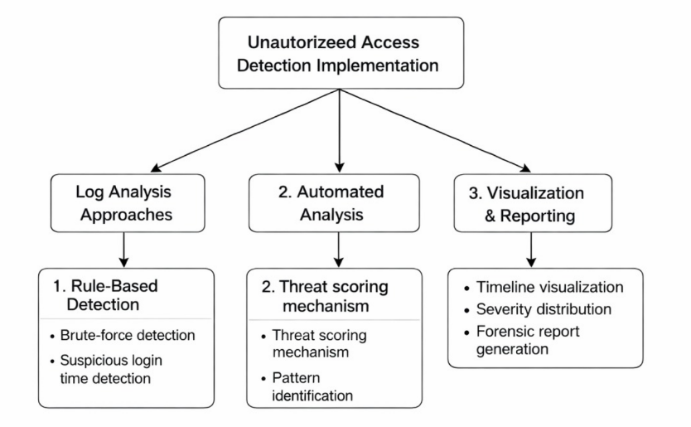
This chapter presents an overview of approaches used to detect unauthorized access through authentication log analysis. Authentication logs record login attempts, timestamps, IP addresses, and login results, which help investigators identify suspicious activities such as brute-force attacks and abnormal login patterns. The proposed system automates the analysis of these logs using detection techniques, threat scoring, and visualization tools to assist investigators in identifying potential security incidents efficiently.

Figure 2.1 Approaches to unauthorized access detection

2.1 DIRECTORY BASED APPROACHES
Directory-based approaches detect suspicious or unauthorized login activities by comparing authentication logs with a predefined directory or database of known users, devices, or IP addresses. The system verifies whether the login attempt matches the stored legitimate information. If any mismatch or unknown entry is detected, it is flagged as a potential security threat. This method helps investigators quickly identify unusual login behavior and supports faster forensic analysis.

2.2 RULE BASED APPROACHES
Rule-based approaches detect unauthorized access by applying predefined rules to authentication logs. These rules analyze patterns such as repeated failed login attempts, unusual login times, or suspicious IP activity. The system flags events when they exceed certain thresholds.
Several security monitoring tools use rule-based detection to identify brute-force attacks or suspicious login behavior. For example, systems may trigger alerts when multiple failed login attempts occur from the same IP address within a short time. Some log monitoring solutions also analyze login attempts during unusual hours, such as midnight to early morning, which may indicate potential compromise.
Rule-based systems are simple to implement and efficient for real-time monitoring. However, they rely on predefined patterns and may not detect new or unknown attack strategies. Because of this limitation, rule-based approaches are often combined with other techniques for improved detection accuracy.

2.3 ML BASED APPROACHES
Machine Learning (ML) based approaches analyze authentication logs using algorithms that learn patterns from historical data. These systems can automatically identify anomalies and suspicious login behavior without relying solely on predefined rules.
Several research works have applied ML algorithms such as Random Forest, Support Vector Machines, and Neural Networks to detect cyber attacks. These models analyze features such as login frequency, IP addresses, user behavior, and time patterns to identify potential threats.
ML-based systems are capable of detecting complex attack patterns and previously unseen threats. They also improve over time as more data becomes available. However, these approaches require large datasets, computational resources, and external processing environments, making them more complex to implement compared to rule-based systems.

2.4 DRAWBACKS
Based on the existing approaches, several limitations can be identified. Many traditional log analysis systems rely heavily on manual investigation, which is time-consuming and prone to human error. Rule-based approaches, while simple, may fail to detect advanced or unknown attack patterns.
Machine learning based systems can provide better accuracy but require significant computational resources, training datasets, and complex implementation. In many cases, these systems also lack clear visualization and structured reporting for investigators.
The proposed system addresses these issues by developing an automated forensic analysis tool that combines multi-layer detection, threat scoring, visual analytics, and structured reporting to assist investigators in quickly identifying unauthorized access attempts.

CHAPTER 3

Methodology

3.1 FUNCTIONAL REQUIREMENTS
The system analyzes authentication logs to detect unauthorized access attempts and generate forensic reports for investigators.
The system should adhere to the following requirements:
- The system should automatically parse authentication log files and extract important information such as IP address, login status, and timestamp.
- The system should detect suspicious activities such as brute-force login attempts, night-time logins, and possible compromise patterns.
- The system should calculate a threat score for each IP address to determine the severity level of potential attacks.
- The system should generate a structured forensic report that helps investigators analyze security incidents quickly.
- The system should provide visualizations such as charts and timelines to support forensic analysis.

3.2 NON FUNCTIONAL REQUIREMENTS

3.2.1 User Interface
The system should provide a simple and user-friendly graphical interface. Investigators should be able to upload authentication log files and view analysis results clearly. The interface should display detection results, threat scores, and visual charts for better understanding of suspicious activities.
3.2.2 Hardware
No special hardware is required for implementing the system. The application can run on a standard computer with basic processing capability.

Software
- Python programming language
- Python libraries such as Tkinter, Pandas, Matplotlib, and Regex
- Operating system supporting Python execution (Windows, Linux, or macOS)

3.2.4 Performance
The system should efficiently process authentication logs and provide quick analysis results. It should handle large log files with minimal delay and ensure accurate detection of suspicious login activities with reduced false positives.

3.3 CONSTRAINTS AND ASSUMPTIONS

3.3.1 Constraints
- The system relies on authentication logs as the primary data source. If the log files are incomplete or corrupted, the analysis results may be affected.
- Different operating systems and servers generate authentication logs in different formats, which may require additional parsing rules.
- Processing extremely large log files may affect system performance and increase analysis time.

3.3.2 Assumptions
- The authentication log files provided to the system follow a standard and consistent format.
- The system is executed in an environment where Python and the required libraries are properly installed.
- Investigators or analysts using the system have basic knowledge of cybersecurity and log analysis.

3.4 SYSTEM MODELS

3.4.1 Use Case Diagram

The overall use case diagram of the entire system is shown in Figure 3.1. The investigator or analyst uploads authentication log files into the system for analysis. The system processes the log data and detects suspicious login activities such as brute-force attempts, unusual login times, or multiple failed login attempts. After analysis, the system generates visualizations and a forensic report to help the investigator understand the unauthorized access attempts.

Pre condition: The user has the system installed and authentication log files are available for analysis.

Post condition: The system analyzes the logs and displays detected suspicious activities along with the generated forensic report.

CHAPTER 4

Schematic Diagram

4.1 SYSTEM ARCHITECTURE

The proposed system, SENTINEL – Forensic Intelligence Platform, is designed as an automated forensic analysis tool for identifying suspicious and unauthorized access attempts from authentication logs. The system is intended to assist digital forensic investigators, SOC analysts, and cybersecurity practitioners in analysing large volumes of login-related events efficiently. Authentication logs are one of the most valuable sources of evidence in cybersecurity investigations because they record critical details such as who attempted to access a system, when the attempt occurred, whether it was successful, and from which IP address it originated. Since manual inspection of large authentication logs is difficult, slow, and error-prone, the proposed system automates the analysis process and transforms raw log data into actionable forensic intelligence. This aligns with the project’s scope and contribution sections, which emphasize automated parsing, suspicious activity detection, visualization, and structured reporting.

The architecture of the system follows a modular and layered design. Each module performs a specific task in the forensic pipeline, starting from log ingestion and ending with report generation. This modular design improves maintainability, scalability, and ease of understanding. It also allows investigators to trace how the data moves through the system, which is important in forensic applications where transparency and interpretability are essential.

At a high level, the system architecture consists of the following major components:

Input Log File → Log Parsing and Preprocessing → Detection Engine → Threat Scoring → Forensic Intelligence Layer → Visualization Dashboard → Report Generation and Export

Each stage of this architecture is described in detail below.
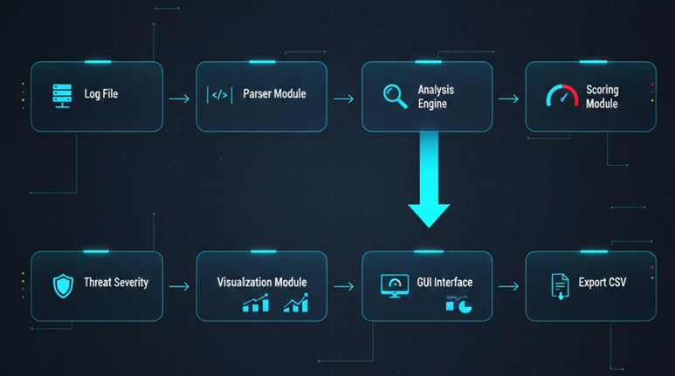
Figure 4.1 System Architecture

4.1.1 Log Input Module
The first component of the system is the Log Input Module, which is responsible for accepting authentication log files from the user. These logs may come from real operating system authentication records or from simulated attack scenarios generated for testing and evaluation. The input logs contain information such as timestamps, usernames, source IP addresses, login results, and other event-related attributes. The quality and completeness of these log files directly affect the effectiveness of the analysis. If the input logs are incomplete, inconsistent, or corrupted, the resulting forensic conclusions may be less reliable. This is consistent with the project’s stated constraints and assumptions regarding dependence on log format and data quality.
The log input process is designed to be simple and investigator-friendly. Through the SENTINEL dashboard, users can load a log file from the local system using the Load Log File option. Once the file is selected, the system validates the input and prepares it for parsing. This design ensures that the tool can be used even by analysts with limited programming knowledge, which supports the project’s goal of building a practical forensic investigation tool.

4.1.2 Log Parsing and Preprocessing Module

Authentication logs are generally stored in a semi-structured or unstructured text format. Before meaningful analysis can be performed, the raw log entries must be converted into a structured representation. This is the role of the Log Parsing and Preprocessing Module.
In this stage, the system uses regular expressions (Regex) and string pattern matching techniques to identify and extract important fields from each log entry. These fields include:
- source IP address
- timestamp of the event
- username or account identifier
- login result (success or failure)
- frequency of attempts
- session-related indicators
The extracted values are then normalized into a structured tabular form so they can be processed by later modules. Timestamp normalization is especially important because authentication logs may store time information in different formats. A consistent timestamp representation helps the system correctly reconstruct the sequence of events and build reliable timelines.
This module plays a major role in reducing forensic complexity. Instead of forcing the investigator to manually read hundreds or thousands of lines of raw log text, the parser converts the data into an analyzable format. The project report already identifies parsing as a key requirement and emphasizes extraction of IP address, login status, and timestamp as core fields.

4.1.3 Detection Engine

The Detection Engine is the core analytical component of the system. After the logs have been parsed and normalized, the detection engine applies multiple rule-based techniques to identify suspicious patterns that may indicate unauthorized access or malicious intent. Rather than relying on manual observation, the system systematically evaluates the structured events to find evidence of attacks.
The detection engine focuses on recognizing the following main categories of suspicious behavior:
Brute Force Login Attempts
This occurs when the same IP address performs multiple failed login attempts in a short period. Such repeated failures may indicate password guessing or credential-stuffing behavior.
Credential Abuse or Possible Account Compromise
If a successful login is observed after several failed attempts from the same source, the activity may indicate that the attacker eventually guessed the password or gained access to valid credentials.
Unusual Login Time Detection
The system checks whether login attempts occur during high-risk hours, such as late night or early morning. Access during abnormal hours may be suspicious, especially when combined with failed attempts or unusual origin patterns.
Repeated Access Attempts from the Same IP
If the same IP repeatedly appears across multiple failed or suspicious sessions, it is flagged for forensic attention.
Anomalous Activity Patterns
The system also identifies behavior that does not follow expected or normal access patterns, such as sudden surges in attempts or suspicious combinations of event characteristics.
These rule-based detections make the system practical and explainable. Since the criteria are explicit, the investigator can understand exactly why an alert was generated. This supports the report’s emphasis on automated detection of brute force, unusual login timing, and possible compromise patterns.

4.1.4 Threat Scoring Module

After suspicious events have been detected, the system calculates a threat score for each entity under investigation, especially IP addresses associated with suspicious access patterns. The purpose of this module is to prioritize incidents based on severity, so that investigators can focus first on the most dangerous or urgent threats.
The threat score is calculated using a weighted mechanism. Different suspicious behaviors contribute different numbers of points according to their forensic significance. Based on the report’s implementation details, the system uses weighted scoring such as:
- failed login attempts contribute 2 points
- successful login after prior failures contributes 3 points
- login during high-risk hours contributes 5 points
The total score represents the overall level of suspicion. Based on the final score, the system classifies the event or IP address into one of the following categories:
- LOW
- MEDIUM
- HIGH
- CRITICAL
This classification is highly useful in digital forensics and incident response. Instead of reviewing every event equally, the analyst can immediately identify which login source or event pattern deserves deeper investigation. The report also states that the tool uses threat scoring to classify severity and improve interpretation of detected incidents.

4.1.5 Forensic Intelligence and Attack Reconstruction Layer
A major strength of the SENTINEL platform is that it does not merely show suspicious events individually; it also helps reconstruct the likely attack progression. The Forensic Intelligence Layer correlates detection results and transforms them into a more meaningful representation of the attack chain.
In the dashboard, this is reflected through the forensic analysis view and the MITRE ATT&CK tab, where suspicious events are mapped to common attacker tactics and techniques. This mapping helps the investigator move from simple event observation to forensic reasoning. Instead of seeing only that “many failures occurred,” the analyst can interpret them as part of a broader attack scenario.
Examples of this mapping include:
- Valid Accounts under Initial Access
- Brute Force under Credential Access
- Command and Scripting Interpreter under Execution
- Indicator Removal under Defense Evasion
This form of correlation is valuable because real attacks are often multi-stage. An unauthorized access attempt may begin with repeated failed logins, then progress to a successful credential compromise, and then continue with execution or evasion behavior. Mapping these to attack phases gives the analyst a structured understanding of the adversary’s possible objectives and methods.

4.1.6 Visualization Module

A key objective of the project is to make forensic outputs easier to interpret through charts, timelines, and dashboards. The Visualization Module converts the analysis results into graphical representations so that investigators can quickly recognize patterns, frequency, intensity, and severity. This is fully consistent with the report’s repeated emphasis on charts, timelines, severity graphs, and graphical dashboards.
The visualization layer includes the following major elements:
Summary Metrics
At the top of the dashboard, counters display total events, failed events, suspects, critical alerts, and anomalies. These give an immediate high-level view of the case.
Timeline Analysis
This helps reconstruct the sequence of login attempts over time. Timeline views are especially important in forensic investigations because they help determine when an attack started, how long it continued, and whether activity escalated.
Severity Distribution
This visualization shows how many events fall into each risk category. It allows the investigator to quickly see whether the case is dominated by low-risk noise or high-risk incidents.
Attack Phase Intensity
The MITRE ATT&CK panel presents the intensity of activity across phases such as Initial Access, Credential Access, Execution, and Defense Evasion. This shows which stages are most prominent in the observed attack behavior.
Operational Technique Dictionary
This tabular element lists attack-related signatures, their formal designations, and the number of occurrences. It provides both technical detail and forensic context.
These visualizations improve human understanding of the case and reduce the effort required to interpret raw data. They are especially useful for presentation, incident summary, and evidence discussion.

4.1.7 Report Generation and Export Module

The final major architectural component is the Report Generation and Export Module. After analysis is complete, the system produces structured forensic outputs that can be reviewed, stored, and shared. These reports summarize the evidence in a clean and organized form.
The report typically includes:
- suspicious IP addresses
- number of failed and successful login attempts
- unusual access times
- assigned threat scores
- severity levels
- identified attack patterns
- timeline-related observations
The tool supports exporting results into CSV format for data storage and later analysis, and also provides HTML report support through the dashboard interface. The report acts as a compact forensic artifact that helps investigators document the incident and preserve evidence in a readable form. The original report also highlights CSV export and structured forensic reporting as important contributions of the project.

4.1.8 User Interface Layer

The entire architecture is tied together through the SENTINEL graphical dashboard. The user interface acts as the interaction layer between the analyst and the forensic engine. It is designed to be simple, professional, and investigation-oriented.
Through the interface, the investigator can:
- load authentication log files
- simulate attack scenarios for testing
- run the forensic analysis process
- view system logs and summary results
- switch between report, timeline, severity, AI analysis, forensics, and MITRE ATT&CK views
- export results for documentation
This design makes the system not only technically functional but also operationally practical. It supports both investigation and demonstration purposes, which is useful in academic, lab, and prototype deployment settings.

4.2 UI DESIGN
The SENTINEL – Forensic Intelligence Platform provides a modern and investigator-friendly graphical user interface that allows the user to interact with the forensic engine in an organized and intuitive manner. The dashboard is one of the major strengths of the system because it transforms complex authentication log analysis into a visually understandable workflow.
The interface is structured into multiple panels and tabs so that users can perform analysis step by step without requiring command-line interaction. This improves accessibility for digital investigators, security analysts, and students who may not be comfortable working directly with raw logs or terminal outputs.
4.2.1 Navigation Panel
The left-side navigation panel contains the main actions required for investigation. These options include:
- Load Log File – used to import authentication logs into the platform
- Simulate Attack – used to generate or load suspicious scenarios for testing and demonstration
- Run Analysis – executes the forensic detection and scoring pipeline
- Show Graphs – displays visual analytics of the case
- HTML Report – opens or generates a structured web-style forensic report
- Export CSV – exports analysis results for storage or documentation
- Settings – allows system-level configuration and preferences
This menu-driven design makes the system easy to use and allows the investigator to move through the analysis process in a clear sequence.

4.2.2 Dashboard Header and Summary Metrics
At the top of the interface, the dashboard displays key summary counters such as:
- total number of events
- number of failed events
- number of suspect entities
- number of critical findings
- number of anomalies
These counters immediately communicate the scale and severity of the incident under analysis. Forensic investigators often need an initial overview before diving into details, and this header serves that exact purpose.

4.2.3 Tab-Based Investigation Views
The central section of the GUI contains multiple tabs such as:
- System Logs
- Report
- Timeline
- Severity
- AI Analysis
- Forensics
- MITRE ATT&CK
Each tab presents a different perspective of the same case. This design allows the investigator to transition smoothly from raw evidence to summarized insights, then to timelines, threat categories, and finally attack-stage interpretation.

4.2.4 MITRE ATT&CK View
One of the most advanced-looking parts of the dashboard is the MITRE ATT&CK tab. This section shows the distribution of detected activities across tactical phases. It also lists operational techniques, their signatures, their formal designations, and the number of occurrences. This helps investigators map local authentication evidence to recognized adversary behaviors and makes the system appear closer to a professional forensic intelligence platform.

4.2.5 Visualization Support
The graphical interface is supported by visual components such as charts, counters, phase intensity bars, and structured tables. These are useful because forensic interpretation becomes faster when evidence is presented visually rather than as plain raw logs.

4.2.6 UI Significance in Digital Forensics
In digital forensics, a user interface is not just for display; it plays an important operational role. It helps the investigator:
- quickly identify suspicious patterns
- compare multiple indicators in one place
- understand event progression
- summarize the findings to faculty, analysts, or supervisors
- document the case clearly for reporting purposes
Thus, the dashboard is not merely cosmetic; it is an integral part of the forensic workflow.

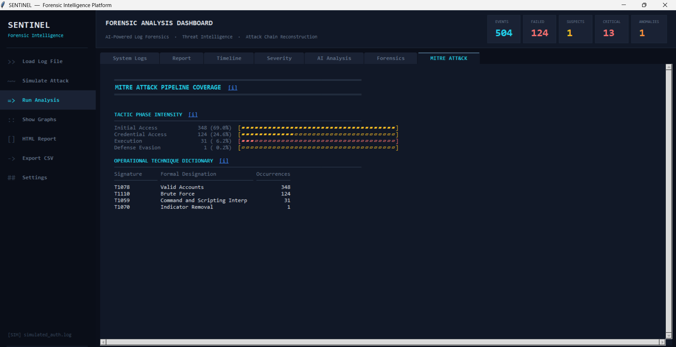
Figure 4.2 UI Design

4.3 MODULE DESIGN

4.4.1 Log Preprocessing
The proposed system is divided into several functional modules, each responsible for a specific stage of the forensic analysis process.

4.3.1 Log Input Module
This module is responsible for receiving authentication log files from the user. It validates the file and makes it available to the parsing engine. Its purpose is to provide a clean entry point into the system.

4.3.2 Parsing and Preprocessing Module
This module reads raw log entries and extracts forensic attributes such as IP address, timestamp, user identity, login status, and event frequency. It also normalizes timestamps and organizes the extracted fields into a structured representation.

4.3.3 Detection Module
This module applies the core analytical rules to identify suspicious access behavior. It detects brute force attempts, unusual login timing, possible compromise patterns, and repeated malicious access attempts.

4.3.4 Threat Scoring Module
This module calculates a weighted risk score for suspicious entities or events. The assigned score is later used to classify events into severity levels such as LOW, MEDIUM, HIGH, and CRITICAL.

4.3.5 Forensic Intelligence Module
This module correlates suspicious events and maps them to meaningful attack interpretations. It supports attack-stage understanding and forensic reconstruction, including ATT&CK-style categorization.

4.3.6 Visualization Module
This module creates graphical outputs such as charts, summary counters, severity displays, and timeline views. It improves interpretability and supports investigator decision-making.

4.3.7 Report Generation Module
This module generates structured forensic reports and enables export in CSV and HTML formats. It is responsible for preserving the final results of the investigation in a usable form.

4.3.8 User Interface Module
This module presents all results to the analyst through the SENTINEL dashboard. It connects user actions to backend processing and integrates the complete workflow into a single platform.

4.4 SYSTEM WORKFLOW
The overall workflow of the proposed system is designed to convert raw authentication log data into meaningful forensic intelligence in a structured and efficient manner. The system follows a sequential pipeline in which each module performs a specific task and passes its output to the next stage. This workflow ensures that the analysis process remains systematic, transparent, and suitable for digital forensic investigation. It also reflects the report’s stated focus on parsing logs, detecting suspicious login behavior, assigning threat scores, and producing visual and structured outputs for investigators.

4.4.1 Log File Loading
The workflow begins when the user loads an authentication log file into the SENTINEL – Forensic Intelligence Platform. Authentication logs serve as the primary source of evidence in this project because they record login-related events such as access attempts, timestamps, usernames, IP addresses, and login outcomes. These logs may represent either real system-generated records or simulated attack data prepared for testing and evaluation. Once the file is selected, the system accepts it as input and prepares it for further processing. This step is important because the quality and completeness of the input log directly affect the reliability of the forensic analysis. As noted in the report, the system depends on authentication logs as its main data source, and incomplete or corrupted logs can affect the analysis outcome.

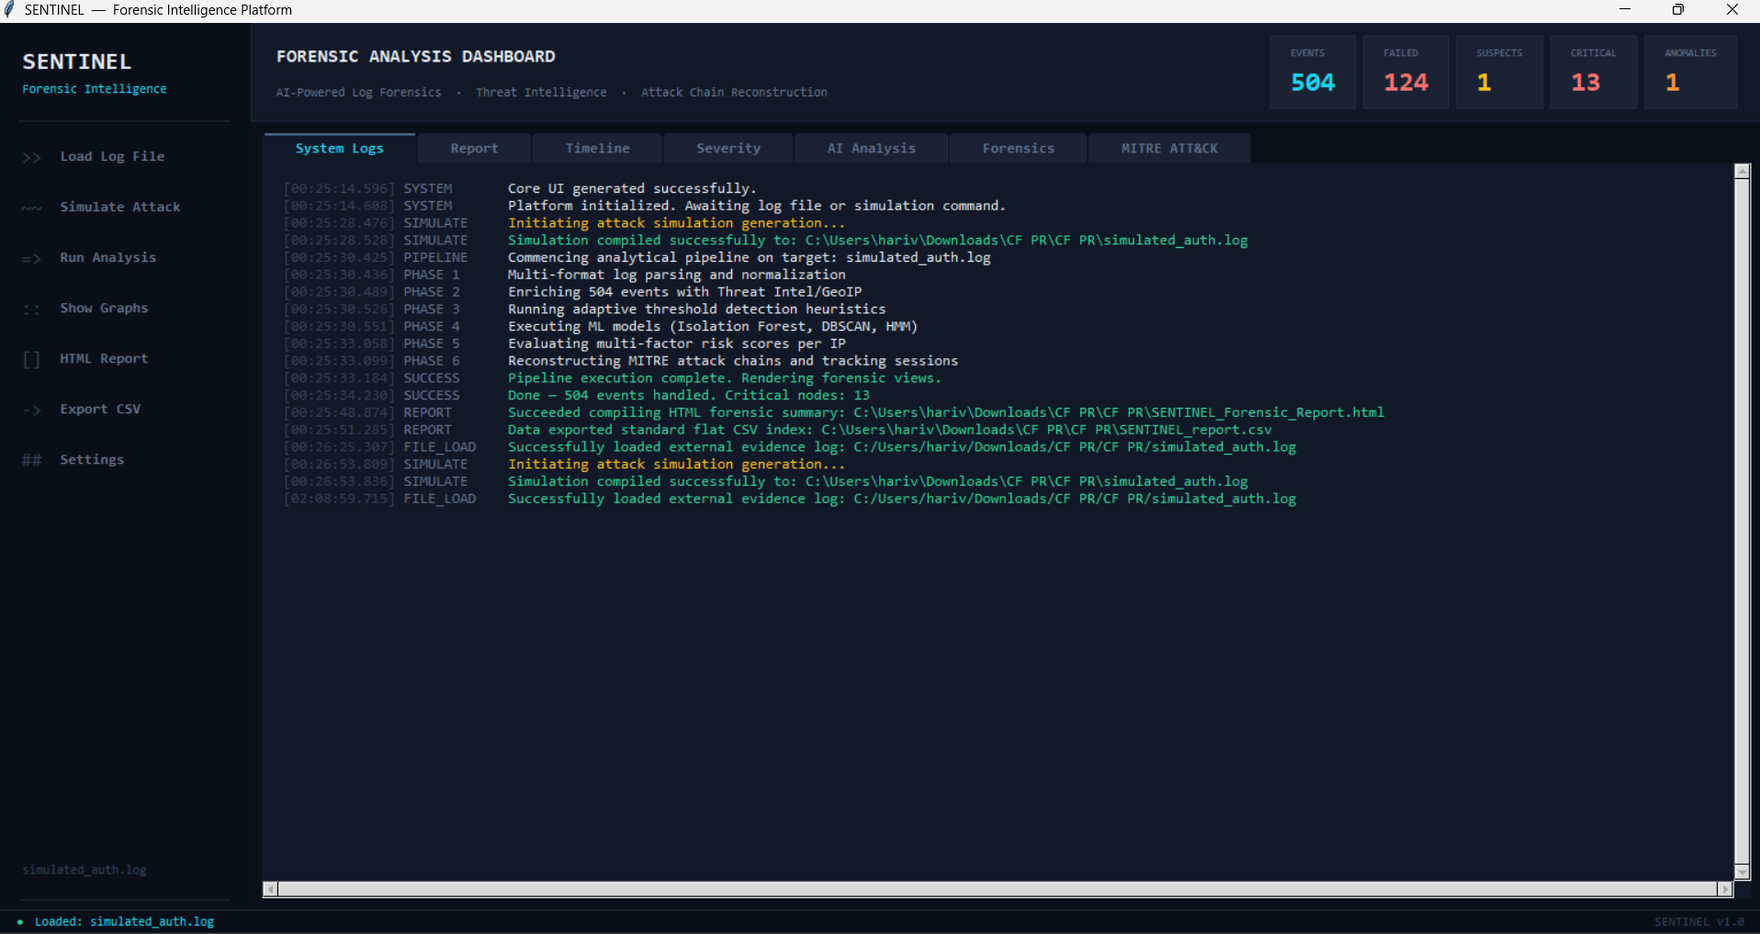
4.4.2 Parsing and Field Extraction
After the log file is loaded, the parser reads the raw log entries and extracts relevant forensic fields from them. Since authentication logs are often semi-structured or unstructured, they cannot be analyzed directly in their original form. The parser therefore uses regular expressions and pattern-matching techniques to identify important attributes such as IP address, timestamp, login status, username, and event sequence. These extracted values are then converted into a structured format so that the later analysis stages can process them accurately. This parsing stage reduces the complexity of manual log inspection and forms the foundation for reliable threat detection. The report already describes parsing as one of the system’s main requirements and implementation components.

4.4.3 Suspicious Activity Detection
Once the log data has been structured, the Detection Engine analyzes the extracted events to identify suspicious or unauthorized access behavior. This stage is one of the most critical parts of the workflow because it transforms ordinary log records into meaningful security findings. The detection engine applies rule-based checks to discover patterns that may indicate malicious intent. These include repeated failed login attempts, successful login after multiple failures, night-time access during unusual hours, and repeated attempts originating from the same IP address. Through these checks, the system can identify signs of brute-force attacks, credential abuse, or other suspicious access behavior. This directly matches the project’s scope and contribution, which emphasize automated detection of brute-force attempts, unusual login timings, and possible compromise patterns.
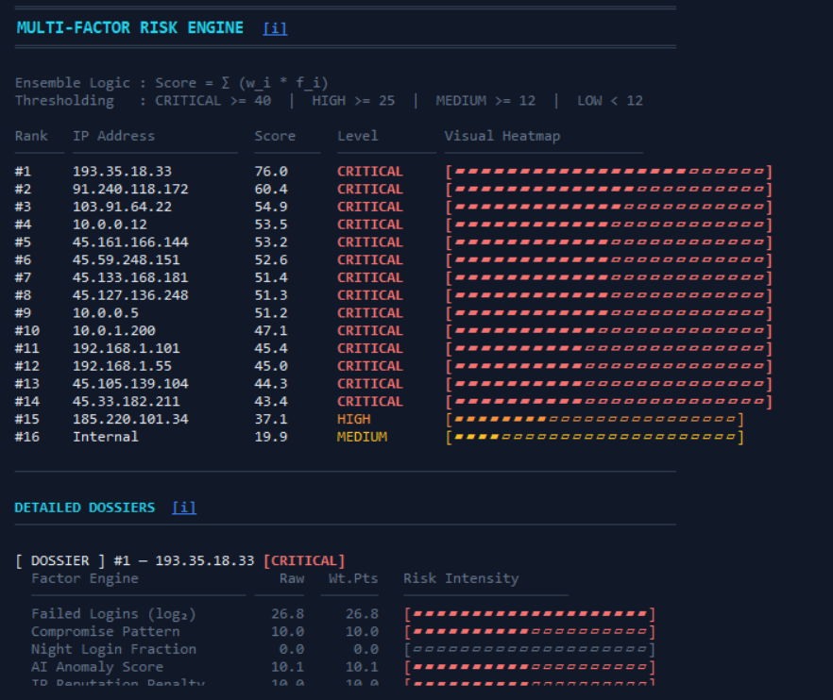

4.4.4 Threat Scoring and Risk Classification
After suspicious events are detected, the Threat Scoring Module calculates risk values for the identified activities. The purpose of this step is to prioritize the events according to their severity so that investigators can focus first on the most critical cases. The scoring system uses predefined weighted values for different indicators of suspicion. For example, failed login attempts contribute to the score, successful access after repeated failures adds more weight, and login attempts during high-risk hours contribute a higher level of concern. Based on the total score, the system assigns severity levels such as LOW, MEDIUM, HIGH, and CRITICAL. This stage improves the interpretability of the analysis by turning raw suspicious patterns into quantifiable risk categories. The report explicitly notes that the system uses weighted scoring and severity levels to support forensic investigation.

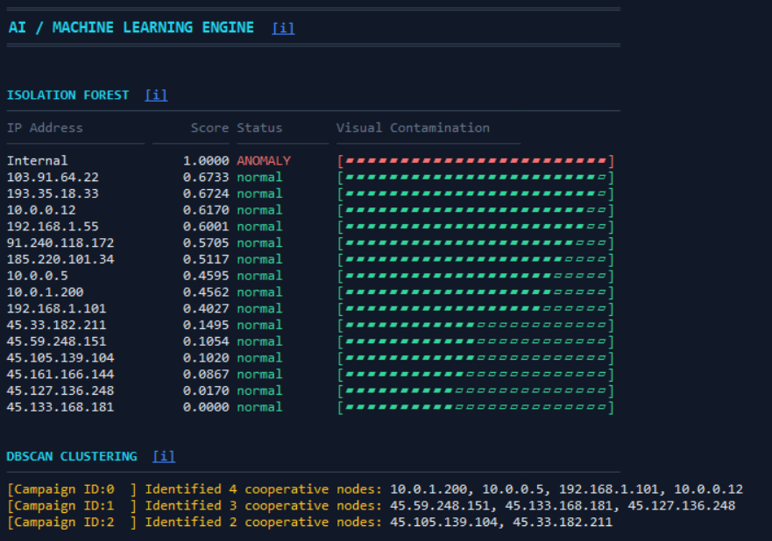

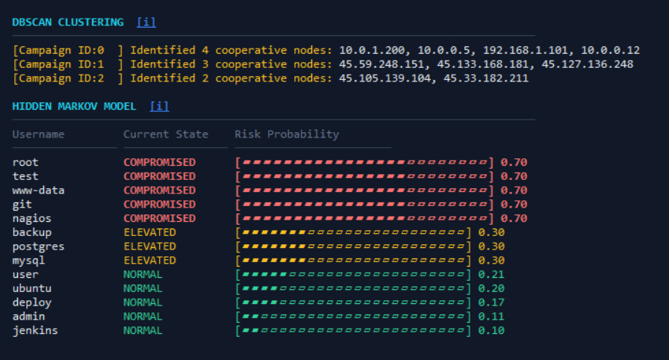

4.4.5 Forensic Intelligence and Attack Correlation
After threat scoring, the system passes the results to the Forensic Intelligence Layer, where the findings are correlated and interpreted in a broader investigative context. Instead of treating each event in isolation, the system attempts to reconstruct likely attack behavior by linking related indicators together. For example, a sequence of repeated failures followed by a success from the same source can be interpreted as a probable compromise attempt. In the SENTINEL platform, this stage is also supported by tactical mapping views inspired by the MITRE ATT&CK framework, where suspicious actions are associated with attacker techniques and phases such as Initial Access, Credential Access, Execution, or Defense Evasion. This adds more investigative value because it helps the analyst understand how the observed login events fit into a larger cyberattack pattern.
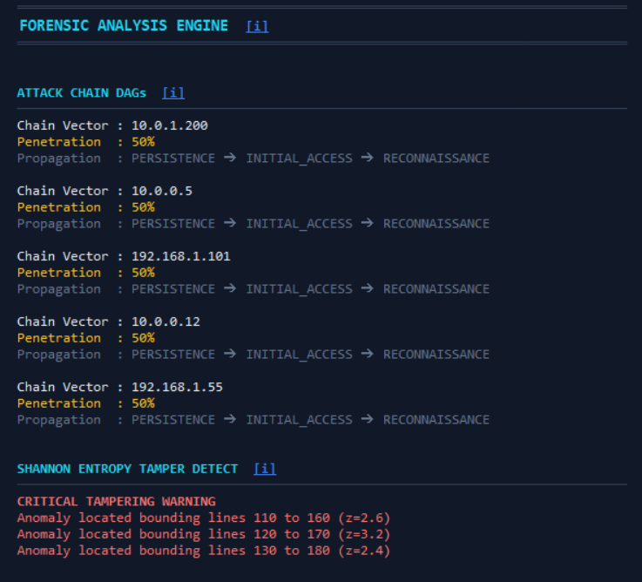

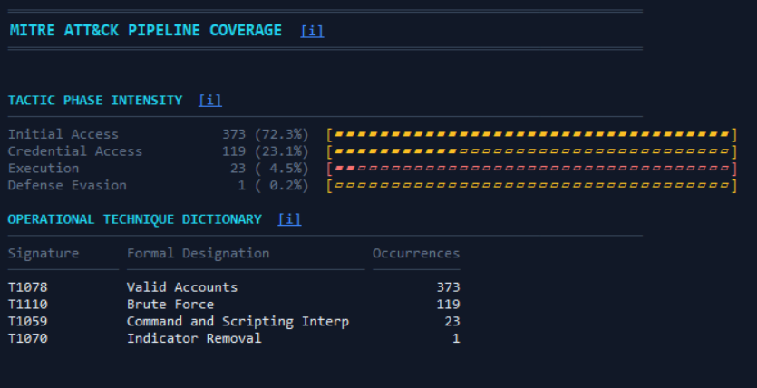

4.4.6 Visualization of Results
The next stage in the workflow is the Visualization Module, which presents the results of the analysis through charts, summary counters, severity distributions, timelines, and tactical panels. Visualization is a key feature of the system because large authentication logs can be difficult to interpret through text alone. By converting the results into dashboards and graphs, the system makes it easier for investigators to identify suspicious IPs, observe the intensity of attack phases, compare risk levels, and understand the chronological progression of events. The original report repeatedly highlights visualization as one of the project’s major contributions, especially in the form of bar charts, timeline charts, and severity graphs.

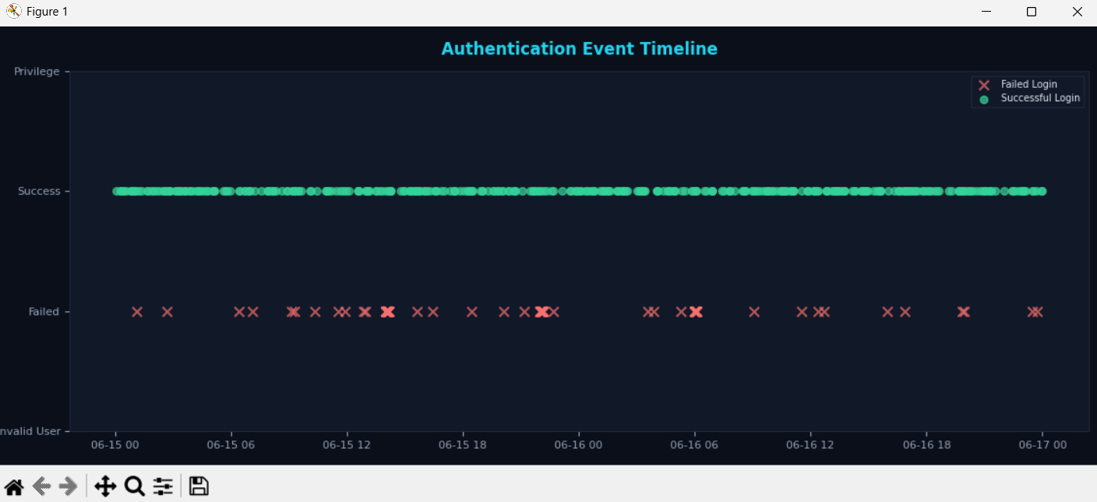
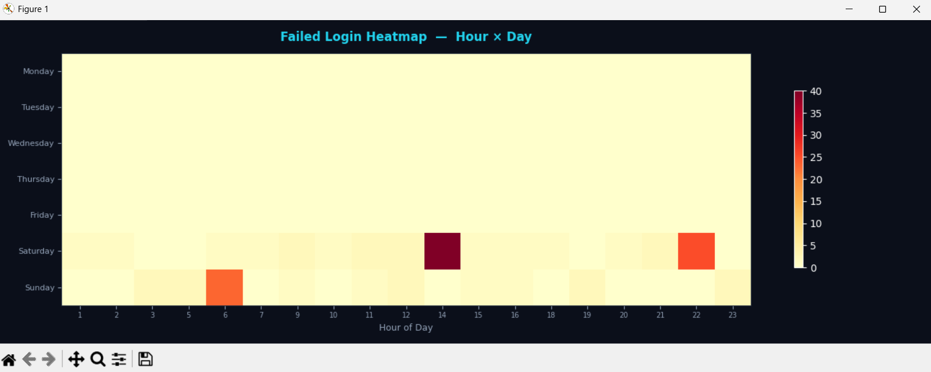
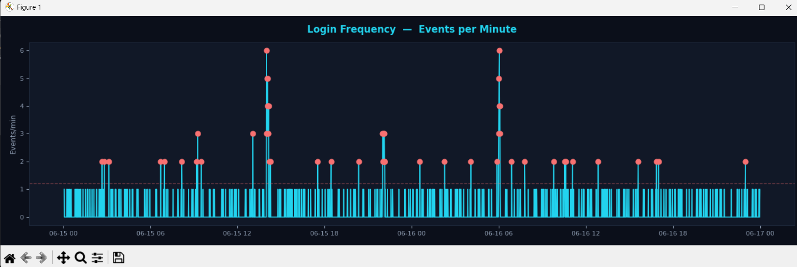
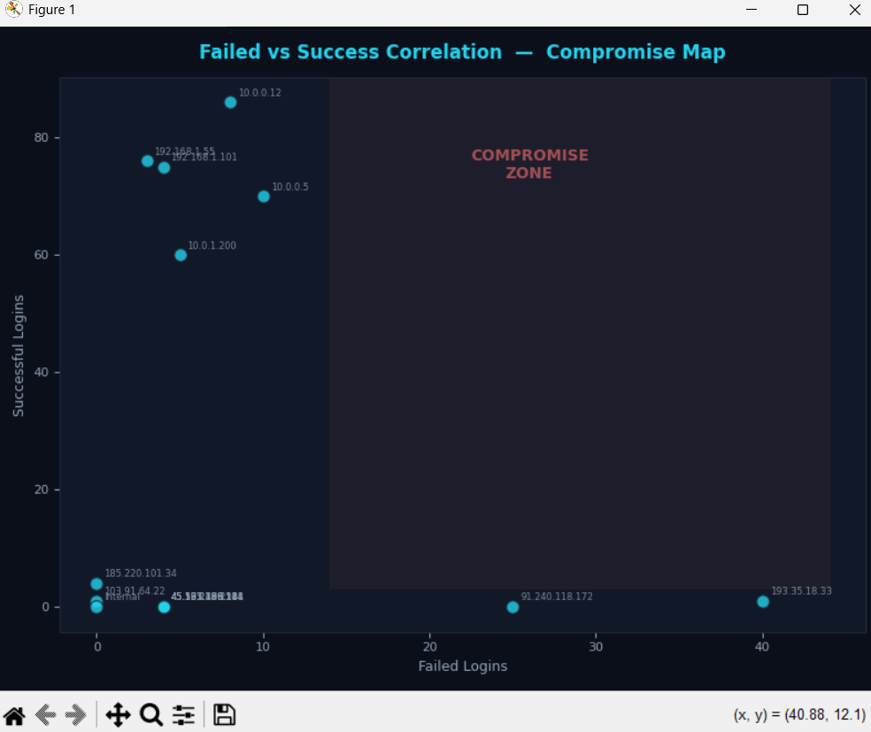
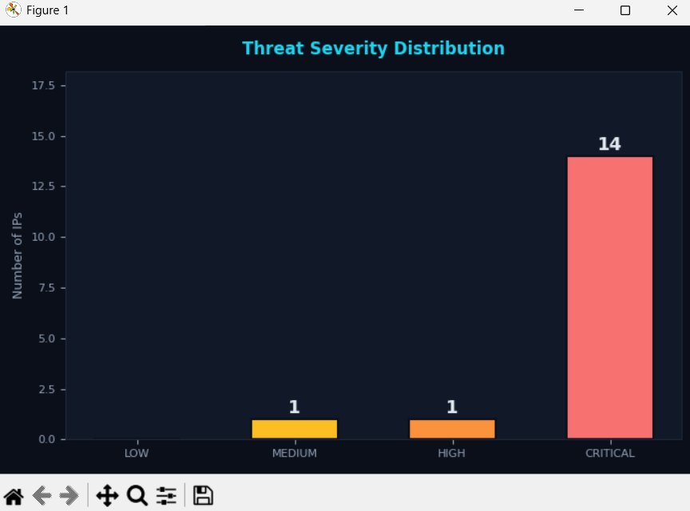
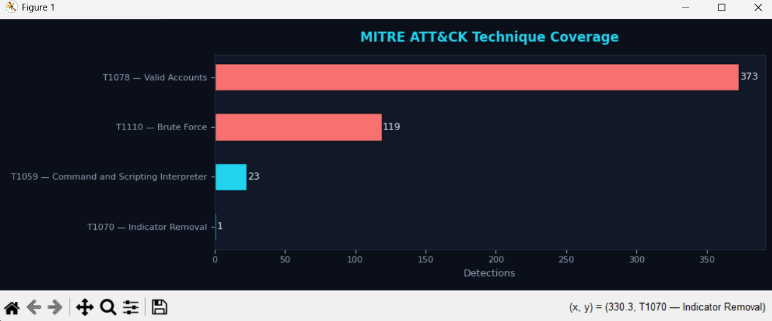

4.4.7 Report Generation and Export
The final stage of the workflow is the Reporting Module, which generates structured forensic summaries based on the completed analysis. These reports include the key findings of the case, such as suspicious IP addresses, failed attempts, unusual login times, calculated threat scores, and severity levels. The system provides export functionality so that these results can be stored, documented, and reviewed later. In the current implementation, reports can be exported in CSV format, and the dashboard also provides support for HTML-based reporting. This makes the system more practical for digital forensic documentation, evidence handling, and case presentation. The report also identifies CSV export and report generation as core features of the implemented platform.

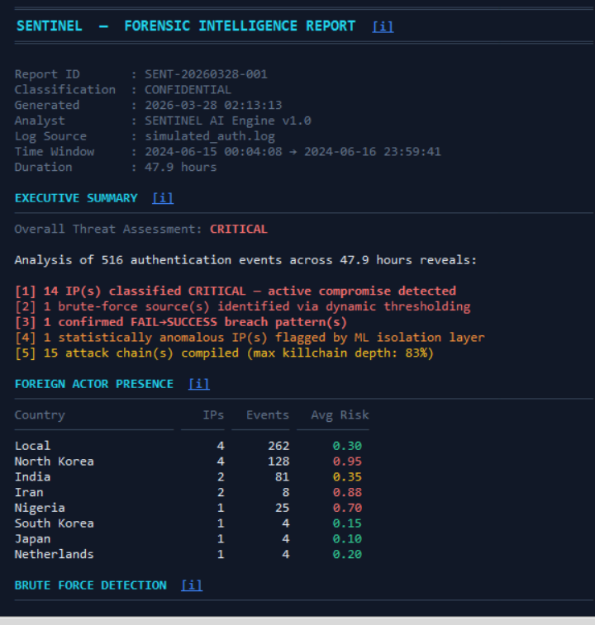

4.4.8 Significance of the Workflow
Overall, the workflow of the SENTINEL platform ensures that the transition from raw evidence to forensic conclusion is systematic, transparent, and efficient. Each stage contributes to reducing manual effort and improving analytical accuracy. The investigator does not need to manually inspect every line of the authentication log; instead, the system automatically parses the evidence, identifies suspicious behavior, assigns severity, reconstructs likely attack patterns, and presents the final findings in a clear visual and report-based form. This makes the workflow well suited for digital forensic analysis, cybersecurity investigation, and academic demonstration purposes.

4.5.1 SYSTEM PERFORMANCE ANALYSIS
The performance of the system depends on the efficiency of the log processing and analysis modules. Each module performs a specific function in detecting unauthorized access attempts from authentication logs. The major modules involved in the system are shown in Table 4.2.
Table 4.2
S.No |  | Module | Description
 | 1 | Log Input | Authentication log files are provided as input to the system.
 | 2 | Log Parsing | The log entries are parsed using regular expressions to extract relevant fields such as IP address, timestamp, and login status.
 | 3 | Threat Detection | The system analyzes login patterns to detect suspicious activities such as brute force attempts and unusual login times.
 | 4 | Threat Scoring | Risk scores are calculated based on detected suspicious activities.
 | 5 | Visualization & Reporting | The analysis results are displayed through charts and exported as forensic reports.
Table 4.2 Performance of system modules

4.5.2 Complexity of the project
The complexity of the project lies in efficiently analyzing large authentication log files to detect suspicious login activities.
- Implementing multi-layer detection mechanisms such as brute force detection, night login detection, and compromise pattern detection increases the reliability of the system.

- Designing a professional graphical user interface with visualization charts requires proper integration between analysis modules and the GUI components.

- Generating forensic reports and CSV exports ensures that the analysis results can be used as evidence for investigation purposes.

- Maintaining smooth system performance while processing logs and generating visualizations was an important factor considered during the system design.

CHAPTER 5

Implementation
The system is implemented using a modular approach consisting of log processing, analysis, and visualization components. The implementation mainly includes modules for log parsing, threat detection, threat scoring, and report generation.
The backend of the system is developed using Python, which handles the processing of authentication log files. It includes modules responsible for parsing logs using regular expressions, detecting suspicious login activities, and calculating threat scores based on predefined rules.
The frontend consists of a Graphical User Interface (GUI) that displays the analysis results to the user. The GUI provides features such as visualization charts, status indicators, and risk level displays to help investigators easily understand the detected threats.
The system also includes modules for visualization and report export, allowing users to generate structured forensic reports and export them in CSV format for documentation and further investigation.
The overall code structure and organization of these modules are illustrated in Table 5.1
Feature / Capability | 25% Implementation (log_analysis.py) | 50% Implementation (guiv3.py)
User Interface | Command-line / Terminal | Graphical User Interface (GUI) with dark theme
Log Parsing | Basic regex extraction | Advanced parsing with timestamp normalization
Detection Types | Brute force only | Brute force, night logins, compromise patterns
Threat Scoring | Not present | Weighted scoring (2×failed + 3×success + 5×night)
Severity Levels | Not present | LOW / MEDIUM / HIGH / CRITICAL
Visualization | None | 3 charts: bar chart, timeline chart, severity distribution
Export Format | None | CSV forensic report
User Feedback | Basic print statements | Progress bar, loading animation, status bar
Risk Assessment | Not present | Investigation risk meter popup
Architecture | Linear script | Modular layered design
Configuration | Hardcoded values | Centralized CONFIG dictionary
Performance | Single-threaded | Centralized CONFIG Threaded (non-blocking UI)
Portability | Fixed paths | Dynamic path detection
Error Handling | Minimal | Logging and exception handling
Target Users | Technical users only | Investigators, analysts, SOC teams

Table 5.1: Comparison of 25% and 50% Implementation

5.1 PROTOTYPE ACROSS THE MODULES
The input and output of each module of the system are described in this section.
• Log Input Module:
This module takes authentication log files as input. The logs contain information such as timestamp, username, login status, and IP address.
• Log Parsing Module:
This module processes the raw log entries using regular expressions and extracts important attributes such as IP address, login attempts, timestamps, and login results.
• Threat Detection Module:
This module analyzes the parsed log data to identify suspicious activities such as brute force attacks, unusual login times, and repeated failed login attempts.
• Threat Scoring Module:
This module assigns a threat score based on the detected suspicious activities. The scoring system helps determine the severity level of the detected threat.
• Visualization and Reporting Module:
This module generates visual charts and structured forensic reports based on the analysis results. The results are displayed through the graphical user interface and can also be exported as CSV reports.

5.2 DETECTION ALGORITHM
The algorithm used for detecting suspicious login activities from authentication logs is as follows.
LOG_ANALYSIS(AL):
- Read authentication log entries from file
- Parse each log entry using regular expressions
- Extract attributes such as IP address, login status, and timestamp
- Count failed login attempts for each IP address
- Check for login attempts during high-risk hours (00:00 – 05:00)
- If failed attempts exceed threshold then
7. Mark as Brute Force Attack
- If login occurs during high-risk hours then
9. Mark as Suspicious Login
- Calculate threat score based on detected activities
- Assign severity level (LOW / MEDIUM / HIGH / CRITICAL)
- Generate analysis results and forensic report
- Display results in GUI and export CSV report

5.3 DEPLOYMENT DETAILS
The system is developed using Python and requires Python 3.x to run. The application processes authentication log files stored on the local system.
The graphical user interface is implemented using Python libraries and provides visualization charts and threat analysis results for investigators.
The system can be executed on any system with Python installed and does not require additional external services. The forensic reports generated by the system can be exported as CSV files for documentation and further investigation.

CHAPTER 6

RESULTS AND DISCUSSION

6.1 DATASET FOR TESTING
The system was tested using sample authentication log files containing various login activities such as successful logins, failed login attempts, and login attempts during unusual time periods. These log files were used to evaluate the system’s ability to detect suspicious access patterns.
The dataset includes multiple log entries from different IP addresses with varying login behaviors. Some entries represent normal login activity, while others simulate potential security threats such as brute force attacks and suspicious login attempts during high-risk hours.
The testing process was conducted to verify whether the system correctly identifies unauthorized access attempts and assigns appropriate threat severity levels. The results obtained from the system confirm that the detection modules are able to identify suspicious login patterns effectively.

6.2 OUTPUT OBTAINED IN VARIOUS STAGES
This section presents the results obtained during the testing of individual modules as well as the overall system.
• Log Parsing Output:
The system successfully extracts relevant information such as IP address, login status, and timestamp from the authentication logs.
• Threat Detection Output:
The system detects suspicious activities such as repeated failed login attempts and login attempts during unusual hours.
• Threat Scoring Output:
Based on the detected patterns, the system assigns a risk score and classifies the threat level as LOW, MEDIUM, HIGH, or CRITICAL.
• Visualization Output:
The system generates visual charts including bar charts, timeline charts, and severity distribution graphs to help investigators analyze login patterns.
• Forensic Report Output:
The final output is presented as a structured forensic report, which can also be exported as a CSV file for documentation and further investigation.
6.2 System Outputs
6.2.1 Log File Input
The system begins by loading the authentication log file that contains login records such as IP address, login status, and timestamp. These logs are used as input for the forensic analysis process.
The program reads the log entries and prepares them for further analysis.

6.2.2 Log Parsing
In this stage, the system parses the log file and extracts important information such as IP address, number of failed login attempts, successful logins, and login time.
The extracted data is structured in a readable format so that it can be analyzed effectively
6.2.3 Suspicious Activity Detection
The system analyzes the parsed logs to identify suspicious activities. It checks for patterns such as repeated failed login attempts and login attempts during unusual hours.
If the number of failed attempts exceeds the predefined threshold, the system flags the activity as a potential brute force attack.

6.2.4 Risk Score Calculation
After detecting suspicious activities, the system calculates a risk score for each IP address based on multiple factors such as failed login attempts, successful logins, and login time.
The risk score helps determine the severity of the detected activity.

6.2.5 Detection Result

The final detection output is displayed after the analysis process is completed. The results show the IP address, number of failed attempts, login time, calculated score, and the corresponding risk level.

The detection results obtained during testing are shown in Table 6.1.
Table 6.1 Detection Results
IP Address | Failed | Success | Night Login: | Score | Level | Detection
45.12.23.9 | 3 | 1 | 1 | 14 | HIGH | Brute Force + Compromise
103.55.12.4 | 0 | 1 | 1 | 8 | HIGH | Night Login
192.168.1.77 | 2 | 0 | 0 | 4 | MEDIUM | Brute Force Attempt
10.0.0.5 | 0 | 1 | 0 | 3 | LOW | Normal
Figure 6.5 Detection Output

6.4 PERFORMANCE EVALUATION

6.4.1 Log Analysis Result
The forensic analysis system evaluates login activities by examining authentication logs and identifying suspicious patterns.
A sample forensic report generated by the system is shown below.

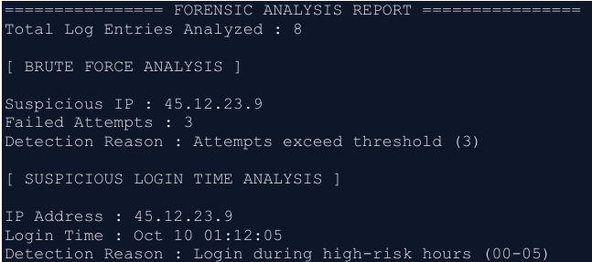
Figure 6.7 Forensic Analysis Output

6.4.2 Current Risks and Mitigation
During the development and implementation of the forensic analysis system, several potential risks were identified that could affect the performance and reliability of the system. These risks are analyzed based on their probability of occurrence and their potential impact on the system. Appropriate mitigation strategies are proposed to reduce or manage these risks effectively.
Risk | Probability | Impact | Mitigation
Large log files | Medium | Performance slow | Implement batch processing if needed
Different log formats | Low | Parsing failure | Add format detection module
False positives | Medium | Analyst confusion | Adjust thresholds and add whitelist
Missing documentation | Low | Submission delay | Start documentation early

Figure 6.8 Current Risks and Mitigation
The above table highlights the possible risks associated with the system and the strategies used to minimize their impact. Proper risk management ensures that the system performs efficiently and reduces the chances of operational issues during log analysis.

CHAPTER 7

CONCLUSIONS

7.1 SUMMARY
This project presents a system for forensic analysis of unauthorized access using authentication logs. The system analyzes login records and identifies suspicious activities such as repeated failed login attempts, login attempts during unusual hours, and abnormal login patterns from different IP addresses.
The system processes authentication logs and extracts important information such as IP address, login status, and login time. Based on predefined rules and thresholds, the system detects potential brute force attacks and suspicious login behaviour. A risk score is calculated for each login activity, and the results are categorized into High, Medium, and Low risk levels.
The system also generates a forensic analysis report that highlights suspicious IP addresses, failed login attempts, and login attempts during high-risk time periods. This helps system administrators quickly identify potential security threats and take necessary actions to protect the system.
Overall, the project demonstrates how log analysis can be used as an effective method for detecting unauthorized access and improving system security.

7.2 CRITICISMS
Although the system successfully detects suspicious login activities, there are some limitations. The analysis depends on the availability and accuracy of authentication logs. If the log files are incomplete or corrupted, the detection results may not be fully reliable.
Another limitation is that the system uses predefined thresholds to detect suspicious activities. In some cases, this may lead to false positives, where normal login behavior is incorrectly marked as suspicious. Similarly, sophisticated attackers may attempt to bypass detection by performing login attempts slowly to avoid triggering the threshold limits.
The system currently analyzes logs from a single format, and variations in log structure from different systems may require additional parsing techniques.

7.3 FUTURE WORK
In the future, the system can be enhanced by supporting multiple log formats from different operating systems and servers. This will improve the flexibility of the forensic analysis system.
Machine learning techniques can also be incorporated to improve the accuracy of detecting suspicious login patterns. By learning from historical login data, the system can better differentiate between normal and malicious activities.
Another improvement would be the integration of real-time monitoring, where the system continuously analyzes logs as they are generated and alerts administrators immediately when suspicious activities are detected.
Additional visualization features such as dashboards and graphical reports can also be added to help administrators easily understand and analyze security events.

REFERENCES

[1] Digital Forensics and Incident Response – Gerard Johansen, Packt Publishing, 2017.
This book explains techniques for investigating cyber incidents and analyzing system logs.

[2] Computer Forensics: Principles and Practices – Linda Volonino and Reynaldo Anzaldua, Pearson Education, 2008. Provides fundamental concepts of computer forensics and evidence analysis.
[3] Guide to Computer Network Security – Joseph Migga Kizza, Springer, 2020.
Discusses network security threats, intrusion detection, and log monitoring methods.

[4] Incident Response and Computer Forensics – Jason T. Luttgens, Matthew Pepe, and Kevin Mandia, McGraw-Hill, 2014.
Covers techniques for detecting and analyzing security incidents.

[5] National Institute of Standards and Technology (NIST).
NIST Special Publication 800-92: Guide to Computer Security Log Management.

[6] OWASP Foundation.
OWASP Logging Cheat Sheet – Best practices for security log monitoring.

[7] Behl, A., Cybersecurity and Cyberwar: What Everyone Needs to Know, Oxford University Press, 2017.Stallings, W., Network Security Essentials: Applications and Standards, Pearson Education, 2017.

