ADITYA UNIVERSITY
Surampalem
Department of Artificial intelligence of machine learning
DBMS CAPSTONE PROJECT
Project Documentation Report
Project Title: Online Shopping System
Submitted by:
S.No | Student Name | Roll Number
1 | PENTAKOTA SRI RAMA LAKSHMI | 25B11AI937
2 | JAYA SRI SAI JOSHI | 25B11AI425
3 | MULASTHANAM DURGA LAVANYA | 25B11AI774
4 | KAKI BHAVYA | 25B11AI452
Course: Database Management Systems (DBMS) Course Code: 2501CS08
Faculty Coordinator: VANGURI GAYATRI LAKSHMI NARSAMBA
Academic Year: 2026-2027 Date of Submission: __________
GitHub Repository Link: https://github.com/rama-9848/Online-Shopping-System-DBMS

TABLE OF CONTENTS
(This table updates automatically when the document is opened in Microsoft Word. If it appears empty, right-click it and choose "Update Field".)
TABLE OF CONTENTS 1
1. ABSTRACT 1
2. INTRODUCTION 1
2.1 Background 1
2.2 Purpose of the Database 1
3. PROBLEM STATEMENT 1
4. OBJECTIVES 1
5. TOOLS & TECHNOLOGIES USED 1
6. DATABASE DESIGN 1
6.1 Identified Entities 1
6.2 Entity Attributes 1
6.3 ER Diagram 1
6.4 Relationships & Cardinality 1
6.5 Relational Database Schema 1
6.6 Normalization 1
7. DATABASE IMPLEMENTATION 1
7.1 DDL — Database and Table Creation 1
7.2 Sample Data — DML 1
7.3 Constraints & Data Integrity 1
7.4 SQL Operations & Queries 1
7.5 Sample Outputs / Screenshots 1
8. MODULES & FUNCTIONALITIES 1
9. GITHUB REPOSITORY & TEAM RESPONSIBILITIES 1
10. ENHANCEMENTS & FUTURE IMPROVEMENTS 1
11. CONCLUSION 1
12. REFERENCES 1
APPENDIX 1
A. Complete SQL Script 1
B. Additional Screenshots / Outputs 1

1. ABSTRACT
1. ABSTRACT
The Online Shopping Database Management System is designed to manage and organize the data involved in an online shopping platform efficiently. The selected domain is e-commerce, where large amounts of information related to customers, products, sellers, categories, orders, payments, carts, and reviews need to be stored and managed. Traditional or manual systems may lead to duplicate data, inconsistent records, slow searching, and difficulties in generating accurate reports. The main purpose of this database is to provide a centralized, structured, and reliable system for storing and retrieving online shopping information.
The database includes major functionalities such as customer and address management, product and category management, seller details, cart and cart-item handling, order and order-item management, payment tracking, and customer reviews. Primary keys, foreign keys, constraints, and normalization are used to maintain data integrity and reduce redundancy. SQL queries can be used to insert, update, delete, and retrieve information efficiently. The proposed system improves data organization, enables faster information retrieval, supports accurate transaction management, and provides a strong foundation for secure and scalable online shopping operations.

2. INTRODUCTION

2.1 Background
2.1 Background
Online shopping has become an important part of modern e-commerce, allowing customers to browse products, add items to a cart, place orders, make payments, and provide reviews through digital platforms. An online shopping system handles a large amount of data related to customers, products, sellers, categories, orders, payments, and reviews. Managing this information manually or using separate files can result in data duplication, inconsistency, difficulty in searching, and errors in maintaining records.
A Database Management System (DBMS) is required to organize and manage this information in a structured and efficient manner. It provides a centralized system where related data can be stored, updated, retrieved, and maintained easily. Relationships between different entities can be established using primary keys and foreign keys, while normalization helps reduce data redundancy and improve data consistency.
The proposed Online Shopping Database Management System is designed to efficiently manage the major operations of an e-commerce platform. It helps maintain accurate records, provides faster data retrieval, supports order and payment management, and makes it easier to generate useful information and reports from the stored data.
.

2.2 Purpose of the Database
2.2 Purpose of the Database
The purpose of the Online Shopping Database Management System is to provide a centralized and organized system for managing the large amount of data generated by an online shopping platform. The database solves problems such as duplicate records, inconsistent information, slow data retrieval, and difficulty in managing customer and transaction details.
The database can be used by different users involved in the shopping system. Customers can browse products, manage their carts, place orders, make payments, and submit reviews. Sellers can manage their products, categories, prices, and stock details. Administrators can manage customers, sellers, products, orders, payments, and reviews and generate useful reports.
The database manages important information including customer details, addresses, seller details, product information, categories, cart items, orders, order items, payment records, and customer reviews. Relationships between these entities are maintained using primary and foreign keys.
Overall, the database provides efficient data storage, easy retrieval, better data consistency, reduced redundancy, and organized transaction management, making the online shopping system more reliable and easier to maintain.

3. PROBLEM STATEMENT
3. PROBLEM STATEMENT
The rapid growth of online shopping has resulted in the generation of large amounts of data related to customers, products, sellers, orders, payments, and reviews. Managing this information using manual records, spreadsheets, or separate files can lead to several problems such as data duplication, inconsistent records, difficulty in searching, data-entry errors, and slow report generation. It can also become difficult to maintain relationships between customers, products, orders, and payments as the amount of data increases.
The existing approach has limitations in terms of data organization, accuracy, consistency, security, and efficient retrieval. Updating information in multiple places may create conflicting records, while searching and generating reports from large datasets can be time-consuming.
The proposed Online Shopping Database Management System addresses these problems by providing a centralized relational database for storing and managing all important shopping information. The system uses primary keys, foreign keys, constraints, and normalization to maintain data integrity and reduce redundancy. SQL queries enable efficient insertion, updating, deletion, and retrieval of data.
The proposed system provides a structured and reliable way to manage customers, addresses, sellers, categories, products, carts, orders, payments, and reviews, improving overall data management and retrieval efficiency.

4. OBJECTIVES
List 3–5 clear and measurable objectives.
- Objective 1: To design a centralized relational database for efficiently storing and managing online shopping data.
- Objective 2: To reduce data redundancy and maintain data consistency using database
- normalization.Objective 3: To maintain accurate relationships between customers, products, sellers, carts, orders, payments, and reviews using primary and foreign keys.
- Objective 4: To enable fast and efficient retrieval, updating, and management of shopping information using SQL queries.
- Objective 5: To provide reliable data management and generate useful reports for customers, sellers, and administrators.
- 5. TOOLS & TECHNOLOGIES USED
List the DBMS software, IDE/client tool, and any front-end or scripting technology used to build and demonstrate the project.
Category | Tool / Technology Used
Database Server | PostgreSQL
Query / Admin Tool | pgAdmin 4
Front-end (if any) | Not Used / Database-based Project
Operating System | Windows 11
Version Control | GitHub

6. DATABASE DESIGN

6.1 Identified Entities
Minimum: 6 entities. Provide a short description of each entity.
S.No | Entity Name | Description
1 | Customer | Stores customer details such as customer ID, name, email, and contact information.
2 |  | Stores the delivery and billing address details of customers.
  Address
3 | Category
  Stores product categories used to organize products.
4 | Seller
  Stores information about sellers who list and sell products on the platform.
5 | Product | Stores product details such as product ID, name, price, stock, and category
6 | Cart | Stores the shopping cart associated with a customer.

6.2 Entity Attributes
List the attributes of each entity. Mark Primary Keys (PK) and Foreign Keys (FK).
Entity | Attribute | Data Type | Key (PK/FK/—) | Attribute Type
Customer | customer_id | INT | PK | Simple
Customer | name |  | _ | Simple
  VARCHAR(100)
Address | Address_id | INT | PK | Simple
Address | customer_id | INT | FK | Simple
Category | Category_id | INT | PK | Simple
Category | Category_name | VARCHAR(100) | _ | Simple
seller | Seller_id | INT | PK | Simple
seller | Seller_name | VARCHAR(100 | _ | Simple
Attribute Type: Simple / Composite / Multi-valued / Derived

6.3 ER Diagram
Insert the complete ER diagram showing entities, attributes, relationships, and cardinalities.
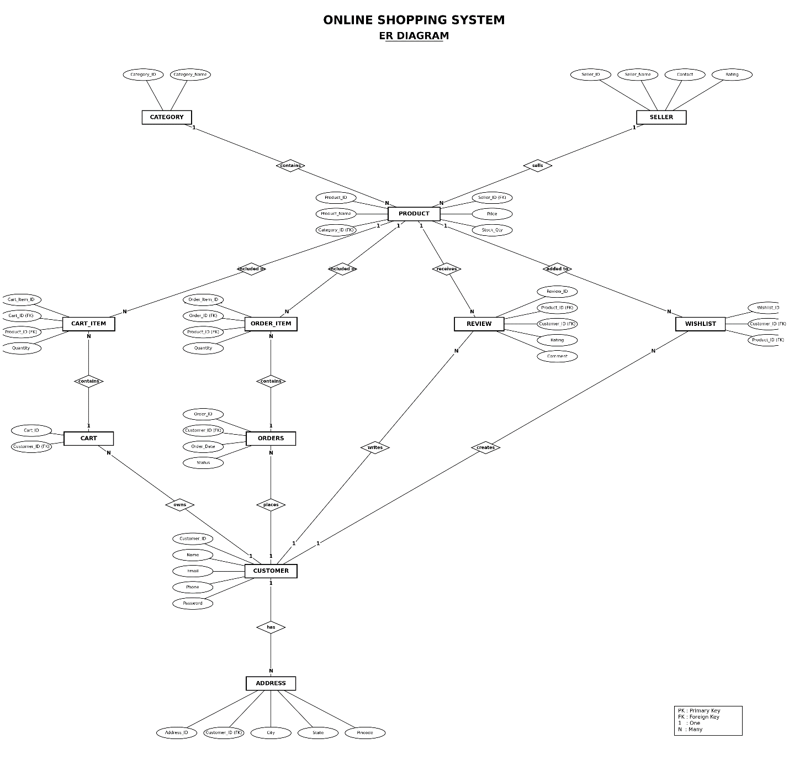

6.4 Relationships & Cardinality
Entity 1 | Relationship | Entity 2 | Cardinality (1:1 / 1:N / M:N)
Customer | Has | Address | 1
Cart | contains | Cart_item | 1
Product | Added to | Cart_item | 1
Orders | places | Order_item | 1
Product | Included in | Order_item | 1
6.5 Relational Database Schema
List every table, its columns, data types, and identify PK/FK columns.
Table Name | Column Name | Data Type | PK/FK/— | Constraints
Customer | Customer_ID | INT |  | NOT NULL, UNIQUE
  PK
Customer | Name |  | _ | NOT NULL
  VARCHAR(100)
Customer | Email | VARCHAR(100) | _ | NOT NULL
Customer | Phone | VARCHAR(15) | _ | NOT NULL, UNIQUE
Customer | Password | VARCHAR(100) | _ | UNIQUE
Address | Address_ID | INT | PK | NOT NULL
Address | Customer_ID | INT | FK | NOT NULL, UNIQUE
Address | Street | VARCHAR(150) | _ | REFERENCES Customer(Customer_ID)

6.6 Normalization
6.6 NORMALIZATION
Normalization is the process of organizing data in a database to reduce data redundancy, avoid update anomalies, and maintain data consistency. The Online Shopping Database is normalized up to Third Normal Form (3NF).
UNF → 1NF → 2NF → 3NF
UNF (Unnormalized Form):
Initially, customer, product, seller, order, payment, and review information may be stored together in a single large table. This can result in repeated customer, product, and seller information.
1NF (First Normal Form):
The data is divided so that each field contains a single atomic value and repeating groups are removed. Separate records are maintained for products, customers, orders, and other details.
2NF (Second Normal Form):
The tables are decomposed to remove partial dependencies. Each non-key attribute depends on the complete primary key. For example, Order_Item stores order-specific product details separately from Orders.
3NF (Third Normal Form):
The tables are further decomposed to remove transitive dependencies. Non-key attributes depend only on the primary key of their respective table. For example, category details are stored in the Category table and seller details are stored in the Seller table instead of repeating them in Product.
Result of Normalization
The final 3NF database contains separate tables such as Customer, Address, Category, Seller, Product, Cart, Cart_Item, Orders, Order_Item, Payment, and Review. This reduces duplicate data, prevents insertion/update/deletion anomalies, improves consistency, and makes the database easier to maintain.

7. DATABASE IMPLEMENTATION

7.1 DDL — Database and Table Creation
Paste CREATE DATABASE / CREATE TABLE statements and include constraints such as NOT NULL, UNIQUE, CHECK, DEFAULT, PRIMARY KEY, and FOREIGN KEY.

11 tables output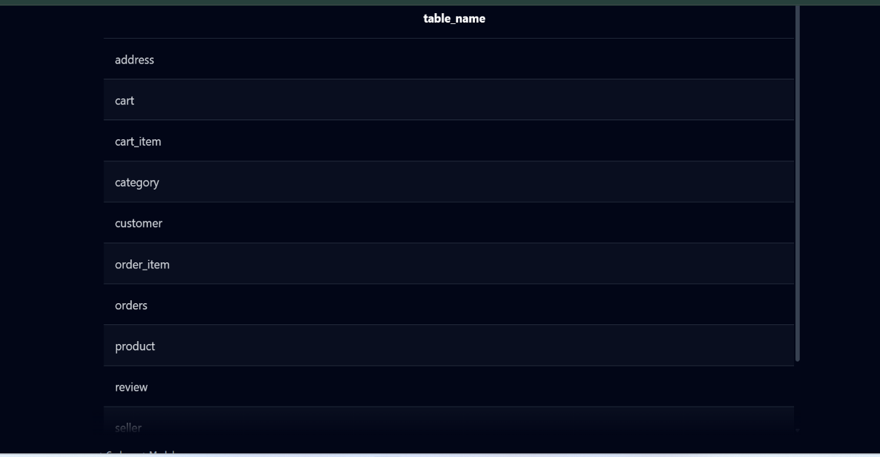
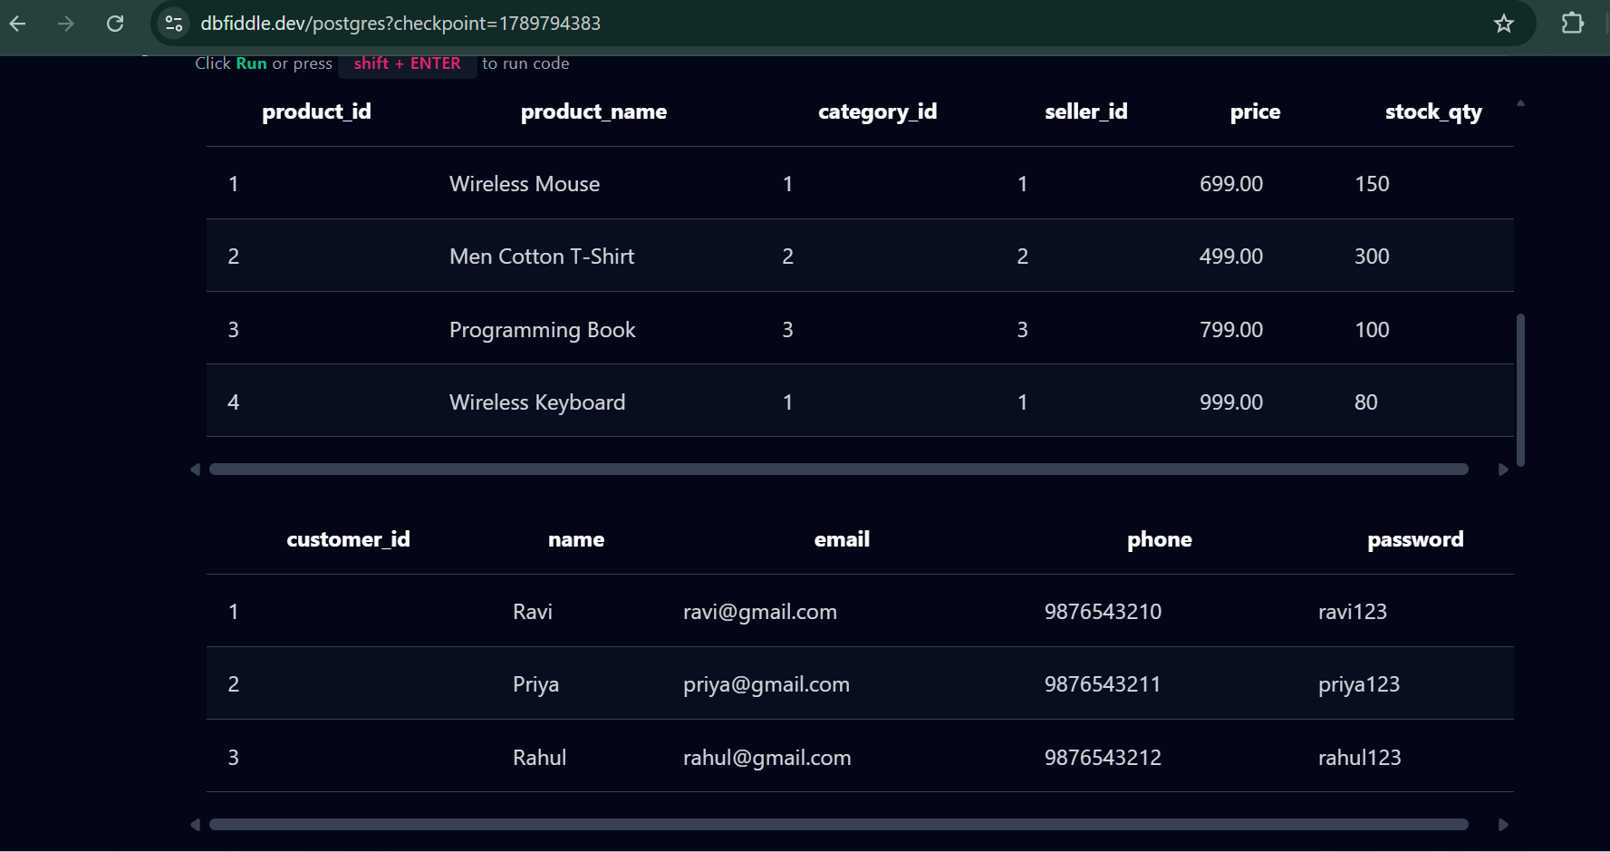
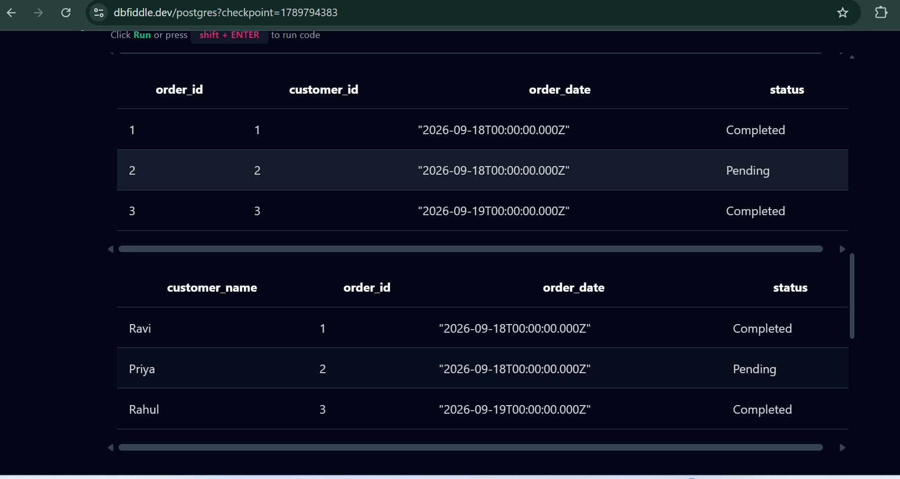

7.2 Sample Data — DML
Insert sufficient sample data into all tables. Include INSERT, UPDATE, and DELETE examples where applicable.
Table | No. of Records | Sample Data / Screenshot Reference
Customer | 5 | Customer details with ID, name, email, phone and password
Address | 5 | Customer address details including city, state and pincode
Category | 5 | Electronics, Clothing, Books, Beauty, Home & Kitchen
Seller | 4 | Seller ID, seller name, email and phone
Product | 8 | Product name, seller, category, price and stock
Cart | 4 | Customer cart details and creation date

7.3 Constraints & Data Integrity
List the constraints and validations applied to keep the data accurate and consistent (no duplicate IDs, valid values, referential integrity).
Constraint / Validation | Applied On | Purpose | Evidence / Screenshot
PRIMARY KEY | All tables | Ensures each record has a unique identifier and prevents duplicate IDs | Screenshot of table structure
FOREIGN KEY | Address, Product, Cart, Cart_Item, Orders, Order_Item, Payment, Review | Maintains referential integrity between related tables | Screenshot of table relationships
NOT NULL | Customer, Product, Seller, Orders, Payment and other required columns | Prevents missing values in mandatory fields | Screenshot of table definition
UNIQUE | Customer.Email, Seller.Email, Category.Category_Name | Prevents duplicate values in unique columns | Screenshot showing UNIQUE constraint
CHECK (Price >= 0) | Product.Price | Prevents negative product prices | Screenshot of CHECK constraint
CHECK (Stock >= 0) | Product.Stock | Ensures stock quantity cannot be negative | Screenshot of CHECK constraint

7.4 SQL Operations & Queries
Include representative examples of DDL, DML, DQL, CRUD, Joins, Aggregate Functions, GROUP BY / HAVING, Subqueries, Views, and other relevant queries.
S.No | Operation / Query | Purpose | SQL Query / Screenshot Ref.
1 | CREATE TABLE | Creates database tables | CREATE TABLE Customer (...);
2 | ALTER TABLE | Modifies an existing table | ALTER TABLE Product ADD COLUMN Brand VARCHAR(50);
3 | INSERT | Adds new records | INSERT INTO Category VALUES (1, 'Electronics');
4 | UPDATE | Modifies existing records | UPDATE Product SET Price = 24999 WHERE Product_ID = 101;
 | DELETE | Removes a record | DELETE FROM Review WHERE Review_ID = 106;
 | SELECT (DQL) | Retrieves records from a table | SELECT * FROM Product;
 | CRUD – Create | Creates a new customer record | INSERT INTO Customer VALUES (6, 'Anu', 'anu@gmail.com', '9876543210', 'pass123');
 | CRUD – Read | Displays customer information | SELECT * FROM Customer;
 | CRUD – Update | Updates customer information | UPDATE Customer SET Phone = '9123456789' WHERE Customer_ID = 1;
 | CRUD – Delete | Deletes a customer record | DELETE FROM Customer WHERE Customer_ID = 6;

7.5 Sample Outputs / Screenshots
Paste important execution screenshots with a short caption. Screenshots should clearly show the query and its output.
Figure 1: product table
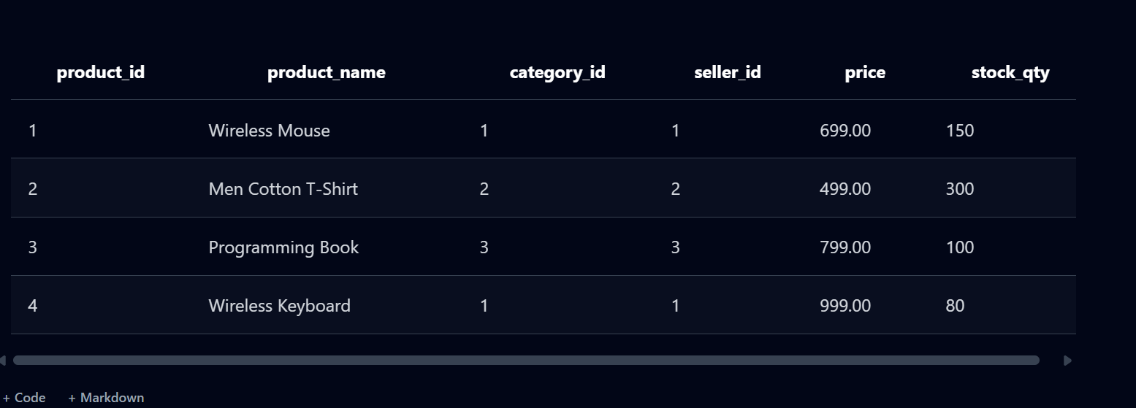
Figure 2: order table
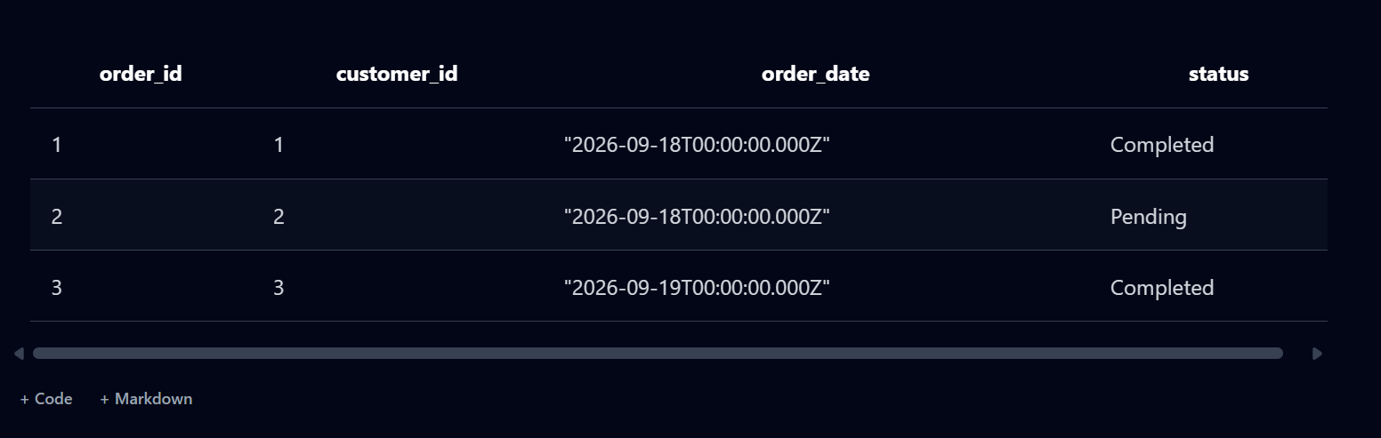

Figure 3: customer table

Figure 4: category table
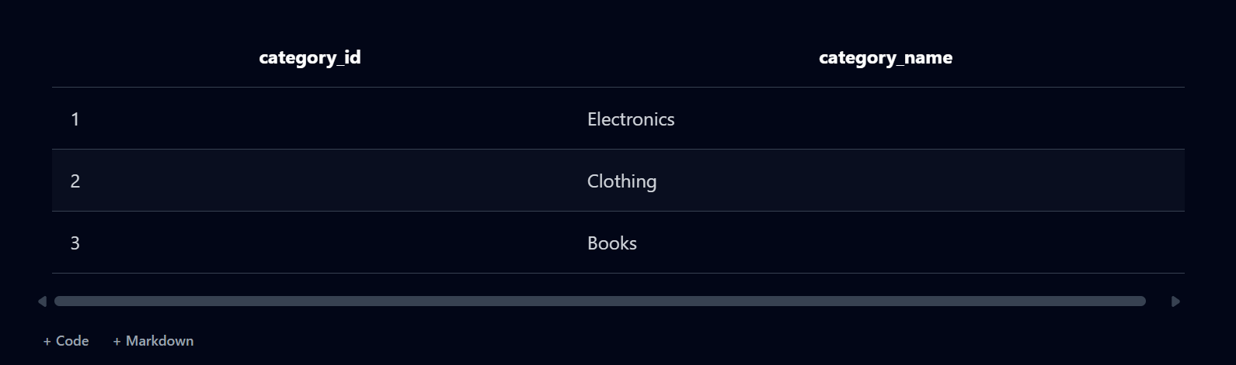
Figure 5:Cart table output
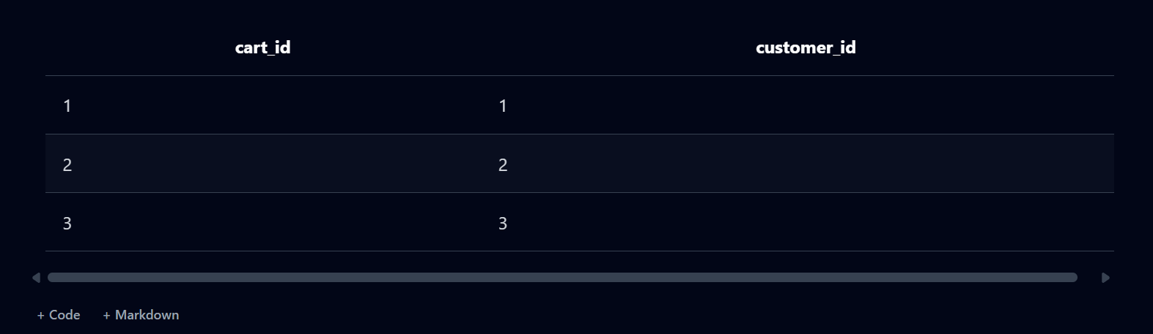

Figure 6: Aggregate function output
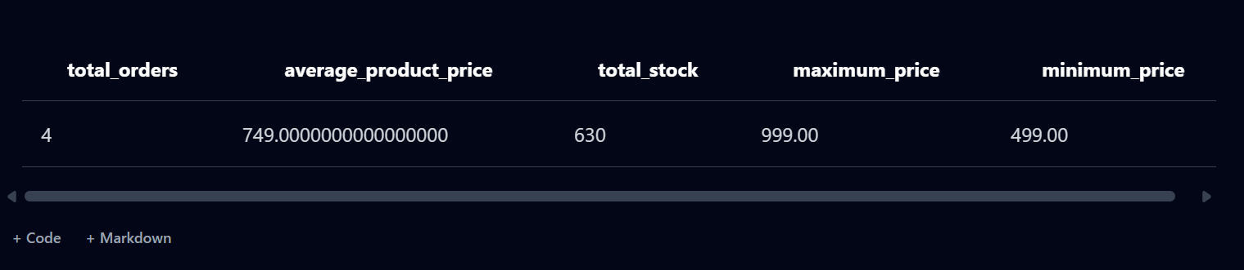
Figure 7: Address Table output
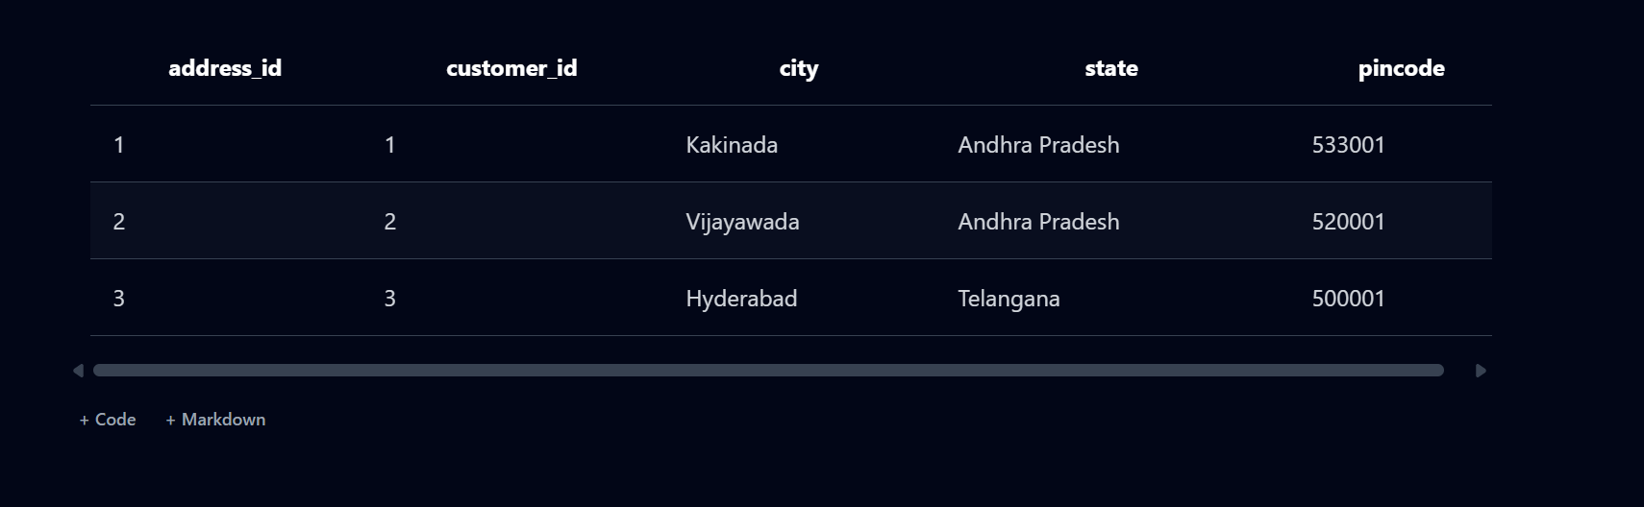

8. MODULES & FUNCTIONALITIES
Explain the major modules/features of the system and what each module does.
S.No | Module Name | Functionality
 | Customer Management | Stores and manages customer details such as customer ID, name, email, phone number, and registration information.
 | Address Management | Maintains customer delivery addresses and links addresses with the respective customers.
 | Category Management | Manages product categories and organizes products based on their categories.
 | Seller Management | Stores seller information and manages sellers who list products on the platform.
 |  | Adds, updates, deletes, and retrieves product details such as name, price, stock, and category.
  Product Management
 | Cart Management | Allows customers to add, update, remove, and view products in their shopping cart.

9. GITHUB REPOSITORY & TEAM RESPONSIBILITIES
Provide the repository link and clearly mention each team member's contribution.
Repository Link: https://github.com/rama-9848/Online-Shopping-System-DBMS
Student Name | Roll Number | Role / Responsibility | Contribution Status
P.SRI RAMALAKSHMI | 25B11AI937 | Database design and SQL implementation | Completed
JAYA SRI SAI JOSHI | 25B11AI425 | ER diagram and database schema | Completed
M.DURGA LAVANYA | 25B11AI774 | Sample data and SQL queries | Completed
K.BHAVYA | 25B11AI452 | Documentation and screenshorts | Completed

10. ENHANCEMENTS & FUTURE IMPROVEMENTS
The proposed Online Shopping Database can be enhanced in the future to make the system more efficient, secure, user-friendly, and scalable.
- User Interface Integration: A web or mobile-based front-end can be developed to allow customers and sellers to interact with the database easily.
- Enhanced Security: User authentication, password encryption, role-based access, and database access controls can be implemented to protect sensitive information.
- Advanced Search and Filtering: Product search can be improved with filters based on category, price, seller, ratings, and availability.
- Performance Optimization: Indexing, query optimization, and efficient database design can be used to improve query performance when the amount of data increases.
- Reporting and Analytics: Reports and dashboards can be added to analyze sales, orders, popular products, customer reviews, and seller performance.
- Additional Modules: Future versions can include modules for wishlist, product recommendations, order tracking, discounts, coupons, and notifications.
- Scalability: The database can be optimized to support a larger number of customers, sellers, products, and transactions as the online shopping platform grows.

11. CONCLUSION
11. CONCLUSION
The Online Shopping Database Management System successfully provides a structured and centralized solution for managing e-commerce data. The project implements important database features including entity identification, relational table design, primary keys, foreign keys, relationships, cardinalities, normalization up to 3NF, and SQL-based data management.
The database efficiently manages information related to customers, addresses, categories, sellers, products, carts, cart items, orders, order items, payments, and reviews. By applying normalization and appropriate constraints, data redundancy is reduced and data consistency and integrity are improved.
Through this project, key concepts of DBMS, ER modeling, relational database design, SQL queries, normalization, and relationship management were learned and applied practically. The defined objectives were achieved by creating an organized database that supports efficient data storage, retrieval, updating, and transaction management.
Overall, the project demonstrates how a well-designed relational database can simplify the management of an online shopping platform and provide a strong foundation for future enhancements such as a user interface, advanced reporting, security features, and product recommendation systems.

12. REFERENCES
List textbooks, articles, documentation, websites, or other resources referred to during the project.
- Abraham Silberschatz, Henry F. Korth, and S. Sudarshan, Database System Concepts, McGraw-Hill Education.
- Ramez Elmasri and Shamkant B. Navathe, Fundamentals of Database Systems, Pearson Education.-*=-098765432
- PostgreSQL Global Development Group, PostgreSQL Documentation.
- PostgreSQL Tutorial and SQL reference materials for learning database concepts, queries, constraints, and normalization.
- W3Schools, SQL Tutorial – reference for SQL commands, database concepts, and query examples.

APPENDIX

A. Complete SQL Script
The complete SQL script for the Online Shopping Database Management System is provided in the project repository. The script contains the database creation commands, table definitions, primary keys, foreign keys, constraints, sample data, and SQL queries used for testing and demonstration.
Repository Path:
/Online-Shopping-Database/SQL/online_shopping.sql
Database: PostgreSQL
SQL Script File: online_shopping.sql
The complete script should be executed in PostgreSQL using pgAdmin 4 to create and test the database system.
.

