NTP Remediation

Disable chronyd & Ensure enable ntpd (SOP)
Created By: Sreelakshmi Vonteddu
Department: Linux Operations
Date: 09-Feb-2026
-----------------------------------------------------------------------------------------------------------------------

1. Purpose
Provide a consolidated SOP + evidence pack showing the disabling of chronyd, enabling/validating ntpd, and end-to-end NTP verification. This version aggregates all command outputs

2. Scope
Rhel 7 and below versions Linux servers using ntpd, Rhel 8 and above servers using chronyd
Below steps for Rhel 7 and below version Linux servers:

3. Procedure (Commands)
systemctl status chronyd
systemctl stop chronyd
systemctl disable chronyd
systemctl mask chronyd
systemctl enable ntpd
systemctl restart ntpd
systemctl status ntpd
ntpq -pn
ntpstat
timedatectl

3.1 chronyd status BEFORE disabling
● chronyd.service - NTP client/server
Loaded: loaded (/usr/lib/systemd/system/chronyd.service; enabled)
Active: inactive (dead)

3.2 Actions to disable chronyd
systemctl disable chronyd
systemctl mask chronyd
Created symlink /etc/systemd/system/chronyd.service → /dev/null

3.3 chronyd AFTER masking
● chronyd.service
Loaded: masked (/dev/null; bad)
Active: inactive (dead)

3.4 ntpq verification
*10.27.189.4 10.5.7.11 3 u 12 64 377 0.684 0.364 0.098
10.27.189.6 10.5.20.54 4 u 5 64 377 0.853 -1.800 0.325

3.5 ntpstat
synchronised to NTP server (10.27.189.4) at stratum 4
time correct to within 109 ms
polling server every 64 s

3.6 timedatectl
NTP synchronized: yes
Time zone: Europe/Warsaw

4. Screenshot
Disabled chronyd:
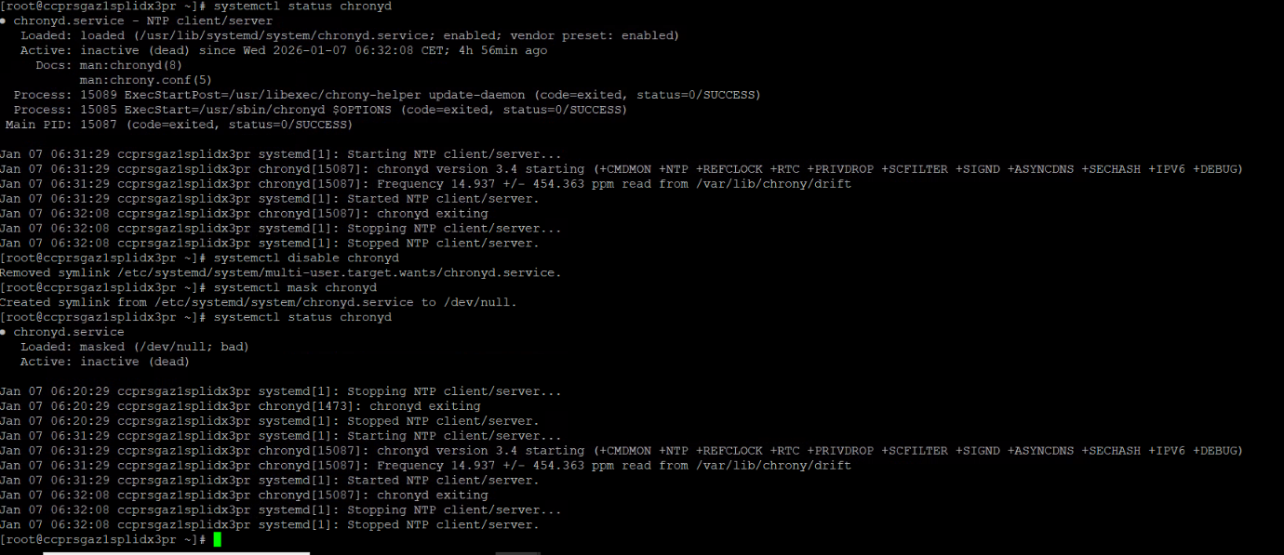
Ntpd service is enabled and running
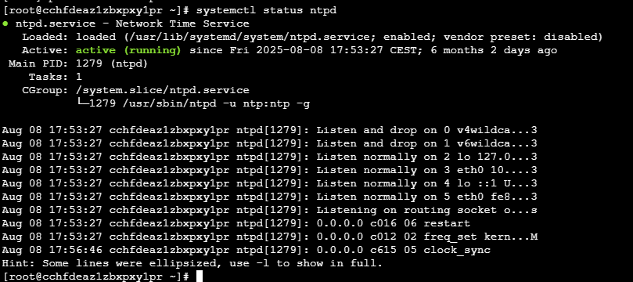

NTP working fine.
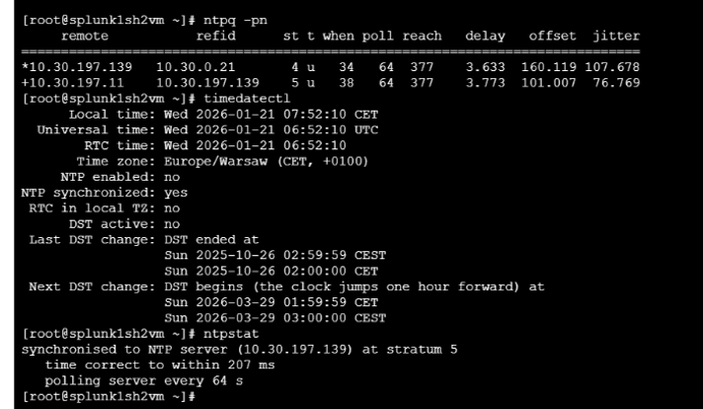

5. Verification Checklist
- chronyd is disabled and masked on all impacted servers
- ntpd is enabled and running
- ntpq -pn shows a selected peer (*) with stable offset/jitter
- ntpstat reports synchronised (stratum ≤ 5)
- timedatectl → NTP synchronized: yes

