Assignment 3 Report
https://github.com/rama-xv/Assignment3CIS310

1-
The datapath contains:
Program Counter (PC): Holds the current instruction address.
Instruction Memory: Outputs a 8-bit instruction split into IR_HI (opcode) and IR_LO
Register File: Two 4-bit registers R0 and R1.
ALU: Supports PASS, ADD, ADDC, and SUB operations.
Control Unit: Generates control signals for selecting ALU operations and managing PC, IR, and RegisterFile writes.
Datapath Buses: Includes the Register Bus, Immediate Bus, ALU Output Bus, and PC Bus.

2-
IF1:
The PC sends its address to instruction memory. The upper nibble of the instruction is loaded into IR_HI.
IF2:
PC increments. The next nibble is fetched and loaded into IR_LO. Now the instruction is complete.
DECODE:
The Control Unit reads IR_HI (opcode) and selects source registers, destination register, ALU operation mode, and whether the instruction uses an immediate value.
EXECUTE:
The ALU receives operands and performs ADD, SUB, PASS, or ADDC.
The result is held but not written yet.
WRITEBACK:
The ALU result or immediate value is written into the destination register.
After this, the FSM returns to IF1 for the next instruction.

3-
IF1: PC outputs the address.
IF2: Instruction Memory returns the 8-bit instruction. IR_HI stores the opcode, IR_LO stores the operand.
DECODE: Control Unit interprets the opcode and drives ALU selection, RegisterFile select, and write-enable signals.
EXECUTE: ALU performs arithmetic operations, or immediate values are prepared for LDI.
WRITEBACK: Results are written to the destination register. PC increments.
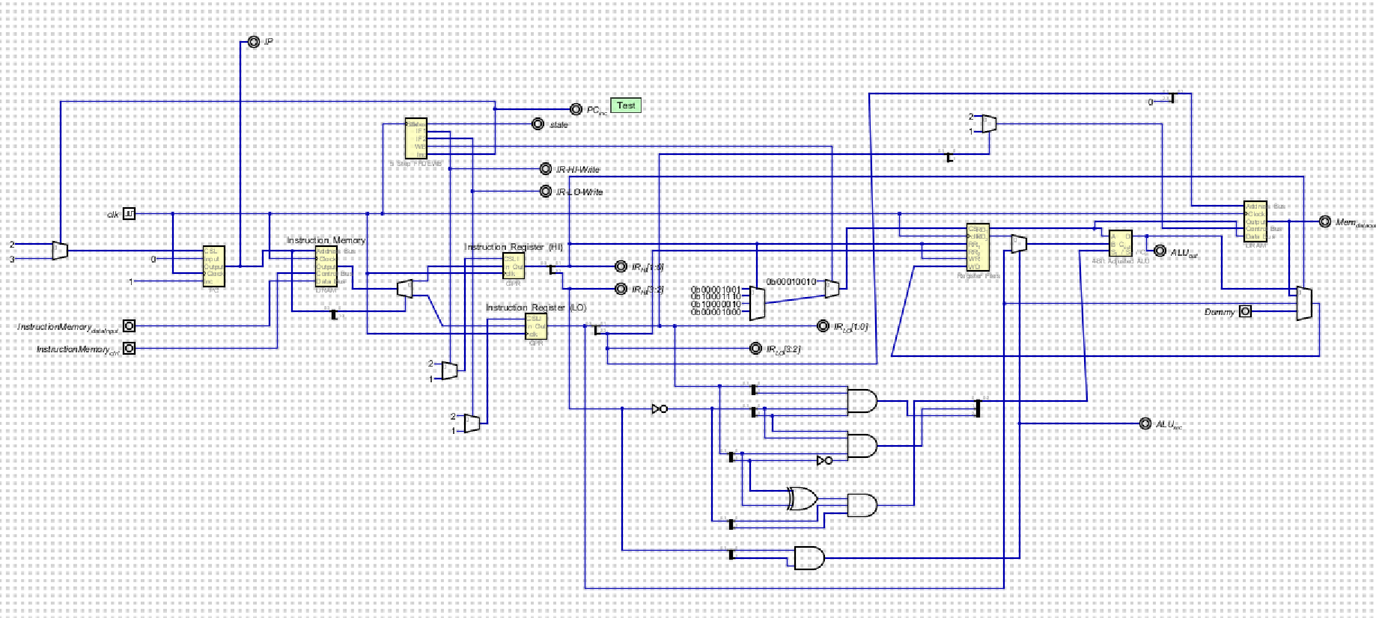

4-