Removing J-Coupling Artefacts from CPMG Relaxation-Dispersion Data with a Neural Network
Progress report — 3 September 2026
Prepared as a first introduction to the project.

1. Goal
We are building a neural network that takes a CPMG relaxation-dispersion curve measured with scalar (J) coupling present and returns the curve that would have been measured if the coupling were absent.
The motivation is practical. CPMG relaxation dispersion is one of the main experimental tools for detecting protein conformational exchange on the microsecond-to-millisecond timescale. The measurement produces a dispersion profile: an effective transverse relaxation rate, R₂,eff, plotted against the CPMG pulsing frequency, ν_CPMG. Fitting that profile to an exchange model recovers the exchange rate k_ex, the population of the minor state p_B, and the chemical-shift difference between states Δω — which is what makes the technique valuable, since it characterises states too sparsely populated to observe directly.
Scalar coupling between the observed nucleus and its attached proton distorts this profile. The distortion depends on the pulsing frequency, so it does not cancel out and it biases the fitted exchange parameters. Experimentally it is suppressed with additional decoupling pulses, which cost measurement time and introduce their own artefacts. If a trained model could remove the distortion computationally, the experiment could be run without that overhead.
Training such a model requires a large set of matched curve pairs — the same molecular system simulated with and without J-coupling. Pairs like this cannot be measured; they can only be simulated. Most of the work so far has therefore gone into building and rigorously validating the simulator that produces the training data.

2. Approach
The simulator propagates nuclear spin magnetisation through a CPMG pulse sequence using a 32×32 matrix representation of the spin system (the Liouvillian), following the formalism of Allard, Helgstrand and Härd (J. Magn. Reson. 1998, 134, 7–16). It includes chemical exchange between two states, dipole–dipole and chemical-shift-anisotropy relaxation, cross-correlation effects, and scalar coupling. Setting the coupling constant to zero and re-running the identical calculation gives the matched J-free partner curve.
Because everything downstream depends on the simulator being correct, it is validated against ChemEx, the community-standard open-source package for analysing relaxation-dispersion data. The validation compares the two programs' matrices element by element under identical physical parameters, with no pulse sequence involved, so that any disagreement is unambiguously a difference in the underlying equations rather than in how the experiment is modelled.

3. Progress since the last update

3.1 Simulator validation is complete, and it found two real errors
An earlier comparison had matched only a reduced 6×6 case. Extending it to the full 30×30 double- and zero-quantum basis exposed two genuine coding errors, both introduced when the published equations were translated into code:
- A sign error. The master equation in the source paper is written in the form dσ/dt = −P·σ, so every element of the printed matrix must be negated on the way into the code. One cross-relaxation term had not been.
- A term that should not exist. A scalar-coupling contribution had been added to the multiple-quantum block. It does not appear in the paper, and we confirmed independently, using explicit spin matrices, that the coupling Hamiltonian commutes with these operators — so the term must be zero.
After both fixes, all 900 matrix elements agree with ChemEx to machine precision. A dependency analysis established that ordinary in-phase experiments never reach the affected block, so previously reported in-phase results are unaffected; continuous-wave CPMG experiments do reach it and have been recalculated.
Interpretation. The simulator can now be treated as a trustworthy source of training data. This was the precondition for everything that follows.

3.2 Training data and first models
Two datasets of paired coupled/uncoupled dispersion profiles were generated (60,000 and 500,000 training profiles, plus held-out validation and test sets), sampling exchange parameters, magnetic field strengths and molecular tumbling times over wide ranges.
A deliberate constraint was imposed: the model is given only quantities an experimenter actually knows at the spectrometer — the pulsing frequency, the measured relaxation rates, the field strength and the coupling constant. It is not given k_ex, p_B or Δω, because those are precisely the unknowns the experiment exists to determine. A model that needed them could never be applied to real data.
Five model families were trained under identical conditions and compared against a null baseline of returning the input unchanged. Performance is quoted as the fraction of the J-coupling artefact removed:
Model | Parameters | Test RMSE (s⁻¹) | Artefact removed
Return input unchanged | 0 | 0.839 | 0%
Linear | 3,400 | 0.606 | 27.8%
Fully-connected network | 852,000 | 0.355 | 57.7%
Transformer | 586,000 | 0.219 | 74.0%
Convolutional network | 770,000 | 0.148 | 82.4%
Table 1. Baseline comparison on clean simulated data, 60,000 training profiles.
Increasing the training set from 60,000 to 500,000 profiles improved the best model substantially without any architectural change: the typical residual error fell from 0.069 to 0.010 s⁻¹, a factor of 6.8. On clean simulated data the method removes the artefact for 93.5% of profiles, with a hundred-fold margin over the distortion being corrected.

3.3 The limiting factor is experimental noise, not the model
Real spectra are noisy, so noise was added to the simulated inputs while keeping the clean curve as the target. An important modelling detail: noise in these experiments is random in the measured peak intensity, not in the relaxation rate. Since the rate is obtained as a logarithm of an intensity ratio, the resulting noise in R₂,eff is strongly uneven — rapidly relaxing points, which carry most of the exchange information, are by far the noisiest. Treating the noise as uniform would have made the problem appear considerably easier than it is.
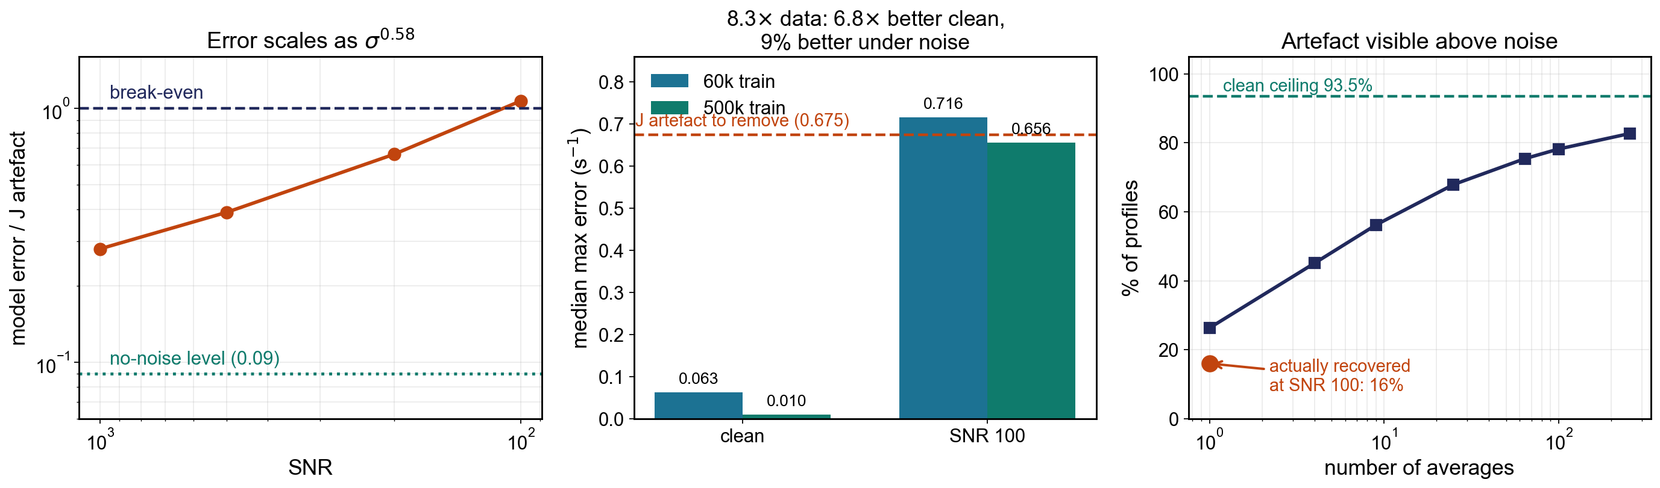
Figure 1. Left: model error relative to the size of the artefact, as a function of signal-to-noise ratio. Centre: effect of increasing the training set eight-fold, on clean data and at SNR 100. Right: fraction of profiles whose artefact is larger than the noise, versus number of repeat measurements.
Two findings emerged. First, the headline metric used above stops being meaningful once noise is present: it reports roughly 85% at every noise level, because the models score well by smoothing away noise, which is not the task. It had to be replaced by a direct comparison against the size of the artefact itself. Second, and more importantly, at a typical experimental signal-to-noise ratio of 100 the J-coupling artefact is smaller than the noise. The median artefact is 0.675 s⁻¹; the median noise is 1.589 s⁻¹.
To quantify this per experiment rather than on average, each test profile was scored individually: it counts as recovered only if at least 75% of that particular profile's artefact is removed.
Condition | Profiles recovered
No noise (the method's own ceiling) | 93.5%
Artefact larger than noise at SNR 100 (physics ceiling) | 26.3%
Actually recovered at SNR 100 | 16.0%
Table 2. Per-profile recovery on 19,944 held-out test profiles.
These three numbers separate two distinct limits. The 26.3% is a hard physical ceiling: for three-quarters of profiles the artefact is simply not present in the data above the noise, and no model of any kind can recover it. The gap between 26.3% and 16.0% is a genuine modelling shortfall worth closing, but closing it entirely would still leave the physical ceiling in place.
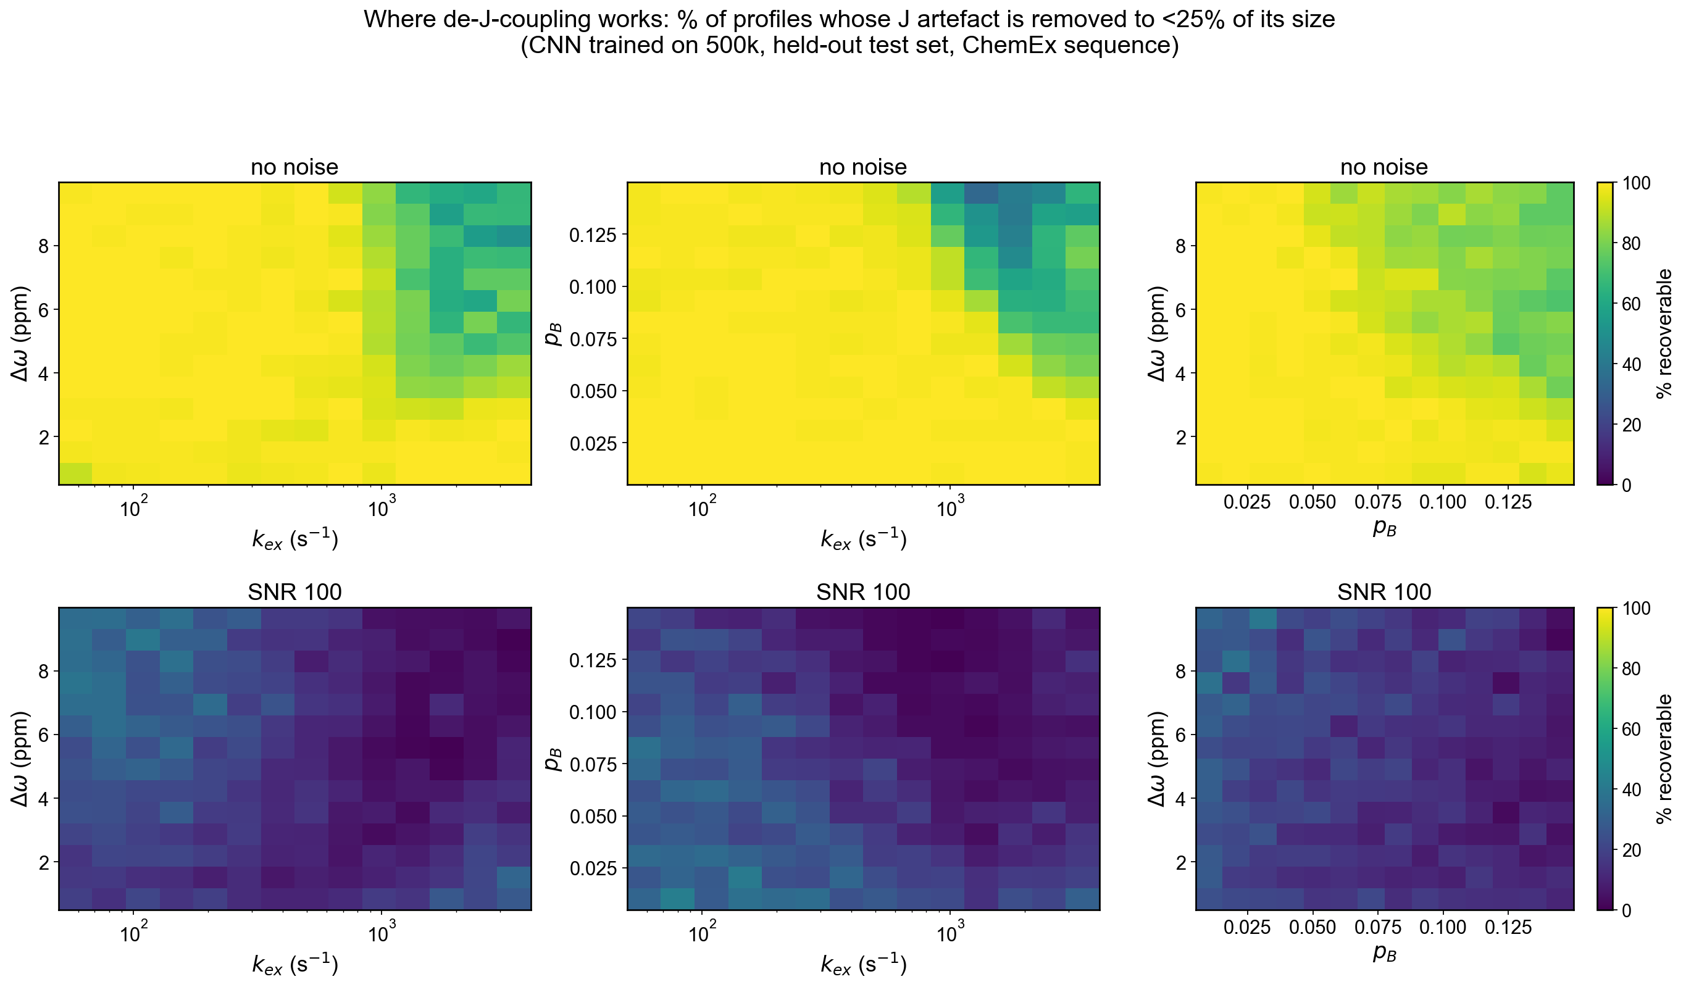
Figure 2. Fraction of profiles successfully corrected, mapped over the exchange parameters. Top row: no noise. Bottom row: SNR 100. On clean data performance is high and nearly uniform, degrading only where fast exchange combines with a large minor-state population or chemical-shift difference. At realistic noise this structure is largely erased; what survives lies in the slow-exchange, low-population corner where relaxation is slowest and signal intensity therefore highest.
Since signal-to-noise improves as the square root of the number of repeat measurements, roughly 100 repeats would be needed before most profiles carried a detectable artefact. That is an impractical amount of instrument time, which redirects the effort towards two cheaper alternatives: restricting the method to the parameter range where it demonstrably works, and acquiring more distinct pulsing frequencies rather than more repeats of the same ones.

4. Current status and next steps
In one sentence: the computational method works well, but at standard experimental sensitivity the signal it needs is mostly buried in noise.
The simulator is validated and can be considered reliable. The learning approach is sound, demonstrated by 93.5% recovery on noise-free data. The open question is entirely experimental — under what conditions the artefact is large enough to be measurable.
Three lines of work follow directly:
- Restrict the parameter ranges. The region where the method works is well defined. If the systems of interest to the group lie within it, the overall picture is considerably better than the global 16% figure suggests. This requires input on which exchange regimes matter experimentally.
- Sample more pulsing frequencies, and consider longer relaxation delays. The artefact varies smoothly with frequency while noise does not, so additional independent points are a more efficient use of instrument time than repeating existing ones.
- Complete the architecture comparison at the larger dataset size. The model ranking in Table 1 was established on the smaller dataset, where performance was limited by the amount of training data rather than by model capacity, so that ranking should not yet be treated as settled. This calculation is currently running.
Beyond that, the natural progression is to validate against experimental data for a system with independently known exchange parameters, which would test whether performance on simulated data transfers to the spectrometer.

5. Notes on reproducibility
All simulation and training code is under version control, with each result recorded alongside the commit that produced it. Datasets are regenerated deterministically from stored random seeds rather than archived. Training runs on a single desktop workstation; the largest dataset took approximately one hour to generate and each model trains in under three hours, so no specialised computing resources are required at present.
Reference. Allard, P., Helgstrand, M. and Härd, T. (1998) The complete homogeneous master equation for a heteronuclear two-spin system in the basis of Cartesian product operators. Journal of Magnetic Resonance 134, 7–16.

