NMR Metabolomics Foundation Model
Laboratory Record of Analyses and Decisions

Self-supervised representation learning on 1D ¹H-NMR serum and plasma spectra, benchmarked against classical machine learning across five clinical classification targets.
Record field | Value
Period covered | up to 29 July 2026
Pretraining corpus | 9,670 human serum / plasma ¹H-NMR spectra (131,072 points each)
Evaluation targets | 5 — Barth, MTBLS326, MTBLS563, BrC-T2D (cancer), BrC-T2D (diabetes)
SSL families | masked autoencoding, jigsaw, joint (masked + jigsaw)
Data version of record | v4 (water + EDTA suppression corrected, row min-max normalised)
Companion markdown | docs/SSL_vs_classical_analysis.md
Status | Backbone scaling axis exhausted; objective and head remain

How to read this record
This is a chronological lab notebook, not a paper. It records what we believed at each point, what we did to test it, what the data said, and where a belief was overturned.
Refuted hypotheses are kept in place rather than deleted — several of the most useful conclusions came from predictions that failed.
Every number is reproducible from the scripts named in each section.

Contents
In Word, right-click below and choose “Update Field” (or press F9) to populate. It refreshes automatically as new sections are added.

1. Where we started
The project set out to test a straightforward proposition: that self-supervised pretraining on a large unlabelled corpus of ¹H-NMR serum and plasma spectra would produce a representation that transfers to small clinical classification problems better than classical machine learning applied directly to the spectra.
The ingredients were in place at the start of this record:
- A pretraining corpus of 9,670 spectra, each 131,072 points, drawn from MetaboLights and Metabolomics Workbench, all human serum or plasma.
- Three self-supervised objectives already implemented and trained: masked autoencoding (reconstruct hidden patches), jigsaw (recover shuffled bin order), and a joint model combining both.
- Four downstream evaluation datasets, later five targets once BrC-T2D was split into cancer and diabetes labels.
- A classical baseline: integrated absolute area in equal-width bins, fed to logistic regression, SVM-RBF and XGBoost.

1.1 The evaluation protocol
Sample sizes are small, so the protocol was fixed per dataset and never varied afterwards. This matters: it is what makes numbers comparable across the whole record.
Target | n | Classes | Cross-validation
Barth syndrome | 37 | 2 (Case / Control) | Leave-one-out
MTBLS326 | 42 | 2 (IP3R expressing / control) | Leave-one-out
MTBLS563 | 113 | 3 (bacterial / viral / control) | Stratified 10-fold
BrC-T2D cancer | 78 | 2 (Cancer / No cancer) | Stratified 10-fold
BrC-T2D diabetes | 78 | 2 (Diabetes / No diabetes) | Stratified 10-fold
Table 1. Evaluation targets and protocols. Barth excludes 3 pooled-QC rows; MTBLS563 excludes 29 rows labelled 'unknown'. Balanced accuracy is the primary metric throughout, because several targets are class-imbalanced.

2. First detour: the data was not what we thought
Before any modelling question could be answered, a routine check turned into the largest single piece of work in this record. The question asked was simply whether the water and EDTA suppression steps had actually been applied to every spectrum.

2.1 Why suppression matters here
Two spectral regions carry artefacts far larger than any metabolite signal. The residual water peak (points 62,500–68,000) and, in some EDTA-anticoagulated plasma samples, the EDTA peak. Both are orders of magnitude taller than real peaks.
The pipeline applies row-wise min-max normalisation. If an artefact peak survives into that step it becomes the row maximum, and every genuine metabolite peak is compressed toward zero. A single unsuppressed artefact therefore corrupts the entire spectrum, not just its own window.

2.2 How we checked, and a false start
The first validator asked "is there a peak here above 3× the local noise?" and reported that 73.5% of the training corpus had water-region peaks. That result was alarming enough to inspect the spectra directly before reporting it — which showed the test itself was wrong, in two ways:
- A correctly suppressed region is flat, but not exactly zero. After row min-max normalisation a hard-zeroed window maps to a small positive constant, so testing against 0.0 fails.
- The EDTA window legitimately contains real, small metabolite peaks in most samples. "A peak is present" was never evidence that suppression had been missed.
Method decision
The correct test for "was a hard mask applied" is FLATNESS, not peak absence: peak-to-peak range within the window, relative to the row's own dynamic range (ptp < 1e-6 × row_ptp).
Peak-above-noise was demoted to a secondary diagnostic. This distinction is what made every subsequent suppression audit trustworthy.

2.3 What the corrected audit found
With the flatness test, the picture was serious and quite different from the first pass:
- Water suppression was missing in 69.7% of the pretraining corpus.
- It was missing in 100% of the Barth evaluation data — the evaluation scripts pointed at the raw pre-pipeline file, not the pipeline's output.
- EDTA suppression had effectively never fired: 1 row out of 9,670.

2.4 Getting EDTA suppression right took three attempts
This is worth recording in full because the first two approaches were plausible and both wrong.
Attempt | Criterion | Why it failed
1. Dominance ratio | Peak height relative to others inside the EDTA window | Confirmed-EDTA and confirmed-Heparin rows had statistically indistinguishable ratios (median ≈1.3 both). Fired on 1 of 9,670 rows.
2. Local prominence SNR | Peak prominence above local noise | Over-fired: suppressed 32 of 33 non-EDTA Heparin rows. Direct visual inspection caught it removing a real 4-line J-coupling multiplet at ~10% of that row's peak scale.
3. Magnitude vs row max | Peak height ÷ row's own maximum elsewhere; suppress if ≥ 0.5 | Adopted. Metadata-free, uniform across all datasets, and directly encodes the actual requirement.
Table 2. Three EDTA-suppression criteria. The decisive correction came from inspecting a plot: attempt 2 was removing genuine chemistry.
Why criterion 3 is the right question
The goal was never "identify EDTA chemically". It was "remove peaks that corrupt normalisation".
A peak comparable in height to other real peaks is harmless, whatever molecule it belongs to. A peak of a totally different magnitude is the problem.
Comparing a candidate peak to the row's own maximum elsewhere expresses exactly that, needs no metadata, and applies identically to every dataset.

2.5 A late bug in the same code
A follow-up audit found the boundary-cutoff in the accepted detector could exceed the candidate peak's own height when the window edge was noisy. The boundary search then never advanced, width came out zero, and a peak already confirmed dominant went unsuppressed. Capping the cutoff at the baseline-to-peak midpoint fixed it, producing the v4 datasets.
Dataset | Missed suppressions | Of which corrupted normalisation
Pretraining corpus (9,670) | 26 (0.3%) | 4 rows (0.04%)
Barth (40) | 0 | 0
MTBLS326 (42) | 5 (11.9%) | 5 (11.9%) — v3 results invalidated
MTBLS563 (142) | 48 (33.8%) | 2 (1.4%)
BrC-T2D (78) | 12 (15.4%) | 1 (1.3%)
Table 3. Impact of the cutoff bug. A missed suppression only corrupts normalisation when the unsuppressed peak was the row maximum — that distinction is what separates the two columns, and it is why the corpus impact was negligible while MTBLS326's was not.
Decision: do not retrain the SSL models for this
Only 4 of 9,670 corpus rows had their normalisation scale changed — about 0.004% of all data points, confined to a 2,000-point window.
Retraining three models for that was not justified. The evaluation datasets were rebuilt and the benchmarks re-run instead.
MTBLS326 was the exception that mattered: 11.9% of its spectra were genuinely corrupted, so its earlier results were discarded.

3. The headline result, and the question it raised
With clean v4 data and freshly retrained SSL backbones, the benchmark gave an unambiguous and initially discouraging answer.
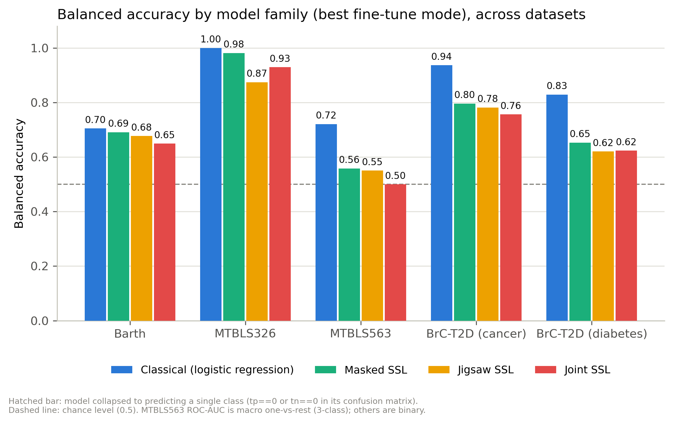
Figure 1. Balanced accuracy by model family, best fine-tuning mode per family, across all five targets. Classical logistic regression (blue) leads everywhere.
Target | Classical LR | Masked | Jigsaw | Joint | Gap
Barth | 0.705 | 0.691 | 0.677 | 0.649 | 0.014
MTBLS326 | 1.000 | 0.981 | 0.874 | 0.930 | 0.019
MTBLS563 | 0.721 | 0.558 | 0.550 | 0.500 | 0.163
BrC-T2D cancer | 0.937 | 0.796 | 0.782 | 0.757 | 0.141
BrC-T2D diabetes | 0.829 | 0.653 | 0.620 | 0.624 | 0.176
Table 4. Headline v4 benchmark. Consistent family ordering: masked > jigsaw ≈ joint. Barth and MTBLS326 gaps are within one sample and should be read as ties; leave-one-out gives no fold variance, hence no error bars.
A linear model on binned areas beating three pretrained transformers by up to 18 points needed an explanation, not just a report. The rest of this record is that investigation.

3.1 The one asymmetry that made the whole thing tractable
Inspecting the two pipelines revealed that the SSL classifier head is:
pooled embedding → LayerNorm → Dropout → Linear(d, n_classes)
That is a linear classifier, fitted by Adam for ~50 epochs with early stopping. The classical track is also a linear classifier, fitted by L-BFGS to convergence with an explicit L2 penalty. Both sides are linear, which means the two tracks can be swapped one component at a time — and every subsequent experiment in this record exploits that.

4. Decomposing the gap
Two very different explanations predict the same headline. Either the SSL embedding discards the discriminative signal (a representation problem), or it retains the signal but the head cannot extract it from ~70 training samples (a head problem). They are distinguished by running the same logistic regression on the frozen SSL embedding, over the same folds.
Validation gate applied before trusting any of this
The probe harness was first required to reproduce the official summary.csv logistic-regression balanced accuracy to six decimal places on all five targets: 0.936842, 0.828877, 0.720785, 1.000000, 0.704969.
Without that check, none of the comparisons below would be interpretable.
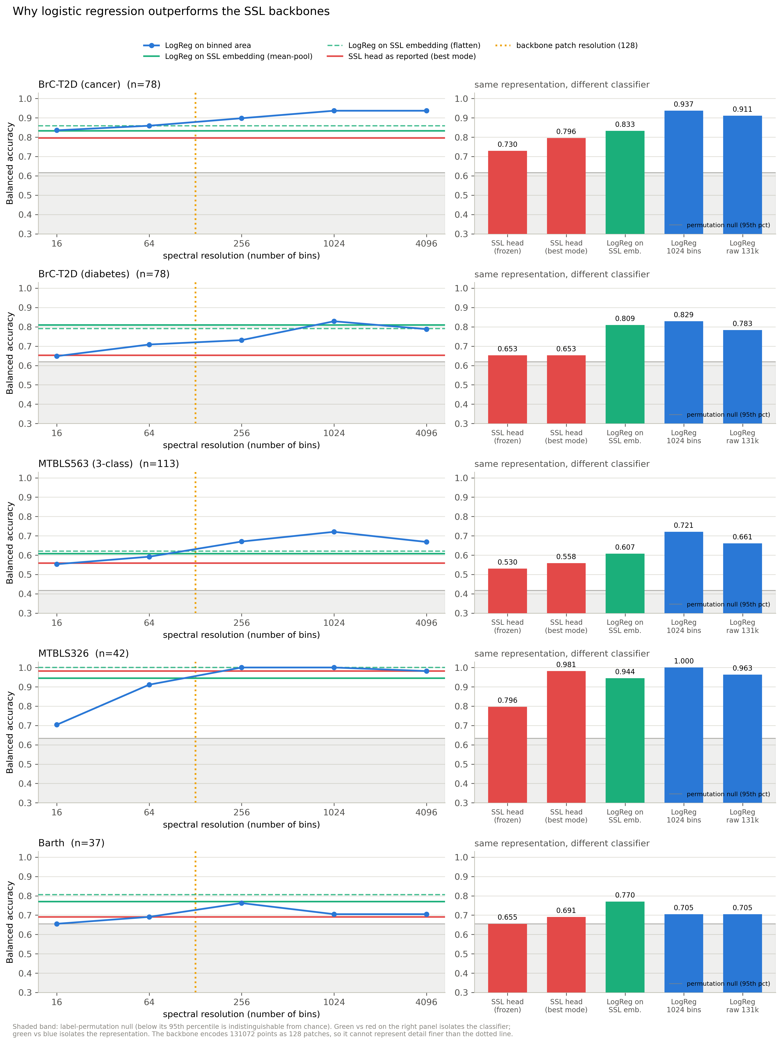
Figure 2. Left: balanced accuracy versus spectral resolution for the classical pipeline, with the SSL embedding and the reported SSL head overlaid, and the backbone's own patch resolution marked. Right: the same quantities against the label-permutation null. Green versus red isolates the classifier; green versus blue isolates the representation.
Target | SSL head | LR on same embedding | LR @1024 bins | Head deficit | Representation ceiling
BrC-T2D cancer | 0.796 | 0.833 | 0.937 | 0.037 | 0.104
BrC-T2D diabetes | 0.653 | 0.810 | 0.829 | 0.157 | 0.019
MTBLS563 | 0.558 | 0.607 | 0.721 | 0.049 | 0.114
Barth | 0.691 | 0.770 | 0.705 | 0.079 | −0.065
MTBLS326 | 0.981 | 0.944 | 1.000 | −0.037 | 0.056
Table 5. Gap decomposition. Diabetes is overwhelmingly a head problem (89% of the gap). Cancer and MTBLS563 are representation problems. On Barth the SSL embedding is genuinely better than binned features (0.770 vs 0.705) — the head was discarding a real advantage.

4.1 Controls: ruling out the boring explanations
Two checks were run before accepting that the classical result was real.
Target | Observed | Null mean | Null 95th pct | Null max | p
BrC-T2D cancer | 0.937 | 0.494 | 0.616 | 0.717 | 0.005
BrC-T2D diabetes | 0.829 | 0.498 | 0.619 | 0.674 | 0.005
MTBLS563 | 0.721 | 0.332 | 0.417 | 0.526 | 0.005
MTBLS326 | 1.000 | 0.485 | 0.634 | 0.737 | 0.005
Barth | 0.705 | 0.498 | 0.655 | 0.792 | 0.020
Table 6. Label-permutation nulls, 200 draws under the identical protocol. p = 0.005 is the floor at 200 permutations. Barth is marginal — its null reaches 0.792, above the observed 0.705 — so the Barth classical result is weak evidence and is treated as such throughout.
A single global intensity scalar (total absolute area) reaches only 0.616 / 0.593 / 0.337 on cancer / diabetes / MTBLS563, far below the full model. The signal is genuinely local spectral structure, not a dilution or concentration confound.

5. Experiment log
From this point the work became a sequence of single-variable experiments. Each is recorded with the prediction that motivated it and the outcome, including the three that failed.

5.1 Experiment #2 — is the head underfitting?
Prediction: if the masking head is poorly fitted, a converged L2 logistic regression on identical frozen features should beat it. Everything else — backbone, pooling, folds — held constant, so any difference is attributable purely to how the linear map is fitted.
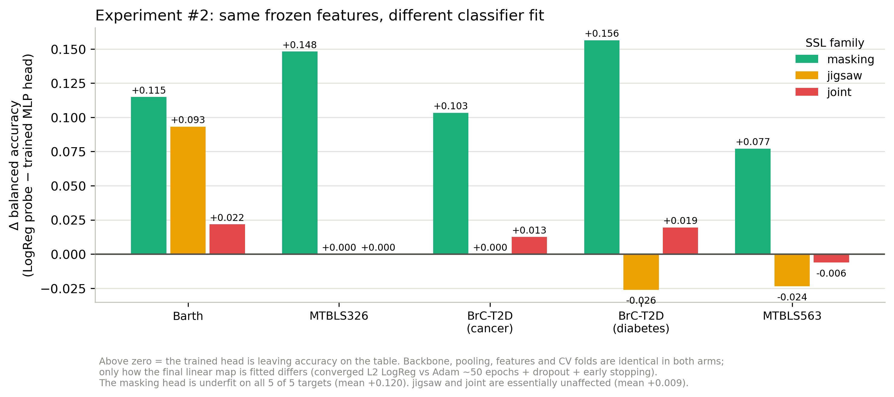
Figure 3. Δ balanced accuracy, logistic-regression probe minus the trained MLP head, on identical frozen features.
Target | Masking | Jigsaw | Joint
Barth | +0.115 | +0.093 | +0.022
BrC-T2D cancer | +0.103 | 0.000 | +0.013
BrC-T2D diabetes | +0.156 | −0.026 | +0.019
MTBLS326 | +0.148 | 0.000 | 0.000
MTBLS563 | +0.077 | −0.024 | −0.006
Mean | +0.120 | +0.009 | +0.009
Table 7. The masking head is underfit on 5 of 5 targets, by +0.077 to +0.156. Jigsaw and joint heads are fine — and their fine-tuned modes actually beat a frozen probe, so they were left alone. Extending the test to all three families is what revealed this is family-specific rather than a general 'sklearn beats Adam' effect.
Outcome and decision
Confirmed for masking only: mean +0.120 on frozen features, +0.057 even against the best fine-tuned configuration.
Adopted as a first-class evaluator (code/evaluation/ssl_linear_probe_eval.py), reported as an ADDITIONAL model rather than replacing the fine-tuned heads — on MTBLS326 the fine-tuned head genuinely wins (0.981 vs 0.963), so a silent swap would have lost accuracy there.
Negative side-finding: selecting the L2 strength by nested CV made things WORSE (gained in 4 of 15 cells, lost in 7). At n=78 with 10 folds the inner CV picks C from ~14 samples, adding variance without reducing bias. Fixed C=1 is the better choice.

5.2 Experiment #3 — does pretraining contribute anything?
This began with an error worth recording. An existing "Xavier ablation" appeared to show pretraining contributing nothing. Checking the flag revealed it reinitialises only the unfrozen layers — so in frozen mode nothing is reinitialised at all, and the two arms are byte-identical (verified: 0.526398 in both). The patch embedding and positional encoding always stay pretrained. It never tested "pretrained versus random".
Read correctly, mode by mode rather than as a maximum over four noisy modes, pretraining helps and helps more with depth — MTBLS326 masked at +3 layers: 0.948 pretrained versus 0.648 reinitialised. The earlier conclusion was retracted and a genuine control was built: same architecture, no pretrained weights loaded anywhere, with the head held fixed at a converged probe so head quality cannot contaminate the comparison.
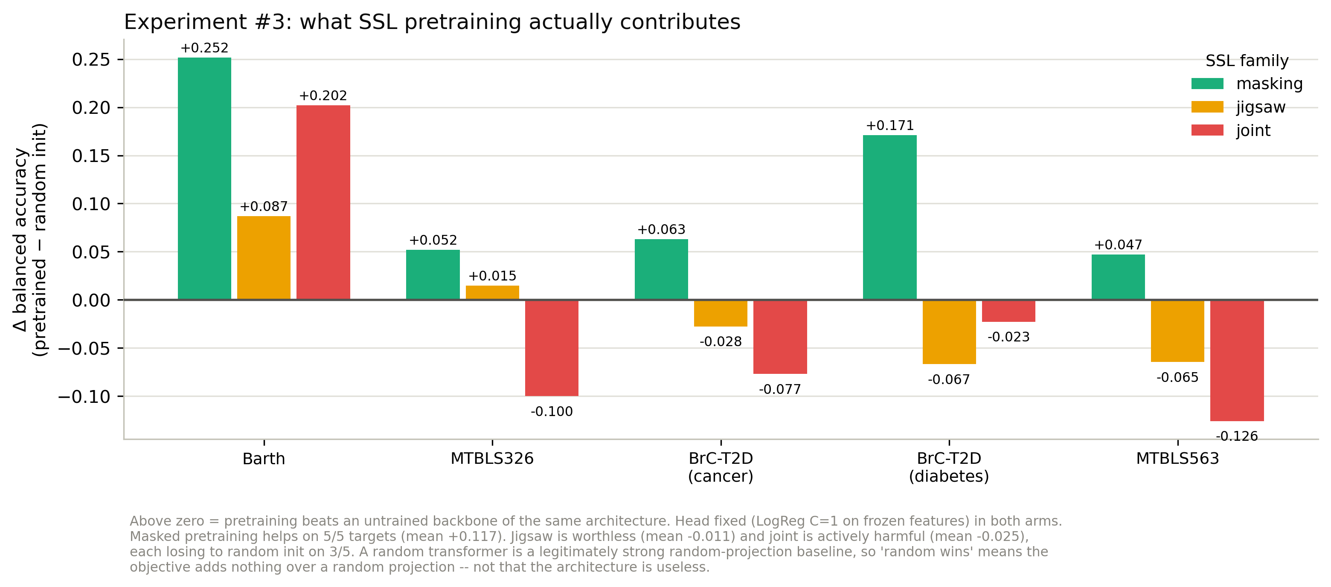
Figure 4. Δ balanced accuracy, pretrained minus true random initialisation, head held fixed in both arms.
Target | Masking | Jigsaw | Joint
Barth | +0.252 | +0.087 | +0.202
MTBLS326 | +0.052 | +0.015 | −0.100
BrC-T2D cancer | +0.063 | −0.028 | −0.077
BrC-T2D diabetes | +0.171 | −0.067 | −0.023
MTBLS563 | +0.047 | −0.065 | −0.126
Mean | +0.117 | −0.011 | −0.025
Table 8. Masked pretraining works — positive on 5 of 5 targets. Jigsaw pretraining is worthless and joint pretraining is actively harmful: a random joint backbone scores 0.846 on BrC-T2D cancer and 0.911 on MTBLS326 versus 0.769 and 0.811 pretrained.
Interpretation caveat
A random transformer is a legitimately strong random-projection baseline, comparable to random-feature kernel methods.
So "random wins" means the objective adds nothing OVER a random projection — not that the architecture is useless.
Consequence for the roadmap: concentrate on the masking objective; jigsaw and joint pretraining need rethinking or dropping.

5.3 Experiment #4 — the patch-resolution hypothesis, refuted
Prediction, and the reasoning behind it: the backbone tokenises 131,072 points into 131072/patch_size tokens. At patch_size = 1024 that is 128 positions. The frozen embedding scored right at what logistic regression achieves on 128 bins, while 1024 bins scored far higher, and the bin sweep showed resolution is exactly what buys accuracy (16→1024 bins: 0.836→0.937 on cancer). Shrinking the patch should therefore lift the ceiling.
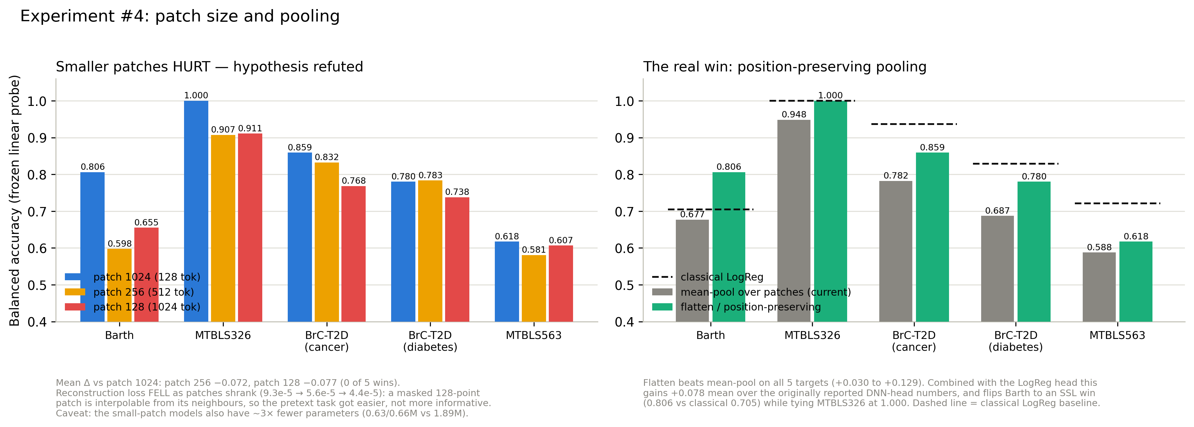
Figure 5. Left: smaller patches made things worse, on every target — the hypothesis is refuted. Right: the win the same experiment did find.
Target | patch 1024 | patch 256 | patch 128
Barth | 0.806 | 0.598 | 0.655
MTBLS326 | 1.000 | 0.907 | 0.911
BrC-T2D cancer | 0.859 | 0.832 | 0.768
BrC-T2D diabetes | 0.780 | 0.783 | 0.738
MTBLS563 | 0.618 | 0.581 | 0.607
Mean Δ vs 1024 | — | −0.072 | −0.077
Table 9. Patch-size comparison, flatten pooling, all arms read at their true nhead = 4. Zero wins out of five for either smaller patch.
Why the prediction failed — and this is the useful part
Validation reconstruction loss FELL as patches shrank: 9.26e-5 → 5.56e-5 → 4.36e-5.
A masked 128-point patch is largely interpolable from its immediate neighbours. Shrinking the patch made the pretext task EASIER, not more informative — the model can solve it by local smoothing without learning metabolite structure.
The reasoning error was considering only what the encoder COULD represent, and not whether the task would still force it to learn anything.
Confound recorded: the small-patch models also have ~3× fewer parameters, since the patch embedding and reconstruction head scale with patch size.

5.4 The win that experiment #4 did produce: pooling
The masking classifier pools tokens with a mean, which averages away where in the spectrum each token came from. Chemical-shift position is precisely the discriminative information in NMR. Replacing the mean with a position-preserving flattened embedding helped on all five targets.
Target | mean-pool | flatten | Gain
Barth | 0.677 | 0.806 | +0.129
BrC-T2D diabetes | 0.687 | 0.780 | +0.093
BrC-T2D cancer | 0.782 | 0.859 | +0.077
MTBLS326 | 0.948 | 1.000 | +0.052
MTBLS563 | 0.588 | 0.618 | +0.030
Table 10. Position-preserving pooling versus mean pooling, patch 1024. This is a pooling fix, not a resolution fix — the tokens always carried the position information; the head was throwing it away.

5.5 How much position is needed? The pooling sweep
Mean-pool and flatten are the two extremes of a spectrum, and they differ in two ways at once: retained positional detail, and feature dimension (128 versus 16,384 — which matters at n = 37–113). Regional pooling separates them: split the tokens into G contiguous groups, mean-pool within each, concatenate. G = 1 is mean-pool; G = number of tokens is flatten.
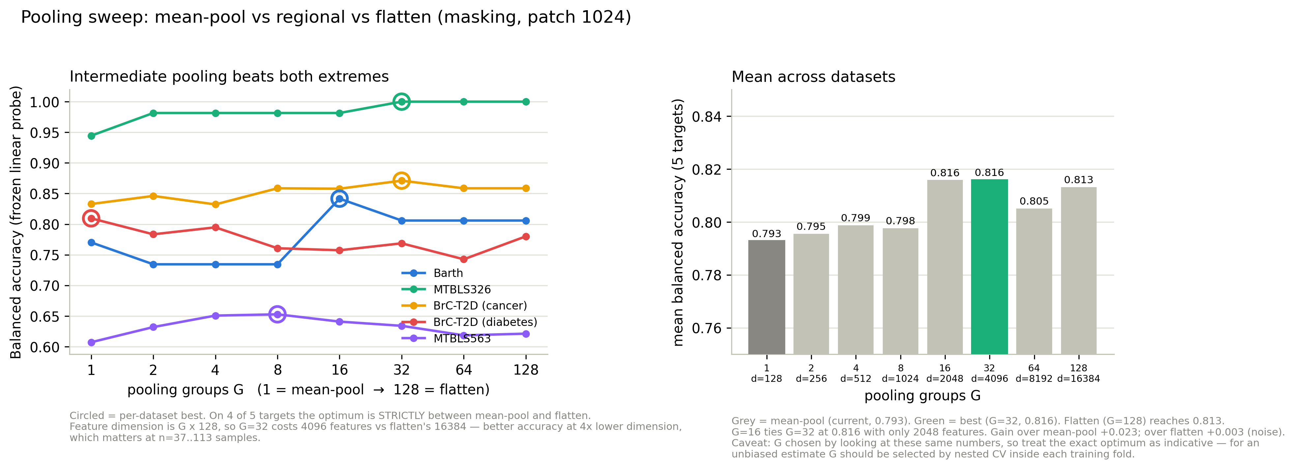
Figure 6. Regional pooling sweep. On 4 of 5 targets the optimum lies strictly between the two extremes. G = 16 matches flatten's accuracy at 2,048 features instead of 16,384.
Pooling groups G | 1 | 2 | 4 | 8 | 16 | 32 | 64 | 128
Feature dimension | 128 | 256 | 512 | 1024 | 2048 | 4096 | 8192 | 16384
Mean bal. acc. | 0.793 | 0.795 | 0.799 | 0.798 | 0.816 | 0.816 | 0.805 | 0.813
Table 11. Mean balanced accuracy across the five targets by group count. G = 1 is mean-pool, G = 128 is flatten. Caveat: G was chosen by inspecting these same numbers, so the exact optimum is indicative — an unbiased estimate requires selecting G by nested cross-validation inside each training fold.

6. Scaling the backbone: four failures
With patch 128 and 256 already having failed, two further backbones were pretrained on the v4 corpus: patch 2048 (64 tokens, 5.42M parameters) and a capacity arm holding patch 1024 fixed while raising d_model 128→256, layers 3→6, feed-forward 256→512 (5.17M parameters). Both early-stopped normally.
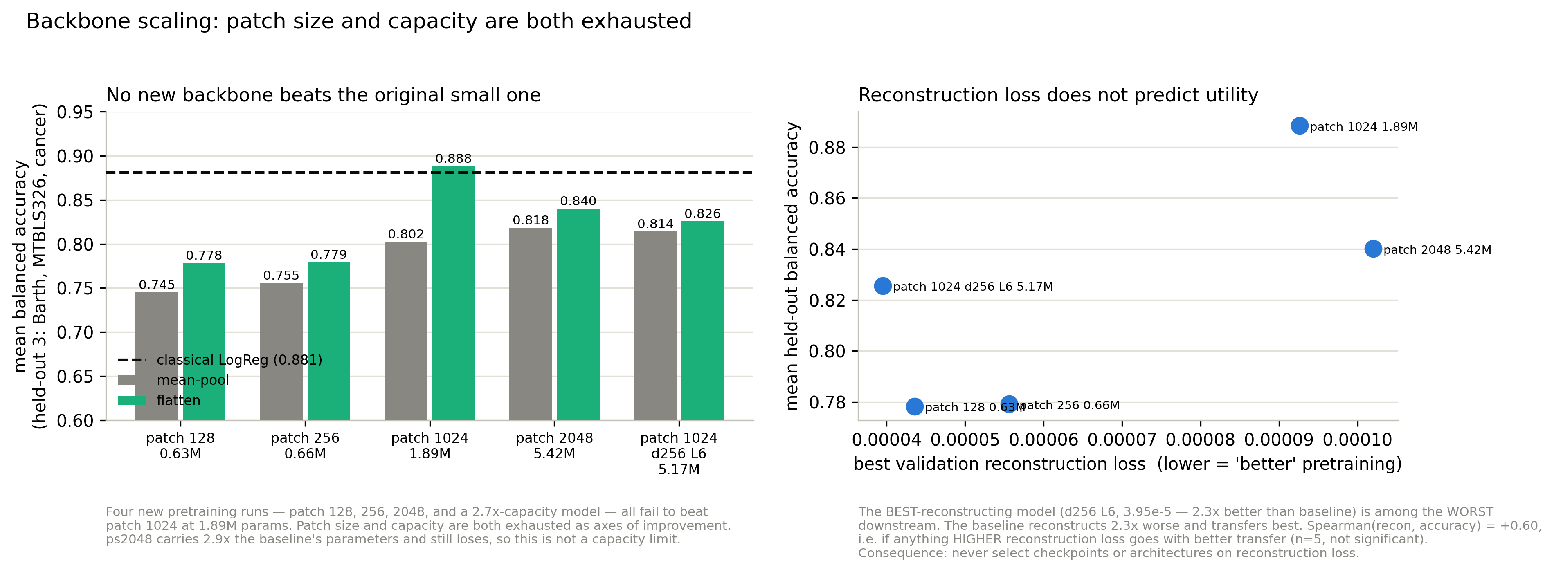
Figure 7. Left: no new backbone beats the original small one, at either pooling. Right: reconstruction loss does not predict downstream utility.
Backbone | Params | Recon loss | mean-pool | flatten
patch 128 | 0.63M | 4.36e-5 | 0.745 | 0.778
patch 256 | 0.66M | 5.56e-5 | 0.755 | 0.779
patch 1024 (original) | 1.89M | 9.26e-5 | 0.802 | 0.888
patch 2048 | 5.42M | 1.020e-4 | 0.818 | 0.840
patch 1024, d256 L6 | 5.17M | 3.95e-5 | 0.814 | 0.826
Classical logistic regression | — | — | — | 0.881
Table 12. Held-out mean balanced accuracy (Barth, MTBLS326, BrC-T2D cancer). Letting each backbone choose its own pooling on the selection subset only gives: original 0.849, patch 2048 0.824, d256 L6 0.817 — the original wins under every pooling.
Two conclusions
1. Patch 1024 is near-optimal and this is NOT a capacity limit. Patch 2048 carries 2.9× the baseline's parameters and still loses. Four attempts — 128, 256, 2048, and 2.7× capacity — all failed. The backbone axis is exhausted.
2. Capacity compensates for bad pooling but does not beat fixing it. Under mean-pool, accuracy rises perfectly monotonically with parameters (Spearman = +1.00, p < 0.01). Yet the 1.89M model with flatten (0.888) beats every 5M model. The bottleneck was information destroyed by pooling, not model capacity.

6.1 Reconstruction loss is not a proxy for downstream utility
Across the five backbones, Spearman correlation between validation reconstruction loss and held-out accuracy is +0.60 for flatten and +0.40 for mean-pool — if anything, worse reconstruction goes with better transfer (n = 5, not significant, but the sign is consistent).
The starkest case: the d256 L6 model reconstructs 2.3× better than the baseline (3.95e-5 versus 9.26e-5) and transfers worse (0.826 versus 0.888). The same disconnect appeared within a single run, where patch 128's final checkpoint had 2.4% better reconstruction and scored lower downstream on 4 of 5 targets.
Operational rule adopted
Never select checkpoints, architectures, or epochs on reconstruction loss.
Selection must use a downstream signal — but on a PRE-COMMITTED subset, never on the datasets used for reporting.

6.2 On selection bias
Raised during review and adopted as standing practice. Comparing many configurations by their downstream cross-validation scores and then quoting the winner inflates the reported number, even though no label information crosses folds — the backbone is pretrained on a disjoint corpus and the probe is fitted on training folds only. It is not leakage, but it is model selection on the reporting set.
- From section 6 onward, configuration choices (pooling G, backbone) are made on a designated selection subset: MTBLS563 + BrC-T2D diabetes.
- Results are reported on the held-out three: Barth, MTBLS326, BrC-T2D cancer.
- Throughout this record, the comparative signs are more trustworthy than the absolute values, because each holds consistently across five independent datasets.

7. Infrastructure defects found along the way
Several of these would silently corrupt results, so they are recorded as findings in their own right.
Defect | Consequence | Resolution
nhead not recorded in checkpoints | nn.MultiheadAttention stores in_proj_weight at (3·d_model, d_model) for any head count, so a checkpoint loads silently under the WRONG nhead while reinterpreting trained weights. Training used 4; every eval script defaulted to 8. | Checkpoints now record the full architecture, read back off the built model. Measured impact was large (diabetes 0.810 vs 0.687) — and counterintuitively the mismatched value performed better.
Barth eval used the raw file | 100% of Barth evaluation spectra had no water suppression. | Evaluation paths repointed to pipeline outputs.
Stale default checkpoint paths | SSL training scripts defaulted to an older, uncleaned 8,892-row corpus; the few-shot script still defaults to a completely unsuppressed Barth file. | Training defaults updated; few-shot paths must be passed explicitly.
tqdm one line per batch | Progress bars redraw via carriage return, which only works on a TTY. Piping through tee produced one line per batch. | Bar disabled when stdout is not a terminal; per-epoch summaries unaffected.
GPU contention unnoticed | A patch-2048 run shared a GPU with another user's job and ran 17× slower than benchmarked — 53 h projected versus 3.2 h. | Moved to an idle GPU. Benchmarks are now taken with contention checked.
Table 13. Infrastructure defects. The nhead issue is the most dangerous class: it produces wrong numbers with no error and no warning.

8. Where we stand
Combining the two cheap wins — the converged linear probe head and position-preserving pooling — with no retraining at all:
Target | Reported DNN head | Probe + flatten | Classical | vs Classical
Barth | 0.691 | 0.806 | 0.705 | +0.101 SSL wins
MTBLS326 | 0.981 | 1.000 | 1.000 | 0.000 tie
BrC-T2D cancer | 0.796 | 0.859 | 0.937 | −0.078
BrC-T2D diabetes | 0.653 | 0.783 | 0.829 | −0.046
MTBLS563 | 0.558 | 0.621 | 0.721 | −0.100
Table 14. Current best position. Mean improvement of +0.078 over the originally reported numbers, achieved without retraining anything. The SSL-versus-classical record moves from 0 wins / 0 ties / 5 losses to 1 win / 1 tie / 3 losses.

8.1 What is established
- Masked pretraining genuinely works: +0.117 mean over a true random-initialisation control, positive on 5 of 5 targets.
- Jigsaw pretraining adds nothing over a random projection; joint pretraining is actively harmful.
- The masking head was underfit by ~0.12 on every target. Fixed.
- Mean pooling was discarding chemical-shift position, worth +0.03 to +0.13. Fixed.
- Patch size 1024 is near-optimal; capacity is not the binding constraint. Four scaling attempts failed.
- Reconstruction loss does not predict — and may anti-correlate with — downstream utility.

8.2 Open caveats
- MTBLS326's perfect score clears its permutation null but permutation does not test batch confounding. Whether the label correlates with acquisition date, run order or instrument has not been checked, and should be before publication.
- Barth and MTBLS326 have no error bars (leave-one-out gives no fold variance); their gaps are within single-sample noise.
- Barth's classical result is marginal — its permutation null reaches 0.792 against an observed 0.705.
- Seven rows repository-wide retain a dominant EDTA-window peak (six in the corpus, one in MTBLS563): four exhaust the peak cap, three sit inside the edge margin.

8.3 Next directions
The evidence points away from scale and toward the pretext objective. Four scaling experiments failed, and reconstruction loss actively misleads — both implicate the objective rather than the architecture.
Priority | Experiment | Rationale
1 | Harder / aligned pretraining objective | Block masking of contiguous multi-patch spans so neighbour-interpolation fails, and peak-weighted reconstruction so capacity goes to peaks rather than baseline. Directly targets the mechanism behind the patch-size failure.
2 | Few-shot benchmark on v4 | The one place SSL's value proposition is untested. At n = 37–113, full-data CV is near the learnable ceiling; transfer is where pretraining should pay off.
3 | Learned attention pooling | Learns which tokens matter rather than using fixed groups. Has trainable parameters, so it must be fitted inside each training fold — a head, not a frozen transform.
4 | Hybrid features | Concatenate SSL embedding with binned areas. They are partly complementary — on diabetes and Barth the embedding beats same-resolution binning.
— | Batch-confound audit of MTBLS326 | Prerequisite for reporting the perfect score.
Table 15. Ranked next steps.
A framing worth considering
Classical logistic regression on 1024 binned features may simply be near-optimal at these sample sizes.
A defensible contribution is: "SSL matches classical on 2 of 5 targets and loses on 3, with a rigorous account of why" — the head deficit, the pooling defect, the exhausted scaling axes, and the reconstruction/utility disconnect are all genuine, well-controlled findings.
That is a stronger result than an unconvincing win.

9. Reproducibility

9.1 Data of record (v4)
Dataset | File
Pretraining corpus | data/combined/combine_unique_MetaboLights_Workbench_Water_EDTA_Suppressed_rowMinMax_v4.npy
Barth | data/Barth/aligned_128K_Workbench_Barth_Syndrome_WS625to680Zero_EDTASuppressed_rowMinMax_v4.npy
MTBLS326 | data/mtbls326/MTBLS326_aligned_spectra_WS625to680Zero_rowMinMax_v4.npy
MTBLS563 | data/mtbls563/MTBLS563_aligned_spectra_WS625to680Zero_rowMinMax_v4.npy
BrC-T2D (revised labels) | data/BrC_T2D/BC_T2D_newlabels_WS625to680Zero_rowMinMax_v4.npy

9.2 Key scripts
Purpose | Script
Build clean datasets | code/preprocessing/build_clean_datasets.py
EDTA magnitude detector | code/preprocessing/suppress_edta_magnitude.py
Suppression audit | code/analysis/validate_suppression.py
Gap decomposition (#1) | code/analysis/probe_logreg_advantage.py
Linear probe (#2) | code/analysis/linear_probe_frozen_embeddings.py
Probe evaluator + random-backbone control (#3, #5) | code/evaluation/ssl_linear_probe_eval.py
Patch-size comparison (#4) | code/analysis/compare_patch_sizes.py
Pooling sweep | code/analysis/sweep_pooling.py
SSL pretraining (masking) | code/training/trainer_revised.py

9.3 BrC-T2D label revision
The revised label file changed the diabetes status of exactly four samples; cancer status changed for none. An earlier count of 41 changes was an artefact of comparing a display string ("Cancer" versus "Breast Cancer"), not the label columns the evaluation reads.
Sample | Old diabetes status | New diabetes status
SM58 | Diabetes | No Diabetes
SM35 | No Diabetes | Diabetes
SM23 | Diabetes | No Diabetes
KM70 | No Diabetes | Diabetes
Table 16. Genuine label changes. Extraction was verified by byte-comparing all 78 extracted spectra against the source array and independently cross-referencing every sample ID — zero mismatches.

End of record. This document is intended to be extended as work continues; each new experiment should be added to section 5 or 6 with its prediction, outcome, and any decision taken.

