A Foundation Model for NMR Metabolomics
Progress report — September 2026
Shankararama Sharma · Prepared for the co-investigator, as a first orientation to the project and its findings to date.

1. Goal and background
Nuclear magnetic resonance (NMR) spectroscopy of blood serum produces, for each patient sample, a single trace that records the concentrations of hundreds of small molecules — metabolites — simultaneously. Because metabolite levels shift with disease, these spectra are an attractive basis for diagnostic classification: distinguishing patients from controls, or one disease state from another.
The obstacle is sample size. Deep neural networks are the standard tool for pattern recognition of this kind, but they typically require tens of thousands of labelled examples. Clinical metabolomics studies routinely have between 30 and 150. This is the gap the project set out to close.
The strategy is the one that transformed language and vision: self-supervised pretraining. A network is first trained on a large pool of unlabelled spectra using a task that needs no diagnosis — here, hiding portions of a spectrum and asking the model to reconstruct them. The hope is that solving this puzzle forces the model to learn the underlying structure of NMR spectra, after which only a small labelled dataset is needed to adapt it to a specific clinical question. A model used this way is often called a foundation model.
We assembled a pretraining corpus of 9,670 serum spectra from public repositories (MetaboLights and Metabolomics Workbench), and set aside four independent clinical cohorts, entirely unseen during pretraining, for evaluation. The central question is simple to state: does this pretraining actually help, compared with conventional statistical machine learning applied directly to the same spectra?

2. Principal finding
It does not. Across every evaluation cohort and every labelled-sample budget we tested, ordinary logistic regression on binned spectral intensities matched or beat the pretrained neural network. The clearest test paired the two methods on identical data splits, so that sampling variation cancels: at the smallest labelled-sample budget the difference was +0.001 ± 0.016 in balanced accuracy (p = 0.74) — indistinguishable from zero.
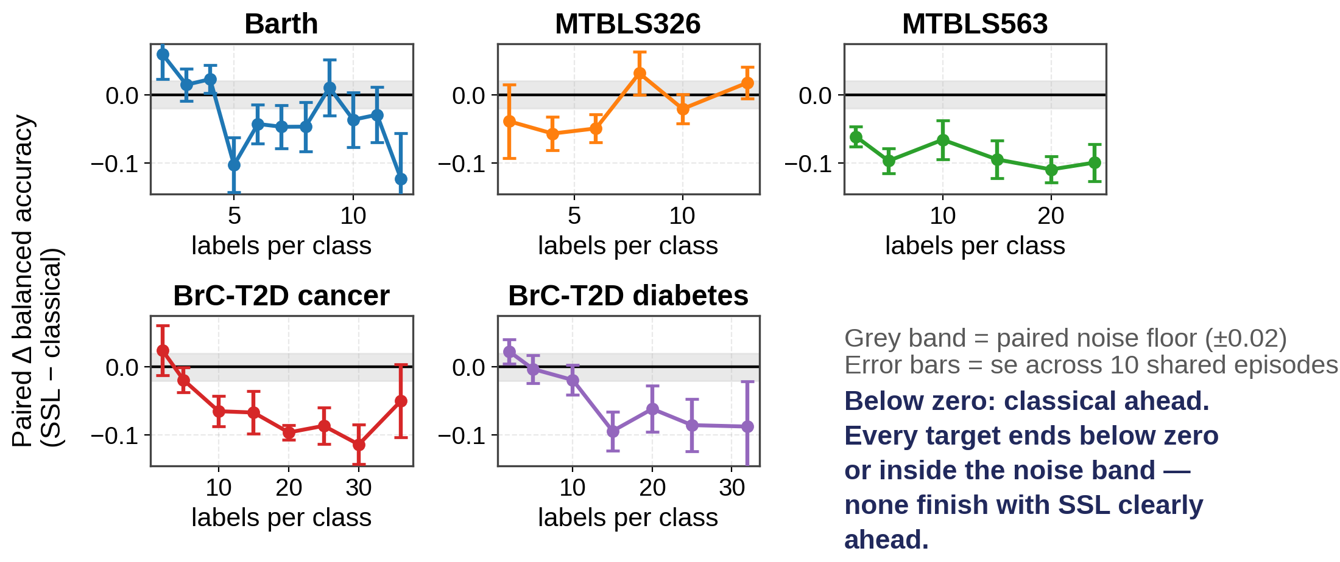
Figure 1. The head-to-head comparison, on all five clinical questions. Each point is the difference in balanced accuracy between the pretrained network and classical logistic regression, trained and tested on exactly the same patients. Zero means the two methods tie; below zero means classical is ahead. The grey band is the measurement noise of the training procedure itself — differences inside it are not real. As the number of labelled patients grows (left to right), every curve moves downward: the more data available, the further ahead the simple method gets.
Two results that initially appeared to favour the neural approach did not survive scrutiny, and both failures are instructive:
- A single cohort (Barth syndrome) showed the network beating classical machine learning by a wide margin. This turned out to be chance. Repeating the pretraining with five different random seeds showed that the reported figure was the best of the five and sat 1.5 standard deviations above the group mean; the other four seeds all fell below the classical baseline.
- A second cohort produced a perfect classification score on 42 samples. This dataset is confounded by experimental design. Cases were measured as samples 1–27 and controls as samples 101–130 — two separate instrument sessions. Any technical drift therefore predicts the diagnosis perfectly. We confirmed the effect is real, not merely possible: regions of the spectrum that contain no metabolite signal at all still classify the label at 73% accuracy.
With those two removed, the honest record on the remaining cohorts is zero wins for the pretrained model.

3. Why it fails — the mechanism
A negative result is only useful if it comes with an explanation, and the most important work of the last month was establishing one.
The pretraining task is too easy. Reconstruction quality had always been reported without a baseline — the equivalent of quoting a classifier's accuracy without saying what chance performance is. When we supplied the missing baselines, the picture changed completely.
Method for filling in hidden spectral regions | Accuracy (correlation)
Linear interpolation from neighbouring points | 0.38
The average spectrum of the whole corpus | 0.56
Copying the most similar other patient's spectrum | 0.90
The trained neural network | 0.92

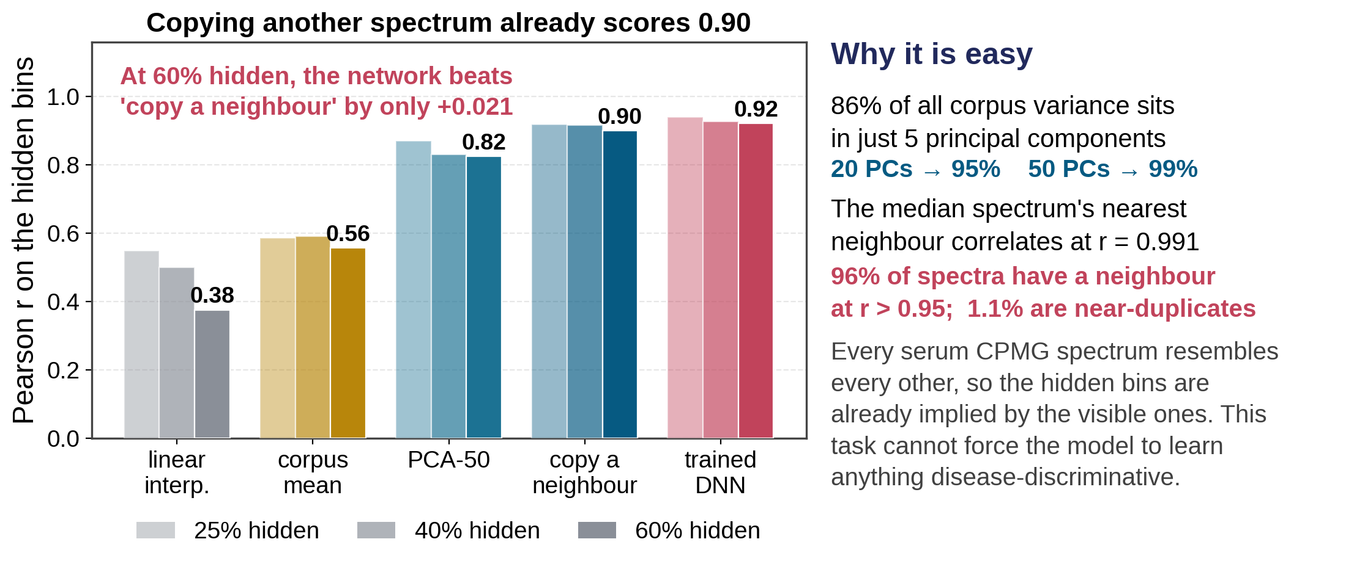
Figure 2. How hard is the pretraining puzzle really? Bars show how accurately each method can fill in hidden regions of a spectrum, at three difficulty levels (25%, 40% and 60% of the spectrum hidden). The neural network is the rightmost bar in each group. The decisive comparison is with the bar immediately to its left: simply finding the most similar other patient in the corpus and copying their values. It nearly matches the network at every difficulty — so the puzzle can be solved without learning any chemistry.
Simply copying another patient's spectrum performs almost as well as the network. The reason is that the corpus is far more homogeneous than its size suggests: 86% of all variation lies in just five underlying dimensions, and the typical spectrum has a near-twin elsewhere in the corpus (correlation 0.99). The reconstruction task can be solved from population averages alone, so it never compels the model to learn the fine chemical detail that distinguishes one patient from another. Disease signal is a small perturbation on top of a very strong common pattern, and the training objective is dominated by the common pattern.
A related measurement reinforced this. Comparing the pretraining corpus against the four evaluation cohorts, we found no contamination — no evaluation sample appears in the training pool, so the results are a genuine test of transfer. But coverage is poor: within the corpus a spectrum's closest match has a correlation of 0.99, whereas for the evaluation cohorts the closest available match is only 0.37–0.78. The corpus is narrow rather than small. Adding more spectra of the same kind would not address this.

4. Data-quality auditing
Because one dataset proved to be confounded, we audited all four cohorts on the same footing. Two tests were used: whether cases and controls were measured in separate instrument sessions, and whether spectral regions containing no metabolite signal can nevertheless predict the diagnosis — which would only be possible if a technical difference tracks the clinical groups.
Design balance, in plain terms. Samples are measured on the spectrometer one after another, over hours or days, and the instrument drifts slightly during that time. A balanced (interleaved) study alternates patients and controls throughout the run, so any drift affects both groups equally and cancels out. A blocked study measures all the patients first and all the controls afterwards. Then the drift itself separates the two groups, and a classifier can score well by detecting when a sample was run rather than what is in it — a machine artefact wearing the costume of a biological discovery.
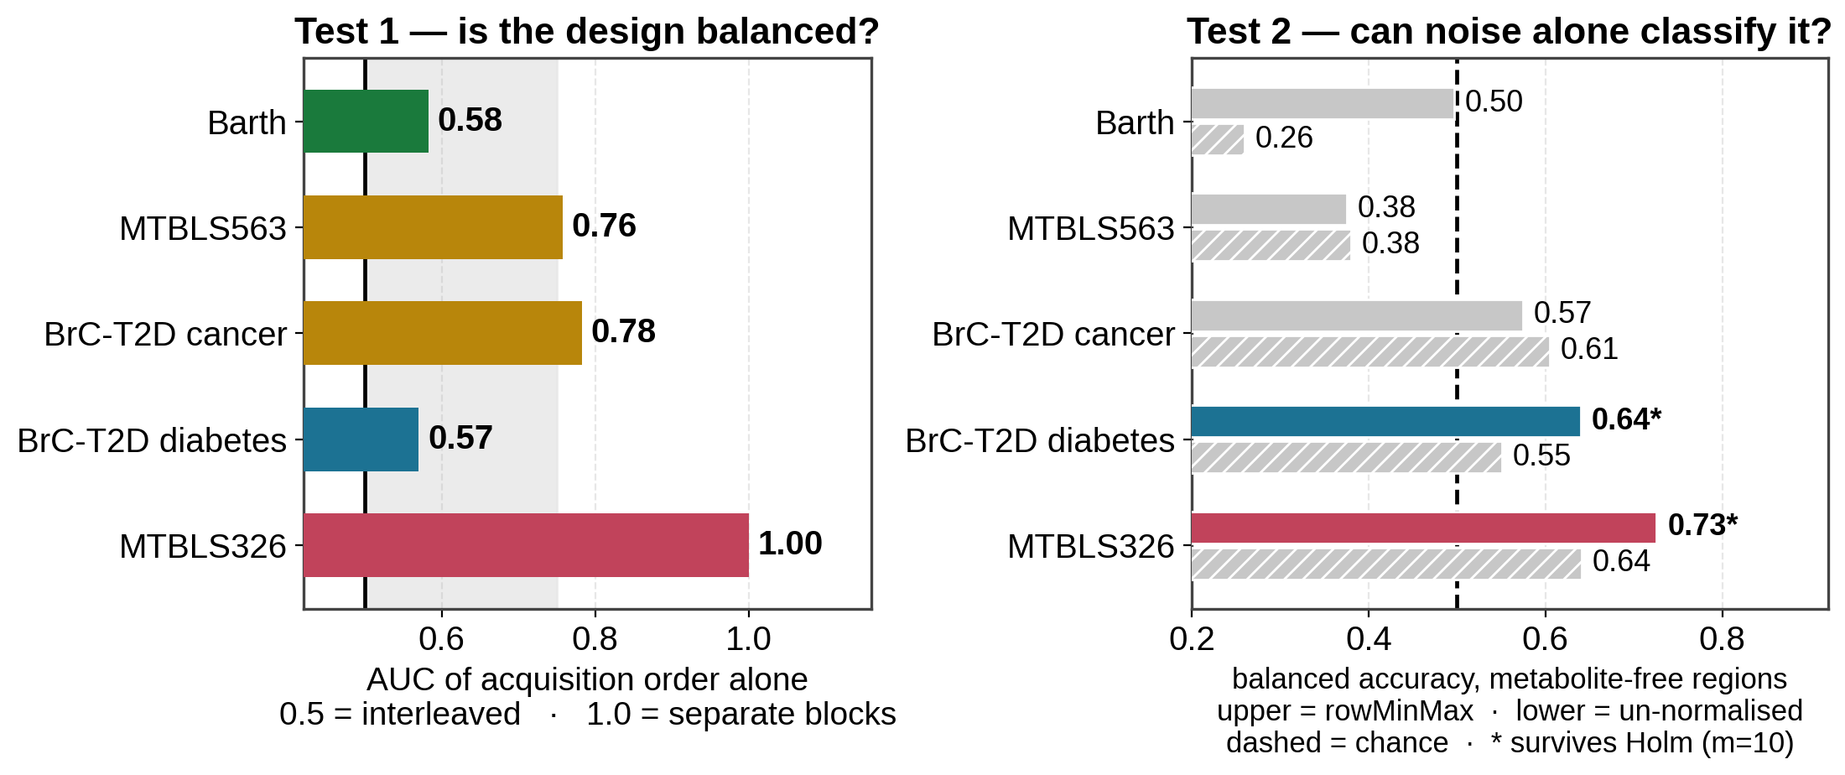
Figure 3. The two audit tests. Left: can the position of a sample in the measurement queue, on its own, predict the diagnosis? 0.5 means no (properly interleaved); 1.0 means the two groups were run as completely separate blocks. Right: can spectral regions that contain no metabolite signal — only noise — predict the diagnosis? The dashed line is chance. MTBLS326 fails both decisively, which is why it was excluded.
Cohort | Design balance | Verdict
Barth syndrome | Interleaved | Clean — passes both tests
MTBLS563 | Partly blocked | Usable, with a design caveat
BrC-T2D (cancer) | Partly blocked | Usable, with a design caveat
BrC-T2D (diabetes) | Interleaved | Ambiguous — see note
MTBLS326 | Fully separated | Not usable

This has methodological value beyond our own project. The standard safeguard in this literature is a label-permutation test, and every one of our datasets passes it — including the confounded one. That test cannot detect a batch effect, because shuffling the labels destroys the batch structure and the biological signal at the same time. A confound has to be attacked directly.
The audit also surfaced a defect in our own processing. The intensity-normalisation step we had adopted, which rescales each spectrum by its own largest peak, converts an absolute intensity difference into a signal-to-noise ratio — and signal-to-noise is a property of the measurement session, not the patient. On two cohorts this measurably increased the amount of non-biological signal available to a classifier. We tested three alternative normalisation schemes; the existing choice remains the best overall, but the caveat is now documented and one cohort's result is flagged for re-checking.

5. Current direction: synthetic training data
If the limitation is that the corpus is too homogeneous, the natural response is to generate spectra that are chemically realistic but more diverse than anything the public repositories contain. Two approaches are under development.

5.1 Recombining windows of real spectra
The first method samples short spectral windows from different patients and stitches them together with overlap. We built and evaluated three variants. All of them produce output that looks entirely convincing to the eye — and this proved to be the trap. Measured against the statistical structure of real data, the naive variant destroys the correlations between different regions of the spectrum, while the variant that preserves those correlations does so only by copying real spectra almost verbatim.
The trade-off is itself the finding. We measured that intensities at different points in an NMR spectrum remain correlated across patients at essentially all separations — this is the chemical fact that all signals from one molecule rise and fall together with its concentration. Consequently any recombination that is genuinely novel at long range is also chemically wrong at long range. Window-based recombination is useful as local augmentation, not as a stand-alone generator.

5.2 Building spectra from known metabolite signatures
The second and more promising method constructs a spectrum as a weighted sum of the known spectral signatures of individual metabolites, with the weights drawn from realistic concentration distributions. This preserves chemical coherence by construction — all signals belonging to one molecule necessarily scale together — while allowing us to set the diversity of the synthetic population deliberately, which is precisely the property the real corpus lacks.
We have built the reference library: 43 serum metabolites drawn from GISSMO, a public database of experimentally validated NMR signatures, simulated at our instrument's field strength. The library is chemically validated — 19 of 21 metabolites with well-established literature values match to within 0.03 ppm. Because a metabolite library contains only small molecules, we additionally extracted the broad lipoprotein contribution empirically from our own data; it accounts for 37.5% of the total signal.
Before generating anything, we imposed a gate: can this model reproduce a real spectrum? At present it explains approximately 50% of the variance, against a target of 90%. The generator is therefore not yet fit for use, and we have deliberately not proceeded to the later stages. The diagnosis is encouraging, however: adding the lipoprotein component substantially improved the model's behaviour without raising this ceiling, which isolates the remaining problem as one of peak alignment rather than missing chemistry.
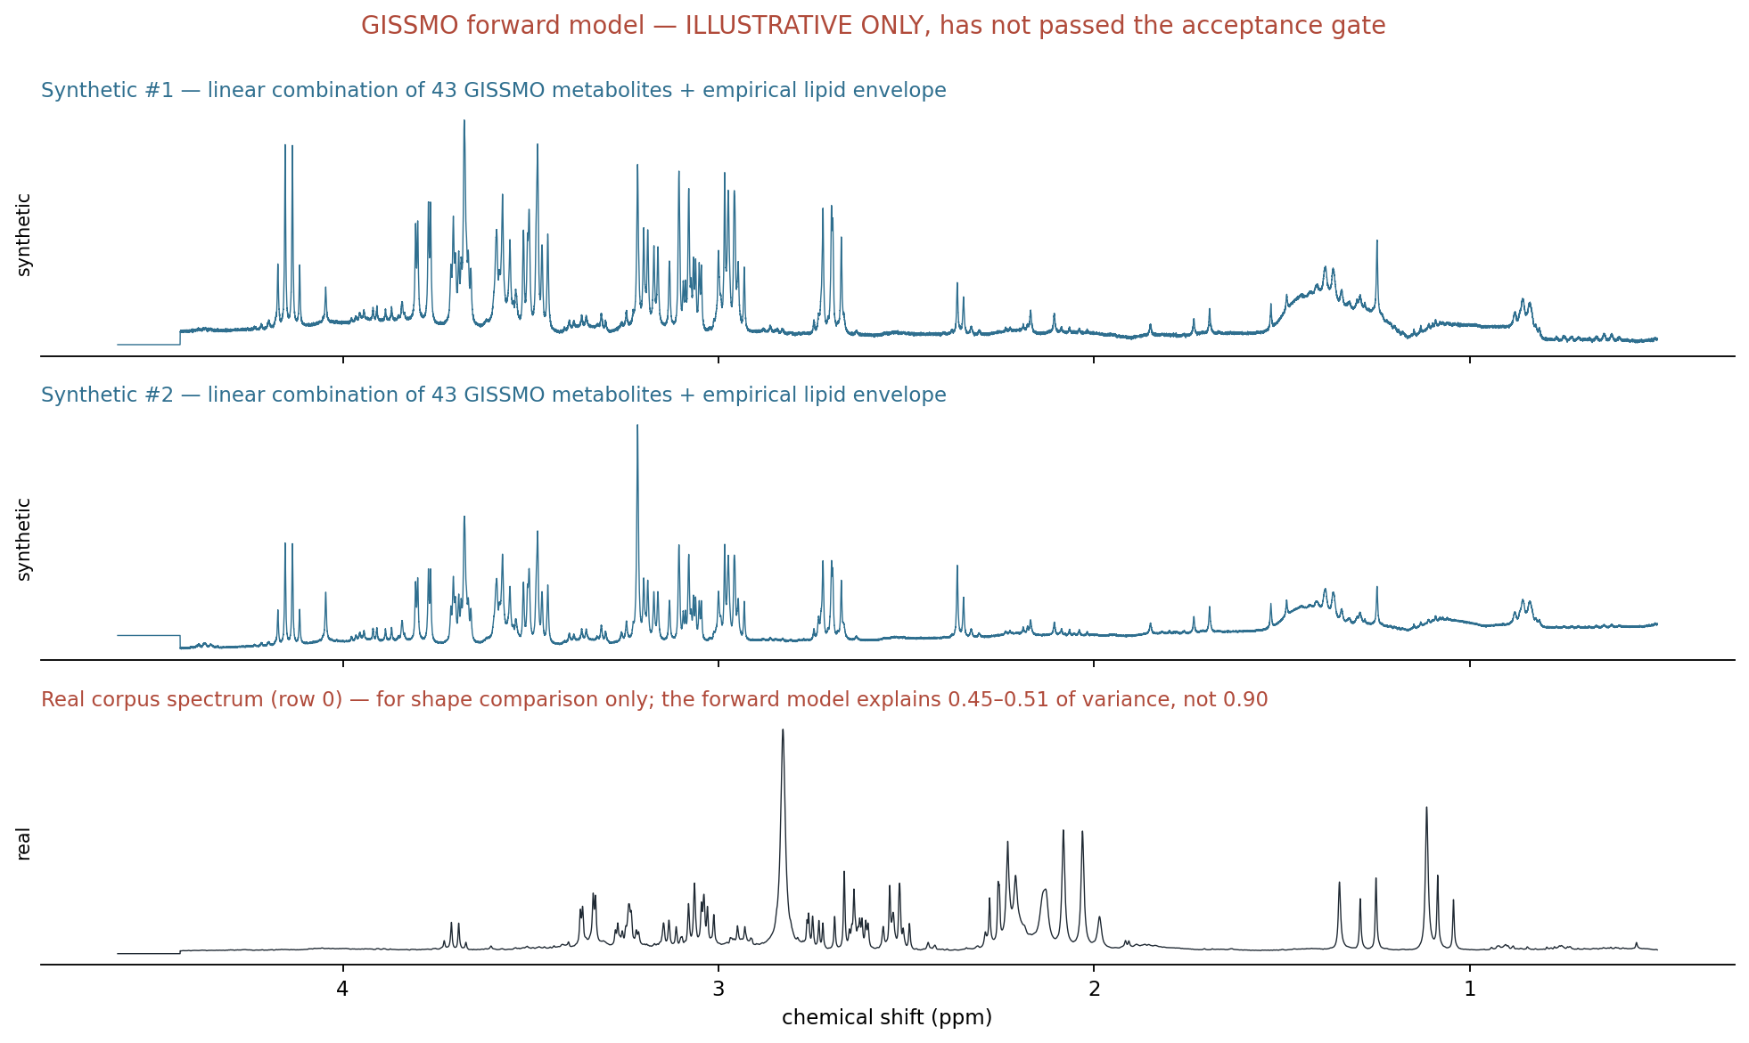
Figure 4. Two synthetic serum spectra built from the metabolite library (top, blue), with a real patient spectrum beneath for comparison (black). The synthetic traces are chemically coherent by construction. They are shown to illustrate that the library is assembled and usable — they are not yet validated training data, for the reason given below.

5.3 The alignment problem, now diagnosed
The original instrument parameter files have since been recovered, and they identify the cause precisely. It lies in our own processing, not in the reference library.
NMR spectra must be placed on a common chemical-shift axis before they can be compared, and this is normally done by reference to a standard compound added to every sample, which produces a marker peak at a known position. The public datasets we assembled do not contain that standard. Our pipeline instead anchored each spectrum by its own rightmost detectable feature, which is a reasonable substitute only if the marker peak is present. It is not: the measured intensity where the marker should be is under 1% of the spectrum's own maximum, and every spectrum extends well past that position into empty noise.
The consequence is systematic. The eleven contributing studies recorded slightly different spectral windows — almost the same width, but shifted by about 0.13 ppm. Anchoring on the edge therefore forced that shift onto the chemistry: roughly 40% of the corpus sits about 800 data points away from the rest. For scale, a single NMR peak is about 13 data points wide, so the affected spectra are displaced by some sixty peak widths. The same metabolite appears in a completely different place depending on which study a sample came from.
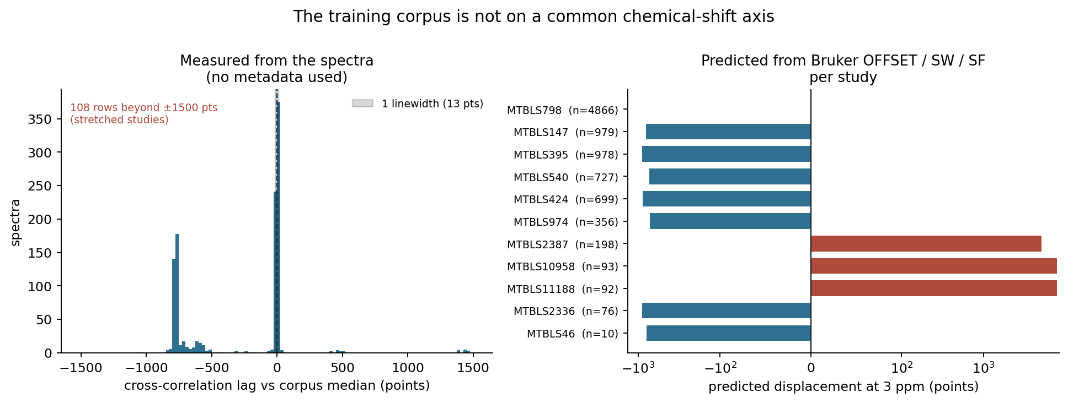
Figure 5. The misalignment, established two independent ways. Left: measured directly from the spectra, with no reference to instrument records — most spectra agree with each other (the spike at zero), but a large group sits about 800 data points away, and a small group very much further. Right: the displacement predicted for each contributing study from its instrument settings alone, without examining any spectrum. The two agree, which is why we regard the diagnosis as settled.
It is repairable, and the repair is arithmetic rather than statistical. Each spectrum's own instrument file records the exact window it was acquired over, so every spectrum can be placed on one common axis with no fitting and no free parameters. It does, however, require rebuilding the dataset from the original archive.
We expected this to explain the 50% ceiling of Section 5.2. It does not. Correcting the displacement and re-running the same test on the same spectra moves the figure from 0.486 to 0.493 — a difference indistinguishable from zero (p = 0.97). More tellingly, the spectra that were actually displaced got slightly worse, while those already aligned got better; had misalignment been the binding constraint, the result would have been the reverse. The misalignment is a genuine defect and will be repaired, but it is not what limits the synthetic-spectrum model. The likelier explanation is now the simpler one: the library contains 43 metabolites where serum holds roughly a hundred, and it allows no freedom for individual metabolite peaks to shift with sample pH, which established quantification software does allow.
What this does and does not affect. The comparison in Section 2 is unaffected: both methods were trained and tested on the same spectra, so a defect they share cannot explain the gap between them. What it does revise is the explanation in Section 3. Spectra from different studies cannot closely resemble one another while displaced by sixty peak widths, so the near-duplication that makes the pretraining puzzle easy must occur within studies. The corpus is more fragmented, and effectively smaller, than its 9,670 spectra suggest. Whether pretraining on a correctly aligned corpus would change the conclusion is now an open question, and the most important one before us.

6. Status and next steps
Question | Status
Does self-supervised pretraining beat classical ML? | Answered: no
Why not? | Answered: the pretraining task is nearly trivial on this corpus
Is the amount of data the limitation? | No — the diversity of the data is
Are the evaluation datasets sound? | Audited; one excluded, two flagged
Can synthetic data supply the missing diversity? | In progress
Is the assembled corpus itself sound? | No — a correctable alignment defect found

The immediate priority is the alignment repair of Section 5.3, which now gates everything downstream. Rebuilding the corpus on a common chemical-shift axis would settle whether the negative result survives a technically sound dataset, unblock the synthetic-data gate, and allow the data-quality audit to be repeated against true acquisition timestamps rather than a proxy. A faster interim option exists — estimating each spectrum's displacement from the data and correcting it in place — which would answer the scientific question in days rather than weeks, though it would not produce a dataset we would want to publish from. Beyond that, the spectral fitting needs to allow each metabolite's peak positions to shift slightly, as established quantification software does. Should the synthetic-data route then succeed, pretraining will be repeated on the enlarged corpus and the entire evaluation rerun.
A note on how this work has been conducted. Several of the findings above are retractions of our own earlier conclusions. Early in the project we measured the run-to-run variability of the training procedure and found it to be roughly twice what we had assumed; applying that threshold retrospectively invalidated several results that had rested on single training runs. Every claim now carries an explicit uncertainty, comparisons are made in a paired design wherever possible, and results that do not survive are recorded as retracted rather than quietly dropped. The negative result reported here is, in our view, considerably more secure for it.

