CS-570 INTRODUCTION TO HUMAN-COMPUTER INTERACTION  
FALL 2022 | PROFESSOR Thebault-Spieker

PROJECT 1: WEB-BASED SERVICES

ALICIA LYU, SAI AKARSH ACHE, RAMAPRIYA RANGANATH

ATHLETICARE

We are building a system which will connect the athletes to the doctors.

Here we want to implement Google O-Auth for data security. The athletes will be able enter the required injury which they are suffering currently, post which the system will show the list of expert doctors in that domain along with their availability and ratings. The athletes can schedule their appointment with the required doctor after looking at their rating and availability date. The athletes will be able to rate the doctor after their session depending on various parameters.

The current state-of-art is the *UHS* online appointment scheduling system. Our initial impression of it is that it is not user-friendly. One cannot see doctor’s information, and has to go through a badly-designed survey to see the appointment slots. We want to build a website that is more user-friendly.

Currently we are starting off this project by building a web-based platform for them to connect but in future we will definitely build a cross platform app which will render both on Android and IoS devices.

We did CI with 3 athletes in UW Madison.

According to our initial understanding, *doctor and appointments choices* are crucial in our design space. That is why we focused on doctor descriptions and ratings.

The problems we identified from Cis are different from our initial understanding. *Immediate availability is the most crucial* for athletes. If one doctor is immediately available, they most likely would go with it. In contrast, rating is not that important. However, *UHS don’t have an emergent service, and don’t even prioritize different patients.* They have to wait the same amount of time as others with minor problems. This finding is reflected in the following story board:

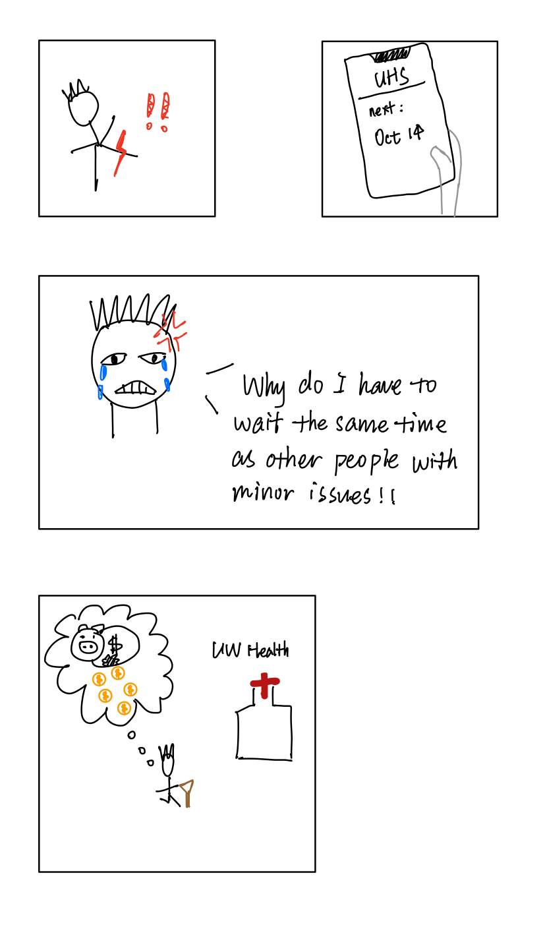

Photos of interviews: (the other one is on zoom)

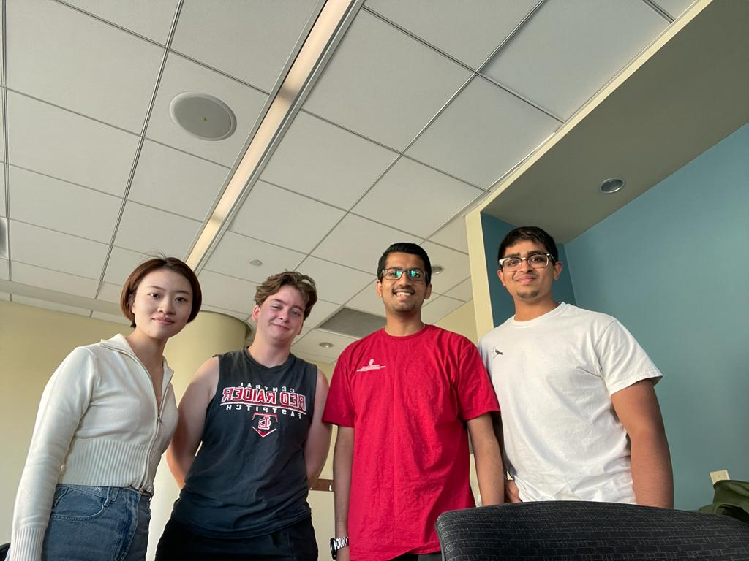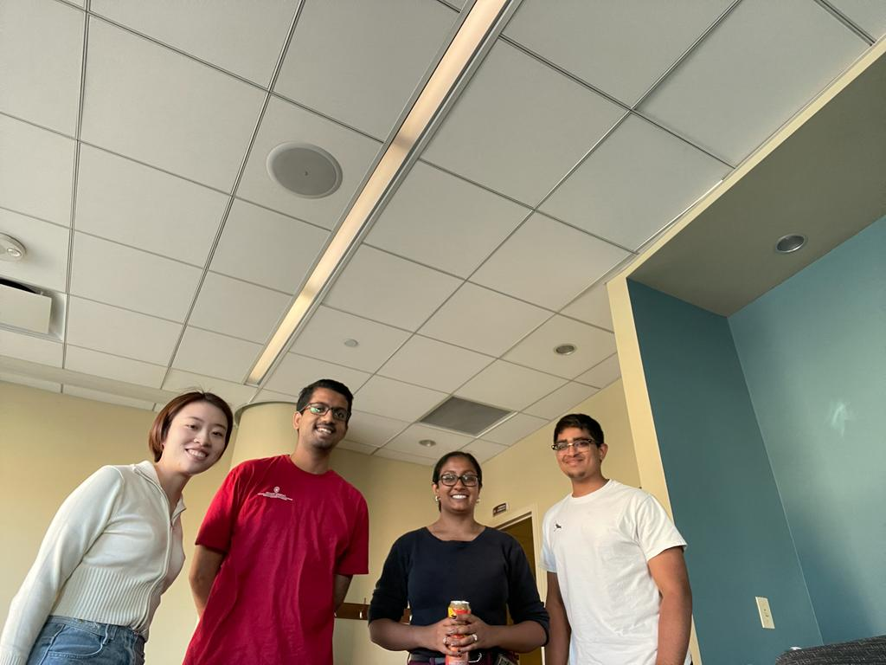

Affinity Diagrams:

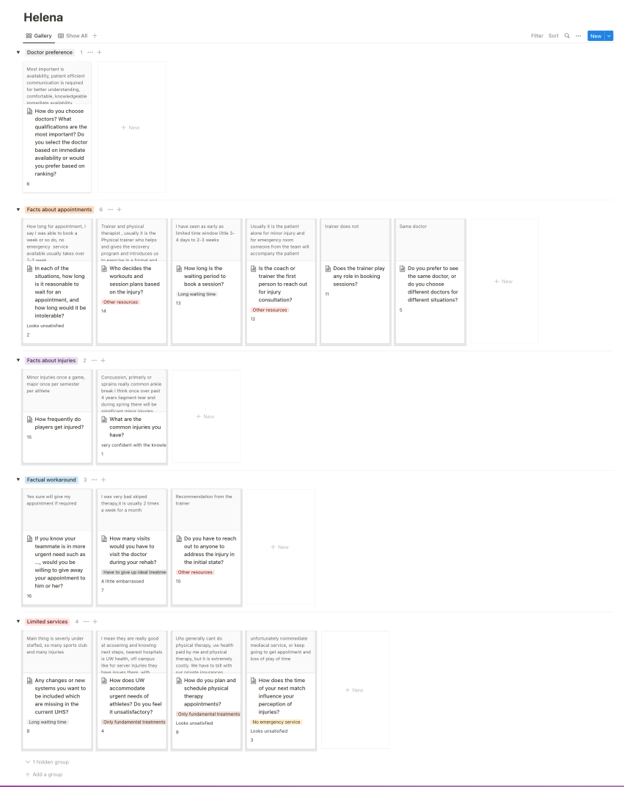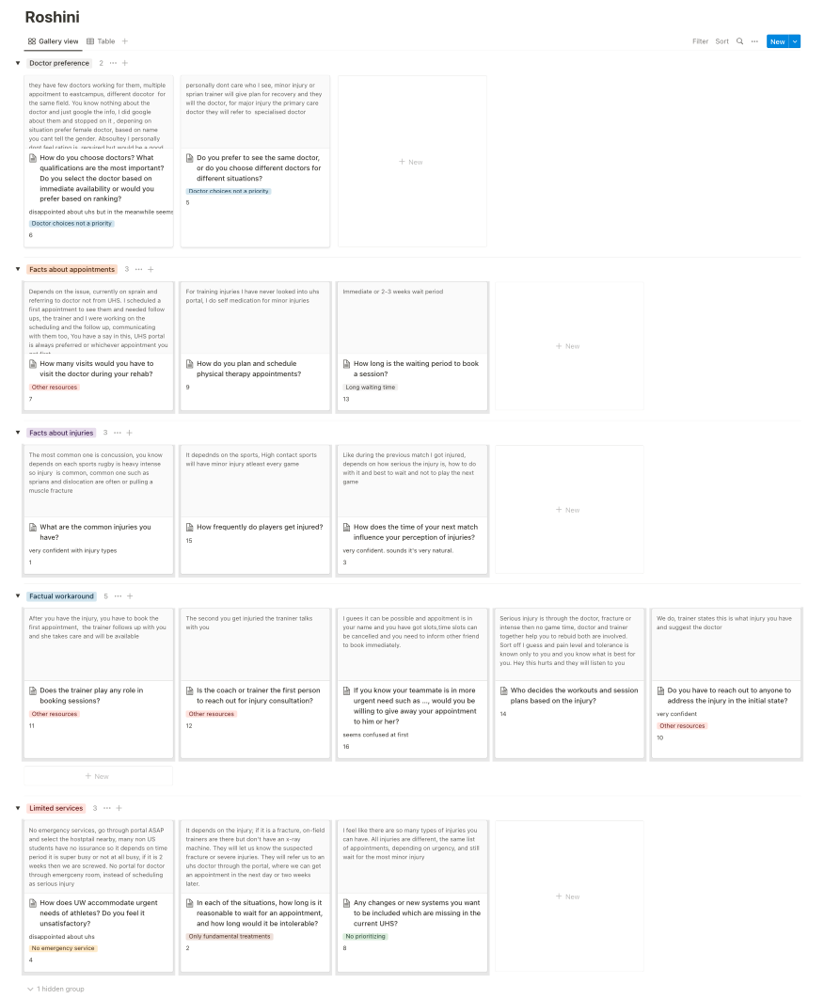

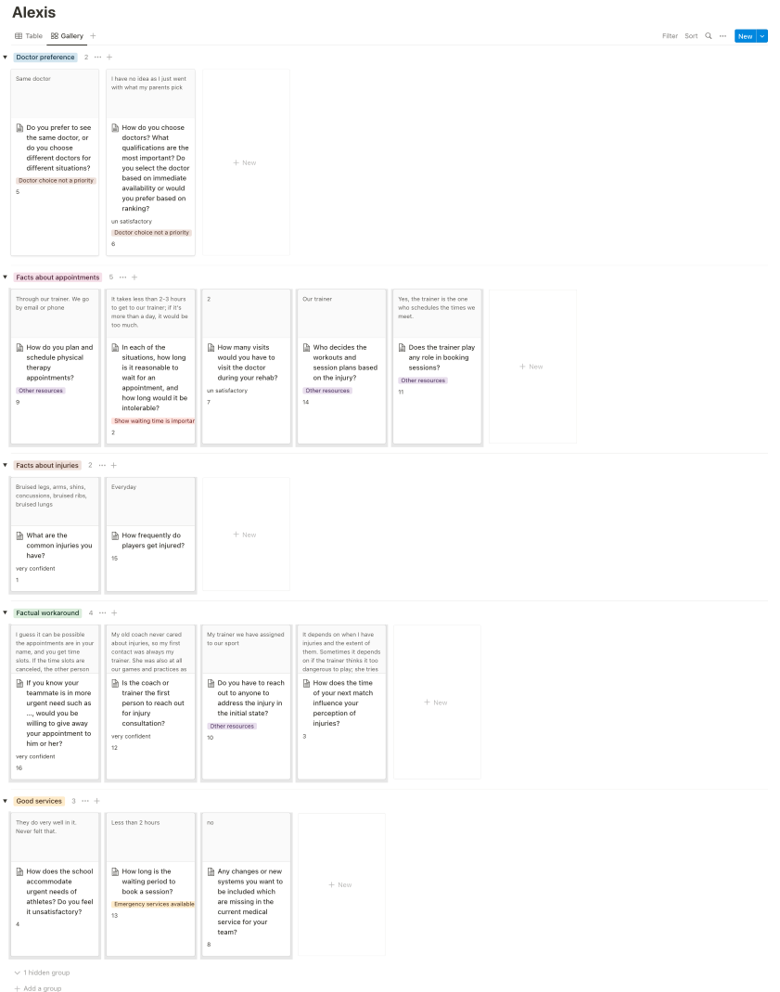

Work Models for 3 Participants: 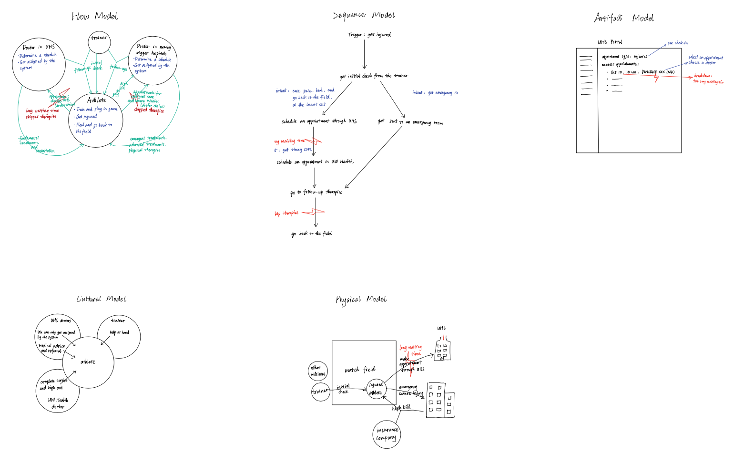

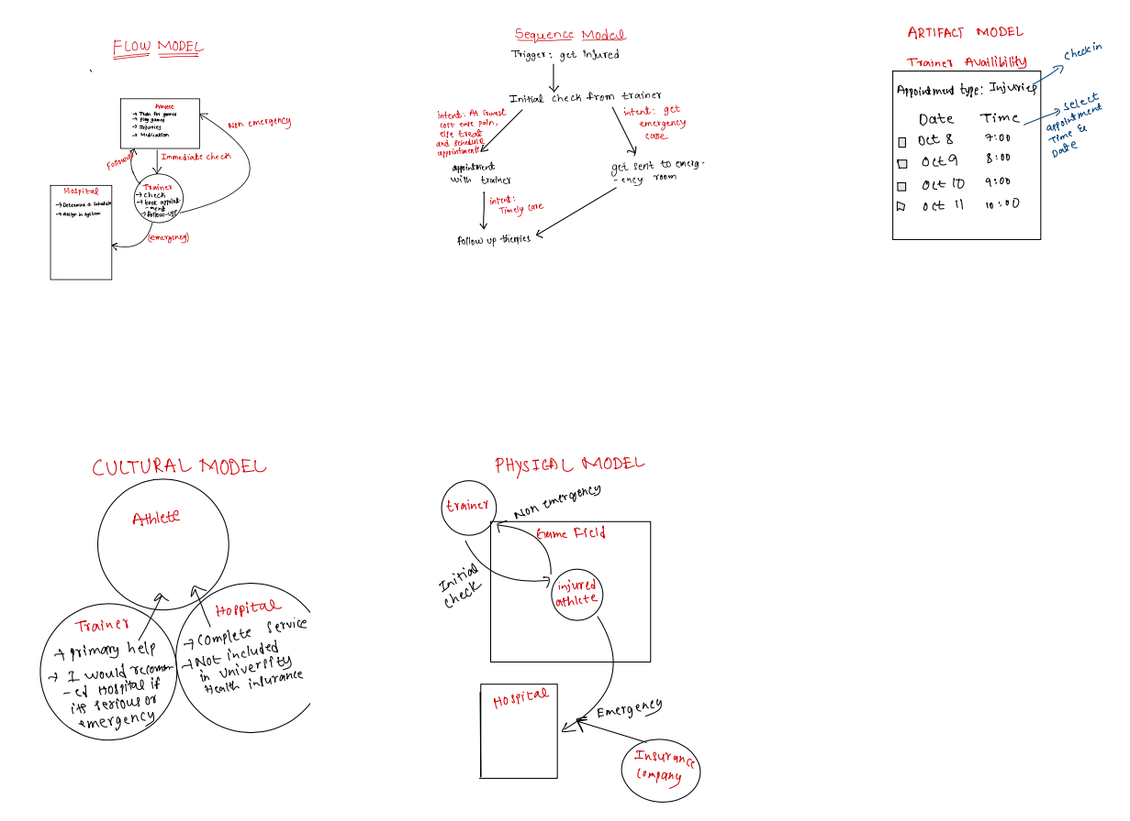

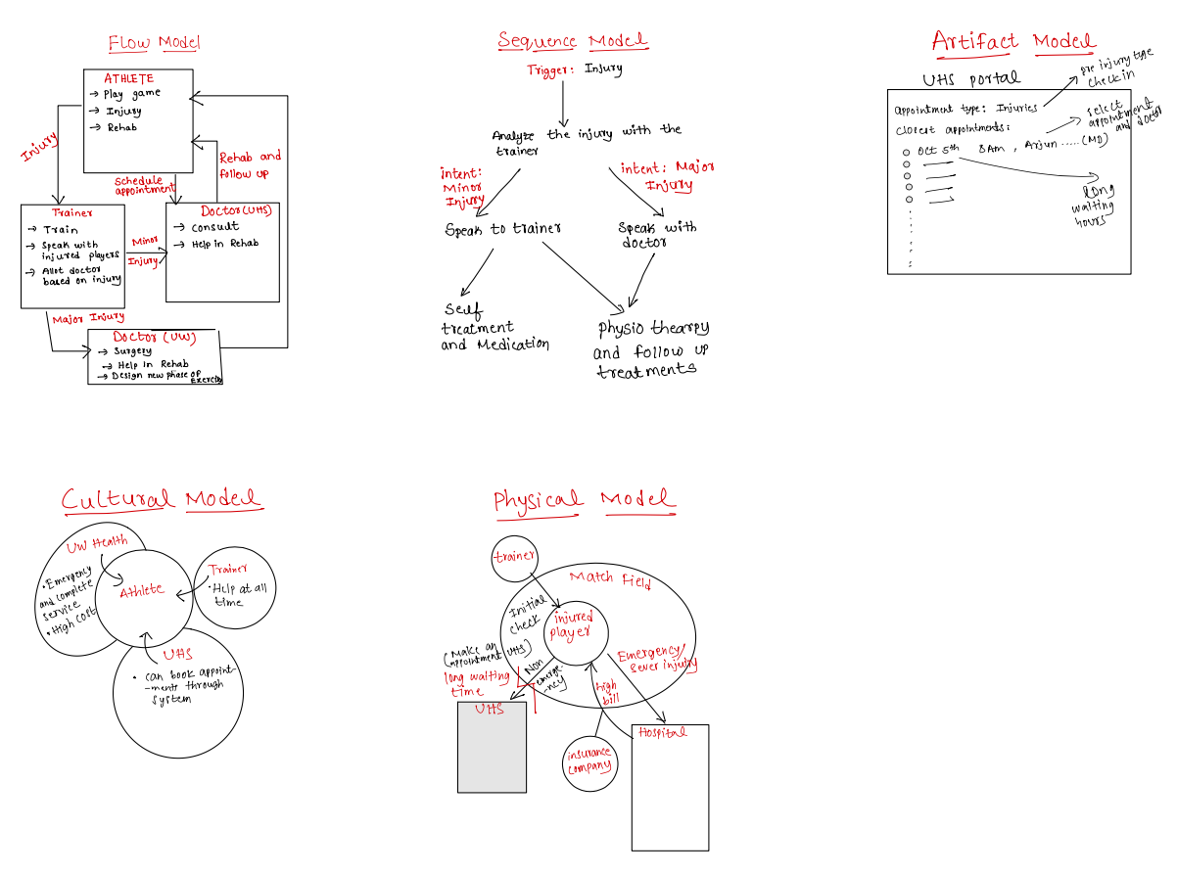

Our main design idea is to build an appointment scheduling platform that is more straightforward and user-friendly than UHS.

The main design feature is **a prioritizing feature**. Patients in urgent needs can indicate their needs and see most recent appointments.

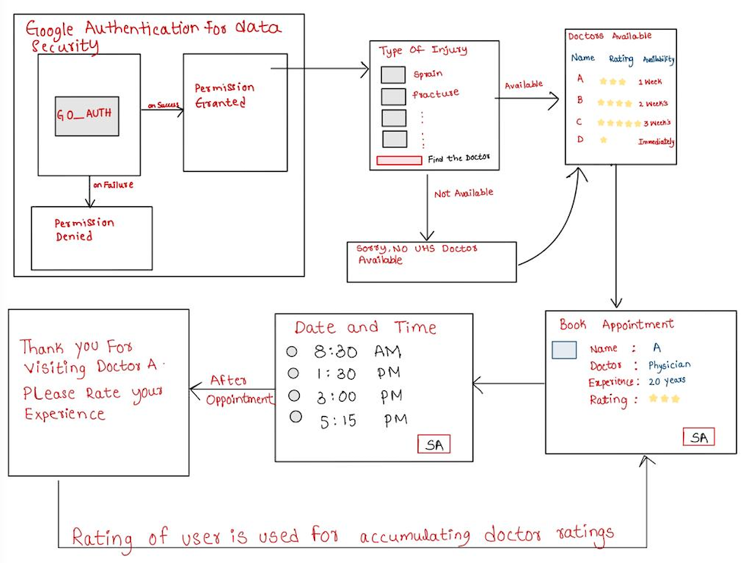Before CIs, we focused on doctors’ ratings and descriptions, so that athletes can choose doctors they want.

After CIs, we realized that prioritizing is the most important. Originally, we want to ask every patient to fill out **a survey** about their conditions:

* The pain they are experience
* The type of injury
* The date of their next game

We want to prioritize accordingly.

However, this design might have a *privacy problem*. We then decide to *give them a* ***checkbox*** *to indicate whether or not they are in urgent needs*.



In order to **prevent possible abuses** of this feature, we are going to remind the limitedness of medical resources and encourage them to lease them to the people in need if they can wait a bit.



**Lo-fi prototypes**: 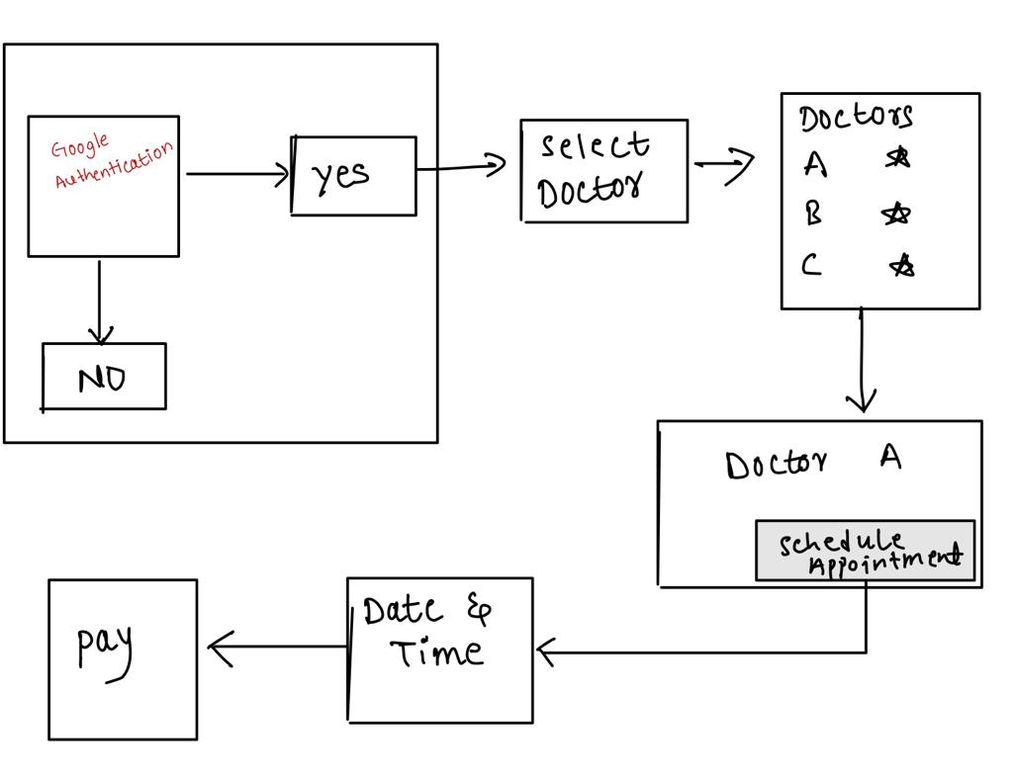



In our lo-fi prototypes before CIs, we implemented Google O-Auth for data security. The athletes will be able enter the required injury which they are suffering currently, post which the system will show the list of expert doctors in that domain along with their availability and ratings. The athletes can schedule their appointment with the required doctor after looking at their rating and availability date. The athletes will be able to rate the doctor after their session depending on various parameters.

**Hi-fi prototype**:

<https://www.figma.com/proto/T7eD6LOOdOHJSrB4zDOC6E/Athleticare---Medical-Appointment-Booking-System-for-Athletes?node-id=2%3A20&scaling=min-zoom&page-id=0%3A1&starting-point-node-id=2%3A20&show-proto-sidebar=1>

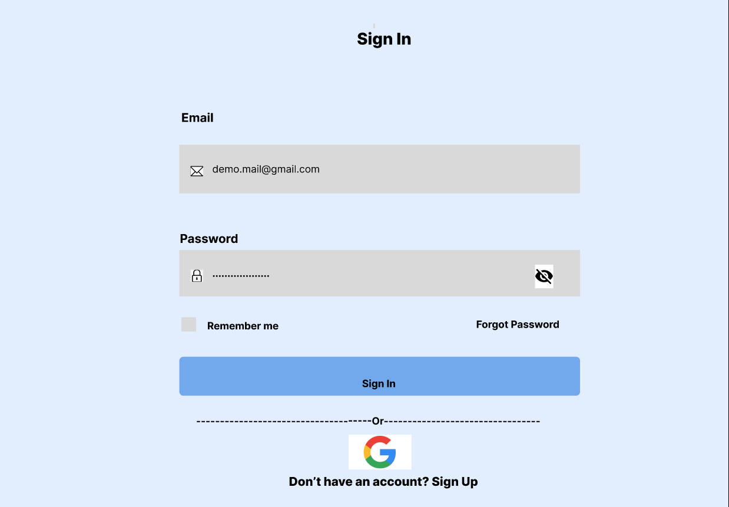

Google O-Auth for data security

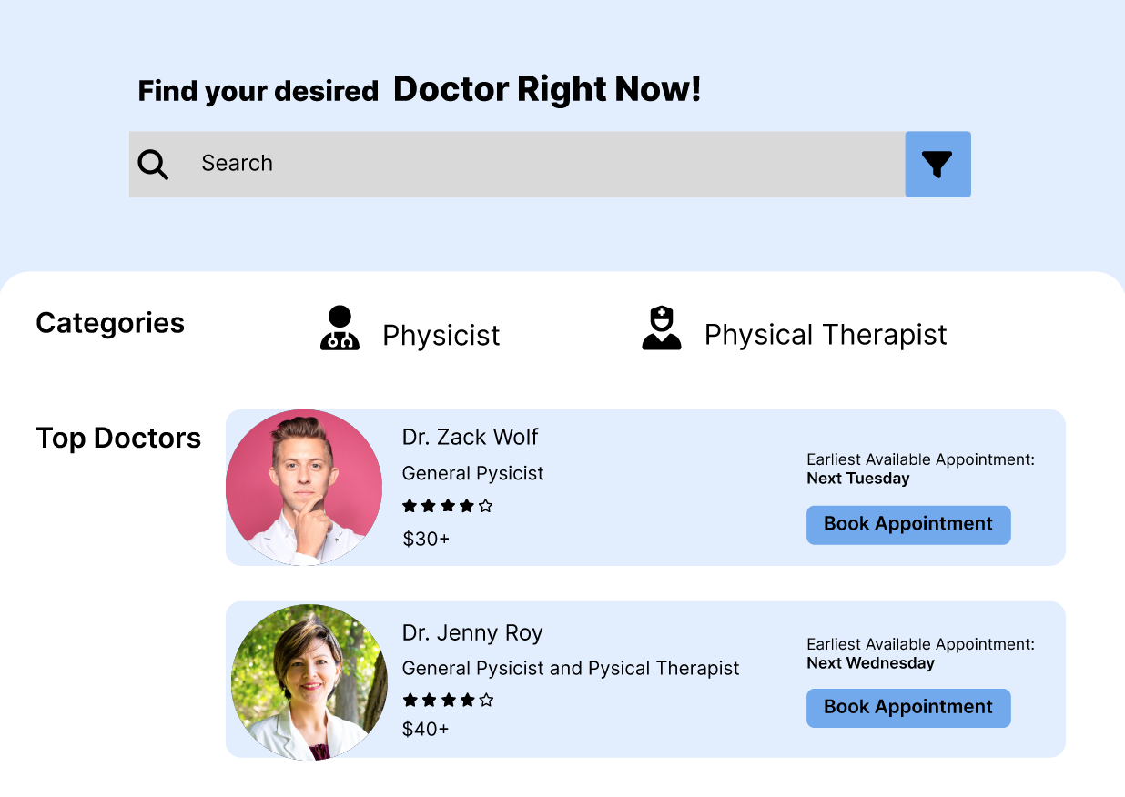

Doctors

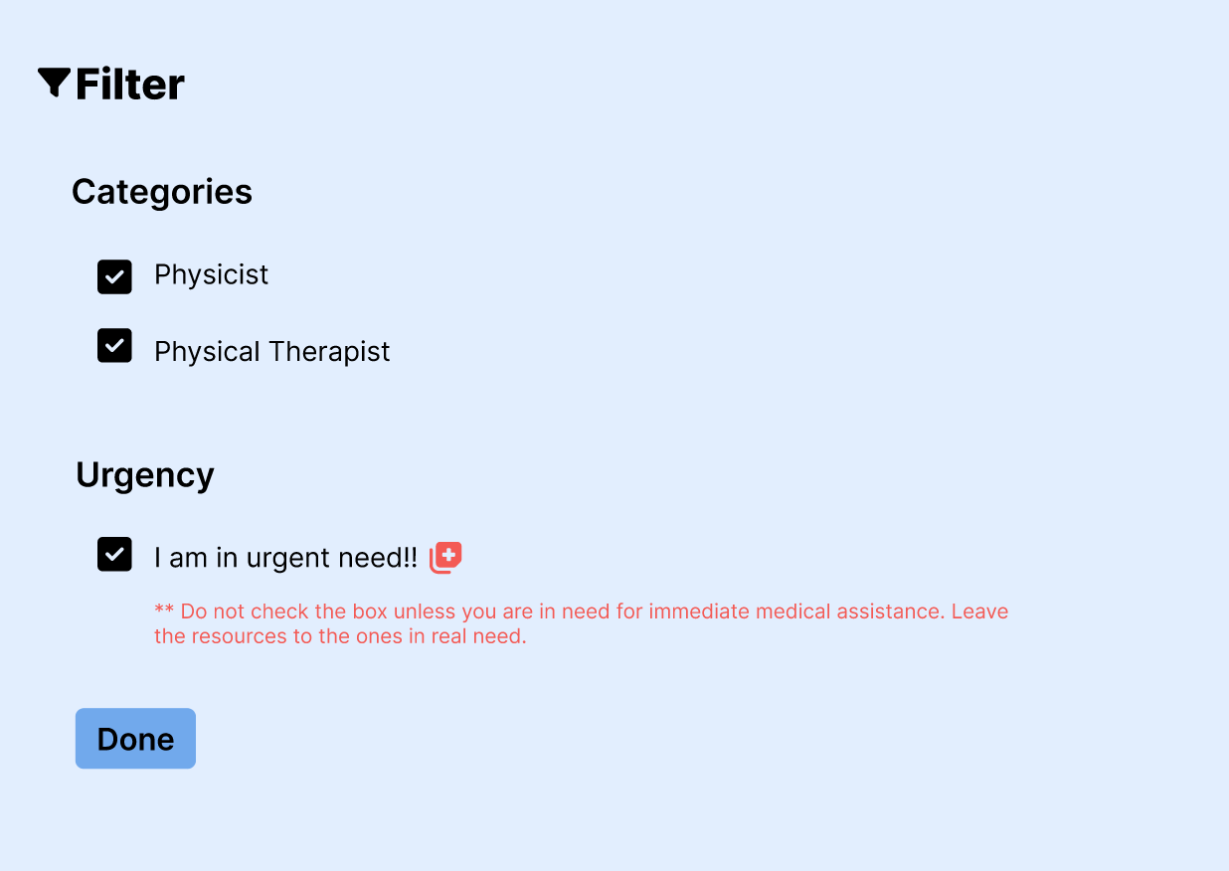

**Prioritizing feature: indicate whether they are in urgent need**

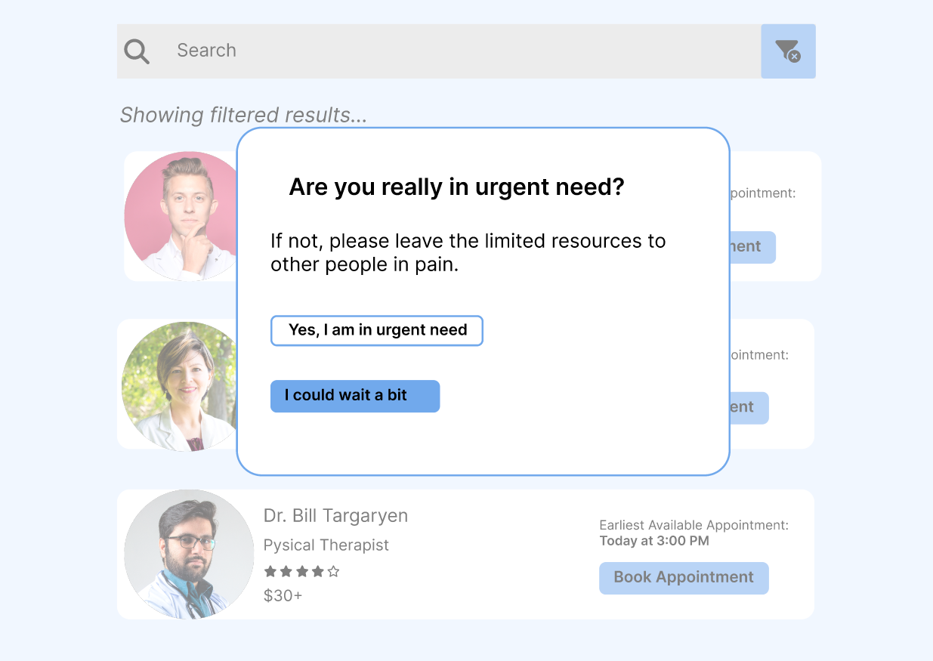

**Prevent abuses of the prioritizing feature**

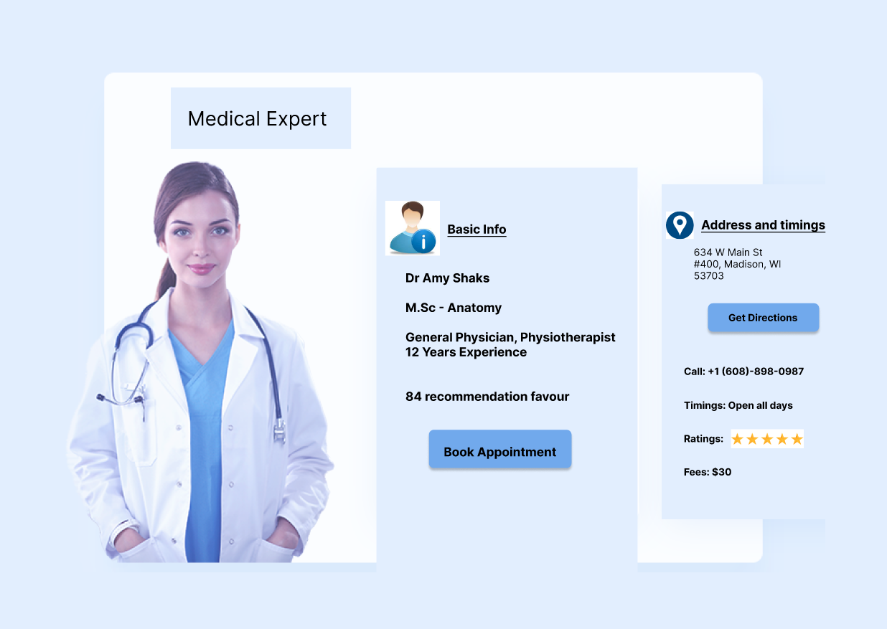

Make appointment and get directions

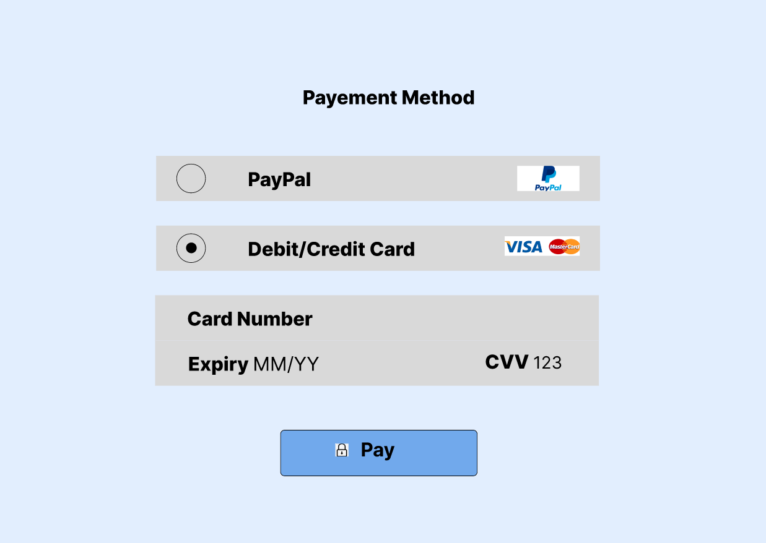

Paypal or credit card to pay

**Methods: Within-Subjects Design; Talk-Aloud Protocol; Task-Based Testing**

Each of our participants are asked to work through the same task path. We conduct 3 individual 15-min usability tests.

* We first use 3–5 min to explain our design and what we are interested to find out in the usability testing.
* We then give him or her a scenario and the tasks.
* Participants are asked to talk aloud during the whole process.

Participants conduct the testing with their own computer in their normal life/work settings.

**2–3 Tasks For 3 Participants:**

You just broke your knee are in an emergent need.

1. Choose a doctor you want
2. Book an appointment ASAP

**Results and Findings:**

Audio and video recordings of usability testing: [Stage 3](https://uwprod-my.sharepoint.com/:f:/g/personal/wlyu27_wisc_edu/EozIALK68RFLhfGNE6Lc_4wByM0bsfN5CqE8Ep1wgVOeyw?e=zCcN6y).

*All three of our participants fail to find the nearest appointment.*

The majority of breakpoints, errors, and confusions our participants encountered are due to the *limitation of figma*. They are used to dynamic and interactive website. Figma’s lack in this respect is a constant confusion.

However, we did observe some data which would lead to improvements in our prototype:

* Breakpoints when the participant
  + want to filter doctor types
  + didn’t see the zip code at payment
  + didn’t see a sorting feature
  + can’t search and didn’t see a tag for specific injuries
  + don’t see WisCard payment type
  + don’t see confirmation email sent
* Confusion about
  + the icon beside the urgent need check box
  + typos in Physicist & Physical Therapist
* Failure
  + to find the nearest appointment before he or she didn’t see the existence of the filter.
  + to find the nearest appointment before he or she didn’t see the existence of the checkbox to indicate urgent need.

Though some of these data points to an improvement in design, such improvement cannot be done in figma. For example, sorting feature and search and input features. Because figma cannot be dynamic, things like adding respective descriptions of doctors are also impractical. We are going to make the feasible improvements in figma.

**Final Prototype:**

<https://www.figma.com/proto/uBAWkvx5VM3qWMhzHkahIT/Athleticare-Final-Solution?node-id=0%3A1&scaling=min-zoom&starting-point-node-id=1%3A37&show-proto-sidebar=1>

**Changes and reasons:**

Add more prompts to let users know that we provide accommodations for urgent needs.



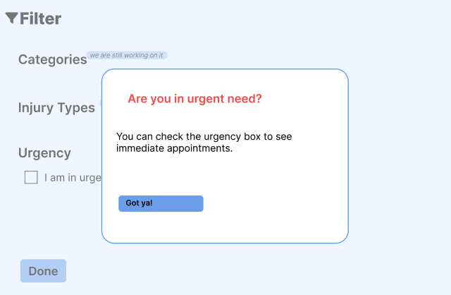

Add doctor specialty to help with choosing

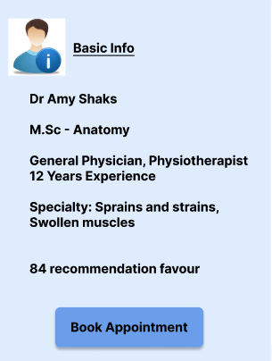

Disable features that cannot be well supported by figma, so that they will not confuse users when they test the prototype. Ex1. categories deleted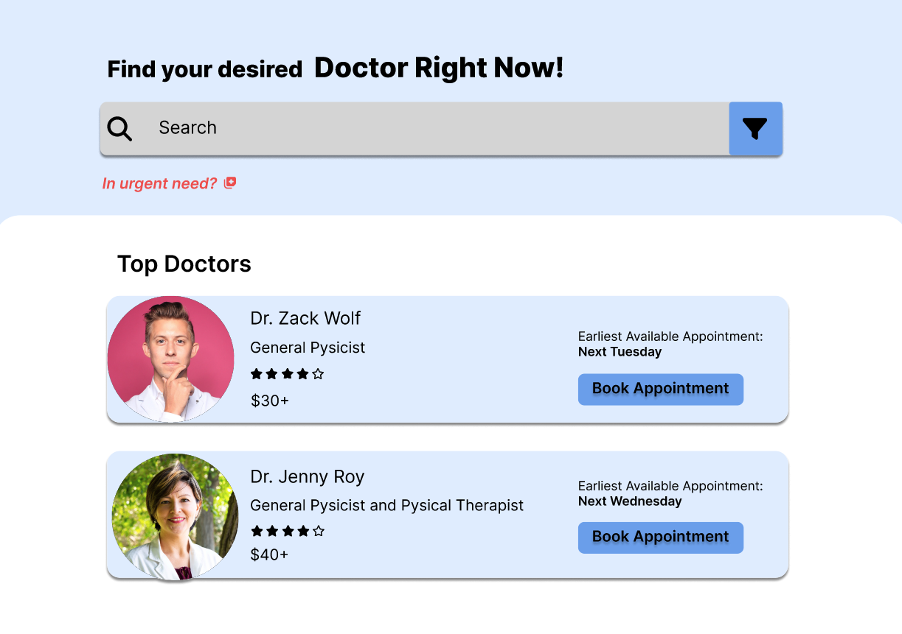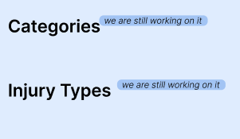

Ex2. paypal as the payment method



Add a prompt that confirmation email is sent, so that the patient can have a record

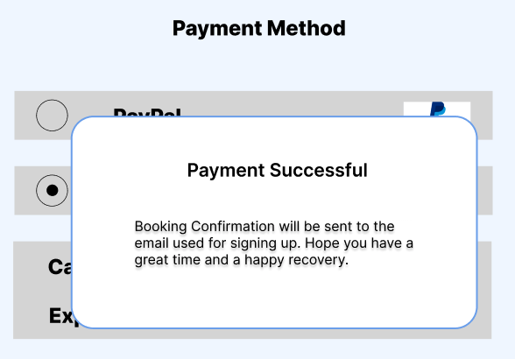

Add outlines to refine the looking. Ex.

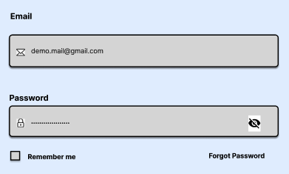

Added backward buttons in main breakpoints to simplify changes. Ex. On the payment page so that if the user wants to change the appointment timing, he can go back to modify the date and time frame.

