**Automating Form Submission Using Selenium**

**Objective:** Automate the process of filling out a Google Form and capturing a screenshot of the confirmation page.

**Tools and Libraries:**

* Vs Code
* Python
* Selenium
* Django
* ChromeDriver

**Set up for Automation for form**

1. **Create a Virtual Environment and activation**

1. **Package installation**

**Selenium installation:** pip install selenium

**Django installation:** pip install Django

**ChromeDriver Intallation:** pip install chromedriver-py

**Scripts Explanation**

1. **Import Libraries**

1. **Chrome Driver SetUp**



1. **Open The Form**



1. **Fill the Form**

1. **Submit Form  
   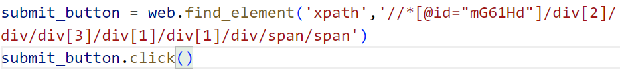**

**Email Submission :**

1. **Set Up:**

In Django settings.py file configure SMTP

1. **Create Email in View**

