Project : Load balancer – Day 3

Task1 : One linux instance,Using the first free linux AMI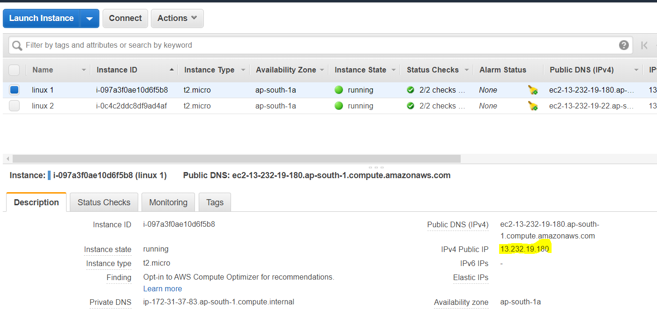

Task 2: Host html login webpage on first servers

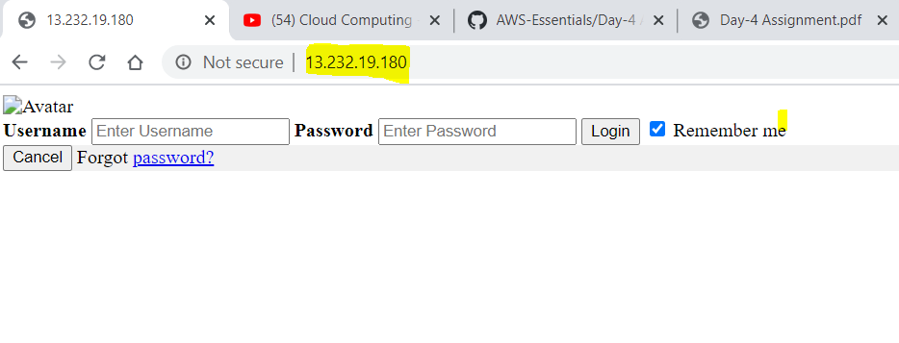

Task 3: 2nd linux instance,Using the first free linux AMI

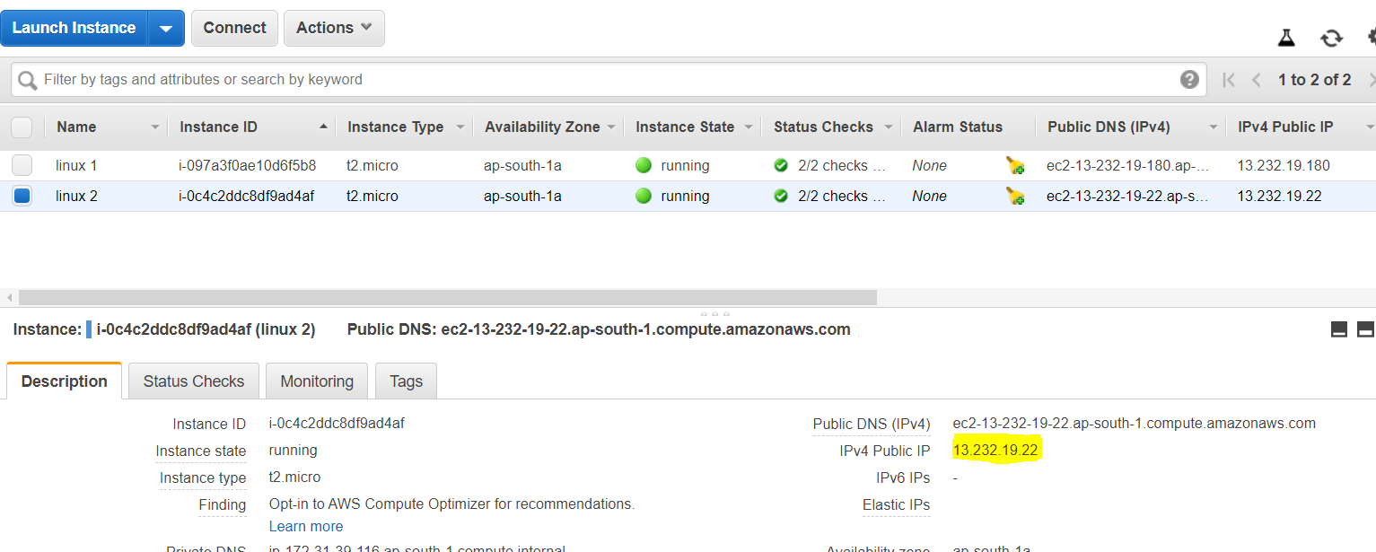

Task 4: Host html login webpage on 2nd server

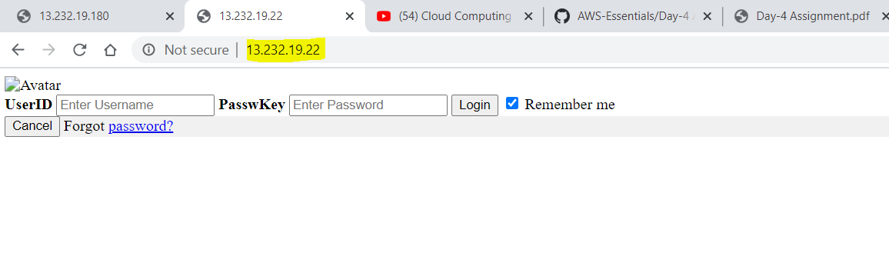

Task 5: Create a application Load balancer with the above two instances as targets

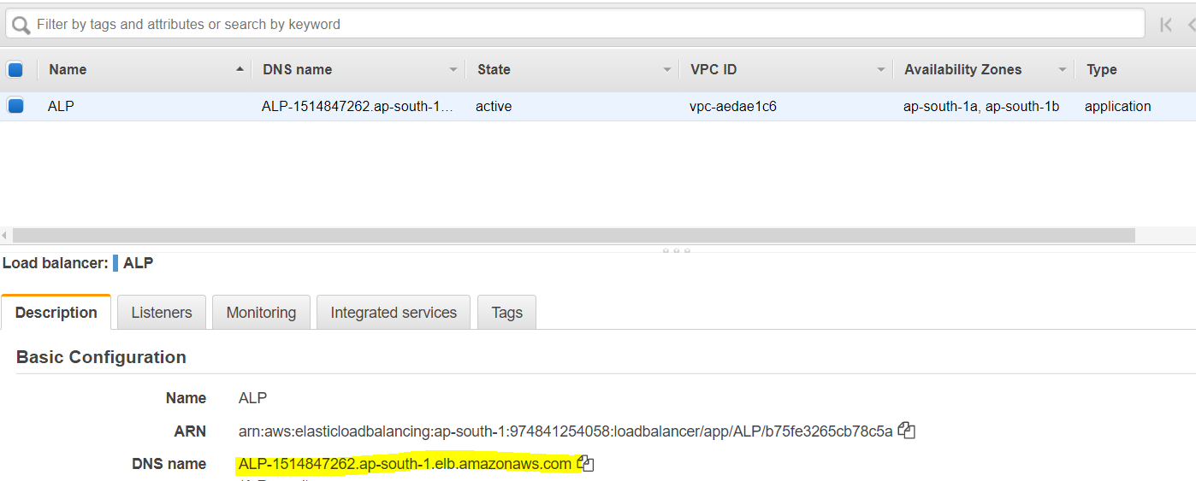

Task 6: Results

