**LogisticRegression:**

ConfusionMatrix:

array([[65, 3],

[ 6, 26]])

**KNearestNeighbors:**

ConfusionMatrix:

array([[64, 4],

[ 3, 29]])

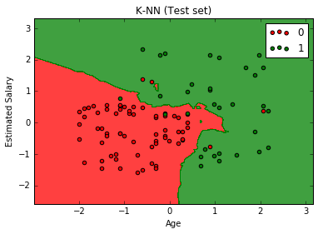

**SVM:**

ConfusionMatrix:

array([[66, 2],

[ 8, 24]])

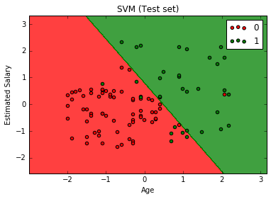

**KernelSVM:**

ConfusionMatrix:

array([[64, 4],

[ 3, 29]])

