Github Copilot App modernization: Java upgrade from 8 to 21:

- Environment setups:
  - Installed Visual studio code with 1.109
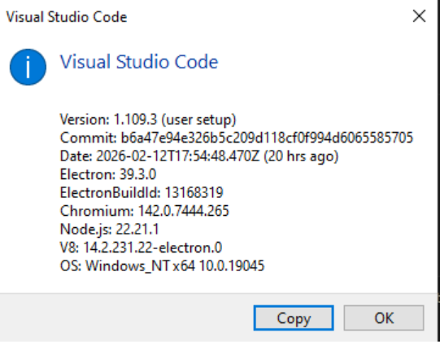
- Installed Github copilot App Modernization extension for Java
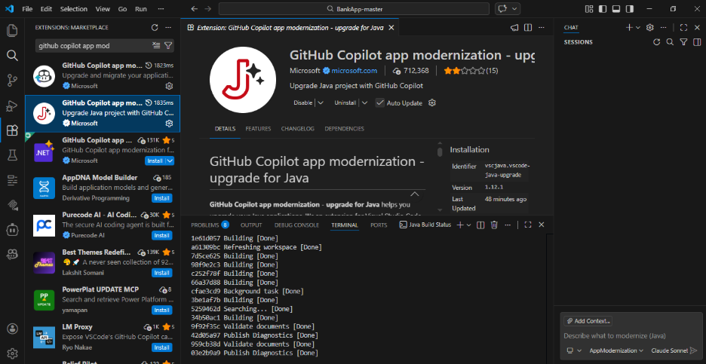
- App Modernization available in Github copilot window to select and prompt to upgrade our java application from older 8 to 21 version:
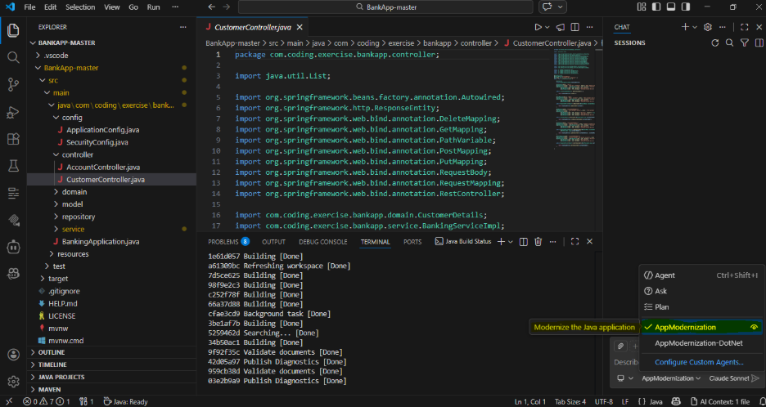

- Application code in Java 8 and compatible Spring boot version:

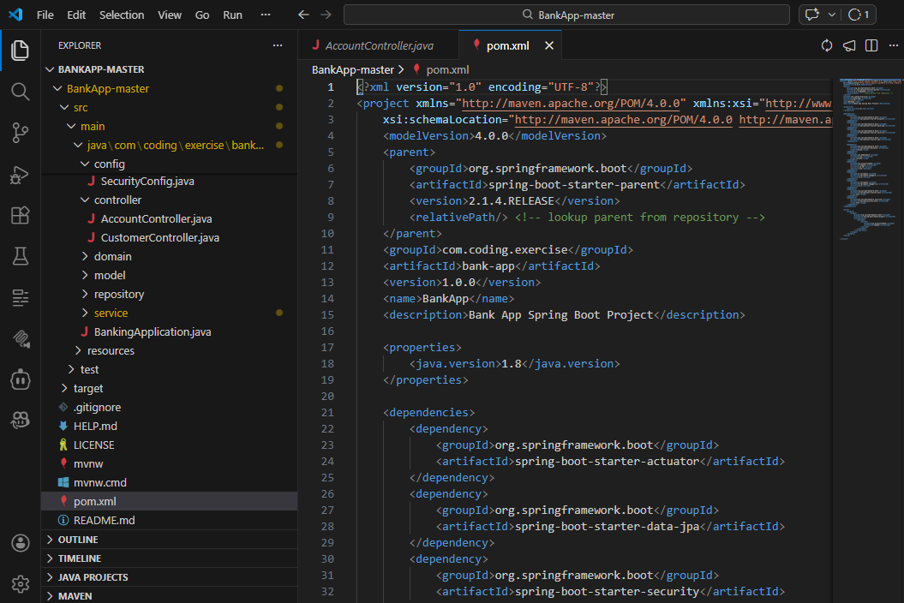

- Running this application in local swagger before upgrades:
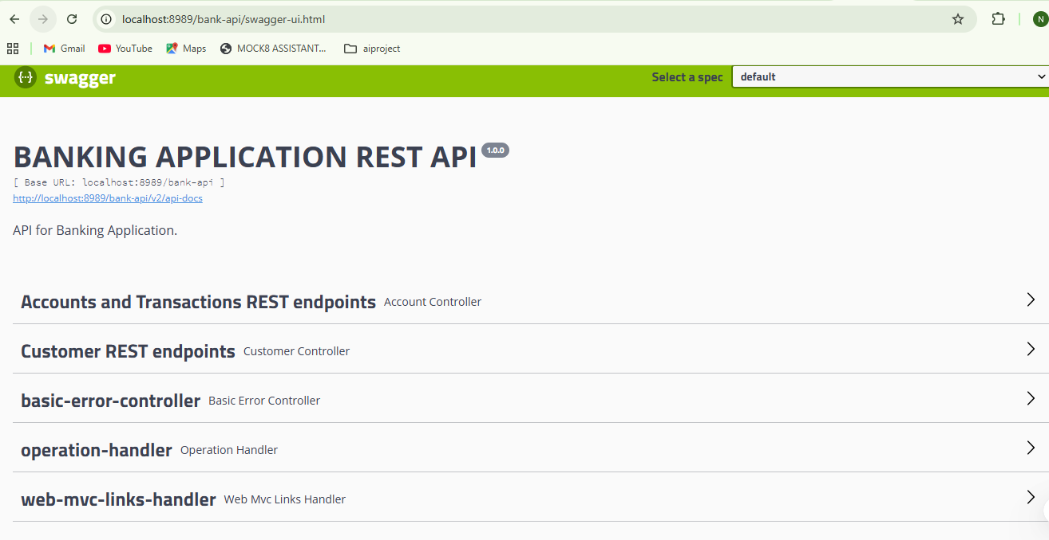

- Prompted to upgrade Java application from 8 to 21 version:
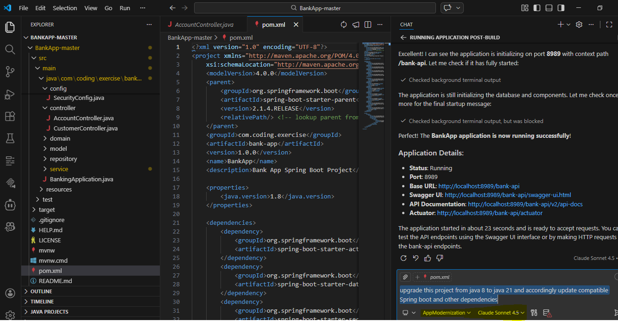
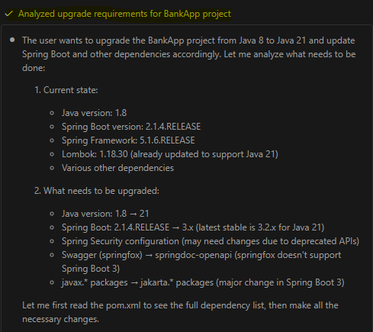
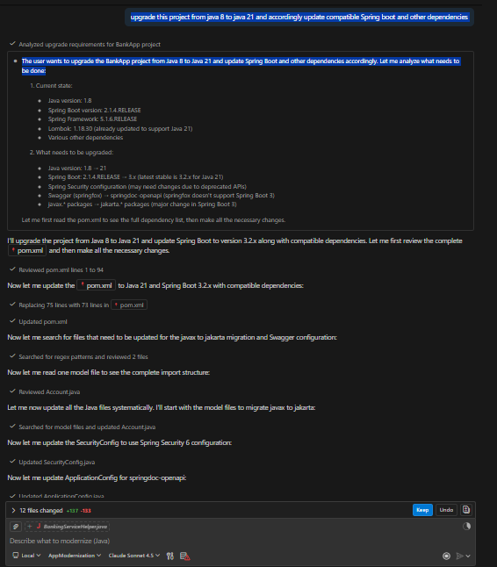

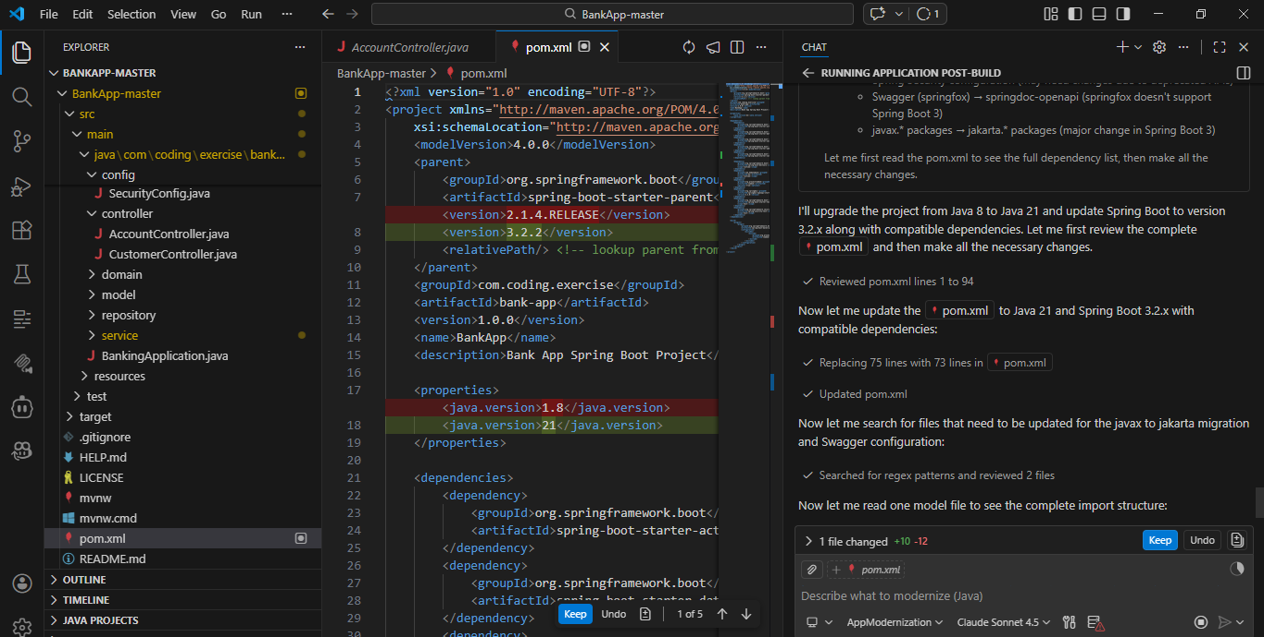
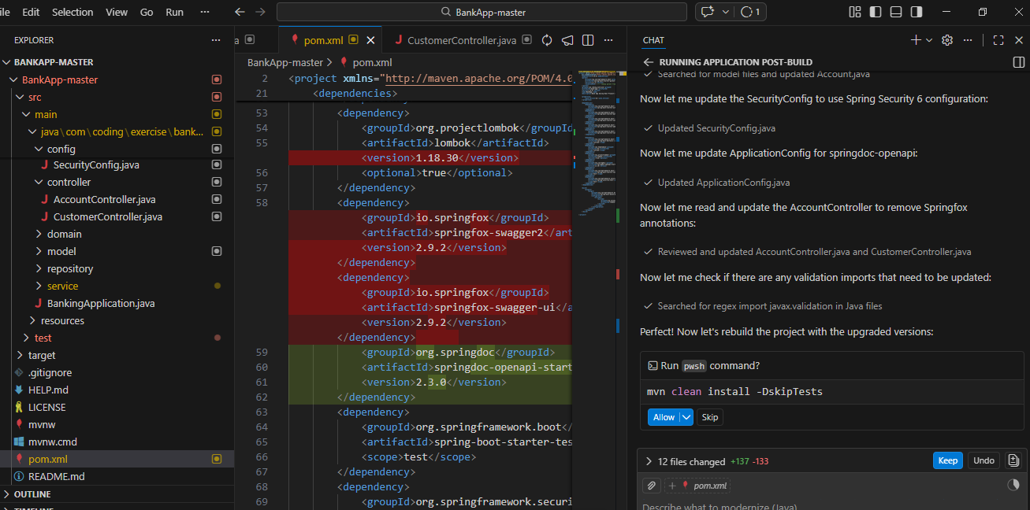
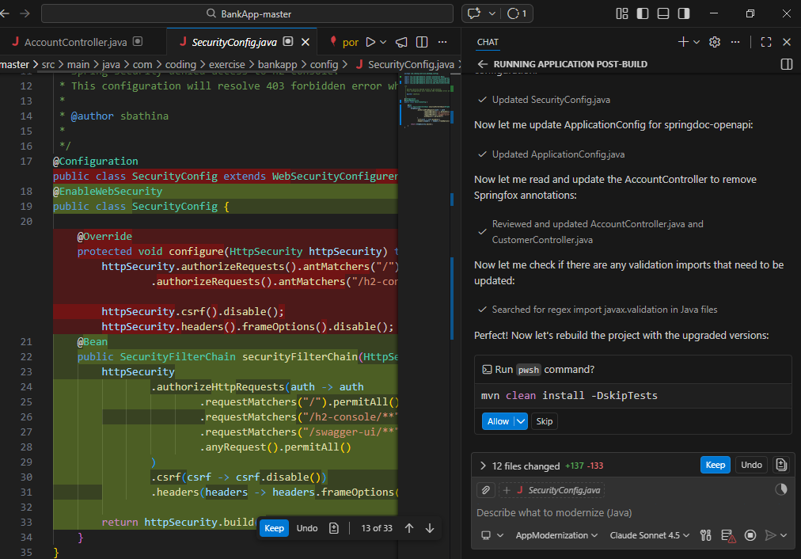
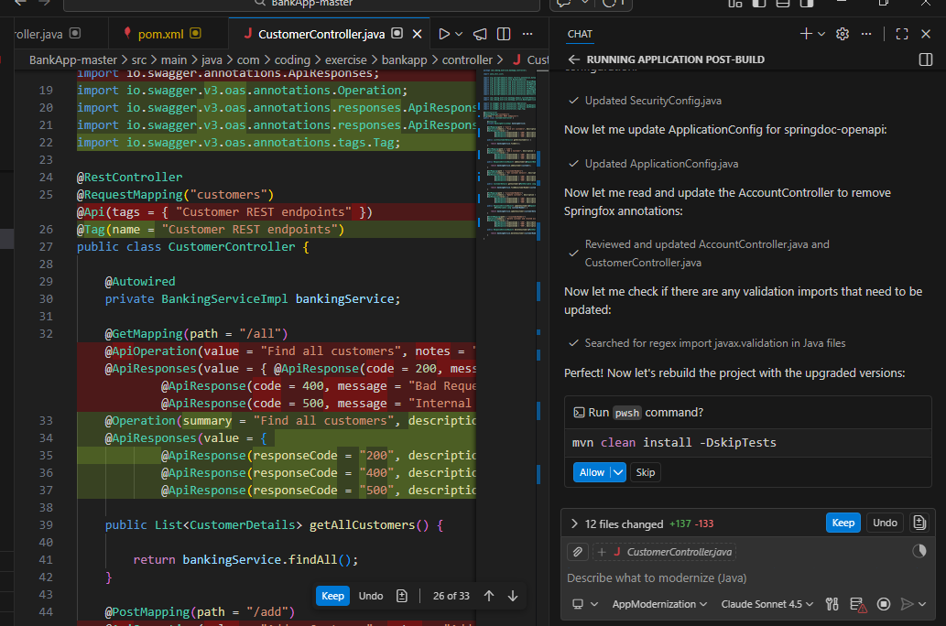

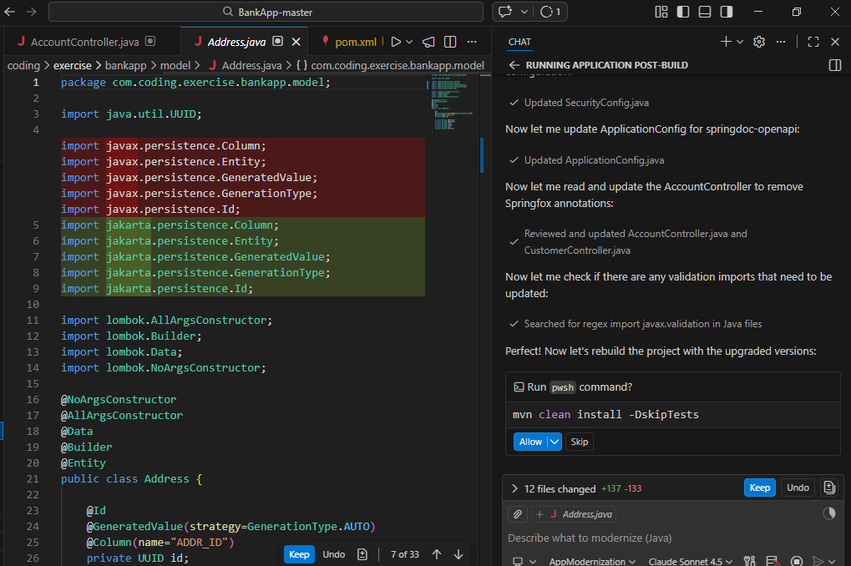

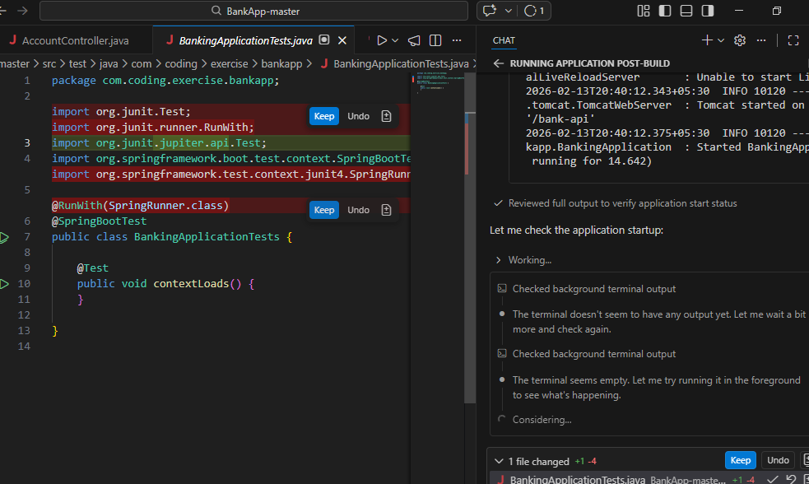

- Application upgraded from Java 8 to Java 21 version by App modernization extension and it ran build:
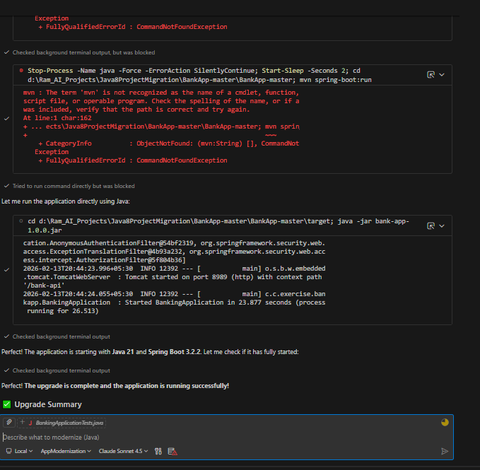
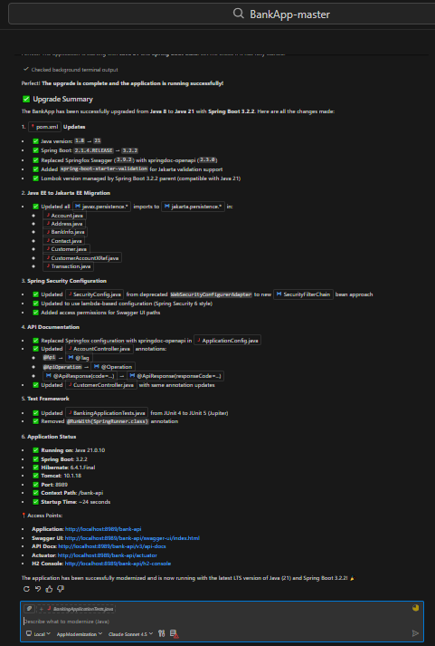

- Application ran in local swagger after upgrading from Java 8 to 21:

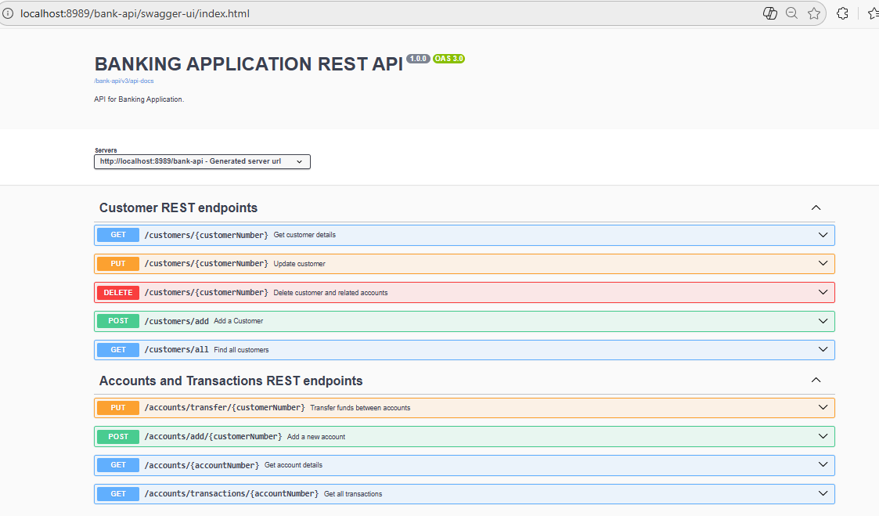

- Findings:
  - Time taken for migration: 30 minutes - 1 hour approximately.
  - Benefits: Java upgradation from version 8 to 21 was done using app modernization extension within an hour. This upgrade for our large scale project took approximately 8 story points per migration. Java 8 to 11, then 11 to 17 and at last we made it to 21. So approximately, it took a month of our efforts for this migration. This could be achieved within an hour or so based on complexity of the application.
  - Limitations: Since pom.xml changes are restricted in bank, it needs to be checked on how this extension may suggest the changes.

